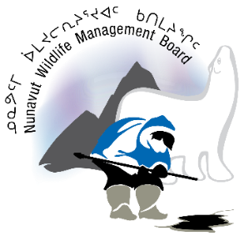
Nunavut Wildlife Research Trust
Carry-over Request Form
Any contributions from the Nunavut Wildlife Research Trust (NWRT) remaining unused at the end of the fiscal year (31 March) must be returned to the NWMB by 1 May. Applicants wishing to carry-over contributions must fill out this form and submit to the NWMB by 15 March. Any requests received after 15 March will not be considered. Applicants can request to carry-over a maximum of 25% of the total NWRT contribution. Carry-over requests are considered on a case by case basis based on the reasoning and justification provided to the NWMB. There is no guarantee that any carry-over request will be approved. A response to all carry-over requests will be provided by 31 March.

Section 1 - General Project Information
NWRT Project #:
Project Title:
NWRT contribution amount:
Amount remaining:
Amount requested to be carried over:

Section 2 – Contact Information
Department:
Project Leader:
Address:
Email Address:
Phone:
Fax:

Section 3 – Explanation for carry-over
Please provide the reason for the carry-over request, including a detailed explanation for why the contribution was not spent during the present fiscal year and how the contribution will be used in the next fiscal year. Also, please include details on other funding sources to ensure the NWMB that the project can go ahead the next fiscal year.

Section 4 – Revised Project Schedule
Identify the dates for beginning and completing each step in the study design that will be supported by the NWRT contribution, including any relevant community consultations.
Output or step | Start Date  (dd/mm/yyyy) | End Date  (dd/mm/yyyy)

Section 5 – Revised Project Budget
Provide a detailed, itemized budget for the project. Include all budget items. Indicate which budget items will be supported by the carry-over request.
Item | Funds ($) | In-Kind (PY or $) | Funded by NWRT (yes/no)

Please return this carry-over request form to the NWMB at the below coordinates:
Nunavut Wildlife Management Board
P.O. Box 1379, Iqaluit, NU, X0A 0H0
Phone: 867-975-7300
Fax: 867-975-7320
Email: receptionist@nwmb.com

To be filled out by the NWMB Director of Wildlife Management:

Section 6 - NWMB’s Approval
Approved |  | Amount Approved:
Not Approved
Rational for the NWMB’s decision:

Signature |  |  |  | Date

