Project Title: Anthropogenic impacts on seabirds in Qikiqtarjuaq, Nunavut (NWSF Project # 2018-006)
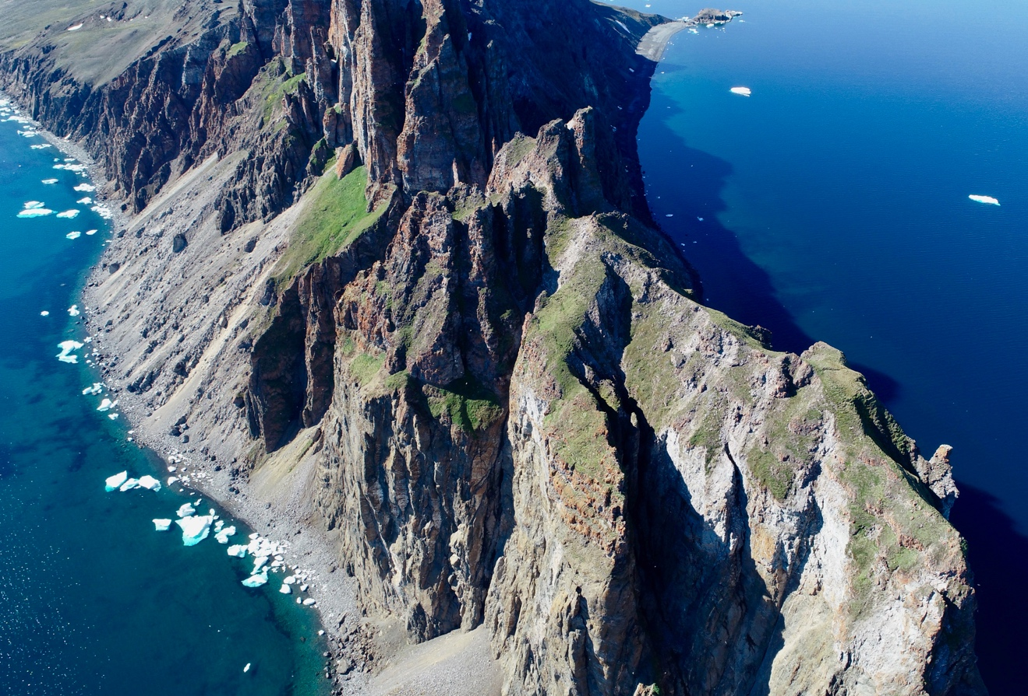

Project Contact
Alison Kopalie
PO Box 10
Qikiqtarjuaq, Nunavut
867 927 8836; nattivak@baffinhto.ca

Jennifer Provencher
Canadian Wildlife Service, Environment and Climate Change Canada
351 Boulevard Saint-Joseph, Gatineau
819 995 1399; Jennifer.provencher@canada.ca

Project Summary

Canada is home to approximately 30% of the North American population of Northern Fulmars, a long-lived species with an average lifespan of more than 30 years. While Northern Fulmar colonies have been reported to be increasing in some regions (e.g., Ireland, UK, Norway), populations are generally stable, declining, or of unknown status in most Arctic regions. In fact, data from the past 35 years indicate that Northern Fulmar populations in Nunavut have been declining slowly. Although the causes of the declines are currently unknown, Northern Fulmars are known to be susceptible to a number of anthropogenic activities. The goal of the project in 2018 was to assess the potential impacts of nearby fisheries, oil pollution, and microplastics on northern fulmars in the Baffin Bay-Davis Strait region.

Seabirds in the Arctic have been found to ingest plastics, and excrete microplastics in their guano. Microplastics have been found to accumulate in sediments as well as filter feeders such as mussels, oysters and clams. There has been little work to investigate how seabird colonies may influence microplastics in the marine and terrestrial biota and habitats around their colonies. Additionally, seabirds can also be affected by shipping and oil-related contaminants. We collected seabirds, as well as other biotic and abiotic samples, with local hunters to evaluate how seabirds in the region are currently experiencing exposure to both plastic pollution and oil-related contaminants.

Project Objectives
During the summer of 2018, there were several project objectives for Northern Fulmars in the Baffin Bay-Davis Strait region.

Overall, these objectives included:
- Update the northern fulmar colony estimates for Baffin Island (Buchan Gulf and Scott Inlet by helicopter, and Qaqulluit and Akpait by boat)
- Assess 4 marine bird species for exposure and impacts from oil-related contaminants
- Obtain up to date information on ingested plastic in marine bird species in the region
- Assess how seabirds may be concentrating microplastics in and around nesting areas of high density

The funding support from the NWMB specifically supported the last two objectives in relation to microplastics in seabirds and the environment around seabird colonies.

Materials and Methods

Northern Fulmar Colony Census

The helicopter-based surveys allowed us to take aerial photos and confirm that both the Buchan Gulf and Scott Inlet Northern Fulmar colonies had the same location as recorded during previous counts. At the Buchan Gulf colony, birds were observed flying around the base of the cliff and in the shore lead, but none could be observed on the cliff with the naked eye. At Scott Inlet, birds were observed on the wing and on the cliff of the colony.
Although an important portion of the colonies were covered, the boat-based surveys of the Qaqulluit and Akpait colonies appeared to be a little more challenging in terms of accessibility. The weather conditions and the lower height of Qaqulluit made it easier to photograph the majority of the cliffs. The use of an unmanned aerial vehicle allowed the team to take photos of the summit of the colony, where the majority of the birds seemed to be nesting. Differently, because of the low clouds and the higher height of the cliffs at Akpait, the part of the colony hosting most of the Northern Fulmars was harder to access, even when using unmanned aerial vehicle. Again, the birds seemed to be nesting on the highest parts of the cliffs or at the summit. These surveys enabled us to confirm that while the Qaqulluit colony is mostly composed of Northern Fulmars, a mix of Northern Fulmars, Thick-Billed Murres, and Black-legged Kittiwakes is found at Akpait. A few Glaucous Gulls were encountered at both sites.

The photos taken at each colony will provide detailed information about the location and density of the birds within the colony, as well as a global estimate of the population size. These data will contribute to the assessment of the sustainability of the fisheries in Nunavut.

Seabird Diets and Environmental Stressors

The auxiliary purpose of this project was to assess how anthropogenic stressors in the region other than fisheries may be affecting local seabird populations. The aim was to improve our understanding of the distribution of both plastics and microplastics in Arctic ecosystems, and how seabirds may act as vectors and concentrators of plastic pollution. Moreover, since it is expected that shipping and boat traffic in Baffin Bay and Davis Strait will increase in the future, we wanted to assess current levels of oil-related contaminants and their effects on seabirds and their habitat. While we have learned much about how ecosystems can be affected by oil spills in some regions, there is little data on oil exposure and the potential effects of oil-related contaminants in northern ecosystems.

During the boat-based surveys conducted at the Qaqulluit and Akpait colonies, the team was able to collect critical samples such as:
- Northern Fulmar and Thick-billed Murre specimens to look at suggested changes in marine prey species, oil-related contaminants and their effects, and plastic pollution ingestion in these birds in the region
- Common Eider and Black Guillemot specimens for also collected for analysis investigating oil-related contaminants
- Surface water, air, and sediments at 11 sites surrounding the Akpait colony to assess how microplastics are distributed around seabird colonies
- Blue mussel specimens for analysis investigating oil-related contaminants and microplastics distribution around seabird colonies

Project Schedule
The project is on schedule to date. Visits to the communities of Qikiqtarjuaq and Pont Inlet by Environment and Climate Change Canada (ECCC) employees are planned for 2019 to follow up with the implementation of the project and communicate the results. Currently the team will report back to the community of Qikiqtarjuaq in May, 2019. All the data and samples collected during the surveys will be compiled and analyzed by an extended team of scientists:

- The census photos are currently being analyzed by Acadia University students under the supervision of Dr. Mark Mallory.
- As part of the Strategic Environmental Assessment in Baffin Bay & Davies Strait, the oil-related contaminant samples of birds and mussels are currently being analyzed by the Ecotoxicology and Wildlife Health division of ECCC.
- The samples related to plastic pollution will be analyzed by graduate students from Carleton University, under the supervision of Dr. Jessie Vermaire, and from University of Toronto, under the supervision of Dr. Chelsea Rochman.

Preliminary results and discussion

Colony Surveys
The analysis of the pictures and drone footage are still underway, but initial counts suggest that the northern fulmar colonies on Baffin Island continue to show a long-term decline in breeding pairs as compared with counts first done in the 1970s. The annual rate of decline is similar across the colonies on Baffin Island, suggesting the driver is something that affects the colonies equally and is widespread in the environment. These trends are similar to other seabird species in the North Atlantic.

Oil-related contaminants
Analysis of the oil-related contaminants in the seabirds and mussels, and their impacts are still underway.

Microplastics
The assessment of microplastics in the seabirds and the environmental samples are underway. Microplastics have been detected in the water and sediment samples to date, but the complete set of samples have not yet been processed. Similarly, the seabirds are to be completed in the Spring of 2019.

Community Involvement

Expert guiding was a key component of this study and was provided by local guides and assistants Jaypootee Aliqatuqtuq, Harry Alookie, Stevie Aulaqiaq, Jaloo Kooneeliusie, Jonathan Aliqatuqtuq, John Alookie, Jeanie Toomasie, and Peter Kooneeliusie. Support in Pont Inlet, Clyde River, and Qikiqtarjuaq was respectively provided through the Mittimatalik HTO by Natasha Mablik, the Kanngiqtugaapik HTO by Gordon Kautuk, and the Nattivak HTO by Alison Kopalie and Members of the Board.

A multi-disciplinary approach to research requires a significant level of logistical support. Dr. Jennifer Provencher (ECCC) and Dr. Mark Mallory (Acadia University) and are the primary investigators for this project. Rian Dickson was the project logistics coordinator and Dr. Evan Richardson (ECCC) led the community consultation in Pond Inlet. The scientific team in the field this summer included Uluriak Amarualik, Cody Dey, Ryan Franckowiak, Michel Gendron, and Catherine Geoffroy for the boat-based surveys and Amie Black and Allan Milton for the helicopter-based surveys. Pictures were provided by C. Dey, M. Gendron, R. Franckowiak, and C. Geoffroy.

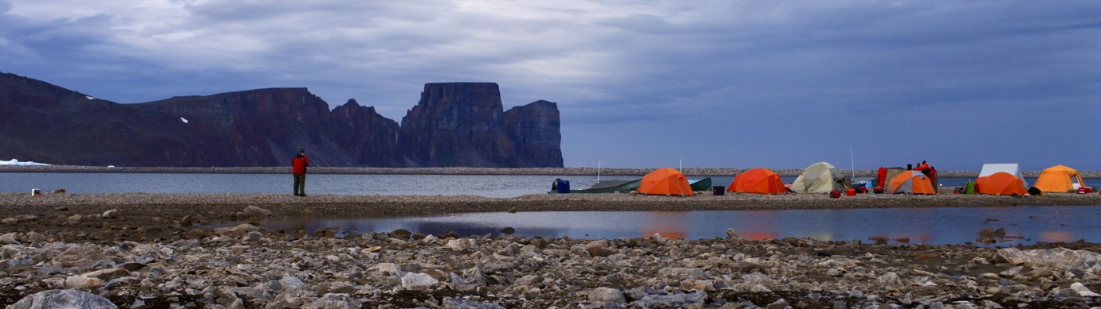
Research in Canada’s North is expensive and funding for this work is necessarily provided by a network of partnerships that includes: ECCC Wildlife Research Division and Canadian Wildlife Service, Nunavut Wildlife Management Board, Polar Continental Shelf Program, NSERC, Acadia University, Carleton University, University of Toronto, Northern Contaminant Program, and Indigenous and Northern Affairs Canada. Importantly, the Mittimatalik HTO, the Nattivak HTO, and the Sululiit ACMC facilitated efficient payment of guides.

