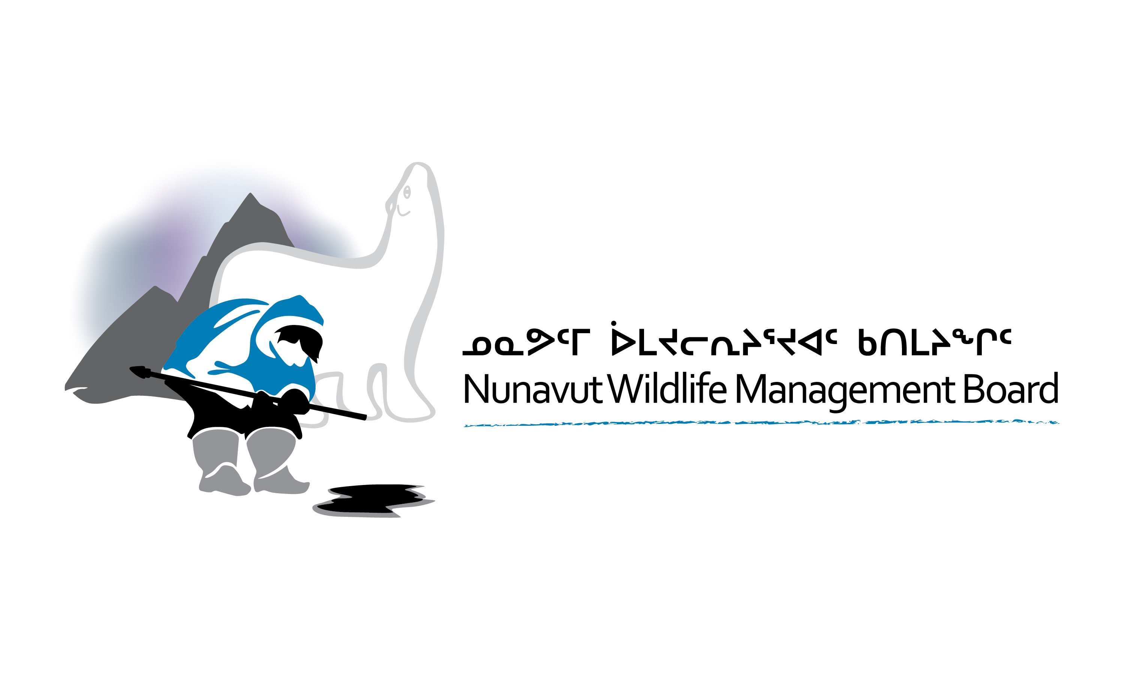

NUNAVUT WILDLIFE STUDIES FUND FUNDING GUIDE (2025)

INTRODUCTION

Article 5.2.37 of the Nunavut Agreement states, “there is a need for an effective system of wildlife management, and to be effective, the system of management requires an efficient, coordinated research effort”.

The Nunavut Wildlife Studies Fund (NWSF) was created by the Nunavut Wildlife Management Board (NWMB or Board) to fund community-based wildlife research projects in Nunavut, in particular projects led by Hunters and Trappers Organizations (HTOs).

Research is necessary to ensure that wildlife resources are harvested in a knowledgeable and sustainable way so that Nunavummiut can continue the hunting and fishing that is so essential to their way of life. The NWMB plays a leading role in this area and remains committed to making wildlife research responsive to the needs and concerns of the people of Nunavut.

The Board issues calls for applications twice a year—in January and May. However, the May call will depend on the number of applications approved from the January call. There will be no call in May if the January intake results in a large number of projects being approved that use all available funds.

ELIGIBILITY FOR FUNDING

To qualify, the project must be conducted within the Nunavut Settlement Area and contribute to wildlife research. Eligible applicants under the NWSF include HTOs, Regional Wildlife Organizations (RWOs), community-based Inuit organizations, and residents of Nunavut.

Applicants are not limited in the number of applications they submit for NWSF funding. However, applicants should consider that there is a limited amount of funding available to be distributed each year. By submitting a proposal, the organization or individual is committing to the time required to complete the project.

Government and non-governmental organizations, including educational institutions and private companies, are not eligible for NWSF funding. The NWMB encourages cooperative research with government and non-governmental organizations, but projects funded under the NWSF must be led by HTOs, RWOs, community-based Inuit organizations, or residents of Nunavut.

The NWSF does not require a minimum funding contribution from an applicant or other external sources when submitting a proposal.

The NWSF will not fund budget items which do not directly support a proposed research project. All equipment and expenses must be used up during the project period. The following are examples of budget items that the NWMB will not fund:

- purchase of equipment that may be reused in future years;
- maintenance cost of equipment already owned;
- funding for equipment or supplies for future years of research if not occurring in the funding year (e.g. large fuel purchases);
- administration fees (e.g. utility bills or office supplies); or
- capital works and/or general infrastructure costs.

APPLICATION PROCEDURE / FORMAT

The Board will accept applications following calls for applications in January and May of each year. Deadlines for submission will be provided in each call for application notice. However, there will be no call in May if the January intake results in strong applications that fully exhaust the available funds. The Board will review and make funding decisions as soon as possible after the application deadline.

Applications can be submitted in Inuktut or English and must comply with the format, content, and submission requirements specified in the application form. The application form can be downloaded from the NWMB’s website (www.nwmb.com/en/funding/nunavut-wildlife-studies-fund) or by contacting the NWMB. A proposal should be submitted as a well-developed research plan ready for implementation. All details in the application must be current at the time of the submission and must be focused on the current funding year and not the long-term research plans for the project. Applicants are responsible for ensuring that their applications are complete. NWMB staff may contact applicants to obtain more information concerning their applications during the evaluation process.

Applications must be submitted by a designated project leader who takes responsibility for the proposed project and communicates the results. The NWMB defines a project leader as an individual who will: (1) be responsible for the direction of the proposed project; (2) assume the administrative and financial responsibility of the project; and (3) receive all related correspondence from the NWMB. In submitting a proposal, the organization or individual and project leader are consenting to the application being publicly available.

At the time of application, all obligations from previously funded projects involving the applicant or their organization must be fulfilled to the NWMB’s satisfaction. These obligations include the submission of final financial and final project reports, and the return of any unused funding.

Additions, deletions, or modifications will not be accepted after the submission deadline, unless they have been requested or pre-approved by the NWMB. Proposals may be withdrawn by providing written notice to the NWMB.

All applications will be assessed for completeness, and an NWSF project number will be issued. The project leader will be notified of this number for future communication. The project leader is expected to use this NWSF project number in all future communications with the NWMB.

The NWMB accepts a broad and simple definition of research as simply “finding things out.” This can be done by Western scientific methods, the gathering of Inuit Qaujimajatuqangit (IQ), or a combination of the two. The NWMB encourages the use of available IQ/Traditional Ecological Knowledge (TEK) in research. Projects that demonstrate that IQ/TEK have been used in the study’s goals, objectives, and design will be preferred.

The NWMB is not an economic development agency; hence, resource development activities such as experimental harvesting programs, product development, and marketing studies will generally not be considered for funding. Similarly, the NWMB is not primarily focused on effects on human health or related issues. Research on contaminants, animal health and diseases, etc., will be considered insofar as they concern the productivity or health of the wildlife populations themselves, which must clearly be outlined in the application.

Projects involving the compilation of existing data will not be funded unless this is an integral part of a project considered necessary to meet wildlife management and research priorities. In such cases, the proposal must include a detailed basis for and a statement indicating the management or research objectives to which the data would contribute and the specific questions to be answered.

FUNDING LEVELS

Individual projects may request single-year funding up to $50,000.

Applicants may apply for single-year funding for a project that was previously funded. However, receiving funding during one funding period does not guarantee that the project will be funded in future years. In addition, each year’s application must state the rationale and research plan for that funding year.

The amount of funding available from the NWSF for the funding year will be decided annually by the Board as part of the annual budget review process in December. The NWMB will consider all eligible applications that meet the submission requirements based on their merits and in light of available funding. Due to limited funding, the NWMB may be unable to fund all applications.

In selecting projects for NWSF funding, the NWMB strives to fund projects that are directly led by HTOs, RWOs, community-based Inuit organizations, or residents of Nunavut and must directly address community needs and concerns. Additionally, the NWMB funds projects that will directly address the identified NWMB and Regional wildlife management and research priorities (please refer to the current NWMB Wildlife Management and Research Priorities and Regional Wildlife Management and Research Priorities available online at www.nwmb.com/en/funding/priorities).

The NWSF does not provide multi-year funding; therefore, a separate application is required for each year if the project needs more than one year to complete its objectives.

UNUSED FUNDS

Notification of unexpended funds must be provided at the end of the project (i.e., by the final report due date). Any unused funds must be returned to the NWMB within 90 days of that date.

The NWSF does not allow the carry-over of funds from one year to the next.

MANAGEMENT AND RESEARCH PRIORITIES

The NWMB will establish its own Wildlife Management and Research Priorities and work with HTOs and RWOs to develop and review Regional Wildlife Management and Research Priorities through the completion of regional workshops as needed (every 3–5 years).

Proposals that address NWMB and regional priorities are more likely to receive funding. The list of current priorities is available at www.nwmb.com/en/conservation-education/list-all-documents/funding-guides/priorities.

CONSULTATION REQUIREMENTS

For NWSF projects that affect more than five communities, a letter of support from the affected RWO(s) is required. A letter from each community HTO is required if fewer than five communities are affected.

Only projects that provide proof of HTO or RWO support will be considered for funding.

The NWMB recommends that all projects provide in-community reporting of the results, but understands this is not always possible. However, projects with plans to report results in the community will score higher during staff evaluation.

REPORTING REQUIREMENTS

The following reports are required by the NWMB:

Call for Application | Project Report | Financial Report | Return Unused Funds
January | March 31 | March 31 | June 30
May | June 30 | June 30 | September 30
* All report deadlines refer to the calendar year following project approval.

The project leader is responsible for coordinating the submission of these reports. Failure to submit the required reports on time or in the format identified in this funding guide will result in the rejection of future funding requests from the project leader or their organization.

Reports may be submitted by email (preferred), fax, or regular mail. If submitting electronically, do not send additional hard copies. Receipt of all reports will be acknowledged by the NWMB when received.

All reports submitted after the deadline will be considered late, and this will be factored into future funding requests as a penalty during the application scoring process. New proposals will not be accepted from applicants with outstanding reports. Applicants who submit a report after the deadline will have six (6) points deducted from applications submitted in the funding year following the missed deadline.

FINAL PROJECT REPORT

Final project reports will be used by the NWMB as the basis for making decisions about the wildlife population in question, if required. Final project reports should follow the format provided below.

Final project reports should provide all relevant results and conclusions from the research. The final project report should be as detailed as possible, including all technical information. There is no page limitation for final project reports.

All final project reports will be uploaded to the NWMB website.
Required format for Final Project Reports:

- NWSF Project Number: (e.g. 2025-001)
- Project Title: Provide a one to two sentence title as identified in your application for funding.
- Project Leader: Provide name and contact information, including a telephone and email where you can be reached.
- Summary: Provide a non-technical summary of your project.
- Project Objectives: Provide an analysis of the project objectives and achievements.
- Materials and Methods: Provide information on materials and methods used during the research project.
- Results: Provide analysis of results of the research, include all data collected.
- Discussion/Management Implications: Provide explanations as to the possible current and future management implications arising from your research. Include recommendations pertaining to the NWMB’s mandate.
- Reporting to communities/resource users: Provide an updated schedule of consultations as per 5.2 of the NWSF application. Indicate any status or changes to schedule.
- References

FINAL FINANCIAL REPORTS

These reports should include projections of expenditures to the end of the fiscal year if research is still ongoing. Final financial reports are required and are to be included with the Final Project Report; and must follow the format provided below. Any significant variance ($1000 or 10% on any line item) from the budget in the original proposal accepted by the NWMB must be explained.

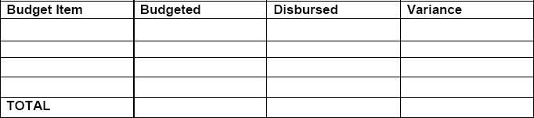
Required format for Financial Reports:

- NWSF Project Number: (e.g. 2026-001)
- Project Title: Provide a one to two-sentence title as identified in your application for funding.
- Project Leader: Provide name and contact information, including a telephone and email where you can be reached.
- Original Project Budget: Provide a copy of the original budget from the application approved by the NWMB. Line items can be explained or expanded on using footnotes.
- Original Contributions: Provide a table summarizing contributions of the NWMB and others, from the application approved by the NWMB with explanations of any variation from the original proposal.
- Explanation of changes: Provide a list of any changes in the original project budget or original contributions.
- Financial Report: Provide a financial report using the format below.

Balance, if any, to be returned to NWMB:

- Explanation of variances: Provide a list of explanations of variances, if applicable.
- Verification of information provided: Use the below statement and provide signature at end of report:

I certify that this is an accurate statement of the Board project funds received and disbursed in accordance with the joint contribution agreement.

Project Leader

PROPOSAL EVALUATION

Applications for NWSF funding are evaluated through a two-stage review: initial scoring by NWMB staff, followed by review by the NWMB Board at its March and October meetings.

The NWMB’s staff evaluation is based on a set scoring system using five main criteria to determine a total score out of 100:

- Research Priority (20 points)
- Quality of Research (25 points)
- Applicant Priority (20 points)
- Training and Employment (20 points)
- Consultation and Reporting (15 points)

Not all proposals advance to the NWSF review meetings for consideration by the Board. A proposal must score at least 50 points to be considered. All project leaders will be notified in writing by the NWMB if their project will proceed to the second evaluation process.

The Board will review the proposals in the second evaluation process at the NWSF meeting. NWMB staff will provide a briefing note summary of the project based on the information provided. Applicants are not required to present their proposals to the Board.

Receiving a high score based on the scoring criteria does not automatically mean that a project will be funded. The Board considers a number of other external factors when determining which projects merit NWSF funding.

NWMB Board members have the right to make recommendations solely on the basis of their knowledge and expertise, and may:

- decide if the proposal meets the eligibility criteria set out in this funding guide;
- identify and consider any other additional information that the proposal or NWMB staff did not consider when recommending a proposal be funded or not funded;
- determine an alternative ranking of the proposals based on more recent priorities;
- assess and recommend different amounts of funding for a proposal; and
- create additional funding conditions prior to the issuance of funding.

SCORING CRITERIA: MANAGEMENT AND RESEARCH PRIORITIES

Management and research priorities are scored by NWMB staff based on NWMB Wildlife Management and Research Priorities and Regional Wildlife Management and Research Priorities for a total score of 20.

The NWMB priorities are established by the Board based on the NWMB’s primary and secondary objectives as outlined in subsections 5.2.33 and 5.2.34 of the Nunavut Agreement. The NWMB’s priorities can be found in the NWMB Wildlife Management and Research Priorities available from the NWMB and in the future on the NWMB’s website (www.nwmb.com/en/funding/priorities). The maximum point allocation for NWMB priorities is 5 points.

The Regional Wildlife Management and Research Priorities are established by the NWMB through regional workshops completed by the NWMB every three to five years. The regional priorities are ranked from 1 to 6, as determined by regional representatives. The maximum point allocation for these priorities is 15 points.

NWMB Priority | 5 points
Regional Priority | 15 points

In order to qualify for the point allocations for the NWMB and regional priorities, the project’s main objectives must address the priority and the results of the project must directly contribute to addressing the priority through the application of results. If a project addresses a number of priorities, the point allocation will be assigned based on the most relevant priority.

SCORING CRITERIA: QUALITY OF THE STUDY

The quality of the study is scored based on three main criteria, for a maximum of 25 points.

Project goals and objectives are clearly defined | 5 points
The proposed methodology will adequately address the project objectives | 10 points
Will the project provide information that will be applicable to the NWMB in its wildlife management activities in the near future (1-3 years)? | 10 points

SCORING CRITERIA: APPLICANT PRIORITY

The NWSF was created by the Nunavut Wildlife Management Board (NWMB or Board) to fund projects led by HTOs, RWOs, community-based Inuit organizations, or residents of Nunavut. The maximum point allocation for priority applicants is 20 points.

Inuit organization (e.g. HTOs) or Inuit Beneficiary | 20/20 points
Nunavut community-based organization (e.g. community research organization) | 15/20 points
Nunavut resident | 10/20 points

SCORING CRITERIA: TRAINING AND EMPLOYMENT

Training and employment are scored based on two main criteria, for a maximum of 20 points.

Skills development or training for Inuit beneficiaries | 10 points
Employment of Nunavut residents | 10 points

SCORING CRITERIA: CONSULTATION AND REPORTING

Consultation and reporting are scored based on two main criteria, for a maximum of 15 points.

Regional or community pre-study consultation and support for project (e.g. HTO board letters, phone calls) | 10 points
Plans for reporting to communities (e.g. in-community oral reporting and/or distribution of a written report) | 5 points

Applicants are strongly discouraged from contacting the NWMB’s staff regarding the scoring of their proposal(s). The breakdown and rationale for the scores made by NWMB staff are not publicly available and are only made available to Board members upon request.

NOTIFICATION OF FUNDING DECISIONS AND FUNDING CONDITIONS

All individual applicants will be advised through written notification of the NWMB’s funding decisions. Projects that have been approved for funding will also be notified of the funding conditions that must be met.

The NWMB may establish additional funding conditions prior to funding being issued.

CONTRIBUTION AGREEMENT

Once the funding conditions have been met, the NWMB will negotiate a contribution agreement with the associated organization or individual. NWMB staff will contact the project leader to negotiate the contribution agreement.

CONTACT INFORMATION

NWMB staff are available to provide general advice and clarification but cannot comment on draft applications or enter into correspondence on the details of applications. Prior to contacting NWMB staff this funding guide should be reviewed carefully.

All NWSF email inquiries should be sent to the address below. Your message will be forwarded to the appropriate NWMB staff member. All email inquiries must include “NWSF inquiry” in the subject line.

NUNAVUT WILDLIFE MANAGEMENT BOARD
310-1106 Ikaluktuutiak Drive, Iqaluit, NU, X0A 3H0
Phone: (867) 975-7300
Fax: (888) 421-9832
Email: researchfunding@nwmb.com

