Kivalliq Caribou Monitoring:
Seasonal distributions and movement patterns of Kivalliq barren-ground caribou in relation to a road, and indices of productivity

Final Report to the Nunavut Wildlife Management Board

NWRT Project Number: 2-18-07

Project Leader: Mitch W. Campbell, Kivalliq Regional Wildlife Biologist, P.O. Box 120, Arviat, NU, X0C 0E0, email: mcampbell1@gov.nu.ca,: (867) 857-3171.

Final Report Based on the Technical Memorandum:
Analysis of Lorillard caribou herd movements relative to the Meadowbank mine and roads: Analysis of recent data sets (2016-2019)
DRAFT August 22, 2019
Authorship (Road Analysis): John Boulanger¹, Robin Kite², Mitch Campbell³, Jason Shaw², David Lee⁴
¹Integrated Ecological Research, 924 Innes, Nelson, B.C., V1L 5T2,
²Caslys Consulting Ltd. Unit 10 -6782 Veyaness Road, Saanichton, B.C., V8M 2C2
³Government of Nunavut, Environment Wildlife Research, PO Box 120, Arviat, NU, X0C 0E0
⁴Nunavut Tunngavik Incorporated, PO Box 280, Rankin Inlet, NU, X0C 0G0

Department of Environment, Wildlife Research Section
Government of Nunavut
PO Box 120, Arviat, NU, X0C 0E0
June 2019


* The contents of this report are the sole responsibility of the authors

Contents
1.0 Abstract (Summary) 1
2.0 Objectives & Introduction 3
3.0 Study area 4
4.0 Methods 8
4.1 Telemetry and Classification Studies 8
4.2 Regression analyses 9
4.2.1 Rationale 9
4.2.2 Regression Covariates 10
4.2.3 Data Processing 12
4.2.4 Regression analyses 13
4.3 Biased-Correlated Random Walk 15
4.3.1 Variation in Individual Movements 15
4.3.2 Data Processing 15
4.3.3 Biased-Correlated Random Walk 17
5.0 Results 18
5.1 Qamanirjuaq Spring Composition 18
5.2 Regression analyses 19
5.2.1 Summary of data used in the analyses 19
5.2.2 Spring migration 21
5.2.3 Late summer/ fall 2016-7 26
5.2.4 Late summer-fall 2018 29
5.3 Biased-Correlated Random Walk 35
5.3.1 Spring Migration 36
6.0 Discussion 38
6.1 Composition Studies 38
6.2 Caribou Telemetry Studies 39
6.3 Road Disturbance - General comments 40
6.4 Zone of influence estimation 42
6.5 Data gaps in analysis 44
6.6 Consideration of all herds that encounter the Meadowbank mine and roads. 44
6.7 Additional Work 45
7.0 Appendices 47
7.1 Appendix 1: Ecological Land Classification habitat classes 47
7.2 Appendix 2 Further investigation of movements in the late summer of 2018 48
8.0 REPORT BY PARTICIPANTS 53
9.0 REPORT TO COMMUNITIES / RESOURCE USERS 54
10.0 Literature cited 55

List of Figures

Figure 1: Ecozones of the Qamanirjuaq caribou herd annual range (1993 to 2008) (Environment Canada, 2009). 5
Figure 2. The Meadowbank Gold Mine is located at the north end of an all-weather access road (red) that stretches from Baker Lake to the mine site. A haul road (brown) connects the Meadowbank site to the Whale Tail Pit expansion. 7
Figure 3. The annual range of three caribou subpopulations overlapping the road and mine site (indicated hereafter as “road”). All three subpopulations are potentially affected by the road; however, of the three, the Lorillard subpopulation contains the highest number of telemetry fixes that directly cross the road, or are within the 20km road buffer (Campbell et al. 2014). 7
Figure 4. An illustration of the change in daily distance from mine variable (∆D_{mine}) for 3 hypothetical paths (left), and the hypothesized relationship between distance from mine and (∆D_{mine}) (right). If caribou move across the road with minimal interference then ∆D_{mine} should not be influenced by distance from mine with random variation in levels of ∆D_{mine} (upper path). If the mine impedes movement then ∆D_{mine} will be reduced or become negative (red ∆D_{mine} numbers in figure; meaning they moved away from the mine road) prior to crossing (lower path). Estimated ZOI is quantified where variation in ∆D_{mine} is not discernible from random variation. 14
Figure 5. Description of step length and absolute angle movement calculated for each segment of a caribou’s path. The derived values were used to identify both delayed and normal road crossers. Step length is described as the distance between two successive telemetry point locations. Longer step lengths indicate faster movement, while shorter step lengths illustrate slower movement patterns. The absolute angle is the angle between the x-direction and the step. Smaller angles are characteristic of clustered movements, while larger angles mean the path follows a straight trajectory. 17
Figure 6. The history of Qamanirjuaq composition studies. Tracking number of calves’ vs number of cows has been found to provide a reliable index of herd productivity and trend. Values below the red line (25 calves/100 cows) suggest a decreasing abundance for mainland migratory caribou. 18
Figure 7. Paths of caribou relative to the Meadowbank mine road for spring migration and late summer/fall periods. The main direction of movements was from the west to east for spring migration and from east to west for the late summer/fall periods. The progression of construction of the Whale tail road is illustrated with most expansion occurring between 2016 and 2017. 20
Figure 8. The movement trajectories of individual caribou points relative to the Meadowbank road (hashed line) by date for the spring migration from 2016-2019. Points to the left of the center line are for caribou before they crossed the road, and points to the right are after they crossed the road. The color of the points indicates the relative displacement (East to West) since the last location. Vertical trajectories indicate movement parallel to the road. 21
Figure 9. The distance of individual caribou points from the Meadowbank road by date for the spring migration for 2016-2019 with road closures illustrated. Points to the left of the center line are for caribou before they crossed the road and points to the right are after they crossed the road. Road closure points are staggered to minimize overlap. As discussed later, the effect of road closure would be best explored with information about traffic volumes. 22
Figure 10. Predictions of segmented model for spring migration (2016-2019). The upper plot shows the full data set and the lower plot is zoomed into the zone of influence area. The zones of influence estimates are shown as a red line on either side of the road with confidence limits as shaded regions. Predicted mean ∆D_{mine} are shown as blue lines (confidence intervals as dashed lines). Observed ∆D_{mine} are shown as points which are color-coded based on net direction since last observation. 25
Figure 11. The trajectories of individual caribou points from the Meadowbank road by date for the spring migration from 2016-2019 with yearly data pooled. Points to the left of the center line are for caribou before they crossed the road and points to the right are after they crossed the road. Predictions of net movement are shown prior to the estimated ZOI at 8.66 km and after the ZOI demonstrating the delay in migration due to the ZOI. If the road has no impact then the two predicted trajectories should meet at the ZOI. 26
Figure 12. The trajectories of individual caribou points relative to Meadowbank roads (hashed yellow line) by date for late-summer/fall 2016-2017. Points to the left of the line are for caribou before they crossed the road and points to the right are after they crossed the road. The color of the points indicates the direction since the last location. 27
Figure 13. Predicted daily change in distance from mine from the segmented regression model for caribou east of the Meadowbank Road (hashed yellow line) for the fall/rut season (blue line with confidence limits as hashed lines) for 2016-2017. Estimated ZOI (after crossing to the west of road) is given as a red line with confidence limits shaded grey. 29
Figure 14. Individual paths of caribou relative to Meadowbank roads during the late-summer and fall of 2018. An animation file (Fall_2018_animation.mp4) also illustrates the sequence of movement by date. 30
Figure 15. The distance of individual caribou points from the Meadowbank road (hashed yellow line) by date for the fall of 2018. Points to the left of the center line are for caribou before they crossed the road and points to the right are after they crossed the road. The color of the points indicates the direction since the last location. The triangles on the center line (which indicates the Meadowbank Road) are dates in which the road was closed to traffic in an attempt to allow caribou to cross the road. 31
Figure 16. Predicted daily change in distance from mine from the segmented regression model for caribou east of the Meadowbank Road (hashed yellow line), and for the fall/rut season (blue line with confidence limits as hashed lines). Estimated ZOI (after crossing to the west of road) is given as a red line with confidence limits shaded grey. Note the higher number of negative ∆D_{mine} values (red data points) east of the road compared to west of the road for the summer season. 34
Figure 17. Collar locations used in analysis dichotomized by zones of influence. Zones of influence were detected for all seasons on the west side of the road (after crossing) and the east side for the late summer season. Locations within 160 km of the mine road were used for the analysis. 35
Figure 18. An example of a single caribou telemetry track (Animal ID BL2018003: 2018-2019) in comparison to the 500 simulated trajectories calculated by the biased-correlated random walk (BCRW) model. The blue path is the observed telemetry points and walklines, while the purple illustrates all simulated trajectories. The delay in crossing time is calculated by the time it takes for the observed points (blue path) to enter the 20km buffer and cross the road. The same comparison is conducted for all simulated trajectories and the crossing times compared between observed and simulated paths. 36
Figure 19. An example of a comparison between two observed trajectories for the spring migration period, one classified as a normal road crosser (Animal ID BL2018017: 2018-2019), and one as a delayed road crosser (Animal ID BL2018003: 2018-2019). The normal crosser has relatively consistent spacing between telemetry points and an uninterrupted migration path. This particular animal does not show significant change in movement speed as it nears the road location. The slow crosser, on the other hand, shows more disjointed path characteristics surrounding the road with many short and convoluted/meandering segments. These attributes show an overall slowing and interrupted path trajectory. 38
Figure 20. Map of Ecological Land Classification (ELC) habitat classes used in the analysis (Campbell et al. 2012). 48
Figure 21. Collar locations in the late summer and fall of 2018 near the Meadowbank road north of Baker Lake 49
Figure 22. NDVI vegetation indices for the Meadowbank road area for the late summer of 2018. 51
Figure 23. Close up of collar paths (in yellow) from daily locations relative to the Meadowbank AWAR in the fall of 2018 showing land areas between lakes that were crossed during the summer and fall period. 52

- Abstract (Summary)
Barren-ground caribou (Rangifer tarandus groenlandicus) herds in the Kivalliq Region have been tracked using GPS telemetry since 1996. In spring 2018, 35 collars were affixed to Lorillard caribou cows migrating and wintering north of Baker Lake. In spring 2019, an additional 35 collars were affixed to Qamanirjuaq caribou cows in the vicinity of Arviat, NU. Telemetry data collected for these subpopulations was used to coordinate spring collaring on both the Qamanirjuaq and Lorillard spring range, and composition studies on the Qamanirjuaq spring range. During the 2018/2019 fiscal year, community concerns regarding the observed impacts of a mining road on caribou movement, behaviour, and distribution, became a research priority. This study assesses the observed impacts of a mining road on caribou, in the hope of developing effective mitigation to these effects, and address community concerns. In addition to the final report, the GNDOE has developed animations of impacts of mining infrastructure, including roads. These animations are available on both the NIRB and GN websites have also been distributed to the Kivalliq HTOs and the Kivalliq wildlife board.
Arctic caribou play an important role in the ecosystem dynamics of the North, and are of key cultural significance to Inuit. Caribou in Canada’s arctic are exposed to several external pressures including, but not limited to, industrial development. This report provides an update to previous analyses of the movements and distribution of collared caribou in relation to the Meadowbank mine’s all-weather access road and Whale Tail expansion road (Kite et al. 2017) which utilizes recent collar data (2016-9) from the Lorillard herd, which has higher fix rates than previous data sets. In this analysis, we further develop the segmented regression approach used in Kite et al (2017) to estimate the zone of influence (ZOI) of the road. Zone of influence is a statistical measure of spatial extent and magnitude of the influence of roads or mine footprint on caribou movements. We also re-apply biased correlated walk methods to further explore response of the caribou to the road. We developed a new metric, relative change in distance from the mine road, to index caribou movement relative to the road. For the majority of the data set caribou were in the proximity of the all-weather access road (AWAR) and therefore ZOI estimates mainly pertain to this road rather than the Whale Tail road. Segmented regression analysis results estimated unique zones of influence for the Meadowbank road for spring migration and late summer/fall periods. In addition, a zone of influence prior to crossing the road and a zone of influence after crossing the road was documented. Zones of influence for spring migration were 8.7 and 4.9 km prior to and after crossing the road for the 2016-2019 periods. In the fall of 2018, caribou exhibited dynamic behaviour relative to the road with a zone of influence of 59.7 km prior to crossing the road and 9.8 km after crossing the road. We suspect that the higher zone of influence in the late summer and fall of 2018 was due to direct and indirect factors related to use of the roads and/or construction. Further investigation into the role of habitat in late summer ZOI estimates is ongoing. Both the zone of influence and biased correlated random walk analysis suggested that the road delayed spring migration. The mean delay based on the change in caribou movements at the zone of influence was 6.2 days, whereas the estimate from the bias correlated random walk specifically for spring migration was 5.0 days. The results of this analysis demonstrate that movements relative to the Meadowbank mine are dynamic with year and season-specific patterning. Of the spring, and late summer/fall seasons considered, the spring migration shows the most consistent patterning and related behavioural effects. Additional analyses will further contrast metrics for assessing zone of influence using data from the Ahiak and Wager Bay subpopulations of tundra wintering barren-ground caribou, and also incorporate all collar data from all subpopulations (1998-2019) in the proximity of the Meadowbank mine.

- Objectives & Introduction
The key objective of this study is to maintain a long-term caribou monitoring program in the Kivalliq Region that tracks both barren-ground caribou movements, seasonal range use, and productivity. Spring composition studies of the Qamanirjuaq Herd, and GPS telemetry through the collaring of caribou cows across the Kivalliq mainland, are both used to monitor these metrics and are key to effective management through informed decision making.
During the 2017 through 2019 fiscal years (April – March), consultations with Kivalliq Communities placed priority on the assessment of mining roads and infrastructure impacts on barren ground caribou. This use of caribou telemetry data then became a primary objective and research focus. Results provided within this report are currently being used within environmental assessment and land use planning processes to help inform wildlife management which aims to safeguard Inuit harvesting rights and practices under the Nunavut Agreement.
Caribou in Canada’s arctic are exposed to a number of external pressures including, but not limited to, industrial development (Fiesta-Bianchet et al. 2011). Because of the inevitable interactions between caribou and industry, it is important to improve our understanding of how, and to what extent, these interactions can impact this species behaviour, and ultimately, its persistence on the northern landscape. In particular, infrastructures with variable permeability such as roads, have been proven to influence caribou movement patterns (Wilson et al. 2016). Potential caribou responses to road infrastructure and activity on roads may include reduced speed during migrations, disrupted selection and use of migration corridors, distributional shifts away from both optimal seasonal habitat (including wintering and/or calving grounds)–or loss of harvesting opportunities within traditional hunting areas. However, without detailed spatial and temporal analysis, it is unclear where, when, and to what magnitude caribou and the people that rely on them, may be impacted by industrial features and activities.
This report provides an update to previous analyses on the Meadowbank road (Kite et al. 2017), utilizing more recent collar data from the Lorillard herd which has higher fix rates than earlier data sets. In this analysis, we further develop the segmented regression approach used in Kite et al (2017) to estimate the zone of influence (ZOI) of the road. We also re-apply biased correlated walk methods to further explore the response of caribou to the road. The objectives of this analysis are:
- Develop a metric to assess caribou movements relative to mine footprints and roads during periods of migration. From this, use a statistical model-based framework (segmented regression) to test statistically for zone of influence, and provide estimates of uncertainty (confidence limits) for both the zone of influence and its associated magnitude/size.
- Develop graphical methods to display the timing of migration and predicted movements and rates of movement relative to mine footprints and roads.
- Use established bias correlated random walk methods to contrast quantified predictions of caribou movement and rate of movement, from segmented regression models.
- Provide further guidance on use of covariates to better assess mechanisms that might be influencing caribou response to the Meadowbank roads.

This report does not aim to provide a full analysis of all caribou subpopulations interacting with the road, but rather, an in-depth analysis of the Lorillard subpopulation’s interactions with the road, due to a greater overlap apparent between Lorillard seasonal range and the road corridor. Further analysis assessing road interactions between the Wager Bay and Ahiak subpopulations will be done, following this report. We suggest readers consult the Kite et al (2017) report while reading this report to provide a full background.

- Study area
For the spring composition portion of the monitoring we worked within the southern Kivalliq out of both Arviat and Rankin Inlet. Using annual location data collected from satellite and GPS collars between 1993 and 2014, we estimated the Qamanirjuaq caribou herd range to cover 310,000 km². The study area is large with its northern extents starting from the southern shores of Baker Lake and Chesterfield Inlet (latitude 57 degrees north), extending south to northeastern Saskatchewan and northern Manitoba. The entire study area is bounded to the east by the Hudson Bay coastline and to the west by longitude 105 degrees. The annual range covers four jurisdictions NWT, Manitoba (MB), Saskatchewan (SK), and Nunavut (NU), and includes seven communities; Brochet MB, Tadoule Lake MB, Black Lake SK, Wollaston Lake SK., Arviat NU, Whale Cove NU, Rankin Inlet NU, Baker Lake NU, and Chesterfield Inlet, NU. Most of the annual range including the calving, post-calving range, as well as the spring and fall migration corridors, lie entirely within Nunavut, while the early- mid- and late-winter ranges are spread across all four jurisdictions.
The Qamanirjuaq caribou annual range extends from the northern Arctic ecozone at its northeastern edge, through the southern Arctic ecozone, into its largest expanse in the taiga shield ecozone, ending with its southern tip within the boreal shield ecozone and at its southeastern tip within the Hudson plain ecozone (Environment Canada, 2001, Figure 2).
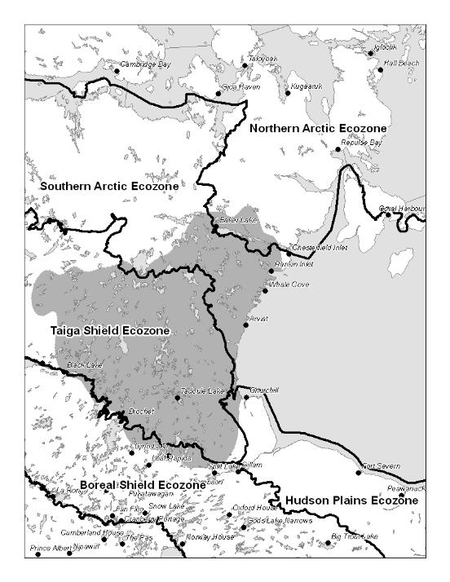
Figure 1: Ecozones of the Qamanirjuaq caribou herd annual range (1993 to 2008) (Environment Canada, 2009).

The Meadowbank Gold Mine began operating in early 2010, and is within the Northern Arctic Ecozone located in the northern Kivalliq Region of Nunavut (Figure 2). The Northern Arctic Ecozone extends over the parts of north-eastern Kivalliq, western Baffin Island, and northern Quebec. Winters in this ecozone pass in near darkness. Snow may fall any month of the year and usually remains on the ground from September to June. The area is classified as having a low arctic ecoclimate with a mean annual temperature of approximately -11°C. Seasonal mean temperatures are 4.5°C in summer and -26.5°C in winter. The mean annual precipitation ranges between 200 and 300 mm. Much of the landscape is typified by barren plains covered in frost-patterned soils and the occasional rock outcrop (Wiken, 1986; Ecological Stratification Working Group, 1996). Typical vegetation includes a discontinuous cover of tundra plant communities dominated by dwarf birch (Betula glandulosa), willow (Salix spp.), northern Labrador tea (Ledum decumbens), Mountain Avens (Dryas integrifolia), and Vaccinium spp. Taller dwarf birch, willow, and alder (Alnus spp) occur on warm sites while wet sites are dominated by willow and sedge (Carex spp). Lichen-covered rock outcroppings are prominent throughout the ecoregion.
Related mine infrastructure includes: maintenance facilities, fuel storage, water and sewage treatment plants, mill, power plant, airstrip, open pits, tailings and waste rock storage facilities (Gebauer et al. 2008). An approximately 100 kilometre all-weather access road connects the hamlet of Baker Lake to the mine and supports all ground traffic to the site. Road construction was completed in 2008. In 2016, construction began on the Whale Tail Expansion Project. The expansion site is located approximately 55 kilometres north of the Meadowbank mine and is connected via the Whale Tail Haul Road. Construction of the Whale Tail haul road was completed in 2018 and commercial production and hauling from this expansion pit is expected to begin in 2019 (Agnico_Eagle 2019).
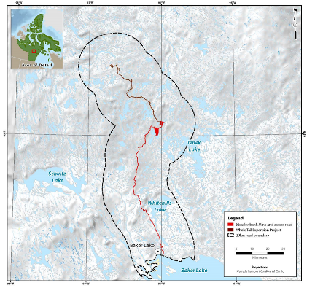
Figure 2. The Meadowbank Gold Mine is located at the north end of an all-weather access road (red) that stretches from Baker Lake to the mine site. A haul road (brown) connects the Meadowbank site to the Whale Tail Pit expansion.

While the annual ranges of five caribou subpopulations overlap the road, telemetry data indicates that only the Ahiak, Wager Bay, and Lorillard subpopulations specifically interact with the road and mine site (Figure 3). Seasonal distributions of the three subpopulations show that interactions with the road are possible primarily during the winter and high movement spring and fall migration seasons. The analyses conducted in Kite et al. 2017 were focused solely on Lorillard collared cows, as the majority of the collar data for 1998-2017 belonged to this subpopulation. Despite the potential for Ahiak, Wager Bay and Lorillard subpopulations to interact with the mine site and road, only a small proportion of the Ahiak and Wager Bay collars deployed between 1998-2017 came within 20 kilometres of the site. As a result, only a limited number of collared individuals and fixes were available to draw population or individual level conclusions. The analyses in this report use data from the Lorillard herd to allow consistent comparison of estimates across years. More recent collar deployments for Ahiak and Wager Bay caribou have captured a greater number of caribou-road interactions. As discussed later in this report, future analyses will consider the effect of different migration patterns relative to the road for each subpopulation (herd).

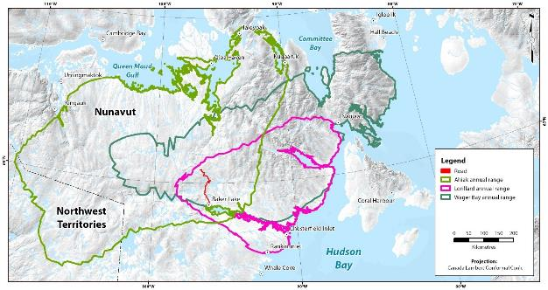
Figure 3. The annual range of three caribou subpopulations overlapping the Meadowbank all weather road, Whale Tail haul road, and mine site (indicated hereafter as “road”). All three subpopulations are potentially affected by the road; however, of the three, the Lorillard subpopulation contains the highest number of telemetry fixes that directly cross the road and/or occur within the 20km road buffer (Campbell et al. 2014).

- Methods

Telemetry and Classification Studies
Thirty five (35) refurbished Telonics GPS Gen-5 collars were deployed on Northeast Mainland caribou cows (primarily the Lorillard subpopulation) north and west of Baker Lake, in the spring of 2018 and thirty three (33) deployed on Qamanirjuaq cows north, south and west of Arviat in the spring of 2019. All collars deployed on Kivalliq caribou have a collar release mechanism attached and programmed to release, four years following deployment. The GPS-5 collar system is also equipped with a satellite beacon to transmit 6 GPS locations daily to the Kivalliq DOE office in Arviat every 4 to 5 days. Wildlife officer patrols and local travelers have been and will continue to provide periodic caribou density information, when in the vicinity of collared caribou. Using a rotary wing aircraft, caribou were captured using a net-gun. Capture effort was allocated based on current collar locations and an initial reconnaissance flight over collar locations to determine approximate relative densities of caribou. Collars were distributed based on collar density whereby the proportion of collars in a specific group would be divided by the total number of collars active. The calculated proportion would then be applied to the total number of collars being deployed rounding to the nearest collar. Collars were evenly distributed along a flight path through the longitudinal axis of an aggregation of existing collared caribou. Only healthy, adult (assessed to be 3+ years) caribou cows were collared. In keeping with agreements developed with Kivalliq communities, only collars will be affixed on the captured cows for the purposes of minimizing handling, no other measurements and/or sampling (with the exception of the collection of a scat sample, when readily available) will be undertaken. Chase times were kept to a maximum of one minute with total capture time (ground based) seldom exceeding 10 min. Following the capture and deployment of one collar, the next capture was directed towards a group undisturbed by the previous capture. An HTO representative was in the capture helicopter during the entire program to ensure animals were handled respectfully, and the agreements to handling restrictions were followed.

Spring classification counts were conducted in late March to early May using collar locations to locate aggregations of caribou. Composition survey efforts were allocated based on the density of collars within the classification target areas to ensure all possible spring aggregations of caribou were sampled in proportion to the entire known spring aggregation. Distribution of effort is important as caribou coming from different areas within their winter range may have experienced varying severity in winter conditions, and as a result, varying calf survival. Since the spring of 2004, classifications have been difficult to conduct using snowmobile because of later caribou arrival onto spring range and associated snow melt, making ground transportation across rivers and lakes dangerous. For these reasons a rotary wing aircraft was used to complete spring compositions. Over some years cow / calf ratios varied depending on where on the spring range these groups were located (e.g. Groups of caribou further west may have had better feeding conditions and as a result, higher cow / calf ratios then groups in the south or eastern portion of their spring range) lending more support to aerial composition methods. Caribou aggregations within each geographically segregated group (as represented by collar locations), were each classified to avoid any error created by distributional inconsistencies. Once located, aggregations were approached and classified at as great a distance as possible. Image stabilizing binoculars were used to maximize approach distances and minimize disturbance. Caribou were classified into adult female, calf, yearling, (both male and female), young adult male, and mature male categories. In total 14,247 caribou of the target number of 15,000, were classified in April 2018.

  - Regression analyses
Two analysis approaches were used to assess caribou movements relative to the Meadowbank road. First, regression analyses were used to assess potential changes in caribou movement characteristics in the vicinity of the road, as well as to delineate an accompanying zone of influence (ZOI) relative to the road where movements were affected. Second, biased correlated random walk analyses were used to estimate potential delays in crossing by the presence of the road.
    - Rationale
Variations in individual movement patterns relative to the road were examined using a regression-based approach. Regression techniques allow for an investigation of mixed factors influencing caribou movement patterns relative to road infrastructure by examining not only movement characteristics (i.e. step length and absolute angle), but also underlying habitat and landscape variables. As an analysis tool, regression models also provide statistics on the relationships between a response variable and a suite of covariates. In the context of caribou-road interactions, a regression model was used to quantify the relationships between caribou movement patterns (response variable), and their proximity to mining infrastructure, habitat type, terrain characteristics, and biological season (covariates). By examining the strength of the associations between caribou movement patterns and a combination of environmental, biological, and disturbance related factors, inferences can be made regarding potential caribou-road interactions. This approach has also provided an estimation of the ZOIs surrounding mines, roads, or related infrastructure (Boulanger et al 2011).
    - Regression Covariates
Assessing changes in caribou movement patterns relative to the road, taking into consideration underlying environmental characteristics, requires telemetry points to be attributed with relevant habitat information (Table 1). Incorporating environmental variables into movement analyses facilitates the identification of changes in caribou movement patterns due to changes in landscape features, or changes driven by road related disturbance. The metrics in Table 1, which have been used in habitat and ZOI studies (Boulanger et al 2011), tested the effect of topographical, habitat, and seasonal/temporal effects on caribou movements. For example, caribou may slow down in rugged areas or areas of higher elevation in the spring due to snow cover. Habitat, as indexed by ecological land classification (ELC) may cause caribou to move less in areas of high habitat value. Seasonal and yearly effects might also influence caribou movements.

Table 1. Summary of covariates included in the regression model.
Covariate | Calculation | Aggregation method | Rationale
Landscape effects
Elevation | Raw values from remotely sensed imagery (DEM) | Median | Movement patterns vary in relation to elevation change
Terrain ruggedness index | Calculation outlined in  Riley (1999) | Median | More rugged terrain may slow movement or increase tortuosity
Distance to nearest lake | Euclidean distance to the shoreline of nearest lake | Median | Semi-frozen lakes act as barriers, affecting movement patterns
Land cover class (ELC) | Kivalliq Ecological Land Classification  (Campbell et al. 2012) | Mode | Caribou may select more favourable habitat areas. A full and pooled (“wet”, “shrub”, ”tundra” and “other”) and full version were considered. See Appendix 1 for details.
Road/mine effects
Distance to road/mine | Calculated from each location in the path segment | Median | A measure for how each segment relates to the road/mine. Roads include the AWAR and Whale Tail road.
East-West | Position of location relative to the road | Used East-West position for the last location in a segment | Provides a measure of segment orientation relative to the road
Direction relative to the road | Direction of caribou movement relative to road | Used the direction for the last movement position in a segment | Provides a measure of movement direction relative to the road
Temporal effects
Year | Direct record from telemetry fix date | Constant | Individual movement patterns will vary year to year
Season | Based on dates of locations | Constant | Caribou will exhibit season-specific movement relative to mine

Distance to the AWAR and Whale Tail haul road was calculated for each caribou telemetry location. As the Whale Tail haul road was under construction during the analysis time period, Sentinel Imagery (10 m resolution) was acquired for 3 dates to verify the haul road extent on the landscape. Cloud free imagery was examined for August 2016, June 2017, and June 2018. Telemetry data were partitioned according to these dates, and the distance to the nearest point on either AWAR or Whale Tail haul road was calculated to ensure the most representative characterization of movement patterns relative to the road.
A complete data set of traffic volume on the Meadowbank AWAR road or related human use data for the road was not available for the analysis. Traffic data for 2014-2016 were provided as Excel workbooks summarizing monthly traffic volumes for the AWAR road and Meadowbank mine sites, however, coding inconsistencies created large gaps in the data. Traffic data were provided with the following attributes: Depart Time, From, To, Arrival Time, Total time, Vehicle Type, and Date. To and From information was provided as non-standardized acronyms referring to unknown locations for the AWAR, mine, and Baker Lake areas. Without standardized and explicit To and From information and vehicle identification codes, traffic volumes could not be reliably related to the road and caribou movements. Traffic data for 2017 -2019 are unavailable. Road closure data was available for 2017-2019 and was summarized as part of analyses but not modelled directly given that accompanying traffic volume and type data was not available. As discussed later, road closure could be considered further in unison with traffic volume and type data in future analyses.
    - Data Processing
The primary dataset was restricted to include only trajectories that passed within 50 kilometres of the road from caribou in the Lorillard herd. Locations from the Lorillard herd were used since they exhibit a consistent east to west migration patterns across the road corridor and, therefore, it could be assumed that they were most likely to exhibit road crossing behaviour (Kite et al 2017). A 50 kilometre buffer distance was used for the regression analysis to capture movement patterns for caribou that did not interact with the Meadowbank mine and roads (AWAR and Whale Tail roads), but displayed similar seasonal movements (i.e. directional movements to/from winter range) as caribou moving through near-road areas. More exactly, only caribou that had at least one location that occurred within 50 km of the mine during the seasons of interest were included in the analysis. These non-interacting individuals act as a control to help quantify variation in pattern driven by the road, and natural variation in pattern driven by terrain and habitat. For the regression analyses, locations that occurred within 160 kms of the mines were used, therefore keeping the analysis study area focused on habitat and locations within the regional area of the mine. Using this approach ensured that there were many locations that were not influenced by the mine while controlling for other factors that may influence caribou movements not related to the habitats within the range of the mine.
This analysis focused on daily location data for caribou which was available mainly after 2015 which includes data from the spring of 2016 to the spring of 2019. Using this interval allowed for the gathering of more detailed information on variation of trajectories (than previous analyses that used 3 day intervals), while still allowing some independence between successive locations for individual caribou.
    - Regression analyses
Initially, a baseline caribou biology model was developed to determine if landscape, biological, and habitat features influenced the movement of caribou relative to mines (Table 1). Once the baseline caribou biology models were developed the impact of disturbance was assessed. The primary predictor variable in this case was distance from mine (Table 1) which is the closest distance to the Meadowbank footprint or the AWAR/Whale tail roads. Segmented regression, as incorporated in the segmented package (Muggeo 2003;2008) in the program R, was used to assess if change in daily distance from mine road (∆D_{mine}) changed with distance from mine/road at an estimated cut-point (threshold) distance. Segmented regression tests whether ∆D_{mine} changes as a function of distance from the road, and at what distance the change becomes negligible (Boulanger et al. 2012). More exactly, if the road is affecting ∆D_{mine}, it would be expected that ∆D_{mine} would be lower near the road (if caribou movement is being restricted by the road) in comparison to levels observed in paths further from the road prior to road crossing (Figure 3). Once the road is crossed it might also be possible that movements were restricted if through gregarious behavior, some caribou are waiting for others to cross or moving away from the road at a quicker rate. In addition, caribou may increase movement rates after crossing the road to make up for delays in migration due to the road. In this context, the road possibly had a ZOI prior to crossing and after crossing, which was tested for in the analysis (for years in which crossing occurred).
We note that segmented regression tests the exact ZOI relationship (Figure 3) and statistically detects the threshold distance at which effects become negligible compared to background levels. Confidence limits are then generated for both the zone of influence as well as the magnitude of zone of influence which is the slope term up to the estimated zone of influence (Figure 4). If a zone of influence is not detected or is weak, then the slope term for the ZOI curve will not be significant and/or the confidence limits of the ZOI estimate will overlap 0. Other approaches such as regular polynomial regression, or comparisons of metrics at binned distance from road intervals do not provide a model-based framework to test for an exact threshold distance. Published studies of caribou disturbance (Boulanger et al. 2012, Johnson and Russell 2014) and simulation/literature review studies further support the use of segmented regression for detecting thresholds in ecology. (Ficetola and Denoel 2009).
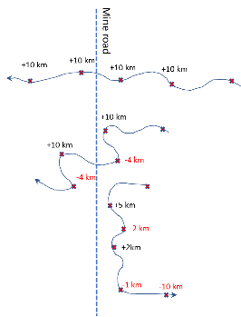 | 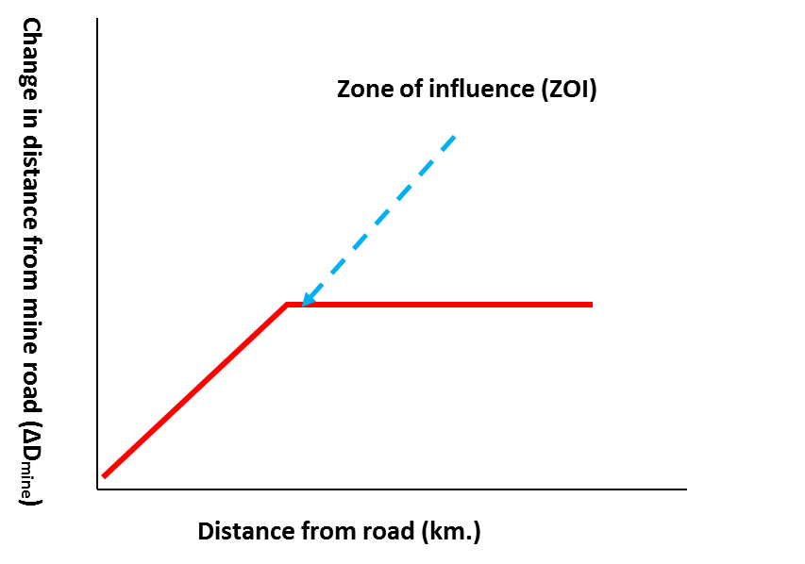
Figure 4. An illustration of the change in daily distance from mine variable (∆D_{mine}) for 3 hypothetical paths (left), and the hypothesized relationship between distance from mine and (∆D_{mine}) (right). If caribou move across the road with minimal interference then ∆D_{mine} should not be influenced by distance from the road, with random variation in levels of ∆D_{mine} (upper path). If the mine impedes movement then ∆D_{mine} will be reduced or become negative (red ∆D_{mine} numbers in figure; meaning they moved away from the mine road) prior to crossing (lower path). Estimated ZOI is quantified where variation in ∆D_{mine} is not discernible from random variation.

The support of baseline caribou biology models and ZOI models were evaluated using information from theoretic model selection methods (Burnham and Anderson 1998). The model with the lowest AIC_{c} score was considered the most parsimonious, thus minimizing estimate bias and optimizing precision. The difference in AIC_{c} values between the most supported model and other models (ΔAIC_{c}), was also used to evaluate the fit of models when their AIC_{c} scores were close. In general, any model with a ΔAIC_{c} score of less than 2 was worthy of consideration. Slope parameter estimates and ZOI estimates from the most supported models were further evaluated in terms of confidence interval and overall parameter significance.
One potential issue with the analysis was autocorrelation of measurements from successive daily locations of individual caribou. To confront this issue, confidence limits and parameter significance were evaluated using a generalized estimating equation model (Koper and Manseau 2009) which modelled autocorrelation of successive locations from individual caribou. In addition, the sample size used for model selection calculation was the number of caribou in the analysis rather than the number of locations.
Analyses were conducted using the segmented (Muggeo 2008;2016), geepack (Yan 2002), AICcmodavg (Mazerolle 2016) in the R (R_Development_Core_Team 2009) statistical package. Results were plotted to graphically explore model results using the ggplot (Wickham 2009) R package.

  - Biased-Correlated Random Walk
    - Variation in Individual Movements
We employed a biased-correlated random walk (BCRW) approach to examine the effect of the road on individual movement patterns in the spring. A BCRW model based on the methods outlined in Wilson et al. (year) was applied using parameters suggested by Bartoń et al. (2009). BCRW methods are primarily used to simulate data (i.e. predicted patterns) that can be compared to recorded data (i.e. observed patterns). Simulated trajectories represent predicted movement patterns under the assumption that the road has no effect on caribou movements occurring in near-road areas. The simulated vs. observed comparison identifies discrepancies between predicted and recorded patterns, and therefore makes it possible to statistically test whether crossing time changes for caribou crossing the road while migrating.
The BCRW relied on expected patterns derived from empirical step length (distance travelled between reporting periods) and absolute angle (direction of travel) distributions calculated from observed data. Expected patterns were compared to observed trajectories to quantify any delays in migration associated with caribou-road interactions. Specifically, the BCRW model identified caribou whose movement trajectories either (a) were delayed, or (b) did not change, when approaching or crossing the road infrastructure.
    - Data Processing
For the BCRW analysis, the primary dataset (66 trajectories) was restricted to includ only trajectories that passed within 20 kilometres of the road, as they represent individuals whose movement patterns could most likely be impacted due to proximity of their movements to the road. Wilson et al. 2016 used an inclusion distance of 15 kilometres as the basis for a similar BCRW analysis, and this distance was derived based on existing literature on caribou responses to human-related disturbance (Boulanger et al. 2012). We increased our threshold to 20 kilometres to ensure that all collars that could potentially be impacted by the road were included in the analysis. Any collars deployed within 20 kilometres of the road were excluded from the analysis (for that year) to account for change in movement patterns resulting directly from the collaring process. As a result, 15 individual caribou trajectories were included in analysis for the spring migration, and 20 were included in analysis for the summer-fall. An individual trajectory could contribute to only one of either the spring or summer-fall analyses, or to both, depending on the data available.
Each of the analysis trajectories were visually inspected to identify: migration start date, migration end date, first location within 20 kilometres of the road, last location within 20 kilometres of the road, road crossing location, and migration end location. The individual migration end dates were defined either by a sustained change in pattern from long range movements to restricted seasonal range movements, or by the first location within the official Lorillard core calving area (Campbell et al. 2014). Individual migration end dates were identified for each dataset based on movement rate, rather than using the official Lorillard subpopulation seasonal dates, specifically to account for individual inter-annual variation in migration periods. Applying the official seasonal date ranges (Nagy 2011) resulted in some truncated migration pathways, while other pathways included short, tortuous movements associated with calving or winter range use.
To characterize the movement patterns for each migration pathway, step length and absolute angle were calculated for each segment in the observed trajectory. Step length is defined as the Euclidean distance between successive telemetry fixes, and can be used to calculate movement rate when divided by the time elapsed between fixes. Absolute angle is described as the angle formed between the x-direction and the step (Figure 5). Absolute angle can be used to determine movement direction and, when examined along the entire trajectory, can be used to quantify overall directionality. For trajectories that demonstrate a high degree of directionality, absolute angles are relatively consistent; whereas, more meandering trajectories are made up of a wider range of angles. The mean resultant length (rho), hereafter referred to as the directionality coefficient, is the parameter in the BCRW model that is used to capture this directionality, and controls the directional persistence of the simulated pathway. Coefficient values close to zero represent weak directional persistence and generate a clustered trajectory; whereas coefficient values close to one (1), represent a strong directional persistence and generate a straight trajectory more typical of migratory behaviour.

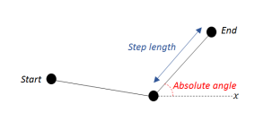
Figure 5. Description of step length and absolute angle movement calculated for each segment of a caribou’s path. The derived values were used to identify both delayed and normal road crossers. Step length is described as the distance between two successive telemetry point locations. Longer step lengths indicate faster movement, while shorter step lengths illustrate slower movement patterns. The absolute angle is the angle between the x-direction and the step. Smaller angles are characteristic of clustered movements, while larger angles mean the path follows a straight trajectory.

    - Biased-Correlated Random Walk
Step length and absolute angle distributions were generated from the observed trajectories for each animal trajectory (Barton et al. 2009). Subsequently, for each individual, 500 trajectories were simulated using the associated step length and absolute angle distributions. From the 500 simulated pathways, a null distribution of crossing times, measured in days, was generated by determining the number of days between the first simulated location within the 20 kilometre ZOI, and when the individual crossed the road. Two metrics were used to compare the observed crossing times to the null distribution: the first a 97.5% quantile (Wilson et al. 2016), and the second a z-score calculated using the mean and standard deviation of the expected null distribution. Individuals were designated as ‘delayed crossers’ if the crossing time was greater than the 97.5% quantile. The z-score was used to identify crossing times statistically slower than the expected mean, corresponding to crossing trajectories affected by the presence of the road. Due to a lack of consistent directionality in movement patterns, the trajectories for the summer-fall period were not suitable for the BCRW model approach.

- Results
  - Qamanirjuaq Spring Composition
The results of the Qamanirjuaq April 2018 spring composition are used primarily as an index of overwinter calf survival. Monitoring trends in overwinter calf survival informs on overall herd productivity. In the past, the proportions of calves to cows has dependably provided an early warning to a potential decline in abundance. As a general rule, a calf/cow ratio of 25% or less suggests a declining population (Figure 6).

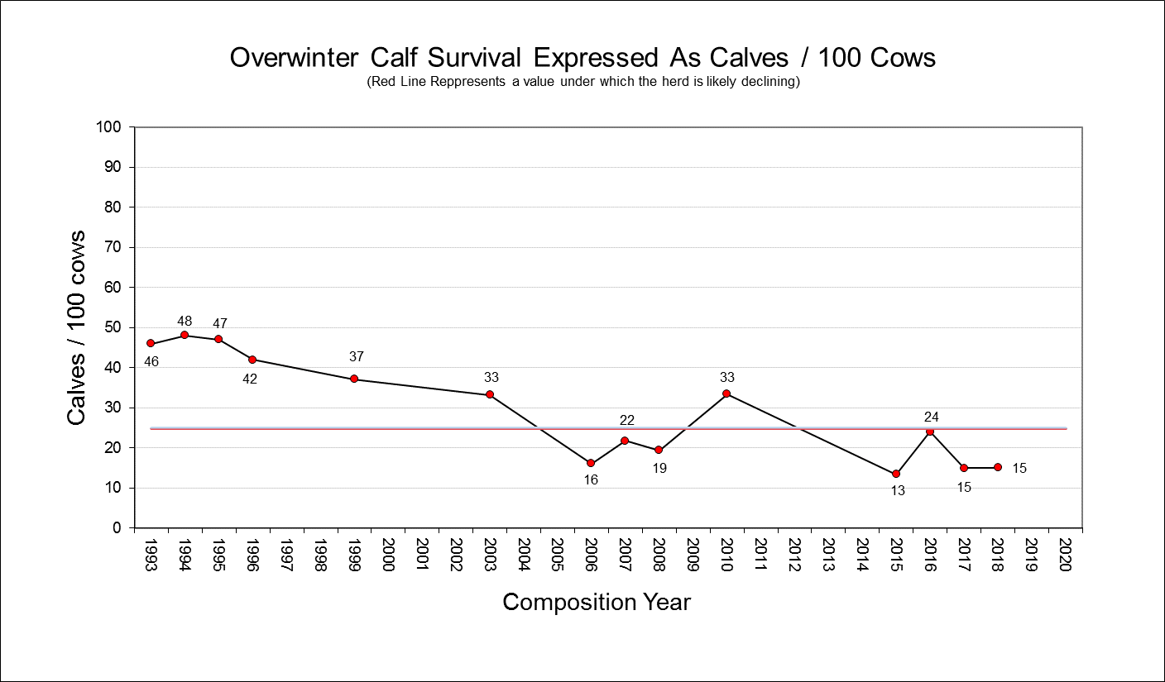
Figure 6. The history of Qamanirjuaq composition studies. Tracking number of calves’ vs number of cows has been found to provide a reliable index of herd productivity and trend. Values below the red line (25 calves/100 cows) suggest a decreasing abundance for mainland migratory caribou.

  - Regression analyses
    - Summary of data used in the analyses
Daily location data from the Spring migration season (April 1- May 28) and Late-summer/Fall (August 13 to December 15) that occurred within 160 km of the Meadowbank road were considered for the analysis. This resulted in yearly sample sizes ranging from four to 15 caribou. Yearly sample sizes of caribou with daily locations, prior to 2016 numbered 2 to 3 caribou per year. Given that year-specific variation in ZOI was an objective of the analysis, the main focus was the 2016-2019 data set for estimation of ZOI. It was also during much of this period, that the Whale Tail road was constructed, therefore presenting a similar disturbance impact across all years considered.

Table 2. Sample sizes of Lorillard collared caribou used in the analysis.
Year | Collars | Total daily locations for collared caribou
 |  |  | mean |  | min | max
Spring migration
2016 | 6 |  | 13.8 |  | 6 | 31
2017 | 0
2018 | 15 |  | 34.0 |  | 29 | 40
2019 | 5 |  | 43.3 |  | 29 | 54
Late Summer -Fall
2016 | 7 |  | 63.3 |  | 7 | 99
2017 | 6 |  | 59.8 |  | 32 | 99
2018 | 15 |  | 68.7 |  | 45 | 119

The yearly paths of caribou are plotted in Figure 7 which suggest relatively similar movement paths relative to the road for spring migration but unique yearly patterns for late-summer and fall. Most notably, in 2018, caribou occurred to the east of the Meadowbank AWAR road from mid-August to mid September. For this reason, yearly spring migration data was pooled across years for the analysis with 2016-2017 and 2018 considered separately for the late-summer/fall migration period.
Lorillard collared caribou primarily encountered the Meadowbank all weather access road (AWAR) in the summer-fall season and encountered both the AWAR and Whale Tail roads in the spring migration season (Figure 7). However, in some cases caribou were in the vicinity of both roads in a given season. Given this, and the lack of traffic volume data, all roads were considered equal rather than separately when estimating of ZOI. As discussed later in the report, it might be possible to consider ZOI for each road separately for a subset of data for situations in which caribou were distinctly near just the AWAR or Whale Tail road. This analysis would be best accompanied by traffic volume data to better discern the potential difference in ZOI of the Whale Tail and AWAR road. Overall, the number of Lorillard caribou encountering and crossing the Whale Tail road was lower and therefore ZOI estimates from this study mainly pertain to the AWAR.

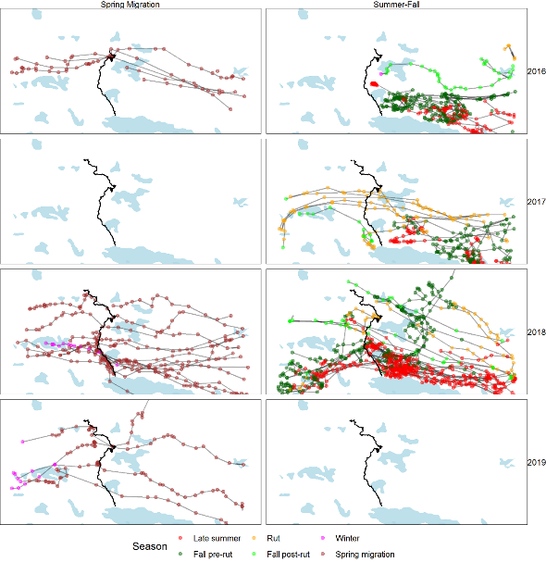
Figure 7. Paths of caribou relative to the Meadowbank mine road for spring migration and late summer/fall periods. The main direction of movements was from the west to east for spring migration and from east to west for the late summer/fall periods. The progression of construction of the Whale tail road is illustrated with most expansion occurring between 2016 and 2017.
    - Spring migration
Spring migration data from 2016-2019 was used for this analysis. Yearly data was pooled, however year-specific values of ∆D_{mine} were considered in cases where migration rates varied between years. A plot of date by distance from mine road revealed a relatively constant rate of travel for most years as indicated by the similar angled trajectories in the data (Figure 8). At approximately 10-20 km from the road, travel rates relative to the road decreased for some caribou as indicated by reduced slope in trajectories along the road and westerly directions of trajectories (away from the road as indicated by red points) in the vicinity of the road. A vertical trajectory indicated movement parallel to the road. Once the road was crossed, the relative rate of travel became similar to that observed for caribou approaching the road from greater than 20 km west of the road. The direction and rate of travel was delayed after crossing the road for a few caribou as indicated by red dots or a slight vertical offset between the trajectory both before and after the road.

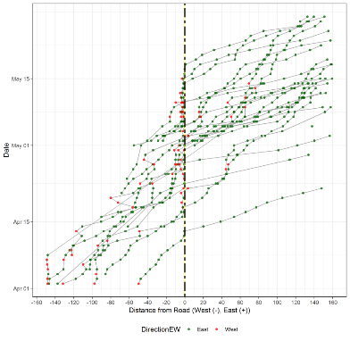
Figure 8. The movement trajectories of individual caribou points relative to the Meadowbank road (hashed line) by date for the spring migration from 2016-2019. Points to the left of the center line are for caribou before they crossed the road, and points to the right are after they crossed the road. The colour of the points indicates the relative displacement (East to West) since the last location. Vertical trajectories indicate movement parallel to the road.
A plot of trajectories by year suggests similar timing of migration relative to the road, with potential delays in migration in all years (as indicated by vertical trajectories near the road). In 2018 and 2019, the road was closed to allow caribou movement during migration as indicated by symbols on the road in Figure 9.
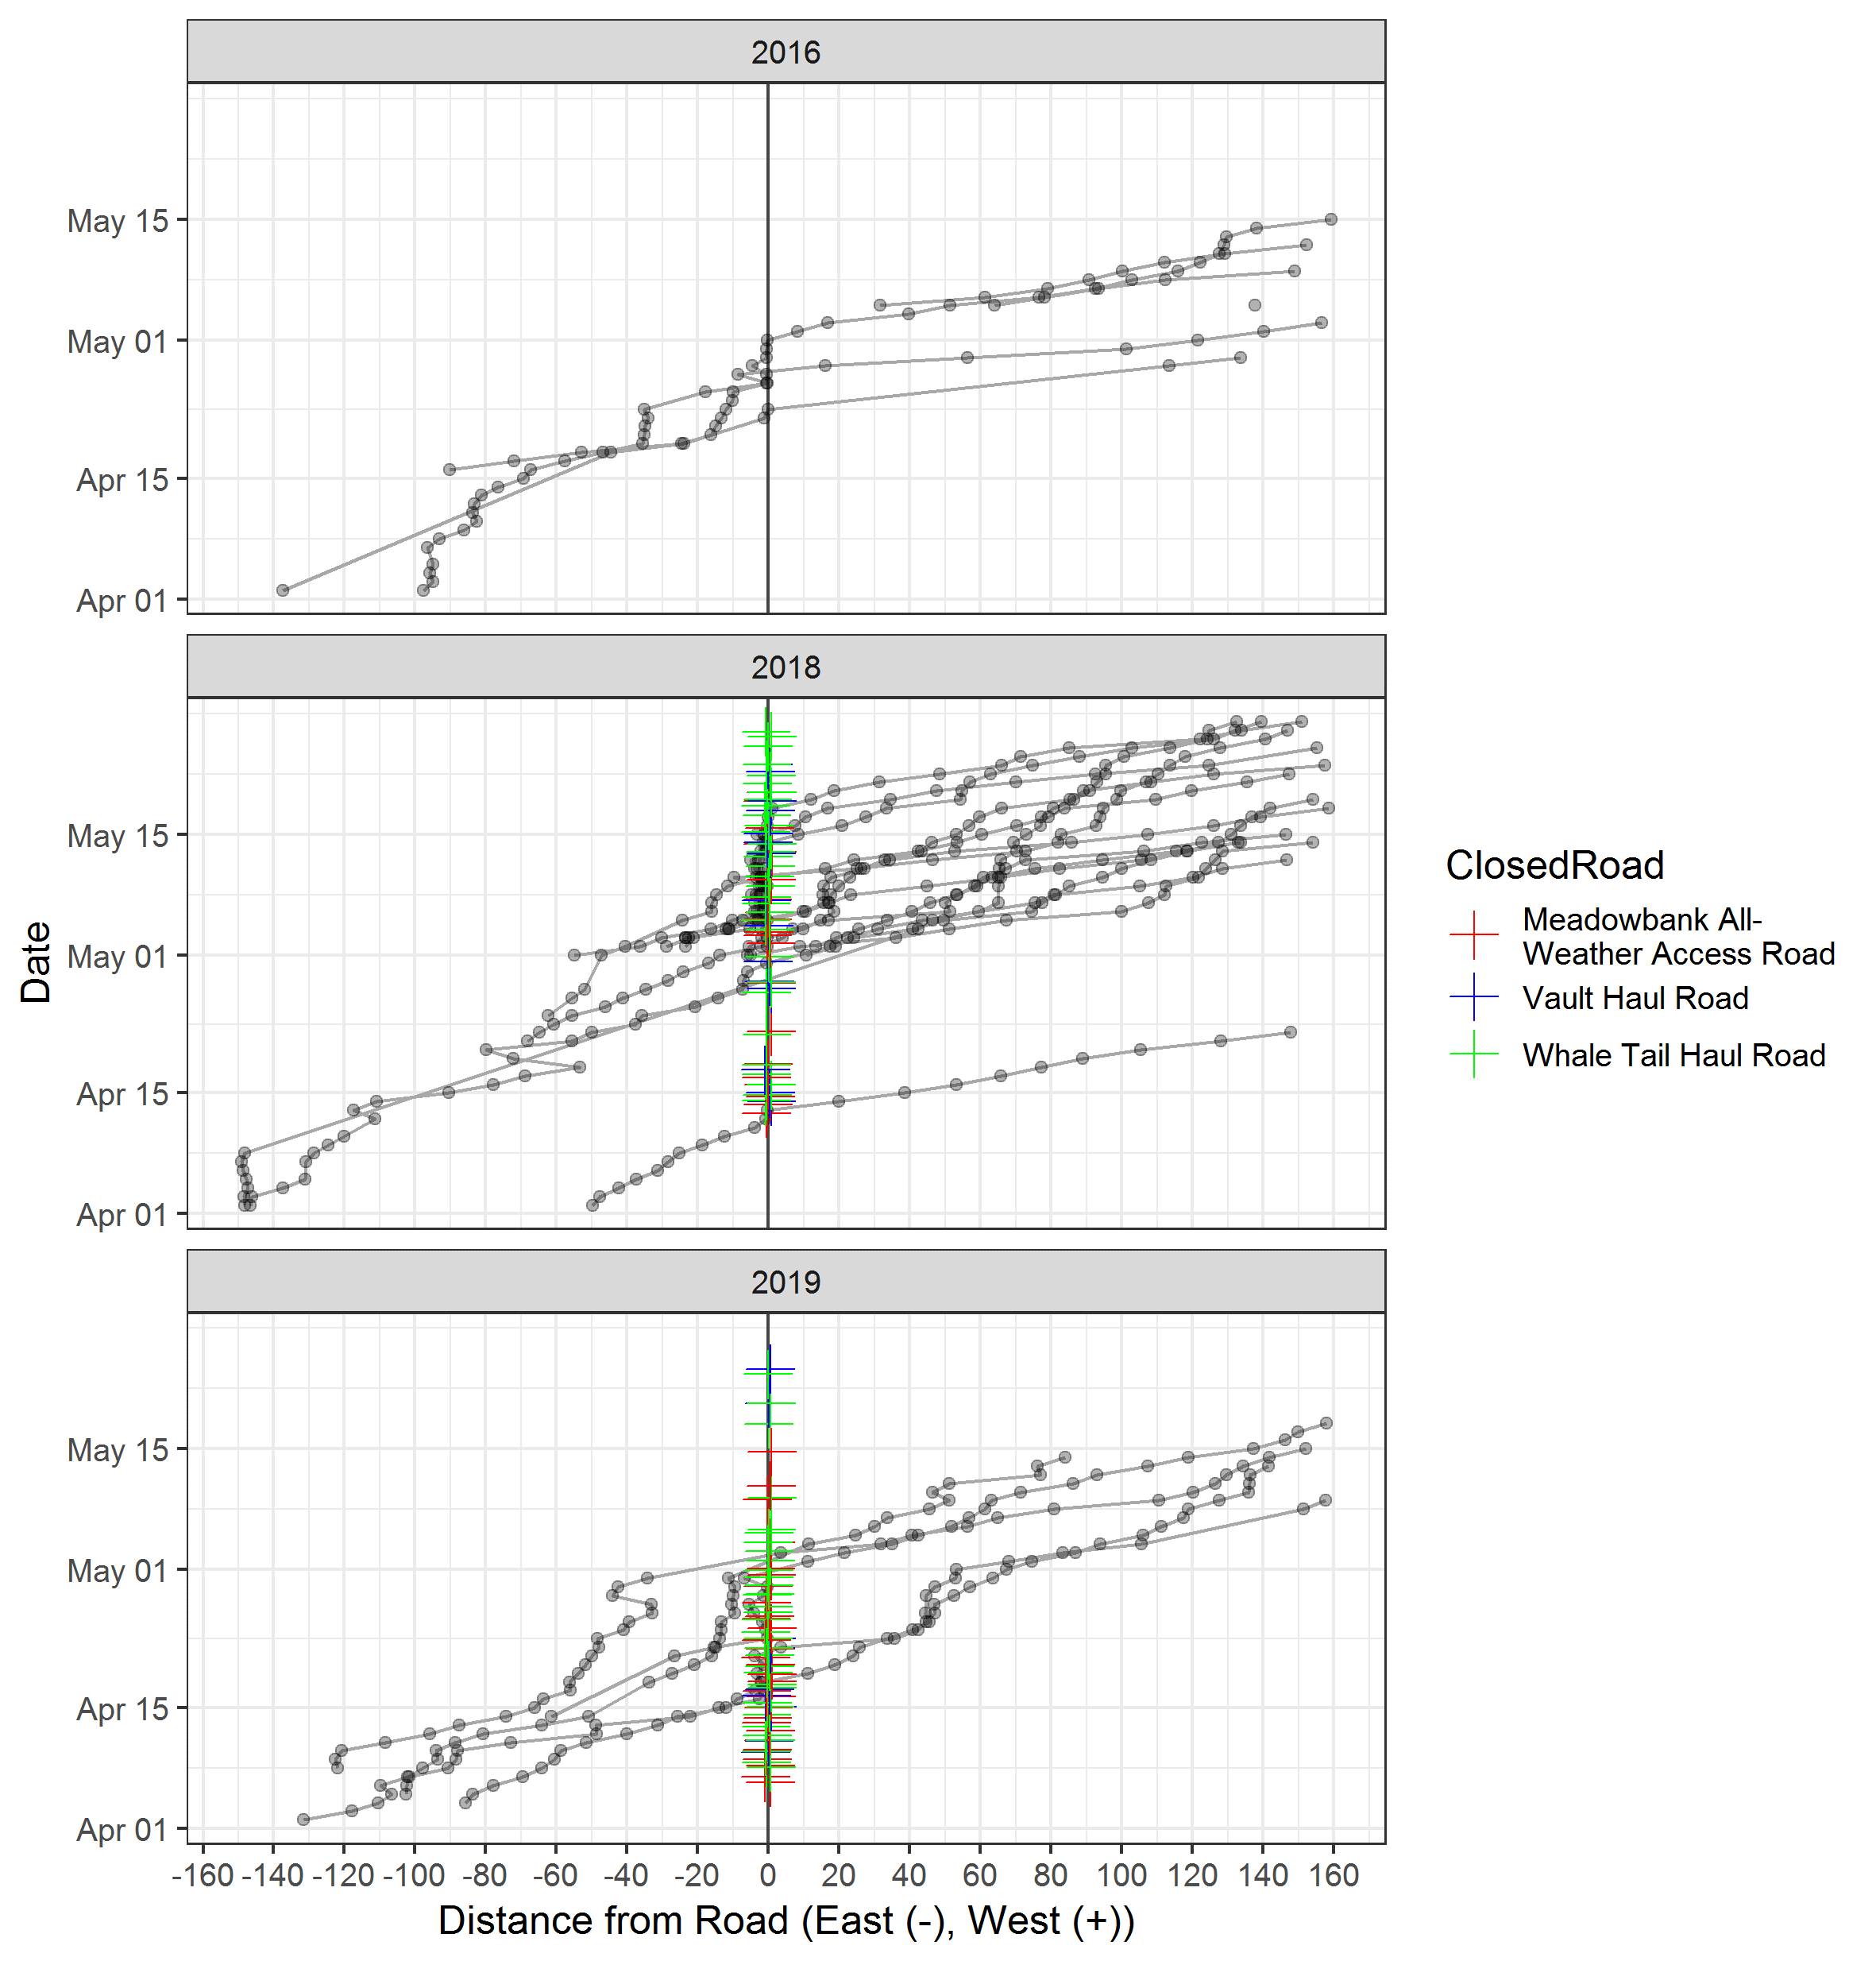
Figure 9. The distance of individual caribou points from the Meadowbank road by date for the spring migration for 2016-2019 with road closures illustrated. Points to the left of the centre-line are for caribou before they crossed the road and points to the right are after they crossed the road. Road closure points are staggered to minimize overlap. As discussed later, the effect of road closure would be best explored in comparison with information about traffic volumes.

Inspections of histograms suggested that the overall distribution of ∆D_{mine} was well described by a normal distribution. As such, a normal distribution was assumed in subsequent analyses. As an initial step, base caribou biology covariate terms were considered (Table 3) with ELCmode and year showing the most support. These covariates were then considered with ZOI terms. Zones of influence terms considered included a ZOI prior to crossing (NC: the west side of the road), and after crossing (C: the east side of the road). In addition, a model with equal zones of influence for both sides of the road was considered (NC=C). Of these models, a model with year-specific mean rate of ∆D_{mine} and different zones of influence for each side of the road was most supported (Table 3, model 1). A model with a single ZOI (model 5: assuming equal zones of influence on either side of the road) was less supported. All ZOI models were more supported than baseline caribou biology models without ZOI terms.

Table 3. Model selection for spring migration (2016-2019) regression analysis of daily change in distance from mine. Only models with more support than an intercept model are shown. Akaike Information Criteria (AIC_{c}), the difference in AIC_{c} values between the ith and most supported model 1 (ΔAIC_{c}), Akaike weights (w_{i}), number of parameters (K), and log-likelihood (LL) are presented. ZOI terms are abbreviates as prior to crossing (NC) which would be the west side of the road and crossing ( C) which would be the east side of the road.
No | Covariates | ZOI | AIC_{c} | ∆AIC_{c} | w_{i} | K | LL
1 | Year | NC+C | 4038.2 | 0.00 | 1.00 | 5 | -2006.9
2 | East-West | NC+C | 4049.7 | 11.52 | 0.00 | 4 | -2014.8
3 | constant | NC+C | 4053.2 | 15.02 | 0.00 | 3 | -2018.4
4 | ELC_ModeP | NC+C | 4056.9 | 18.70 | 0.00 | 4 | -2016.2
5 | Year | NC=C | 4084.0 | 45.80 | 0.00 | 4 | -2033.8
6 | ELC_ModeF |  | 4145.4 | 107.19 | 0.00 | 3 | -2067.7
7 | Year |  | 4147.3 | 109.10 | 0.00 | 3 | -2068.7
8 | TRI |  | 4160.3 | 122.09 | 0.00 | 2 | -2076.6
9 | constant |  | 4158.3 | 120.07 | 0.00 | 1 | -2076.9

Evaluation of coefficients for the most supported model demonstrated that all parameters were significant (Table 4).
Table 4. Model parameter estimates for model 1, Table 3 from GEE model.
Parameter | Estimate | Std. Error | Wald | Pr(>|W|)
(Intercept) | 22.31 | 1.63 | 13.67 | 0.0000
Year-2018 | -4.65 | 1.58 | -2.95 | 0.0032
Year-2019 | -5.91 | 1.54 | -3.85 | 0.0001
ZOI (cross) Slope | -2.50 | 0.42 | -5.89 | <0.0001
ZOI (not cross) Slope | -0.79 | 0.21 | -3.81 | 0.0001

ZOI of the road were significant, as indicated by confidence limits that did not overlap 0 for both the east and west side of the road (Table 5).

Table 5. Estimates of zone of influence from model 1 (Tables 3 and 4).
Zone of influence | Est. | SE | 95% confidence limit
East side (crossed) | 4.9 | 1.4 | 2.2 | 7.7
West side (not crossed) | 8.7 | 3.5 | 2.1 | 15.3

Plots of yearly model predictions and ∆D_{mine} observations shows a higher density of ∆D_{mine} observations of lower value (or less than 0 indicating net movement west away from the road) prior to crossing, with the estimated ZOI of 8.66 km for each year (Table 5). The ZOI on the east side of the road (at 4.9 km) is influenced by a lower number of westward movements as well as a slightly higher overall rate of travel away from the road once it was crossed (Figure 10). Also illustrated are different yearly mean values of ∆D_{mine} as modelled by the year-specific intercept terms (Table 4).
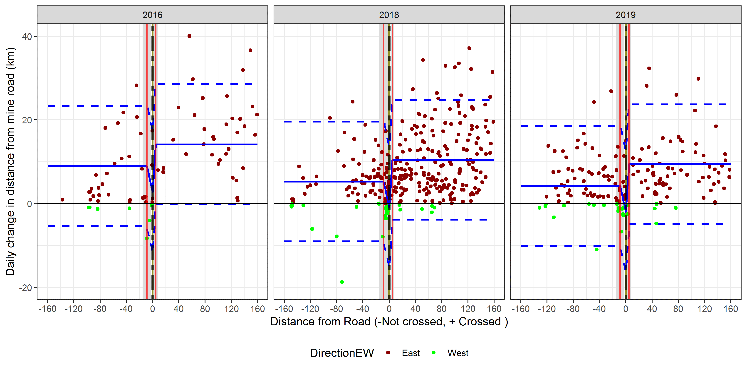
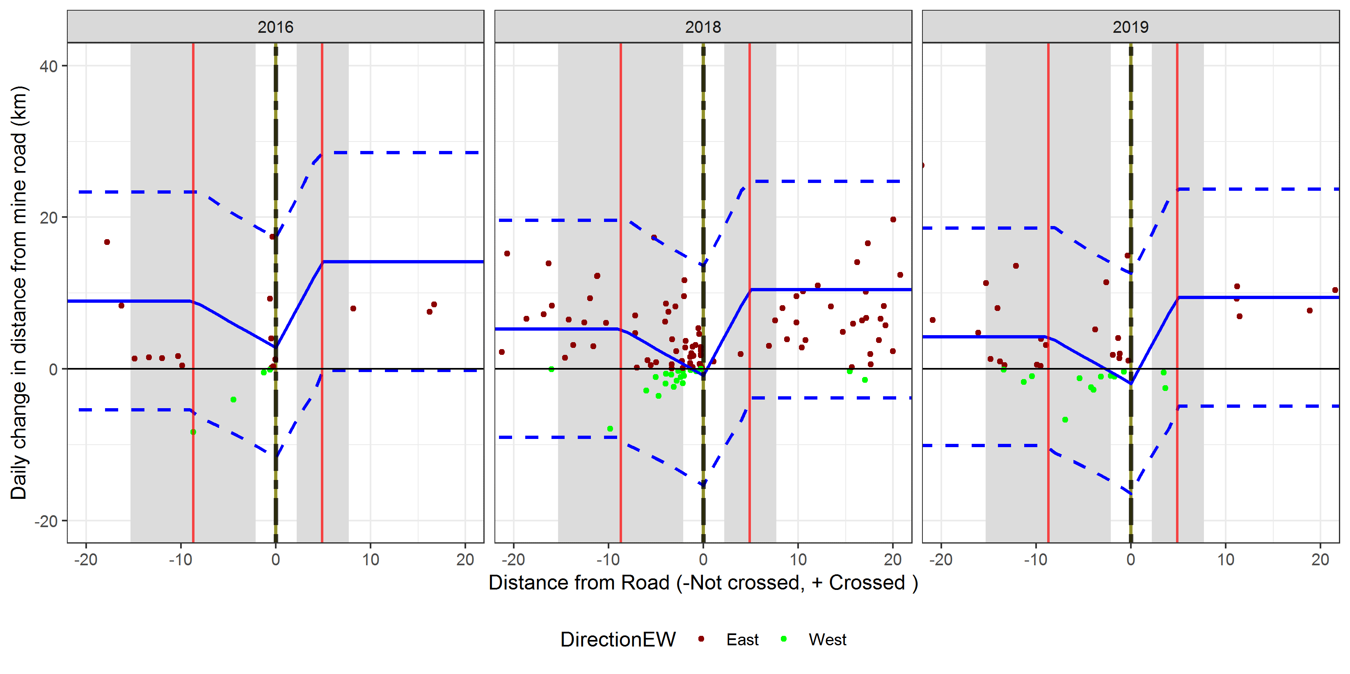
Figure 10. Predictions of segmented model for spring migration (2016-2019). The upper plot shows the full data set and the lower plot is zoomed into the zone of influence area. The zones of influence estimates are shown as a red line on either side of the road with confidence limits as shaded regions. Predicted mean ∆D_{mine} are shown as blue lines (confidence intervals as dashed lines). Observed ∆D_{mine} are shown as points which are color-coded based on net direction since last observation.

One application of the zone of influence was to estimate the delay in crossing due to ZOI. To do this, a regression analysis was conducted where trend in distance from road was used to estimate date in which the road would be encountered using only the data for distances before the estimated ZOI (at 8.66 km). The general approach is graphically shown in Figure 11. This provided an estimate of the predicted date of road crossing without the estimate of ZOI. This analysis was run using a random intercepts model (with individual yearly caribou as the sample unit) therefore allowing unique estimates of road crossing for each caribou. Predicted date of road crossing with no influence of the ZOI was compared to actual crossing dates of individual caribou. The mean difference was 6.2 days (std=3.24, min=1.9, max=11.1), suggesting the predicted date of road crossing was significantly sooner than the actual date of road crossing.
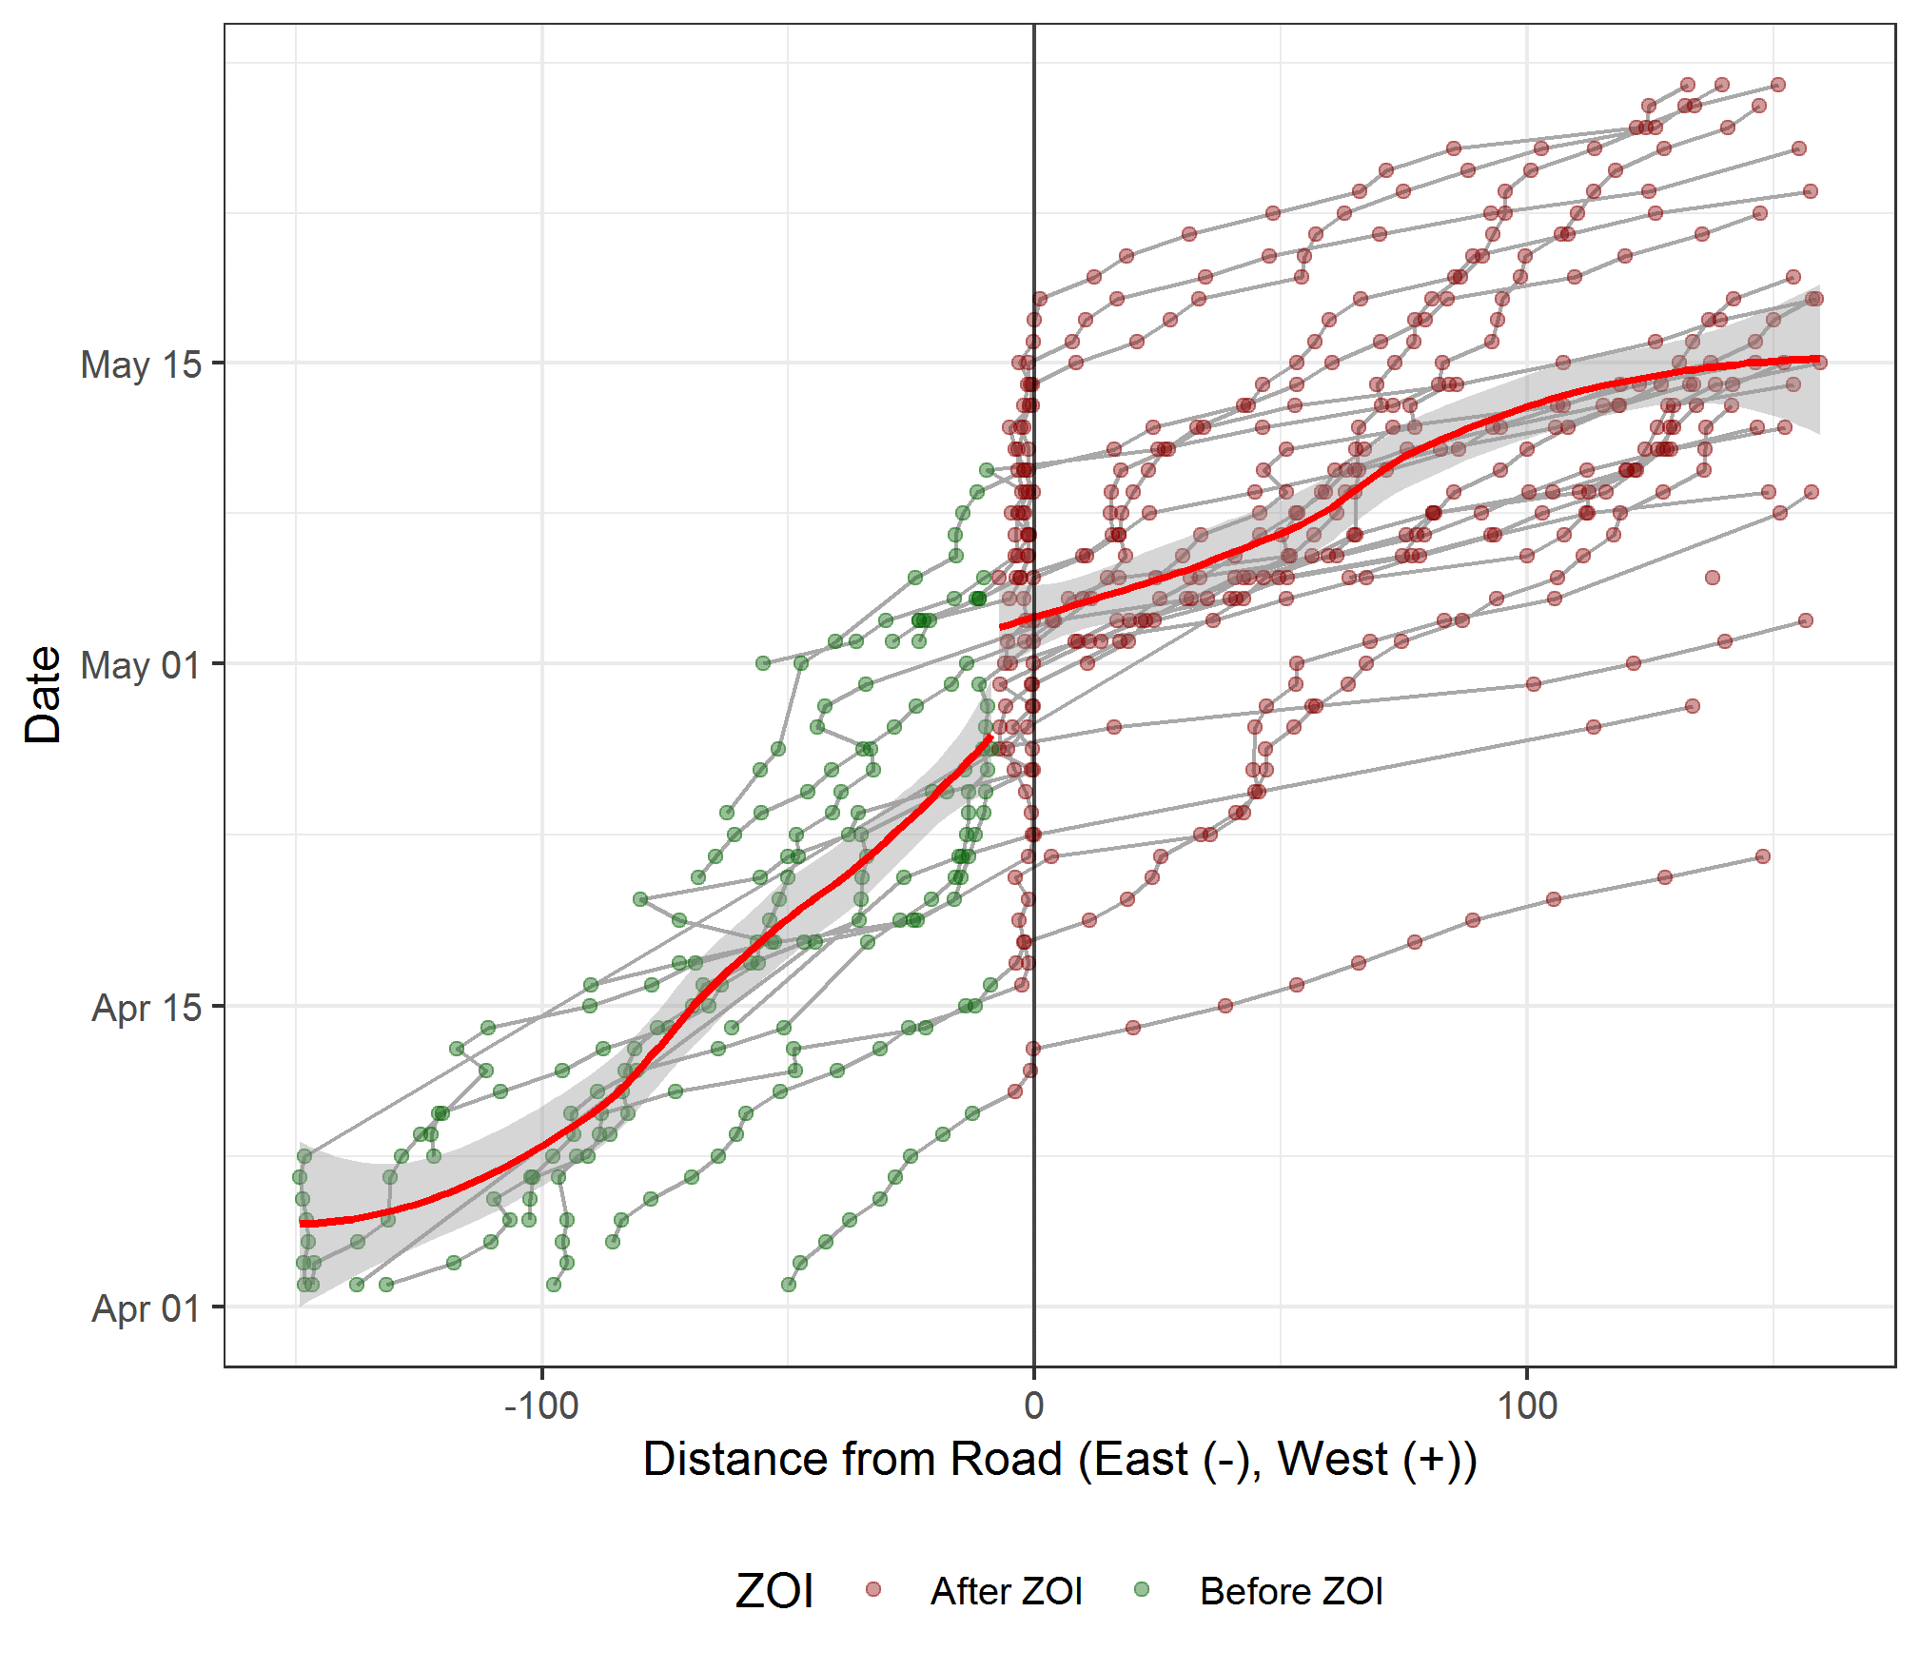
Figure 11. The trajectories of individual caribou points from the Meadowbank road, by date, for the spring migration from 2016-2019 with yearly data pooled. Points to the left of the center-line are for caribou before they crossed the road and points to the right are after they crossed the road. Predictions of net movement are shown prior to the estimated ZOI at 8.66 km and after the ZOI, demonstrating the delay in migration due to the ZOI. If the road has no impact then the two predicted trajectories should meet at the ZOI.
    - Late summer/ fall 2016-7
Caribou were spread out at a distance of 10 – 160 km from the road during the late summer and early fall for 2016 and 2017 (Figure 7 and Figure 12) with non-directional movement in relation to the road in September followed by movement toward the road in mid-September and movement away from the road in mid-October. A group of 5 caribou did cross the road during the rut in 2017.
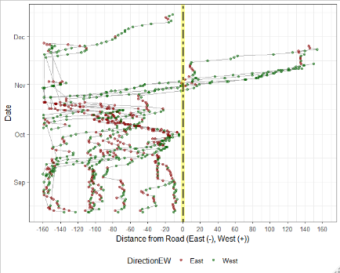
Figure 12. The trajectories of individual caribou points relative to Meadowbank roads (hashed yellow line) by date for late-summer/fall 2016-2017. Points to the left of the line are for caribou before they crossed the road and points to the right are after they crossed the road. The colour of the points indicates the direction since the last location.

Model selection results suggested that mean ∆D_{mine} levels were affected by season, which was grouped by Rut and Summer-Fall. Given that caribou crossed the road during the rut, this would have the largest impact on ∆D_{mine} values (Table 6). In addition, ∆D_{mine} was also affected by whether the road was crossed (East-West term). The most supported model estimated ZOI for crossing but not prior to crossing, suggesting ZOI was only potentially detectable once the road was crossed, and not prior to crossing. This result makes sense given the relative distribution of the collars relative to the road, and lack of distinct movement patterns prior to crossing (Figure 10).
Table 6. Model selection for summer-fall 2016-2017 regression analysis of daily change in distance from mine. Only models with more support than an intercept model are shown. Akaike Information Criteria (AIC_{c}), the difference in AIC_{c} values between the ith and most supported model 1 (ΔAIC_{c}), Akaike weights (w_{i}), number of parameters (K), and log-likelihood (LL) are presented. ZOI terms are abbreviates as prior to crossing (NC) which would be the east side of the road and crossing (C) which would be the west side of the road.
No | Covariates | ZOI | AIC_{c} | ∆AIC_{c} | w_{i} | K | LL
1 | Season + East-West | C | 5853.14 | 0 | 0.50 | 4 | -2913.6
2 | Season | C | 5853.16 | 0.02 | 0.49 | 3 | -2917.3
3 | Season | NC+C | 5861.76 | 8.62 | 0.01 | 4 | -2912.68
4 | Season |  | 5866.99 | 13.85 | 0.00 | 2 | -2929.16
5 | East-West |  | 5938.32 | 85.18 | 0.00 | 3 | -2964.83
6 | Year | NC+C | 5939.51 | 86.37 | 0.00 | 4 | -2951.56
7 | ELC | NC+C | 5939.52 | 86.38 | 0.00 | 4 | -2951.56
8 | Year |  | 5941.56 | 88.42 | 0.00 | 3 | -2966.45
9 | Constant | NC+C | 5946.33 | 93.19 | 0.00 | 3 | -2960.17
10 | ELC |  | 5950.06 | 96.92 | 0.00 | 7 | -2956.83
11 | Constant |  | 5977.98 | 124.84 | 0.00 | 1 | -2986.39

Tests for parameter significance suggested that all terms were significant except the slope term for the ZOI, suggesting that the ZOI was weak (Table 7).

Table 7. GEE parameter estimates for model 1, Table 6
Parameter | Estimate | Std. Error | Wald test | Pr(>|W|)
(Intercept) | 17.09 | 3.40 | 5.03 | 0.0000
Season | -10.37 | 2.05 | -5.06 | 0.0000
East-West | 7.72 | 2.47 | 3.12 | 0.0018
Slope-ZOI cross | -0.41 | 0.27 | -1.52 | 0.1292

Estimates of ZOI for crossing were 33.9 km (SE=16.21, CI=2.2-65.8 km). This estimate should be interpreted cautiously given the non-significance of the slope term as well as the relatively low sample size of collars that crossed the road (4) that was used for estimates. A plot of predicted ∆D_{mine} values shows large confidence limits on both ZOI and model prediction (Figure 13). With these limitations in mind, the pattern of movements after the road was crossed does suggest that caribou did increase movement levels after crossing the road. However, low sample sizes of collars and low numbers of data points on the crossed side of the road preclude a definitive estimate of ZOI size and effect, but do not dismiss its existence.
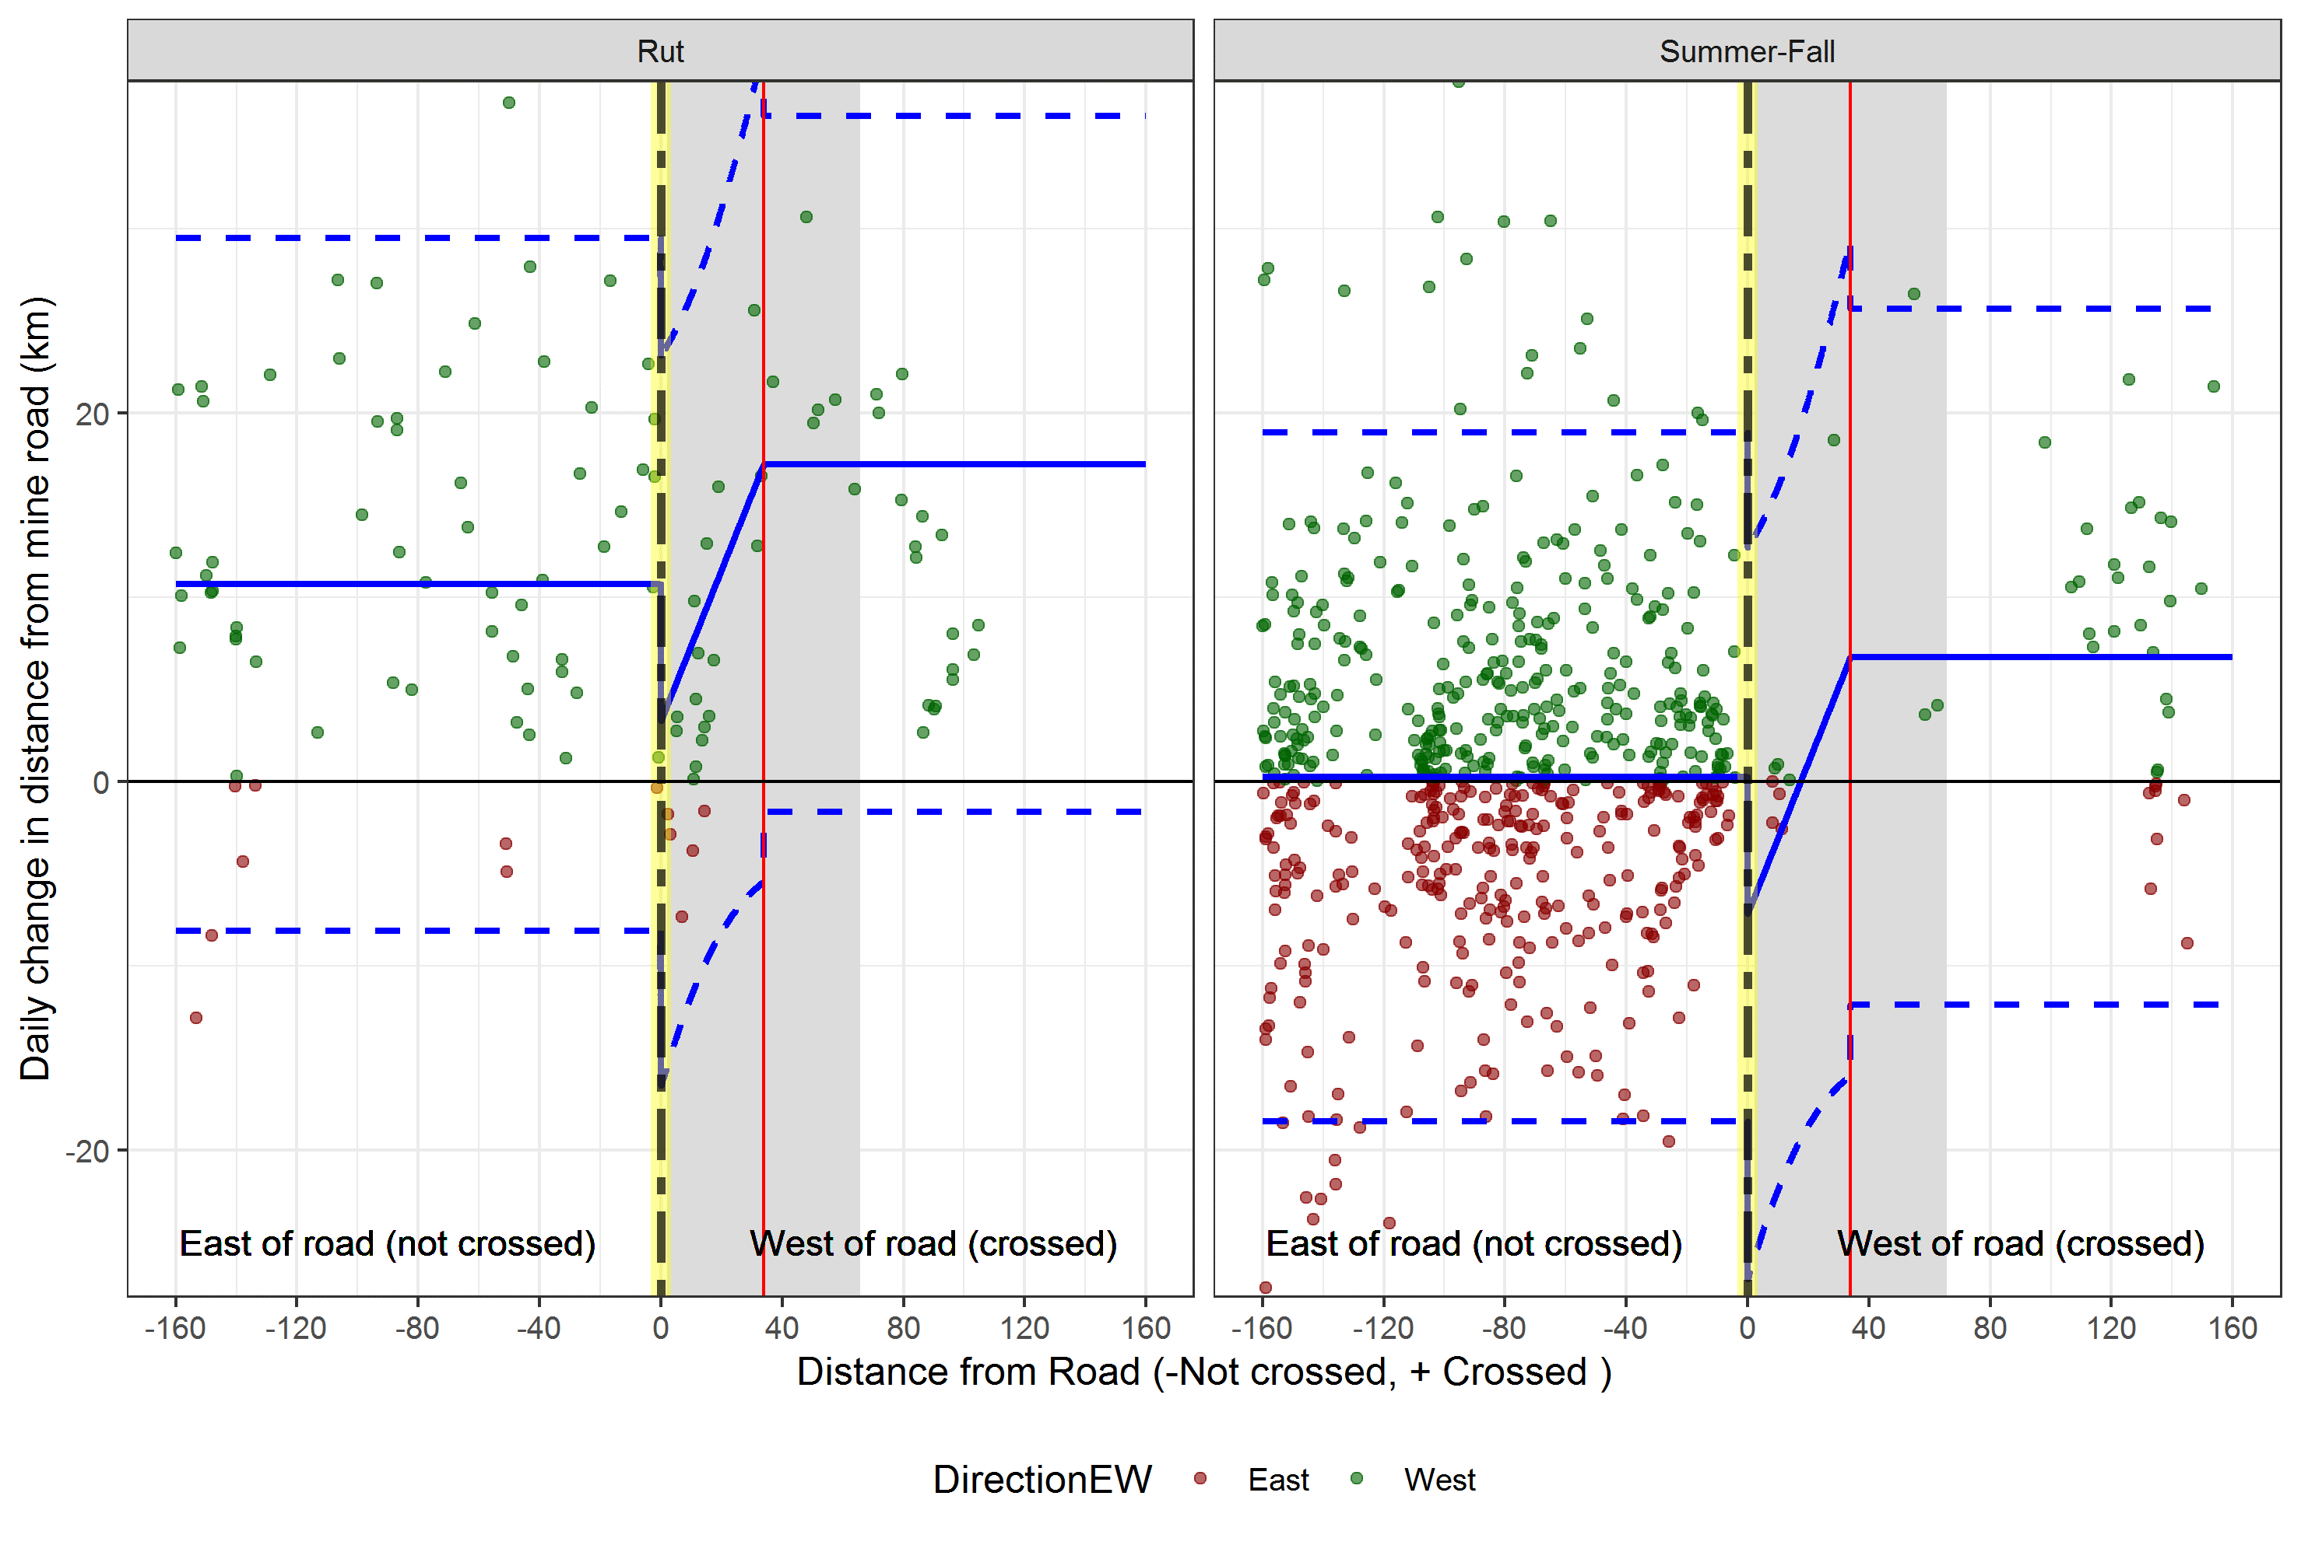
Figure 13. Predicted daily change in distance from mine from the segmented regression model for caribou east of the Meadowbank Road (hashed yellow line) for the fall/rut season (blue line with confidence limits as hashed lines) for 2016-2017. Estimated ZOI (after crossing to the west of road) is given as a red line with confidence limits shaded grey.

    - Late summer-fall 2018
Collared caribou exhibited dynamic patterns of movement relative to the road in the late summer and fall of 2018. The best way to conceptualize movements, and individual variation in movement, is through observation of individual paths during this time (Figure 14). From these paths it can be seen that 12 of the 15 collared caribou occurred at the far south end of the road in late summer of 2018. The collars exhibited complex movement patterns near the road after which 8 crossed the road in the late summer period. Three of the caribou then crossed the road in early fall, 3 crossed during the rut, and one never crossed the road. A video of these movements (Fall_2018_animation.mp4) is available to allow further interpretation of movements.
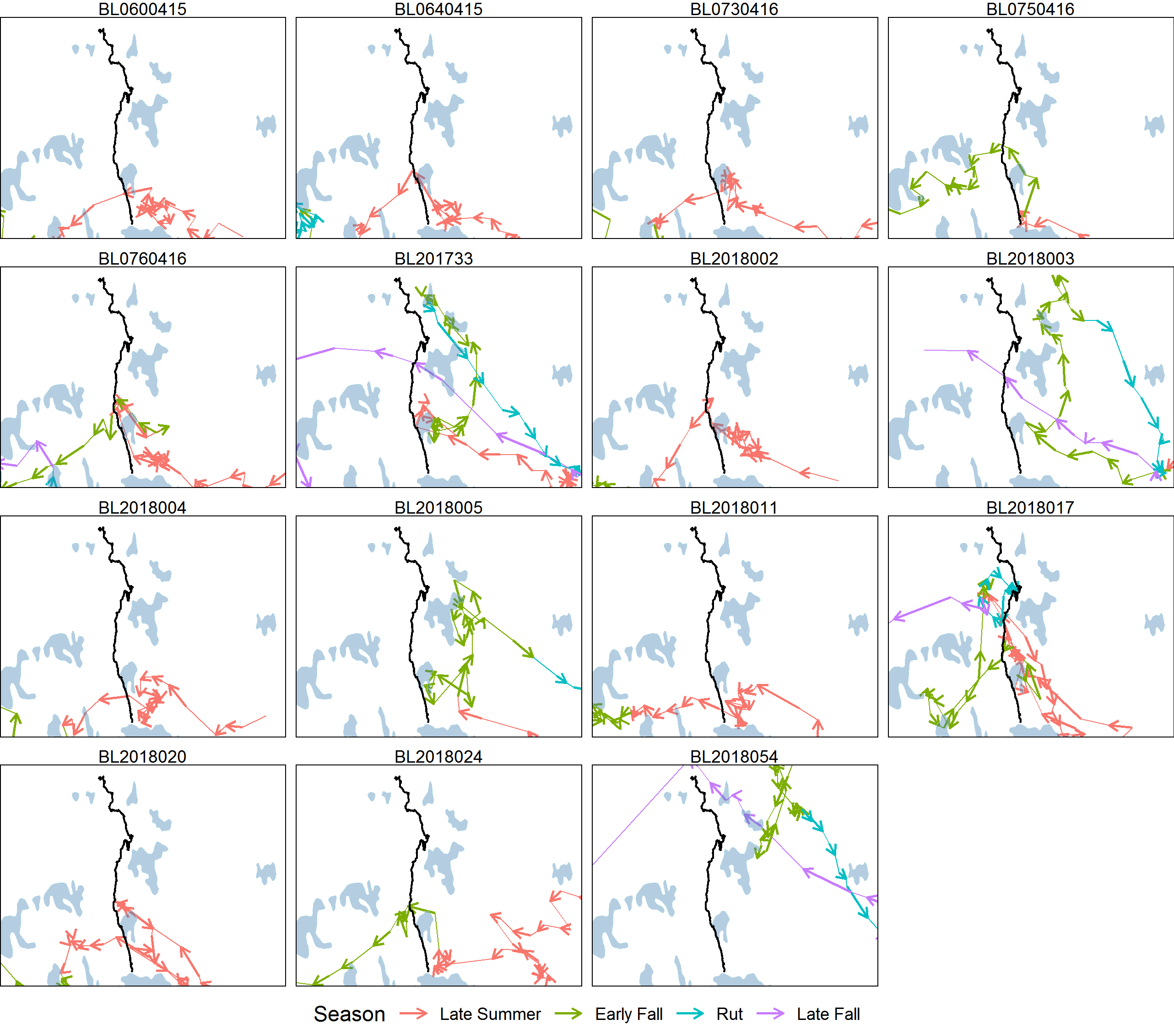
Figure 14. Individual paths of caribou relative to Meadowbank roads during the late-summer and fall of 2018. An animation file (Fall_2018_animation.mp4) also illustrates the sequence of movement, by date.

The movements are further illustrated with distance from road as a function of date for individual caribou (Figure 15). This figure shows that the caribou were within 20-40 km of the road from mid-August to mid-September at which time 11 crossed with the 4 others moving away from the road. During this time, the road was closed to allow caribou movement, as indicated by triangles on the road.
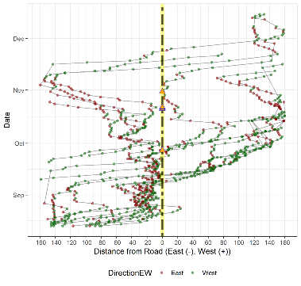
Figure 15. The distance of individual caribou points from the Meadowbank road (hashed yellow line) by date for the fall of 2018. Points to the left of the centre-line are for caribou before they crossed the road and points to the right are after they crossed the road. The colour of the points indicates the direction since the last location. The triangles on the center line (which indicates the Meadowbank Road) are dates in which the road was closed to traffic in an attempt to allow caribou to cross the road.

Given that the analysis time period spanned late summer, fall, and the rut, it was likely that the rate of movement during this time may have been affected by season (Table 8). This finding was verified by the analysis where season, as dichotomized by late summer and fall/rut, was supported as a covariate for ∆D_{mine.} Other covariates such as habitat (ELC), geography (TRI), and distance to nearest lake, were less supported. Various ZOI terms were considered with a base season model including seasonal zones of influence (models 1, 12 and 17) and unique zones of influence for crossing, (the west side of the road) and not crossing (east side of the road). Of the models considered, a model with a ZOI for the summer season (not crossed-east side of road) and a ZOI for crossing (west side), for all seasons, was most supported. A model that assumed equal zones of influence for either side of the road (model 4) was less supported. The effect of lakes on ZOI estimates was further explored (Appendix 2) with minimal evidence for confounding of ZOI estimates due to movements near lakes.
Table 8. Model selection for summer-fall 2018 regression analysis of daily change in distance from mine road. Akaike Information Criteria (AIC_{c}), the difference in AIC_{c} values between the ith and most supported model 1 (ΔAIC_{c}), Akaike weights (w_{i}), number of parameters (K), and log-likelihood (LL) are presented. ZOI terms are abbreviates as prior to crossing (NC) which would be the east side of the road and crossing (C) which would be the west side of the road.
No | Base parameters | ZOI terms | AIC_{c} | ∆AIC_{c} | w_{i} | K | LL
1 | Season (Late summer& fall-rut) | NC_{summer}+C | 7414.29 | 0.00 | 0.94 | 4 | -3692.1
2 | Season (Late summer& fall-rut) | C + NC | 7421.52 | 7.23 | 0.03 | 5 | -3695.8
3 | Season (Late summer-early fall & late fall-rut) | C + NC | 7421.53 | 7.24 | 0.03 | 5 | -3695.8
4 | Season (Late summer& fall-rut) | C=NC | 7423.99 | 9.70 | 0.00 | 3 | -3703.6
5 | Season (Late summer& fall-rut) |  | 7427.08 | 12.79 | 0.00 | 3 | -3709.4
6 | Season (Late summer-early fall & late fall-rut) |  | 7428.82 | 14.53 | 0.00 | 2 | -3710.3
7 | Constant (intercept only) |  | 7431.14 | 16.85 | 0.00 | 1 | -3713.1
8 | East-West |  | 7431.28 | 16.99 | 0.00 | 2 | -3711.5
9 | TRI |  | 7431.69 | 17.40 | 0.00 | 2 | -3711.8
11 | Season (Late summer& fall-rut) X log (distance from nearest lake) |  | 7431.96 | 17.09 | 0.00 | 4 | -3710.0
10 | Constant (intercept only) | C + NC | 7433.44 | 19.15 | 0.00 | 4 | -3705.5
12 | Season (Late summer& fall-rut) | NC_{summer+} NC_{fall} + C | 7433.47 | 19.18 | 0.00 | 6 | -3689.7
13 | notcrossed | C + NC | 7436.97 | 22.68 | 0.00 | 5 | -3703.5
14 | ELC_ModeP |  | 7437.43 | 23.14 | 0.00 | 3 | -3712.7
15 | Season (Late summer& fall-rut) X ELC_ModeP |  | 7445.90 | 31.60 | 0.00 | 6 | -3707.9
16 | ELC_modeF |  | 7452.96 | 38.67 | 0.00 | 6 | -3711.5
17 | Season (Late summer& fall-rut) | Season X ZOI | 7485.5 | 71.23 | 0.00 | 10 | -3704.7

Model parameter estimates from the generalized estimating equation model (accounting for autocorrelation of caribou movements) indicate that the ZOI slope terms were significant, but the season term was not significant (Table 9). This is potentially due to the ZOI term modelling seasonal variation given that the seasonal term is significant when the ZOI term was not included in the model.
Table 9. Generalized Estimating Equation model parameter estimates for the most supported model (model 1, Table 6)
Parameter | Estimate | Std.err | Wald test | Pr(>|W|)
(Intercept) | 11.14 | 1.99 | 31.30 | 0.0000
Season (Fall Summer) | 0.63 | 1.02 | 0.38 | 0.5377
ZOI crossed (west side) | -0.45 | 0.21 | 4.46 | 0.0346
ZOI not crossed (east side) | -0.11 | 0.04 | 7.59 | 0.0059

Estimates of ZOI were 59.7 km for the late summer season for the east side of the road and 9.83 km for the west side (after crossing) (Table 10). Confidence limits for estimates did not overlap, suggesting they were significantly different for prior to and after crossing of the road. Estimates of ZOI were similar for model 2, which estimated a pooled ZOI for the east side of the road, however, confidence limits were wider.
Table 10. Estimates of ZOI from model 1, (Tables 8 and 9).
ZOI | Estimate | SE | 95% confidence limit
East side (not crossed) | 59.7 | 23.3 | 20.3 | 99.1
West side (crossed) | 9.8 | 9.7 | 1.9 | 24.6

A plot of model predictions and observations of ∆D_{mine} show lower values near the road for the summer season prior to crossing as well as higher values after crossing for both summer and fall (Figure 16).
The estimate of ZOI of 59.7 corresponds to the distance travelled away from the road in early September, before crossing, as shown in Figure 15.

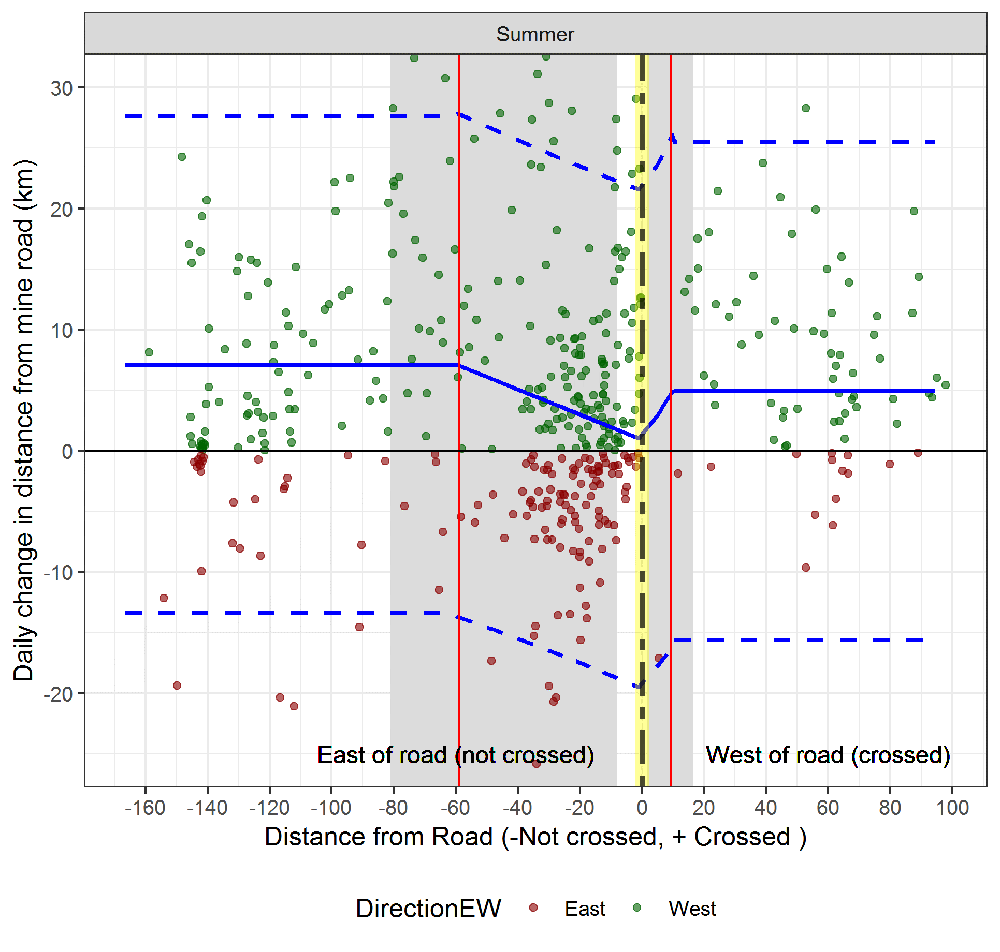
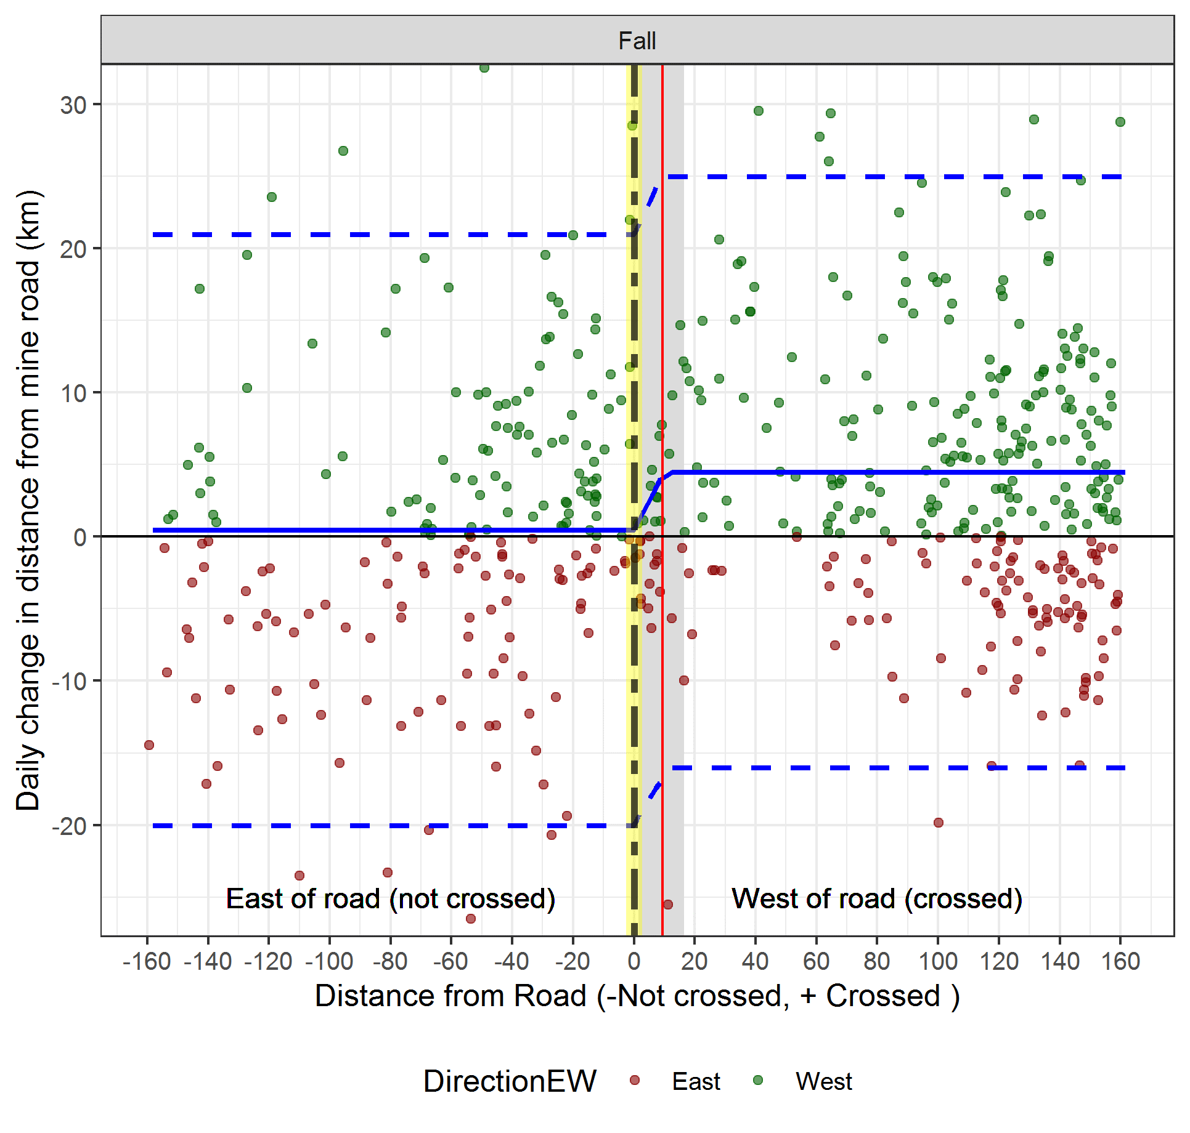
Figure 16. Predicted daily change in distance from mine from the segmented regression model for caribou east of the Meadowbank Road (hashed yellow line), and for the fall/rut season (blue line with confidence limits as hashed lines). Estimated ZOI (after crossing to the west of road) is given as a red line with confidence limits shaded grey. Note the higher number of negative ∆D_{mine} values (red data points) east of the road compared to west of the road for the summer season.

Figure 17 illustrates seasonal zones of influence in the context of the larger data set, and movements of caribou relative to the Meadowbank mine road. This figure shows an aggregation of collars on the east side of the road relative to movements and collar density further east of the estimated ZOI. The late summer ZOI most directly applies to the AWAR where collared caribou were congregated. Sparse coverage for the eastern side of the Whale tail road precludes a solid estimation of ZOI for this area. As discussed later in the report and Appendix 2, the role of habitat, direct, and indirect ZOI effects will be considered further to better understand the estimated late summer ZOI.
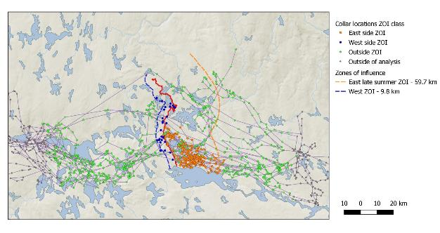
Figure 17. Collar locations used in analysis dichotomized by zones of influence. Zones of influence were detected for all seasons on the west side of the road (after crossing) and the east side for the late summer season. Locations within 160 km of the mine road were used for the analysis.

  - Biased-Correlated Random Walk
Potential delays caused by changes in movement behaviours around road and mine site infrastructure, are important for migrating caribou under pressure to reach breeding areas, calving, and wintering grounds. An example of an observed trajectory for the spring migration and its associated simulated trajectories is presented in Figure 18 based on the empirical distributions of step lengths and turning angles built from the observed data. While the spatial distribution of trajectories is wide at the start of the trajectory (in the wintering grounds to the west of the road), it narrows as the simulated caribou approach the final location.
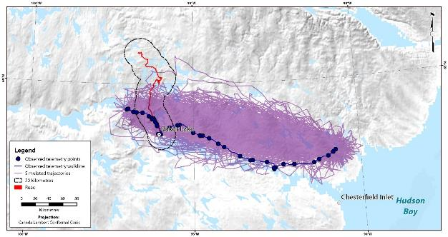
Figure 18. An example of a single caribou telemetry track (Animal ID BL2018003: 2018-2019) in comparison to the 500 simulated trajectories calculated by the biased-correlated random walk (BCRW) model. The blue path is the observed telemetry points and walklines, while the purple illustrates all simulated trajectories. The delay in crossing time is calculated by the time it takes for the observed points (blue path) to enter the 20km buffer and cross the road. The same comparison is conducted for all simulated trajectories and the crossing times compared between observed and simulated paths.

    - Spring Migration
The BCRW approach determined that 8 of the 15 caribou that crossed the road during the spring migration were ‘delayed crossers’, meaning that the observed crossing time was greater than the expected 97.5% quantile (Table 11 and Figure 19). For example, BL2018003: 2018-2019 was designated as a delayed crosser, spending 12 days within 20 kilometres of the road before crossing, in comparison to an expected time of 3 days. The mean number of crossing days for the caribou with delayed crossing times was 11 days (std. dev= 4, min=8, max=14 days, n=8), compared to a mean expected crossing time of 3 days. This means that on average these caribou had crossing times 8 days slower than would be expected if the road had no effect.
The group of caribou whose crossing times were not delayed had a mean crossing time of 4 days (std. dev= 4, min=1, max=8 days, n=7), which was similar to the expected value of 2 days. For all caribou in Table 4, the mean of the difference between observed and expected mean was 4.95 days (std. dev.=3.9, min=0, max=10).
Table 11. Observed and expected crossing times (in days) for spring migration. Slow crossers (97.5 quantile>) are indicated in bold. Crossing times that are significantly different from the mean are indicated with an asterix (*).
Collar ID | Observed | Expected Mean | Expected 97.5% Quantile | Z-score
BL0600415: 2018-19 | 6 | 3 | 7 | 1.81
BL0600415: 2019-20 | 8 | 2 | 7 | 3.35*
BL0640415: 2019-20 | 4 | 2 | 6 | 1.19
BL0730416: 2018-19 | 3 | 3 | 6 | 0.33
BL0750416: 2018-19 | 11 | 4 | 8 | 3.75*
BL201733: 2018-19 | 7 | 2 | 4 | 5.67*
BL2018002: 2018-19 | 8 | 3 | 9 | 2.17*
BL2018003: 2018-19 | 12 | 3 | 9 | 4.80*
BL2018011: 2018-19 | 12 | 2 | 5 | 8.08*
BL2018011: 2019-20 | 1 | 3 | 9 | -0.78
BL2018017: 2018-19 | 2 | 1 | 3 | 0.78
BL2018024: 2019-20 | 9 | 2 | 6 | 4.79*
BL2018054: 2019-20 | 14 | 2 | 6 | 6.50*
BL0600415: 2016-17 | 11 | 3 | 7 | 4.39*
BL0640415: 2016-17 | 3 | 2 | 5 | 1.00

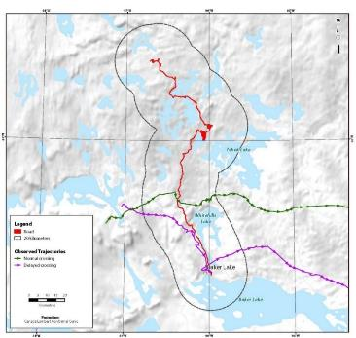
Figure 19. An example of a comparison between two observed trajectories for the spring migration period, one classified as a normal road crosser (Animal ID BL2018017: 2018-2019), and one as a delayed road crosser (Animal ID BL2018003: 2018-2019). The normal crosser has relatively consistent spacing between telemetry points and an uninterrupted migration path. This particular animal does not show significant change in movement speed as it nears the road location. The slow crosser, on the other hand, shows more disjointed path characteristics surrounding the road with many short and convoluted/meandering segments. These attributes show an overall slowing and interrupted path trajectory.

- Discussion

Composition Studies
Results of the Qamanirjuaq 2018 spring composition study suggest that the Qamanirjuaq Herd is in a continued decline. We have now logged 4 years of calf / cow proportions of less than 25, with a mean value of 16.8 over four years of study, which is well below the indexed break point of 25 calves / 100 cows. These findings along with continued shipments of Qamanirjuaq caribou meat to Baffin communities through internet sales is concerning in the wake of the current quantified declines for the herd. A full abundance survey of the Qamanirjuaq Herd should be considered within the next two to three years if this indexed trend continues. Additionally, monitoring efforts should be continued and where possible, increased so that prompt management action can be carried out should the herd begin to decline at a steeper rate.

Caribou Telemetry Studies
Though the focus of telemetry studies and analysis since 2018 have been centered around road interactions, a parallel reassessment of barren-ground seasonal ranges, though delayed, is ongoing and expected for release in February 2020. In Canada’s western Arctic, the distribution of annual calving and post-calving grounds covers a relatively small geographic area. The uncertainty created by knowledge gaps for many herds necessitates closure of areas that at times may be larger than necessary due to the imprecision of small data sets. The alternative is to risk disturbance that could negatively affect caribou productivity. Tolerance for disturbance by declining caribou populations are typically low due the generally poor condition of individuals making up a declining population. In such a situation, disturbance within critical habitats such as core calving and post calving grounds, can have their most negative effects in the form of depressed productivity and low calf survival. The results of the spatial analysis of telemetry data has and will continue to be used to identify core seasonal range such as calving grounds as well as such as key access corridors that identify critical habitat, based on a herd’s dependence on a specific geographic area over multiple seasons.
Caribou are particularly vulnerable to disturbance during their critical calving and post-calving aggregation periods in the late spring and early summer, though disturbance can impact caribou productivity during all seasons on the year. The mainland herds are particularly sensitive because they congregate in such large numbers on annual concentrated calving areas, post calving areas, and along migratory corridors. Currently most calving grounds are only lightly protected by “caribou protection measures” (CPM), which recommend, but do not enforce, area closures to development and exploration during calving. These measures, however, do not protect these sensitive habitats from development effects such as road construction, plant and surficial habitat modification, and aerial disturbance, when CPMs cannot be practiced due to weather and/or emergencies, movement barriers, and the long-term storage of onsite hazardous waste storage (tailings and tailings ponds etc). All these effects would impact caribou health and modify and/or impede caribou movement through these critical areas as well as represent a long-term hazard. Due to the number of calving grounds, post-calving grounds, and migratory corridors, these Federal caribou protection measures are ineffectively monitored by Federal and Territorial agencies, as evidenced by several reports by hunters, wildlife officers, and biologists alike of a lack of compliance with caribou protection recommendations. In addition, current calving ground delineations and seasonal range distributional shifts, suggest that CPM is data deficient and its scope inadequate to offer effective protection to caribou populations throughout sensitive times of the year in Nunavut (Nagy et al, 2011; Nagy and Campbell, 2012).
We are now in a period of intense exploration and development, and caribou are declining in numbers across Nunavut and the Northwest Territories. Jurisdictions sharing mainland barren-ground caribou subpopulations need to develop an economic base, but this development must be sustainable and balanced to the wellbeing of Indigenous People and the caribou on which they rely. Caribou have and will decline naturally, and at some point in this cycle there will not be sufficient caribou to meet the needs of subsistence hunters. This will lead to conflict between conservation goals, subsistence needs, and development/commercial interests
Identifying critical seasonal range extents will be complemented by the use of caribou monitoring data to strategically identify and define specific disturbance effects. Roads are believed to cause major impacts to caribou in some circumstances. The ongoing study of road effects on migratory barren-ground caribou has identified substantial impacts to caribou, many of which we are just now beginning to understand (Wilson et al. 2014). The GN will continue to analyse caribou telemetry data to help inform any issues that may be explained through the assessment of caribou spatial data.
  - Road Disturbance - General comments
The results of the road analysis demonstrate that movements relative to the Meadowbank mine and associated roads are dynamic with year and season-specific patterning. This complexity makes it difficult to generalize analyses across years, given that caribou are often interacting differently with the mine on an annual and seasonal basis. Of seasons considered, caribou displayed reasonably similar patterns during spring migration compared to late summer and fall. We note that estimates of ZOI from this study pertain to the Lorillard Herd.
The mechanisms that cause zone of influence can be dichotomized into direct and indirect effects. Direct effects would include immediate stressors around the road such as high traffic volume, aggregate size used in road construction, dust, increased snow thickness (snow fence effect), noise, and other factors that could cause caribou to reduce movements around the road vis visual and physical stimuli. This is the type of zone of influence assumed in most caribou studies. Indirect effects would be factors that are associated with the road such as hunter access, the road as a travel corridor to allow easier access of predators to caribou, and other disturbance factors that would not exist if the road were not present. We note that the zone of influence estimates in this study will include both direct and indirect effects.
The best way to tease apart direct and indirect effects would be the use of covariates such as traffic volume, broken down by haul truck traffic, hunter traffic including tracks of areas traveled off the road, hunter and predator kill locations, assessments of snow thickness and hardness along the road, and other physical and spatial data measured through time, where appropriate. These types of covariates were not available for the analysis in this report.
Both the ZOI and biased correlated random walk analysis suggest that the road and/or its effects delayed spring migration through the modification of caribou behaviour and movement patterns. The mean delay based on the change in caribou movements at the ZOI was 6.2 days (std=3.2, min=1.9, max=11.1, std=3.24) whereas the estimate from the bias correlated random walk was 4.95 days (std. dev.=3.9, min=0, max=10). The relative similarity in estimates is reassuring in this case, given different assumptions of the respective analyses. We note that it was not an objective of this analysis to infer demographic impacts of delays in migration. This type of analysis which would require the use of demographic modelling and is beyond the scope of the current analysis. We do believe, however, that the results of this analysis set the foundation for further study into demographic consequences to the observed behavioural modifications in this specific road analysis.
One assumption of the analyses is that caribou are exhibiting migratory behaviour which obligates them to cross the road. Using the data from the Lorillard herd helped meet this assumption given the East-West and West-East migration pattern relative to their calving grounds in most years. Other herds such as the Ahiak and Wager Bay have calving grounds at higher latitudes than the mine and therefore the migration paths of these herds may not always traverse through the mine area as they express a different trajectory than the Lorillard (Campbell et al. 2014). Directional migration behaviour was certainly evident for the spring migration as shown in date plot figures (Figures 8 and 9). Though the late summer and fall trajectories are less deterministic, in most cases, all the caribou had crossed the road by the end of the fall, which indicates that the road did restrict movement during various periods, of which the 2018 was the most significant. We do not believe that small lakes, rivers or streams represent an important barrier to caribou during the ice-free period given caribou’s well-known ability to swim across substantial waterbodies. Frozen lakes during spring migration are known to be used by caribou as travel corridors and migrating caribou are frequently seen travelling and resting on Lakes of any size. Though lakes and Rivers with ice cover not sufficient to support caribou can slow or at times divert migratory caribou, they are generally in these conditions for only a short period during late fall and are still not considered a complete barrier to movement, as observed by biologists and hunters alike. Lakes are present in this area, however lakes did not restrict access to the road in the southern area where milling occurred, suggesting they did not play a significant role in the delays.
A more obvious example depicting the ZOI can be seen in the paths of 2 collared caribou in September of 2018. The 2 caribou were near the road then travelled approximately 59 km from the road before turning back and crossing the road (Figure 15). The influence of habitat in the summer will be considered further using NDVI vegetation green up indices. It is possible that habitat factors may draw caribou to this area and increase milling behaviour, which might inflate zone of influence estimates, however, habitat cannot explain the abrupt edge in distribution at the road, or the larger-scale movements away from the road (Figure 14).
  - Zone of influence estimation
Zone of influence provides a standardized metric to consider the spatial impact of the road, across years and seasons. Unlike other metrics, it provides a statistical estimate of both spatial extent and magnitude of effect of roads or other stressors that can be compared temporally, and between studies (Boulanger et al 2011). Zone of influence can be used to better assess mitigation measures such as road closure (by estimating zones of influence when roads are closed versus not closed). It was also employed in this study to estimate delays in caribou timing for road crossings during spring migration. An estimated zone of influence could also be used to signal road closure times (when caribou are within the zone of influence during spring migration).
Our approach to this analysis has been to first develop graphical methods to show patterns in the data, followed by multivariate statistical modelling and analyses. The date trajectory plots (Figures 8, 9, 11, and 12) provided a way to show relative movement of caribou in the vicinity of the mine roads for the seasons considered in the analysis. Effects of the road are indicated by vertical trajectories near the road compared to distances further from the road. This graphical approach is then followed by analyses of ZOI impacts and spatial extent. Predictions of ZOI were then plotted with the raw point data to further allow readers to evaluate the relative fit and support of ZOI models.
An interesting finding of the ZOI analysis was the identification of a ZOI prior to crossing the road and one after crossing the road. A ZOI prior to crossing the road is easily explained by caribou displaying potential blocking or aversion responses, resulting from the road and therefore restricting movement. The zone in this context is defined as the area where caribou movements (as indicated by ∆D_{mine}) were influenced by the road.
Movement responses in relation to the road included lower movement rates toward the road, movements parallel to the road, and movements away from the road. The ZOI after crossing, which was smaller, was potentially due to gregarious behaviour as well as increased movement rates after crossing the road to compensate for delays in migration, especially during the spring migration period. Once caribou moved past the ZOI ∆D_{mine} values were equal or higher than prior to crossing, especially during the spring migration. The general finding of caribou increasing movement rates if delayed by crossing roads has been found in other studies (Wilson et al 2016).
One potential confounding factor with estimation of zone of influence after crossing is that daily fixes are only capturing a partial path of actual movements of caribou when they cross. If movement rates near the road are reduced prior to crossing then it is possible that the lower ∆D_{mine} value, which is measured daily may be assigned to a point once the road is crossed. The best way to assess finer scale movements would be to use collar data with finer scale fix rates (i.e. every 4 hours) to construct finer scale paths of caribou. The finer scale data sources are only available for a subset of recent collar data. It is likely that this effect would mainly pertain to zone of influence estimates after crossing, than zone of influence prior to crossing.
The regression analyses account for non-independence of repeated locations of caribou by using the generalized estimating equation approach to estimate parameter significance and confidence limits. However, analyses did assume independence between individuals, which may be partially violated by gregarious behaviour especially during spring migration. Inspection of movement trajectories (Figure 8) suggests that caribou migration occurred across a range of dates, as indicated by the spread of trajectories. Further randomization methods could be used to better explore the effect of this assumption of estimates. The most likely result of non-independence would be lower precision of estimates rather than bias in point estimates of zone of influence.
Given the variability of caribou movements relative to the mine footprint and roads, various metrics need to be considered to measure caribou response to the road. The results of the analysis suggest that change in daily distance from the mine ∆D_{mine} is a useful metric, especially when caribou interact directly with the mine road and are directly east or west of the mine road. This metric directly measures the interaction of the caribou with the mine road. If caribou are moving directly toward the mine road then values will be higher for a given path length then if the caribou are moving parallel, away, or milling near the road. In contrast, tortuosity, used in previous analyses, considers relative complexity of path and therefore, may show similar values if a caribou is moving toward or away from the mine road. Tortuosity is potentially a better metric when caribou are at further distances from the mine road given that it will be more sensitive to small-scale variation in path complexity.
Regardless, estimates of ZOI which were primarily based on caribou locations prior to crossing (36.3 km (CI=10.3-62.3) for fall migration 2012-2017) from previous analyses (Kite et al. 2017) were reasonably similar to estimates for the late-summer season in 2018 (59.7 km, CI=20.2-99.1). Future research will provide more exact guidelines for the use of tortuosity versus change in daily distance from mine.
  - Data gaps in analysis
A major data gap in this analysis is relative traffic volume, given that the impact of a road with high traffic volumes is likely to be very different than a road with minimal traffic. For example, the road was closed intermittently during spring migration which may have assisted in caribou crossing, though did not resolve the problem. In addition, traffic volume on the Whale Tail haul road is likely to be different in size and volume than the all- weather access road. In addition, the all-weather access road may also be used for hunting, which would create a different response than constant vehicle traffic. Further, the use of the road corridor by predators to access caribou that are delayed by either direct and/or indirect road-related effects can further complicate disturbance mechanisms and demographic impacts. Ideally, both traffic volume and road use information could be used to better assess the utility of the timing and duration of road closures to crossing behaviour. In the absence of traffic volume data, it would have to be assumed that traffic volume was constant throughout the entire time in which caribou were in the vicinity of the road (to allow assessment of road closure on caribou crossing).
The other limitation to the analysis was lower sample sizes of caribou over some years/seasons which reduced power and resolution to estimate ZOI and assess distribution of caribou relative to the road. A larger sample size of collars would improve resolution of ZOI estimates including more detail on seasonal and yearly variation in caribou response to the Meadowbank road. Inclusion of collar data from other herds will increase sample size but this increase will potentially be offset by additional complexity needed to model subpopulation (herd)-specific differences in migration patterns. The power to detect a ZOI will be influenced by collar sample size and the magnitude of the effect (how much does ∆D_{mine} change as caribou come closer to the mine in relation to areas further from the mine), as well as the statistical method employed to estimate ZOI. The analyses in this report used an analysis of covariance approach to estimate ZOI, where primary factors causing variation in ∆D_{mine} were included in the model, and ZOI terms were added individually to obtain the most parsimonious model to estimate the ZOI. Simulations could be used to further assess the power of models to detect zones of influence; however, this type of analysis is beyond the scope of the current report.
  - Consideration of all herds that encounter the Meadowbank mine and roads.
The estimate of overall ZOI depends on how well the collared caribou represent caribou that encounter the mine area in a given year and season. The current analysis used collar locations from the Lorillard caribou herd given that they exhibit the most consistent migration pattern through the mine area and have the most complete historic data set (Kite et al 2017), therefore allowing comparison of ZOI estimates between the current analysis and the analysis of Kite et al (2017). Dependent on the year and season, Ahiak and Wager Bay caribou may interact with the mine road during migration or other periods. Ongoing analysis suggests that the Wager Bay caribou herd has a more northerly migration path in the spring, with a higher likelihood of this herd passing north of the mine area and encountering the Whale Tail road. The Ahiak infrequently encounters the mine and road and also has a tendency to pass, or deflect, north of the mine. The Beverly herd rarely encounters the mine area given that their migration corridor is mainly to the north.
  - Additional Work
The analyses in this report detail the development of new metrics (∆D_{mine}), new methods to display migration data, as well as season and road-side specific zones of influence. The analysis has substantiated significant effects, either direct or indirect, of the road on caribou behaviour and associated movement patterns. This work will be further developed with the following future analyses which will allow more precise estimates of ZOI and testing of potential impacts of mine and roads on caribou distribution and movement.
- Collars from other herds will also be considered in future analyses, however, herd-specific migration patterns would need to be considered further and accounted for in the analysis given the different locations of calving grounds of each herd and likely differences in migration patterns relative to the mine. Part of this analysis will also consider the likelihood of each herd occurring near the road in each season and year (where collar sample permit) therefore allowing a ZOI estimate that considers the relative abundance as well as the number of collared caribou interacting with the mine in each herd. This analysis is currently in progress. In general, estimates of ZOI with all herds have been relatively similar to the Lorillard only analysis in this paper. However, analyses are still considering herd-specific trajectories and deflection behaviour to the north around the road.
- The earlier data sets (prior to 2016) detailed in Kite et al (2017) will be further assessed using the ∆D_{mine} metric in comparison to the tortuosity. Guidelines will be given on the best metric for specific situations such as relative distance of the caribou from the Meadowbank Mine roads.
- Specific zones of influence for the AWAR and Whale Tail haul road could be considered for situations when caribou were in the immediate vicinity of either road. However, if caribou traverse both road types it may be difficult to separate different road effects due to correlation of distance from each road. Ideally, this analysis would be conducted in unison with traffic volume and road closure data. A complete set of traffic volume data was not available for this analysis. Further discussion on relative traffic volume by date range (i.e. high, moderate, or low) may suffice if exact traffic volume data remains unavailable. If relative traffic volume can be formulated, a more direct approach would be to estimate ZOI’s as a function of traffic volumes rather than for the AWAR and Whale tail road separately given that the main distinction between the two roads is likely the relative traffic volume. Future analyses will also produce metrics on the proportion of locations nearest to each road to provide a relative index of the magnitude of effect, expressed for each of the two road types, and their respective effects on caribou movement (if a ZOI is detected).
- It is possible to estimate additional distances walked when caribou were delayed in road crossing from the ZOI analysis (Figure 11. This type of analyses would mainly pertain to the spring migration season when trajectories relative to the road were more deterministic.
- Further consideration of habitat effects in the late-summer will be considered including the use of RSF (Resource Selection Function) methods to model ZOI and the use of NDVI metrics to assess seasonality of forage as discussed further in Appendix 2.

- Appendices
  - Appendix 1: Ecological Land Classification habitat classes
Table 12 and Figure 19 below shows the pooling of ELC groups (Campbell et al. 2012) used in regression analyses as also discussed in Kite et al (2017).

Table 12. Ecological Land Classification (ELC) groups used in the analysis. The grouping of the two covariates used in the analysis are given by numbered groupings.
ELC Group | Group | ELC_ModeF | ELC_ModeP
Water | Abiotic | 1 | 1
Wet Graminoide | Biotic | 2 | 2
Graminoide Tundra | Biotic | 2 | 2
Graminoide/Heath Tundra | Biotic | 2 | 2
Graminoide/Shrub Tundra | Biotic | 3 | 3
Shrub Thicket | Biotic | 3 | 3
Shrub Tundra | Biotic | 3 | 3
Shrub/Heath Tundra | Biotic | 4 | 3
Forbe (Dryas) Tundra | Biotic | 4 | 3
Heath Tundra | Biotic | 4 | 3
Heath Upland | Biotic | 4 | 3
Heath Upland/Rock Complex | Biotic | 5 | 4
Lichen Tundra | Biotic | 5 | 4
Lichen/Rock Complex | Biotic | 5 | 4
Sand | Abiotic | 6 | 4
Boulder/Gravel | Abiotic | 6 | 4
Rock | Abiotic | 6 | 4

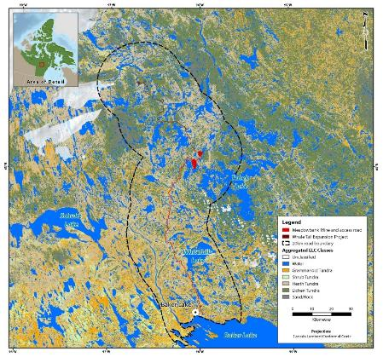
Figure 20. Map of Ecological Land Classification (ELC) habitat classes used in the analysis (Campbell et al. 2012).

  - Appendix 2 Further investigation of movements in the late summer of 2018
The larger zone of influence estimate (59 km) for the late summer of 2018 was potentially due to a variety of factors such as direct effects (road traffic), indirect effects (hunter or other assess of individuals via the road). Of additional interest was the role of lakes and habitat in caribou movements and subsequent ZOI estimates.
In review, collared caribou moved north of Baker Lake up to Whitehills Lake where they remained west of the road for approximately one month in the late summer of 2018 (Figures 6 and 13-15). The collars exhibited complex movement patterns near the road after which 8 crossed the road in the late summer period. Three of the caribou then crossed the road in early fall, 3 crossed during the rut, and one never crossed the road. Closeup views of the paths reveal that they traversed around Whitehills lake and between Whitehills Lake and the road but only crossed in defined areas near the lake (Figure 20).
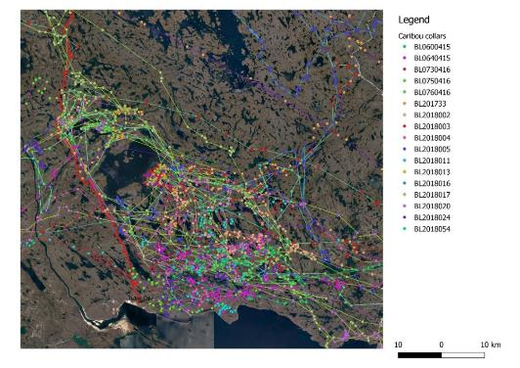
Figure 21. Collar locations in the late summer and fall of 2018 near the Meadowbank road north of Baker Lake
One question of interest is whether lakes influence daily distance from mine (∆D_{mine}) especially during the late summer of 2018. Distance from road and distance from lakes were minimally correlated (Pearson correlation=0.14, CI=0.08-0.21), however, this did not necessarily mean that lakes did not affect ∆D_{mine} at a certain threshold distance from lakes if caribou movements were disrupted by lakes.
To investigate this further distance from the nearest lake was entered as a term in the segmented regression model introduced in the main report (Table 8). In this case, the segmented regression model estimated whether there was a threshold distance around lakes where ∆D_{mine} was affected which would potentially confound ZOI estimates based on distance from road. Model selection results (Table 13) suggested minimal support for the effect of distance from lakes when modelled on the log scale (models 8 and 9 which models a diminishing effect of lakes at longer distance) or as a segmented regression terms for late summer (model 4) or fall and late summer (model 6). A model that included the most supported ZOI road terms and summer distance from lake terms (model 5) was also not supported. These results suggest minimal confounding in ZOI based on movement from lakes. Animation of the collar data (Fall_2018_animated.mp4) which was supplied with this report suggests that daily caribou movement in general occurred at a larger scale than the size of lakes which may explain this result.
Table 13. Model selection for summer-fall 2018 regression analysis of daily change in distance from mine road. Akaike Information Criteria (AIC_{c}), the difference in AIC_{c} values between the ith and most supported model 1 (ΔAIC_{c}), Akaike weights (w_{i}), and number of parameters (K), and log-likelihood (LL) are presented. ZOI terms are abbreviates as prior to crossing (NC) which would be the east side of the road and crossing (C) which would be the west side of the road and Lake is the distance from nearest lake. See Table 8 for additional model selection results.
No | Base parameters | ZOI/segmented terms | AIC_{c} | ∆AIC_{c} | w_{i} | K | LL
1 | Season | NC_{summer}+C | 7414.29 | 0.00 | 0.97 | 4 | -3692.1
2 | Season | C+NC | 7421.52 | 7.23 | 0.03 | 5 | -3695.8
3 | Season |  | 7428.82 | 14.53 | 0.00 | 2 | -3710.3
4 | Season | Lake(summer) | 7429.99 | 15.69 | 0.00 | 3 | -3706.7
5 | Season | NC_{summer}+C+Lake(summer) | 7435.45 | 21.16 | 0.00 | 5 | -3690.7
6 | Season | Lake(summer)+Lake(fall) | 7438.66 | 24.37 | 0.00 | 4 | -3704.3
7 | Season+Log(Road) |  | 7431.38 | 17.09 | 0.00 | 3 | -3711.6
8 | Season X Log(Lake) |  | 7431.96 | 17.67 | 0.00 | 4 | -3710.0
9 | Season +Log(Lake) |  | 7434.32 | 20.03 | 0.00 | 3 | -3713.1
10 | ELC_ModeP |  | 7437.43 | 23.14 | 0.00 | 3 | -3712.7
11 | SeasonFall:ELC_ModeP |  | 7445.90 | 31.60 | 0.00 | 6 | -3707.9
12 | ELC_modeF |  | 7452.96 | 38.67 | 0.00 | 6 | -3711.5

There was minimal support for habitat models including interaction models between season and ELC habitat class (Table 13: models 10-12), however the ELC class used does not account for seasonal green up of vegetation. NDVI indices (Goward et al. 1985, Laidler et al. 2008) to index vegetation green up were recently compiled (Figure 21) and will be considered in future analyses. It can be seen that areas of potential higher habitat value were present in the areas between Baker and Whitehills Lake but also extended across the road to the west and to the north. Therefore, the observed break in collar distribution relative to the road cannot be directly ascribed to habitat.
We note that the regression analysis considers only used points and therefore is not a proper RSF analysis (which would compare used vs random locations with selection rather than ∆D_{mine} being the response variable). A full RSF analysis is being considered to further explore whether habitat influenced the higher levels of aggregation and the subsequent effect on zone of influence. This type of analysis could also be used to provide an alternative estimate of zone of influence for the late summer season based on habitat selection as opposed to caribou movement relative to the mine roads.
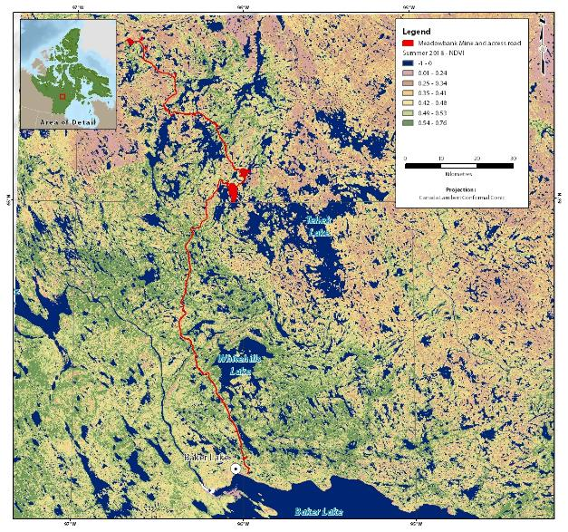
Figure 22. NDVI vegetation indices for the Meadowbank road area for the late summer of 2018.

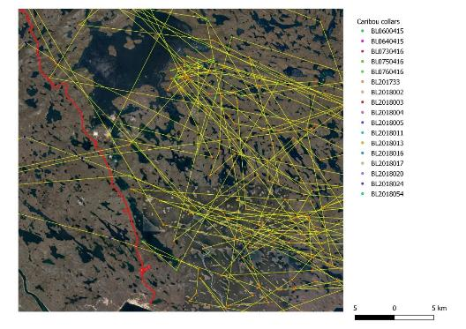
Figure 23. Close up of collar paths (in yellow) from daily locations relative to the Meadowbank AWAR in the fall of 2018 showing land areas between lakes that were crossed during the summer and fall period.

REPORT BY PARTICIPANTS
Leo Ikakhik
My name is Leo Ikakhik, and I took part in the collaring of caribou cows in the spring of 2018/2019. I was selected by the Arviat HTO to take part in this research and to report back to them and the GN Biologist Mitch Campbell. I flew with the helicopter crew and monitored the capture of caribou so I could make sure they were following the rules agreed upon with the Arviat HTO and the GN Biologist Mitch Campbell. On the first day we captured and collared 6 caribou without problems then we had 3 deaths (snapped necks) in a row. I suggested to the capture crew that we stop collaring and report back to Mitch Campbell in Arviat and discuss what we should do next. The capture crew followed my direction and headed back to Arviat. Before speaking with Mitch we collected all the meat from the three dead caribou and when we got back to Arviat I distributed all the meat to needy families based on the HTOs direction. The families were very grateful for the meat as they didn’t have any equipment to go harvest caribou themselves. After speaking with Mitch, we determined that a thaw/freeze happened prior to the collaring which made a thick layer of Ice on top of the snow which may have been the cause of the deaths as the caribou hooves were breaking through and the caribou were tripping. As the forecast was for warmer (above zero) temperatures it was decided to not collar today and start collaring tomorrow when the ice layer will have softened overnight.
We continued collaring the next day and collaring went extremely well with no deaths or injuries. We finished the collaring late that night. I found the capture crew to be very good and respectful of the animals. They also always checked with me all the time to make sure they were following the rules. It was really good to see the country side and all the caribou. The caribou looked healthy and it is good that I am a part of this research as I am concerned about our herds and this information helps me and the HTO to speak with the people about how our herds are doing and how we might be able to help keep our herds healthy and abundant. I would like to be involved the next time caribou are being collared in our Region. I would like to thank everyone involved with this program and for involving me, and for help in putting this report together. If you wold like to speak with me further about my experience with the collaring program, or about my report, you can contact me at my home number (867)857-2631.

REPORT TO COMMUNITIES / RESOURCE USERS

In late January/early February of both 2018 and 2019, the Kivalliq Regional Wildlife Biologist, Technician, and Regional Operations Manager, and a representative from Nunavut Tungavik, met with the communities of Arviat, Baker Lake, Chesterfield Inlet, Coral Harbour, Naujaat, Rankin Inlet, and Whale Cove, to present all research findings and proposed research. During these meetings survey results, composition results, and annual caribou movements were presented and discussed. Additionally, results on the impacts of roads on caribou behaviour and companion animations of caribou movements and behavioural changes along a road corridor, were presented and discussed in detail. General consensus amongst Kivalliq communities is that these impacts on barren ground caribou are extremely concerning and need immediate attention. Additionally HTOs indicated the immediate need to continue this type of analysis and to keep all community-based HTOs informed of study results as soon as they are available.
The GN DOE Kivalliq Wildlife Biologist, Technician, and Regional Manager, and a representative from Nunavut Tungavik plan to meet again with all Kivalliq community HTOs in Jan/Feb. 2020, to discuss all new research results and proposals.

10.0 Literature cited
Agnico_Eagle. 2019. Appendix 45: Meadowbank and Whale Tail 2018 Wildlife Monitoring Summary Report. Meadowbank Gold Project - 2018 Annual Report. Accessed: July 10,2019 < http://www.nirb.ca/application?strP=r>
Barton, K. A., B. L. Phillips, J. M. Morales, and J. M. Travis. 2009. The evolution of an ‘intelligent’ dispersal strategy biased, correlated random walks in patchy landscapes. Oikos:309—319.
Boulanger, J., K. G. Poole, A. Gunn, and J. Wierzchowski. 2012. Estimating the zone of influence of industrial developments on wildlife: A migratory caribou and diamond mine case study. Wildlife Biology 18:164-179.
Burnham, K. P., and D. R. Anderson. 1998. Model selection and inference: A practical information theoretic approach. Springer, New York, New York, USA.
Calenge, C. 2015. Home range estimation in R: the adehabitatHR package. Version 0.4.1.4.
Campbell, M., J. Shaw, and C. A. Blyth. 2012. Kivalliq Ecological Land Classification Map Atlas: A Wildlife Perspective. Government of Nunavut, Department of Environment. Technical Report Series#1-2012. 274 pp.
Campbell, M. W., A. Kelly, B. Croft, J. G. Shaw, and C. A. Blyth. 2014. Barren-ground Caribou in Nunavut and Northwest Territories – Map Atlas. Government of Nunavut, Department of Environment. Government of Northwest Territories, Department of Environment and Natural Resources. Technical Report in preparation.
Ficetola, G. F., and M. Denoel. 2009. Ecological thresholds: an assesment of methods to identify abrupt changes in species-habitat relationships. Ecography 32:1075-1084.
Fiesta-Bianchet, M., J. C. Ray, S. Boutin, S. D. Cote, and A. Gunn. 2011. Conservation of caribou (Rangifer tarandus) in Canada: an uncertain future. Canadian Jounal of Zoology 89:419-434.
Gebauer, M. B., C. Lee, J. Boulanger, and J. Shaw. 2008. Meadowbank Gold Mine Project: 2008 Wildlife Monitoring Summary Report, Gebauer and Associates Environmental Consultants.
Goward, S. N., C. J. Tucker, and D. G. Dye. 1985. North American vegetation patterns observed with the NOAA-7 advanced very high resolution radiometer. Vegetatio 64:3-14.
Johnson, C. J., and D. E. Russell. 2014. Long-term distribution responses of a migratory caribou herd to humandisturbance. Biological Conservation 177:52-63.
Kite, R., J. Boulanger, M. Campbell, G. Harvey, J. Shaw, and D. Lee. 2017. Seasonal caribou distributions and movement patterns in relation to a road in the Kivalliq region of Nunavut.
Koper, N., and M. Manseau. 2009. Generalized estimating equations and generalized linear mixed-effects models for modelling resource selection. Journal of Applied Ecology 46:590-599.
Laidler, G., P. Treitz, and D. Atkinson. 2008. Remote sensing of arctic vegetation: relations between the NDVI, spatial resolution and vegetation cover on Boothia Peninsula, Nunavut. Arctic 1.
Mazerolle, M. J. 2016. AICcmodavg: Model selection and multimodel inference based on (Q)AIC(c). . R package version 2.1-0.: https://cran.r-project.org/package=AICcmodavg.
Muggeo, V. M. R. 2003. Estimating regression models with unknown break-points. Statistics in Medicine 22:3055-3071.
_____. 2008. segmented: An R package to fit regression models with broken line relationships. R News 8:20-25.
_____. 2016. Testing with a nuisance parameter present only under the alternative: a score-based approach with application to segmented modelling. J of Statistical Computation and Simulation DOI: 10.1080/00949655.2016.1149855.
R_Development_Core_Team. 2009. R Foundation for Statistical Computing, Vienna, Austria.
Wickham, H. 2009. ggplot2: Elegant graphics for data analysis. Springer, New York.
Wilson, R. R., L. S. Parrett, K. Joly, and J. R. Dau. 2016. Effects of roads on individual caribou movements during migration. Biological Conservation, 195:2-8.
Yan, J. 2002. Geepack: Yet another package for Generalized Estimation Equations. R News 2/3:12-14.

All movement metrics were calculated using the adehabitatLT package in R Calenge, C. 2015. Home range estimation in R: the adehabitatHR package. Version 0.4.1.4.
Empirical distributions (a sample of observations whose value at a given point is equal to the proportion of observations from the sample that are less than or equal to that point) were defined from all steps that fell outside the 20 kilometre zone of influence for a given migration season. The length of each simulated step was generated by randomly sampling a distance from the step length distribution and the absolute angle (i.e. movement direction) from a wrapped cauchy distribution A wrapped cauchy distribution is used to model circular data. The directionality coefficient used to define the cauchy distribution was derived from the empirical absolute angle distribution and held constant along the simulated trajectory. However, the mean direction used to define the distribution varied from step to step, as the mean direction was determined based on the location of the previously simulated step relative to the migration end point.

