Nunavut Wildlife Management Board
Final Project Reports

NWRT Project Number : #2-18-10

Project Title:

Dolphin and Union caribou (Rangifer tarandus groenlandicus x pearyi) 2018 collaring

Project Leader:
Lisa-Marie Leclerc
Kitikmeot Regional Biologist
PO Box 377
Kugluktuk, NU X0B 0E0
Phone: 867-982-7444
Email: LLeclerc@gov.nu.ca

Summary:

Dolphin and Union Caribou (Rangifer tarandus groenlandicus x pearyi) has a vast distribution encompassing Victoria Island and the north coast of the Canadian mainland. This paler and smaller caribou, similar to Peary Caribou in appearance, are genetically distinct from other barren-ground caribou (Rangifer tarandus groenlandicus) in addition to showing unique behaviors. The main objective of this study is to deploy collars on the Dolphin and Union caribou herd to delineate movements of this subpopulation of socioeconomic and conservation importance. Between April 15 - 24th, 2018, a total of 50 Lotek Globalstar Lifecycle GPS collars were deployed on 47 females and 3 males on the wintering grounds of Dolphin and Union Caribou.

A total of 35 collars were deployed on the west side of Bathurst Inlet and the remaining 15 collars were deployed on the east side of Bathurst Inlet, more precisely on the Kent Peninsula. During the collaring, samples were taken such as blood, feces, and hair samples. Additionally, photos were taken of the side of the body, teeth, antlers, and eyes of capture animals to compare phenotypic differences and obtain an approximate age of the animals. Potential mortalities were observed a few days post-collaring. Among these mortalities, six collared caribou were harvested from the east side of Bathurst Inlet from hunters from Cambridge Bay, and the collars were returned to the Department of Environment (DOE) research section. Another five collared animals died on from natural mortality; such as predation or undetermined causes.

Data from these collars is anticipated to continue being transmitted for three years. Pre-programming of data transmission coincided with three-years battery lifespan, with the collar release mechanism to be activated in fall 2021.

1.0 Purpose and Objectives
1.1 Rationale
Dolphin and Union caribou (Rangifer tarandus groenlandicus x pearyi) are of great importance for Inuit subsistence and cultural needs for the communities of Kugluktuk, Cambridge Bay, Bay Chimo and Bathurst Inlet. A partial herd estimate and an extrapolated total herd estimate were undertaken in 1997 and 2007. During the 2007 survey, the Dolphin and Union Caribou herd was estimated to be 27,787 ± 7,537 (95% Cl, 20,250 - 35,324). The latest survey was realized in fall 2015 and the population estimate was 18,413 ± 6,795 (95% C, 11,664 - 25182).

Numerous reported anthropogenic and environmental factors are having a negative impact on the population of Dolphin and Union. Potential increases in the number of wolf and grizzly bear reported by community members of Kugluktuk and Cambridge Bay (HTO pers. comm 2015), increasingly late sea-ice formation (Pool et al. 2010), and the increased presence of mining development on the winter range may all have some degree of impact on this caribou herd. The multiplicity of threats which may be facing the Dolphin and Union herd, combined with their declining numbers, call for better monitoring, and additional research on the implications these threats may have on the long-term conservation or the recovery of this subpopulation.

In 2004, due to the minimal information on the population size in relation to increased harvesting of this herd, the Dolphin and Union Caribou was assessed by the Committee on the Status of Endangered Wildlife (COSEWIC) in Canada and listed under Schedule 1, Part 4 of the Species at Risk Act in Canada (COSEWIC 2004; Miller 1990b; Gunn et al. 2000; Harding 2004). In 2011, Dolphin and Union caribou were listed as a species of “Special Concern” by the Canadian Wildlife Service under the Species at Risk Act (SARA). COSEWIC re-assessed this herd as Endangered in 2017. This study aims to provide the needed information to better understand habitat selection, spatial requirements during sea-ice crossing, calving, and movement patterns in order to provide information critical to the management and conservation of this herd.

1.2 Objectives
The main goal of this study is to monitor and track movements of the Dolphin and Union herd for the purposes of generating information for management and facilitate population abundance surveys. Mostly, the decline in number of Dolphin and Union caribou measured triggered the need for a new population survey which required collars to monitor the caribou locations and movement during the survey, which took place in Fall 2018. In addition, health, parasite, and stress conditions will be assessed through blood, hair and fecal samples collected. Later analysis could be used to to study change in distribution, habitat selection, and seasonal ranges.

1.3 Application of the Anticipated Results
Collar locations will be used in a management context to inform population estimate surveys and also used in land use planning processes, and to provide to industry stakeholders. If needed, management recommendations will be established in close collaboration with co-management partners. Future decisions for the management of the herd will be based equally on new scientific information generated by this study, with local knowledge, and Inuit Traditional Knowledge.

In addition to management implications, new information generated by the collar data generated will bring new insights on changes in movement patterns, changes in migration routes, and possible shifts in distribution. Furthermore, with the current mine (TMAC and Sabina) and increase in mining exploration in the Dolphin and Union winter range, monitoring how the population responds to an increase in anthropogenic pressure and habitat fragmentation is essential.

3.0 Materials and Methods
3.1 Study Area, spring 2018
This study took place in two key locations where the Dolphin and Union are known to be present in spring; on the north mainland coast on each side of Bathurst Inlet. During winter, Dolphin and Union caribou are found on the tundra of the mainland around east and west sides of Bathurst Inlet. As the spring approaches, near the end of March to May, the caribou move to the coast of the mainland and caribou are seen starting to cross back to Victoria Island (Thorpe et al. 2001; Bates, 2006). At this time, they are found near the coastlines, from Tree River to Hope Bay. Collaring will be done in mid-April at these locations to maximize the opportunity to access the herd before they reach and disperse onto Victoria Island.

3.2 Project Design
In mid-April, between the east side of Bathurst Inlet to Hope Bay and including the Kent Peninsula, 50 Dolphin and Union Caribou (47 females and 3 males) were collared with Lotek GPS Globalstar Lifecycle satellite collars following the capture methods involving tangle net and helicopter net gunning team (TAEM, 1996). Caribou captures were performed by an experienced capture crew. Once the caribou was immobilized, hair samples from two different body locations (shoulder and hip), feces, blood samples and photographs were taken and a body condition score was given according to CARMA’s protocol level 2 for live animals (CARMA, 2008). The time between the beginning of the pursuit to the animal being released was kept under 10 minutes, this was done in order to keep stress levels to a minimum and thereby to increase the survival rate of animal post-collar.

4.0 Project Schedule
HTO and community consultation occurred in January 2018, prior to the start of the program. Collaring started in mid-April and was completed within 10 days. Table 1 summarizes the steps of the project, as well as what has already been completed.

Table 1: Project schedule for the Dolphin and Union 2018 collaring. The light grey rows refer to the completed steps in 2018 and the darker rows what will be completed in 2018-19.
Project | Starting Date | End Date
Community consultation and HTOs (Kugluktuk and Cambridge Bay) | January, 2018 | February, 2018
Public consultation with the community of Cambridge Bay | February, 2018
Collaring of Dolphin and Union caribou | April 15, 2018 | April 24, 2018
Population surveys, aerial surveys | October 20, 2018 | November 4, 2018
Data analysis- population surveys | November, 2018 | March, 2019
Final reporting | April, 2019 | September, 2019

5.0 Preliminary Results
5.1 Body Condition, Age and Physical Dimorphism
Body condition was assed according to CARMA’s Rangifer Health & Body Condition Monitoring Protocol Level II, section 3. Palpation of animals was undertaken during collaring of captured caribou as a health index. Shoulders, ribs, hips and spine were felt using bare hands to determine the general fat coverage and then scored on scale of 1 through 12, with one being considered very bony with grooves between ribs and no back fat present, while 12 being very broad in the shoulder, ribs nearly flush with tissue between them and hips well padded. Figure 1 shows the body condition index for the 50 captured caribou.

The body index condition inclines towards healthy caribou, as these types of animals were targeted for collaring. Healthy animals will have a better chance to resist disease, harsh winter conditions, and predation and stay alive for the entire duration of the collar life. Thus, 52% of the caribou had a health index of 12, with very few caribou had a lower index of 8 (Figure 1).

Figure 1: Average body score condition displayed as a frequency of occurrence (%) of the 50 captured caribou. The Health index score scale goes from 3 to 12, where lower numbers represent unhealthy caribou and higher numbers represent healthy caribou.
5.2 Samples Collected
During fieldwork, samples were taken for future analyses as part of an ongoing biological sampling program (which is mainly composed of harvest sampling). For each collared animal, blood, hair, and feces samples were collected. All the samples collected were kept frozen until they will be sent to specific laboratories, genetic analysis and to determine the percentage of pregnant females.

Picture of the full body, antler, eye, and incisor teeth were taken for each caribou collared. These photos will be able to provide some insight into the approximate age of each animal. Cervid herpesvirus has been found to lead to an outbreak of keratoconjunctivitis (das Neves et al., 2010), and this was monitored in the field. There were not noticeable and superficial injuries noticed while collaring, but two mortality events occurred.

5.3 Telemetry Studies
Collar activation followed shortly after battery replacement on April 8th, 2018. In addition, collars were tested for satellite connection for a duration of a week to ensure activation had occurred prior to collaring. The collars were deployed when outside temperatures were above -25C to mitigate against frozen lung tissue, which is known to cause an increased risk of mortality. The collaring generally took place in late morning at warmer temperatures. Target locations for caribou capture were based on past information on winter distribution from the 2015 and 2016 collars, currently deployed collar locations, local observations, and Inuit Qaujimajatuqangit. From Kugluktuk, the collar deployment began on April 15th, and after being re-located on April 21st, from Cambridge Bay on April 22th (Figure 2).

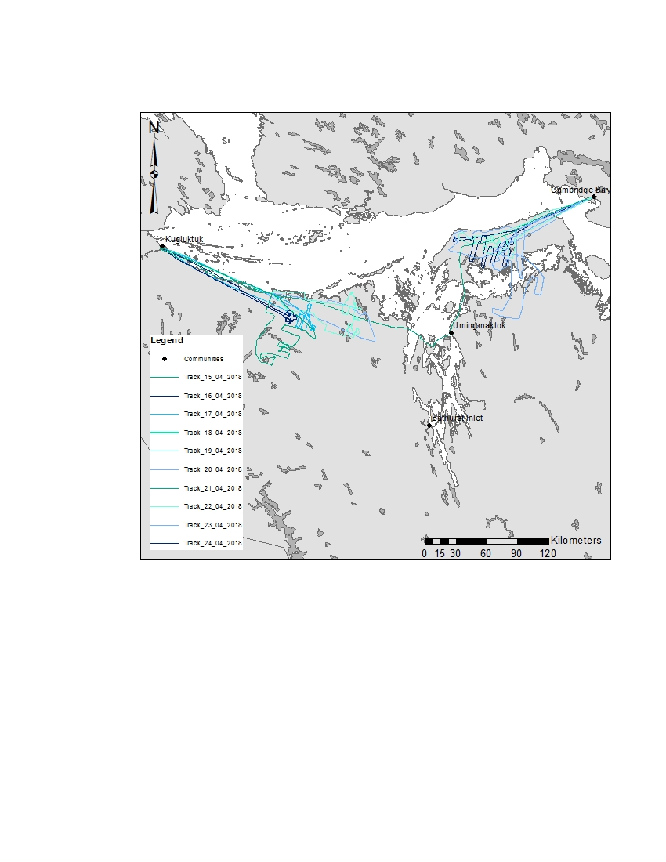
Turnagain Point
Port Epworth
Figure 2: Non-systematic transect line cover in search for Dolphin and Union caribou during collar deployment between April 15th-24th, 2018.

On April 15, we decided to go inland south of Port Epworth in search of herds of caribou. Five groups of caribou were seen and one collar per group was deployed. On the way back, we found an aggregation of caribou and recorded this location to return to the next day. On April 16, 10 collars were deployed around this same area. Many small groups of caribou were aggregating in close proximity to each other. Following the extent of this distribution of caribou, we travelled west on April 17, and deployed an additional nice collars. From those successful collar locations, nothing was seen father north, closer to the coastline. On April 18, we left Kugluktuk in the afternoon, but weather conditions were too poor to collar. The next day, looking for more caribou west of Tree River, we decided to continue our search in the direction of Wentzel River. We saw only one group of caribou and a collar was deployed. The next large aggregation was around Wentzel Lake. On April 19 and the following day, 6 and 5 collars were deployed respectively at this location. No caribou were seen close to the shore line during our non-systematic search on the west side.

In aiming to deploy 15 collars on the east side of Bathurst Inlet, we re-located the helicopter to Cambridge Bay on April 21. As we get into late April, we decided to focus on starting to deploy the collar on the Kent Peninsula, as the caribou migration might have by then been well underway. On April 22, we were able to collar seven caribou on the Kent Peninsula south-east of Turnagain Point as nothing was seen east, while ferrying. In April 23, we conducted an extensive search aiming to collar caribou south on the Kent Peninsula, around halfway cabin, and Kuururjuaq Point. We collared 3, before searching on the mainland in a location that was known to have caribou in the previous years (2016). However, no caribou were seen on the mainland. In the evening flight, we flew close by the north shore of the Kent Peninsula and collared two additional caribou. Having 4 collars left to deploy on April 24, we had to search within the previous search area in a more systematic way, to try to find new group of caribou. When groups were encountered, we flew over to ensure no caribou in the group were already collared. If one caribou within the group was collared, the group was immediately left alone and the search continued. During the collaring, no caribou were seen on the east side of the Kent Peninsula. Figure 3 shows the specific location of where the collared caribou were collared.

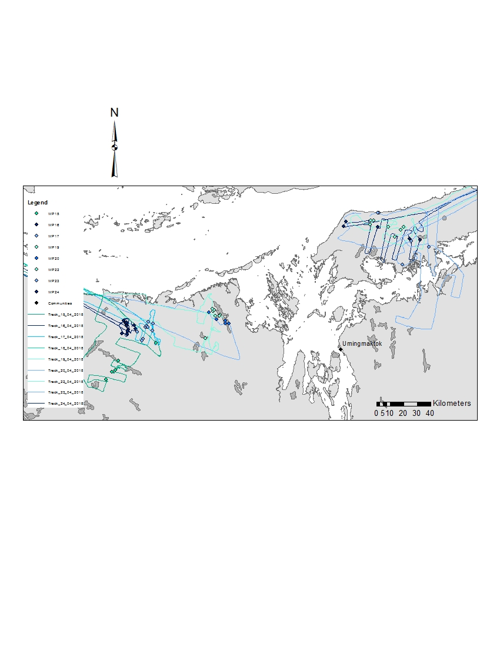
Wentzel River
Port Epworth
Kuururjuaq Point
Turnagain Point
Figure 3: Map of Bathurst Inlet representing the 50 collar locations made between April 15th to 24th, 2018 on the west side of the Inlet and on Kent Peninsula.
A number of mortality events occurred during collaring and in the weeks following the collaring program (Table 2). At the Kent Peninsula (68.58562N, -107,23687W), we spotted an old collar on a caribou, and we decided to re-capture the animal to remove the collar as the drop off mechanism failed to open. As we were removing the net from the animal, this female had a heart attack. We tried to re-animate it, but died. We collected the old collar (DU-16-2015) and sampled the animal (DU-192-2018). The second mortality also occurred on Kent Peninsula (68.52082N, -106.89381W), as the caribou were running during capture and broke their front legs. In this instance, we had to do a mercy kill and sampled the animal (DU-193-2018). For both cases, the caribou were butchered on-site and the meat conserved for consumption, and provided to the Cambridge Bay food distribution bank. The Cambridge Bay HTO was notified.
After the fieldwork, six collared caribou were harvested and the collars were brought back to the Wildlife office, and five natural mortality events were recorded. DU-153-2018 collar stopped transmitting soon after collaring. One collar stopped transmitting soon after deployment, which might indicate a malfunction of the collar, or a post-collar mortality due to stress. To determine the cause of natural mortality, a site examination must be performed, which the logistic cost and timeline prohibit it. Six months after collaring (September 2018), there are currently 38 collars still transmitting.

Table 2 Summary of mortality events from April to September 2018.
Collar ID | Mortality Date | Mortality Type
DU-144-2018 | May 03 2018 | Harvested
DU-146-2018 | May 10 2018 | Harvested
DU-149-2018 | May 10 2018 | Harvested
DU-153-2018 | April 21, 2018 | Post-collar, Malfunction
DU-156-2018 | May 12 2018 | Natural
DU-163-2018 | May 27 2018 | Natural
DU-167-2018 | May 2 2018 | Harvested
DU-175-2018 | May 22 2018 | Natural
DU-178-2018 | June 1 2018 | Natural
DU-179-2018 | June 4 2018 | Natural
DU-185-2018 | May 29 2018 | Harvested
DU-186-2018 | May 29 2018 | Harvested

Thus, a total of 50 collars were successfully collared, three males and 47 females (Figure 3). In 2015, height collars were unintentionally deployed on barren-ground caribou, most likely Beverly or Ahiak that were mixed amongst Dolphin Union on the east side of Bathurst Inlet. These animals were phenotypically different than Dolphin Union with darker hides, faces and legs and were found to not cross on Victoria Island, and calve at on the Queen Maud Gulf Sanctuary in June. Genetic analysis later confirmed that these darker animals were Barren-Ground caribou. Since gross physical characteristics can be used to identify Dolphin and Union from Barren-Ground caribou, in 2018 no Barren-Ground caribou were collared. Preliminary results show that all the collars on the Kent Peninsula successfully crossed back to Victoria Island (Figure 4).
Four maps will be generated during the next year. These maps will include three months of data received from the 2018 collars deployed. These maps will be used to provide co-management partners with a general understanding of where the caribou are located during different timeframes. The first map, April to June, showed that all the collars move back to Victoria Island to calve. No collared caribou migrated to the eastern side of Victoria Island and they appeared to be mainly aggregated in the southern central and western part of Victoria Island. Contrary to the observed 2015/2016 caribou locations in June, no females reached the Northwest part of Victoria Island, they stay in more southern locations.
Figure 4 : Map representing the movement of the 50 collar locations between April 15th to June 30th, 2018.

7.0 References

Bates, P. 2006. Knowing caribou: Inuit, ecological science and traditional ecological knowledge in the Canadian North. Ph.D. dissertation, Aberdeen University, Aberdeen, Scotland. 270 pp.

Campbell, M, D. Lee, J. Boulanger, A. Kelly, M. Dumond and J. McPherson. 2013. Calving ground abundance estimates of the Beverly and Ahiak subpopulations of Barren-Ground Caribou (Rangifer tarandus groenlandicus)- June 2013. Government of Nunavut, Dept of Env, Tech Rep Ser No: 01-2013.

CARMA. 2008. Rangifer Health and Body Condition Monitoring: Monitoring Protocols Level 2. CircumArctic Rangifer Monitoring and Assessment Network. 54 p.

COSEWIC. 2004. COSEWIC assessment and update status report on the Peary caribou Rangifer tarandus pearyi and the barren-ground caribou Rangifer tarandus groenlandicus (Dolphin and Union population) in Canada. Committee on the Status of Endangered Wildlife in Canada, Ottawa.

Das Neves, C., S. Roth, E. Rimstad, E. Thiry, M. Tryland. 2010. Cervid herpesvirus 2 infection in reindeer: a review. Vet Microbiol. 134 (1): 70-80.

Gunn, A., D. Russell, and J. Eamer. 2011. Northern caribou population trends in Canada. Canadian Biodiversity: Ecosystem Status and Trends 2010, Technical Thematic Report No 10 Canadian Councils of Resource Ministers. Ottawa, ON. iv+71p.

Pool, K., A. Gunn, B. Patterson and M. Dumond. 2010. Sea ice and migration of the Dolphin and Union caribou herd in the Canadian Arctic: An uncertain future. Arctic 63: 414-428.

TAEM, 1996. 1995/1996 Year One Progress Report. Development and Application of Animal Borne GPS Technology on Woodland Caribou. A report of the Research and Development Committee of Manitoba Hydro.

Thorpe, N.L., S. Eyegetok, N. Hakongak, and Qitirmiut Elders. 2001. The Tuktu and Nogak Project: a caribou chronicle. Final Report to the West Kitikmeot Slave/Study Society. West Kitikmeot Slave/Study Society. Ikaluktuuttiak, Northwest Territories. 198 pp plus maps.

