Abundance Estimates of the Northeastern Mainland Tundra Wintering Subpopulations of Barren-Ground Caribou (Rangifer tarandus groenlandicus) on the Nunavut Eastern Mainland – June 2021
Ahiak Herd
Final Report to the Nunavut Wildlife Management Board

Government of Nunavut
Department of Environment
NWMB Project No: 02-21-04

Mitch Campbell
Department of Environment, Arviat, NU

John Boulanger
Integrated Ecological Research, Nelson, BC

John Ringrose
Department of Environment, Pond Inlet, NU

Amélie Roberto-Charron
Department of Environment, Kugluktuk, NU

&

Chrstopher Mutch
Department of Environment, Pond Inlet, NU

September 27, 2022



ABSTRACT.

We set out to estimate the abundance of the three acknowledged herds making up the Northeast Mainland of Nunavut. The three herds include the Ahiak, Wager Bay, and Lorillard herds of barren-ground caribou. Of the three herds assessed, only the Ahiak had been previously assessed in June 2011 using aerial high coverage and double observer pair visual methods. The survey effort began June 4, 2021 on the Ahiak calving range and concluded June 15, 2021 on the Lorillard calving range. In total we surveyed 259,746 km² between the three herds and flew 30,625 km on transects. We estimated 39,131 (95% CI = 33,385-45,867, CV=7.8%) Ahiak caribou (not including yearlings), 45,005 (95% CI=38,735-52,293, CV=7.3%) Wager Bay caribou, and 33,454 (95% CI=22,503-49,735, CV=19.2%) Lorillard caribou, for an estimated 117,590 caribou within Nunavut’s Northeast Mainland. We detected a statistically significant (p<0.0001) decline in Ahiak herd (with the inclusion of Adelaide Peninsula estimates) abundance from 58,090 caribou (1+year old) (95% CI=51,458-65,577, CV=6.1%), to 30,369 caribou (95%CI=26,515-34,784, CV=6.7%) between June 2011 and June 2021, yielding an estimated decline of 52%, or 5.2% per year. A summary of movements pooled across all years suggests a reasonable level of fidelity was evident for the Beverly (0.86), Wager Bay (0.69), and Lorrilard (0.69) calving grounds though one should use caution in interpreting these results as Wager Bay (40 collars) and Ahiak (37 collars) collar sample sizes were relatively small.

Key words: Calving ground visual survey, Caribou calving ground, Kitikmeot Region, Kivalliq Region, Double-observer pair method, Barren-ground caribou, Beverly Subpopulation, Ahiak Herd, Lorillard Herd, Wager Bay Herd, Northeast Mainland, Adelaide Peninsula, Nunavut, Rangifer tarandus groenlandicus, abundance, population survey, decline.

TABLE OF CONTENTS.

1.0 INTRODUCTION 5
2.0 STUDY AREA 12
3.0 METHODS. 13
3.1 Aerial Survey Methods. 13
3.1.1 Pre-Survey Stratification. 15
3.1.2 Collar Analysis. 16
3.1.3 Double Observer Visual Method 17
3.1.4 Modelling of sighting probability variation 19
3.1.5 Data recorder observations 20
3.1.6 Estimates of Breeding Females, adult Females and Adults on the Calving Ground. 21
3.1.7 Calving Composition Surveys. 27
3.1.8 Fall Composition Survey. 30
4.0 RESULTS & DISCUSSION. - 33 -
4.1 Estimates of Adult Caribou Within Calving Strata. - 33 -
4.1.1 Survey Strata. - 33 -
4.1.2 Survey Observations. - 35 -
4.1.3 Collar monitoring. - 36 -
4.2 Double observer analysis of transect data - 40 -
4.2.1 Data summary. - 40 -
4.2.2 Modelling Estimates - 45 -
4.3 Composition surveys - 51 -
4.4 Estimates of adult females, breeding females, herd size. - 55 -
4.5 Comparison of Ahiak 2011 and 2021 estimates. - 59 -
4.6 Analysis of historic collar data to assess fidelity and movements. - 62 -
5.0 Conclusions - 73 -
5.1 Survey Recommendations & Conclusions - 74 -
6.0 Acknowledgements. - 77 -
7.0 Literature Cited - 79 -
8.0 Appendix - 83 -
Appendix 1-Sensitivity of estimates to inclusion of data recorder observations using program MARK - 83 -
Appendix 2-Estimates from strip transect estimator - 85 -

1.0 INTRODUCTION

The Northeastern Mainland (NEM) caribou subpopulations, or herds, within the context of this report include the Ahiak, Wager Bay, and Lorillard herds of tundra wintering barren-ground caribou (Nagy and Campbell, 2012). Of the communities living on, and/or harvesting from the NEM caribou herds, including Chesterfield Inlet, Rankin Inlet, Naujaat, Gjoa Haven, Taloyoak, Baker Lake, Sanirajak, Igloolik, and Kugaaruk, many have reported concerns regarding Northeastern Mainland caribou health and numbers. Of these same communities, all have communicated the need for abundance monitoring and many, the need for Telemetry research so that all co-management partners might better manage the herds sustainably into the future. Some prominent concerns raised regarding these herds include, impacts from industrial development, the internet sale of caribou meat, increased disease prevalence, and predation. With limited information available on the number and size of caribou populations within the NEM region, their range requirements and seasonal range use, managers had been unable to address community concerns.
Surveys flown between 1976 and 1987 found three distinct densities and associated calving grounds occupying the NEM in June; the Melville, Wager, and Lorillard Herds (Calef and Helmer, 1976; Calef and Heard, 1981; Heard et al., 1981; Heard et al, 1987; Donaldson, 1981). A VHF collaring program deployed within the Wager and Lorillard ranges during the 1980’s found the presence of at least three additional aggregations of caribou displaying calving ground fidelity (Heard et al., 1986). Further research to confirm these aggregations involved a series of aerial surveys, of which only one, flown in 1983, has examined the entire Northeastern Mainland Region producing an estimate of 119,800 +/- 13,900 caribou (Heard et al., 1987). The 1983 survey also identified a fourth area with high caribou densities south of the Queen Maud Gulf. A follow up survey in this area in 1986 (Gunn and Lambert in prep.) found a discrete calving ground utilized by approximately 40,000 animals which at the time was considered the Ahiak heard. The most recent population estimate of Northeastern mainland caribou was made in May 1995. The survey results suggested that caribou numbers had dropped significantly from 119,800 +/- 13,900 animals in 1983 to 73,994 +/- 11,670 caribou in 1995. Though survey results suggested a decline, survey effort (measured as survey area coverage) was very low and more representative of a reconnaissance level survey effort. This low survey coverage raises concerns that smaller aggregations of calving caribou, typical of this herd in certain years, could have been missed, despite apparent statistical confidence. On Melville Peninsula, caribou had all but disappeared and had significantly declined north of Wager Bay which was also indicated in March 2014, during an assessment of caribou on northern Melville Peninsula (Campbell et al., 2015). Reasons for this possible 84% decline in caribou are unknown, as are the populations or population involved. By the early 2000’s communities, Wildlife Biologists, and Wildlife Managers were generally in agreement that the main herds of the NEM included the Ahiak (Figure 1), Wager Bay (Figure 2), and Lorillard herds (Figure 3) (Nagy and Campbell, 2012; Nagy et al., 2011).

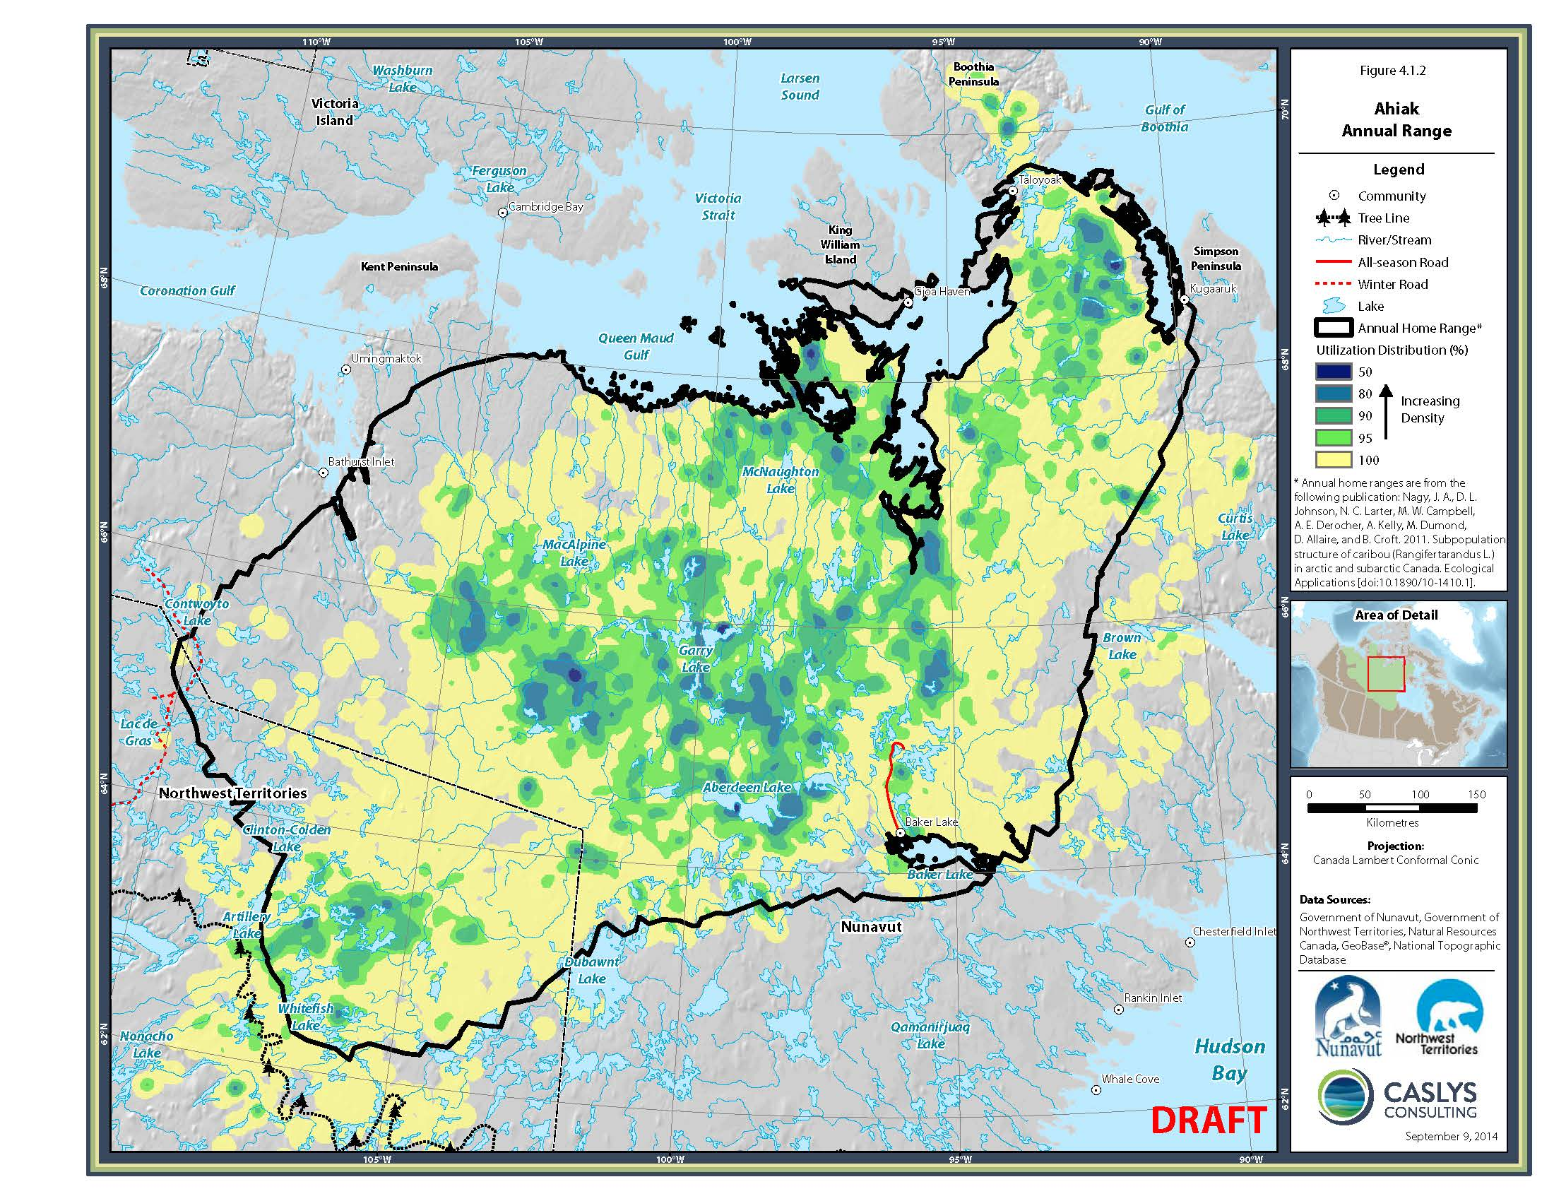
Figure 1. Ahiak herd annual range based on a kernel analysis of multi-annual telemetry locations of collared Lorillard cows.

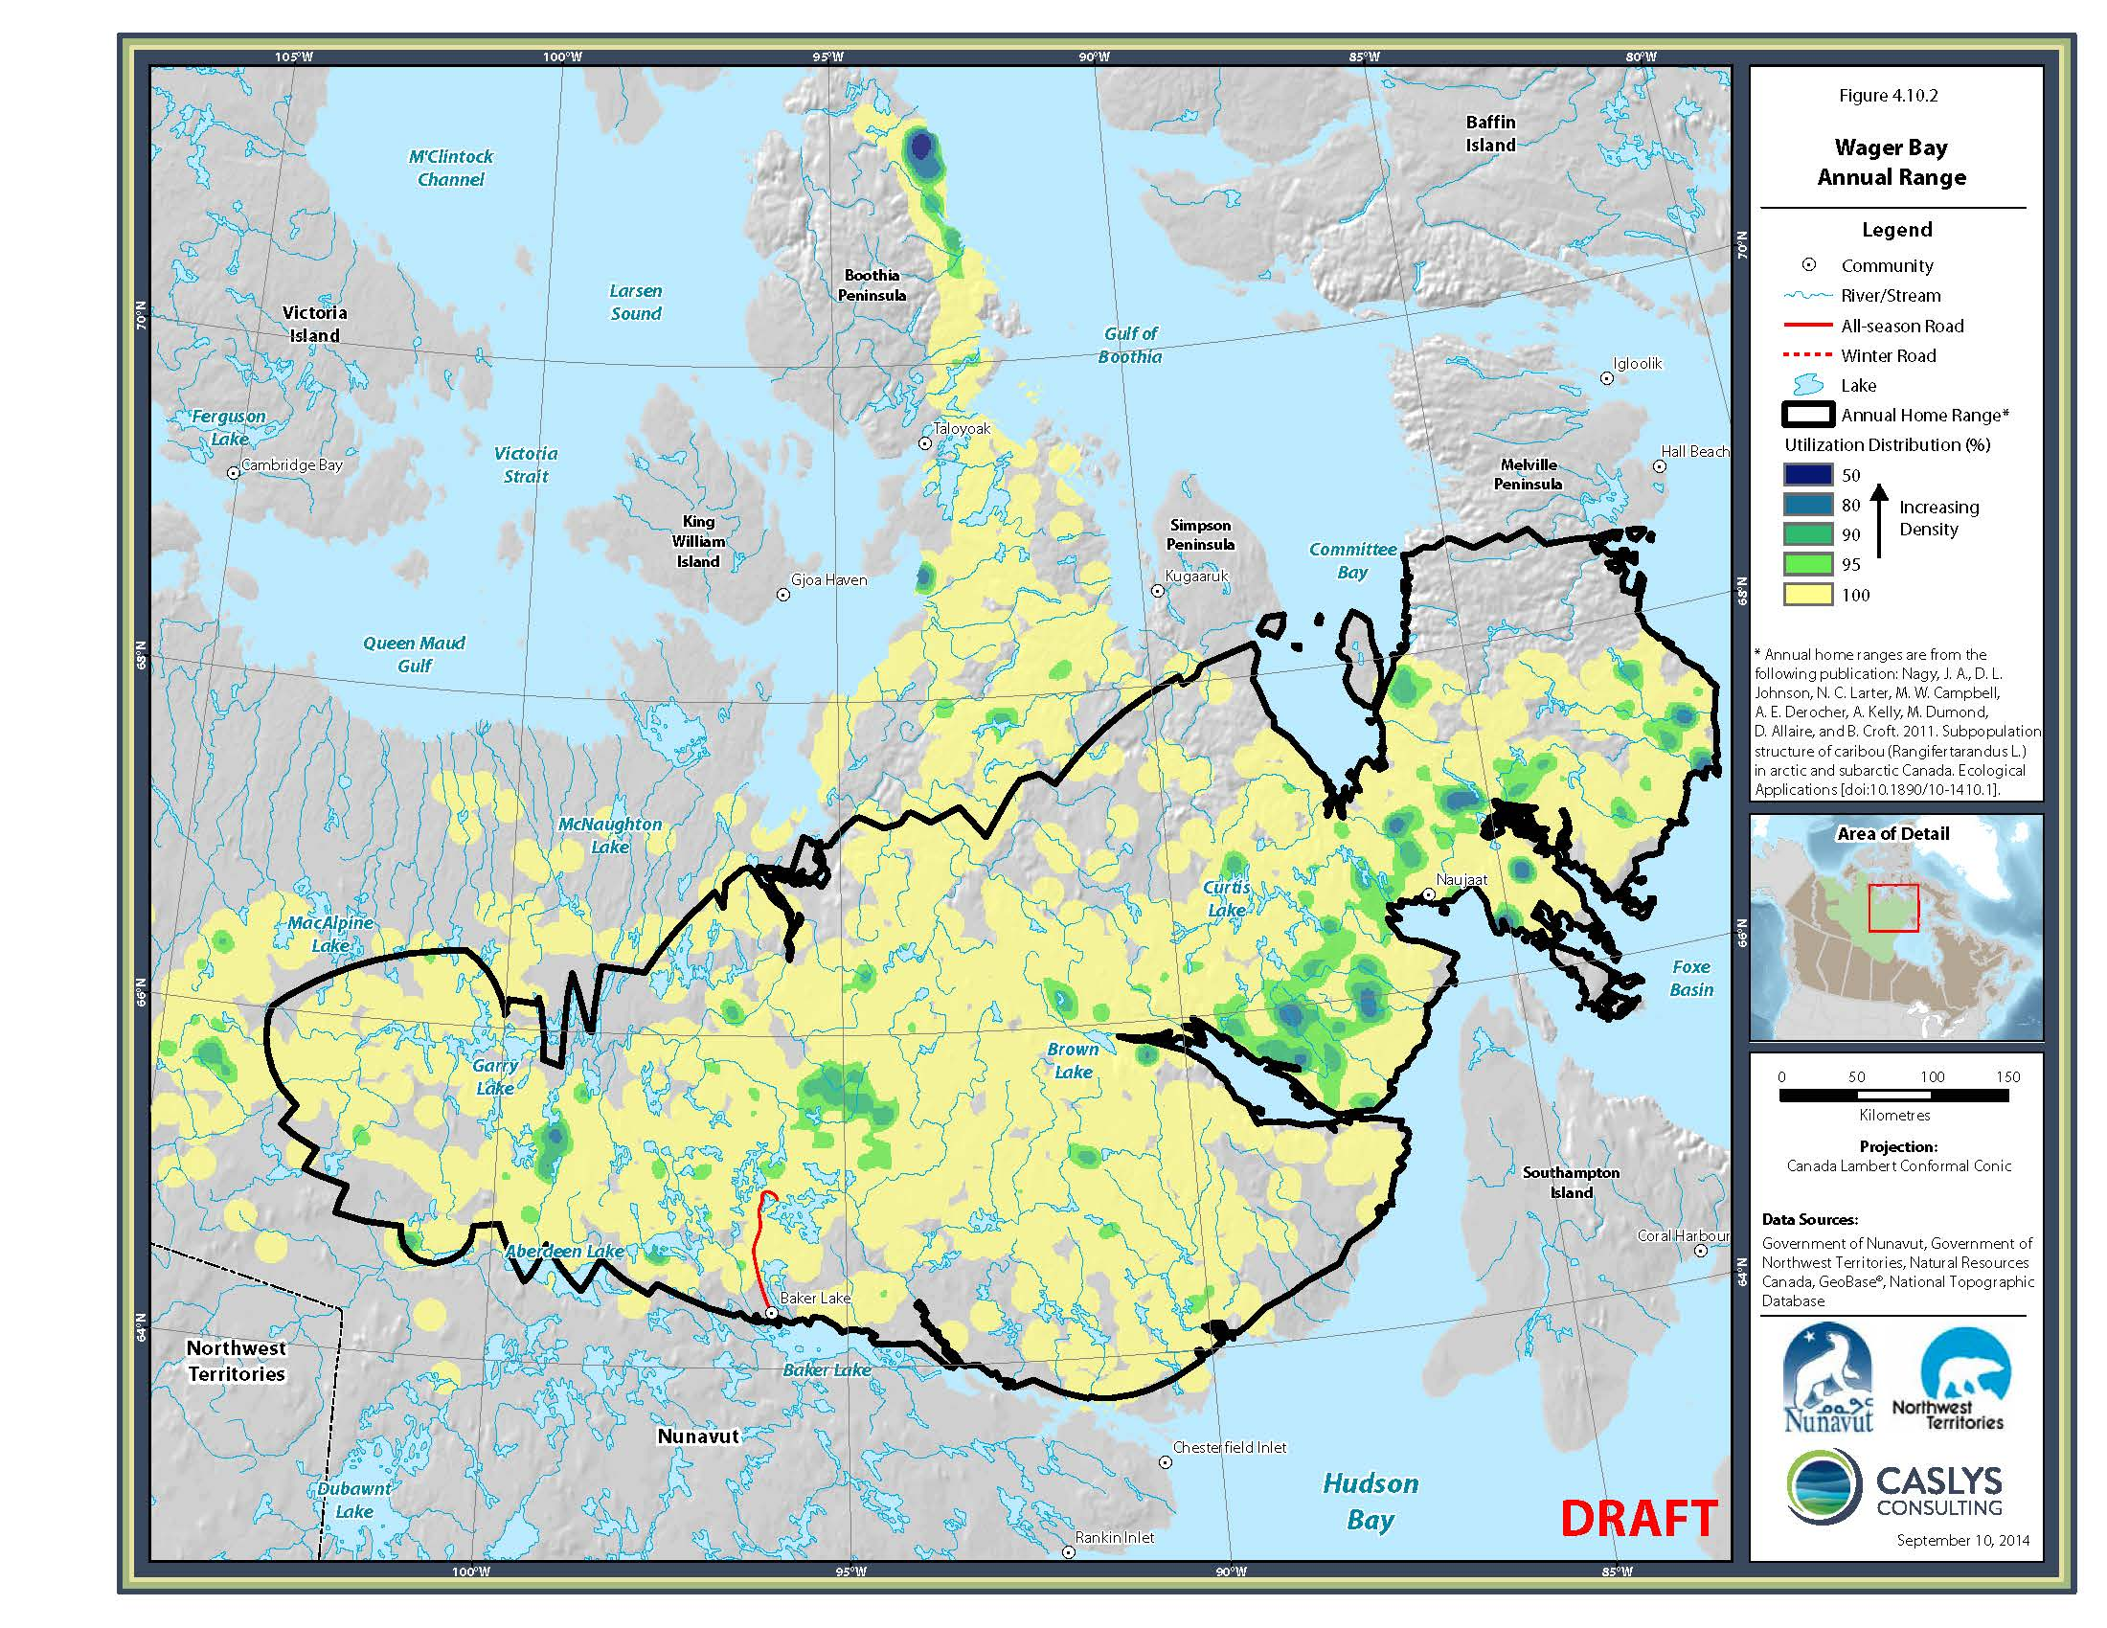
Figure 2. Wager Bay herd annual range based on a kernel analysis of multi-annual telemetry locations of collared Wager Bay cows.

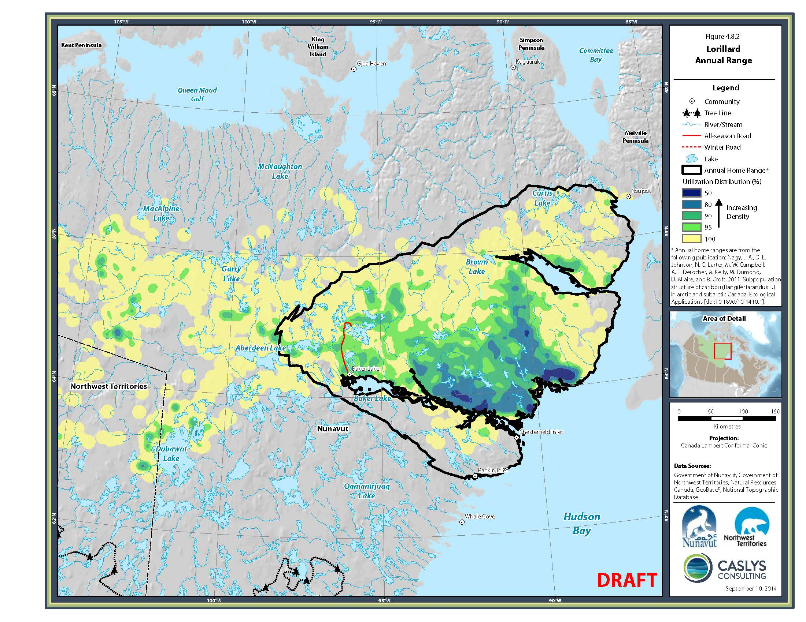
Figure 3. Lorillard herd annual range based on a kernel analysis of multi-annual telemetry locations of collared Lorillard cows.

A study of Northeast Mainland Caribou through the use of satellite telemetry and periodic calving ground delineation’s began April 15th, 1999 (Campbell, 2005). All collaring study areas were based on past survey observations, and local Inuit knowledge. From mid to late April 1999 and again in April 2000, ten ST-14 satellite collars were systematically placed on barren-ground caribou cows (total = 20). Collaring occurred between the north shore of Chesterfield Inlet and the south shore of Wager Bay (Lorillard Herd), and the following year between the north shore of Wager Bay and the northern tip of Repulse Bay (Wager Herd). Calving ground delineations were then flown, using satellite collar locations to guide survey effort, within each of these study area extents. Reconnaissance level surveys were flown in June from 1999 through to 2004. This program aimed to delineate important seasonal range for the Lorillard and Wager Bay Herds with an emphasis on delineating core calving range extents.
Following a 5 year gap, monitoring programs targeting the NEM herds were re-initiated due to concerns by communities and Biologists over industrial development in the region. A 15 collar deployment was completed on Ahiak caribou cows in the vicinity of Baker Lake in spring 2010, and again in 2012, and a mixed deployment of 15 collars, 11 on Lorillard and 4 Ahiak caribou cows, completed in 2014. Since 2014, deployment on Ahiak caribou cows has been problematic due to spring concentrations of Lorillard caribou having difficulty crossing the Meadowbank all weather mining road and saturating Ahiak collaring study area extents. The Wager Bay subpopulation has not been extensively collared since 2006. This collaring program has been instrumental in detecting significant migratory delays along an all-weather mining road north of Baker Lake. Additionally, locations of collard NEM caribou cows have and are currently used to assess seasonally important caribou range, and are used to design and deploy abundance surveys to monitor herd abundance and trend. More recent studies have aimed to specifically target collaring efforts on the Wager Bay and Ahiak Herds. Following program cancellations due to the global pandemic, the Government of Nunavut (GN) research staff, in partnership with local HTOs, were able to successfully deploy 40 collars on NEM caribou cows, 15 on Lorillard, 10 on Ahiak, and 15 on Wager Bay.
This report represents the continuation of an investigation into the seasonal distribution and herd delimitation of caribou populations occupying ranges north of Chesterfield Inlet and Wager Bay collectively referred to as the Northeast Mainland caribou subpopulations. This work aimed to estimate the abundance of the Lorillard, Ahiak and Wager Bay barren-ground caribou subpopulations. Within this report, we will discuss the status regarding the abundance of the Ahiak, Wager Bay, and Lorillard Herds of over wintering barren-ground caribou based on June 2021 survey results. Additionally, we will discuss the current population trend of the Ahiak Herd as the 2021 survey effort represents the second abundance survey for that population within the last 10 years. We will also assess mixing between the NEM herds as it applies to individual herd estimates and calving ground fidelity.

2.0 STUDY AREA

The Northeast Mainland survey study area extends eastward from longitude 96⁰ W to longitude 84⁰ W, and northward from latitude 63⁰ 30” N to latitude 70⁰ N (Figure 4). Communities harvesting on the Northeast Mainland range include Chesterfield Inlet, Naujaat, Rankin Inlet, Coral Harbour, and Baker Lake. Communities situated within the ranges of the Lorillard, Wager Bay, and Ahiak subpopulations include Naujaat, Baker Lake, and Chesterfield Inlet.
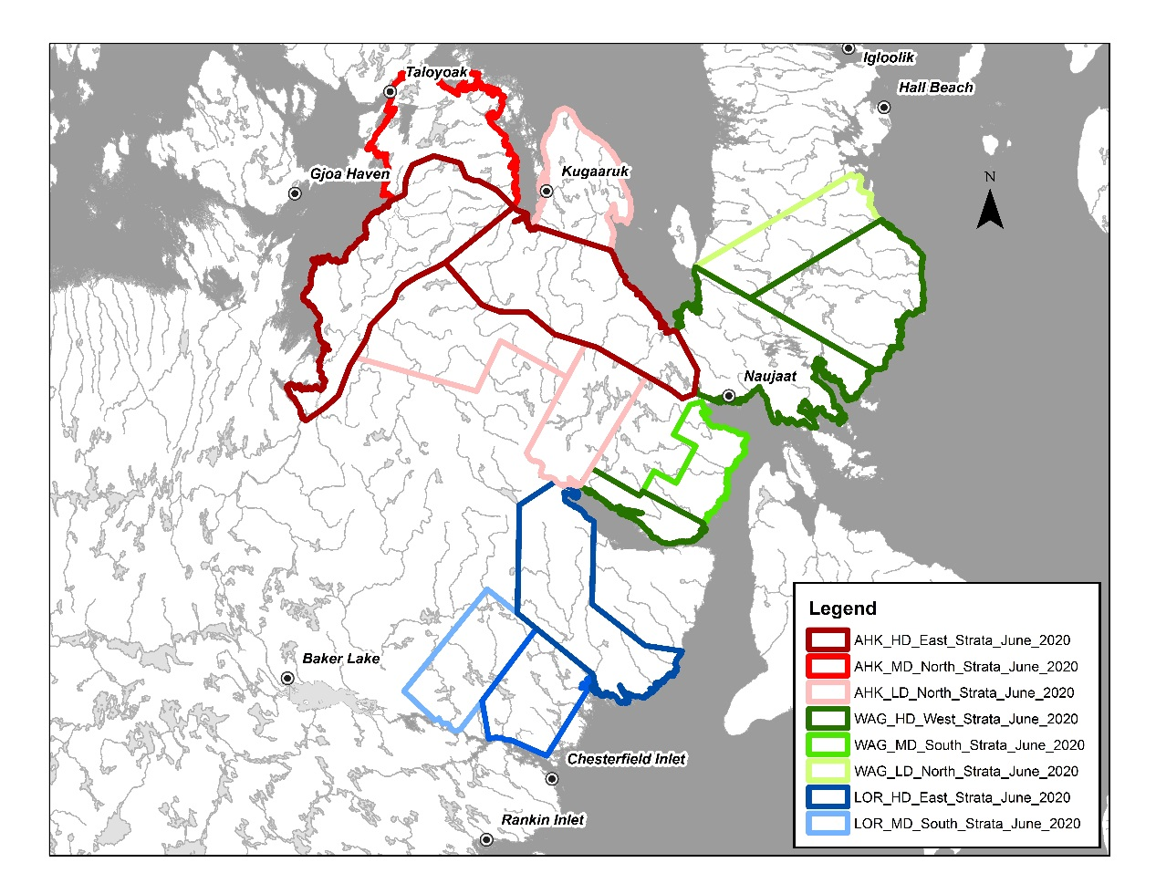
Figure 4. The June 2021 Northeast Mainland caribou calving ground survey study area.

3.0 METHODS.

3.1 Aerial Survey Methods.

The June 2021 Northeast Mainland dependent double observer pair survey of the Ahiak, Wager Bay, and Lorillard subpopulations of overwintering barren-ground caribou, was based out of the communities of Gjoa Haven, Kugaaruk, Naujaat, and Rankin Inlet. Survey aircraft included three Dehavaland Twin Otters, all equipped with radar altimeters to ensure that an altitude of 121.92 m (400 feet) above ground level (AGL) was maintained. The strip width on each side of the aircraft was 400 meters, for a total transect width of 800 m. Survey strips widths were marked by streamers attached to the wing struts (Figure 5) and were calculated using the formula of Norton-Griffiths (1978):

w = W * h/H
Where W is the required strip width (400 m), h is the height of the observer’s eye from the tarmac and H is the expected flying altitude (400 ft)

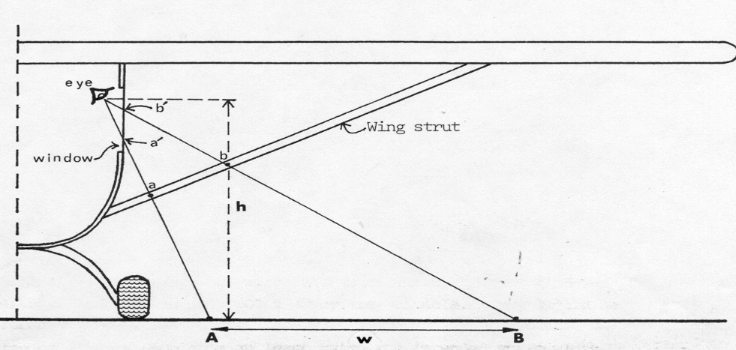
Figure 5. Schematic diagram of aircraft configuration for strip width sampling (Norton-Griffiths, 1978). W is marked out on the tarmac, and the lines of sight a’ – a – A and b’ – b – B established. The streamers are attached to the struts at a and b, and a’ and b’ are the window marks.

The abundance surveys for each of the Ahiak, Wager Bay, and Lorillard survey areas were flown as close together as possible to guard against large-scale movements of caribou between strata. All three survey areas were stratified using previous survey and telemetry data collected for the three subpopulations from research dating back to 1986. Though current telemetry data on NEM caribou cows was limited, we adjusted survey stratum boundaries where necessary to insure aggregations associated with collared caribou were included. The abundance surveys for all three NEM subpopulations began June 4th and was completed June 15th. following the completion of the reconnaissance survey on June 12th (Table 1).
Table 1. The June 2021 Northeast Mainland June calving ground survey. The X’s indicate flying days for both the abundance (fixed wing) and composition (rotary wing) surveys.
Survey Type | Jun-04 | Jun-05 | Jun-06 | Jun-07 | Jun-08 | Jun-09 | Jun-10 | Jun-11 | Jun-12 | Jun-13 | Jun-14 | Jun-15
Ahiak
Abundance | X | X | X | X
Composition |  |  |  |  |  | X | X | X
Wager Bay
Abundance | X | X | X | X | X | X | X | X
Composition |  |  |  |  |  |  |  | X | X | X
Lorillard
Abundance |  |  |  |  |  |  |  |  | X | X | X | X
Composition |  |  |  |  |  |  |  |  |  | X | X | X

The abundance survey also collected composition data where and when possible to aid in bolstering a strata composition survey flown with a rotary wing aircraft. During composition surveys, survey strata were assessed for antler status, calf presence, short yearling presence (last year’s calves), yearling presence, and sex. Both the abundance and composition surveys were completed as quickly as possible over the same survey period, an effort highly dependent on weather. The study area, within which all survey phases were flown, covered 259,746 km². Of this greater survey area, 62,255 km² covered Ahiak calving extents, 96,993 km² covered Wager Bay calving extents, and 50,249 km² covered the Lorillard calving extents, and encompassed the known extent of caribou calving in the area of the Queen Maud Gulf and Adelaide Peninsula ACCA (Annual Concentrated Calving Area) (Johnson and Mulders 2002; Johnson et al. 2008; Johnson and Williams 2008; Kelly in prep. 2010; Nagy et al. 2011, Campbell et al. 2012, Campbell et al. 2014) (Figure 4).
The survey utilized a dependent double-observer pair method. The typical configuration was comprised of a pilot and co-pilot, two data recorders (front left and front right) and four observers (two on the left side of the aircraft and two on the right side) (Figure 6). Only caribou observed within the strip, as defined by the inner and outer streamers attached to the left and right struts, were recorded.
The survey comprised five main components:
- Pre-stratification utilizing all available survey and telemetry data.
- Collar analysis, used in combination with telemetry based daily movement rates, to determine the timing and extent of calving;
- Dependent double-observer pair stratified abundance survey to estimate caribou abundance;
- Calving-ground composition surveys to estimate female and breeding female abundance within survey strata, and;
- Fall composition surveys to estimate the proportion of females within the subpopulations.

3.1.1 Pre-Survey Stratification.
Due to the size of the combined survey areas, the small representation of collared cows during the June 2021 survey, and time restraints encountered due to the need to complete the survey effort within the peak calving period, a reconnaissance survey to asses relative densities of caribou for stratification was not flown. In its place, and prior to the surveys deployment, we utilized all existing survey and telemetry distributional information to assess and stratify the extents of high, medium, and low densities of calving caribou within each of the Ahiak, Wager Bay, and Lorillard subpopulations (Figure 7).
Collar data was primarily used to assess the coverage of survey strata. In particular, both past and current movements of collared caribou were assessed up to the time surveying occurred and post survey in the Beverly and Adelaide Peninsula area to determine if there was overlap or a break between the Beverly, Ahiak, Wager Bay, and Lorillard herds in 2021.
Further analyses were conducted to also assess overall movements of caribou between the Ahiak, Lorillard and Wager Bay herds to assist in interpretation of estimates. For this analysis, the June location of collared females was classified based on calving ground location. Using this information, movements between calving grounds as well as fidelity to the same, were assessed graphically. Multi-state models (Hestbeck et al. 1991, Brownie et al. 1993) in program MARK (White and Burnham 1999) were then used to estimate movement (transition probabilities) between calving ground areas for females that were monitored for more than one calving season.

3.1.2 Collar Analysis.
Collar data was initially used to assess the extents and coverage of survey strata, and to determine the beginning of peak calving. Movements of collared caribou were monitored prior to, during, and following the aerial assessments to determine and/or document any overlap and/or separation between the Ahiak, Wager Bay, and Lorillard Herds in 2021. We used both past and current daily movement rates of collared Lorillard, Wager Bay and Ahiak caribou cows to identify past and actual dates of the onset and cessation of peak calving, defined as June movement rates below 5 kilometers per day. The calculation of daily movement rates of collared females has been shown to indicate the beginning of peak calving when movement rates drop below 5 km per day (Campbell et al. 2012; Boulanger et al. 2018) (Figure 8).
Further analyses were conducted to also assess overall 2021 movements of caribou between the Ahiak, Lorillard and Wager Bay herds to assist in interpretation of estimates. For this analysis, the June locations of collared females were classified based on previously delineated, and current calving ground location (Campbell et al. 2014). Using this information, movements between calving grounds as well as fidelity were assessed graphically. Multi-state models (Hestbeck et al. 1991, Brownie et al. 1993) in program MARK (White and Burnham 1999) were then used to estimate movement (transition probabilities) between calving ground areas for females that were monitored for more than one calving season.

3.1.3 Double Observer Visual Method
The dependent double-observer pair method used during the NEM calving ground surveys was designed to replace the need for a photo plane for surveys encountering densities of ≤ 15 caribou per square kilometer (Campbell et al. 2012). The method requires two observers on each of the left- and right-hand sides of the aircraft: A front or “primary” observer who sits in the front seat of the plane and a rear or “secondary” observer who occupies the seat behind the front observer (Figure 6). The dependent double observer pair method adhered to five basic steps:
- The primary observer called out all groups of caribou (number of caribou and location) he/she saw within the 400 m wide strip transect before they passed halfway between the primary and secondary observer (approximately at the wing strut). This included caribou groups that were between approximately 12 and 3 o’clock for right side observers, and 9 and 12 o’clock for left side observers (Figure 6). The main requirement was that the primary observer should have enough time to call out all caribou seen before the secondary did;
- The secondary observer called out whether he/she saw the caribou that the first observer saw and observations of any additional caribou groups. The secondary observer waited to call out caribou until the group had passed half- way between the observers;
- The observers discussed any differences in group counts (Hence the term “dependent” double observer pair) to clarify whether they had called out the same groups or different groups, and to ensure accurate counts of larger groups;
- The data recorders, one in the right-hand seat beside the pilot, and the other in the rearmost seat on the left side of the aircraft, categorized and recorded counts of each caribou group into “primary only”, “secondary only”, and “both”;
- The primary observer on each side switched places with the secondary observer approximately half way through each survey day (i.e. at lunch or during refueling) to address observer fatigue and to monitor observer ability based on their position within the aircraft. The recorders noted the names of the primary and secondary observer for all observations.
The sample unit for the survey was “groups of caribou” not individual caribou. Recorders and observers were instructed to consider individuals to be those caribou that were observed independent of other individual caribou and/or groups of caribou. We considered individual caribou within an estimated 100 meters of one another as a group.
Estimates of caribou on survey strata and associated variance were estimated using the mark-recapture distance sampling (MRDS) package (Laake et al. 2012) in program R program (R Development Core Team 2009). In MRDS, a full independence removal estimator which models sightability using only double observer information (Laake et al. 2008a, Laake et al. 2008b) was used therefore making it possible to derive double observer strip transect estimates. Strata-specific variance estimates were calculated using the formulas of (Innes et al. 2002) with the “S2” encounter rate estimator (Fewster et al. 2009). Estimates from MRDS were cross checked with strip transect estimates (that assume sightability=1) using the formulas of Jolly (1969)(Krebs 1998). Data was explored graphically using the ggplot2 (Wickham 2009) R package. GIS operations were conducted using the simple features (Pebesma 2018) R package and QGIS software (QGIS Foundation 2020).

3.1.4 Modelling of sighting probability variation
One assumption of the double observer method is that each caribou group observed had an equal probability of being sighted (Figure 9). To account for differences in sightability we also considered the following sightability covariates in the MRDS analysis (Table 2). Each observer pair was assigned a binary individual covariate and models were introduced that tested whether each pair had a unique sighting probability. Previous analyses (Campbell et al. 2012, Boulanger et al. 2014) suggested that the size of the group of caribou had strong influence on sighting probabilities and therefore we considered linear and log-linear relationships between group size and sightability (Table 2). Cloud and snow cover were recorded as they changed by data recorders as ordinal rankings. We suspected that sightability was most likely lowest in mixed snow cover conditions and therefore we considered both categorical and linear models to describe variation in sightability caused by snow cover. A snow patchiness covariate to describe mixtures of bare ground and snow cover was also used. Cloud cover could also influence sightability by causing glare, flat light, or variable lighting. We used the same basic strategy to model cloud cover variation and snow cover variation. Herd surveyed was also considered as a covariate since it described regional survey conditions as well as observers specific to each herd surveyed.
Table 2. Covariates used to model variation in sightability for double observer analysis.
Covariate | acronym | description
observer pair | obs | each unique observer pair
group size | size | size of caribou group observed
 | Log(size) | Natural log of group size
snow cover | snowF | snow cover (0,25,75,100)
 | snowc | continuous
cloud cover | cloudcat | cloud cover (0,10,25,75,100)
 | cloud | continuous
Snow patchiness | PatchF | Patchyness (1-salt and pepper, 6-solid)
 | PatchC | continuous
Herd | Herd | Herd surveyed

The fit of models was evaluated using the Akaike Information Criterion (AIC) index of model fit. The model with the lowest AIC_{c} score was considered the most parsimonious, thus minimizing estimate bias and optimizing precision (Burnham and Anderson 1998). The difference in AIC_{c} values between the most supported model and other models (ΔAIC_{c}) was also used to evaluate the fit of models when their AIC_{c} scores were close. In general, any model with a ΔAIC_{c} score of less than 2 was worthy of consideration.

3.1.5 Data recorder observations
Data recorder observations, where data recorders saw caribou that were not observed by observers were recorded for all of the observer pairs. Data recorder observations do not necessarily need to be included in analyses given that the method allows for observers to miss caribou and therefore the fact that a small percentage of caribou are only seen by data recorders is not surprising. In the context of the dependent double observer method, use of data recorder observations presents some challenges. First, observations from the data recorder are partial; the data recorder only records observations that he/she observes but are not observed by either other observer which limits the ability to use data recorder observers as a unique third observer. In this context, data recorder observations basically supplement the second observer in “testing” the primary observer.
One approach to include data recorder observations is to pool the 2nd observer and data recorder as a single observer. The main potential issue caused by this approach is that it will increase the difference in detection probabilities between the primary and 2nd observer regardless of observer position therefore violating the assumption of equal detection probabilities between observers. This could be thought of as always having one primary and 2 secondary observers that have a combined higher detection probability. Because the removal estimator considers observer order, this approach could potentially cause a negative bias in detection probabilities with a subsequent positive bias in abundance estimates. This scenario would likely correspond to cases when both observers have reasonable sighting probabilities. Another scenario, that likely occurred, was where both observers were weak and not including data recorder observations substantively reduced observations leading to a negative bias in estimates. In this case, observer probabilities are low and cannot be estimated using the double observer data alone. To detect this potential scenario, we estimated detection probabilities with and without data recorder observations under that rationale that these pairs could be identified by large differences in detection probabilities with data recorder observations included and excluded. In this case observations from these pairs were potentially included in the analysis with the 2nd and data recorder observations pooled.
Strategies for inclusion of data recorder observations were evaluated further using generalized removal models from the Huggins closed population estimation model (Huggins 1991) in program MARK (White and Burnham 1999) that allows the data recorder to be considered as a third sampling session (Appendix 2). As a final sensitivity analysis, estimates were derived for herds using all data recorder observations, filtered (weak observer only) data recorder observations, and no data recorder observations. These estimates were compared to strip-transect estimates (that include all data recorder observations). The rationale behind this comparison is that double observer estimates should be close to or larger than strip transect estimates.
Estimates of caribou on survey strata and associated variance were estimated using the mark-recapture distance sampling (MRDS) package (Laake et al. 2012) in program R program (R Development Core Team 2009). In MRDS, a full independence removal estimator which models sightability using only double observer information (Laake et al. 2008a, Laake et al. 2008b) was used therefore making it possible to derive double observer strip transect estimates. Strata-specific variance estimates were calculated using the formulas of (Innes et al. 2002) with the “S2” encounter rate estimator (Fewster et al. 2009). Estimates from MRDS were cross checked with strip transect estimates (that assume sightability=1) using the formulas of Jolly (1969)(Krebs 1998). Data was explored graphically using the ggplot2 (Wickham 2009) R package. GIS operations were conducted using the simple features (Pebesma 2018) R package and QGIS software (QGIS Foundation 2020).

3.1.6 Estimates of Breeding Females, adult Females and Adults on the Calving Ground.
Composition surveys were conducted concurrently with visual surveys. During surveys, caribou were classified as yearlings, bulls, cows with calves, cows with udders, cows without udders and with antlers, and cows without udders or antlers. Breeding cows were tallied as cows with calves, cows with udders, and udderless cows with antlers. Non-breeders were tallied as udderless cows with no antlers, yearlings and bulls. Using this information, the proportion breeding females, adult females and adults was estimated for each stratum surveyed on the calving ground. Bootstrap methods were used to obtain variance estimates. In this case, 1000 resampling of the data were used and the mean and standard deviation from resampling were used as point estimates of proportion breeders and the associated standard error (Manly 1997).
Estimates of proportion breeders were then multiplied by the double observer estimate of all caribou for each stratum to obtain an estimate of the number of breeding females. Variances for combined visual strata were obtained using mrds therefore accounting for covariances introduced by the double observer sightability models. Variances for photo and visual strata, or composition survey and strata estimates were obtained for the combined estimates using the delta method (Seber 1982, Williams et al. 2002) assuming no correlation between the two estimates. Degrees of freedom for combined estimates were estimated using the formulas of Buckland et al (1993).

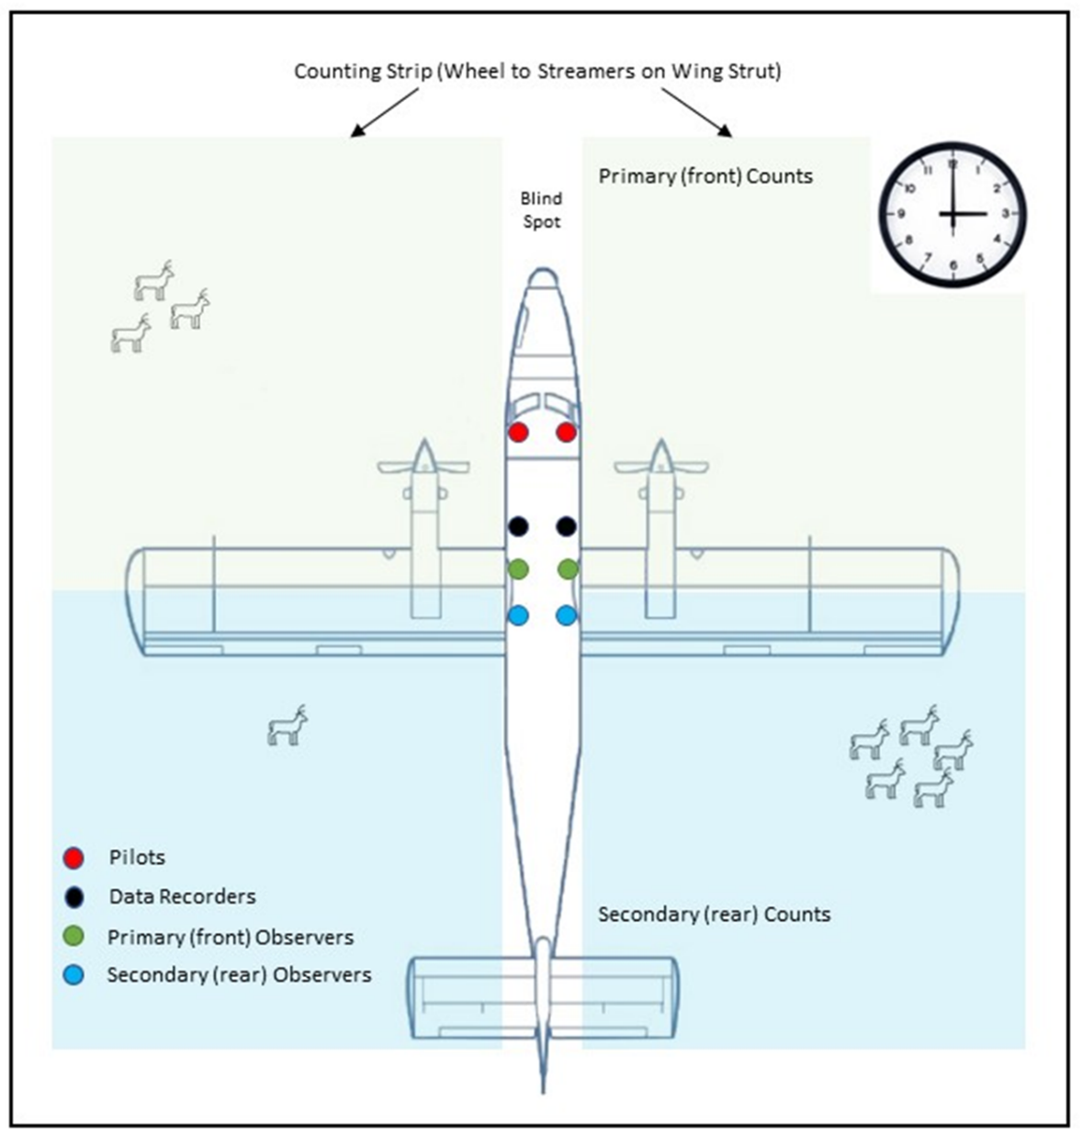
Figure 6. Observer position for the double observer method employed on this survey. The secondary (rear) observer calls caribou not seen by the primary (front) observer after the caribou have passed the main field of vision of the primary observer (green shaded area). The small hand on a clock is used to reference relative locations of caribou groups (e.g. “Caribou group at 3 o’clock” would suggest a caribou group 90º to the right of the aircrafts longitudinal axis.).

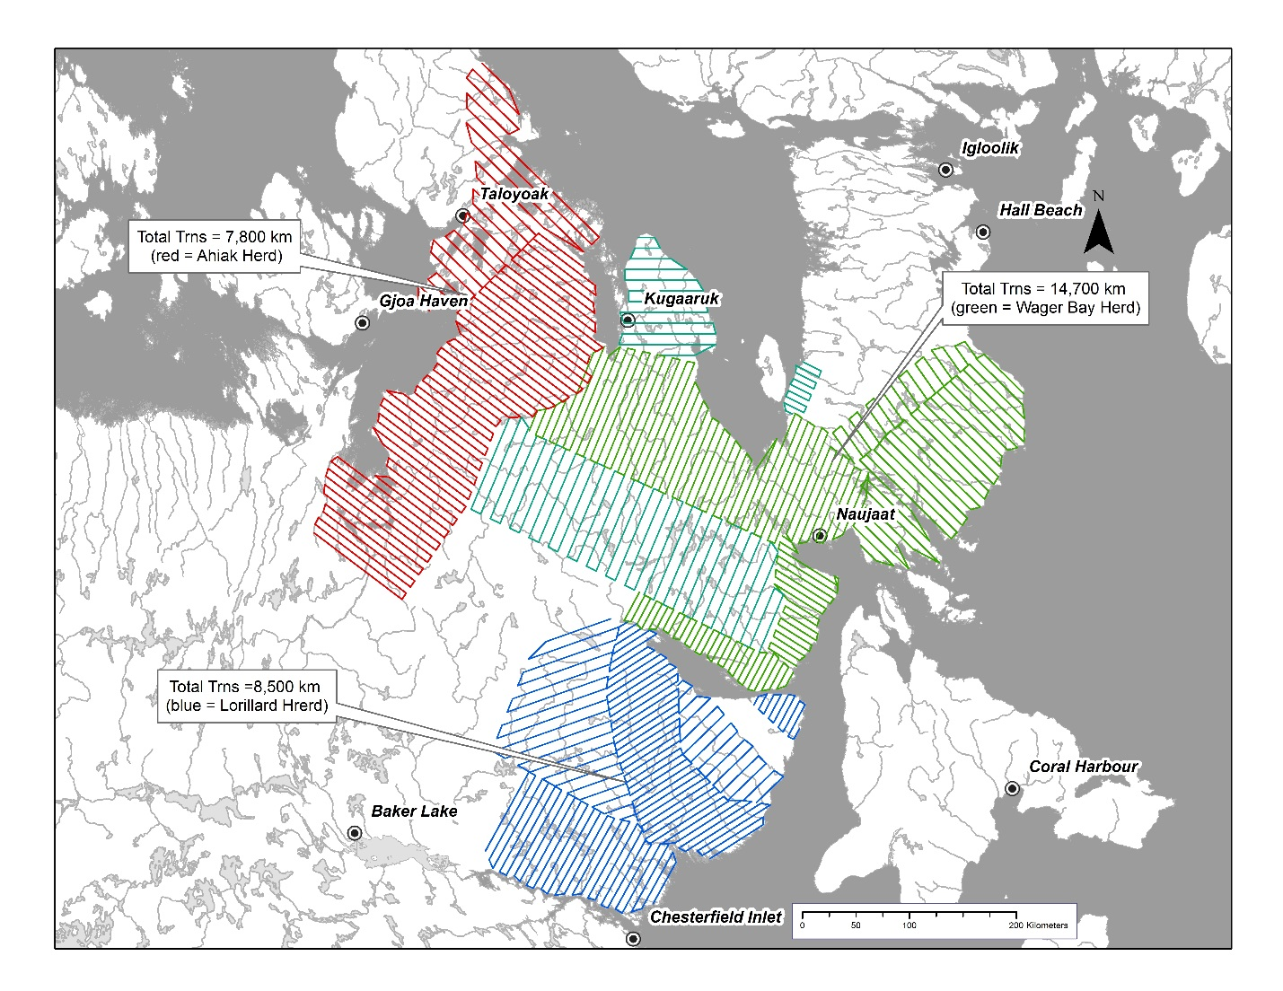
Figure 7. The June 2021 Northeast Mainland caribou herd calving ground survey strata and strata transect coverage. Red represents the Lorillard Herd, Green the Wager Bay herd, and blue the Lorillard herd. Note transect spacing within each strata. Strata coverage has been divided into low, medium, and high survey coverage.

Figure 8. Movement rates of Qamanirjuaq caribou during the June 2017 calving ground survey. The red line (cow movement rate of 5 km/day) indicates movement rates consistent with the beginning of peak calving (bright red bars) (Boulanger et al. 2018).

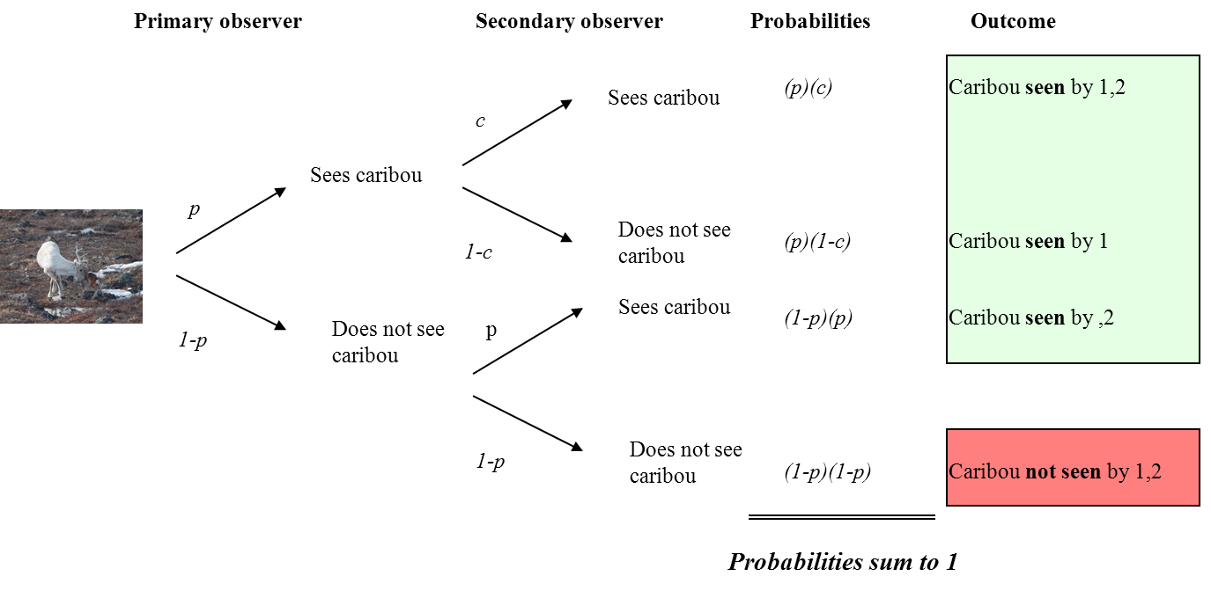
Figure 9. Conceptual diagram of how the probability of both observers not sighting a caribou group is estimated, and how the probability that at least one of the observers sees the caribou group (p*) is estimated. The green boxes correspond to outcomes where caribou are seen and the red box corresponds to both observers missing a caribou group.

3.1.7 Calving Composition Surveys.
June composition surveys were timed as close as possible to begin concurrently with visual abundance to ensure minimal movement of animals occurred between strata. For the Ahiak herd, abundance surveys began June 4th and ended June 7th while composition surveys began June 9th and were completed June 11th. Wager Bay herd abundance surveys began June 4th and ended June 11th while composition surveys began June 11th and were completed June 13th. Finally, Lorillard herd abundance surveys began June 12th and ended June 15th while composition surveys began June 13th and were completed June 15th. For the Ahiak herd, abundance surveys began June 4th and ended June 7th while composition surveys began June 9th and were completed June 11th. Sampling was structured to begin at a fuel cache and then proceed to a predetermined transect station and associated route. From this point composition proceeded along a predetermined route informed by fixed wing survey observations. While travelling along the predetermined route every observed caribou group within 5 km of the route based transect would be sampled. The composition proceeded within the 5 km buffer along the flight route on a priority sampling basis based on the nearest observed group. This method generally produced a zig zag pattern using the proximity of the route track to equally distribute composition effort (Figure 10). At times, observed groups of caribou “pulled” the aircrew from the pre-planned flight path. When sampling caused deviation from the preplanned flight path, the aircrew would stop sampling caribou groups that were seen greater than 5 kilometers perpendicular to the original predetermined flight path. From this point, only caribou groups observed within this five-kilometer buffer would be sampled and an attempt to rejoin the original flight path made. During re-positioning flights from the stratum to the fuel caches, caribou encountered within a maximum of 2 km inside of target stratum boundaries were classified opportunistically and variation of flight paths was held to within 2 km to reduce deviation from the planned flight paths and fuel caches.
During surveys, caribou were classified as yearlings (≥ 1.0 years and < 2 years of age), bulls, cows with calves (calves < one month old), cows with udders, udderless cows with antlers, and udderless cows without antlers. Breeding cows were tallied as cows with calves, cows with udders, and udderless cows with antlers. Non-breeders were tallied as udderless cows with no antlers, yearlings and bulls. Using this information, we estimated the proportions of breeding females, and adult females.

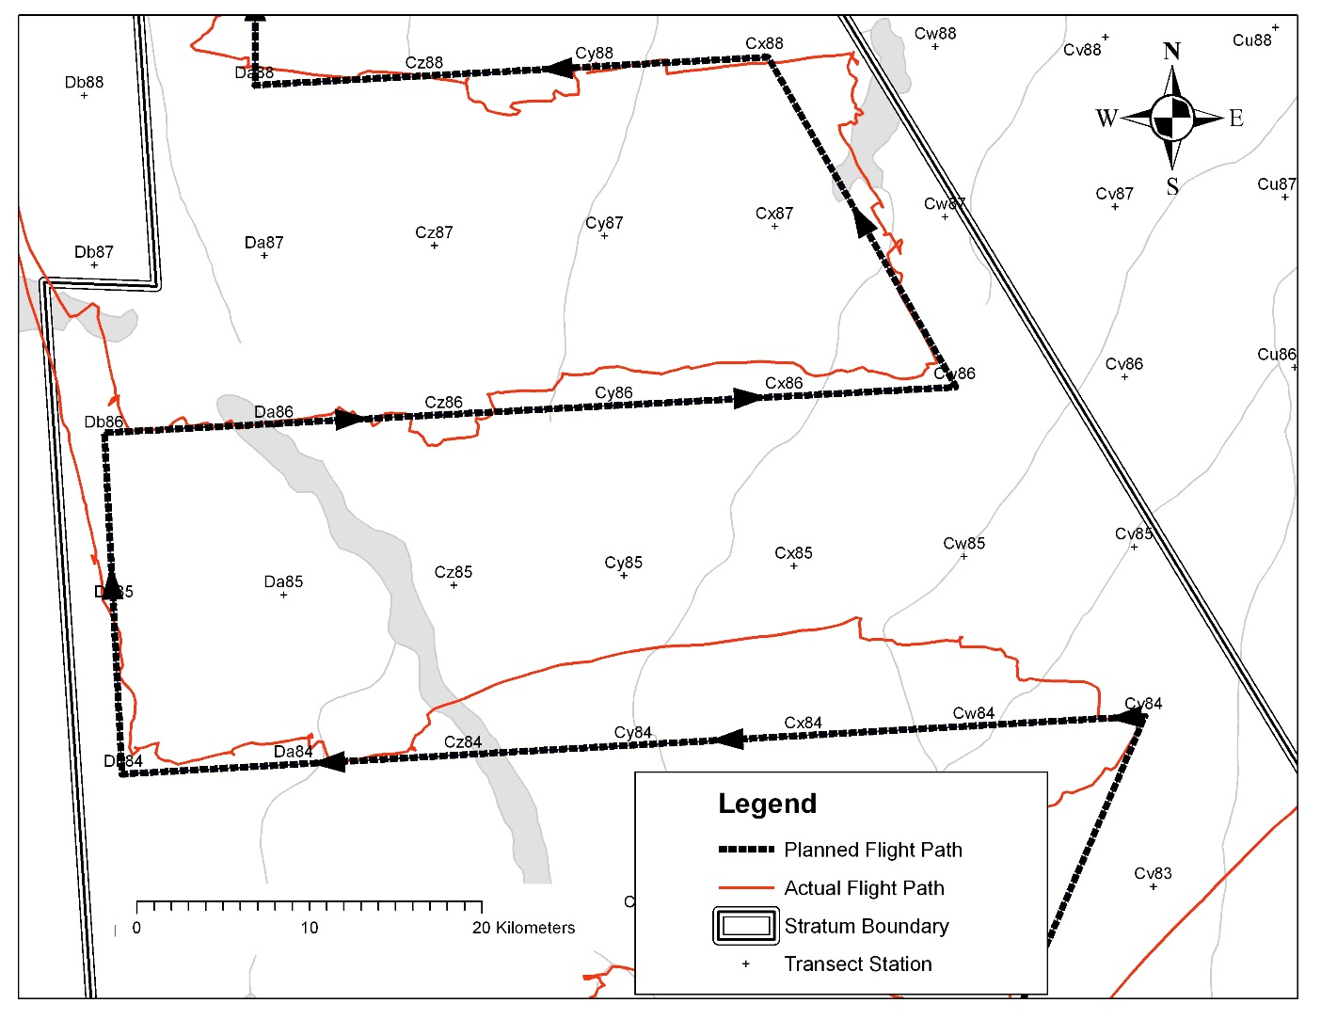
Figure 10. Stratum composition methods utilizing pre-planned flight lines based on a standard reconnaissance grid. Deviations (red line) away from planned routes (black lines) are required to classify all observed caribou groups. The next nearest group would be classified up to a maximum of 5 km perpendicular to the planned route (half way between transect stations).

3.1.8 Fall Composition Survey.
The GNWT conducted a composition (sex ratio) survey of the Beverly Herd in the fall of 2011. We choose the use of Beverly fall composition data to estimate whole herd abundance for the Ahiak, Wager Bay and Lorillard Herds as it represented the closest quantitative assessment of herd sex ratios the NEM herds. Due to funding constraints, a fall composition survey following the June 2021 survey was not possible. Therefore, we are using the 2011 GNWT Beverly fall composition results, as the best available scientific information, to develop the whole herd estimate derived in this report. The objective of the 2011 fall composition survey was to determine bull-cow ratios on the Beverly subpopulation fall rut seasonal range (Figure 11). The survey was conducted during the rut when all caribou ages and sexes are gathered together in mixed sex and aged groups. The bull-cow ratio is needed to extrapolate subpopulation estimates from the calving ground survey by dividing the estimate of the number of breeding females on the calving ground by the sex ratio of the subpopulation. Our use of composition data from 2011 could bias our results, because over time and across different population cycles, adult sex ratios can and likely do change. We are confident, however, that these variations are generally small and will have little impact on the overall estimates.
A three-person crew conducted the fall composition surveys: front seat observer, rear seat data recorder, and pilot. Caribou were classified from the helicopter as cows, prime bulls, young bulls or calves (less than 1 year old) and yearlings (greater than 1 but less than 2 years old). Females were classified based on the presence of a dark vulva patch, and calves were identified based on their small body size and rounded skull profile. Bulls were classified as either prime bull or young bulls based on body size and height of antlers. Classifications were recorded with tally counters and recorded into a notebook as an observation point. Each observation point was accompanied by a GPS waypoint. Cochran’s (1977) jackknife technique was used in the field to calculate associated variances in age and sex ratios to determine optimum sample size. Bootstrap methods (Manly 1997) were used to estimate variances in age and sex ratios for final whole herd calculations.
Before the GNWT 2011 fall composition survey, a fixed-wing reconnaissance survey was conducted to determine the distribution of caribou in the study area. The sampling area was determined using the location of collared cows during the survey, as well as the geographic areas used by collared Beverly cows during the rut season, since 2006 (Nagy et al., 2011). Collars were radio-tracked to determine the relative numbers of caribou associated with each collar. This information was used to finalize the sampling design so that information from a representative portion of the subpopulation could be obtained during the composition survey.
The bull-cow ratio is reported as the count of bulls divided by the count of cows, whereas the proportion of adult cows is the number of cows divided by the number of adult cows and adult bulls. As with the calving ground composition survey data, a bootstrap procedure was used with the raw composition data for point estimates, standard error, and percentile-based confidence limits. One thousand resamples were conducted with the original data set (Manly, 1997).
We used an extrapolation method to estimate total subpopulation size, whereby the estimate of breeding females is divided by the proportion of adult females pregnant which is then divided by the proportion of adult cows in the population (collected in the fall composition survey) to estimate total subpopulation size (of caribou that are 1+ years old) (Heard, 1985). Estimates of adult females alone are solely based on the proportion of females derived from fall composition results (Campbell et al., 2012). Variances for photo and visual strata, or composition survey and strata estimates, were obtained for the combined estimates using the delta method assuming no correlation between the two estimates (Seber 1982, Williams et al. 2002). Degrees of freedom for combined estimates were estimated using the formulas of Buckland et al. (1993). Log-normal confidence limits were used for both the dependent double observer pair visual estimates and extrapolated estimates, as log-normal estimates provide better coverage than standard parametric intervals (Buckland et al. 1993).

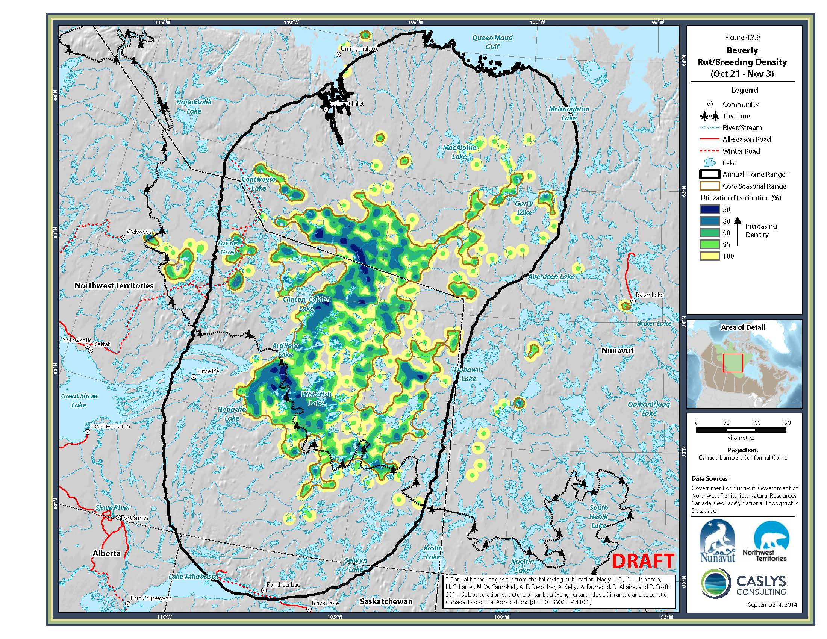
Figure 11. The Beverly mainland migratory barren-ground caribou rutting seasonal range from which fall NEM sex ratio results were derived. Kernel analysis based on telemetry data, current to 2012 (Campbell et al. 2014, Nagy et al. 2011).

4.0 RESULTS & DISCUSSION.

4.1 Estimates of Adult Caribou Within Calving Strata.

Composition surveys were conducted concurrently with visual surveys. During surveys caribou were classified as yearlings, bulls, cows with calves, cows with udders, udderless cows with antlers, and udderless cows without antlers. Breeding cows were tallied as cows with calves, cows with udders, and udderless cows with antlers. Non-breeders were tallied as udderless cows with no antlers, yearlings and bulls. Using this information, the proportion breeding females, adult females and adults was estimated for each stratum surveyed on the calving ground. Bootstrap methods were used to obtain variance estimates. In this case, 1000 resampling of the data were used and the mean and standard deviation from resampling were used as point estimates of proportion breeders and the associated standard error (Manly 1997).
Estimates of proportion breeders were then multiplied by the double observer estimate of all caribou for each stratum to obtain an estimate of the number of breeding females. Variances for combined visual strata were obtained using mrds therefore accounting for covariances introduced by the double observer sightability models. Variances for photo and visual strata, or composition survey and strata estimates were obtained for the combined estimates using the delta method (Seber 1982, Williams et al. 2002) assuming no correlation between the two estimates. Degrees of freedom for combined estimates were estimated using the formulas of Buckland et al (1993).

4.1.1 Survey Strata.
Survey strata were defined for the Ahiak, Lorillard, and Wager Bay based on prior locations of collared caribou on calving grounds (Figure 12). Table 3 provides details for each survey strata.

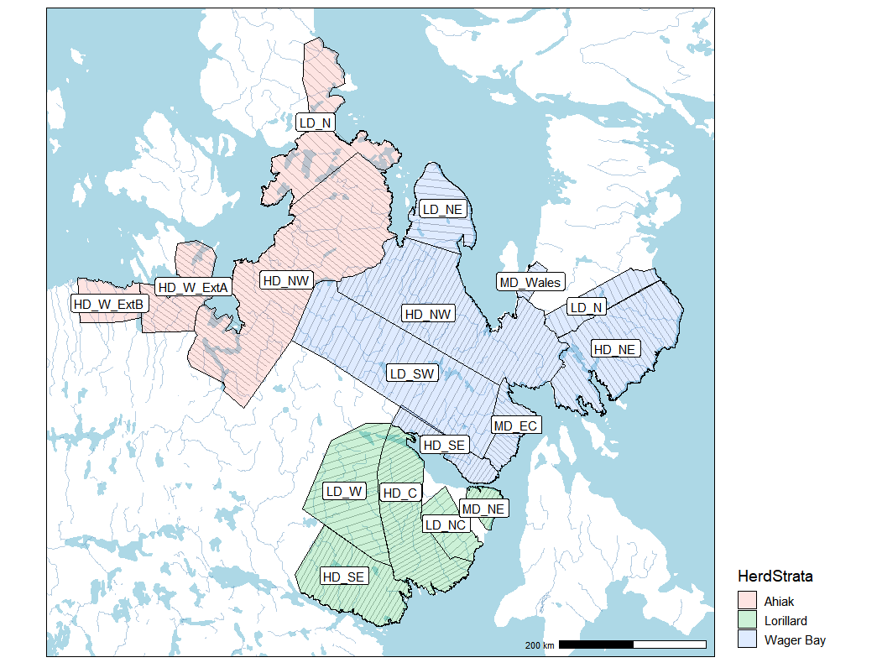
Figure 12. Locations of survey strata.

Table 3. Description of survey strata.
Strata Name | Strata coding | Strata  Area | No Transects | Baseline | Coverage
Ahiak High Density North West | A_HDNW | 37335 | 51 | 362.2 | 11.3
Ahiak Low Density North | A_LDN | 12687 | 22 | 206.5 | 7.6
Ahiak West Extension A | A_WEX_A | 7798 | 21 | 147.175 | 11.2
Ahiak West Extension B | A_WEX_B | 4435 | 10 | 83.88 | 9.8
Lorillard High Density Central | L_HDC | 15018 | 39 | 236.487 | 13.4
Lorillard High Density South East | L_HDSE | 13661 | 24 | 168.444 | 11.6
Lorillard Low Density North Central | L_LDNC | 4840 | 10 | 102.976 | 8.0
Lorillard Low Density West | L_LDW | 14697 | 19 | 187.592 | 8.0
Lorillard Medium Density North East | L_MDNE | 2033 | 9 | 53.828 | 13.5
Wager High Density North East | W_HDNE | 18060 | 27 | 207.293 | 10.0
Wager High Density North West | W_HDNW | 28194 | 46 | 311.066 | 11.5
Wager High Density South | W_HDS | 4640 | 28 | 167.782 | 13.3
Wager Low Density North | W_LDN | 5215 | 16 | 158.909 | 7.9
Wager Low Density North East | W_LDNE | 7143 | 12 | 119.831 | 8.1
Wager Low Density South West | W_LDSW | 28511 | 31 | 313.473 | 7.9
Wager Medium Density East Central | W_MDEC | 4164 | 18 | 100.36 | 13.8
Wager Medium Density Wales Island | W_MDWA | 1066 | 9 | 52.752 | 10.8

4.1.2 Survey Observations.
Surveys were conducted from June 5 to June 7 for Ahiak strata, June 12 to 15 for Lorillard, and June 4 to June 14 for Wager Bay strata (Figure 13). Observations were classified based on the following prioritized categories: presence of calves, presence of hard antlered females, and presence of bulls with other groups assigned unknown/non-breeder status. Core calving areas of higher density and with calves/hard antlered females were evident in high strata for all the calving grounds. A higher density area of breeding caribou was observed in the Queen Maud Gulf that may have been partially composed of Beverly caribou (as discussed later).
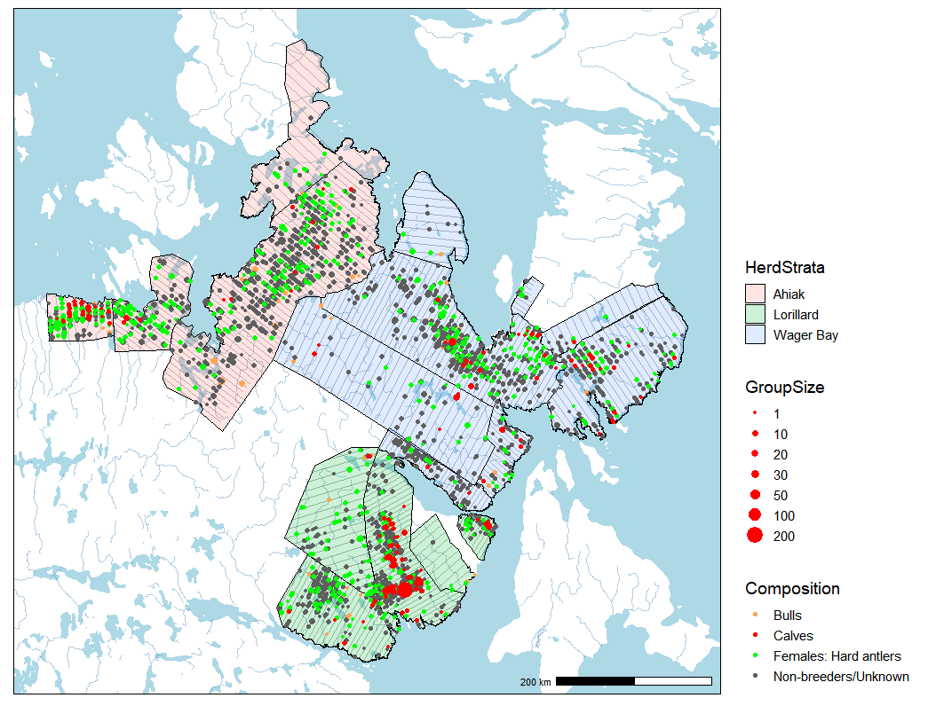
Figure 13. Observations for transect surveys with composition noted.

4.1.3 Collar monitoring.
Twelve collared caribou were within the survey area in 2021 (Figure 14). Their migration paths and locations on June 5 for Ahiak collars and June 15 for other collars are shown. Also shown are historic calving locations for collared females monitored since 1996 (Figure 15). The low number of collared caribou precluded substantive analysis of the collar data for the Wager Bay and Lorillard herds. Of critical interest was whether the Ahiak herd was separate from the Beverly herd when the survey occurred on June 5. Migration paths of caribou that occurred in the Ahiak strata were south through the MacAlpine Lake area, whereas Beverly herd paths skirted Bathurst Inlet up to the time when surveying of the Ahiak HD_WEX_B and HD_WEX_A strata occurred. When the survey occurred two collars were inside the HD_WEX_B strata, one collar was just north of the boundaries of HD_WEX_B and HD_WEX_A strata, and two collars were in the HD_WEX_A stratum. After the survey occurred the Beverly collars occurred throughout HD_WEX_B strata but not in the HD_WEX_A stratum which had the 2 collars that were in the stratum during the survey. These patterns suggest that the HD_WEX_B was primarily Beverly (or at likely contained the leading edge of the Beverly when the survey occurred) whereas HD_WEX_A was more likely Ahiak.

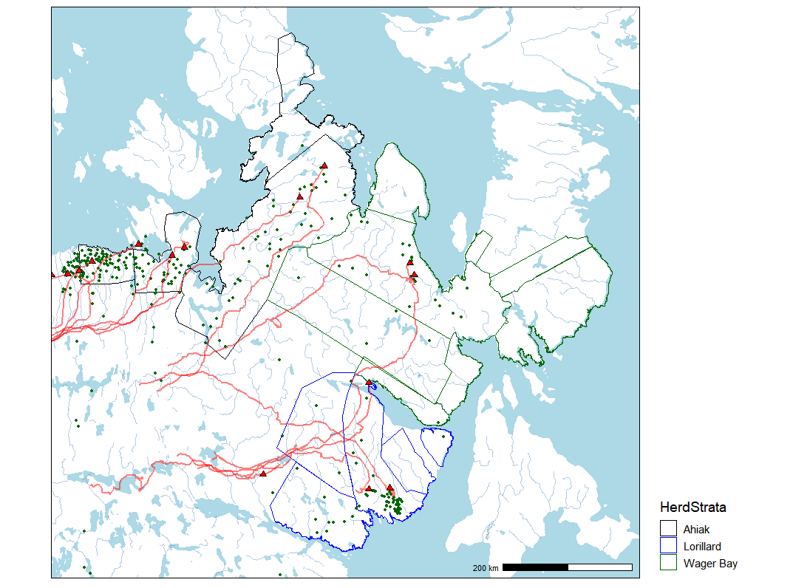
Figure 14. Locations of collared caribou monitored during the 2021 survey (red triangles with migration paths in red). Historic calving locations of female caribou are also shown as green dots for reference.

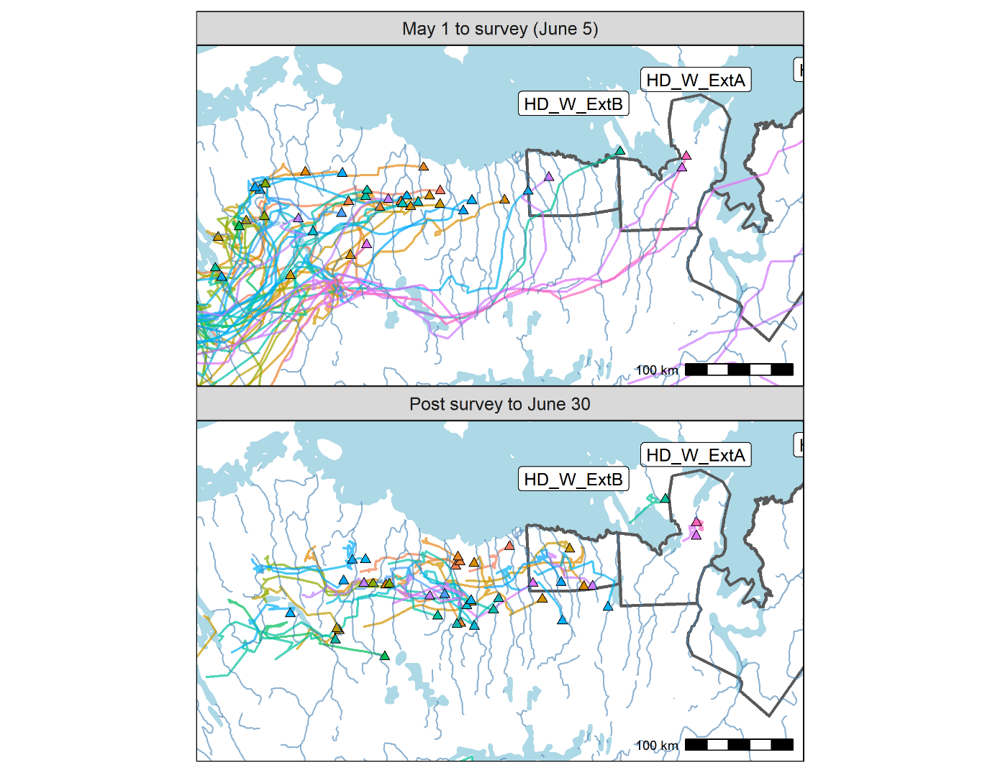
Figure 15. Collar locations from May 1 to June 5 when the Ahiak survey western strata were surveyed compared to locations after the survey occurred. Each collar and path has a unique collar.

4.2 Double observer analysis of transect data

4.2.1 Data summary.
Observer were paired primarily by observers that shared primary and secondary observer positions over the course of the survey. In some cases, sample sizes were too low for a single observer pair in which case pairs were pooled based on shared observers. A “0” observer pair was also created composed of pairings of very low sample sizes. This pair was modelled as an intercept term meaning they were given mean probabilities of all the other observers. Overall there were 16 observer pairings (Table 4). Summary statistics are shown for each pairings with naïve detection probabilities for each pair. Most observers (15 of 16) had at least 100 observations (Table 5). All but one pair had data recorder observations, although in all but four cases data recorder observations composed 5% or less of observations. Of the four pairs with more than 5%, three had substantial data recorder observations (pairs 7, 14 and 15). Single observer (proportion observations not seen by the primary observer) and double observer (cumulative probability across both observers) were estimated with and without the data recorder data included. Inclusion of data recorder data reduces detection probabilities since in all cases the primary observer did not see these caribou. The effect of data recorder observations on detection probabilities is best seen graphically by plotting single and double detection probabilities with and without data recorder data included (Figure 16). For most pairs detection is reduced minimally. However, for three pairs (7, 14, and 15) the reduction is substantial suggesting that detection was low for these pairs and the low detection was not being adequately captured using data from just the observers.
As discussed previously, inclusion of data recorder observations (by pooling with the second observer) can potentially bias estimates if observer pairs are efficient. However, for these three pairs it was more likely that they were not working efficiently (estimating detection probabilities) and therefore an analysis strategy where data recorder observations were included for these three pair was used for the primary analysis with sensitivity analyses undertaken to asses this strategy. The effect of data recorder observations on detection probabilities is best seen graphically by plotting single and double detection probabilities with and without data recorder data included (Figure 16). For most pairs detection is reduced minimally. However, for three pairs (7, 14, and 15) the reduction is substantial suggesting that detection was low for these pairs and the low detection was not being adequately captured using data from just the observers.
As discussed previously, inclusion of data recorder observations (by pooling with the second observer) can potentially bias estimates if observer pairs are efficient. However, for these three pairs it was more likely that they were not working efficiently (estimating detection probabilities) and therefore an analysis strategy where data recorder observations were included for these three pair was used for the primary analysis with sensitivity analyses undertaken to asses this strategy. Other covariates for detection probabilities included group size. A histogram suggested that most observation where at least one observer missed caribou occurred in smaller group sizes (Figure 17). Other covariates included snow patchiness, snow cover and cloud cover (Figure 18). The highest frequencies for snow patchiness were for bare ground (patchiness=6). The snow patchiness 5 and 6 were considered as a pooled categorical class given smaller sample sizes for class 6. Snow cover was relatively even across categories with cloud cover dominated by clearer conditions. Another covariate considered was herd surveyed. This covariate would reflect the temporal timing (and related conditions) of the survey since it was conducted sequentially as well as observers that were specific to each herd.

Table 4. Observer pairings used in the analysis. Pairs were made based upon primary and secondary observer pairings as well as viable sample sizes needed for modelling. The 0 observer pair was composed on small sample size pairings and was modelled as an intercept term.
PairN | primary | secondary | observations | PairN | primary | secondary | observations
0 | EdmondB | RayMilo | 1 | 7 | JackQav | LucienS | 139
0 | RayMilo | EdmondB | 21 | 7 | LucienS | JackQav | 192
0 | JohnRin | LenaDav | 6 | 8 | ConnorF | SeamusA | 69
0 | ChrisMu | Laurent | 9 | 8 | SeamusA | ConnorF | 27
0 | TerryMi | AmelieR | 9 | 8 | SeamusA | SonnyIt | 29
1 | DanKalu | KevinSu | 60 | 8 | SonnyIt | SeamusA | 12
1 | KevinSu | DanKalu | 32 | 9 | PaulAng | RayMilo | 49
2 | DavidAm | RogerOw | 126 | 9 | RayMilo | PaulAng | 36
2 | RogerOw | DavidAm | 153 | 10 | JackSki | WillieA | 132
3 | EugeneK | KellyNu | 40 | 10 | WillieA | JackSki | 14
3 | KellyNu | EugeneK | 111 | 11 | EddieUq | JacobSi | 117
4 | EzrahGr | Michael | 12 | 11 | JacobSi | EddieUq | 82
4 | EzrahGr | RogerOw | 181 | 12 | HopIssa | OliverS | 66
4 | RogerOw | EzrahGr | 24 | 12 | OliverS | HopIssa | 195
5 | GeorgeJ | KevinSu | 91 | 13 | JeremyA | JoshuaA | 2
5 | KevinSu | GeorgeJ | 33 | 13 | JeremyA | RonaldI | 136
6 | Isidore | ReneNas | 90 | 13 | RonaldI | JeremyA | 198
6 | Isidore | TomKaya | 16 | 14 | JohnEll | Laurent | 118
6 | LenaDav | Isidore | 2 | 14 | Laurent | JohnEll | 171
6 | LenaDav | AlbertA | 25 | 15 | KennySi | Solomon | 71
6 | ReneNas | Isidore | 28 | 15 | Solomon | KennySi | 38
6 | AlbertA | Solomon | 1 | 16 | OliverP | WillieA | 42
 |  |  |  | 16 | WillieA | OliverP | 16

Table 5. Summary of double observer pairings with sample sizes and naïve detection probabilities for each pair. Observations are summarized by observation type (BO-both observers, FLD/FRSD-front left/right data recorder, FO-front observer, RO-rear observer). Naïve detection probabilities are based upon proportions not seen by front observer. Single (p) and double observer (p2x) probabilities are shown. They are calculated excluding data recorder observations (no DR) and including data recorder observations (DR).
Pair | Observations (type) |  |  |  |  | Totals |  | Naïve detection probabilities
 | BO | FLD | FO | FRD | RO | total | DR only | P1x  (no DR) | p2x  (no DR) | P1x  (DR) | P2x  (DR)
0 | 23 | 2 | 13 | 0 | 8 | 46 | 2 | 0.82 | 0.97 | 0.78 | 0.95
1 | 64 | 7 | 12 | 0 | 9 | 92 | 7 | 0.89 | 0.99 | 0.83 | 0.97
2 | 201 | 7 | 34 | 1 | 34 | 277 | 8 | 0.87 | 0.98 | 0.85 | 0.98
3 | 124 | 0 | 18 | 0 | 9 | 151 | 0 | 0.94 | 1.00 | 0.94 | 1.00
4 | 166 | 4 | 20 | 0 | 27 | 217 | 4 | 0.87 | 0.98 | 0.86 | 0.98
5 | 91 | 5 | 17 | 0 | 11 | 124 | 5 | 0.91 | 0.99 | 0.87 | 0.98
6 | 100 | 2 | 27 | 0 | 31 | 160 | 2 | 0.80 | 0.96 | 0.79 | 0.96
7 | 182 | 68 | 39 | 0 | 42 | 331 | 68 | 0.84 | 0.97 | 0.67 | 0.89
8 | 106 | 0 | 17 | 2 | 12 | 137 | 2 | 0.91 | 0.99 | 0.90 | 0.99
9 | 64 | 3 | 5 | 0 | 13 | 85 | 3 | 0.84 | 0.97 | 0.81 | 0.96
10 | 121 | 0 | 8 | 8 | 8 | 145 | 8 | 0.94 | 1.00 | 0.89 | 0.99
11 | 142 | 0 | 24 | 6 | 27 | 199 | 6 | 0.86 | 0.98 | 0.83 | 0.97
12 | 247 | 0 | 5 | 4 | 5 | 261 | 4 | 0.98 | 1.00 | 0.97 | 1.00
13 | 267 | 0 | 36 | 7 | 26 | 336 | 7 | 0.92 | 0.99 | 0.90 | 0.99
14 | 181 | 0 | 39 | 26 | 43 | 289 | 26 | 0.84 | 0.97 | 0.76 | 0.94
15 | 70 | 0 | 10 | 10 | 19 | 109 | 10 | 0.81 | 0.96 | 0.73 | 0.93
16 | 48 | 0 | 4 | 3 | 3 | 58 | 3 | 0.95 | 1.00 | 0.90 | 0.99

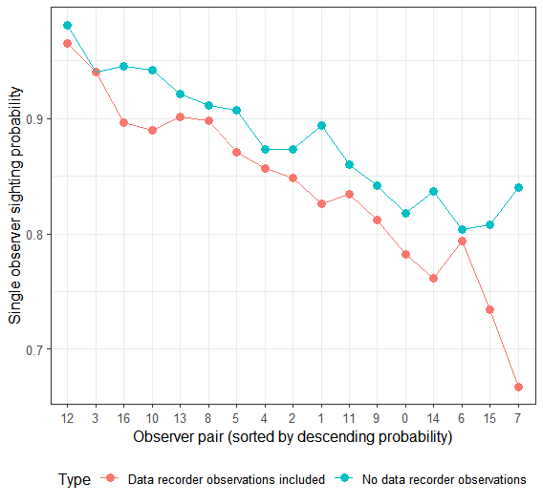 | 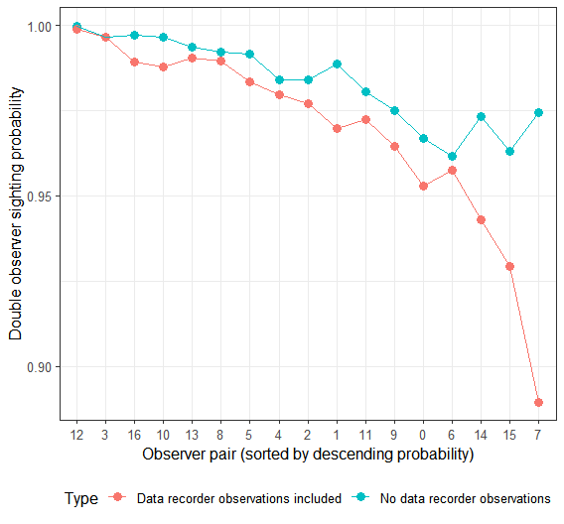
Figure 16. Naïve single and double observer probabilities by observer pair. Pairs are sorted by descending detection probabilities. Estimates with and without data recorder observations are shown.

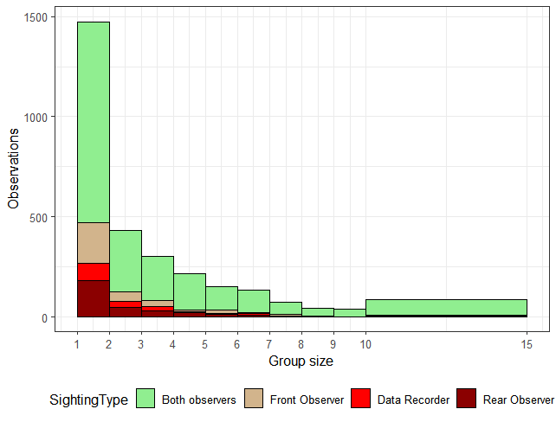
Figure 17. Observations by caribou group size. Groups sizes above 15 were pooled into the 15 class.

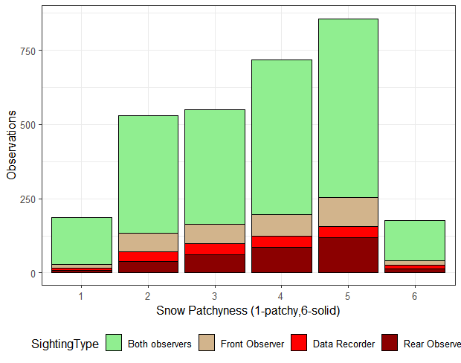 | 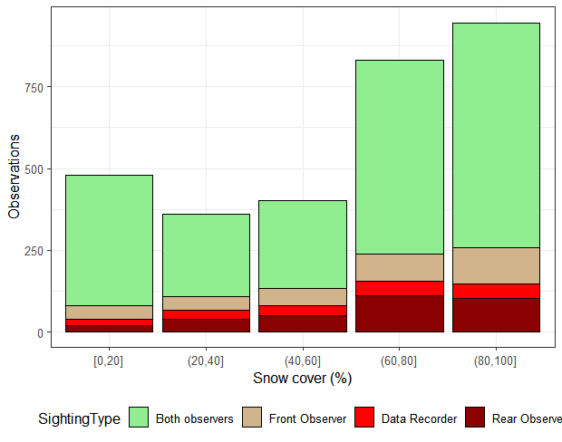
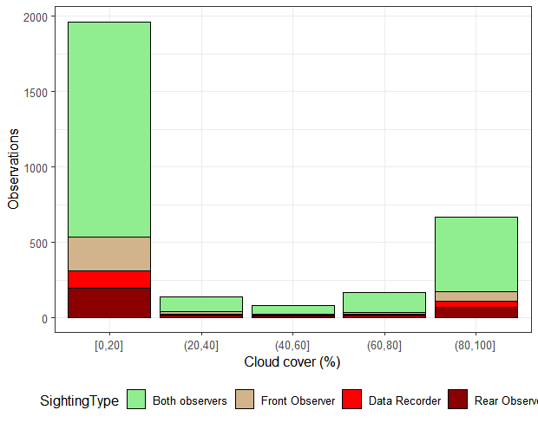 | 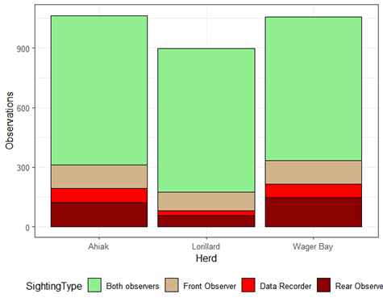
Figure 18. Distributions of covariates used in the analysis with observation type noted.

4.2.2 Modelling Estimates
Double observer models were built starting with univariate models where each covariate was tested individually (Table 6). Most covariates, with the exception of cloud cover showed higher support than a constant null model (Model 23). Of the covariates, observer pair (Obs) (Model 10) showed the strongest support. Models were then built using observer pair combined with other supported covariates. Of these models, a model with observer pair, snow patch, herd, and size (group size) (Model 1) was most supported. Predictions from the most supported model showed a range of detection probabilities as a function of group size and snow patchiness while plots by observer pair show reasonable differences between some observer pairings (Figure 19 & 20).
Estimates for survey stratum are given in Table 7. For the Ahiak herd, the HD_Ext_B stratum was excluded since it likely contained Beverly caribou when the survey occurred (Figure 15). Estimates for the Ahiak and Wager Bay were very precise with CV’s of less than 10%. The Lorillard herd estimate was less precise (CV=15.2%) due to low precision of the LD_HDC stratum that contained aggregated distributions of caribou (Figure 13).
A comparison of estimates for double observer analyses including, excluding, and filtering data recorder observations revealed a range of estimates with estimates below the strip transect estimator if all data recorder observations were excluded (Figure 21). The approach used included data recorder observations for weak observer pairs where estimates were below an estimate that included all data recorder observations. This further suggested that the filtering approach was a compromise between the risk of positive bias (by including all data recorder observations) and negative bias (by excluding all data recorder observations). This approach was further validated using program MARK models as detailed in Appendix 1. A listing of strip transect estimates is given in Appendix 2.
The precision of the double observer analyses is higher than the strip transect estimators despite the higher complexity of the double observer models. The reason for this is that a more advanced variance estimator that considers spatial patterns in distribution (Fewster et al 2009) was used for the double observer analysis as incorporated in the mrds package. We note that for this comparison all Ahiak strata were used since this estimate was most applicable to the double observer methods employed. For subsequent analyses the HD_ExtB stratum was excluded from Ahiak estimates.

Table 6. Dependent double observer pair model selection results. Sample size adjusted Akaike Information Criterion (AICc), the difference in AICc between the most supported model for each model (ΔAIC_{c}), AIC_{c} weight (w_{i}), number of model parameters (K) and deviance is given.
No | Model | AIC_{c} | AIC_{c} | w_{i} | K | LL
1 | Obs + PatchC + Herd + size | 2282.85 | 0.00 | 0.74 | 21 | -1118.06
2 | Obs + PatchC + Herd + snowC + size | 2284.92 | 2.07 | 0.26 | 22 | -1117.85
3 | Obs + size | 2295.25 | 12.40 | 0.00 | 18 | -1127.9
4 | Obs + PatchC | 2302.62 | 19.77 | 0.00 | 18 | -1131.58
5 | Obs + PatchC5 | 2305.32 | 22.47 | 0.00 | 18 | -1132.93
6 | Obs + Herd | 2308.52 | 25.67 | 0.00 | 19 | -1133.33
7 | Obs + snowC | 2310.00 | 27.15 | 0.00 | 18 | -1135.27
8 | Obs + PatchF | 2310.19 | 27.33 | 0.00 | 22 | -1130.48
9 | Obs | 2310.31 | 27.46 | 0.00 | 17 | -1136.62
10 | Obs + snowF | 2310.82 | 27.97 | 0.00 | 21 | -1132.04
11 | Obs + PatchF5 | 2312.31 | 29.46 | 0.00 | 21 | -1132.79
12 | Obs + cloudF + snowF | 2316.95 | 34.10 | 0.00 | 25 | -1130.07
13 | pair15 + pair14 + pair7 | 2341.54 | 58.69 | 0.00 | 4 | -1166.68
14 | Weakobs (pooled) | 2343.16 | 60.31 | 0.00 | 2 | -1169.55
15 | Herd | 2407.78 | 124.93 | 0.00 | 3 | -1200.83
16 | snowF | 2431.83 | 148.98 | 0.00 | 5 | -1210.77
17 | cloudF + snowF | 2435.75 | 152.90 | 0.00 | 9 | -1208.44
18 | size | 2449.97 | 167.12 | 0.00 | 2 | -1222.96
19 | Logsize | 2454.21 | 171.36 | 0.00 | 2 | -1225.08
20 | PatchF | 2456.76 | 173.91 | 0.00 | 6 | -1222.18
21 | PatchC | 2458.84 | 175.99 | 0.00 | 2 | -1227.39
22 | snowC | 2460.56 | 177.71 | 0.00 | 2 | -1228.25
23 | constant | 2466.45 | 183.60 | 0.00 | 1 | -1232.22
24 | cloudc | 2468.43 | 185.58 | 0.00 | 2 | -1232.19
25 | cloudF | 2471.69 | 188.84 | 0.00 | 5 | -1230.7

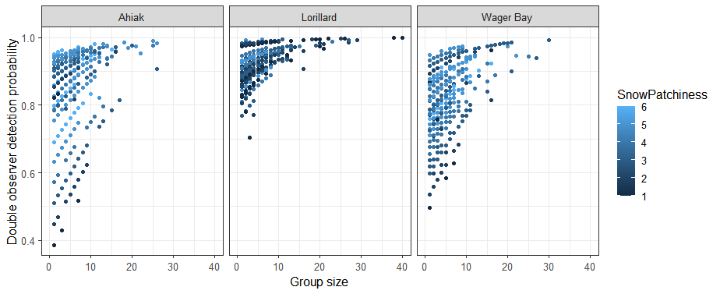
Figure 19. Estimates of double observer sighting probability for different herds as a function of snow patchiness and observer pair.

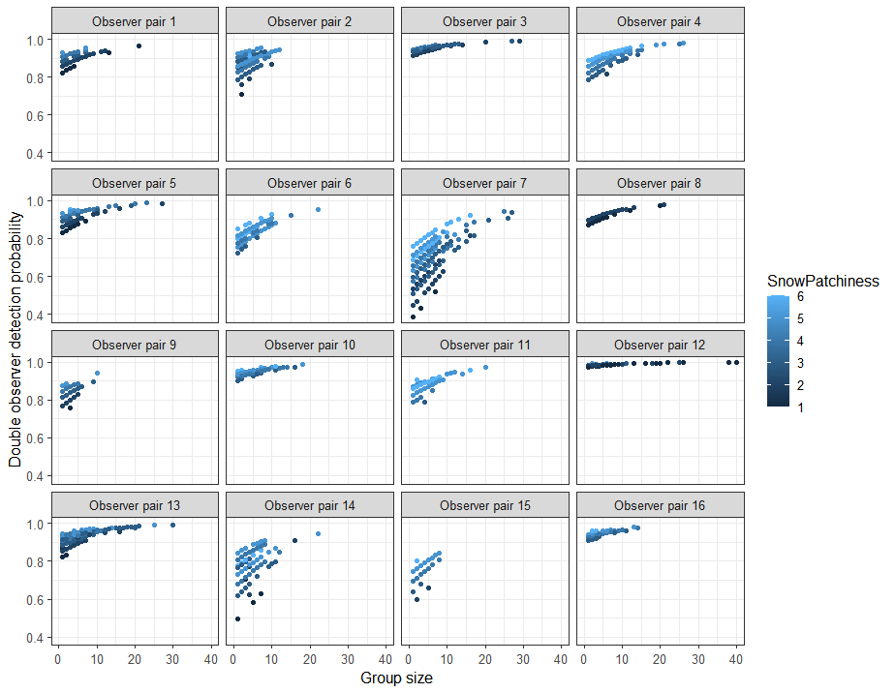
Figure 20. Estimated double observer detection probability for observer pairs as a function of snow patchiness and herd surveyed.

Table 7. Estimates of caribou in survey strata using the most supported double observer model (obspair+size+herd+patchC).
Strata | Caribou observed | N | SE | LCL | UCL | CV
Ahiak
A_HDNW | 2,576 | 23,799 | 1896.11 | 20,219 | 28,014 | 8.0%
A_LDN | 83 | 1,111 | 407.05 | 508 | 2,426 | 36.6%
A_WEX_A | 596 | 5,459 | 583.14 | 4,320 | 6,898 | 10.7%
Total | 3,255 | 30,369 | 2033.87 | 26,515 | 34,784 | 6.7%
Beverly (partial)
A_WEX_B | 842 | 8,670 | 1258.52 | 5,982 | 12,565 | 14.5%
Lorillard
L_HDC | 2,245 | 16,755 | 4548.84 | 9,606 | 29,223 | 27.1%
L_HDSE | 945 | 8,187 | 847.29 | 6,538 | 10,251 | 10.3%
L_LDNC | 10 | 107 | 67.22 | 27 | 418 | 62.7%
L_LDW | 422 | 5,308 | 1359.96 | 3,026 | 9,309 | 25.6%
L_MDNE | 191 | 1,437 | 229.99 | 956 | 2,161 | 16.0%
Total | 3,813 | 31,794 | 4828.84 | 23,294 | 43,394 | 15.2%
Wager Bay
W_HDNE | 555 | 5,792 | 597.05 | 4,649 | 7,215 | 10.3%
W_HDNW | 2,392 | 21,558 | 2062.07 | 17,700 | 26,259 | 9.6%
W_HDS | 309 | 2,432 | 304.97 | 1,862 | 3,177 | 12.5%
W_LDN | 36 | 474 | 137.13 | 247 | 910 | 28.9%
W_LDNE | 30 | 375 | 148.57 | 147 | 954 | 39.6%
W_LDSW | 230 | 3,002 | 475.98 | 2,150 | 4,192 | 15.9%
W_MDEC | 140 | 1,054 | 204.36 | 682 | 1,627 | 19.4%
W_MDWA | 52 | 489 | 218.71 | 163 | 1,465 | 44.7%
Total | 3,744 | 35,177 | 2255.18 | 30,879 | 40,073 | 6.4%

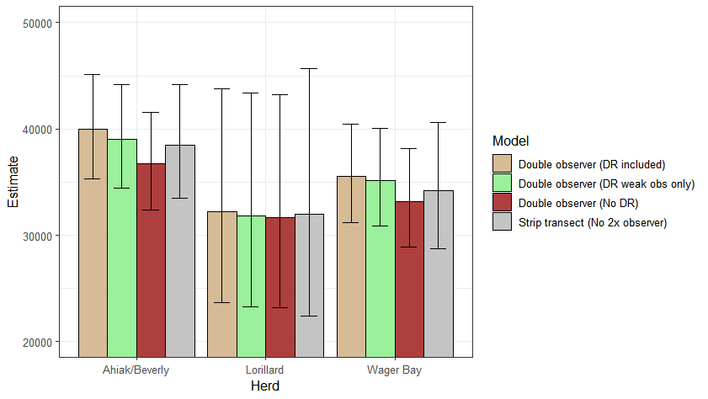
Figure 21. Comparison of estimates of herd size using various double observer and strip transect methods. The estimate used (double observer DR weak obs only) is colored green. All Ahiak strata were used for the Ahiak estimate for this comparison whereas the A_WEX_B was removed for estimates of the Ahiak herd.

4.3 Composition surveys

Composition surveys occurred from June 9 to June 15, 2021 with the main strata for each herd being surveyed (Figure 22). Some strata were not surveyed and therefore a pooling approach was used to estimate proportion of adult females in these strata based on adjacent strata. Composition data on visual flights (Figure 23) suggests similar locations of breeder groups of caribou as well as higher densities targeted during composition flights. Breeder caribou (delineated by red dots (calves) or green dots (hard antlered females) were found in all strata. A summary of composition data is given in Table 8.

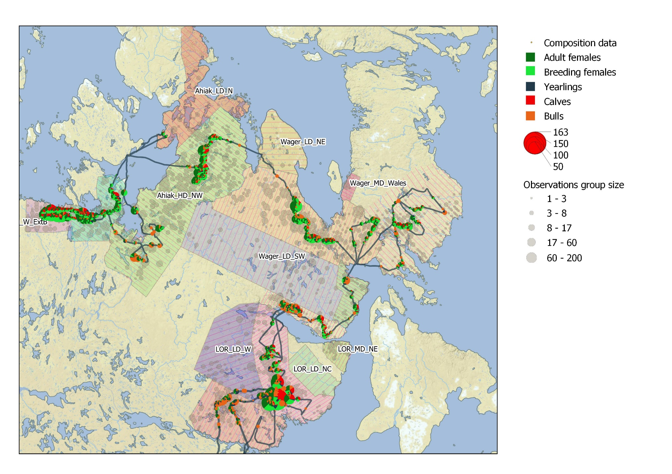
Figure 22. Composition sampling of survey strata. Pie charts delineate classifications for each observation with flight lines shown. Also shown in the background are observations on transect (as shown in more detail in Figure 2 and 12).

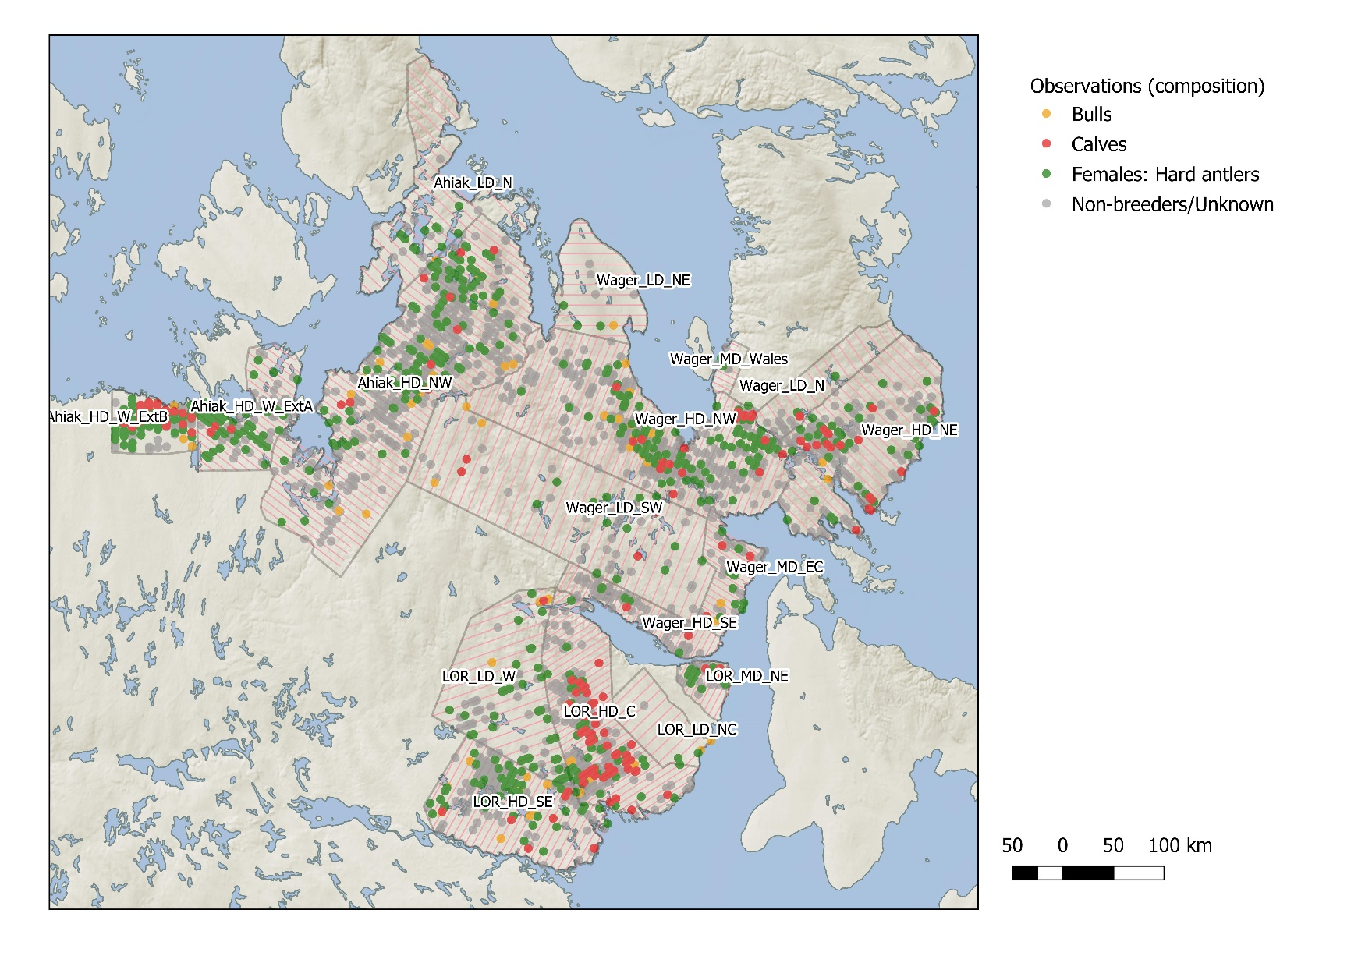
Figure 23. Composition data collected during visual surveys. An observation was coded (sequentially) red if at least one calf was observed, green if hard antlered caribou were observed, brown if bull caribou were observed, and grey if no caribou were classified in the observation).

Table 8. Summary of observations from composition surveys.
Strata | Cows |  |  | Calves | Bulls | Yearlings | Total Caribou | groups
Strata | Breeding | Non-breeding | Total cows
Ahiak
A_HDNW | 410 | 108 | 518 | 176 | 191 | 39 | 709 | 90
A_WEX_A | 457 | 79 | 536 | 155 | 59 | 75 | 595 | 80
A_WEX_B | 427 | 38 | 465 | 267 | 36 | 37 | 501 | 32
Lorillard
L_HDC | 1065 | 203 | 1268 | 897 | 320 | 140 | 1588 | 77
L_HDSE | 15 | 84 | 99 | 4 | 222 | 94 | 321 | 60
L_LDW | 6 | 45 | 51 | 3 | 52 | 34 | 103 | 15
Wager Bay
W_HDNE | 169 | 36 | 205 | 85 | 75 | 24 | 280 | 62
W_HDNW | 479 | 85 | 564 | 156 | 125 | 58 | 689 | 87
W_HDS | 144 | 37 | 181 | 83 | 134 | 56 | 315 | 51
W_LDN | 42 | 8 | 50 | 3 | 17 | 5 | 67 | 12
W_MDE | 29 | 7 | 36 | 15 | 29 | 9 | 65 | 11

4.4 Estimates of adult females, breeding females, and herd size.

Not all survey strata were sampled for composition and therefore adjacent strata were used to estimate composition in some cases to allow estimation of breeding and adult females. Table 9 has a composition strata column that details strata used for composition strata. Cells are shaded when different strata were used to estimate composition than the survey strata. In all cases the number of caribou in strata with adjacent strata used for composition estimates was low and therefore estimates are not highly sensitive to this approach. Adult females and breeding females were estimated for each stratum and herd (Tables 9 and 10). We used the adult female based estimate which is simply the estimate of adult females for each herd divided by the proportion females in the herd (Table 8) and represents adult female and males in the herd (excluding yearlings). For estimates, we used the Beverly 2011 proportion cow estimate for extrapolated herd estimates. We note the difference in proportion cows is not that large between herds (Table 11) so estimates will not be very sensitive to the proportion cows that is used. Potential sex ratios used for estimates was based upon various herds (Boulanger et al. 2018, Campbell et al. 2019) to obtain estimates of extrapolated herd size (Table 12).

Table 9. Estimates of adult females for survey strata based on total estimate of caribou and proportion adult females in strata (pf). Survey strata and strata used for composition (Comp Strata) are given. Cells are shaded when a different strata was used to estimate composition in the survey strata.
Strata | Total caribou |  |  | Proportion  Adult females |  | Adult females
Survey | Composition | N | CV | pf | CV | N | SE | LCL | UCL | CV
Ahiak
A_HDNW | A_HDNW | 23,799 | 8.0% | 0.731 | 5.2% | 17,388 | 1652.6 | 14,317 | 21,118 | 9.5%
A_LDN | A_HDNW | 1,111 | 36.6% | 0.731 | 5.2% | 812 | 300.4 | 369 | 1,786 | 37.0%
A_WEX_A | A_WEX_A | 5,459 | 10.7% | 0.901 | 1.6% | 4,918 | 531.0 | 3,882 | 6,230 | 10.8%
Total |  | 30,369 | 6.7% |  |  | 23,118 | 1761.6 | 19,777 | 27,023 | 7.6%
Lorillard
L_HDC | L_HDC | 16,755 | 27.1% | 0.798 | 3.8% | 13,379 | 3667.0 | 7,631 | 23,455 | 27.4%
L_HDSE | L_HDSE | 8,187 | 10.3% | 0.308 | 11.7% | 2,525 | 394.1 | 1,801 | 3,540 | 15.6%
L_LDNC | L_HDC | 107 | 62.7% | 0.798 | 3.8% | 85 | 53.8 | 22 | 335 | 63.3%
L_LDW | L_LDW | 5,308 | 25.6% | 0.495 | 16.8% | 2,628 | 804.6 | 1,349 | 5,120 | 30.6%
L_MDNE | L_HDC | 1,437 | 16.0% | 0.798 | 3.8% | 1,147 | 188.7 | 754 | 1,744 | 16.4%
Total |  | 31,794 | 15.0% |  |  | 19,764 | 3780.0 | 13,309 | 29,350 | 19.1%
Wager Bay
W_HDNE | W_HDNE | 5,792 | 10.3% | 0.732 | 6.5% | 4,241 | 516.8 | 3,272 | 5,497 | 12.2%
W_HDNW | W_HDNW | 21,558 | 9.6% | 0.819 | 2.9% | 17,647 | 1761.4 | 14,365 | 21,679 | 10.0%
W_HDS | W_HDS | 2,432 | 12.5% | 0.575 | 7.8% | 1,397 | 206.7 | 1,020 | 1,914 | 14.8%
W_LDN | W_LDN | 474 | 28.9% | 0.746 | 11.6% | 354 | 110.2 | 176 | 713 | 31.1%
W_LDNE | W_HDNE | 375 | 39.6% | 0.732 | 6.5% | 275 | 110.2 | 107 | 707 | 40.1%
W_LDSW | W_HDS | 3,002 | 15.9% | 0.575 | 7.8% | 1,725 | 305.1 | 1,189 | 2,502 | 17.7%
W_MDEC | W_MDEC | 1,054 | 19.4% | 0.554 | 23.4% | 584 | 177.5 | 298 | 1,144 | 30.4%
W_MDWA | W_LDN | 489 | 44.7% | 0.746 | 11.6% | 365 | 168.6 | 118 | 1,130 | 46.2%
Total |  | 35,177 | 6.4% |  |  | 26,588 | 1894.7 | 22,950 | 30,802 | 7.1%

Table 10. Estimates of breeding females for survey strata based on total estimate of caribou and proportion breeding females in strata (pbf). Survey strata and strata used for composition (Comp Strata) are given. Cells are shaded when a different strata was used to estimate composition in the survey strata.
Strata |  | Total caribou |  | Proportion breeding females |  | Breeding female estimates
Survey | Composition | N | CV.N | pb | CV | N | SE | LCL | UCL | CV
Ahiak
A_HDNW | A_HDNW | 23,799 | 8.0% | 0.578 | 7.4% | 13,762 | 1500.1 | 11,014 | 17,196 | 10.9%
A_LDN | A_HDNW | 1,111 | 36.6% | 0.578 | 7.4% | 642 | 240.2 | 289 | 1,424 | 37.4%
A_WEX_A | A_WEX_A | 5,459 | 10.7% | 0.768 | 3.3% | 4,193 | 469.2 | 3,282 | 5,357 | 11.2%
Total |  | 30,369 | 6.7% |  |  | 18,597 | 1590.0 | 15,910 | 21,738 | 8.5%
Lorillard
L_HDC | L_HDC | 16,755 | 27.1% | 0.671 | 7.2% | 11,237 | 3155.2 | 6,325 | 19,962 | 28.1%
L_HDSE | L_HDSE | 8,187 | 10.3% | 0.047 | 32.1% | 383 | 129.2 | 187 | 783 | 33.7%
L_LDNC | L_HDC | 107 | 62.7% | 0.671 | 7.2% | 72 | 45.4 | 18 | 283 | 63.0%
L_LDW | L_LDW | 5,308 | 25.6% | 0.058 | 53.1% | 309 | 182.2 | 92 | 1,043 | 59.0%
L_MDNE | L_HDC | 1,437 | 16.0% | 0.671 | 7.2% | 964 | 169.0 | 617 | 1,506 | 17.5%
Total |  | 31,794 | 15.0% |  |  | 12,965 | 3167.9 | 8,730 | 19,253 | 24.4%
Wager Bay
W_HDNE | W_HDNE | 5,792 | 10.3% | 0.604 | 8.6% | 3,496 | 470.2 | 2,626 | 4,654 | 13.4%
W_HDNW | W_HDNW | 21,558 | 9.6% | 0.695 | 4.1% | 14,987 | 1557.6 | 12,097 | 18,567 | 10.4%
W_HDS | W_HDS | 2,432 | 12.5% | 0.457 | 10.9% | 1,112 | 185.0 | 781 | 1,583 | 16.6%
W_LDN | W_LDN | 474 | 28.9% | 0.627 | 14.6% | 297 | 96.3 | 143 | 615 | 32.4%
W_LDNE | W_HDNE | 375 | 39.6% | 0.604 | 8.6% | 226 | 91.8 | 87 | 588 | 40.6%
W_LDSW | W_HDS | 3,002 | 15.9% | 0.457 | 10.9% | 1,372 | 264.4 | 915 | 2,056 | 19.3%
W_MDEC | W_MDEC | 1,054 | 19.4% | 0.446 | 26.5% | 470 | 154.5 | 228 | 970 | 32.9%
W_MDWA | W_LDN | 489 | 44.7% | 0.627 | 14.6% | 307 | 144.2 | 97 | 967 | 47.0%
Total |  | 35,177 | 6.4% |  |  | 22,267 | 1677.4 | 19,220 | 25,797 | 7.5%

Table 11. Proportion cows and bull cow ratios from previous caribou calving ground surveys
Herd | Year | Proportion cows |  |  |  | Bull-cow ratio
Herd | Year | estimate | SE | cilow | cihigh | Estimate | cilow | cihigh
BNE | 2021 | 0.603 | 0.022 | 0.562 | 0.640 | 0.660 | 0.563 | 0.779
Bathurst | 2020 | 0.610 | 0.029 | 0.554 | 0.665 | 0.641 | 0.505 | 0.806
Qamanirjuaq | 2016 | 0.619 | 0.010 | 0.601 | 0.639 | 0.616 | 0.566 | 0.664
Beverly | 2011 | 0.590 | 0.009 | 0.570 | 0.610 | 0.693 | 0.650 | 0.740

Table 12. Extrapolated herd estimates based on Beverly 2011 fall comp estimate of proportion cows.
Herd | Adult females |  | Proportion cows |  | Herd estimate
Herd | N | CV | pc | SE | N | SE | LCL | UCL | CV
Ahiak | 23,118 | 7.6% | 0.59078 | 0.01 | 39,131 | 3034.5 | 33,385 | 45,867 | 7.8%
Lorillard | 19,764 | 19.1% | 0.59078 | 0.01 | 33,454 | 6416.4 | 22,503 | 49,735 | 19.2%
Wager Bay | 26,588 | 7.1% | 0.59078 | 0.01 | 45,005 | 3271.8 | 38,732 | 52,293 | 7.3%

4.5 Comparison of Ahiak 2011 and 2021 estimates.

Estimates from June 2011 were compared to the June 2021 estimates for the Ahiak herd. A comparison of survey strata from each year suggests reasonable overlap between years (Figure 24). In 2011, the survey did not extend as far north, however, few caribou were detected in this area in 2021. In 2021, the northern Adelaide Peninsula was not surveyed to the west, however, few caribou were detected in this area in 2011. In 2011, areas to the east up to Kugaaruk were included as Ahiak strata, however in 2021 these were surveyed as Wager Bay strata and therefore were not included in the comparison.
In 2011, only a portion of the strata were surveyed for composition which prevented an estimate of adult females that was comparable with the 2021 estimate. Therefore, we compared estimates of adult (1+ year old caribou). Also, the Adelaide Peninsula has contained both Beverly and Ahiak caribou and therefore trend analysis was conducted with and without strata on the Adelaide Peninsula to test the sensitivity of trend estimates to inclusion of this area (Table 13). Viewed graphically, the decline is evident regardless of whether Adelaide Peninsula is included in estimates (Figure 25). Estimates of overall and yearly trend were generated using the ratio of the two estimates (assuming a log-normal distribution of estimates with exponential change in abundance between surveys) (Table 14). Overall change was significant (p<0.0001) as indicated by confidence limits of estimates. Annual change equated to a significant decline of 4-5% per year.

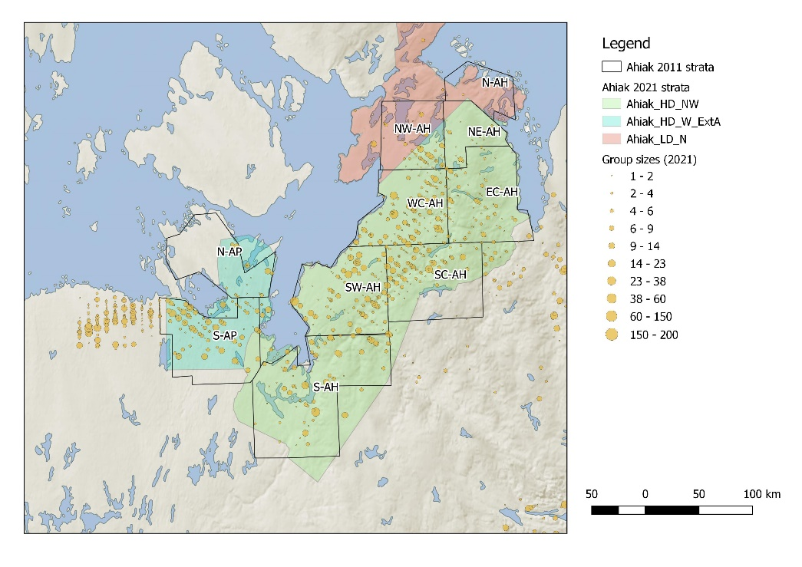
Figure 24. Survey strata from 2011 used to compare with 2021 survey strata. Strata from 2011 are labelled whereas 2021 strata are denoted by colored polygon. Observations from 2011 are shown for reference purposes.

Table 13. Estimates of adult caribou in the Ahiak herd in 2011 and 2021 with and without the Adelaide Peninsula included in estimates
Area | Year | Caribou counted | N | SE | Conf. Limit |  | CV
Ahiak (AP) | 2011 | 7420 | 58090 | 3535.5 | 51458 | 65577 | 6.1%
Ahiak (AP) | 2021 | 3255 | 30369 | 2033.9 | 26515 | 34784 | 6.7%
Ahiak (-AP) | 2011 | 5669 | 40341 | 2926.2 | 34877 | 46660 | 7.3%
Ahiak (-AP) | 2021 | 2659 | 24910 | 1939.9 | 21253 | 29196 | 7.8%

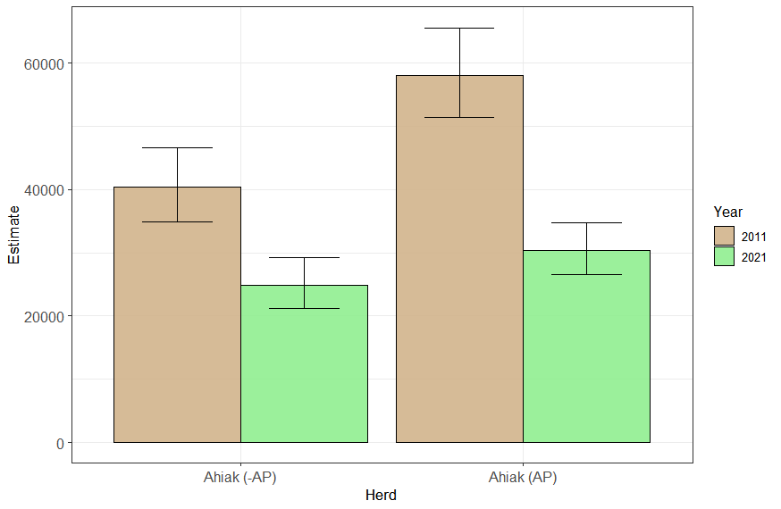
Figure 25. Estimates of the Ahiak herd without and with the Adelaide Peninsula strata included.

Table 14. Estimates of overall change (over the 10-year interval between surveys) and annual change for the Ahiak herd with and without the Adelaide Peninsula strata included.
Data set | Overall change | SE | Confidence limit |  | Yearly change (λ) | SE | Confidence limit
Ahiak (-AP) | 0.62 | 0.07 | 0.50 | 0.76 | 0.95 | 0.01 | 0.93 | 0.97
Ahiak (AP) | 0.52 | 0.05 | 0.44 | 0.62 | 0.94 | 0.01 | 0.92 | 0.95

4.6 Analysis of historic collar data to assess fidelity and movements.

For interpretation of estimates we wanted to know the relative fidelity of caribou to calving grounds. If there was minimal fidelity, then it would suggest the estimates should be interpreted as a larger super/sub population estimate rather than calving ground specific estimate. As done in 2018 for the Beverly survey analysis (Campbell et al. 2019), we assigned calving grounds to caribou based on polygons shown below. These were adjusted to mirror the 2021 strata (Figure 26). We then assessed whether caribou show fidelity to their calving areas each year. Below is a plot that show migration paths and locations for collared females from 2016-2021 (Figure 27). Migration paths often are fairly intertwined suggesting some overlap in wintering areas. The data in Figure 27 was further analyzed to assess fidelity (Figure 28). The plot below shows mean locations of calving each year for caribou monitored more than 1 year with an arrow connecting successive mean calving ground locations. The tail of the arrow is the previous year calving location, and the head of the arrow is the current year location. So, caribou that moved little are basically shown as the head of an arrow. Arrows are colored based on the previous year’s calving ground. This plot illustrates movement between most areas each year with a reasonable amount of variation in the location of calving for Wager Bay.
The data set was reduced to caribou detected in at least 2 years to allow observation of fidelity of movement to other calving grounds. Yearly sample sizes of caribou in calving ground polygons was low (<10) for most calving grounds with the exception of the Beverly. A summary of movements pooled across all years suggests movement within the Beverly-Adelaide-Ahiak, and Wager Bay-Lorillard calving ground complexes with occasional movement between these two groupings/complexes. In addition, a reasonable level of fidelity was suggested for the Beverly, Wager Bay, and Lorillard calving grounds. For example, 115 caribou calved in successive years in the Beverly calving ground.
A challenge with interpreting these summaries is differing sample sizes of collared caribou on each calving ground. Multi-state models were fit to this data to estimate probabilities of movement based on the frequencies in Table 15. A simple model with calving ground-specific movements (termed transition probabilities) was fit with no yearly variation in movements. This estimated a mean movement across all years. Limited sample sizes precluded more elaborate model fitting (Table 16). Movement parameters were fixed at zero if there were zero recorded movement events in the data set. This strategy allowed model fitting to the relatively sparse data set. Markov Chain Monte Carlo methods were used to crosscheck estimates.
Table 17 lists the estimates of movement from each calving ground. If the same calving ground is listed then it is an estimate of fidelity (movement from a calving ground back to the same calving ground). These estimates suggest higher fidelity to the Beverly (0.86), Wager Bay (0.69) and Lorillard Calving grounds (0.69) (Table 15). In contrast, fidelity was lower for the Adelaide (0.25) and Ahiak (0.44) with relatively high movement probabilities between Adelaide to Beverly (0.61) and Ahiak to Beverly (0.29) as well as Wager Bay to Lorillard (0.29) (Table 15). A graphical representation of these results provides a spatial understanding of the results. Figure 29 illustrates movement events from each calving ground with the boxed numbers giving frequencies of caribou returning to the calving ground in successive years and the arrows illustrating movements. A plot of movement probabilities shows how geographic location influences probability of movement (Figure 30). Namely, caribou in the Adelaide are more likely to occur in the Beverly calving ground compared to the Ahiak calving ground. Ahiak caribou often end up in any of the other calving grounds with a tendency to move towards the Adelaide or Beverly calving grounds. The Wager Bay and Lorillard have inter-calving ground movement with a suggestion of directional movement to the Lorillard.
A further challenge with interpreting probabilities of movement is that they can represent different numbers of caribou given differences in herd size based on each calving ground. To explore this further we used estimates of adult females for each of the calving ground areas (Table 9) and estimates of adult females for the Beverly in 2018 (62,620 excluding the Adelaide Peninsula)(Campbell et al. 2019). These were then multiplied by the movement probabilities between calving-grounds and an approximate yearly survival rate (0.8) to estimate the number of adult female caribou that might stay and move between calving-grounds in a given year. We note that this estimate is a gross simplification since it does not account for yearly variation in movements, the role of recruitment, as well as variance estimates. These conclusions therefore should be interpreted cautiously. As discussed, later a more elaborate meta-population simulation, IPM is needed to better understand the role of movements in herd dynamics.
The approximate N estimates demonstrate that while the movement probability estimates from larger herds like the Beverly are low (<0.1) they still amount to a relatively large number of caribou moving to the Adelaide and Ahiak calving grounds (relative to the number of caribou present on these calving grounds) (Figure 31). These results illustrate the need for a simulation or IPM approach to better understand the role of movement in the demography of these herds.

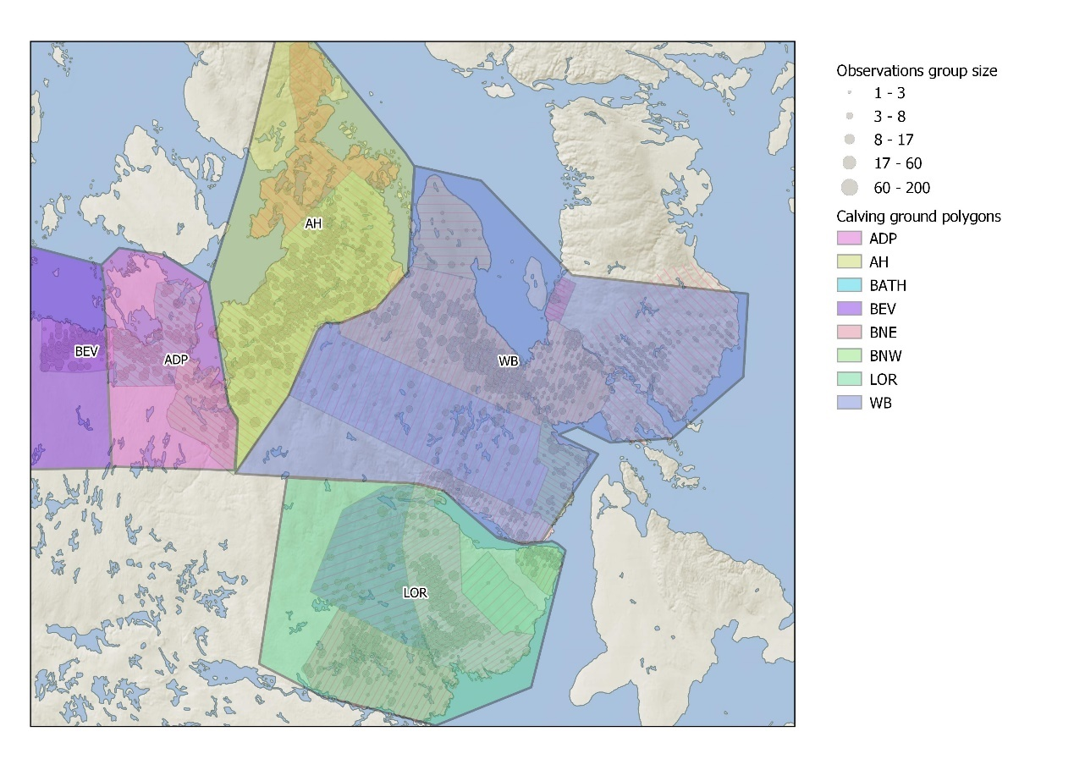
Figure 26. Polygons used to assign calving grounds to mean collar locations (on June 15 each year).

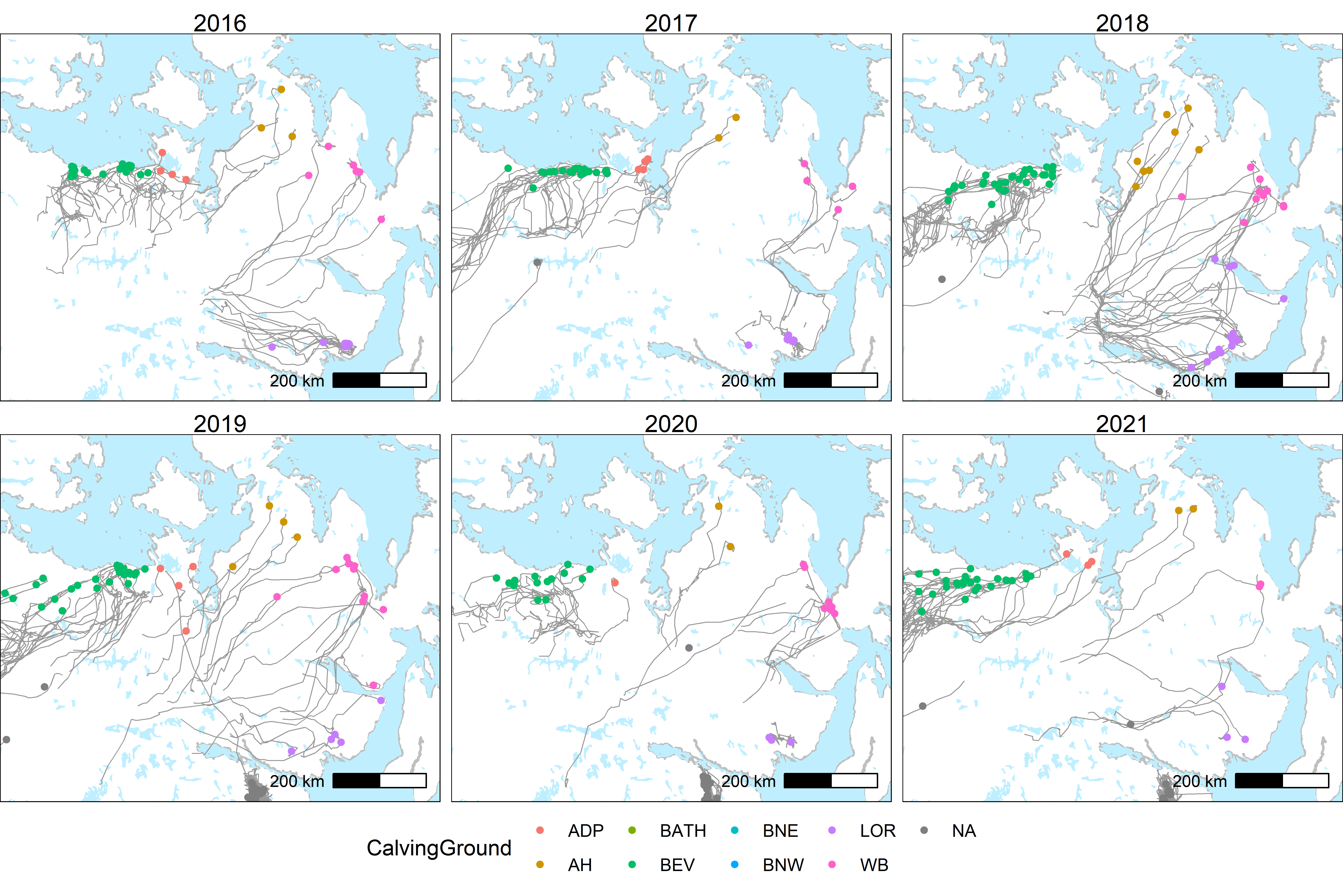
Figure 27. Migration paths and mean collar locations from 2016-2021. The locations of collars.

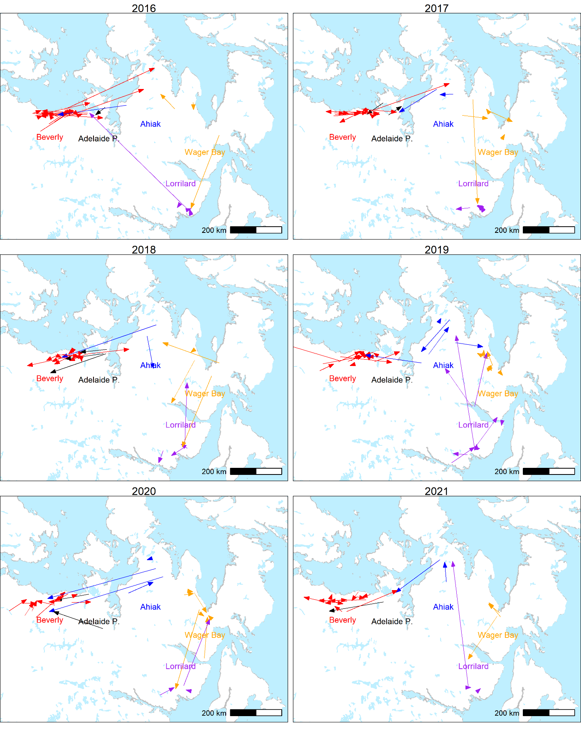
Figure 28. Mean calving ground locations for caribou in the previous year (tail of arrow) and current year (head of arrow) with the arrow colored according to the previous year calving ground.

Table 15. Multi-strata model estimates of movement probabilities between calving grounds. Estimates were not derived for movement events that had 0 frequency.
Movement | events | Movement  probability | SE | Conf. Limit
Beverly to:
Beverly | 115 | 0.86 | 0.03 | 0.80 | 0.91
Adelaide | 11 | 0.07 | 0.02 | 0.03 | 0.11
Ahiak | 8 | 0.05 | 0.02 | 0.02 | 0.09
Wager Bay | 0
Lorrilard | 0
Adelaide to:
Beverly | 10 | 0.61 | 0.11 | 0.38 | 0.80
Adelaide | 5 | 0.25 | 0.10 | 0.07 | 0.44
Ahiak | 2 | 0.11 | 0.07 | 0.03 | 0.35
Wager Bay | 0
Lorrilard | 1 | 0.03 | 0.01 | 0.00 | 0.10
Ahiak to
Beverly | 7 | 0.29 | 0.08 | 0.12 | 0.45
Adelaide | 2 | 0.11 | 0.06 | 0.01 | 0.22
Ahiak | 11 | 0.44 | 0.09 | 0.26 | 0.63
Wager Bay | 3 | 0.11 | 0.06 | 0.02 | 0.22
Lorrilard | 3 | 0.06 | 0.03 | 0.00 | 0.10
Wager Bay to
Beverly | 0
Adelaide | 0
Ahiak | 3 | 0.07 | 0.05 | 0.01 | 0.17
Wager Bay | 20 | 0.69 | 0.08 | 0.52 | 0.84
Lorrilard | 5 | 0.22 | 0.07 | 0.08 | 0.37
Lorillard to
Adelaide | 0
Ahiak | 0
Wager Bay | 6 | 0.13 | 0.05 | 0.05 | 0.27
Lorillard | 34 | 0.85 | 0.05 | 0.73 | 0.95
Beverly | 1 | 0.03 | 0.02 | 0.00 | 0.07

Table 16. Yearly sample sizes of female collared caribou that were detected at a calving ground based on collared caribou detected in at least 2 different years.
Year | Beverly | Adelaide | Ahiak | Wager Bay | Lorillard
2011 | 6 | 1 | 7 | 0 | 6
2012 | 15 | 1 | 6 | 0 | 5
2013 | 6 | 5 | 4 | 0 | 4
2014 | 24 | 4 | 0 | 1 | 3
2015 | 27 | 2 | 1 | 3 | 5
2016 | 23 | 4 | 3 | 5 | 9
2017 | 22 | 4 | 2 | 4 | 8
2018 | 28 | 0 | 6 | 8 | 13
2019 | 24 | 4 | 4 | 10 | 5
2020 | 15 | 1 | 2 | 7 | 3
2021 | 13 | 2 | 2 | 2 | 3
Total | 203 | 28 | 37 | 40 | 64

Table 17. Summary of movement events between calving grounds pooled across 2011-2021.
Current Calving ground | Previous calving ground
Current Calving ground | Beverly | Adelaide | Ahiak | Wager Bay | Lorillard
Beverly | 115 | 11 | 8 | 0 | 0
Adelaide | 10 | 5 | 2 | 0 | 1
Ahiak | 7 | 2 | 11 | 3 | 3
Wager Bay | 0 | 0 | 3 | 20 | 5
Lorillard | 1 | 0 | 0 | 6 | 34

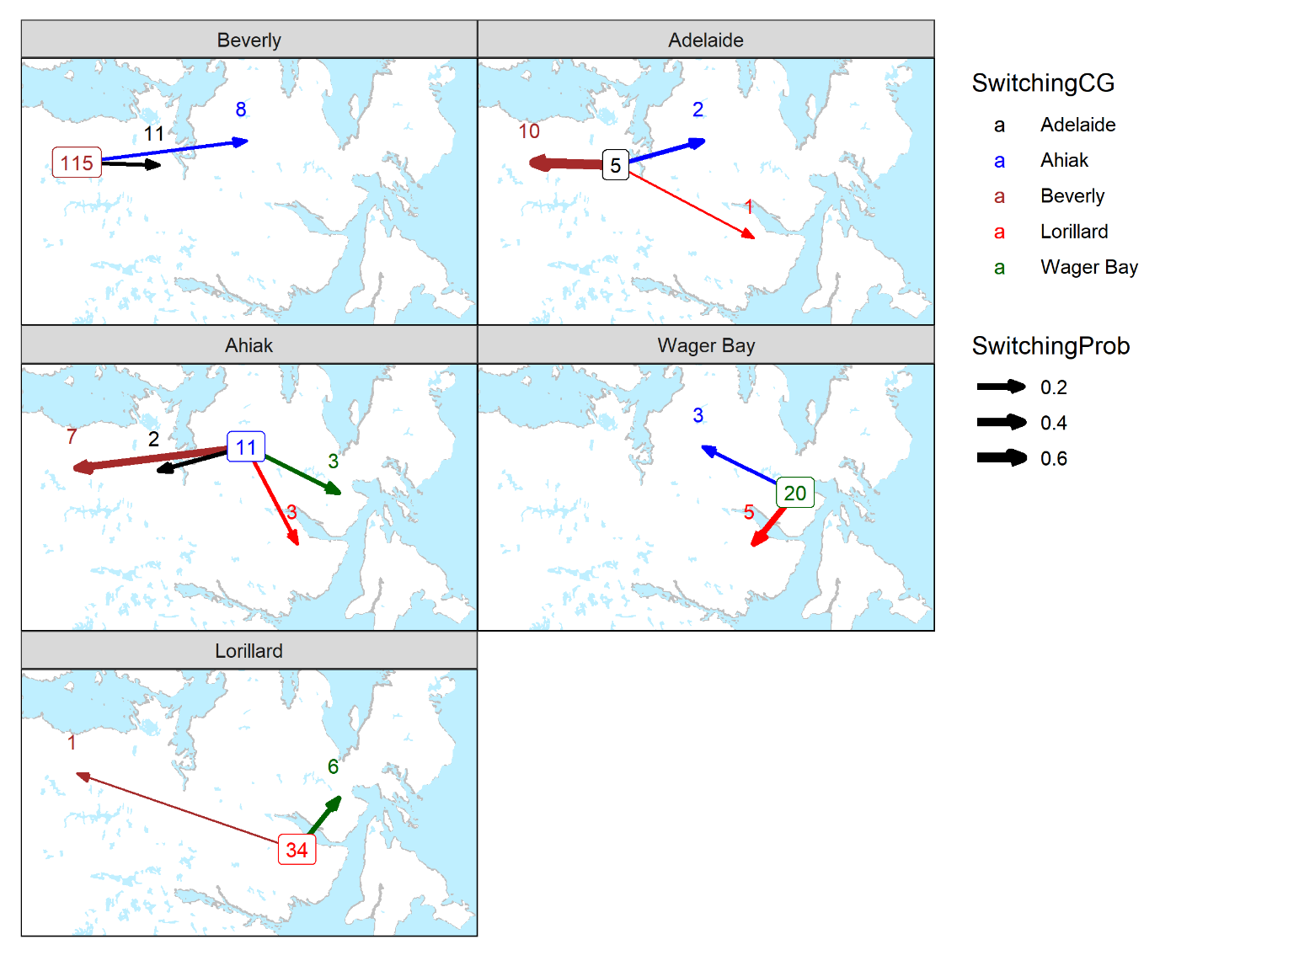
Figure 29. Frequencies of movement events between each calving ground from 2011-2021. Each plot shows movement from the given calving ground. The boxed number is the number of successive yearly movements back to the calving ground (fidelity) whereas the arrows and associated numbers are movements to other calving grounds (delineated by color and location of arrow endpoint). The width of the arrow is proportional to the movement probability (Table 16).

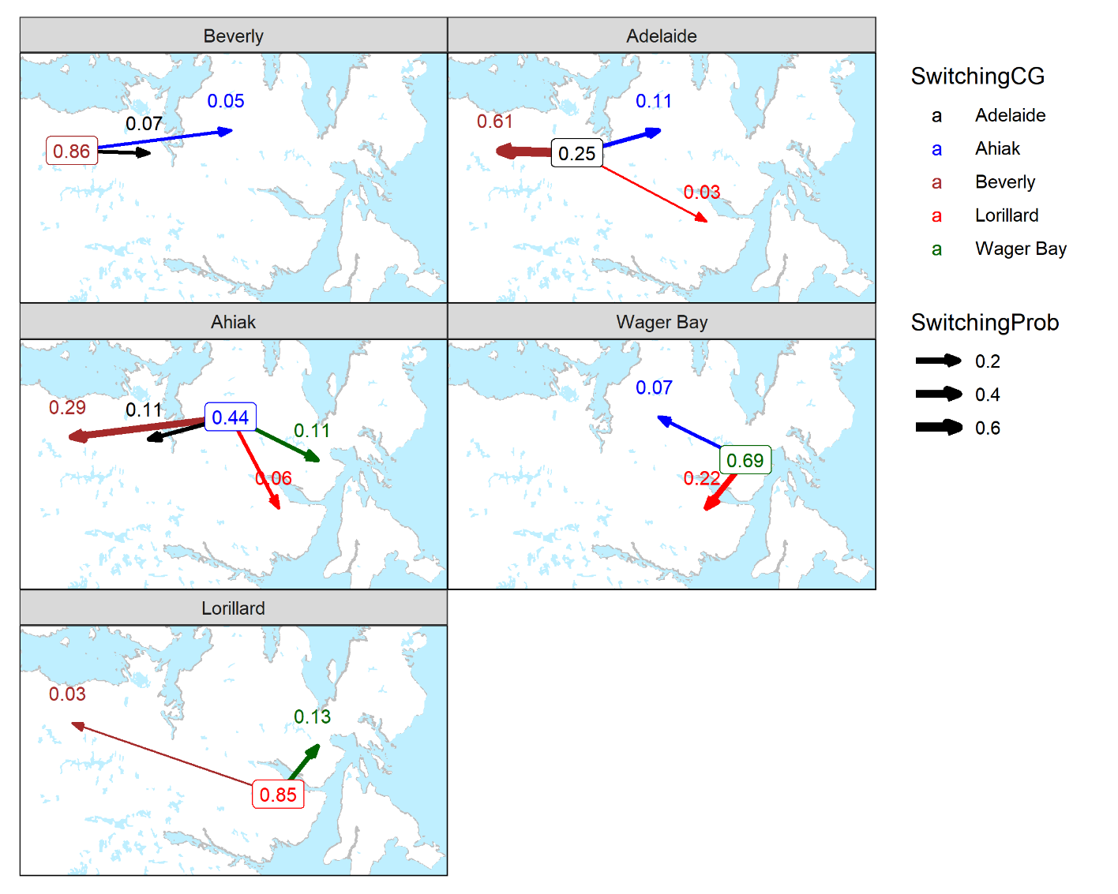
Figure 30. Movement probabilities between each calving ground from 2011-2021. Each plot shows movement from the given calving ground. The boxed probability is the probability of going back to the calving ground (fidelity) whereas the arrows and associated probabilities are movements to other calving grounds (delineated by color and location of arrow endpoint). The width of the arrow is proportional to the movement probability (Table 16).

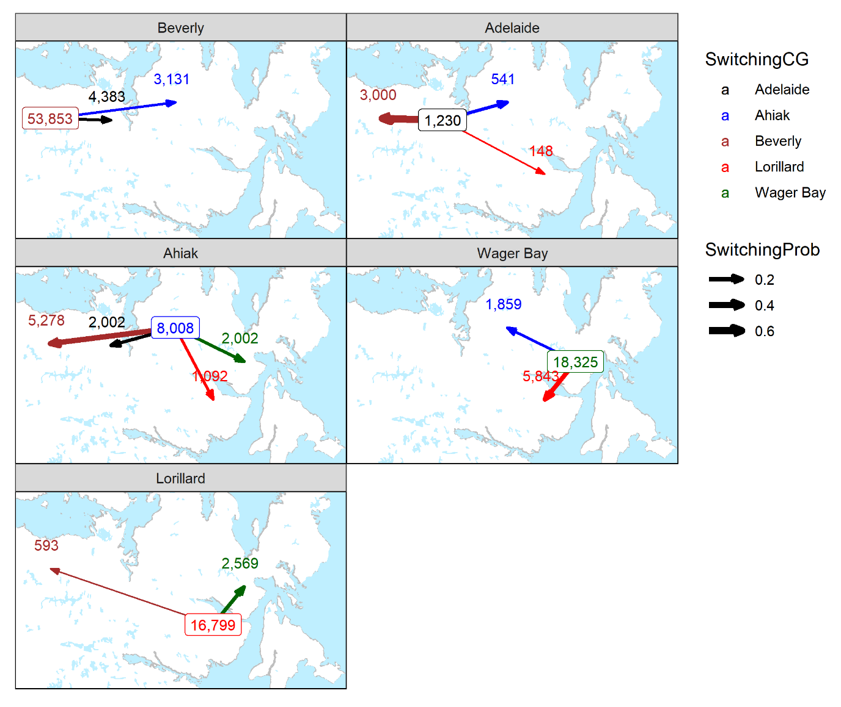
Figure 31. Approximate relative mean numbers of caribou moving between each calving ground from 2011-2021. Each plot shows an estimated number of caribou moving from the given calving ground in a year assuming initial herd sizes estimated in this survey and the 2018 Beverly. The boxed estimate is the number of caribou returning calving ground (fidelity) whereas the arrows and associated probabilities are movements to other calving grounds (delineated by color and location of arrow endpoint). The width of the arrow is proportional to the movement probability (Table 16). These numbers are more for illustrative purposes and should be interpreted cautiously.

5.0 Conclusions

The June 2021 Ahiak, Wager Bay, and Lorillard (collectively known as the Northeast Mainland caribou herds) abundance survey effort aimed to effectively involve Inuit participation and training opportunities, to build capacity and understanding within Nunavut communities as well as within Nunavuts wildlife research programs. In total our survey crew was made up of 48 individuals from HTO representatives to biologists to plots. Of our crew 31, or 66%, were made up of HTO selected participants from the communities of Baker Lake, Gjoa Haven, Kugaaruk, Naujaat, Rankin Inlet, and Taloyoak. In total we surveyed 209,494 km² between the three herds including the Ahiak (62,255 km²), Wager Bay (96,993 km²) and Lorillard (50,246 km²) and flew 30,625 km on transect, 9299 km within the Ahiak survey area, 13,707 km within the Wager Bay survey area, and 7,619 km within the Lorillard survey area. We estimated 39,131 (95% CI = 33,385-45,867, CV=7.8%) Ahiak caribou (not including yearlings), 45,005 (95% CI=38,735-52,293, CV=7.3%) Wager Bay caribou, and 33,454 (95% CI=22,503-49,735, CV=19.2%) Lorillard caribou, for an estimated 117,590 caribou within Nunavut’s Northeast Mainland. We detected a statistically significant (p<0.0001) decline in Ahiak herd (with the inclusion of Adelaide Peninsula estimates) abundance from 58,090 caribou (1+year old) (95% CI=51,458-65,577, CV=6.1%), to 30,369 caribou (95%CI=26,515-34,784, CV=6.7%) between June 2011 and June 2021, yielding an estimated decline of 52%, or 5.2% per year.
Surveys of the NEM herds flown between 1976 and 1995 suggested that caribou numbers had dropped significantly from 119,800 +/- 13,900 animals in 1983 to 73,994 +/- 11,670 caribou in 1995 (Calef and Helmer, 1976; Calef and Heard, 1981; Heard et al., 1981; Heard et al, 1987; Donaldson, 1981; Heard et al., 1986; Gunn and Lambert in prep.). Results suggested that caribou within the NEM herds likely underwent a decline of an estimated 62% between 1983 and 1995, an estimated 5.2% per year. These results, however, should be used with caution as both surveys methods utilized very low coverage (5%, Transect spacing = 32.5 km) that was not consistent with modern line transect abundance surveys. Neither survey (1983 or 1995) was flown at coverage values at 10% or higher, nor were they based on spatially robust (Telemetry and survey related observations) caribou distribution or relative density information. Additionally, of the 1983 and 1995 surveys, only the 1983 survey matched well with the 2021 survey area while the 1995 survey area was smaller missing the western most extents over Adelaide Peninsula flown in both 1983 and 2021. With these concerns known, results suggest the NEM may have, between 1995 and 2021 (26 years), recovered to levels recorded in June 1983. However, due to the long period between surveys, (26 years), we are unable to determine any trends in abundance. Of the Ahiak, Wager, and Lorillard calving-grounds surveyed, only the Ahiak calving grounds has been surveyed using more contemporary methods, at what we consider to be an abundance intensity, twice (2011 and 2021). We detected a statistically significant (p<0.0001) decline in Ahiak herd (with the inclusion of Adelaide Peninsula estimates) abundance from 58,090 caribou (1+year old) (95% CI=51,458-65,577, CV=6.1%), to 30,369 caribou (95%CI=26,515-34,784, CV=6.7%) between June 2011 and June 2021, yielding an estimated decline of 52%, or 5.2% per year. Without a similar comparison for the Wager Bay and Lorillard herds, we are unable to conclude how this detected decline for the Ahiak herd may relate to survey findings for the Wager Bay and Lorillard. On Melville Peninsula, caribou had all but disappeared and had significantly declined north of Wager Bay, which was also indicated in March 2014, during an assessment of caribou on northern Melville Peninsula (Campbell et al., 2015). Reasons for this possible 84 % decline in caribou are unknown, as are the populations or population involved.
A summary of movements pooled across all years suggests a reasonable level of fidelity was evident for the Beverly (0.86), Wager Bay (0.69), and Lorrilard (0.69) calving grounds though one should use caution in interpreting these results as Wager Bay (40 collars) and Ahiak (37 collars) collar sample sizes were relatively small.

5.1 Survey Recommendations & Conclusions

- The current strategy used with data recorder observations balances inclusion of data with potential biases. The program MARK and sensitivity analysis both suggest it is reasonable. It would take a fairly large effort to derive an estimator that exactly includes data recorder observations. A key issue is that the current MRDS package has some sophisticated ways to estimate variance which would be difficult to duplicate. In the end the difference in estimates between inclusion and partial inclusion of data recorder estimates is not large in the context of overall estimate precision. We could spend days coding a new estimator and estimates would change little and perhaps be less precise.
- Comparison of detection probabilities with and without data recorders does provide a potential way to identify weak observer pairs. So this does provide a use of data recorder observations.
- Estimates for the Lorillard are less precise which we believe is due to a large cluster of breeding caribou in the center of the strata with few in other lines. There are some alternative variance estimator in MRDS that might help here.
- Composition coverage was limited in some strata that might result in overestimates of adult females if non-breeder groups were not sampled. Figure 12 comparing visual composition and helicopter comp does suggest reasonable correspondence.
- We noted that the estimate of total caribou in strata is about 80% of the herd estimate for Ahiak, Wager Bay and about 95% of herd estimate for Lorillard suggesting that the majority of the Lorillard herd was within survey strata during the survey. However, a proportion of Ahiak and Wager Bay herd (bulls primarily) were not within survey strata suggesting future survey efforts focus on females and the total herd extrapolation approach for these herds.
- Estimates of extrapolated herd size based on previous fall comp surveys from different herds assumes similar bull cow ratios. Various approaches could be used such as average ratios from various herds. However, the difference in proportion cows is not that large so I suspect estimates will not be too sensitive to the proportion used.
- The current estimates are for adults and exclude yearlings. It might be possible to include yearlings if we use the composition data to create an adult females+adult female proportion estimate.
- The comparison of Ahiak estimates for 2011 and 2021 does have some assumptions that should be discussed. Including and excluding the AP does show that the trend still exists when this strata is included and excluded. We were not in splitting adult females out of the 2011 data that was comparable to 2021 given the lack of comp data for many of the strata.
- The collar analysis suggests there is movement between the various calving grounds especially the Ahiak and others. Some sort of simulation model might help assess how this might influence demography of each area. Our assessments are limited due to the limitations within the limited collar database in terms of data to get firm estimates of movement. The approx. N plot (Figure 18) is interesting but we should be cautious as to how it is interpreted and presented moving foreword particularly with respect to the development of management actions and plans.

6.0 Acknowledgements.

The success of any largescale wildlife survey initiative is completely dependent on the quality of the team assembled to complete the task. Our team was made up of 41 individuals of whom 31 were observers selected by the HTOs from the communities of Baker Lake, Gjoa Haven, Kugaaruk, Naujaat, Rankin Inlet, and Taloyoak, on the Northeast Mainland caribou range. We wish to extend our most sincere thanks to Albert Amautinuar, David Ammaq, Eddie Uqarqluk, Edmond Bruce, Eugene Kabluitok, George Jr. Okalik, Hop Issaluk, Isidore Qirngnuq, Jack Qavvik, Jacob Sikkuark, Jeff Siusangnark, Jeremy Ashevak, John Ell Tinashlu, Joshua Aqqaq, Kelly Nutaradlaluk, Kevin Subgut, Kenny Sivanertok, Laurent Kringayark, Lucien Sigguk, Michael Eleehetook, Oliver Porter, Paul Angutetuar, Ray Milortok, Rene Nasalik, Roger Owingayak, Ronald Inutuinaq, Seamus Ayaruak, Solomon Malliki, Sonny Ittinuar, Tom Kayaitok, and Willie Aglukkaq for their hard work and excellent observation skills. We would also like to thank the community HTOs from Baker Lake, Gjoa Haven, Kugaaruk, Naujaat, Rankin Inlet, and Taloyoak for all their tireless work coordinating observers and providing essential input into the survey design and deployment. We would also like to extend a sincere thanks to our primary funders including ECCC (Environment and Climate Change Canada) and NWMB (Nunavut Wildlife Management Board) for making this survey effort possible. We would also like to thank Clayton Tartak, and Conor Faulkner from the Kivalliq Wildlife board for their critical contributions to survey design and field participation. Ezrah Greene with NTI provided critical support to the field program and assisted in data management and communication. We would also like to extend our thanks DOE (Department of Environment) wildlife staff Lena Davies, Jack Skillings, Oliver Shipton-Ouellet, and Dan Kaludjak for their support and participation in the field deployment of this survey effort. We would like to thank Joel Consaul with Kenn Borek Air and Bryan Laserich with Buffalo Air for their coordination of fixed winged support, and to Nicole with Custom Helicopters Ltd for the coordination of rotary wing aircraft. Fixed wing pilots Andrew Wojcicki, Doug Sperlich, Ken Janzen, Alex Sinclair, Ian Brady, and Jake, and rotary wing pilot Victor Cobb, did an excellent job while keeping us all worry-free and safe. We would also like to extend a thanks to Jason Shaw with Caslys consulting for their behind the scenes support of the many twists and turns in this survey, and for keeping us updated on collared caribou movements. Simple thanks cannot adequately express our immense appreciation to all those involved in this survey from the observers to the charter companies, organizations, and hotel staff that safely and comfortably, carried, and accommodated our team.

7.0 Literature Cited

Boulanger, J., M. Campbell, D. Lee, M. Dumond, and J. Nishi. 2014. A double observer method to model variation in sightability of caribou in calving ground surveys. Unpublished manuscript
Boulanger, J., M. Campbell, and D. S. Lee. 2018. Estimating Abundance and Trend of the Qamanirjuaq Mainland Migratory Barren-Ground Caribou Subpopulation - June 2017. Government of Nunavut Department of Environment Technical Summary – No: 01-2018.
Brownie, C., J. E. Hines, J. D. Nichols, K. H. Pollock, and J. B. Hestbeck. 1993. Capture-recapture studies for multiple strata including non-markovian transitions. Biometrics 49:1173-1187.
Buckland, L., J. Dragon, A. Gunn, J. Nishi, and D. Abernethy. 2000. Distribution and Abundance of Caribou on the Northeast Mainland, NWT In May 1995. Department of Resources, Wildlife and Economic Development. Government of the Northwest Territories. Manuscript Report. No. 125. 24 pp.
Burnham, K. P., and D. R. Anderson. 1998. Model selection and inference: A practical information theoretic approach. Springer, New York, New York, USA.
Calef, G.W. and Helmer, A. 1981. A population estimate for the Melville Peninsula caribou herd in 1976. 16 pp.
Calef, G.W. and Heard, D.C. 1981. The status of three tundra wintering caribou herds in northeastern mainland, N.W.T. 25 pp.
Campbell, M.W., A. Kelly, B. Croft, J.G. Shaw, C.A. Blyth. 2014. Barren-ground Caribou in Nunavut and Northwest Territories – Map Atlas. Government of Nunavut, Department of Environment. Government of Northwest Territories, Department of Environment and Natural Resources. Map series.
Campbell, M., J. Boulanger, D. Lee, M. Dumond, and J. McPhearson. 2012. Calving Ground Abundance Estimates of the Beverly and Ahiak Subpopulations of Barren-Ground Caribou (Rangifer tarandus groenlandicus) – June 2011, Technical Summary. Department of Environment, Government of Nunavut.
Campbell, M., D. Lee, and J. Boulanger. 2019. Calving Ground Abundance Estimates of the Beverly Subpopulations of Barren-Ground Caribou (Rangifer tarandus groenlandicus) – June 2018. Technical Summary. Government of Nunavut.
Fewster, R. M., S. T. Buckland, K. P. Burnham, D. L. Borchers, P. E. Jupp, J. Laake, and L. Thomas. 2009. Estimating the Encounter Rate Variance in Distance Sampling. Biometrics 65:225-236.
Heard, D.C., Calef, C.W. and Cooper, S. 1981. Numbers, distribution and productivity of caribou in northeastern Keewatin District, N.W.T. 27 pp.
Heard, D.C., Williams, T.M. and Jingfors, K. 1986. Precalving distribution and abundance of barren-ground caribou on the northeastern mainland of the Northwest Territories. Arctic. 39(1): 24-28.
Heard, D.C., T.M. Williams and K. Jingfors. 1986. Precalving Distribution and Abundance of Barren-Ground Caribou on the Northeast Mainland of the Northwest Territories. Arctic. Vol. 39, No. 1. 24–28.
Hestbeck, J. B., J. D. Nichols, and R. A. Malecki. 1991. Estimates of movement and site fidelity using mark-resight data of wintering Canada geese. Ecology 72:523-533.
Huggins, R. M. 1991. Some practical aspects of a conditional likelihood approach to capture experiments. Biometrics 47:725-732.
Innes, S., M. P. Heidi-Jorgensen, J. L. Laake, K. L. Laidre, H. J. Cleator, P. Richard, and R. E. A. Stewart. 2002. Surveys of belugas and narwhals in the Canadian High Arctic. NAMMMCO Scientific Publications No. 3.
Johnson, D., J. Nagy and J. Williams. 2008. Calving Ground Surveys of the Ahiak Herd of Barren Ground Caribou June 2006-2008. Department of Environment and Natural Resources. Government of the NWT. Manuscript Report No. XX. 34 pp.
Jolly, G.M. 1969. Sampling methods for aerial census of wildlife populations. East Afr. Agric. For. J. 34:46-49.
Krebs, C. J. 1998. Ecological Methodology (Second edition). Benjamin Cummins, Menlo Park, California.
Laake, J., D. L. Borchers, L. Thomas, D. Miller, and J. Bishop. 2012. Mark-recapture distance sampling (MRDS) 2.1.0. R statistical package program.
Laake, J., M. J. Dawson, and J. Hone. 2008a. Visibility bias in aerial survey: mark-recapture, line-transect or both? Wildlife Research 35:299-309.
Laake, J., R. J. Guenzel, J. L. Bengtson, P. Boveng, M. Cameron, and M. B. Hanson. 2008b. Coping with variation in aerial survey protocol for line-transect sampling. Wildlife Research 35:289-298.
Manly, B. F. J. 1997. Randomization and Monte Carlo Methods in Biology. 2nd edition. Chapman and Hall, New York.
Nagy, J. and M.W. Campbell. 2012. Herd Structure, Movements, Calving Grounds, Activity Periods, Home Range Similarity, and Behaviours of Migratory and Tundra-Wintering Barren-Ground Caribou on Mainland Nunavut and Eastern Mainland Northwest Territories, Canada. Nunavut Department of Environment. Wildlife Research Section. Technical Report Series. No. 01-12. 152 pp.
Nagy, J.A.S. 2011. Use of Space by Caribou in Northern Canada. Department of Biological Sciences. University of Alberta. Edmonton Alberta. PhD Thesis. 164 pp.
Nagy, J.A., D.L. Johnson, N.C. Larter, M.W. Campbell, A.E. Derocher, A. Kelly, M. Dumond, D. Allaire, and B. Croft. 2011. Subpopulation Structure of Caribou (Rangifer tarandus L.) in Arctic and Subarctic Canada. Ecological Applications. 21(6): 2334-2348.
Norton-Griffiths, M. 1978. Counting Animals. Serengetti ecological monitoring programme Handbook No. 1. Afropress Ltd., Nairobi Kenya. 139pp.
Pebesma, E. 2018. Simple Features for R: Standardized Support for Spatial Vector Data. The R Journal 10:439-446.
QGIS Foundation. 2020. QGIS Geographic Information System. QGIS Association. http://www.qgis.org.
R Development Core Team. 2009. R Foundation for Statistical Computing, Vienna, Austria.
Seber, G. A. F. 1982. The Estimation of Animal Abundance. 2nd edition. Charles Griffin and Company, London.
Thompson, W.L., G.C. White and C. Gowan. 1998. Monitoring Vertebrate Populations. Academic Press Inc. San Diego. 365 pp.
White, G. C., and K. P. Burnham. 1999. Program MARK: Survival estimation from populations of marked animals. Bird Study Supplement 46:120-138.
Wickham, H. 2009. ggplot2: Elegant graphics for data analysis. Springer, New York.
Williams, B. K., J. D. Nichols, and M. J. Conroy. 2002. Analysis and management of animal populations. Academic Press, San Diego.

8.0 Appendix

Appendix 1-Sensitivity of estimates to inclusion of data recorder observations using program MARK
As discussed in the main report inclusion of data recorder observations as a third sampling session is not possible in the mrds R package. In addition, partial records of data recorder observations makes it difficult to consider them as a third independent session. Pooling of data recorder observations with the secondary observer can potentially bias observation if it inflates detection probabilities of the secondary observer. However, in the case of weak observers, who are likely missing many caribou, exclusion of data recorder observations can also cause a negative bias since the double observer method lacks data to estimate their true detection probabilities.
To explore this scenario, simple analyses were run using the Huggins closed estimation model in program MARK (White and Burnham 1999) where estimates of groups observed were compared for 3 sessions (2 observer+ data recorder) to 2 sessions (1 primary + 1 secondary/data recorder session). For the 3 session analysis it was assumed that the data recorder saw all the caribou observed by the primary and secondary observers.
Of interest was whether the estimates of groups would be similar for the full data set/3 session analysis (that modelled data recorder observations as a unique 3rd session) compared to analyses that pooled the data recorder/secondary observer observations and how estimates were affected by filtering of data recorder observations. More exactly, the data recorder filtered data set that only used data recorder observations for weak observer pairs was included in addition to a data set with all data recorder observations filtered out
The MARK models estimate groups observed on transect as opposed to the number of caribou observed on transect. A rough estimate of caribou on transect could be derived by multiplying groups observed by the mean group size (3.9) across all strata. Estimates of single and cumulative sighting probabilities, groups observed and approximate caribou observed on transect were generated for each analysis scenario.
Results of the analysis suggested that data sets with the data recorder filtered for just weak observers had relatively similar estimates to the full data set where data recorder observations were treated as a unique session. Data sets that included all data recorder observations had higher estimates of group sizes and data sets without any data recorder observations had substantially lower estimates. While bias is not possible to infer from this empirical comparison, these results suggest that the strategy of including data recorder observations for weak observer pairs was a viable strategy to reduce positive bias (due to inclusion of all data recorder observations) while also reducing negative bias caused by very low detection probabilities of weak observer pairs. This analysis, as well as the comparison of various herd size estimates (Figure 10) suggests that the relative difference between the various formulations of data recorder inclusion is not great in comparison to overall variance (confidence interval width) in the data set.
Table 17: Program MARK Huggins closed model analysis to assess sensitivity of estimates to inclusion of data recorder (DR) observations. Sessions/observers refers to the number of sessions in the mark analysis. Three sessions modelled detection by data recorders only as a unique session whereas 2 session analyses pooled data recorder observations with the secondary observer. Primary p is the detection probability for the primary observer and the overall p is the cumulative detection probability for the number of observers (two or 3) . Groups observed is the number of groups included in the data set with groups estimated as the number estimated (including missed groups). Approximate caribou on transect is the product of groups estimated times mean group size (3.9 across all strata).
Data set | Sessions/  Observers | Primary p | Overall  p* | Groups observed | Groups  estimated | CIL | CIU | Approximate  Caribou on transect
DR included | 3 | 0.81 | 0.99 | 3017 | 3039 | 3031 | 3052 | 11852
DR weak obs only | 2 | 0.83 | 0.97 | 2956 | 3045 | 3022 | 3075 | 11874
DR included | 2 | 0.81 | 0.96 | 3017 | 3136 | 3108 | 3173 | 12231
No DR | 2 | 0.87 | 0.98 | 2852 | 2901 | 2886 | 2922 | 11313

Appendix 2-Estimates from strip transect estimator
Estimates from the strip-transect Jolly estimator for total caribou are displayed in Table 18.
Table 18: Estimates of caribou in survey strata using the standard Jolly strip-transect estimator.
Strata | Caribou observed | N | SE | LCL | UCL | CV
Ahiak
A_HDNW | 2,629 | 23,201 | 2183.3 | 19,213 | 28,016 | 9.4%
A_LDN | 91 | 1,199 | 362.5 | 648 | 2,218 | 30.2%
A_WEX_A | 610 | 5,430 | 1164.4 | 3,489 | 8,450 | 21.4%
A_WEX_B | 847 | 8,650 | 934.7 | 6,779 | 11,038 | 10.8%
Total | 4,177 | 38,480 | 2669.7 | 33,523 | 44,169 | 6.9%
Lorillard
L_HDC | 2,263 | 16,837 | 5331.8 | 9,005 | 31,481 | 31.7%
L_HDSE | 962 | 8,299 | 1523.7 | 5,694 | 12,095 | 18.4%
L_LDNC | 10 | 125 | 81.7 | 33 | 481 | 65.2%
L_LDW | 425 | 5,313 | 1392.9 | 3,091 | 9,133 | 26.2%
L_MDNE | 192 | 1,423 | 200.2 | 1,031 | 1,966 | 14.1%
Total | 3,852 | 31,997 | 5721.6 | 22,403 | 45,700 | 17.9%
Wager Bay
W_HDNE | 561 | 5,595 | 920.2 | 3,999 | 7,828 | 16.4%
W_HDNW | 2,407 | 20,962 | 2694.4 | 16,198 | 27,128 | 12.9%
W_HDS | 312 | 2,338 | 385.6 | 1,671 | 3,272 | 16.5%
W_LDN | 38 | 480 | 190.2 | 213 | 1,084 | 39.6%
W_LDNE | 30 | 371 | 177.3 | 137 | 1,007 | 47.8%
W_LDSW | 231 | 2,915 | 595.6 | 1,929 | 4,406 | 20.4%
W_MDEC | 142 | 1,032 | 222.2 | 658 | 1,617 | 21.5%
W_MDWA | 52 | 483 | 241.8 | 162 | 1,437 | 50.0%
Total | 3,773 | 34,176 | 2964.1 | 28,749 | 40,628 | 8.7%

