NWRT Final Report
NWRT Project Number: 2-21-05
Project Title: Kivalliq Ungulate Monitoring
Project Leader:
Mitch Campbell
Kivalliq Regional Wildlife Biologist
Department of Environment
Government of Nunavut
Box 120 Arviat, NU, X0C 0E0
(867)857-3171
Mcampbell1@gov.nu.ca

Summary:
In November 1997 the GNWT’s Department of Environment deployed 5 satellite collars on female Qamanirjuaq caribou, 3 in the southwestern Kivalliq and the remaining 2 just west of Rankin Inlet. An additional 5 collars were deployed in April 1998 of which 2 were placed on Qamanirjuaq cows west of Arviat and the remaining 3 west of Rankin Inlet. Following a collar recovery program in November 2000 an additional 10 Telonics ST-3 satellite collars were deployed on Qamanirjuaq caribou cows in April 2001. In April 2004, 9 Telonics GPS III collars were deployed on Qamanirjuaq caribou cows. In April 2006, 6 ST-14 satellite collars and 14 GPS III collars were deployed in late March on adult Qamanirjuaq cows. In April 2008 an additional 10 GPS IV collars were deployed on adult female Qamanirjuaq caribou followed by an additional 10 in April 2010, 25 in April 2012, 25 in April 2014, 15 in April 2015, 25 in April 2017, and 25 in April 2019. A 15 collar deployment was completed on Ahiak caribou cows in the vicinity of Baker Lake in spring 2010, 2012, 2014, 2016, 10 in April 2015, and 30 in April 2018. Most recently 35 collars were deployed on Qamanirjuaq caribou cows in April 2019 and 25 in April 2022. Between deployments dropped collars were recovered while in the area conducting spring and/or fall recruitment studies. New dropped collars have to be recovered to receive store on board data as well as to determine if the collar was properly dropped or the result of the animal’s death.
We successfully completed composition surveys on the Qamanirjuaq herd between March and May 2021 and 2022 using rotary wing aircraft to determine overwinter calf survival (Recruitment). We recorded cow to calf ratios of 16 calves per 100 cows in April 2021 and 27 calves per 100 cows in April 2022. Based on the assumption that 25 to 35 calves per 100 cows is consistent with population stability in terms of population growth, averaged April 2021 and 2022 results suggest a continued slow declining trend though April 2022 results show values consistant with stability. Since the initiation of this project interests in mining across Kivalliq caribou range have continued to increase. In Addition, low spring recruitment values and a trend analysis of Qamanirjuaq caribou on their calving grounds have confirmed a slow decline in the subpopulation. These two issues continue to amplify concerns from both Biologists and Inuit experts alike, that Qamanirjuaq caribou herd vulnerability is increasing.
Satellite based GPS telemetry offers a useful tool to monitor caribou and identify potential conflicts with resource development, as well as improving our understanding of caribou range use. The collars currently deployed transmit 6 locations daily to orbiting satellites. These locations are then transported via. E-mail to DOE offices for processing every second day. Collar location data is used by local HTOs, regional organizations, and used biologically to: prevent conflicts with resource development, locate concentrations of caribou for survey work, identify seasonal ranges including core calving grounds and key access corridors, determine spring, rut and fall migration corridors and movement patterns, and to monitor post-calving aggregations and movements. These data are then used to inform all stakeholders to assist in their participation in land use planning and protections. In concert with spring composition work, telemetry can also be used to track productivity through an assessment of annual movements, habitat use, and recruitment rates, as an index of herd vulnerability and trend.
In general, Kivalliq caribou herd movements differed little between 2021 and 2022. Qamanirjuaq herd movements during calving and post calving continue to press into the north eastern extents of their calving, post calving and annual range. Within Northeast Mainland (NEM) collared cows in the vicinity of Baker Lake, migration delays and deflections along a mining road continue to occur despite efforts of communities and wildlife managers to strengthen mitigation measures. The GN continues to work with co-management partners and the Kivalliq Wildlife Board (KWB) regarding impacts along linear mining infrastructure. At present the GN and KWB are working in partnership on road effects studies north of Baker Lake during fall migration for the NEM herds, and on a mining road in the vicinity of Rankin Inlet within the Qamanirjuaq herds post calving Range.
In June 1994, the Qamanirjuaq herd size was estimated to be 496,000 and the Beverly 279,000. A reassessment of herd abundance of the Qamanirjuaq herd in June 2008 suggested the herd had declined to 348,000. A re-assessment of Beverly Herd abundance in June 2011 revealed a decline to 124,000 caribou. An abundance survey flown in June 2014 confirmed a statistically significant decline in Qamanirjuaq numbers to 264,718 animals. A more recent survey of the Qamanirjuaq herd in June 2017, estimated 288,244, however this increase in mean abundance was not found to be statistically significant. Additionally, hunter reports from Arviat, Chesterfield Inlet, Whale Cove and Rankin reported a suspected mixing of herds in 2014 and 2015 based on physical traits, while collar movements of the Lorillard and Ahiak caribou herds in 2015 suggest the likelihood of some mixing of the herds on the Qamanirjuaq calving ground over the 2014 survey period which may have inflated the estimate of the Qamanirjuaq herd. Most recently the Qamanirjuaq herd was successfully re-assessed in June 2022, with initial estimates expected in winter 2023.
As development and mineral exploration activity increases in the Kivalliq, there will be increasing disturbance of caribou across all seasonal ranges. Existing and proposed caribou protection measures are ineffective as they are poorly enforced, unproven guidelines making any mitigated benefits largely ineffective. Additionally, all regulatory organizations have lacked, and continue to lack, the capacity to properly monitor developments adherence to these measures. Any measures would have to be complemented with a monitoring program which; 1) determines the geographically significant components of mainland migratory caribou range, 2) determines how these components relate to the herd’s seasonal use of its range, and 3) defines seasonal range use annually, monitors migratory corridors, and ensures that conflicts between caribou and exploration and mining activity can be acknowledged and effectively mitigated using scientifically verified methods in an attempt to minimize disturbance, and maximize herd productivity and as a result, harvesting opportunities for Inuit.

5. Introduction:
The Qamanirjuaq Caribou Herd is the largest herd in the western arctic occupying a massive (300,000km²) yet poorly understood annual range. Kivalliq Inuit utilize over 8,000 Qamanirjuaq caribou per year followed by Manitoba Dene utilizing just over 2,000 caribou per year. Both Saskatchewan and NWT aboriginal harvesters utilize an estimated 500 to 1,000 animals though this harvest varies from year to year depending on the subpopulations seasonal distribution (InterGroup, 2008). In total an estimated 10,000 to 11,000 Qamanirjuaq caribou are harvested annually with an estimated annual value of over fifteen (15) million dollars. Any decline in productivity or increase in mortality herd wide would have a devastating impact on thousands of subsistence harvesters and their families across the range.
The logistics involved in determining how these caribou use their range are for the most part both logistically and cost restrictive. The modification of a satellite telemetry program launched in 1993 into a GPS/satellite program has aided in the building of a comprehensive location and activity database. This database has been providing biologists, Hunter Trapper Organizations, Regional Wildlife Organization and inter-jurisdictional and jurisdictional management boards with the only source of information connecting the Qamanirjuaq caribou to their range. In recent years observations of Qamanirjuaq caribou movements have indicated substantial shifts in their use of migratory corridors, and spring staging areas. Qamanirjuaq winter range over the last five years has shown considerable overlap with the Bathurst and Beverly populations of barren ground caribou. The Qamanirjuaq herd has recently been estimated (June 2022) with survey results pending, hovever there remains concern that all monitoring information is pointing to a continued decline.
Historically, a dramatic decline in Qamanirjuaq numbers, first identified in the early 1950’s, sparked a flood of scientific studies all attempting to understand the underlying mechanisms responsible for the decline (Heard, 1985; Parker, 1972). Research efforts were at their peak between the late 1970’s and late 1980’s. A population survey in 1982 showed that the trend was dramatically, and despite research based predictions, reversed (Gates, 1989). This unexplained increase was not surprising to local hunters as the local knowledge of the time disagreed strongly with scientific findings. Population surveys estimating the size of the Qamanirjuaq population of barren-ground caribou has shown considerable change over the years. An increase from 44,000 animals in 1977 to 221,000 (SE = 72,000) animals in 1988 to 495,665 (SE = 105,426) animals in 1994 (Williams 1995) then declining to 348,661 (SE = 44,861) by June 2008 (Campbell et al., 2010), indicates just how widely this population is capable of fluctuating (Heard, 1981; Gates, 1983; Russell, 1990; Campbell et al., 2010)). An abundance survey flown in June 2014 confirmed a statistically significant decline in Qamanirjuaq numbers to 264,718 animals from the 2008 findings. A more recent survey of the Qamanirjuaq herd in June 2017, estimated 288,244, however this increase in mean abundance was not found to be statistically significant. Additionally, hunter reports from Arviat, Chesterfield Inlet, Whale Cove and Rankin reported a suspected mixing of herds based on physical traits, while collar movements of the Lorillard and Ahiak caribou herds over the same period suggested some mixing of the herds on the Qamanirjuaq calving ground over the survey period which may have inflated the estimate of the Qamanirjuaq herd. Most recently the Qamanirjuaq herd was successfully re-assessed in June 2022, with initial estimates expected in winter 2023.
In recent years estimates of herd size are based on aerial photography of the calving ground where the numbers of breeding cows are counted and herd abundance extrapolated using fall composition counts. Up until 1994 the herd has appeared to have been growing. Presently there is no quantitative evidence to confirm the current trend of the population though monitoring indices clearly describe a declining population though hunter reports of fewer caribou and high incidence of disease. This community based information has raised considerable concern for the future of the herd across the Kivalliq region. These concerns were heightened with a documented drop in relative densities of calving Qamanirjuaq caribou between reconnaissance surveys flown between June 2008 and June 2010 and again between June 2010 and June 2012.
Results from a photographic calving ground survey of the Bathurst herd in 2003 and 2006 (Gunn et al. 2005, GNWT 2006) indicated that the Bathurst herd has been declining at about 5% a year for the past decade. At present the Bathurst Herd has declined below the basic needs of subsistence harvesters leading to a harvest moratorium in an attempt to recover herd numbers. Post-calving photographic surveys of the Cape Bathurst and Bluenose East and West herds in July 2005 and 2006 (Nagy and Johnson 2006a, 2006b) showed significant and continued declines in these three herds from 2000. There appears to be synchronicity between the barren ground herds that could be in response to large-scale events such as weather patterns, density dependant reproductive disease and parasites, all suggesting that these mainland caribou declines could be linked and thus beginning to impact eastern herds. With mining and exploration on the increase within calving and post calving habitat of the Qamanirjuaq herd, it is important that managers determine the status of herd abundance and movements in order to provide timely mitigation of potential human impacts to prevent and/or ease any of these impacts that would have a negative influence on reproductive productivity.
The Beverly and Qamanirjuaq Caribou Management Board (BQCMB 2005) co-ordinates and provides a single forum for the management of the Qamanirjuaq herd and is mandated to pursue partnerships for the herd’s management. The BQCMB's overall purpose is to safeguard the caribou herds for traditional users, all Canadians, and people of other nations. Information on herd size is an integral part of the 2005-2012 management plan as enhanced management actions are called upon if herd trend is declining. Further management actions are also required if herd size is not able to meet subsistence needs levels. The BQCMB in its most recent annual report has listed the Qamanirjuaq and Beverly Herds as vulnerable and in need of heightened land use management aimed to protect critical caribou habitat. Information on herd size and trend is required for land use planning, decisions on commercial and resident harvest levels, forest fire management, and environmental assessments. The BQCMB is concerned that not monitoring the demographic parameters of mainland migratory caribou herds may lead to loss of critical habitat, herd fragmentation, or possible over harvest scenarios which, like the Bathurst herd, may, over time, leave the herd with too few caribou to support the basic needs of subsistence harvesters across the range. Our collective experience from the Bathurst Herd study warns that major declines in mainland migratory barren-ground caribou subpopulations must be caught early to reduce the hardship of a long term restrictive harvest on subsistence harvesters. Knowing the trend and status of the population will allow managers to start, if required, less restrictive actions, such as non-quota limitations (NQLs) and critical range protection, earlier in the cycle to foster earlier and quicker recovery. All population indices indicate that the Qamanirjuaq and Beverly herds are declining, lack of appropriate management actions may exacerbate, prolong, or prevent herd recovery and place future undue hardship on communities that harvest this herd both commercially and for subsistence.
Ungulate monitoring programs are crucial to the development of management plans, effective mitigation methods and plans, seasonal closures, and the steering of land use activities in an informed and conservation minded direction. As land use activities heighten to meet the needs of a rapidly growing natural resource based economy, the maintenance of viable wildlife populations with high sustainable yields will require an escalation in our attempts to monitor caribou movements and quantify seasonally important caribou habitat (Gray and Donihee, 1983; Scotter, 1980; Thompson et al, 1980). Knowing where the caribou are is the key to protecting critical habitats and avoiding conflicts between natural resource industries and caribou (Tennenhouse, 1986).

Project Objectives:
The objectives of the research are to maintain a collar deployment of GPS/satellite collars on adult Qamanirjuaq and Lorillard caribou. The information collected from these collars will be used to: 1) establish an important habitats information base for the Qamanirjuaq and NEM subpopulations by integrating the location and activity database, using spatial analysis software, with vegetation, hydrological, topographical, exploration, and land use databases, 2) provide resource users, regional Wildlife Organizations, Jurisdictional and inter-jurisdictional Management Boards access to an information base with which to make management decisions and steer land use activities in an informed and conservation minded direction, 3) locate caribou concentrations for annual spring classifications, future population surveys, and calving ground and other seasonal delineations, and 4) Continue analysis into the effects of Anthropogenic disturbance/infrastructures effects on caribou distribution and long-term health and abundance. Following is a breakdown of the studies main objectives:
1) To provide a near real time accessible information base to wildlife managers, commercial stakeholders, Land use regulators, RWO’s, and HTOs. To provide the necessary deliverables for informed land use planning, to assess and steer land use in an environmentally sustainable manner: Biological rationale: Conflicts can and will arise when commercial development occurs on caribou seasonal range. Without current, adequate knowledge of commercial impacts on caribou health, distribution, and ultimately, productivity, long-term and/or permeant alterations of wildlife populations and habitat, resulting from development, hunting and trapping, and natural change, separately or combined are at high risk of occurring (Donihee and Grey, 1982). Telemetry was and continues to be used to monitor Qamanirjuaq and NEM adult cow movements to insure conflicts with natural resource users and industries can be avoided and/or mitigated in a timely manner and, using methods that are proven effective.
2) Locate and quantify the seasonally important range for the Qamanirjuaq and NEM caribou using GPS/satellite telemetry: Biological rationale: Habitat quality, quantity and availability, largely define the biological limitations of wild populations (Gray and Donihee, 1983; Scotter, 1980; Thompson et al, 1980; Dasmann, 1981). An understanding of the locations and size of important habitat, and how these habitats are important to these herds of barren-ground caribou will as assist wildlife managers and land use planners, in assessing the potential for seasonal levels of disturbance, potential cumulative effects on herd distribution and productivity, and impacts to Inuit harvesting rights under the Nunavut Agreement. A GPS/satellite telemetry program offers the most cost effective and logistically simple means of identifying and monitoring caribou range use on a seasonal basis.
3) To cost effectively locate Qamanirjuaq and NEM herds for population studies: Biological rationale: The most time consuming and costly component in the assessment of caribou demography is the assurance that all possible aggregations of caribou cows are located and quantified. Because of the often massive range of barren-ground caribou herds, telemetry programs have become a critical component used to insure appropriate coverage during demographic surveys. Using collar locations as the focal points for any proposed scientific study, would save considerable time and money relative to the cost of collar deployment and maintenance.
4) To access overwinter calf survival as an indicator of herd vulnerability, health, and abundance trends.

Materials and Methods:

Different types of spatial data will be compiled to cover the full extent of the study area. Telemetry data, showing the caribou locations over time will form the main dataset for future analyses. Base data (at various scales) and anthropogenic information will also be compiled to facilitate the mapping and to provide a time snapshot of what the current conditions are on the landscape. The seasons identified in the Nagy analyses (Nagy et al. 2011) and (Campbell et al, 2014) will be correlated and updated for each subpopulation and grouped into nine seasons for this project: spring migration, calving, post-calving, summer, late summer, fall migration – pre-breeding, rut/breeding, fall migration – post-breeding, and winter. The date ranges defining the season for each subpopulation are outlined in appendix 6. Based on a review of the movement patterns, some of the date ranges may be refined from the Nagy seasons based on animal movements.
The most current telemetry data will be partitioned into the nine seasons and analysed according to subpopulation, as seasonal space-use patterns for subpopulations in the study area are distinct (Nagy et al. 2011). Seasonal ranges will be identified for the calving, post-calving, summer, late summer, rut/breeding and winter seasons using utilization distribution surfaces derived from a kernel density analysis on the location data (points). Movement corridors, characterized by high movement rates, will be identified for spring, fall pre-breeding, and fall post-breeding migration seasons using the movement paths represented by walk lines between locations. The resulting seasonal use and corridor surfaces will be combined to define the core seasonal ranges. These analyses will be developed separately for each subpopulation and the results merged together to derive a study area wide dataset depicting regional distribution. In areas of overlap the highest density will be priority.
While there are many possible approaches to seasonal range identification, minimum convex polygon (MCP) (e.g., Dyer et al., 2001; Hins et al., 2009; Mosnier et al.,, 2003) and utilization distribution methods (UD) (e.g., Koehler & Pierce, 2003; Rivrud et al., 2010; Skarin et al., 2008; Smulders et al., 2012) are most commonly applied (Laver and Kelly 2008; Powell 2000). The MCP approach delineates home ranges by creating a minimum bounding convex polygon that encompasses all sampled location points. Defining seasonal ranges using MCP is practical, as it is straightforward to implement and interpret, and requires no input parameter selection by the user. However, the approach’s simplicity is also limiting as it can overestimate range size by incorporating unused areas found between outlying points and it equal use of the land base within its boundaries (Powell 2000, Börger et al. 2006, Nilsen et al. 2007, Long and Nelson 2012).
Utilization distribution (UD) approaches differ from MCP in that they delineate seasonal ranges based on probability of use contours derived from density surfaces. Kernel density estimation (KDE) is arguably the most common UD method (Börger et al. 2006, Kie et al. 2010). KDE generates a density surface from sample location points by placing a probability density function over each location point to estimate a density value for that area. A user-defined continuous grid is superimposed on the data and a density estimate is produced for each cell. For cells where the probability density functions overlap, estimates are averaged (Silverman 1986, Worton 1989, Seaman and Powell 1996). KDE requires the user to select an output grid size, kernel shape and search radius size; however, of these, the search radius has been shown to have the most influence on the resulting range boundaries (Worton 1989, Seaman and Powell 1996, Hemson et al. 2005, Kie et al. 2010). Many search radius selection methods have been proposed (e.g., least squares cross validation, likelihood-cross validation, reference search radius selection, plug in search radius selection), but no consensus has been reached on which is most appropriate. KDE is an improvement over MCP as it better represents seasonal range boundaries and provides a measure of space-use that can be used to distinguish areas of intense versus occasional use within the defined range (Börger et al. 2006; Kie et al. 2010; Laver and Kelly 2008; Worton 1987). KDE was selected for this proposed analysis since it would allow for the identification of key habitats, characterized by high use, within each of the caribou subpopulations’ seasonal ranges. Additionally, KDE has been widely used to identify seasonal and home ranges for wide ranging mammals living in multi-use landscapes similar to that of the barren-ground caribou subpopulations in the study area (Dalerum et al. 2007, Mitchell and Powell 2007, Berland et al. 2008, Sorensen et al. 2008, Sjoberg 2013).
Spring classification counts will be conducted in late March to early May using existing collar locations to locate aggregations of caribou. Since the spring of 1999 classifications have been difficult because of the herd’s distribution into areas logistically difficult or impractical to reach using ground transportation. For these reasons a rotary wing aircraft was required to effectively complete this monitoring component. In addition, cow / calf ratios varied depending on where on the spring range these groups were located (eg. Groups of caribou further west may have higher cow/calf ratios then groups in the south or eastern portion of their spring range). It is essential that caribou aggregations within each of the geographically segregated groups be classified to avoid any error created by this effect. Once located, aggregations were approached and classified at distance using image stabilizing binoculars to maximize approach distances. Allocation of effort will be based on relative collar densities to insure representative sampling.

Study Area:
The study area for the 2021 spring monitoring program encompassed the Qamanirjuaq spring range (Figure 1). The range sits predominantly within the forest ecotone though migrating caribou had moved out onto tundra environment by late April. Composition flights for both the 2021 and 2022 field seasons was based out of Arviat.

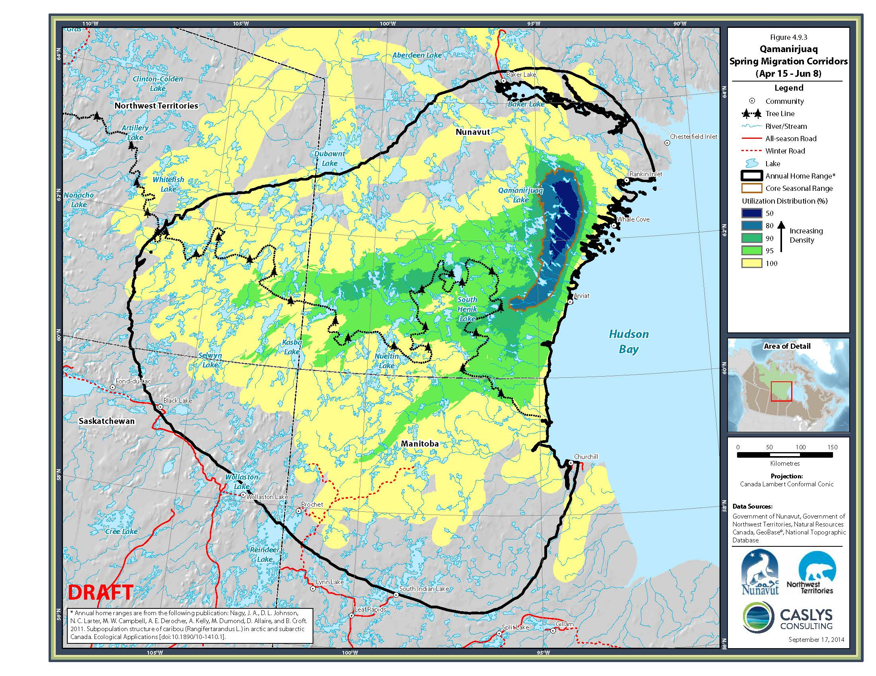
Figure 1. The Qamanirjuaq spring study area as defined by Qamanirjuaq spring seasonal range extents.

Results/Discussion:
An update to caribou seasonal range use for both the NEM and Qamanirjuaq Herds is ongoing with an expected completion date of winter 2023 due to continued covid related cancellations of face to face consultations. Unfortunately video conferencing proved difficult and frustrating to all participants due to the marginal internet connections within most communities. A new series of consultations involving representatives from DOE, NTI, KWB, and NWMB is planned for every Kivalliq community in early February 2023.
Caribou telemetry movements recorded over 2021 and 2022 display continued expansion of the Qamanirjuaq herd into the northeastern extents of their range when compared with 2013 seasonal range assessments (Figure 2), while NEM herds displayed only minor changes between years (Figure 3 through 6). The Qamanirjuaq expansion is primarily occurring within calving, post-calving, and summer seasonal ranges. The reasons for these observed changes are uncertain at this time. The NEM herds continue to display avoidance and deflection behaviours along AEMs mining road system north of Baker Lake during both the spring and fall migratory periods suggesting to communities and wildlife managers that mitigation measures along the road are falling short of reaching a reasonable resolution of these impacts. There continues to be concern these impacts and delays along the road could be effecting the herds ability to reach critical habitat. In a further attempt to try and understand the mechanisms behind these impacts the GN DOE, in partnership with the KWB, has initiated a continued study into the effects of industrial linier infrastructure on barren-ground caribou distribution and movements. The study will look to assess fall migratory impacts along the all season meadowbank mining road and Whale Tail haul road north of Baker Lake and will also examine potential impacts to post calving and late summer caribou distribution and movements along an all season mining road north of Rankin Inlet. The group hopes to have initial results available for discussion in early 2024. Currently real-time collar distribution and movement data is provided to mining and Regional management authorities with the express purpose of informing these authorities of approaching caribou in the hopes that effective mitigation measures can be triggered in a timely fashion. Unfortunately these efforts to provide early warning do not seem to be resolving the negative impact of the road on caribou migratory behaviour.
Spring composition studies in 2021 were initiated April 24th and completed May 1st, and involved 3 days of flying and 5 weather days during which the composition crew was grounded (Figure 7). Spring composition studies in 2022 took 3 days beginning April 24 and were completed April 26th (Figure 8). Flight tracks flew through the main aggregations of collars and composition effort spread based on relative collar densities. Though the 2021 composition effort maintained good collar coverage within coastal aggregations of caribou, the western most extents of collared caribou received only partial coverage, though composition results differed little from those recorded within coastal groups of caribou suggesting consistency amongst geographically distinct groups. Spring composition in April 2022 was able to cover all main collar aggregations finding relatively consistent cow to calf ratios between female dominant groups. We classified 12,228 caribou cows, yearlings, calves, young bulls and mature bulls, in 115 groups of caribou in April 2021, and 11,765 caribou in 100 groups of caribou in April 2022. Calf to cow ratios in 2021 were 16%, a value consistent with a declining population, while 2022 results showed calf to cow ratios of 27%, just slightly over the lower limit of the estimated ratios indicative of stability (Figure 9). Over all, the past two years of spring composition, when combined, suggest a small continued decline for the Qamanirjuaq herd (over winter calf survival rates over the 2 year period averaging below 25%).

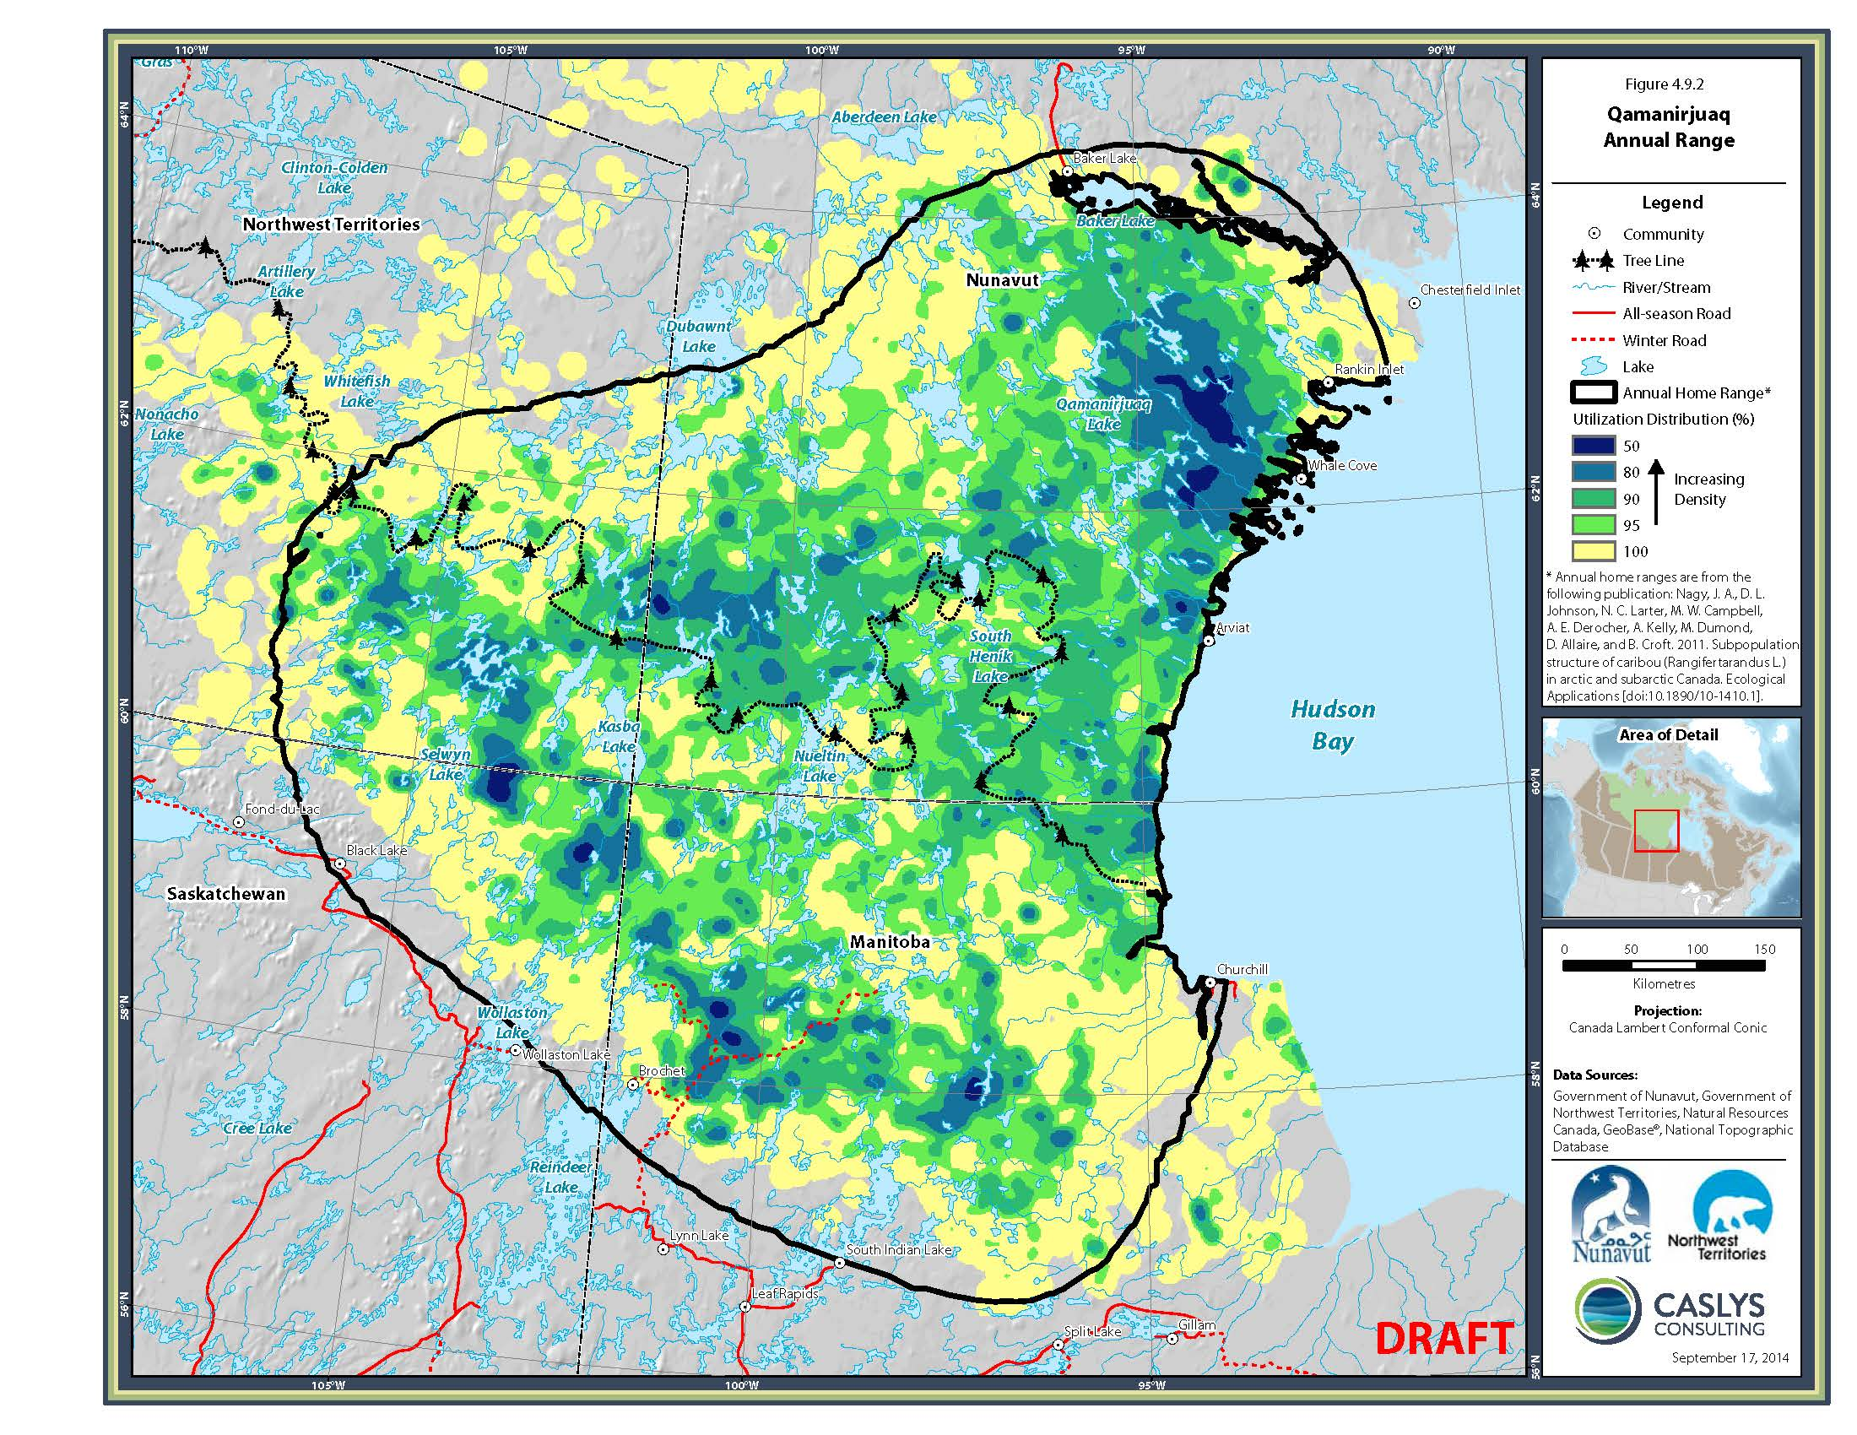
Figure 2. The annual range of the Qamanirjuaq herd developed using kernel analysis of telemetry data current to 2013. When compared with 2021 and 2022 movement data (Tables 3 through 6), it appears that recent movements have indicated increased use of the northeastern extents of their range (calving, post-calving, and summer range) in the vicinity of Chesterfield Inlet.

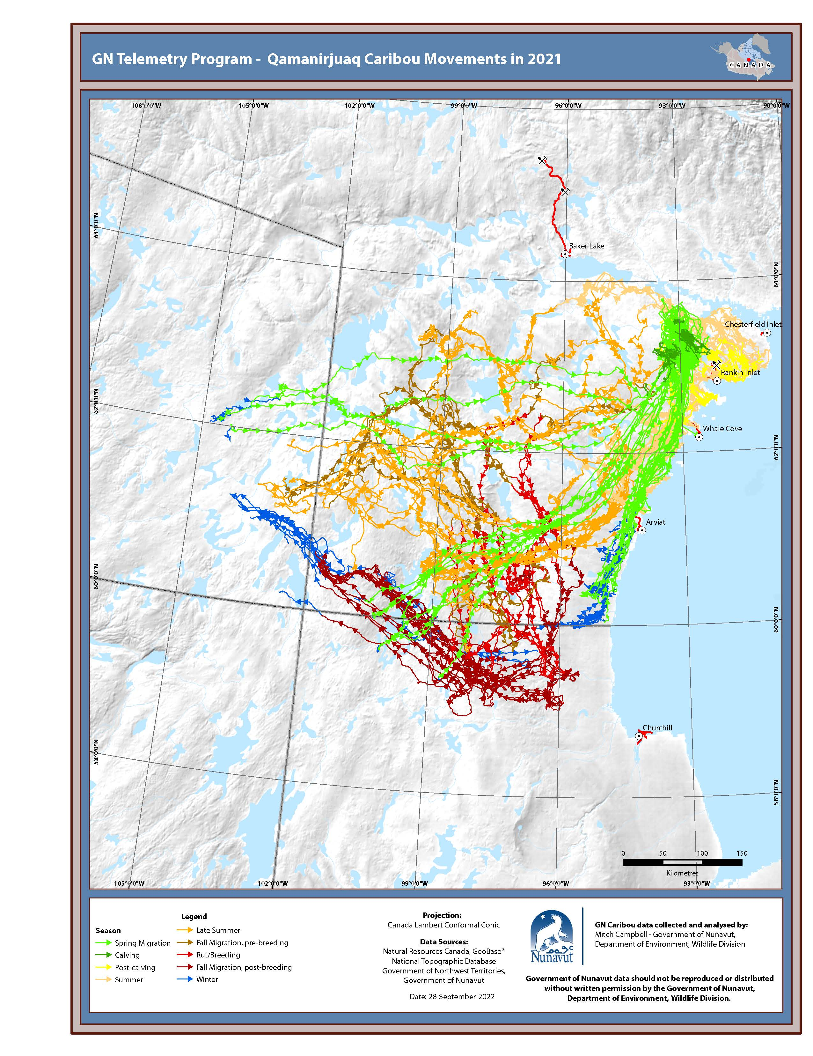
Figure 3. Annual movements by month of collared Qamanirjuaq cows, 2021.
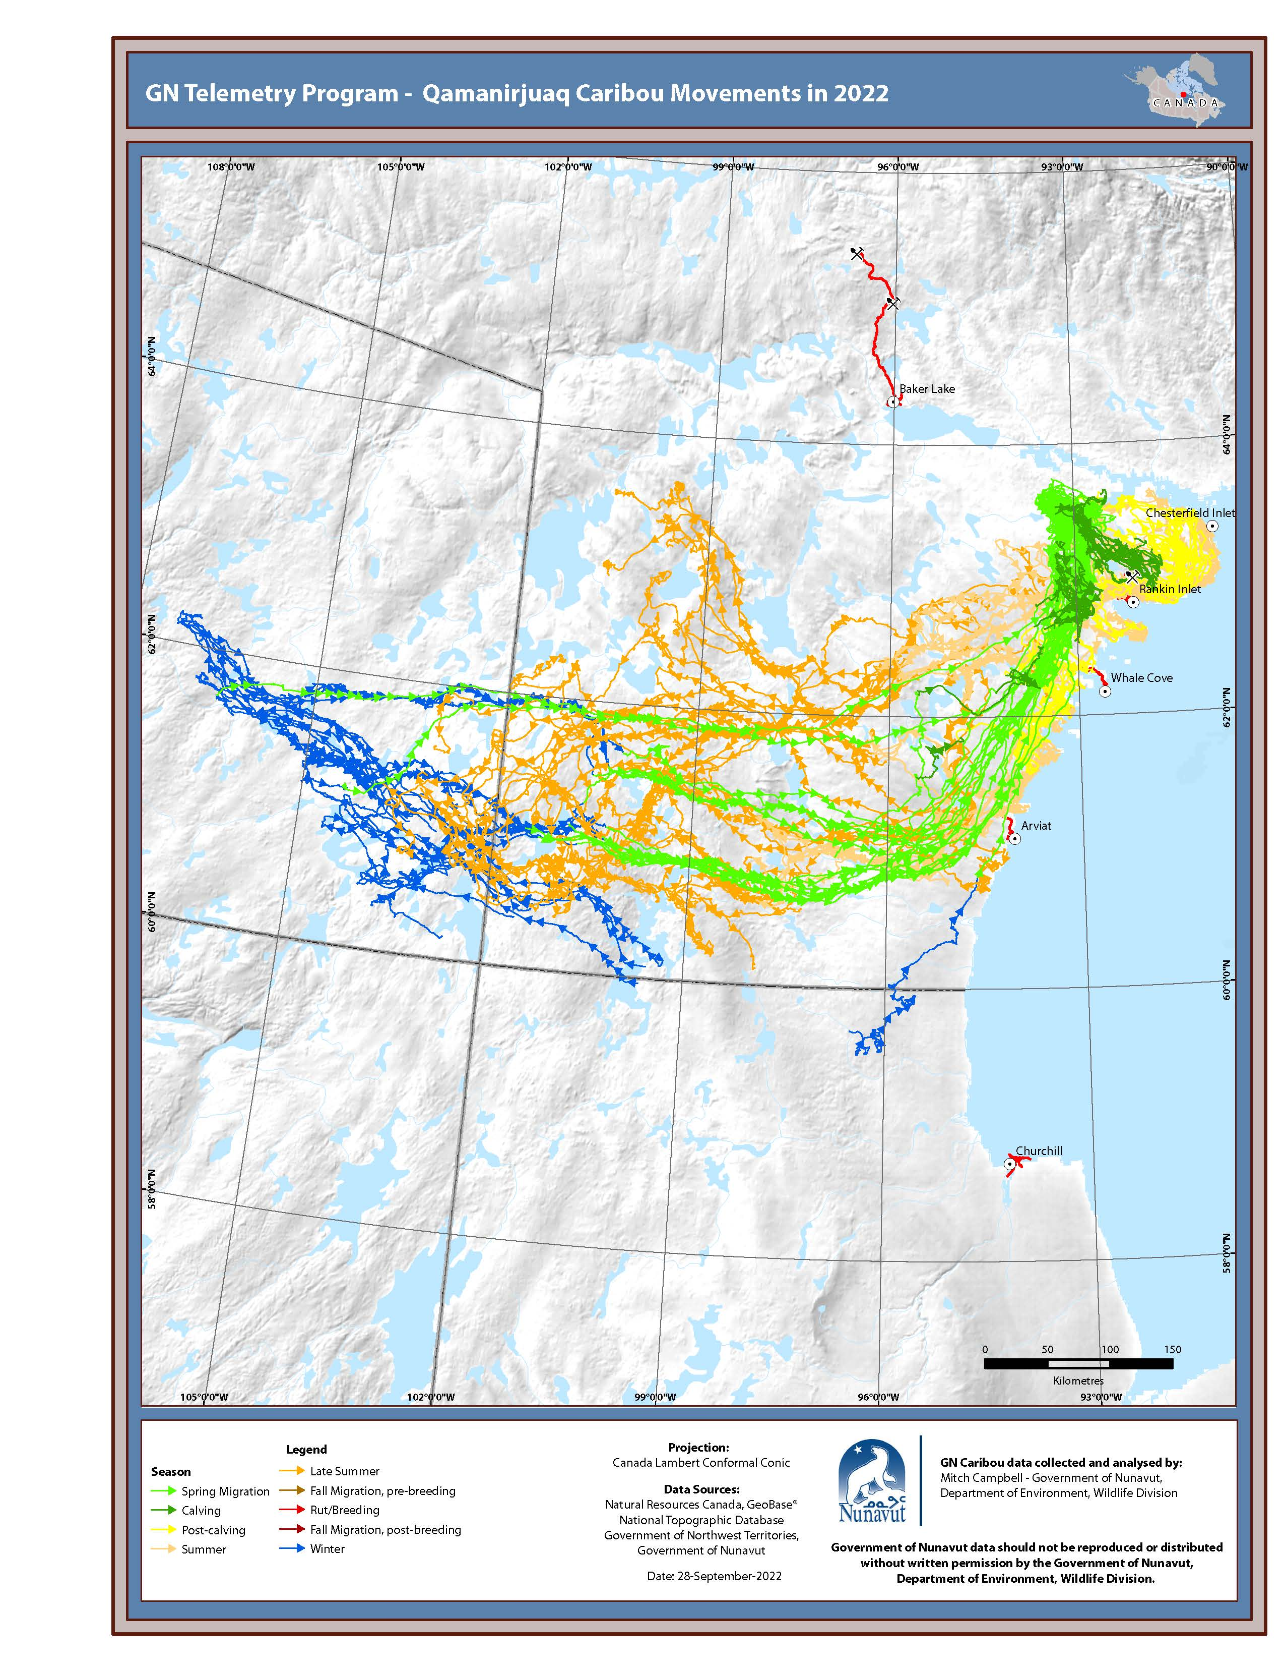
Figure 4. Annual movements by month of collared Qamanirjuaq cows, 2022.
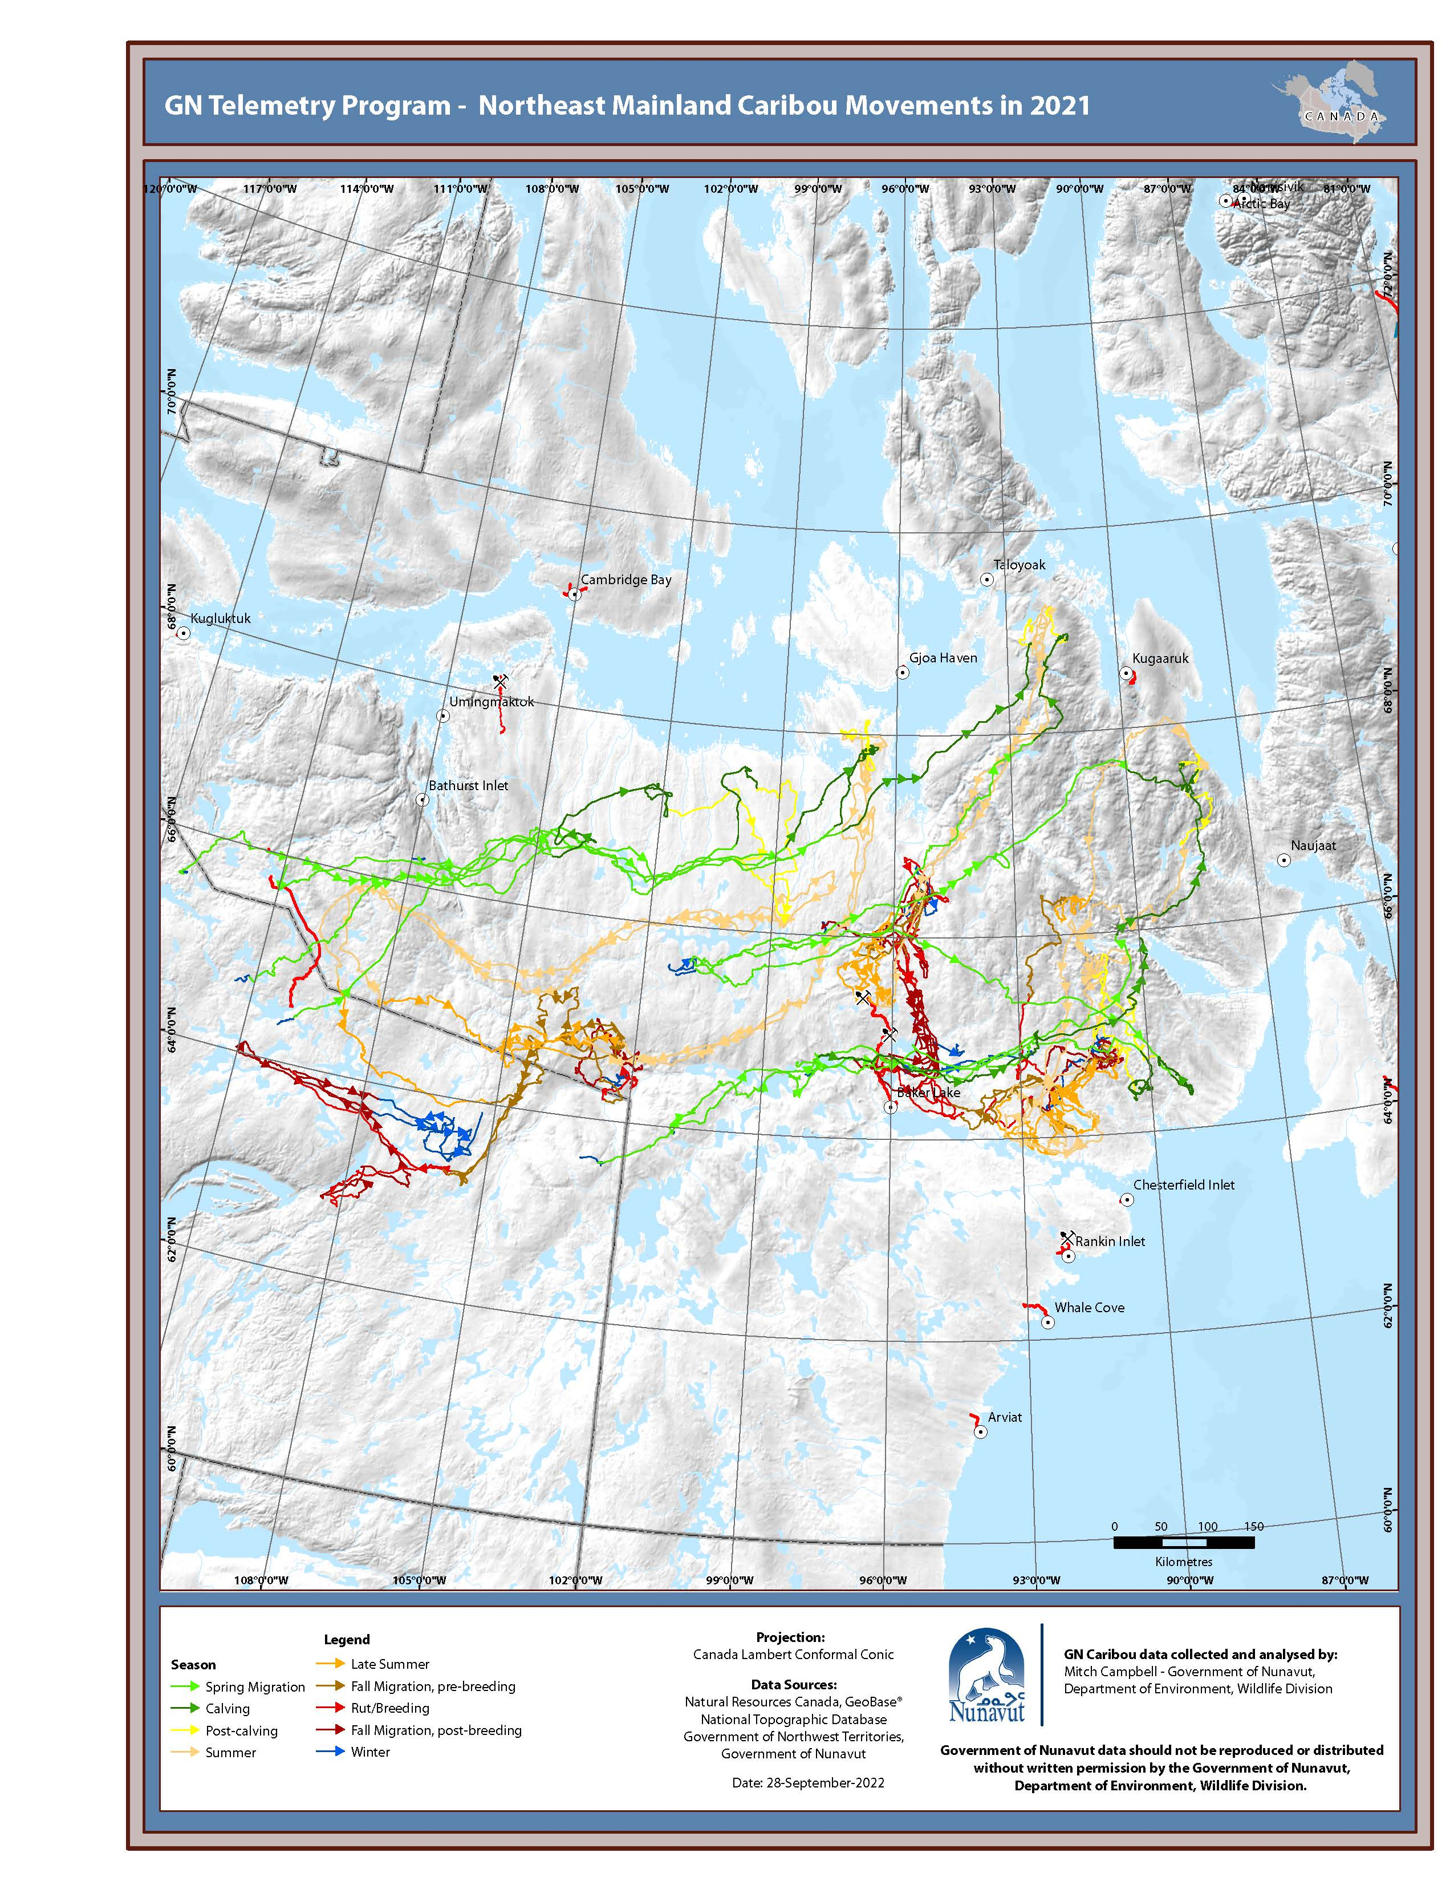
Figure 5. Annual movements by month of collared NEM cows, 2021.
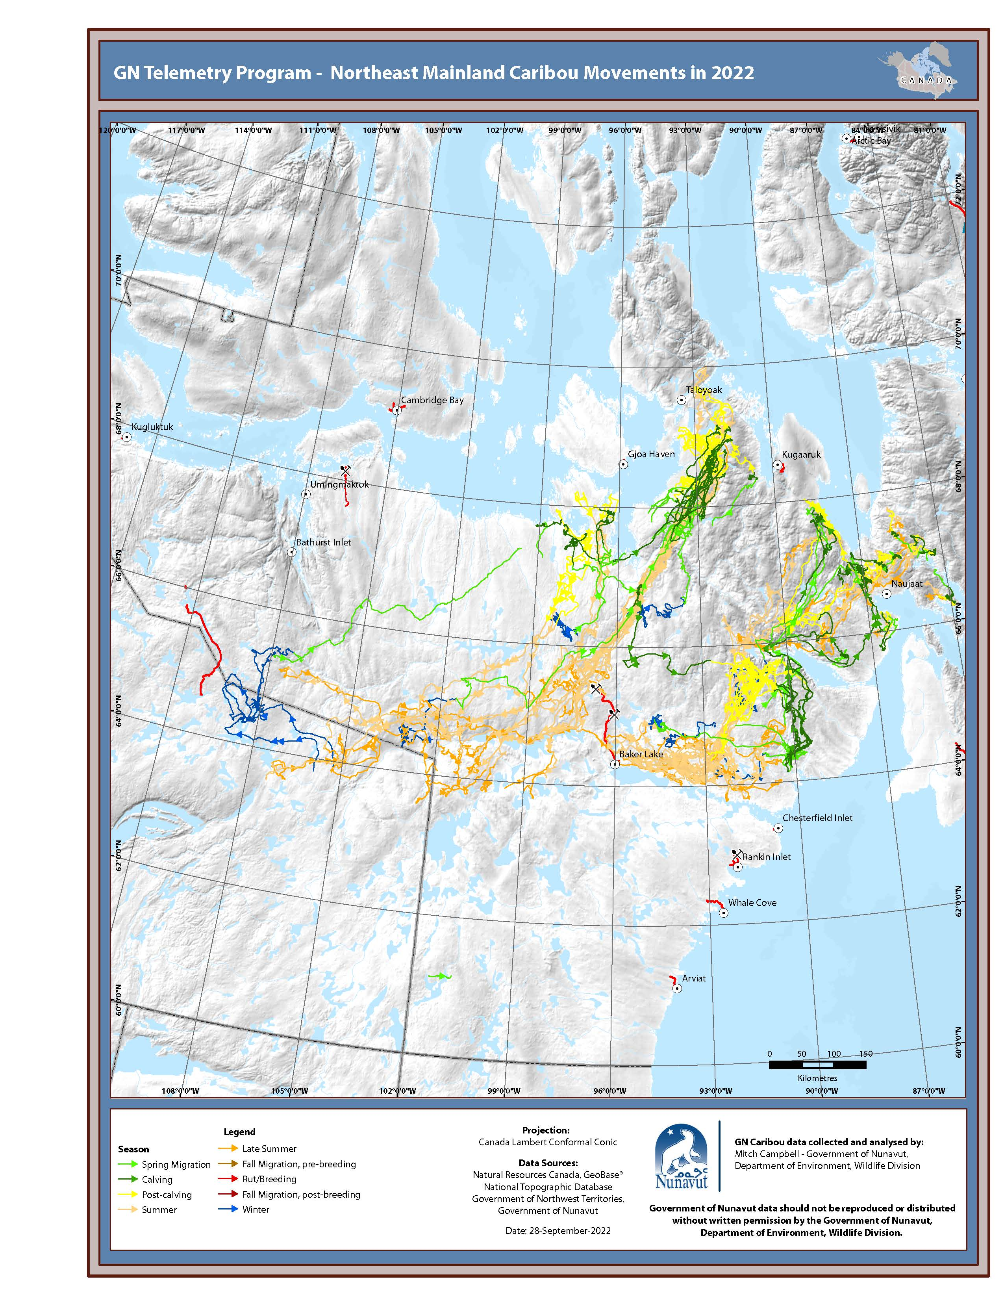
Figure 6. Annual movements by month of collared NEM cows, 2022.

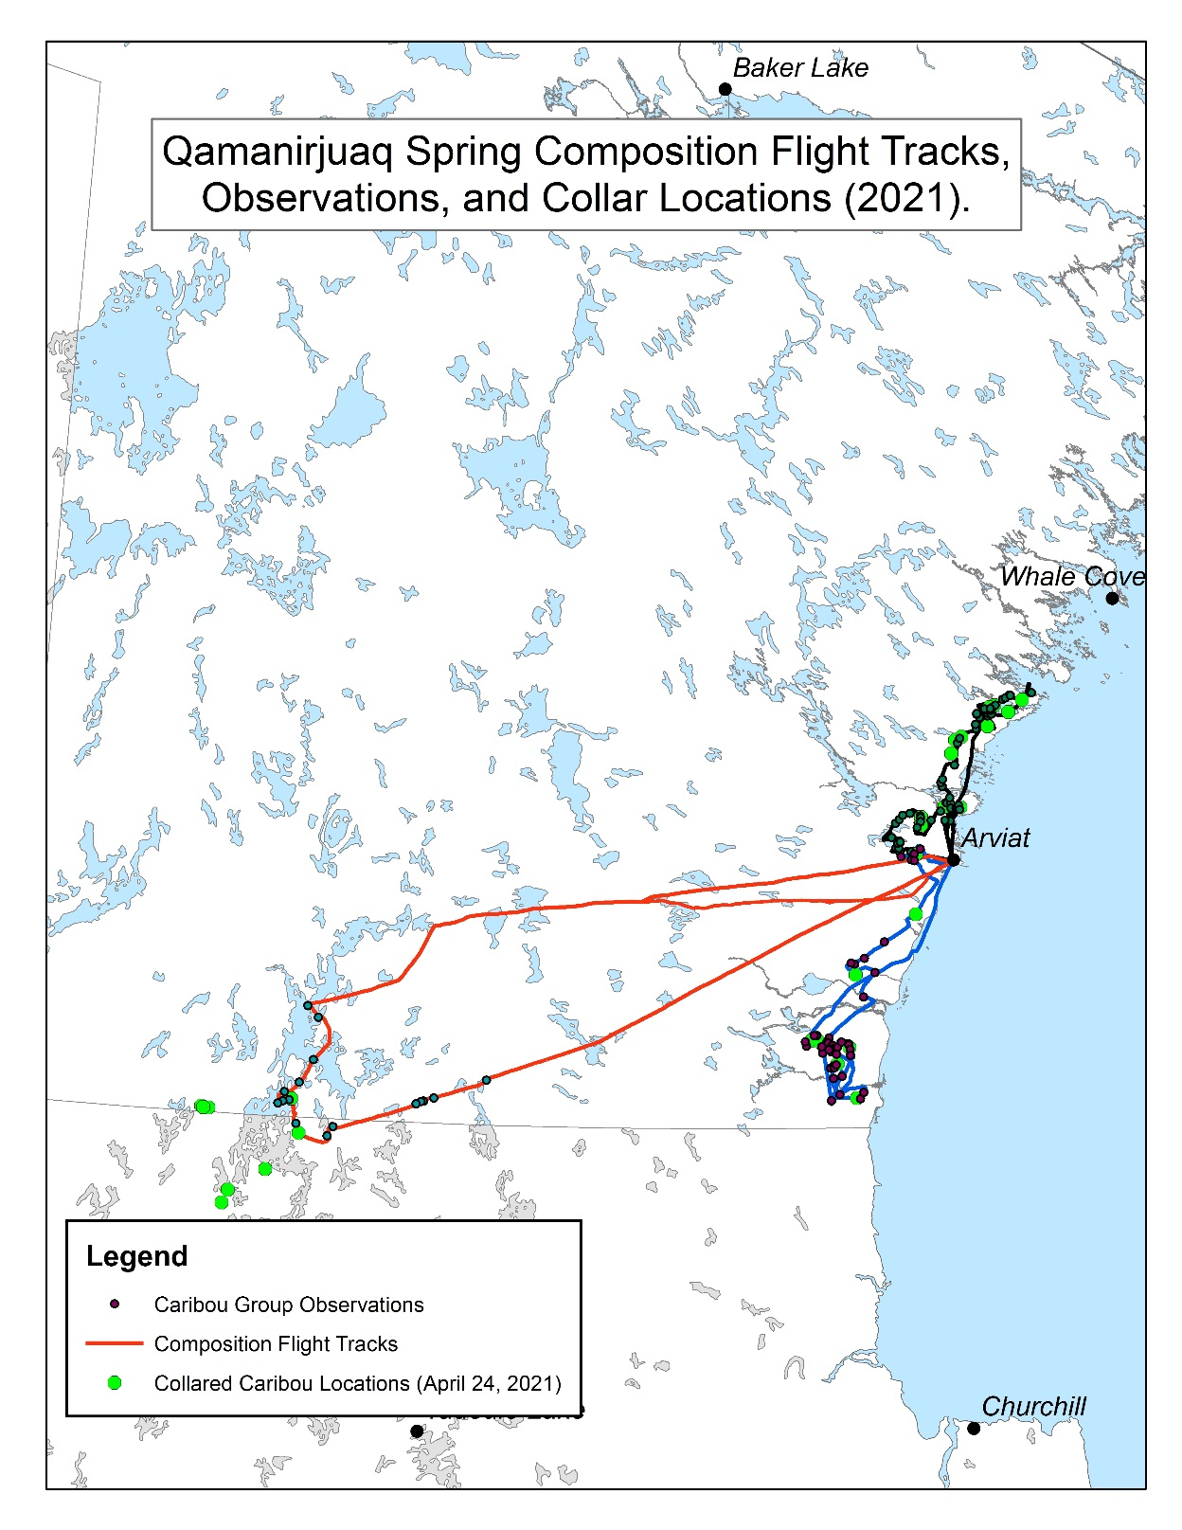
Figure 7. Flight tracks, observed caribou groups, and collard cow locations recorded for the Qamanirjuaq April 2021 spring composition survey.

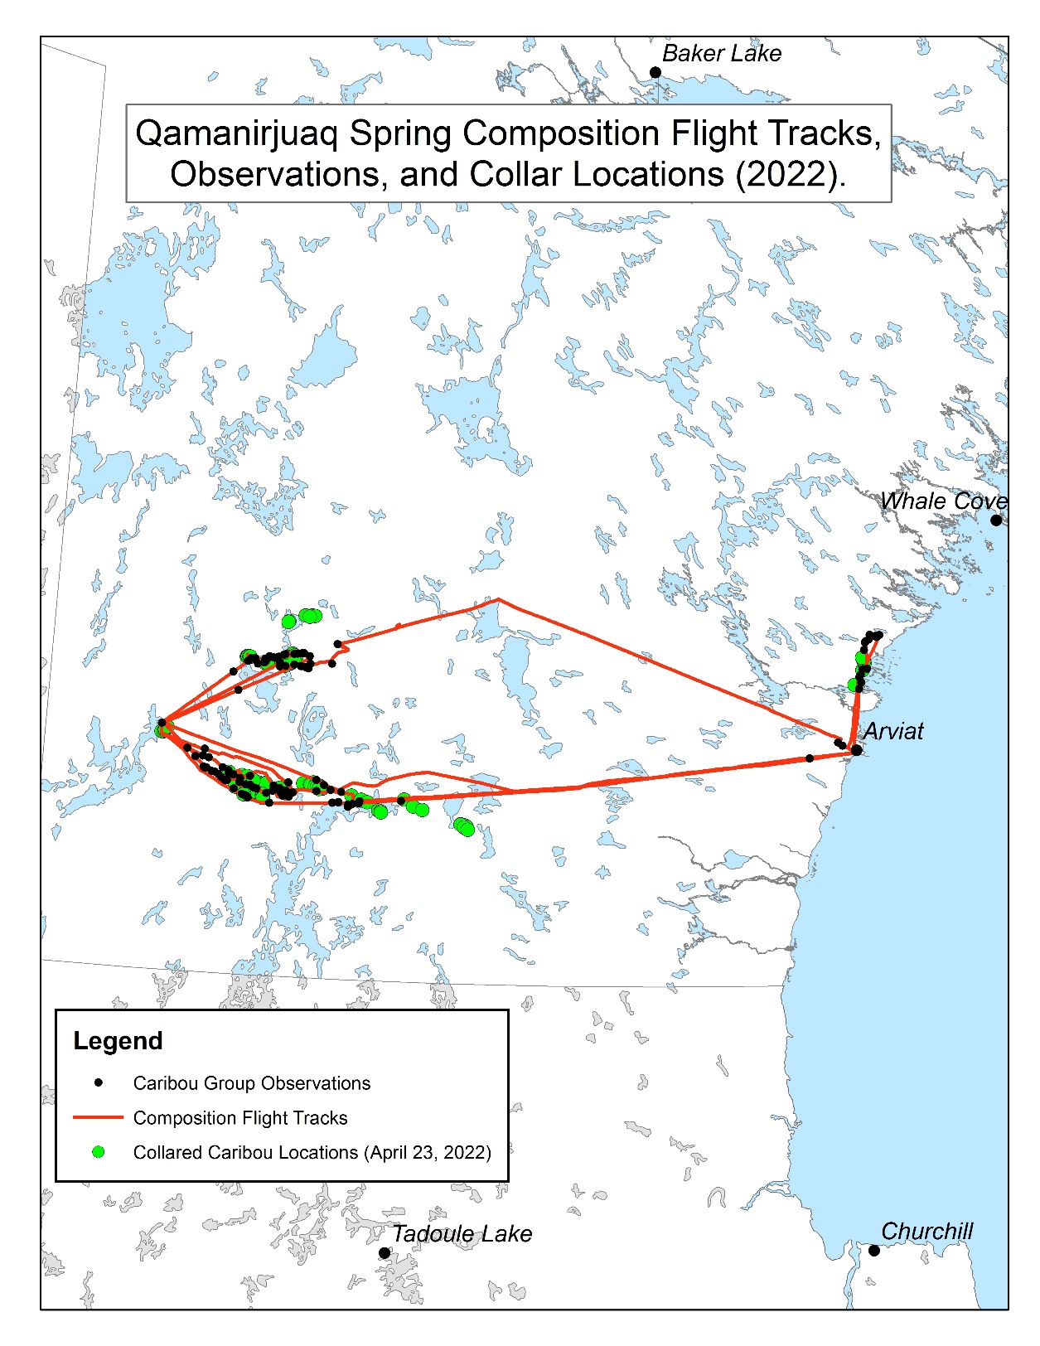
Figure 8. Flight tracks, observed caribou groups, and collard cow locations recorded for the Qamanirjuaq April 2022 spring composition survey.

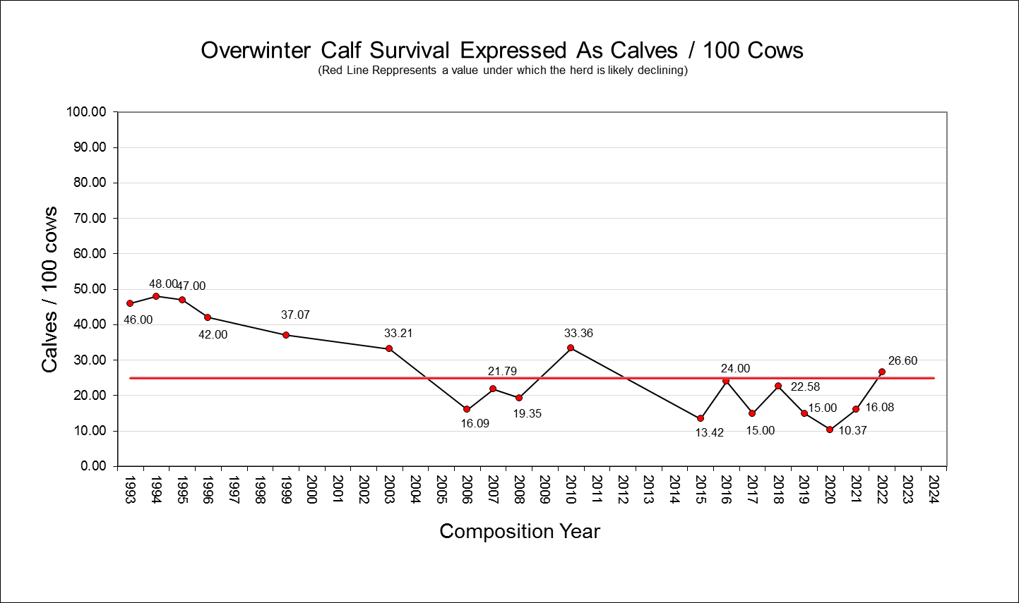
Figure 9. Spring composition results from March/April 1993 through April 2022. Trends have been on average, below stability indices since April 2010.

Management Implications:
At present the results of this study suggest more effort is needed to address impacts to migratory caribou from industrial linier infrastructure as current mitigation measures along this infrastructure is falling short of resolving significant impacts to caribou distribution and movements. We strongly recommend that accelerated research into the mechanisms of disturbance along roads and other linear infrastructure within caribou habitat be advanced as soon as possible. We further suggest more accountability of industrial developments to their impacts on northern wildlife, specifically caribou in this case, and there effective mitigation. We also recommend a protected areas strategy be developed and actioned for Barren-ground caribou before critical areas such as calving grounds and key access corridors, are lost to regulatory “existing rights” developed following permissions for exploration within these critical areas for caribou. Each year more and more existing rights are being secured within caribou critical habitat. As industrial development accelerates across caribou range we will start to see behavioural, distributional, and abundance changes within our caribou populations that if left unchecked, will likely lead to range/herd fragmentation, lower long-term abundance, loss of local hunting areas, and loss of Inuit harvesting opportunities.

Composition results suggest a continued slow decline in Qamanirjuaq abundance. A survey flown in June 2022 will allow us to re-assess how these declines in overwinter calf survival over the last 5 years have impacted overall abundance of the herd. With the currently indicated declines, however, monitoring should continue at the present level pending survey results. Accurate timely information is critical to the co-management process, and allows for communities to internally adjust harvesting practices, if necessary, to ease current declines in an effort to avoid more restrictive management actions.

Reporting to communities/resource users:

Initial composition results and collard caribou movements have been presented at the KWB (Kivalliq Wildlife Board) fall annual general meeting (2020-2022) and to the BQCMB (Beverly and Qamanirjuaq caribou Management Board) (2020-2022), and other stakeholders for management and mitigation purposes. A consultation tour to all Kivalliq HTOs is planned for February 2022 at which time presentation of, and discussions with, community HTOs is planned to take place. All programs have received unanimous support from the KWB as well as support from the Arviat, Whale Cove, Rankin Inlet, Naujaat, and Baker Lake HTOs. Information on caribou seasonal movements is provided to HTOs on request when for management purposes and engagement in the land use planning process. A collaborative partnership to assess the effects of mining infrastructure on caribou movements in the vicinity of Rankin Inlet is being developed with the KWB, Rankin Inlet, and Baker Lake HTO (all other Kivalliq HTOs welcome to take part) and is expected to begin mid-winter (2022/23). The BQCMB, an interjurisdictional caribou management board represented by Government and Indigenous members from the NWT, NU, Manitoba, and Saskatchewan, are in full support of this ongoing monitoring program.

Acknowledgements:
We would like to thank the ECCC, NWMB, and the GN for their financial support of this program. Without this support this program would not exist. We would also like to thank the KWB and all Kivalliq HTOs for their support and involvement in the program from its beginnings. I would like to thank Clayton Tratak with KWB for his tireless assistance with the development of this program, and Leo Ikakhik for his assistance during the composition field program. Victor Cobb and Nick Cantin did an excellent job of flying for the program, keeping us safe and keeping any disturbance to caribou minimized. Finally I would like to thank Wildlife Officers Joe Savikataaq Jr., Oliver Shipton-Ouellet, Russell Toolooktook, and Brad McInnes for their critical support of this program, again we could not have achieved the goals and objectives of this program without their help.

References:
Banfield, A.W.F. 1954. Preliminary investigation of the barren-ground caribou: Part 1: Former and present distribution, migrations, and status. Part 11: Life history, ecology and utilization. Canadian Wildlife Service. Wildlife Management Bulletin, Series 1, No. 10 A and 10B. 79 and 112 pages.
Berland, A., T. Nelson, G. Stenhouse, K. Graham, and J. Cranston. 2008. The impact of landscape disturbance on grizzly bear habitat use in the Foothills Model Forest, Alberta, Canada. Forest Ecology and Management 256:1875–1883. <http://linkinghub.elsevier.com/retrieve/pii/S0378112708005719>. Accessed 5 Mar 2013.
Börger, L., N. Franconi, G. De Michele, A. Gantz, F. Meschi, A. Manica, S. Lovari, and T. Coulson. 2006. Effects of sampling regime on the mean and variance of home range size estimates. The Journal of animal ecology 75:1393–405. <http://www.ncbi.nlm.nih.gov/pubmed/17032372>. Accessed 27 Feb 2013.
Boulanger, J., K. G. Poole, A. Gunn, and J. Wierzchowski. 2012. Estimating the zone of influence of industrial developments on wildlife: a migratory caribou Rangifer tarandus groenlandicus and diamond mine case study. Wildlife Biology 18:164–179. <http://www.bioone.org/doi/abs/10.2981/11-045>.
Campbell, M.W., A. Kelly, B. Croft, J.G. Shaw, C.A. Blyth. 2014. Barren-ground Caribou in Nunavut and Northwest Territories – Map Atlas. Government of Nunavut, Department of Environment. Government of Northwest Territories, Department of Environment and Natural Resources. Map series.
Campbell M.W., J. Nishi, and J. Boulanger. 2010. A Calving Ground Photo Survey of the Qamanirjuaq Migratory Barren-Ground Caribou (Rangifer tarandus groenlandicus) Population – June 2008. Nunavut Department of Environment. Technical Report Series. No. 1–10. 121 pp.
Caslys Consulting LTD. 2010. Analysis of Wildlife Geospatial Data in Support of the Nunavut Land Use Plan: Summary Report for the Nunavut Planning Commission.
Caslys Consulting LTD. 2012. Caribou Migration Corridor Mapping-Kivalliq Region, Nunavut. Summary Report for the Department of Environment, Government of Nunavut.
Dalerum, F., S. Boutin, and J. S. Dunford. 2007. Wildfire effects on home range size and fidelity of boreal caribou in Alberta, Canada. Canadian Journal of Zoology 85:26–32.
Donihee, J. and P.A. Gray. 1982. Critical habitat in the Northwest Territories. Can. Comm. Ecol. Land. Classif. Newsletter, No. 12:13-15.
Dyer, S. J., J. P. O’Neill, S. M. Wasel, and S. Boutin. 2001. Avoidance of industrial development by woodland caribou. Journal of Wildlife Management 65:531–542. <http://www.jstor.org/stable/3803106\n<Go to ISI>://WOS:000169650900019>.
Gates, C.C. 1983. Composition of the Kaminuriak caribou population in the fall of 1979 and 1981. N.W.T. Wildlife Service File Report No. 00. 25pp.
Gates, C.C. 1984. The fall and rise of the Kaminuriak caribou population. Proceedings of the Second North American Caribou Workshop. McGill Subarctic Research Paper 40. 215-228.
Gates, C. 1989. IN: People and Caribou in the Northwest Territories. Ed Hall, Editor. Department of Renewable Resources Publication. 190pp.
Heard, D.C. 1981. An estimate of the size and structure of the Kaminuriak Caribou Herd in 1977. ESCOM Report No. AI-40. 40pp.
Heard, D.C. and G.W. Calef. 1986. Population dynamics of the Kaminuriak Caribou Herd, 1968-1985. Rangifer. Special Issue 1. 159-166.
Hemson, G., P. Johnson, A. South, R. Kenward, R. Ripley, and D. Mcdonald. 2005. Are kernels the mustard? Data from global positioning system (GPS) collars suggests problems for kernel home-range analyses with least-squares cross-validation. Journal of Animal Ecology 74:455–463.
Hins, C., J. P. Ouellet, C. Dussault, and M. H. St-Laurent. 2009. Habitat selection by forest-dwelling caribou in managed boreal forest of eastern Canada: Evidence of a landscape configuration effect. Forest Ecology and Management 257:636–643.
Horne, J. S., E. O. Garton, S. M. Krone, and J. S. Lewis. 2007. Analyzing animal movements using Brownian bridges. Ecology 88:2354–63. <http://www.ncbi.nlm.nih.gov/pubmed/17918412>.
Kie, J. G., J. Matthiopoulos, J. Fieberg, R. a Powell, F. Cagnacci, M. S. Mitchell, J.-M. Gaillard, and P. R. Moorcroft. 2010. The home-range concept: are traditional estimators still relevant with modern telemetry technology? Philosophical transactions of the Royal Society of London. Series B, Biological sciences 365:2221–31. <http://www.pubmedcentral.nih.gov/articlerender.fcgi?artid=2894967&tool=pmcentrez&rendertype=abstract>. Accessed 23 May 2013.
Koehler, G. M., and D. J. Pierce. 2003. Black bear home-range sizes in Washington: climatic, vegetative, and social influences. Journal of Mammalogy 84:81–91. <http://asmjournals.org/doi/abs/10.1644/1545-1542(2003)084%3C0081%3ABBHRSI%3E2.0.CO%3B2>. Accessed 18 Jun 2013.
Laver, P. N., and M. J. Kelly. 2008. A critical review of home range studies. Journal of Wildlife Management 72:290–298. <http://www.bioone.org/doi/abs/10.2193/2005-589>.
Long, J., and T. Nelson. 2012. Time geography and wildlife home range delineation. The Journal of Wildlife Management 76:407–413. <http://doi.wiley.com/10.1002/jwmg.259>. Accessed 2 Mar 2013.
Long, R. A., J. G. Kie, R. Terry Bowyer, and M. A. Hurley. 2009. Resource Selection and Movements by Female Mule Deer Odocoileus hemionus: Effects of Reproductive Stage. Wildlife Biology 15:288–298.
Mitchell, M. S., and R. a. Powell. 2007. Optimal use of resources structures home ranges and spatial distribution of black bears. Animal Behaviour 74:219–230. <http://linkinghub.elsevier.com/retrieve/pii/S0003347207001182>. Accessed 3 Apr 2013.
Mosnier, A., J. Ouellet, L. Sirois, and N. Fournier. 2003. Habitat selection and home-range dynamics of the Gaspé caribou: a hierarchical analysis. Canadian Journal of Zoology 81:1174–1184.
Nagy, J.A.S. 2011. Use of Space by Caribou in Northern Canada. Department of Biological Sciences. University of Alberta. Edmonton Alberta. PhD Thesis. 164 pp.
Nagy, J.A., D.L. Johnson, N.C. Larter, M.W. Campbell, A.E. Derocher, A. Kelly, M. Dumond, D. Allaire, and B. Croft. 2011. Subpopulation Structure of Caribou (Rangifer tarandus L.) in Arctic and Subarctic Canada. Ecological Applications. 21(6): 2334-2348.
Nilsen, E. B., S. Pedersen, and J. D. C. Linnell. 2007. Can minimum convex polygon home ranges be used to draw biologically meaningful conclusions? Ecological Research 23:635–639. <http://www.springerlink.com/index/10.1007/s11284-007-0421-9>. Accessed 8 Mar 2013.
Parker, G.R. 1972. Biology of the Kaminuriak population of barren-ground caribou. Canadian Wildlife Report Series number - 20. 95pp
Powell, R. 2000. Animal home ranges and territories and home range estimators. Pages 65 –110 in L. Boitani and T. K. Fuller, editors. Research technologies in animal ecology - controversies and consequences. Columbia University Press, New York, NY.
Rivrud, I. M., L. E. Loe, and A. Mysterud. 2010. How does local weather predict red deer home range size at different temporal scales? Journal of Animal Ecology 79:1280–1295.
Russell, H.J. 1990. A photocencus of the Kaminuriak Herd in July 1987. Dept. of Renewable Resources Government of the N.W.T. File Report No. 97. 24pp.
Scotter, G.W. 1980. Management of wild ungulate habitat in the Western United States and Canada: A Review. Journal of Range Management. 33(1):16-24.
Seaman, D. E., and R. A. Powell. 1996. An Evaluation of the Accuracy of Kernel Density Estimators for Home Range Analysis. Ecology 77:2075–2085.
Silverman, B. W. 1986. Density estimation for statistics and data analysis. CRC Press.
Sjoberg, J. 2013. Relationship between moose (Alces alces) home range size and crossing wildlife fences. Examensarbete i ämnet biologi.
Skarin, A., Ö. Danell, R. Bergström, and J. Moen. 2008. Summer habitat preferences of GPS-collared reindeer Rangifer tarandus tarandus. Wildlife Biology 14:1–15.
Smulders, M., T. a. Nelson, D. E. Jelinski, S. E. Nielsen, G. B. Stenhouse, and K. Laberee. 2012. Quantifying spatial–temporal patterns in wildlife ranges using STAMP: A grizzly bear example. Applied Geography 35:124–131. Elsevier Ltd. <http://linkinghub.elsevier.com/retrieve/pii/S0143622812000653>. Accessed 22 Mar 2013.
Sorensen, T., P. D. McLoughlin, D. Hervieux, E. Dzus, J. Nolan, B. Wynes, and S. Boutin. 2008. Determining Sustainable Levels of Cumulative Effects for Boreal Caribou. Journal of Wildlife Management 72:900–905. <http://www.bioone.org/doi/abs/10.2193/2007-079>. Accessed 17 Mar 2014.
Taillon, J., M. Festa-Bianchet, and S. D. Côté. 2012. Shifting targets in the tundra: Protection of migratory caribou calving grounds must account for spatial changes over time. Biological Conservation 147:163–173.
Tennenhouse, E. 1986. Caribou Protection Measures for the Beverly and Kaminuriak Caribou herds. Series ED: E. Hall. Publication of the N.W.T. Dept. of Renewable Resources. 17pp.
Thompson, D.C. and C.A. Fisher. 1979. Distribution and numbers of the Kaminuriak Herd in March and April, 1977. Arctic 32(3). 266-274.
Thompson, D. C. G.H. Klassen, and J. Cihlar. 1980. Caribou Habitat Mapping in the Southern District of Keewatin, N.W.T.: An application of digital Landsat data. Journal of Applied Ecology. 17:125-138.
Worton, B. 1987. A review of models of home range for animal movement. Ecological modelling 38:277–298. <http://www.sciencedirect.com/science/article/pii/0304380087901013>. Accessed 13 May 2013.
Worton, B. 1989. Kernel methods for estimating the utilization distribution in home-range studies. Ecology 70:164–168. <http://www.esajournals.org/doi/abs/10.2307/1938423>. Accessed 13 Aug 2013.

Default kernel shape in ArcMap is a quartic kernel function

