Nunavut Wildlife Management Board
Final Project Reports

NWRT Project Number:

Project Leader:
Lisa-Marie Leclerc
Kitikmeot Regional Biologist
PO Box 377
Kugluktuk, NU X0B 0E0
Phone: 867-982-7444
Email: LLeclerc@gov.nu.ca

Staffs: Mitch Campbell, Malik Awan, Amelie Roberto-Charron, Terry Milton, Lena Davies, Sammy Angnaluak, Russell Akeeagok and Randy Hinanik.

Project Title:
Muskox (Ovibos moschatus) distribution and abundance of
Central Mainland, Nunavut (MX-11)
Introduction:

Muskox (Ovibos moschatus) has been an integral part of Inuit culture and the tundra biome for thousands of years. Once close to be extirpated, small clusters of muskoxen were left south of Bathurst Inlet, in the Thelon Game Sanctuary, as well as in the west side of Kugluktuk (Tener, 1965; Dumond, 2007). Since then, muskox appears to have increased in number and expanding in range.

In the 90s, muskox population was blooming on Victoria Island (Gunn and Patterson, 2000) allowing to support a commercial harvest and leading to fructiferous economic development from the sale of muskox meat and qiviut, as well as use horn for art and craft. Two decades later, muskox number declined due to a range of causes, including but not limited to the apparition of a new predator, grizzly bear, as well as the emergence of new diseases (Erysipelothrix and Brucellosis) on the Island that negatively impacted population growth (EHTO pers. Comm.; Kutz et al., 2015; Rothenburger et al., 2021; Tomaselli et al., 2019). This was also reflected in the harvest. During the commercial harvest years up to 2012, to our best of our knowledge and available information, between 180 to 400 muskoxen were harvested annually (including commercial, sport, subsistence) in the muskox management unit, MX-07 (Victoria Island). After the closure of the commercial harvest, the total harvest oscillated between 2 and 15 muskoxen the last three years (Leclerc, unpublished results).

The Hamlet of Cambridge Bay’s economy suffered, and harvesters are now looking to maximize harvesting opportunities and maintaining sustainability by harvesting muskox elsewhere. The Kent Peninsula and the adjacent part of the Canadian Mainland seem to offer some possibilities, as local knowledge have reported many small groups (5 to 10) of muskox on the Peninsula. However, there is not information available on how well muskox (population trend) are doing since there was no survey done the last 15 years.

In fact, the Kent Peninsula and the adjacent part of the Canadian Mainland belong since 2015 to the central mainland muskox management unit, MX-11. In September 2013, the western part of this management unit, 35,564 km², was surveyed, as the community of Kugluktuk notified an increase in muskox number east of the Coppermine River. The survey resulted in an estimate of 6,746 muskoxen, but it is not possible to compare with previous estimates due to the difference in the survey area delimitation between survey years (Leclerc, 2015). From historic survey data, the muskox density seems to be very low in the remaining of the management unit with a best estimate of 750 muskoxen. Combined, the population estimate of MX-11 might be at best 7,500 muskoxen. From this limited and available information, the Total Allowable Harvest (TAH) was set to 225, where it was decided an allocation of 120 tags for Kugluktuk, 25 tags for Cambridge Bay, 40 tags for Kingaut and 40 tags for Omnigmaktok. This TAH has remained consistent since 2015.

Currently in Nunavut, setting of the harvest quota is based on the number of muskoxen estimated in a define muskox management unit, which is accomplished via aerial survey as the only practical approach to survey large geographic area. Monitoring program that contributes to the establishment, modification, or the removal of levels of Total Allowable Harvest for stocks or population where there is believed to be a conservation concern or that are priority species for harvest by Inuit was set as a top priority by co-management partners. Re-evaluating the existing quotas in MX-11 would be beneficial for the western Kitikmeot communities (Kugluktuk, Cambridge Bay, Kingaut and Omnigmaktok)- by either allowing for an increase in muskox harvest (which will contribute to decreasing food insecurity) or reducing harvest pressure to ensure long-term resource availability.

Objectives:

The main goal of this study is to foremost determine the muskox population estimate in the entire muskox management unit, MX-11. In addition, the survey will allow to identify area of high and low muskox density. Based on the new IQ and scientific information, the total allowable harvest for this management unit will be review and adaptive community-based management strategies will be review, update and new ones might be developed.

Muskox Management Unit, MX-11:

The muskox management unit MX-11 is in the Kitikmeot region and extends from the south by the Nunavut boundary with the Northwest Territories to the north by the Northwest Passage. This management unit is delimited by two rivers, the Coppermine River to the west and the Perry River in the Queen Maud Gulf Sanctuary to the east (Figure1).

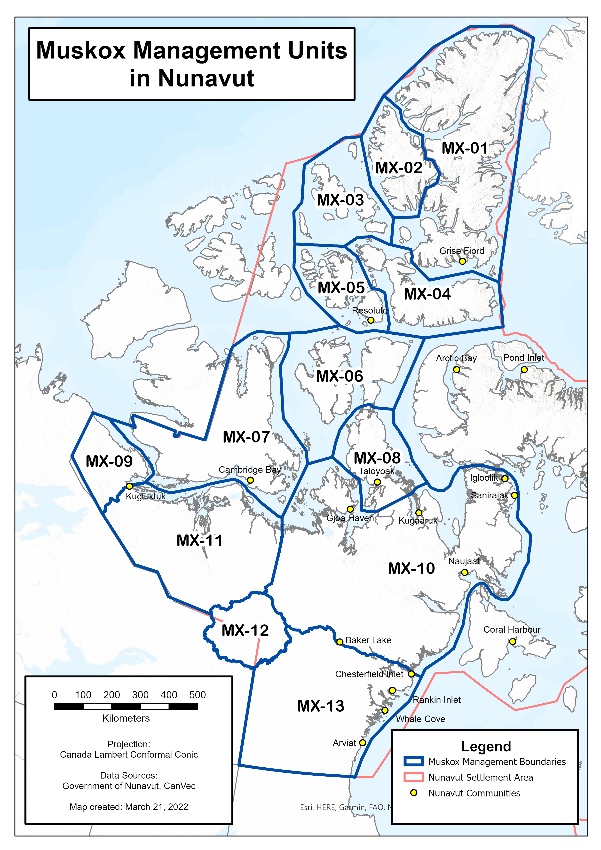
Figure1: Muskox Management Units in Nunavut.

The ecogeographic factors influence greatly the distribution of muskox. The west side of this management unit is on the Canadian Shield, which is characterised with rough rock outcrops. From the taiga forest and scattered stand of spruce present to the south, the boreal forest gently give place to a northward vegetation dominated by sedge meadows and shrubs, dwarf birch, willow mixed with various herbs, lichens, and mosses. There are two terrestrial ecoregions in this management unit, the Takikuq Lake Upland and the Coronation Hills regions (Environment Canada, 1995).

Materials and Methods:

In Nunavut, monitoring of wildlife population must be done by balancing Inuit Qaujimajatuqangit (IQ) and science. Not only this project answers a very specific community needs and is grounded in NWMB wildlife priorities, but Inuit participation is pivotal to the success of this research program. Co-management partners involvement started with the survey design, the community took part to the survey, and feedback will be sought for the interpretation of the results. This way, Inuit will be involved at each step of this research program.

For the survey design, we used IQ as recommendation of areas to be surveyed, as well as precaution to be used to mitigate the effect of the airplane on muskox to avoid disturbance. HTOs provided maps (Figure 2) identifying locations of interest and known muskox high density areas where they wanted the effort of this survey to be concentrated. In addition, according to local knowledge, muskox in the west part of the management unit seems to move 15 to 20 miles inland during the winter, in contrary to the summer where a coastal distribution procure them with a cold refreshing ocean breeze. Hunter from Cambridge Bay, Bay Chimo, and Bathurst Inlet pointed to the Kent Peninsula as a very important location, where groups of 5 to 10 muskoxen are usually seen dispersed on the landscape. Muskoxen are known to wander on the nearby islands, and therefore it was also recommended to include islands in the survey area. This survey should start in early March, to avoid disturbance during the peak calving season in April.

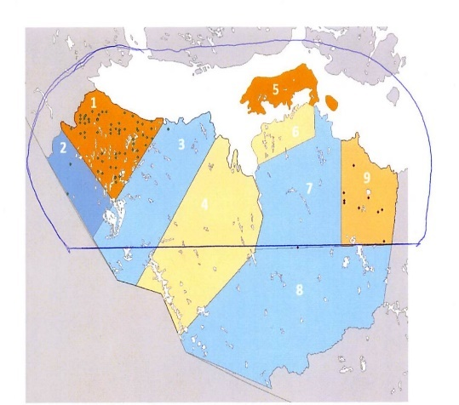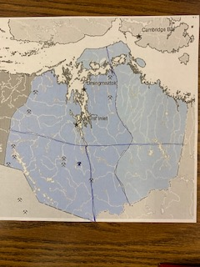
C
B
A
Figure 2: Maps showing probable area of high muskox density from the Burnside and Omingmaktok HTO (A), Ekaluktutiak HTO (B), and Kugluktuk Angoniatit Association (C).

To stratify, in addition to include local expert’s knowledge, we used previous distribution from aerial surveys that were conducted in the area between 2015 and 2021. Since MX-11 has never been entirely surveyed and there are limited amount observations made during winter, we had to seek for muskox sightings thought out the years including summers. Thus, we further stratify based on muskox distribution found during the 2013 muskox survey of the west part of the management unit (August), 2018 Beverly calving ground survey (June), and 2018 and 2021 Bathurst calving ground survey (June).

Distance sampling (bins) assume that animals are randomly distributed in their habitat. However, muskoxen are non-randomly distributed, and this distribution is influence by the habitat (Wilkinson et al. 1976, Smith 1989, Gunn 1990). This is partially compensated for by stratification based on density and increasing the number of sample units (transects). The muskox management unit MX-11, of a superficies of 178,058 km², was then divided into 10 strata. Since there is requirement to determine the density per strata, effort was set per stratum based on presumed density.

The software Distance 7.3 was used to designs systematic line transect survey (Thomas et al., 2006). We allocated a minimum of 10 transects in the low-density strata (2, 4, 6, and 9) and at least 20 transects in the high-density strata (1, 5, 10) to be able to generate a reliable estimate (Table1 and Figure3) (Thomas et al., 2007). The stratum9 was considered a low priority stratum if conditions, time and budget allowed since limited harvesting take place. According to the size of each strata the edge effect was assumed to be minimal due to the large geographical area to be surveyed. In this scenario, 166 transect lines (samplers) have been distributed among each stratum to survey the management unit (Figure3). The transects that span the full width of the strata and are perpendicular to known density and/or to maintain the axes of the strata to assure transects of relative equal length.

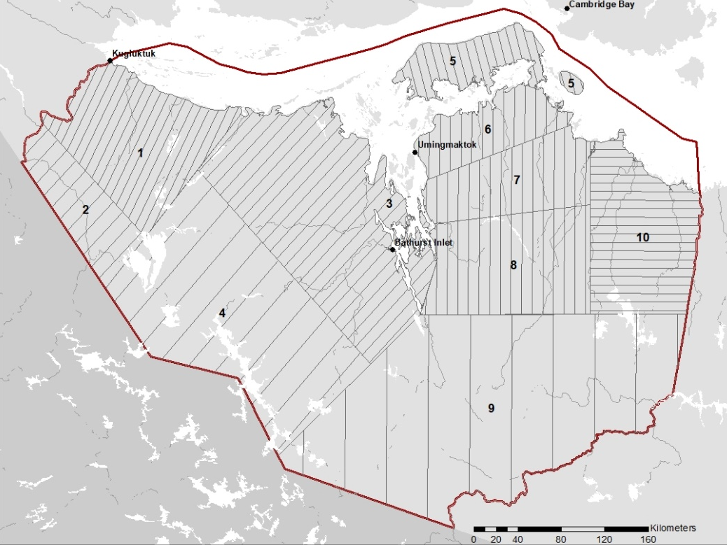
Figure 3: Designed strata and transect lines in the muskox management units MX-11.

Table1: Summary of the muskox management unit MX-11 survey design, number of transects allocated in each stratum, and respective planned survey effort.
Stratum | Name | Area  (km2) | Samplers | Distance Between  Transect (km) | Transect  Length (km) | On Effort  Track length(km)
1 | HD_West | 15,045 | 21 | 8 | 2,333 | 1,890
2 | LD_West | 7,080 | 11 | 13 | 798 | 534
3 | MD_Central | 28,257 | 25 | 10 | 3,527 | 2,843
4 | LD_Central_ | 29,945 | 10 | 23 | 1,700 | 1,278
5 | HD_East_N | 5,555 | 20 | 8 | 1,143 | 709
6 | LD_East | 6,530 | 15 | 10 | 964 | 656
7 | MD_East_N | 9,275 | 16 | 10 | 1,241 | 935
8 | MD_East_S | 14,136 | 16 | 10 | 1,775 | 1,446
9 | LD_East_S | 48,232 | 10 | 39 | 2,016 | 1,250
10 | HD_East | 14,012 | 22 | 8 | 2,127 | 1,749
--- | ------ | 178,058 | 166 | ---- | 17,164 | 13,801
Field design:
Two Twin Otters were used for flying the total line transects. One aircraft was stationed in Kugluktuk and the other in Cambridge Bay. Consistently the fixed-wing engine will fly over the transect lines at a speed of 160 km/hr. and an altitude of 150 m (400 feet), which was kept consistent by using a radar altimeter. Bins on the wing struts were set at 200, 400, 600, 1,000 and at 1,500 meters on each side of the plane for a truncated sampling width of 1.5 km (Campbell et al., 2015; Campbell et al., 2021) that were calculated using the formula of Norton-Griffiths (1978):

w= W*h/H

Where, W= the required strip width; h= the height of the observer’s eye from the tarmac; and H= the required flying height.

Bins were label from A to E for identification when an observation was called. The total transect width was then totalizing 3 km. All sightings above 1.5 km were still recoded, but label as “off transect”, same with the observations made during ferrying to and from transect lines.

The study used a double independent observer configuration with full independence for each side of the airplane. The full independence between the front and back observers were kept separated by using two audio intercoms, so they wouldn’t be able to hear each other. Observers were also separated with cardboard to prohibit any visual clues between them. Observations were made perpendicularly to the transect lines and the observations was based on the clusters of muskoxen, or group observed. Data recorders were recoding the GPS location, distance, and the number of muskox adults, yearlings, and calves seen. Co-variates influencing detection were recorded including: cloud, visibility, snow cover, snow patch, elevation variation (topography), habitat, speed (Campbell et al., 2021). During this survey other species sighting was also recorded such as: Grizzly bear (Ursus arctos horribilis), Arctic wolf (Canis lupus arctos), Polar Bear (Ursus maritimus), caribou (Rangifer tarandus groenlandicus). Carnivore sightings were standardized using the predator index (Heard, 1992), where the predator sightings per species will be expressed per 100 hours.

Data Analysis:
We are currently working on the data analysis, where different models are currently being tested. The program R with the package Distance and MRDS is being used to build distance sampling and mark-recapture model to fit a detection function on our observations (Laake et al., 2012). Covariates such as the observer, distance, and group size are being taken into consideration in the model. Then, models will be evaluated using a Akaika Information Criterion (AIC) resulting in selecting the model with the lowest AIC score. In addition, a Goodness fit test, chi-square test (χ²), will be performed to test for adequate fit (Buckland et al., 1993; Buckland et al., 2004). An estimate for each stratum will be derived based on transect lengths and strata areas using the best fitted detection model.

Results:
To flying the transect lines, we had two planes: one twin otter from Buffallo (C-GFYN) based in Kugluktuk and a second twin otter from Keen Borek (GXXB) based on Cambridge Bay. The field work took part from March 15 to March 27, 2022. During this period, we experienced mostly good weather beside the low pressure west of Bathurst Inlet delaying the completion of the Stratum 3 to 6 days (March 18 to 24). Table 2 summarised the timeline of the survey while figure4 depicts in more detail the transect lines flew by each plane. Unfortunate, the stratum 9 was left unsurvey, as the Keen Borek aircraft was requested elsewhere and our contract came to an end.
Table2: Summary of the survey timing of each strata during the muskox survey between March 15 and March 27, 2022 that was accomplished with the Buffalo Twin Otter (C-GFYN) and the Keen Borek Twin Otter (GXXB).
Date | Aircraft and Strata
Date | C-GFYN | GXXB
March 14 | Arrival Kugluktuk | Arrival Cambridge Bay
March 15 | Stratum 1 | Weather
March 16 | Strata 1&2 | Weather
March 17 | Strata 2&3 | Strata 5,6&10
March 18 | Stratum 3 | Stratum 10
March 19 | Stratum 3 | Strata 5,6,7&8
March 20 | Stratum 3 | Strata 5,6,7&8
March 21 | Stratum 3 | Mechanical
March 22 | Departure | Strata 5&7
March 23 | --- | Strata 3&8
March 24 | --- | Stratum 3
March 25 | --- | Weather/Arrival Kugluktuk
March 26 | --- | Strata 3&4
March 27 | --- | Strata 4 and Depature
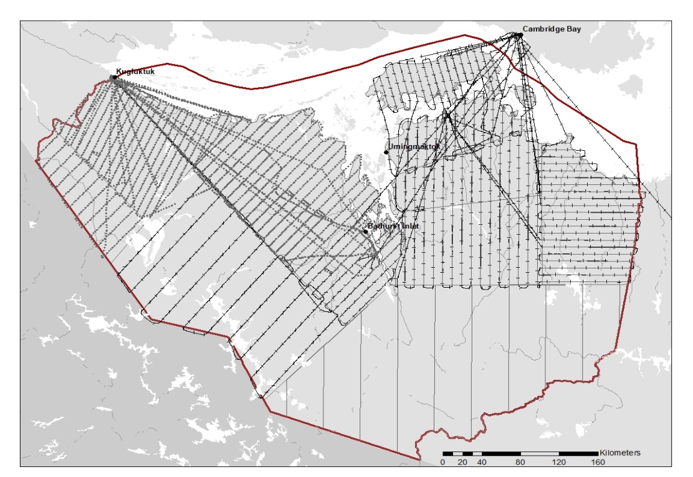
Figure 4: Completed daily flight tracks for the Buffalo Twin Otter C-GFYN (dotted line) and the Keen Borek Twin Otter GXXB (crossed line) between March 15 and March 27, 2022.
All sighing of muskox on and off transect was recorded as well as incidental observations of caribou, moose, wolf, wolverine, fox and poalr bear, such observations are represent in figure5 below. Muskox groups were observed mainly in the strata 1, 3, 5 and 10 with little observation in other strata. Survey of stratum 4, to the east side of Contwoyto Lake, releved a remarkable aggregation of caribou, mostly from the Beverly herd. Wolf accounted for the predator with most sigthing where their distribution was dispersed across both side of Bathurst Inlet.

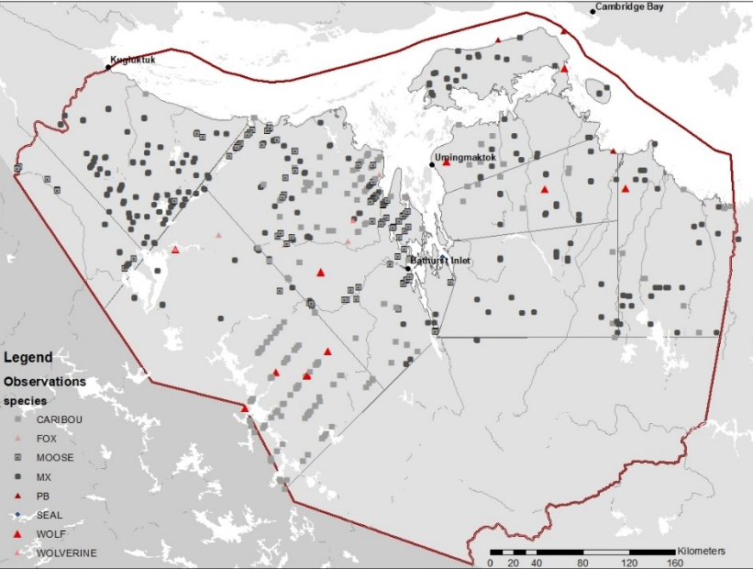
Figure 5: Ungulate observations; caribou (grey square), moose (doted square), and muskox (black square) in relation with carnivores; wolves (big red triangle), wolverive (medium red triangle), fox (small pink triangle) and polar bear (dark small triangle).

Muskox group size observed ranged from 1 to 150 animals, with a mean of 16 muskoxen per group (figure6). It was anticipated that large group of muskox (< animals per group) would be observed frequently, which was not the case. Only one group of 150 animals were encounter where counting the total number animal in this group was challenging. Only a partial estimate was provided in this case. Nonetherless, since the great majority are small groups, we are confident that the observers were able to provide accurate animal count within a group.

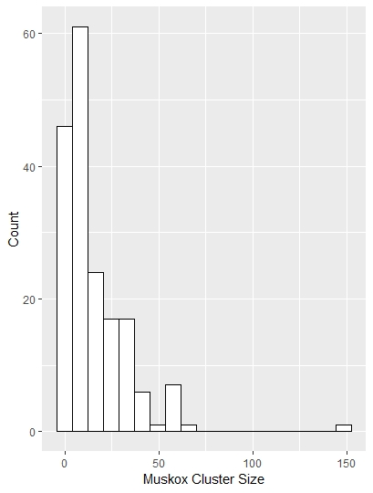
Figure 6: Frequency of occurrence of muskox group size encouters during the survey.

At the start of the survey, observers were giving basic instructions as to how to detect animal and the importance of detecting them closer to the plane to meet the general assumption of the distance sampling method. 15 different observers took part in this survey. Very few observers (n=2) concentrated their observation on the first bin (0 to 200m), while other (n= 8) focused their observation to the last bins (>800 m) closer to the horizon (Figure7). What we were expecting is a distribution of observation like observer “AA”, “DK” and “MA” where observations are made in all bins with focus closer to the plane.

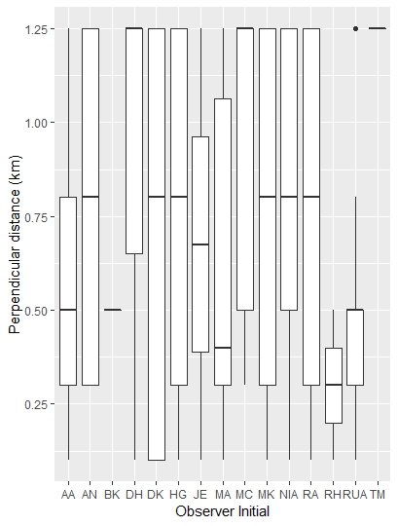
Figure 7: Boxplot of distance by observer, each 15 observers are represented by their initial.

For the analysis, only the muskox sighting on transect was kept. Also, since all observations from the front, back, right and left observers were recorded, group of muskox seen by both observers on the same side of the plane were paired. We did this by calculating the distance between all muskox group on the same side of the plane. If this distance was between 0 and 1.5 kilometer they were assigned as the same group, otherwise for a distance greater than 1.5 kilometers they were considerer a separate group. In total, 139 muskox groups were taken into consideration in the final abundance analysis (figure8).

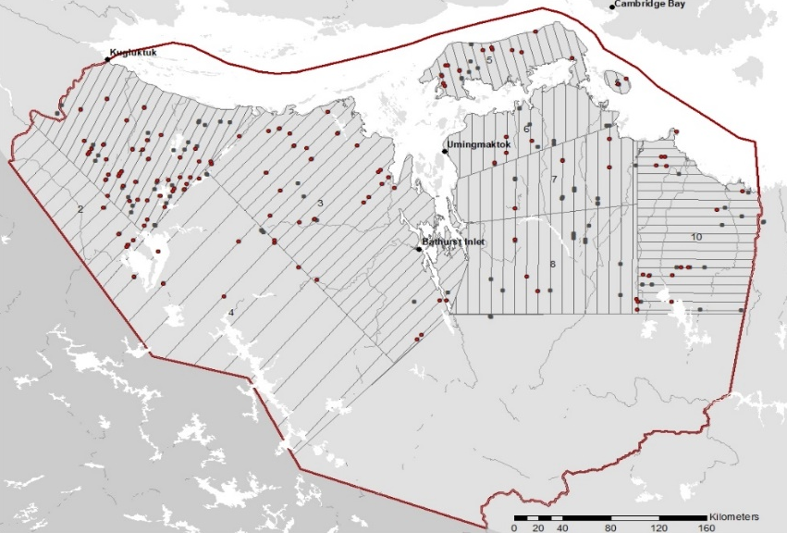
Figure 8: Total number of muskox group observed on transect (red dot) that were consdered unique group. The muskox group observed off transect (black dot) are also illustrated.

The average distance of the observations were made at 708 m from the aircraft, where most observations where made in the 1.0-1.5 km bin. Usually it should be expected that the number of observations decreased moving away from the airplane, as it is harder to detect animal far away. Figure 9 show the frequency of occurrence of detection for each bin.

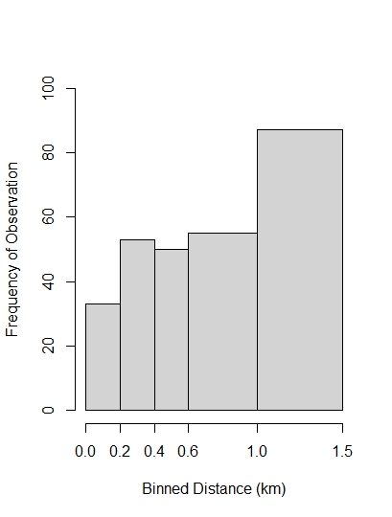
Figure 9: Distribution of perpendicular distance for binned distance of 0-0.2 km, 0.2-0.4 km, 0.4-0.6 km, 0.6-1 km and 1.-1.5 km.
Discussion:
The survey of the muskox management unit MX11 was realized with success. Although the entire study region wasn’t covered (strata9), we are still confident that this survey will provide the information needed to make meaningful harvest decision for this management unit. The unsurvey strata was determined as a low priority, since harvesters don’t focus their muskox harvest at this location and seldomly travel there. Data analysis is still underway, preliminary analysis of the data has resulted in finding two limitations of the data in this study.

Foremost, the frequency of detection as a function of distance (figure9) shown that the highest detection occurred in the last bin (1-1.5 km). This was also reflected in the distribution of observation per observers showing a trend in detecting animals’ father away from the plane (figure7). The dark brown color of the muskox on a snowy white background might have facilitated the detection of muskox at a greater distance when compared with muskox survey effectuated during the summer. Figure7, revealed that most observers scanned mostly right to left. This resulted in the observers focusing their observations in a particular bin and then possibly the muskox group were called on-transect when they were off-transect due to the difficulted to assess the narrower farther bin. A second explanation might be that the plane triggered a flight response where muskox moved away from the plane and observation were called father away then the original location of the animal before their responsive movement. The data set is problematic as the main assumption of the Distance sampling methods is that it assumed that all observation closer to the plane will be detected and we will fail to detect animals far away, (g (0) = 1). When the detection at distance 0 is uncertain, a double observer platform survey is used to estimate abundance. This is the approach that will be taken.

The second potential issue was the non-random distribution of muskox group in this study area. This was at priory accounted for by stratifying and increasing the number of samples in the known higher muskox density based on local expert knowledge. This extra step in the survey design was advantageous as strata 1, 3, 5, and 10, where most effort were concentrated, reflected the assumed higher muskox density. Still considerable effort was also allocated in strata 6, 7, and 8, but resulted in less then five muskox groups on transect detected within each of these strata. As presumed, strata 2 and 4 had very little observations. Thus, the final representation of muskox on the landscape (figure8) confirmed that some part of the muskox management unit MX11 might be more suitable muskox habitat and therefore influence their distribution. To take into account environmental covariates (topography roughness, snow cover, surface temperature, vegetation) that might have influenced muskox distribution, we are intending to run a Density Surface Model analysis (DSM), as it doesn’t depend upon a random sampling design. Such model has been proven successful in determining the relationship between distribution and environment covariates to better estimate abundance.

In conclusion, we are confident to develop a robust analysis to estimate the muskox abundance in the management unit MX-11. With the scarcity of caribou, harvesters require alternative sources of country food such as muskox. This work will result in re-evaluating the existing quota by either allowing for an increase in muskox harvest and/or reducing harvest pressure to ensure long-term resource availability.

References:

Buckland, S.T., Anderson D.R., Burnham, K.P., Laake J.L. (1993). Distance Sampling. Estimating Abundance of Biological Populations. Chapman &Hall, London.

Buckland, S.T., Anderson D.R., Burnham, K.P., Laake J.L., Borchers., D.L. and Thomas L. (2004). Advanced Distance Sampling: Estimating abundance of biological populations. Oxford. Chapter 7, 416pp.

Campbell M., Ringrose J., Boulanger J., Roberto-Charron A., Methuen K., Mutch C., Davidson T., Wray C. (2021). An Aerial Abundance Estimate of the Dolphin and Union Caribou (Rangifer tarandus groenlandicus x pearyi) herd, Kitikmeot Region, Nunavut – Fall 2020. Government of Nunavut, Technical Report Series No 01-2021. 146 pp.

Campbell M., Goorts J., Lee D.S., Boulanger J., Pretzlaw T. (2015). Aerial abundance estiamtes, seasonal range use, and spatial affiliations of the barren-ground caribou (Rangifer tarandus groenlandicus) on Baffin Island- March 2014. 2015 Government of Nunavut, Department of Environment, Technical Report Series- No 01-2015. 196 pp.

Dumond, M. 2007. Muskoxen Distribution and Abundance in the Area Between Bathurst Inlet, and the Coppermine River, Kitikmeot Region, Nunavut (MX19 and West MX14). Gov. of Nunavut, Unpubl. Rep., 27 pp.

Environment Canada 1995. Ecological Framework of Canada. http://ecozones.ca/english/. Accessed September 1 2019.

Gunn, A. 1990. Distribution and abundance of muskoxen between Bathurst Inlet and Contwoyto lake, NWT, 1986. NWT DRR File Report No.100. 28pp.

Gunn, A. and Patterson, B.R. 2000. Distribution and Abundance of Muskoxen on Southeastern Victoria Island, Nunavut. Gov. of the N.W.T., Unpubl. Rep.

Laake, J., Borchers D.L., Thomas L., Miller D., Bishop J. 2012. Mark-recapture distance sampling (MRDS) 2.1.0 R. statistical package program.

Leclerc, L-M, 2015. Muskox (Obivos moschatus) distribution and abundance, muskox management units MX-11 subdivision, Kugluktuk, September 2013. Status Report. Government of Nunavut, Department of Environment. 16 pp.

Kutz, S. J. et al. (2015). Erysipelothrix rhusiopathiae associated with recent widespread muskox mortalities in the Canadian Arctic. Can. Vet. J. 56, 560–563 (2015).

Miller, D.L., Burt M.L., Rexstad E.A., Thomas L. 2013. Spatial models for distance sampling data:recent developments and future directions. Methods in Ecology and Evolution. 10pp.
Norton-Griffiths, M. 1978. Counting Animals. Serengetti Ecological Monitoring Programme Handbook No.1. Afropress Ltd., Nairobi Kenya. 139 pp.
R Development Core Team. 2009. R Foundation for Statistical Computing. Vienna, Austria

Rothenburger, J. L. et al. (2021). Corynebacterium freneyi bacterial septicemia secondary to contagious ecthyma in a wild muskox (Ovibos moschatus). J. Wildl. Dis. 57, 225–229.

Smith, T. E. 1989. The role of bulls in pioneering new habitats in and expanding muskox population on the Seward Peninsula, Alaska. Canadian Journal of Zoology 67:1096-1101.

Tener, J.S. 1965. Muskoxen in Canada; a biological and taxonomic review. Canadian Wildlife Service. Queens Printer and Controller of Stationary. Ottawa.

Thomas, L., R., D. Williams, D. Sandilands (2007) Designing line transect surveys for complex survey regions. Journal Cetaceans Resource Management 9(1) 1-13

THOMAS, L., J. L. LAAKE, S. STRINDBERG, F. F. C. MARQUES, S. T. BUCKLAND, D. L. BORCHERS, D. R. ANDERSON, K. P. BURNHAM, S. L. HEDLEY, J. H. POLLARD, J. R. B. BISHOP AND T. A. MARQUES. 2006. Distance 5.0. Release 1. Research Unit for Wildlife Population Assessment, University of St. Andrews, U.K. http://www.ruwpa.st-and.ac.uk/distance.

Tomaselli, M. et al. (2016) Contagious ecthyma, rangiferine brucellosis, and lungworm infection in a muskox (Ovibos moschatus) from the Canadian Arctic, 2014. J. Wildl. Dis. 52, 719–724.

Wilkinson, P. F.; Shank, C. C., and Penner, D. F. 1976. Muskox-Caribou summer range relations on Banks Island, N.W.T. Journal of Wildlife Management; 40:151-162.

