**From:** Orman, Lynda   
**Sent:** September 9, 2016 12:56 PM  
**To:** 'HTA Manager'  
**Cc:** Anderson, Morgan  
**Subject:** RE: Musk-ox Tags for Devon Island

Unnusakkut,

Qujannamiik, Jobie for the Ikajutit Hunters’ and Trappers’ Association recommendation on this important Devon Island muskox co-management issue. Your input will be discussed at the NWMB meeting next week.

Thank you to the HTA for its co-management  and willingness to continue to work together on this with co-management partners.

Lynda

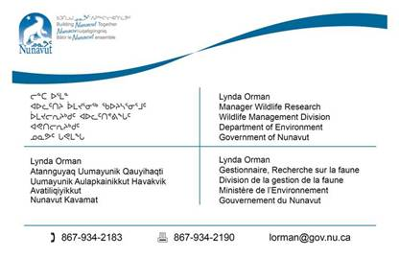

____________________________________________________________________________________

**From:** HTA Manager [<mailto:hto_ab@qiniq.com>]   
**Sent:** September 9, 2016 11:01 AM  
**To:** Orman, Lynda  
**Subject:** Musk-ox Tags for Devon Island

Arctic Bay HTO is fully supporting option #3, combination whereby the TAH could be removed the first year (2016-17) with unlimited Inuit harvest, Community could agree to having harvest monitoring in place.

Thank you for your letter that you have send , we will be fully corporative as process goes along.

Ikajutit HTO

Jobie Attitaq Chairperson

Grace Aola

Ikajutit Hunters' & Trappers' Association

Arctic Bay, Nu

Tel: (867) 439-8483

Fax: (867) 439-8916

_____________________________________________________________________________________

**From:** Orman, Lynda   
**Sent:** August 11, 2016 2:59 PM  
**To:** 'hto_ab@qiniq.com'  
**Cc:** Anderson, Morgan  
**Subject:** Devon Island Muskox  
**Importance:** High

Hello Grace and Jobie,

Biologist Morgan Anderson is currently out on the Prince of Wales and Sommerset Island muskox and Peary caribou survey or she would be contacting you today.

Further to Biologist Morgan Anderson’s recent letter to you and then following our telephone call last week, I was wondering if the Arctic Bay HTO Board has some recommendations on muskox harvest management for Devon Island? This would be in terms of the following options which I believe Morgan discussed with you:

1. remove the TAH in light of good abundance; however, harvest monitoring and community coordination would not be easily facilitated without the use of tags
2. increase the TAH from 15 to 100 muskox with tags, which can help facilitate harvest coordination and help maintain the harvest data base for co-management
3. Or a combination whereby the TAH could be removed the first year (2016-17) with unlimited Inuit harvest, communities could agree to having harvest monitoring in place, and a coordinated community hunt could proceed among the three communities (Arctic Bay, Resolute Bay, Grise Fiord); following this, a TAH of 100 could be put in place for subsequent years.

The Department of Environment recognizes that it would be beneficial for Inuit to harvest Muskox on Devon Island not only for the immediate families of these communities, but perhaps also to help facilitate the supply of meat to other communities on Baffin Island where caribou country food is currently scarce. Along with option 3) for your consideration, DOE would be receptive to a request from the communities for assistance in helping to coordinate such a large community hunt in 2016-17, with an intention to try to facilitate some of the logistics in terms of getting the meat distributed among communities if the hunt was successful. While DOE is open to such a request, this would be subject to the Department finding the resources to assist in this way, if asked.

Please let me know the Board’s thoughts on the above 3 options, and I would appreciate it if you could get back to me by reply email tomorrow, and/or with your Board’s Resolution on this.

Many Thanks,

Qujannamiik,

Lynda Orman

Manager Wildlife Research

Department of Environment