Peary caribou, muskox, and wolves on the Bathurst Island Complex Final Project Report
- NWRT Project Number: 2-20-01

- Project Title: Bathurst Island Peary caribou , muskox, and wolf study

- Project Leader:
Conor Mallory
Wildlife Biologist II – High Arctic
P.O. Box 209
Iglulik, NU
X0A 0L0
867-934-2175
cmallory@gov.nu.ca

- Summary:

In 2019, we initiated a study on the Bathurst Island Complex to improve our understanding of wolf predation on Peary caribou and muskox in the High Arctic. Last year we were only able to deploy one collar, in part due to weather delays limiting our time in the field, but also because we found fewer wolves than expected. Despite this, and based on the data we obtained through a single collar, we believe it is worthwhile to continue the project but have scaled back accordingly. In July 2020, we hope to conduct kill site visits to identify prey species (based on existing collar data) and deploy up to three additional collars on wolves. In late-August 2020, we plan to do another few days of kill site visits that would incorporate data from the newly deployed collars. This year we also want to expand the program to collect genetic data from Peary caribou and muskox fecal pellets. We intend to build on previous genetic work to better understand gene flow and population definition in the Arctic Archipelago. In the event of abrupt changes in population on the Bathurst Island Complex, having recent genetic samples will also help us to identify whether changes are likely the result of immigration, emigration, or reproduction. We will also use fecal samples to begin a pilot project looking at Peary caribou and muskox diet analysis across the High Arctic.

Outreach and local involvement are important aspects of our project. In the early development phase of the project, we met with the Resolute Bay Hunters and Trappers Associations and sought their involvement. We will provide them with regular updates as the project unfolds. Local observers have and will continue to be integral to the fieldwork and have been invaluable asset during past surveys.
- Project Objectives:
Predation component

- Estimate predation rates on Peary caribou and muskoxen by wolves
- Compare predation between two High Arctic wolf populations (Bathurst Island and Ellesmere Island) with very different prey populations (there were no Peary caribou in the area of the Ellesmere Island wolf study during its four-year duration).
- Along with abundance and composition data (from 2019 and 202 surveys), assess the impact of wolf predation on Peary caribou and muskoxen on the Bathurst Island Complex.

Genetic component
- Continue to build on work that has been done to characterize and spatially identify movement corridors, sex-based dispersal, and landscape features blocking/facilitating movement.
- Collect genetic samples for future use in identifying mechanisms of population decline or recovery for the Bathurst Island Complex.
- Continue to build on work to delineate and characterize genetic differences between Peary caribou across the High Arctic.
- Diet analysis pilot project: Investigate the value of using metabarcoding to analyse differences between Peary caribou and muskox diets at the individual level, and across the archipelago. If this type of methodology is useful and practical, we hope it could be used as a non-invasive means to assess diest quality for ungulates across the High Arctic.

- Material and Methods:
SAMPLING METHODS
Wolf capture - Cancelled
Although non-invasive techniques have become popular methods for monitoring wildlife populations, the most effective and reliable way to investigate the behavior of highly mobile species in remote areas remains GPS telemetry.
Wolf density on Bathurst Island does not appear to be high. During our 2019 capture work, we were only able to capture and collar one wolf, a 65 lb male that was part of a group with three other wolves. We flew over 30 hours across Bathurst Island and saw the same wolf that we collared and his pack 3 times in different places. We only saw one other wolf on the southeastern shore of Bathurst Island, but we weren’t able to capture it due to strong winds.
During the 2020 field season, we plan to deploy GPS collars on 3 wolves in as many packs as possible. Multiple collars may be deployed in a single pack to investigate variability in movements between individuals in a pack, and as a backup in case of collar malfunction. Wolves will be captured by net gun or chemically immobilized by dart gun from a helicopter. Collars will be programmed to acquire locations every hour and will be collected through the Iridium satellite network. Collar batteries should last 1-2 years on this schedule and remote drop-offs on the collars will be programmed release at 14 months. Dropped collars will be retrieved and refurbished.

Kill site visits - Cancelled
To identify wolf kill sites, during the 2019 field season, we employed a cluster algorithm developed by Knopff et al. (2009) and previously used by Anderson et al. (2016) on Ellesmere and Axel Heiberg islands. We had good success with this method (we identified 16 kill sites in 2019) and will continue to use it to identify kill sites on the Bathurst Island Complex in 2020.

We can use the identification of prey at kill sites to infer predation rates on different prey species. Investigating wolf kill sites can also reveal patterns of predation pressure on specific age or sex classes of prey, differences in seasonal predation risk, and habitat or landscape variables that increase predation risk. The relative importance of different prey species to wolf diet and the potential for functional responses in shifting between preferred prey species further informs predation risk. Once we have a sufficient sample of kill sites, our aim is to examine kill rates based on number of animals and total biomass consumed per pack and per wolf.

Fecal pellet samples - Cancelled
We will collect fresh pellet samples opportunistically from groups of Peary caribou and muskoxen when searching for wolves and visiting kill sites. Fresh pellets will be swabbed, with the swab stored in a nontoxic salt buffer solution for shipment to the lab. Pellets will be stored in a cooler until they can be frozen for shipment. Genetic and diet analysis will be conducted by collaborators at Trent University
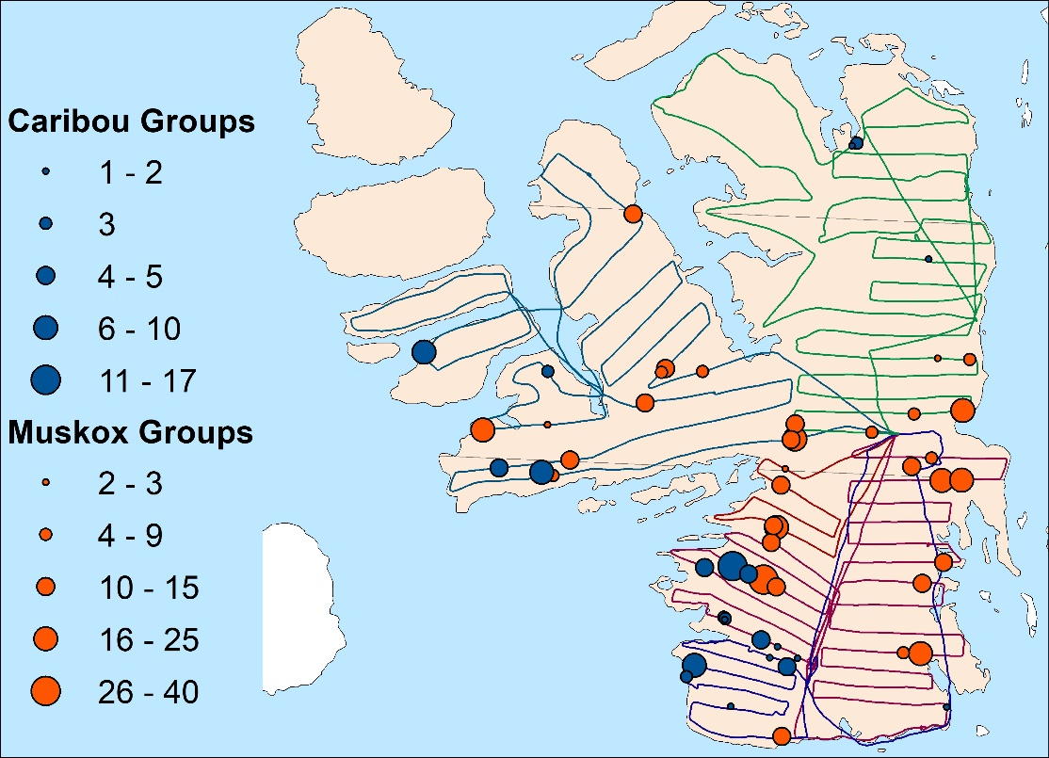
This study will occur on the Bathurst Island Complex. The figure below shows the wolf capture and composition flight lines from spring 2019 fieldwork, to give an idea of the scope of work proposed here. Note that in 2020 we are not proposing to do composition, but will be conducting an abundance survey of the area in March 2020.

Abundance Survey- March 2021
Fixed-width transect aerial surveys are a standard way to monitor ungulate populations and have been used in the High Arctic since 1961. Bins can be marked on the wing struts to permit distance sampling (Buckland et al. 2001, Thomas et al. 2009) as well as standard fixed-width strip transect sampling (Jolly 1969, Caughley 1977, Cochran 1977, Kingsley and Smith 1981). We propose to fly the Bathurst Island Complex with east-west transects 5-km apart, except for on Cornwallis Island where we would fly at 10-km spacing. With transects spaced 5 km apart with a strip width of 500 m either side of the aircraft, we would achieve around 24% coverage of the area. Distance sampling protocols would increase coverage.

The survey crew would include a pilot and co-pilot, a navigator/recorder, and 2 observers on each side of the aircraft, to enable a cooperative double-observer platform. Aircraft (probably a Twin Otter) would follow transects at 90 kts and 150 m above ground level. The range on a Twin Otter precludes the need for fuel caching and should allow the Bathurst complex to be completed out of Resolute in 6 or 7 full flying days.
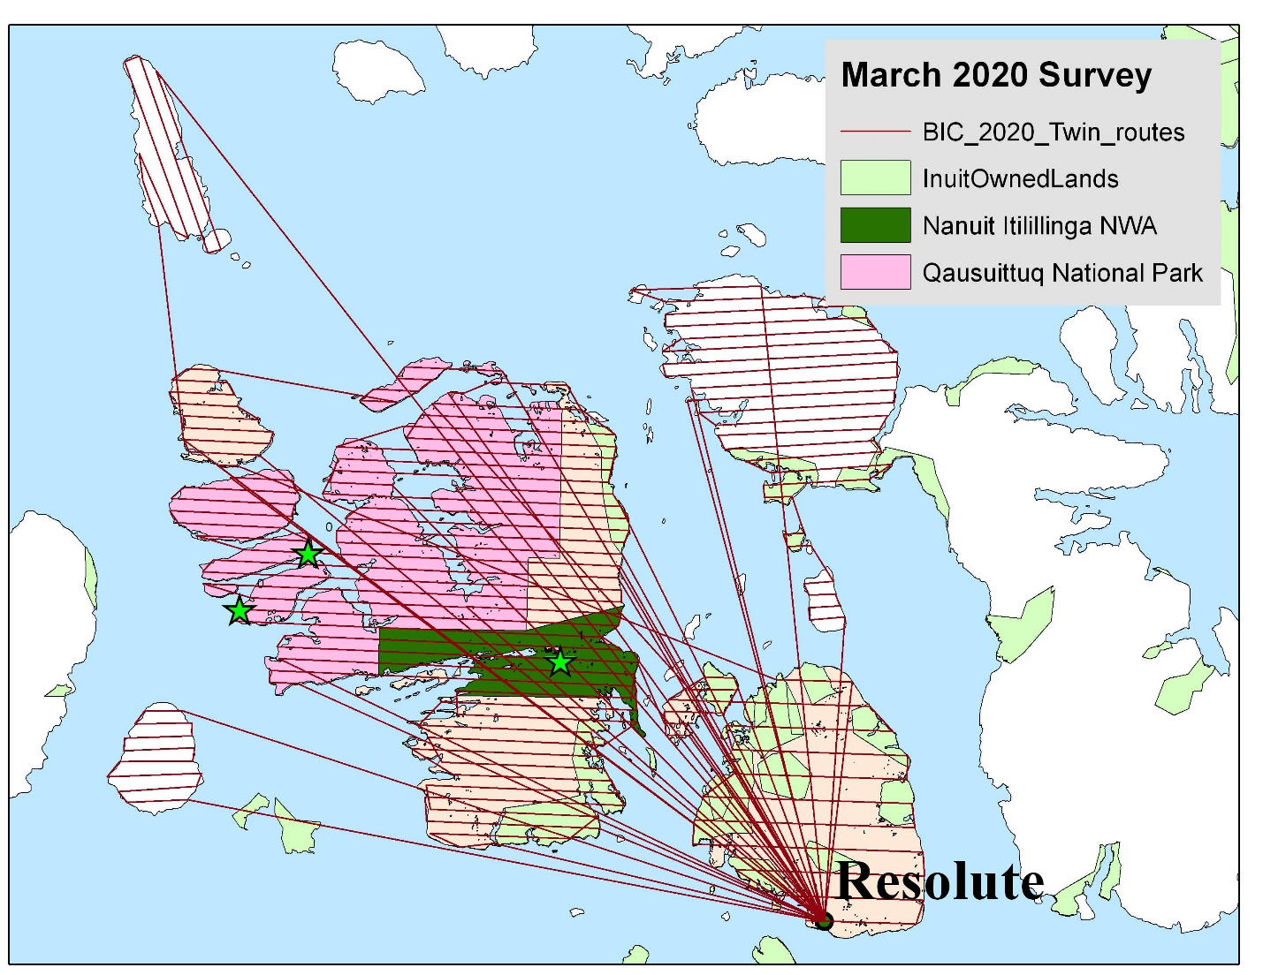

INCORPORATION OF IQ
Because of the expense and logistical difficulties in High Arctic research, we plan to prioritize search areas based on local knowledge and IQ as much as possible. We are particularly interested to know if there are areas where people have seen caribou and muskoxen previously or where they see them most often. During our 2021 fieldwork, community participants will be used to ensure the continues cooperation and high quality of our surveys. We try to share information and results with the communities as they come in, and the final analysis will be reported back to the community HTA in-person as well as in a comprehensive report. Discussion and interpretation of results also relies on community consultations. Any application of the results for management or recovery planning is done in the context of IQ and local input and co-management consultations.
- Project Schedule:
Output or step | Start date (dd/mm/yyyy) | End date (dd/mm/yyyy)
Pre-project consultation | 01/07/2019 | 24/01/2020
Predation study - cancelled | 26/06/2020 | 31/03/2021
Fecal pellet collection -cancelled | 26/06/2020 | 31/08/2020
Analysis-cancelled | 01/09/2020 | 31/03/2021
Reporting- cancelled | 01/09/2020 | 31/03/2021
Post-project consultation -email | 01/09/2020 | 31/03/2021
Bathurst Island Survey | 01/03/2021 | 30/03/2021
Bathurst Analysis and reporting | 01/04/2021 | 03/31/2022
Post Survey consultation | 01/09/2021 | 31/03/2022

- Preliminary results/discussion:
Unfortunately due to the Covid travel restrictions that occurred this past summer the field work was canceled. This means that the proposed project that was funded did not occurred and no funds spent.

- Reporting to communities/resource users:
We met with the Resolute Bay HTA in November 2018, January 2019, March 2019, July 2019, October 2019, and January 2020. We discussed planning for the project during all the meetings and in these meeting it was requested the we extend the survey to include Byam martin and northwest Devon Island as well. We did not get to Resolute since January 2020 for consultaions due to Covid restrictions.

