SUBMISSION TO THE

NUNAVUT WILDLIFE MANAGEMENT BOARD

FOR

Information: X Decision:

Issue: Results of 2009-2010 Aerial Surveys of the Foxe Basin polar bear sub-population (FB).

Background:

- The boundaries of FB encompass the northern part of Hudson Bay, the western end of Hudson Strait and Foxe Basin proper (Figure 1). This region is seasonally ice-free, spanning some 1.1 million km² across Nunavut and Nunavik in northern Quebec. Seven communities in Nunavut (Cape Dorset, Chesterfield Inlet, Coral Harbour, Hall Beach, Igloolik, Kimmirut, and Repulse Bay) and four communities in Quebec (Akulivik, Ivujivik, Puvirnituq, and Salluit) lie within the bounds of FB.

- A subpopulation estimate of 2,197 ± 260 (S.E.) bears was developed in 1996 from analysis of mark-recapture data collected between 1989 and 1994 using tetracycline biomarkers (Taylor et al. 2006). The findings of this study suggested the harvest was unsustainable, and a phased reduction was implemented (in Nunavut) between 1993 and 1996.. During this period, the Total Allowable Harvest (TAH) was reduced from 137 to 96. The TAH remained at 96 until 2004.

- During community consultations in 2003/2004 (when the new polar bear Memorandum of Understanding was developed) local knowledge indicated that the abundance of polar bears in FB had increased since 1996 (McDonald et al. 1997; GN community consultations 2004-2009). In 2004 the population estimate was increased to 2300, and the TAH was increased to a 106 (see Table 1).

- Harvesting from FB by residents of Nunavik is unregulated and has averaged 2.5 bears per year over the last 10 years.

Current Status:

- In 2009 and 2010, the GN conducted comprehensive aerial surveys of FB (see attached report). The surveys estimated overall abundance at about 2,580 bears, with a 95% confidence interval of 2,093 to 3,180 (CV: 10.7%). Observed litter sizes were comparable to those documented in other subpopulations with robust annual growth rates, suggesting that recruitment is currently indicative of a healthy subpopulation. Anecdotally, polar bears observed during the aerial surveys generally appeared to be in good body condition, further suggesting that FB is a healthy subpopulation.

- Although the aerial survey provides important informationon the abundance and distribution of bears in FB, it does not provide estimates of survival and recruitment which are necessary to determine population growth rate (i.e. trend) and to calculate long-term sustainable harvest. However, estimates of abundance from the 1989-1994 (mark-recapture) and 2009-2010 (aerial survey) studies are not statistically different. Although the comparability of these two studies is uncertain due to potential biases in one or both methods, this finding suggests that the current harvest management regimen has allowed FB to remain relatively stable since the early 1990s.

- Additional research to examine the movement patterns, range size and habitat use of FB polar bears is underway. These studies, which incorporate satellite tracking of bears in FB and surrounding subpopulations, as well as the collection of IQ from local communities, will support status assessment and permit the re-evaluation of boundaries for FB.

Consultations:

Meetings with HTO representatives in each of the Foxe Basin communities (Igloolik, Hall Beach, Coral Harbour, Chesterfield Inlet, Repulse Bay, and Cape Dorset) with the exception of Kimmirut were conducted between June 25 and July 26, 2012. The meeting with the Kimmirut HTO was postponed due to lack of board member availability, however it has been added to the agenda for their next HTO meeting. The purpose of these meetings was to present research findings and to generate discussion on management implications for the subpopulation. (See consultation summary document, attached).

The Nunavik Marine Regional Wildlife Board and the Government of Quebec have received a copy of the Foxe Basin Report and has been asked to provide input or feedback.

Recommendations:

The FB Polar Bear MOU (Section 5.7.1) states that when new research information becomes available the TAH will be adjusted as necessary. Taking into account results from the recent aerial survey, DOE recommends no change in the present TAH of 106, to be allocated among the communities according to the existing MOU and subject to modification under the flexible quota system.

This recommendation balances the best available scientific information and Inuit observations to ensure that harvest does not cause a conservation concern for the population. This constitutes a reasonable application of the precautionary principle based on the following rationale:

- Unlike physical mark-recapture methods, aerial surveys do not generate estimates of survival and recruitment that are necessary to model the impacts of differing levels of harvest. The resulting uncertainty necessitates a more conservative approach to setting a TAH. Current harvest levels appear to have allowed the subpopulation to remain relatively stable. Assuming subpopulation growth rate remains unchanged in future and the management objective is to keep abundance at or near its current level, the existing harvest management regimen carries little risk in terms of over-harvest.

- FB may be subject to a range of pressures in future which could negatively affect population size and productivity, and hence sustainable harvest. For example, long-term declines in sea-ice quality and quantity have been documented (Sahanatien and Derocher 2012) in FB. If these trends persist they could reduce habitat quality for polar bears potentially lowering carrying capacity. Shipping and other activities associated with industrial developments such as the proposed Mary River iron ore mine could also negatively affect polar bears and their habitat in FB. Finally, in accordance with the NLCA, decisions regarding the harvest of wildlife populations in Nunavut must take into account harvesting activities outside Nunavut. Harvest of FB bears is unregulated in Nunavik. Although low at present, a recent spike in the take of polar bears from Southern Hudson Bay by Nunavik hunters has demonstrated the risks associated with unregulated harvesting when access to bears and/or hide prices increase.

References:

McDonald, M, L. Arragutainaq and Z. Novalinga (eds.). 1997. Voices from the Bay: Traditional ecological knowledge of Inuit and Cree in the Hudson Bay Bioregion. Canadian Arctic Resources Committee and the Environmental Committee of the Municipality of Sanikiluaq, Ottawa, ON.

Sahanatien, V. and A.E. Derocher (2012). Monitoring sea-ice habitat fragmentation for polar bear conservation. Animal Conservation: In press.

Taylor, M., J. Lee, J. Laake and P. McLoughlin. 2006. Estimating population size of polar bears in Foxe Basin using tetracyclin biomarkers. Government of Nunavut, Department of Environment, Final Wildlife Report. 13 pp.

Date: August 10, 2012

Figure 1. The FB polar bear subpopulation spans more than 1 million km² in Nunavut and northern Quebec. Multiple strata were delineated for the FB aerial surveys.
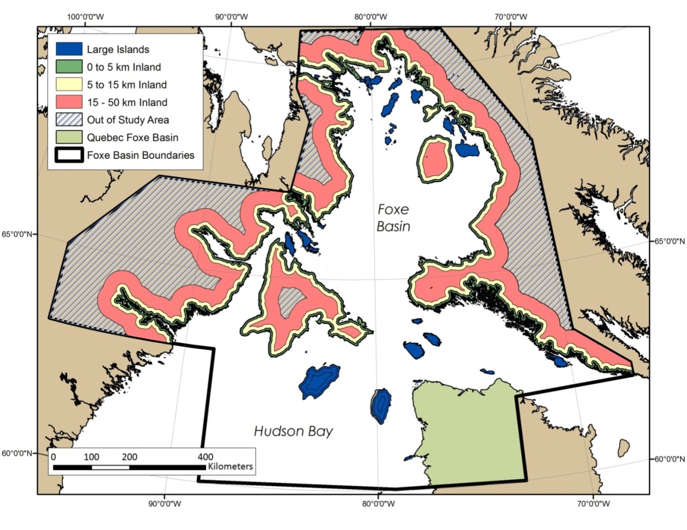

Table 1. Total Allowable Harvest (TAH) base allocations for Nunavut communities hunting in the Foxe Basin polar bear population. (Source: Polar Bear Management Memorandum of Understanding for the Management of the Foxe Basin Polar Bear Population, 2005)

NUNAVUT | TOTAL
Cape Dorset | 10
Chesterfield Inlet | 8
Coral Harbour | 40
Hall Beach | 8
Igloolik | 10
Kimmirut | 10
Repulse Bay | 12
Kivalliq Wildlife Board | 4
Qikiqtaaluk Wildlife Board | 4
Subtotal | 106

Excludes Nunavik (Quebec) harvest
In some years TAH was less than 96 to compensate for over harvest the year prior, as per the flexible quota system.
Population trend could be established in future by conducting a series of aerial surveys at intervals (e.g. every 5 years).

