ᓄᓇᕗᒥ ᐆᒪᔪᓕᕆᔨᕐᔪᐊᒃᑯᑦ ᑲᑎᒪᔨᖏᑦ ᑲᑎᒪᑎᑦᓯᑎᓪᓗᒋᑦ ᑭᒃᑯᑐᐃᓐᓇᕐᓂᒃ ᖃᑉᓯᓂᒃ ᐊᕕᒃᑐᖅᓯᒪᔪᓂ ᓄᓇᓕᕐᔪᐊᓂ ᑐᒃᑐᒍᓐᓇᖃᑦᑕᕋᔭᕐᓂᖏᓐᓄᑦ ᑐᒃᑐᔭᖅᑐᑉ ᒥᒃᓵᓂ ᑐᒃᑐᓂᒃ−ᑲᓇᖕᓇᖓᓂᒥᐅᓂᒃ ᔫᓐ 16-17, 2016

ᐱᔭᐅᔪᑦ ᓄᓇᑦᓯᐊᖅ ᒐᕙᒪᒃᑯᖏᓐᓂᑦ (GNWT), ᐊᕙᑎᓕᕆᔨᒃᑯᑦ ᐊᒻᒪ ᓄᓇᒥᐅᑕᓕᕆᔨᒃᑯᑦ (ENR)

ᓇᐃᒡᓕᒋᐊᖅᓯᒪᔪᑦ: ᑖᒃᑯᐊ ᑎᑎᕋᖅᓯᒪᔪᑦ ᐱᔾᔪᑎᖃᖅᐳᑦ ᖃᓄᐃᓕᖓᓕᕐᓂᖏᓐᓄᑦ ᑐᒃᑐᔭᖅᑐᑉ ᒥᒃᓵᓂ ᑐᒃᑐᖏᑦ ᑲᓇᖕᓇᖓᓂᒥᐅᑦ Bluenose-East . ᑲᑦᓯᐅᓂᖏᑦ. ᐱᑕᖅᑕᐅᓯᒪᓕᖅᑐᑦ ᐊᐅᓚᑕᐅᓂᖏᑦ ᑲᒪᒋᔭᐅᓂᖏᓪᓗ ᓄᓇᑦᓯᐊᒥ, ᓄᓇᑦᓯᐊᑉ ᒐᕙᒪᒃᑯᖏᓪᓗ ᐱᖁᔨᕗᖔᓕᐅᕈᑎᒋᓚᐅᖅᑕᖏᑦ ᐱᑕᖅᑕᐅᖃᑦᑕᕐᓂᖏᓐᓄᑦ ᑖᕙᓂ ᑐᒃᑐᐃᑦ. ᑐᑭᓯᒋᐊᒃᑲᓐᓂᕈᓐᓇᖅᐳᓯ ᑐᒃᑐᐃᑦ ᑖᒃᑯᐊ ᐱᓪᓗᒋᑦ ᑎᑎᖃᓂ. ᓇᓚᐅᑦᓵᕈᑎᖃᖅᖢᑎᒃ ᓈᓴᐃᓚᐅᖅᐳᑦ 2010-ᒥ ᑖᒃᑯᓂᖓ ᑐᒃᑐᓂᒃ ᑲᓇᖕᓇᖓᓂ ᑐᒃᑐᔭᖅᑐᑉ 100,000ᖑᓂᕋᐃᓪᓗᑎᒃ, ᑭᓯᐊᓂ ᐊᒥᓲᖏᓐᓂᖅᓴᐅᓂᖃᓕᖅᐳᑦ 68,000-ᓄᑦ 2013-ᒥ ᐊᒻᒪ 38,600 2015-ᒥ. ᐊᑯᓐᓂᖓᓂ 2013 ᐊᒻᒪ 2015 ᐊᕐᓇᓪᓗᐃᑦ ᓄᕐᕋᖅᑖᖅᐸᒃᑐᑦ ᐊᒥᓲᖏᓐᓂᖅᓴᐅᓕᓚᐅᖅᐳᑦ 50% ᐊᕐᕌᒍᓄᑦ ᒪᕐᕈᑐᐃᓐᓇᕐᓂ. ᖃᓄᐃᑉᐸᓪᓕᐊᓯᒪᓂᖏᑦ (ᐊᕐᓇᐃᓪᓗᐃᑦ ᐊᓐᓇᐅᒪᔪᑦ, ᓄᕐᕋᐃᑦ ᐊᓐᓇᐅᒪᔪᑦ, ᓄᕐᕋᒃᓴᖅᑖᖃᑦᑕᕐᓂᖏᑦ) ᒥᒃᖠᕙᓪᓕᐊᒃᑲᓐᓂᕈᑕᐅᓂᐊᕋᓱᒋᔭᐅᕗᖅ. ᓄᓇᑦᓯᐊᒥ ᓄᓇᖃᖅᑐᑦ ᑮᓇᐅᔭᓕᐅᕈᑎᖃᖅᖢᑎᒡᓗ ᐱᔅᓂᔅᖃᖅᑐᑦ ᐊᖑᓇᓱᐊᕐᓂᕐᒧᑦ ᑐᒃᑐᖃᑦᑕᖁᓐᓃᖅᑎᑕᐅᓚᐅᖅᐳᑦ ᔭᓐᓄᐊᕆ 2010−ᒥ. ᓄᓇᖃᖅᑳᖅᓯᒪᔪᑦ ᑭᒡᓕᖃᖅᑐᓂᒃ ᑐᒃᑐᒍᓐᓇᖅᑎᑕᐅᓪᓗᑎᒃ ᑎᑭᑦᖢᒍ 2014-2015-ᒧᑦ ᐱᑕᒐᒃᓴᐃᑦ ᑭᒡᓕᖃᖅᑎᑕᐅᓕᓚᐅᖅᖢᑎᒃ 1,800−ᓄᑦ ᐊᒻᒪ 80%ᓂᒃ ᐊᖑᓴᓪᓗᖕᓂᒃ ᑕᒪᓐᓇ ᐱᖁᔭᐅᓚᐅᖅᖢᓂ ᑲᑎᒪᔨᕋᓛᕆᔭᐅᔪᓄᑦ ᐱᓕᕆᖃᑎᒌᓄᑦ ᐆᒪᔪᐃᑦ ᐊᐅᓚᑕᐅᓂᖏᓐᓄᑦ ᑲᒪᒋᔭᐅᓂᖏᓐᓄᑦ (ACCWM) ᐊᖏᖅᑕᐅᓚᐅᖅᓯᒪᓪᓗᓂ ᑕᒪᓐᓇ ᐊᕙᑎᓕᕆᔨᒃᑯᓐᓄᑦ ᓄᓇᒥᐅᑕᓕᕆᔨᒃᑯᓐᓄᓪᓗ. ᑎᓴᐱᕆ 2015-ᒥ, ᓄᓇᑦᓯᐊᑉ ᒐᕙᒪᒃᑯᖏᑦ ᐊᒻᒪ ᐊᓪᓚᐃᑦ ᑭᓕᑦᓱ ᒐᕙᒪᒃᑯᖏᑦ (Tłı̨chǫ) (TG) ᑐᒃᓯᕋᐅᑎᖃᓚᐅᖅᐳᑦ Wek'èezhìi Renewable Resources Board (WRRB) ᑲᑎᒪᔨᖏᓐᓄᑦ ᐊᑐᓕᖁᔨᒍᑎᖃᓚᐅᖅᖢᑎᒃ ᑐᒃᑐᖃᑦᑕᕈᒪᓂᕐᒧᑦ 950-ᓂᒃ (ᑕᒪᕐᒥᒃ ᐊᖑᓴᓪᓗᐃᑦ) ᑕᒡᕙᖓ ᑐᒃᑐᔭᖅᑐᑉ ᒥᒃᓵᓂ ᑐᒃᑐᓂᒃ ᑲᓇᖕᓇᖓᓂ Bluenose-East ᑕᒪᐃᓐᓂᑦ. ᐊᑐᓕᖁᔨᒍᑎᖃᓚᐅᖅᐳᑦ ᑕᐃᒪᓐᓇ ᒥᒃᖠᒋᐊᓚᐅᖅᑎᓪᓗᒋᑦ ᑐᒃᑐᐃᑦ ᑕᐃ,ᖓᓕᑦ 2010-ᒥᑦ, ᓄᕐᕋᓕᐅᖏᓐᓂᖅᓴᐅᓕᖅᑎᓪᓗᒋᓪᓗ ᐊᕐᓇᓪᓗᐃᑦ 2013-2015-ᒧᑦ. ᐊᔾᔨᐸᓗᖓᓂᒃ ᑐᒃᓯᕋᐅᑎᖃᓚᐅᖅᐳᑦ ᓄᓇᑦᓯᐊᑉ ᒐᕙᒪᒃᑯᖏᑦ ᑖᒃᑯᓄᖓ ᐊᓪᓚᐅᖕᒥᔪᓄᑦ Sahtú Renewable Resources Board (SRRB) ᑲᑎᒪᔨᖏᓐᓄᑦ ᐊᒻᒪ ᐆᒪᔪᓂᒃ ᒥᐊᓂᖅᓯᓂᕐᒧᑦ ᖃᐅᔨᒪᑎᑦ ᑲᑎᒪᔨᖏᓐᓄᑦ − ᓄᓇᑦᓯᐊᒥ (WMAC-NWT), ᐊᒻᒪ ᑲᑎᑦᓗᒋᑦ ᐱᑕᖅᑕᐅᔪᓐᓇᖅᑐᑦ ᐊᔾᔨᒌᒃᖢᑎᒃ. ᑲᑎᓪᓗᒋᑦ ᐱᑕᖅᑕᐅᔪᓐᓇᖅᑐᑦ 611ᖑᓂᐊᕐᓗᑎᒃ ᓄᓇᑦᓯᐊᒥ ᐊᒻᒪ 339 ᓄᓇᕗᒥ, ᓄᓇᑦᓯᐊᑉ ᒐᕙᒪᒃᑯᖏᑦ ᐊᓯᖏᓪᓗ ᓄᓇᑦᓯᐊᒥ ᑎᒥᐅᔪᑦ ᐃᓕᑕᖅᓯᓯᒪᓪᓗᑎᒃ ᓄᓇᕗᒥᐅᓂᒃ ᐊᐅᓚᑦᓯᖏᓐᓂᕐᒧᑦ ᖃᐅᔨᒪᓪᓗᑎᒃ. ᐱᑕᒐᒃᓴᐃᑦ 611 ᑲᑎᑦᖢᒋᑦ ᐊᒥᖅᑳᖃᑦᑕᐅᑎᔭᐅᓂᐊᖅᓗᑎᒃ ᑖᒃᑯᓄᖓ ᐊᓪᓚᓄᑦ ᑭᑦᓱ, ᓴᑐ, ᑎᑦᓱ, ᐃᓄᕕᐊᓗᐃᑦ, ᓄᓇᑦᓯᐊᒥ ᐊᓪᓚᖓᔪᑦ, ᐊᑭᑦᓱ ᐊᒻᒪ ᐅᐊᖕᓇᖓᓂ ᐊᓪᓚᖓᔪᑦ North Slave Métis Alliance. ᐊᒥᐊᒃᑯᖏᑦ ᑐᑭᓯᒋᐊᕈᑎᒃᓴᐃᑦ ᑕᒡᕙᓃᑦᑐᑦ ᐅᑯᓂᖓ ᐱᔾᔪᑎᖃᖅᐳᑦ: (1) ᑐᒃᑐᔭᖅᑐᑉ ᒥᒃᓵᓂ ᑐᒃᑐᐃᑦ ᖃᑦᓯᐅᓂᖏᑦ Bluenose-East , (2) ᖃᓄᕐᓗ ᐊᐅᓚᑕᐅᓂᖏᑦ ᑖᒃᑯᐊ ᑐᒃᑐᐃᑦ Bluenose-East , (3) ᒫᓐᓇᓵᖑᓚᐅᖅᑐᒥ ᐱᑕᖅᑕᐅᓯᒪᔪᑦ ᐊᐅᓚᑕᐅᓂᖏᓪᓗ ᑐᒃᑐᔭᖅᑐᑉ ᒥᒃᓵᓂ ᑐᒃᑐᐃᑦ Bluenose-East ᓄᓇᑦᓯᐊᒥ 2010-2015, ᐊᒻᒪ (4) ᓄᓇᑦᓯᐊᑉ ᒐᕙᒪᒃᑯᖏᑦᑕ ᖃᑦᓯᓂᒃ ᐱᑕᖃᑦᑕᖁᔨᓂᖏᑦ ᑖᒃᑯᓇᖓᑦ Bluenose-East−ᓂᒃ.

- ᑐᒃᑐᔭᖅᑐᑉ ᒥᒃᓵᓂ ᑐᒃᑐᐃᑦ ᑲᓇᖕᓇᖓᓂ Bluenose-East herd ᖃᓄᐃᓕᖓᓂᖏᑦ

ᑐᒃᑐᔭᖅᑐᑉ ᒥᒃᓵᓂ ᑐᒃᑐᐃᑦ Bluenose-East ᖁᖓᓯᕈᓯᖅᓯᒪᓂᖏᓐᓄᑦ ᑕᐃᒪᖓᓂᑦ 1996-ᒥ ᖃᐅᔨᒪᔭᐅᕗᑦ ᑕᐃᒪ 200,000-250,000 km2 (ᓇᓗᓇᐃᖅᓯᒪᔪᒥ 1). ᓄᕐᕋᓕᐅᕐᕕᖓᑦ ᑕᐃᒪᖓᓂᑦ 2000-ᒥᑦ ᐱᖓᓐᓇᖓᓂ ᖁᕐᓗᖅᑑᑉ ᓄᓇᕗᒥ, ᐊᐅᔭᒃᑯᑦ ᓄᓇᕗᒦᖃᑦᑕᖅᖢᑎᒃ. ᐅᑭᐅᒃᑯᑦ ᓄᓇᑦᓯᐊᒦᖃᑦᑕᖅᖢᑎᒃ ᑕᒫᓂ ᑲᓇᖕᓇᖓᓂ ᓂᒋᐊᓂᓗ ᑕᓯᕐᔪᐊᑉ Great Bear Lake.

ᔫᓐ 2015−ᒥ ᓄᕐᕋᓕᐅᕐᕕᖓᑦ ᐊᔾᔨᓕᐅᖅᑕᐅᓚᐅᖅᑎᓪᓗᒍ ᖃᐅᔨᓴᖅᑕᐅᓚᐅᖅᑎᓪᓗᒋᑦ ᑕᐃᑲᓂ ᑐᒃᑐᐃᑦ Bluenose-East ᓇᓚᐅᑦᓵᖅᑕᐅᓯᒪᓪᓗᑎᒃ ᐅᓄᕐᓂᖃᖅᐳᑦ 17,396 ± 4,616 (95% Confidence Interval) ᐊᕐᓇᓪᓗᐃᑦ ᓄᕐᕋᓕᑦ, ᐆᒃᑐᑎᒋᓗᒍ ᔫᓐ 2013-ᖑᓚᐅᖅᑐᒥ 34,472 ± 4,363
ᐊᒥᖏᓐᓂᖅᓴᐅᓕᖅᐳᑦ ᐃᒪᓐᓇᑎᒋ ~29% ᐊᕐᕌᒍᑕᒫᑦ (Fig. 2; Boulanger et al. 2016). ᑖᒃᑯᐊ ᖃᐅᔨᓴᕈᑕᐅᓯᒪᔪᑦ ᐅᓗᕆᐊᓇᕈᑎᖃᒻᒪᕆᒃᐳᑦ ᒪᕐᕉᖕᓂᒃ ᐱᔾᔪᑎᖃᖅᖢᑎᒃ: 1) ᐊᒥᓲᖏᑉᐸᓪᓕᐊᓂᖏᑦ ᓱᑲᑦᑐᒻᒪᕆᖕᒥᒃ ᐊᒥᓲᖏᑉᐸᓪᓕᐊᓂᖃᖅᐳᑦ ᒪᕐᕈᐃᖅᑕᖅᖢᑎᒃ ᓱᑲᓐᓂᖅᓴᐅᓪᓗᑎᒃ -14% ᐊᕐᕌᒍᒧᑦ ᐊᓯᔾᔨᖃᑦᑕᖅᖢᑎᒃ ᖃᐅᔨᓴᕈᑕᐅᓚᐅᖅᑐᓂᒃ ᓄᕐᕋᓕᐅᕐᕕᖕᒥ 2013 ᐊᒻᒪ 2010; ᐊᒻᒪ 2) ᑕᒪᓐᓇ ᖃᐅᔨᓴᖅᑕᐅᓯᒪᔪᖅ ᐊᕐᕌᒍᑕᒫᑦ ᖃᑦᓯᐅᓕᕐᓂᖏᓐᓄᑦ -29% ᑲᔪᓯᓂᐊᖅᐸᑦ, ᑕᒪᒃᑯᐊ ᓄᕐᕋᓕᐅᖅᑐᑦ ᐊᕐᓇᓪᓗᐃᑦ ᐊᕝᕙᖏᓐᓂᑦ ᐅᓄᖏᓐᓂᖅᓴᐅᒐᔭᖅᐳᑦ ᐅᓪᓗᒥᐅᓕᖅᑐᒥᑦ ᐊᕐᕌᒍᓂ ᒪᕐᕉᖕᓂ, ᖃᐅᔨᓴᕐᓂᐊᕆᓪᓗᑕ ᑕᒪᒃᑯᓂᖓ ᔫᓐ 2018-ᒥ. ᓱᑲᑦᑐᒃᑯᑦ ᓄᖑᑉᐸᓪᓕᐊᑐᐃᓐᓇᕐᓂᖏᓐᓄᑦ ᑕᒪᒃᑯᐊ ᐊᒥᓲᓚᐅᖅᓯᒪᓪᓗᑎᒃ ᑐᒃᑐᔭᖅᑐᑉ ᒥᒃᓵᓂ ᑐᒃᑐᐃᑦ ᑲᓇᖕᓇᖓᓂ Bluenose-East herd ᑕᐃᒪᓐᓇᑎᑐᑦ ᓄᖑᑉᐸᓪᓕᐊᕗᑦ ᕿᖓᐅᑉ ᒥᒃᓵᓂ ᑐᒃᑐᐃᑦ 2006-2009−ᒥᓗ ᖃᐅᔨᓴᖅᑕᐅᓚᐅᖅᓯᒪᓪᓗᑎᒃ, ᐊᕐᕌᒍᑕᒫᑦ ᐅᓄᕐᓂᖏᑦ ᒥᒃᖠᕙᓪᓕᐊᓚᐅᕐᒪᑕ ᑕᒪᒃᑯᐊ ᐊᕐᓇᓪᓗᐃᑦ ᓄᕐᕋᓕᐅᖅᐸᒃᑐᑦ ᓇᓚᐅᑦᓵᖅᑕᐅᓯᒪᓪᓗᑎᒃ ᐅᖓᑖᓄᑦ ~-30%. ᐊᕐᕌᒍᒥ 2015 ᐊᔾᔨᓕᐅᖅᑕᐅᓯᒪᔪᑦ ᖃᐅᔨᓴᖅᑕᐅᒍᑎᑦ ᖃᐅᔨᓐᓇᕈᑕᐅᕗᑦ ᑖᒃᑯᐊ ᑐᒃᑐᐃᑦ Bluenose-East ᖃᐅᔨᔭᐅᓚᐅᖅᖢᑎᒃ ᖃᐅᔨᓴᕈᑎᓂ ᔫᓐ 2014−ᒥ ᖃᐅᔨᒋᐊᖅᖢᒍ ᓄᕐᕋᓕᐅᕐᕕᖏᑦ. ᑖᒃᑯᐊ ᑐᒃᑐᐃᑦ ᓇᓚᐅᑦᓵᖅᑕᐅᓯᒪᕗᑦ ᐃᒪᓐᓇᑎᒋᐅᓂᖏᓐᓂ 38,592 ± 4,733 (CI) 2015−ᒥ, ᐆᒃᑑᑎᒋᓗᒍ 68,295 ± 18,041 ᐊᕐᕌᒍᒥ 2013−ᒥ ᐊᒻᒪ 100,000 ᐊᕐᕌᒍᒥ 2010−ᒥ (Fig. 3).

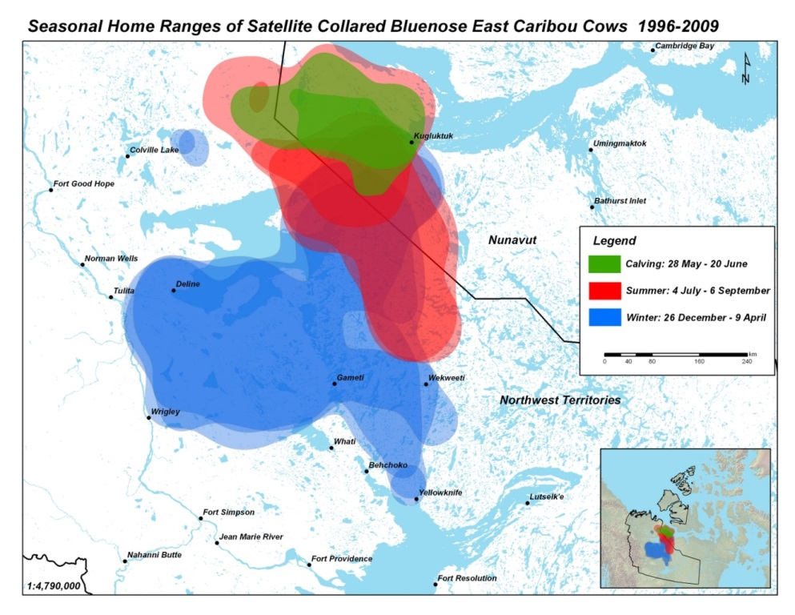

ᓇᓗᓇᐃᒃᑯᑕᖅ 1: ᓄᕐᕋᓕᐅᕐᕕᑦ, ᐊᐅᔭᖅᓯᐅᕐᕕᖏᑦ, ᐅᑭᐅᖅᓯᐅᕐᕕᖏᓪᓗ ᑖᒃᑯᐊ ᑐᒃᑐᐃᑦ ᑐᒃᑐᔭᖅᑐᑉ ᒥᒃᓵᓂ ᑲᓇᖕᓇᖓᓂ ᑐᒃᑐᐃᑦ, 1996-2009, ᖁᖓᓯᕈᓯᖅᑐᐃᓂᖅᓴᐅᓚᐅᖅᖢᑕ ᐊᕐᓇᓪᓗᖕᓂᒃ. ᓇᓃᓐᓂᖏᑦ ᑕᒪᒃᑯᐊ ᑐᒃᑐᐃᑦ Bluenose-East ᑕᑯᓐᓇᖅᖢᒍ ᓄᓇᑦᓯᐊᖅ ᐊᒻᒪ ᓄᓇᕗᑦ ᑕᑯᒃᓴᐅᕗᑦ ᑎᑎᕋᖅᓯᒪᔪᒥ. ᐱᔭᐅᔪᑦ ᖃᐅᔨᓴᖅᑕᐅᓂᑯᑦ Boulanger et al. (2016).

ᐊᓯᖏᑦ ᖃᑦᓯᐅᓂᖏᓐᓄᑦ ᖃᐅᔨᓴᕈᑕᐅᔪᑦ ᑖᒃᑯᓄᖓ ᑐᒃᑐᓄᑦ ᐊᕐᕌᒎᓯᒪᓕᖅᑐᓂ ᐊᔾᔨᒋᕙᖏᑦ ᐊᒥᓲᖏᓕᖅᐸᓪᓕᐊᓂᖏᑦ 2010-2015−ᒥᓗ. ᐅᑭᐅᓕᖅᑎᓪᓗᒍ ᓄᕐᕋᖅᑖᕆᔭᐅᓂᑯᑦ:ᐊᕐᓇᓪᓗᐃᓪᓗ ᖃᑦᓯᐅᖃᑦᑕᕐᓂᖏᑦ ᐊᕐᕌᒎᓯᒪᓕᖅᑐᓂ ᐅᓄᕐᓂᖏᑦ ᐊᑖᓃᖃᑦᑕᖅᐳᑦ 30 ᓄᕐᕋᐃᑦ:100 ᐊᕐᓇᓪᓗᐃᑦ (ᖃᑦᓯᐅᖃᑦᑕᐅᑎᓂᖏᑦ 30-40 ᓄᕐᕋᐃᑦ:100 ᐊᕐᓇᓪᓗᐃᑦ ᐊᒥᓲᓂᖅᓴᐃᓪᓘᓐᓃᑦ ᖃᓄᐃᖏᓐᓂᖅᓴᐅᑎᓪᓗᒋᑦ). ᓇᓚᐅᑦᓵᖅᑕᐅᓯᒪᔪᑦ ᐊᕐᓇᐃᓪᓗᐃᑦ ᐃᒪᓐᓇᐃᓚᐅᖅᐳᑦ 2012-2015-ᒧᑦ 71%, ᐊᑖᓂ 80% ᖃᓄᐃᖏᓐᓂᐊᖅᐸᑕ ᑕᐃᒪᓐᓇᐃᒋᐊᖃᕋᓗᐊᕐᒪᑕ (Boulanger et al. 2016) ᖃᐅᔨᓴᕐᓂᑯᖏᑦ. ᓄᕐᕋᖅᑖᓗᐊᖃᑦᑕᖏᑉᐳᑦ ᐃᓛᓐᓂᑯᑦ ᐃᓚᖏᓐᓂ ᐊᕐᕌᒍᓂ, ᐊᒻᒪ 2010, 2012 ᐊᒻᒪᓗ 2015−ᒥ (ᐊᕙᑎᒥᐅᑕᓕᕆᔨᒃᑯᑦ ᓄᓇᒥᐅᑕᓕᕆᒃᑯᓪᓗ 2014a). ᖃᐅᔨᓴᕈᑕᐅᔪᑦ ᐆᒃᑐᕈᑎᒋᔭᐅᔪᑦ ᒥᑭᔫᓚᐅᕋᓗᐊᖅᑎᓪᓗᒋᑦ, ᑲᑎᑦᓯᓚᐅᕐᒪᑕ ᐊᓪᓚᐃᑦ ᐊᖑᓇᓱᐊᖅᑎᖏᑦ Tłı̨chǫ ᐅᑭᐅᒃᑯᑦ ᐅᖃᖃᑦᑕᓚᐅᖅᖢᑎᒡᓗ ᐊᕐᓇᓪᓗᐃᑦ ᐊᑲᐅᖏᓕᐅᕈᑎᖃᓚᐅᕐᒪᑕ ᐊᕐᕌᒍᓂ 2010 ᐊᒻᒪ 2014−ᒥ, ᐊᒻᒪ ᐱᓗᐊᖅᑐᒥᒃ 2010-2012 (ᐊᕙᑎᒥᐅᑕᓕᕆᔨᒃᑯᑦ ᓄᓇᒥᐅᑕᓕᕆᔨᒃᑯᓪᓗ 2014a). ᐱᒻᒪᕆᐅᕗᖅ ᐅᔾᔨᕐᓇᕐᓂᖓ ᑖᒃᑯᐊᑐᐊᑦ 61% ᖃᐅᔨᓴᖅᑕᐅᓚᐅᖅᑐᑦ ᑖᒃᑯᓇᖓᑦ ᑐᒃᑐᔭᖅᑐᑉ ᒥᒃᓵᓂ ᑐᒃᑐᐃᑦ ᑲᓇᖕᓇᖓᓂ Bluenose-East ᓄᕐᕋᓕᐅᕐᕕᖕᒥ ᔫᓐ 2015-ᒥ ᓄᕐᕋᓕᐅᖃᑦᑕᖅᑑᓚᐅᖅᐳᑦ ᐊᕐᓇᓪᓗᐃᑦ; 80%− ᐅᕙᓘᓐᓃᑦ ᐅᖓᑖᓄᐊᕐᓂᐊᕋᓱᒋᔭᐅᓚᐅᖅᖢᓂ ᓄᕐᕋᖅᑖᓕᖅᑎᓪᓗᒋᑦ, ᑕᒡᕙᓂ 2009 (84%)ᖑᓚᐅᕐᒪᑕ ᐊᒻᒪ 2012 (82%)ᖑᓚᐅᖅᖢᑎᒃ. ᓇᓗᓇᐃᔭᖅᑕᐅᓯᒪᑦᓯᐊᖅᐳᑦ ᖃᐅᔨᓴᕈᑕᐅᓯᒪᔪᓂ ᑖᒃᑯᐊ ᑐᒃᑐᐃᑦ ᒥᒃᓵᓄᑦ ᑎᑎᕋᖅᓯᒪᔪᖅᑕᖃᒃᑲᓐᓂᖅᖢᓂᓗ; ᖃᑦᓯᐅᓂᖏᓐᓄᑦ ᓈᓴᖅᑕᐅᑎᓪᓗᒋᑦ ᐅᓂᒃᑳᓕᐅᖅᓯᒪᔪᑦ (Boulanger et al. 2016) ᖃᑦᓯᐅᓂᖏᓐᓄᓪᓗ ᑖᒃᑯᐊ ᑐᒃᑐᐃᑦ ᐅᓂᒃᑳᖅᑕᐅᓯᒪᓪᓗᑎᒃ.

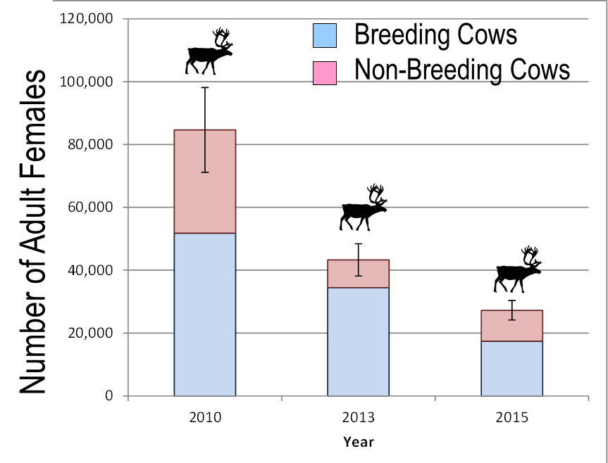

ᓇᓗᓇᐃᒃᑯᑕᖅ 2. ᓇᓚᐅᑦᓵᖅᑕᐅᓯᒪᔪᑦ ᖃᑦᓯᐅᓂᖏᑦ ᓄᕐᕋᓕᐅᖅᑐᑦ ᓄᕐᕋᓕᐅᖏᑦᑐᓪᓗ ᐊᕐᓇᓪᓗᐃᑦ (± 95% CI) ᑖᒃᑯᓇᓂ ᑐᒃᑐᔭᖅᑐᑉ ᒥᒃᓵᓂ ᑲᓇᖕᓇᖓᓂ Bluenose-East 2010-2015−ᒥ, ᓄᕐᕋᓕᐅᕐᕕᖓᑦ ᐊᔾᔨᓕᐅᖅᑕᐅᓯᒪᓪᓗᓂ ᖃᐅᔨᓴᖅᑕᐅᓯᒪᔪᑦ.

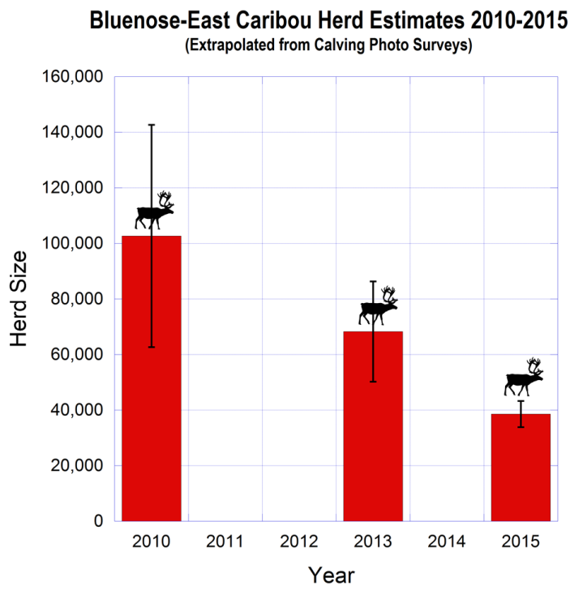;;

ᓇᓗᓇᐃᒃᑯᑕᖅ 3. ᓇᓚᐅᑦᓵᖅᑕᐅᓯᒪᔪᑦ ᖃᑦᓯᐅᓂᖏᑦ ᐃᓐᓇᐃᑦ ᑐᒃᑐᐃᑦ (± 95% CI) ᑐᒃᑐᔭᖅᑐᑉ ᒥᒃᓵᓂ ᑲᓇᖕᓇᖓᓂ Bluenose-East 2010-2015−ᒥ, ᖃᐅᔨᓴᖅᑕᐅᓂᑯᑦ ᒪᓕᒃᖢᒋᑦ ᐊᔾᔨᓕᐅᖅᑕᐅᓯᒪᔪᓂᒃ ᖃᐅᔨᓴᖅᑎᓪᓗᒋᑦ ᓈᓴᐃᑎᓪᓗᒋᑦ.

- ᐊᐅᓚᑕᐅᓂᖏᑦ ᒥᐊᓂᕆᔭᐅᓂᖏᑦ ᑐᑦᑐᔭᖅᑐᑉ ᑲᓇᖕᓇᖓᓂ ᒥᒃᓵᓂ ᑐᒃᑐᐃᑦ

ᑕᒪᐃᑎᒍᑦ ᐊᐅᓚᑕᐅᓂᖏᑦ ᒥᐊᓂᕆᔭᐅᓂᖏᑦ: ᐊᐅᓚᑦᓯᓂᕐᒧᑦ ᒥᐊᓂᖅᓯᓂᕐᒧᑦ ᐸᕐᓇᐅᑕᐅᓯᒪᔪᑦ ᐊᕐᕙᖅᒥ, ᑐᒃᑐᔭᖅᑐᑉ ᒥᒃᓵᓂ ᐱᖓᓇᖓᓂ ᑐᒃᑐᐃᑦ Cape Bathurst, Bluenose-West and Bluenose-East ᐋᖅᑭᒃᓱᖅᑕᐅᓚᐅᖅᐳᑦ ᖃᓄᐃᓕᖓᑎᑕᐅᓂᐊᕐᓂᖏᓐᓄᑦ ᑎᑎᕋᖅᓯᒪᔪᒥ ᐋᖅᑭᒃᑕᐅᓯᒪᓪᓗᑎᒃ ᐊᑎᖃᖅᑐᒥ Taking Care of Caribou ᐋᖅᑭᒃᓱᖅᑕᐅᓚᐅᖅᓯᒪᓪᓗᑎᒃ ᐆᒪᔪᕐᓂᒃ ᑲᒪᒋᔭᖃᕐᓂᕐᒧᑦ ᑲᑎᒪᔨᕋᓛᓄᑦ (ACCWM). ᐸᕐᓇᐅᑕᐅᓚᐅᖅᑐᖅ ᑖᓐᓇ ᐱᐊᓂᒃᑕᐅᓚᐅᖅᓯᒪᓪᓗᓂ 2014-ᒥ, ᓄᓇᑦᓯᐊᑉ ᒐᕙᒪᒃᑯᖏᓐᓄᓪᓗ ᐊᑐᖅᑕᐅᓂᐊᖅᓗᓂ ᐊᐅᓚᑦᓯᓂᖏᓐᓄᑦ ᒥᐊᓂᖅᓯᓂᖏᓐᓄᑦ ᑕᒪᒃᑯᓂᖓ ᐱᖓᓱᓂᒃ ᑐᒃᑐᓂᒃ ᐊᔾᔨᒌᖏᑦᑐᓂᒃ. ᑲᑎᒪᔨᑦ ᑭᒡᒐᖅᑐᐃᓪᓗᑎᒃ ᑖᒃᑯᓂᖓ ACCWM−ᑯᓐᓂᒃ ᐅᑯᐊ ᐆᒪᔪᓕᕆᓂᕐᒧᑦ ᖃᐃᔨᒪᑎᑦ ᑲᑎᒪᔨᖏᑦ ᓄᓇᑦᓯᐊᒥ (WMAC-NWT), ᐃᖅᑭᓕᑦ ᒍᐃᑦᓯᓐ ᐆᒪᔪᓕᕆᓂᕐᒧᑦ ᑲᑎᒪᔨᖏ (GRRB), ᑖᒃᑯᐊ ᐃᖅᑭᓕᑦ Ɂehdzo Got’ı̨nę Gots’ę̨́ Nákedı - Sahtú ᐆᒪᔪᓕᕆᓂᕐᒧᑦ ᑲᑎᒪᔨard (SRRB), ᐊᒻᒪ Wek’èezhìi ᐆᒪᔪᓕᕆᓂᕐᒧᑦ ᑲᑎᒪᔨᖏᑦ SRRB), ᐊᒻᒪ ᕿᑎᕐᒥᐅᑦ ᐆᒪᔪᓕᕆᓂᕐᒧᑦ ᑲᑎᒪᔨ (KRWB), ᐊᒻᒪ ᑐᒃᑎᓐ ᓄᖓᐃᑦ ᑲᓇᑕᒥ ᒥᓐᖑᐃᖅᓯᕐᕕᓕᕆᔨᒃᑯᑦ ᑲᑎᒪᔨᖏᑦ (TNNPMB)

ᑖᒃᑯᐊ ACCWM−ᑯᑦ ᐸᕐᓇᒃᓯᓴᒍᑎᖏᓐᓄ ᐃᓚᐅᑎᑎᕗᑦ ᑕᒪᐃᑎᒍᑦ ᐊᐅᓚᑦᓯᒍᑎᖃᕐᓂᐊᕐᓂᖑᑦ ᐱᖓᓱᓂᒃ ᑐᒌᖏᑦᑐᓂᒃ ᑕᒪᐃᑎᒍᑦ ᖃᑉᓯᐅᓂᖏᑦ ᒪᓕᒡᓗᒋᑦ (ᓇᓗᓇᐃᔭᖅᓯᒪᔪᖅ 4). ᓯᑕᒪᐅᖕᒪᑕ ᓇᓗᓇᐃᒃᑯᑕᓂ: ᐆᔭᐅᔭᖅ ᐊᒥᓲᓂᖅᐹᑦ, ᖁᖅᓱᖅᑐᖅ ᖃᓄᐃᓗᐊᖏᑦᑐᑦ, ᐊᒻᒪ ᐊᒥᓱᖑᖅᐸᓪᓕᐊᓪᓗᑎᒃ, ᐊᒻᒪ ᐊᐅᐸᔮᖓᔪᖅ ᖃᓄᐃᖏᑦᑐᑦ ᐊᒥᓲᖏᓕᖅᐸᓪᓕᐊᓪᓗᑎᒡᓗ ᐊᒻᒪ ᐊᐅᐸᖅᑐᖅ ᖃᑦᓰᓐᓇᐅᑐᐃᓐᓇᕐᓂᖏᑦ. ᑕᒪᒃᑯᐊ ᑐᒃᑐᔭᖅᑐᑉ ᒥᒃᓵᓂ ᑲᓇᖕᓇᖓᓂ ᑐᒃᑐᐃᑦ Bluenose-East, ᐊᐅᐸᖅᑐᒥ ᑎᑎᕋᖅᓯᒪᔪᑦ ᖃᑦᓯᐅᓂᖏᑦ ᐱᒋᐊᕐᓂᐊᖅᖢᑎᒃ 20,000 ᒥᑭᓂᖅᓴᐅᓪᓘᓐᓃᑦ ᐆᔭᐅᔭᖅ 60,000 ᐊᒥᓲᓂᖅᓴᕐᓘᓐᓃᑦ.

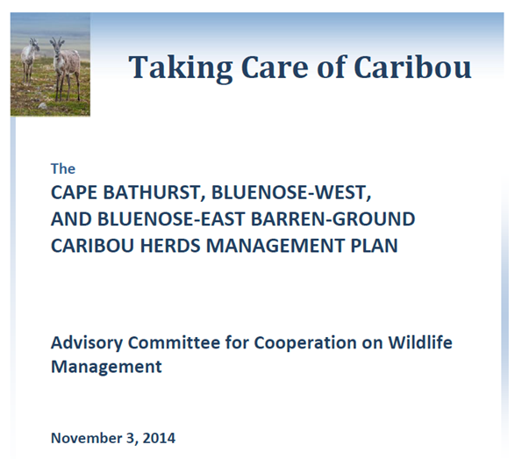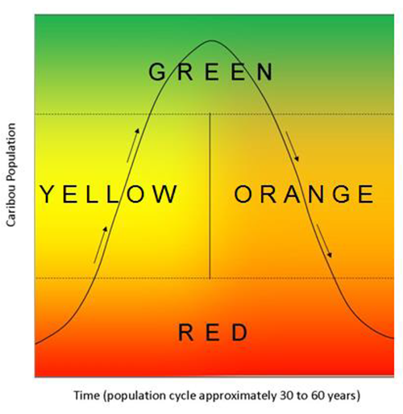

ᓇᓗᓇᐃᔭᖅᓯᒪᔪᖅ 4. ᑖᒃᑯᐊ ACCWM−ᑯᑦ ᑐᒃᑐᓂᒃ ᐊᐅᓚᑦᓯᔨᑦ ᐸᕐᓇᐅᑎᖏᑦ ᒪᓕᒃᖢᑎᒃ ᑎᑎᕋᖅᓯᒪᔪᓂᒃ Taking Care of Caribou (ᓴᐅᒥᐊᓂ) ᐊᒻᒪ ᑲᓚᖓ ᓇᓗᓇᐃᒃᑯᑕᖃᖅᖢᓂ ᖃᑦᓯᐅᓂᖏᑦ ᑐᒃᑐᐃᑦ ᒪᓕᒃᖢᒋᑦ ᖃᓄᐃᑉᐸᓪᓕᐊᓂᖏᓪᓗ.

ᒪᓕᒡᓗᒋᑦ ᓇᓚᐅᑦᓵᖅᑕᐅᓯᒪᔪᑦ ᐃᒪᓐᓇᑎᒋᐅᓂᖏᓐᓄᑦ 38,600 ᐊᕐᕌᒍᒥ 2015−ᒥ ᐊᒻᒪ ᐊᒥᓲᖏᓕᖅᐊᓪᓕᐊᑐᐃᓐᓇᖅᖢᑎᒃ, ᑖᒃᑯᐊ ᑐᒃᑐᔭᖅᑐᑉ ᒥᒃᓵᓂ ᑲᓇᖕᓇᖓᓂ ᑐᒃᑐᐃᑦ ᐊᐅᐸᔮᖓᔪᒥ ᑎᑎᖅᓯᒪᔪᒃ (ᒥᒃᖠᕙᓪᓕᐊᔪᑦ). ᑕᐃᒪᓐᓇ ᐊᒥᓲᖏᓕᖅᐸᓪᓕᐊᑐᐃᓐᓇᖅᐸᑕ ᐊᐅᐸᖅᑐᒦᓐᓂᐊᖅᐳᑦ (ᐊᒥᓲᖏᓐᓂᖅᓴᐃᑦ 20,000 ᑐᖔᓂᓗ) ᐊᕐᕌᒍᓂ ᒪᕐᕉᖕᓂ ᐱᖓᓱᓂᓘᓐᓃᑦ ᐊᓂᒍᖅᐸᑕ. ᐊᐅᓚᑦᓯᓂᕐᒧᑦ ᒥᐊᓂᖅᓯᓂᕐᒧᑦ ᐊᑐᖅᑕᐅᒍᒪᔪᑦ ᐅᓂᒃᑳᖅᓯᒪᕗᑦ ᑕᒪᒃᑯᐊ ᐊᐅᐸᔮᖅᑐᒦᑦᑐᑦ; ᑕᒪᒃᑯᐊ ᑲᑎᓪᓗᒋᑦ ᐱᑕᖅᑕᐅᔪᓐᓇᖅᑐᑦ ᓈᒻᒪᒋᔭᐅᔪᑦ ᑖᒃᑯᓄᖓ ᑲᑎᒪᔨᓄᑦ ACCWM−ᑯᓐᓄᑦ, ᐊᒻᒪ ᒪᒃᑯᖕᓂᖅᓴᐃᑦ, ᒥᑭᓂᖅᓴᐃᑦ ᐊᖑᓴᓪᓗᐃᑦ. ᐊᓯᖏᑦ ᐊᐅᓚᑦᓯᒍᑎᑦ ᒥᐊᓂᖅᓯᒍᑎᑦ ᓂᕈᐊᖅᑕᐅᔪᓐᓇᖅᑐᑦ ᐅᑯᐊᖑᓪᓗᑎᒃ ᓂᕿᑐᖅᐸᒃᑐᑦ ᖃᓄᐃᓕᐅᖅᑕᐅᓂᐊᕐᓂᖏᑦ, ᓄᓇ ᐊᑐᖅᑕᐅᓂᖓᓄᑦ ᐊᐅᓚᑕᐅᓂᖓ ᐊᒻᒪ ᖃᐅᔨᓴᕐᓂᖏᑦ.

ᓄᓇ ᐊᑐᖅᑕᐅᓂᖓ ᐊᕙᑎᒥᐅᑕᕗᓪᓗ ᖃᐅᔨᓴᖅᑕᐅᓂᖓ: ᐅᔭᕋᖕᓂᐊᕐᕕᒃᑕᖃᖏᑉᐳᑦ ᐱᓕᕆᕕᐅᔪᓂᒃ ᒫᓐᓇ ᑖᕙᓂ ᑐᒃᑐᔭᖅᑐᑉ ᒥᒃᓵᓂ ᑲᓇᖕᓇᖓᓂ ᑐᒃᑐᑦ ᐃᓂᒋᔭᖓᓂ ᓄᓇᑦᓯᐊᒥ ᓄᓇᕗᒥᓗ (ᓇᓗᓇᐃᒃᑯᑕᖅ 5), ᑖᒃᑯᐊᓕ ᕿᖓᐅᑉ ᒥᒃᓵᓂ ᑐᒃᑐᖃᕐᕕᑦ ᑲᓇᖕᓇᖓᓂ ᓯᑕᒪᓂᒃ ᐅᔭᕋᖕᓂᐊᕐᕕᖃᖅᐳᑦ ᐅᔭᕋᖕᓂᒃ ᓯᑎᓂᖅᐹᓂᒃ ᐅᔭᕋᖕᓂᐊᖅᑐᓂᒃ ᑕᐃᒪᖓᓂᓪᓗ ᐊᖅᑯᑎᖃᖅᖢᓂ ᑖᕗᖓ ᐅᑭᐅᒃᑯᓪᓗ ᐊᖅᑯᑎᖃᖃᑦᑕᖅᖢᑎᒃ. ᐅᔭᕋᖕᓂᐊᖅᑎᑦ Tundra Copper ᕿᓂᖅᓯᒪᕗᑦ ᐅᔭᕋᖕᓂᐊᒐᒃᓴᒥᖕᓂᒃ ᓄᕐᕋᓕᐅᕐᕕᖓᓂ ᑐᒃᑐᔭᒃᑐᑉ ᒥᒃᓵᓂ ᑲᓇᖕᓇᖓᓂ ᑐᒃᑐᓂᒃ 2014 ᐊᒻᒪ 2015−ᒥ. ᓄᓇᑦᓯᐊᑉ ᒐᕙᒪᒃᑯᖏᑦ ᐊᒻᒪ ᓄᓇᑦᓯᐊᒥᐅᑕᐃᑦ ᑎᒥᐅᔪᑦ ᐊᑭᕋᖅᑐᖅᓯᒪᕗᑦ ᑕᒪᑐᒥᖓ ᓄᕐᕋᓕᐅᕐᕕᖕᒥ ᐱᓕᕆᖁᔨᖏᑦᖢᑎᒃ ᐃᖢᐃᓪᓕᐅᕈᑕᐅᑐᐃᓐᓇᕆᐊᖃᕐᓂᖏᓐᓄᑦ ᓄᕐᕋᓕᐅᖅᑐᓄᑦ ᑕᐃᑲᓂ ᐃᒃᐱᒍᓱᒃᓴᕋᐃᑦᖢᑎᒡᓗ ᓄᕐᕋᖏᑦ.

ᐊᕙᑎᒥᐅᑕᓕᕆᔨᒃᑯᑦ ᓄᓇᒥᐅᑕᓕᕆᔨᒃᑯᓪᓗ ᐃᓚᐅᓯᒪᕗᑦ ᒫᓐᓇᓵᖑᓚᐅᖅᑐᒥ ᐊᕙᑎᒥᐅᑕᓂᒃ ᖃᐅᔨᓴᕈᑕᐅᓚᐅᖅᑐᓂᒃ ᓄᓇᑦᓯᐊᒥ ᐃᒃᐱᒍᓱᒍᑕᐅᔪᓐᓇᖅᑐᓂᒃ ᓇᐹᖅᑐᖃᖏᑦᑐᒥᐅᑕᓄᑦ ᑐᒃᑐᑦ ᐃᓂᒋᕙᒃᑕᖏᓐᓄᑦ. ᐊᕙᑎᒥᐅᑕᓕᕆᔨᒃᑯᑦ ᓄᓇᒥᐅᑕᓕᕆᔨᒃᑯᓪᓗ ᐃᓚᐅᓯᒪᒋᓪᓗᑎᒃ ᐊᕙᑎᒥᐅᑕᓂᒃ ᖃᐅᔨᓴᖅᑎᓪᓗᒋᑦ ᓄᓇᕗᒥ ᐃᒃᐱᒍᓱᒃᑎᑕᐅᑐᐃᓐᓇᕆᐊᖃᕐᓂᖏᓐᓄᑦ ᑐᒃᑐᔭᖅᑐᑉ ᒥᒃᓵᓂ ᑲᓇᖕᓇᖓᓂ ᑐᒃᑐᐃᑦ ᓄᕐᕋᓕᐅᕐᕕᖏᑦ ᐊᐅᔭᖅᓯᐅᕐᕕᖏᓪᓗ (ᓲᕐᓗ Tundra Copper). ᓄᓇᖃᖅᑳᖅᓯᒪᔪᓪᓗ ᒐᕙᒪᒃᑯᖏᑦ ᐊᓯᖏᓪᓗ ᑎᒥᐅᔪᑦ ᐃᓚᐅᓯᒪᓪᓗᑎᒃ ᐊᕙᑎᒥᐅᑕᓂᒃ ᖃᐅᔨᓴᕐᓂᕐᒧᑦ ᓄᓇᑦᓯᐊᒥ ᓄᓇᕗᒥᓗ. ᐊᕙᑎᒥᐅᑕᓕᕆᔨᒃᑯᑦ ᓄᓇᒥᐅᑕᓕᕆᔨᒃᑯᓪᓗ ᐃᓚᐅᓯᒪᒋᓪᓗᑎᒃ ᐃᓕᓐᓂᐊᖅᑎᑕᐅᓯᓐᓈ ᑲᑎᒪᒍᑕᐅᔪᓂ ᓄᓇᕗᒥ ᓴᐳᔾᔭᐅᓯᒪᖁᓪᓗᒋᑦ ᑐᒃᑐᐃᑦ ᐃᓂᒋᕙᒃᑕᖏᑦ, ᐊᑭᕋᖅᑐᑦᓯᐊᖅᖢᑎᒡᓗ ᐱᓕᕆᕕᐅᖁᔨᖏᑦᖢᑎᒃ ᓇᐹᖅᑐᖃᖏᑦᑐᒥᐅᑕᐃᑦ ᑐᒃᑐᐃᑦ ᓄᕐᕋᓕᐅᕐᕕᖏᓐᓂ.

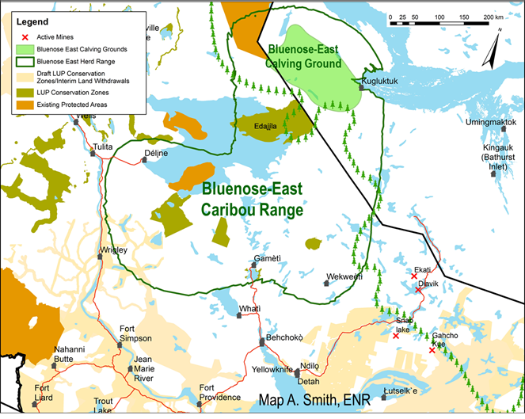

ᓇᓗᓇᐃᒃᑯᑕᖅ: 5. ᐊᕐᕌᒍᑲᒫᑦ ᐃᓂᖃᕐᓂᖏᑦ ᑖᒃᑯᐊ ᑐᒃᑐᔭᖅᑐᑉ ᒥᒃᓵᓂ ᑲᓇᖕᓇᖓᓂ ᑐᒃᑐᐃᑦ Bluenose-East ᓄᓇᑦᓯᐊᒥ ᓄᓇᕗᒥᓗ. ᑖᒃᑯᐊ ᑐᒃᑐᐃᑦ ᓄᕐᕋᓕᐅᕐᕕᖓ ᐅᐊᖕᓇᖓᓂ ᖁᕐᓗᖅᑐᑉ. ᓴᐳᔾᔭᐅᔪᑦ ᐃᓂᑦ ᐊᒃᑐᖅᑕᐅᒋᐊᖃᖏᑦᑐᑦ ᐆᔭᐅᕐᓚᐃᑦ ᐊᐅᐸᔮᖅᑐᓪᓗ. ᓄᓇᓖᑦ ᐊᒻᒪ ᐅᔭᕋᕐᕕᑦ ᐊᖅᑯᑎᓪᓗ ᑎᑎᖅᓯᒪᖃᑕᓪᓗᑎᒃ.

ᑐᒃᑐᑐᖅᐸᒃᑐᑦ ᖃᓄᐃᓕᐅᖅᑕᐅᓂᖏᑦ: ᑕᐃᒪ ᐊᒥᓲᖏᓐᓂᖅᓴᐅᕙᓪᓕᐊᑐᐃᓐᓇᖅᑎᓪᓗᒋᑦ ᕿᖓᐅᑉ ᒥᒃᓵᓂ ᑐᒃᑐᐃᑦ ᐊᒻᒪ ᑐᒃᑐᔭᖅᑐᑉ ᒥᒃᓵᓂ ᑲᓇᖕᓇᒥ ᑐᒃᑐᐃᑦ ᐱᓪᓗᒋᑦ, ᓄᓇᑦᓯᐊᑉ ᒐᕙᒪᒃᑯᖏᑦ ᓯᕗᓕᖅᑎᐅᓯᒪᕗᑦ ᐃᑲᔪᖅᑐᖅᓯᒪᓪᓗᑎᒡᓘᓐᓃᑦ ᖃᓄᐃᓕᐅᕈᑎᒃᓴᓂᒃ ᐊᒪᕈᕐᓂᖅᓴᐅᔪᓐᓇᖃᑦᑕᖁᓪᓗᒋᑦ ᐃᓄᐃᑦ ᑐᒃᑐᐃᑦ ᐱᔭᐅᖏᓐᓂᖅᓴᐅᖁᓪᓗᒋᑦ ᐃᓐᓇᐃᑦ ᐊᒻᒪ ᓄᕐᕋᐃᑦ ᐊᓐᓇᐅᒪᓂᖅᓴᐅᔪᓐᓇᖁᓪᓗᒋᑦ. ᐃᒪᓐᓇᐃᓕᖅᐳᒍᑦ ᐃᓚᖓᒍᑦ:

ᓄᓇᑦᓯᐊᑉ ᒐᕙᒪᒃᑯᖏᑦ ᐊᕙᑎᒥᐅᑕᓕᕆᔨᒃᑯᑦ ᓄᓇᒥᐅᑕᓕᕆᔨᒃᑯᑦ ᖃᐅᔨᓴᖅᑎᑦᓯᒋᐊᕐᓂᐊᖅᐳᑦ ᐊᒪᕈᖃᕐᕕᐅᔪᓂ 2016-ᒥ, ᖃᓄᐃᓕᐅᕈᓐᓇᐅᑎᖃᕈᓐᓇᕐᓂᕐᒧᑦ ᖃᐅᔨᓇᓱᐊᕐᓂᐊᖅᐳᑦ ᖃᑦᓯᑐᕋᔭᕐᓂᖏᓪᓗ ᐊᑐᖅᑕᐅᓂᐊᖅᑐᑦ ᖃᐅᔨᓴᕐᓗᑎᒃ. ᑕᐃᒪᓐᓇ ᐊᒪᕈᐃᑦ ᑲᒪᒋᔭᐅᑦᓯᐊᕆᐊᖁᓪᓗᒋᑦ ᑐᒃᑐᐃᑦ ᒪᑭᑉᐸᓪᓕᐊᑎᑕᐅᓇᓱᐊᕐᓗᑎᒃ ᓇᐹᖅᑐᖃᖏᑦᑐᒥᐅᑕᐃᑦ. ᑕᒪᓐᓇ ᖃᐅᔨᓴᕈᑕᐅᓂᐊᖅᖢᓂ ᐱᓕᕆᖃᑎᒋᔭᐅᓗᑎᒃ ᐃᖅᑭᓕᑦ ᑭᓕᑦᓱ ᒐᕙᒪᒃᑯᖏᑦ ᐊᒻᒪ ᐃᓚᒋᔭᐅᖃᑕᐅᒋᓪᓗᑎᒃ ᓄᓇᖃᖅᑳᖅᓯᒪᔪᑦ ᒐᕙᒪᖏᑦ ᐊᒻᒪ ᐊᐅᓚᑦᓯᔨᓂᕐᒧᑦ ᐱᓕᕆᖃᑎᒋᔭᐅᔪᑦ.

2015−ᒥ, ᓄᓇᑦᓯᐊᑉ ᒐᕙᒪᒃᑯᖏᑦ ᐋᖅᑭᒋᐊᖅᓯᓚᐅᖅᐳᑦ ᐊᒪᕈᖃᑦᑕᖅᑎᑕᐅᓂᖏᓐᓄᑦ ᓄᓇᑦᓯᐊᒥᐅᑕᐃᑦ ᐱᖓᓱᓂᒃ ᐋᖅᑭᒃᓯᓯᒪᒍᑎᖃᖅᖢᑎᒃ ᖃᓄᖅᑑᕈᑎᒃᓴᖃᖅᓗᑎᒃ (ᓇᓗᓇᐃᒃᑯᑕᖅ 3). ᐊᒪᕈᖅᑐᖅ ᐋᒃᑐᖅᓯᒪᖏᑦᑐᒥᒃ ᐃᓗᐃᑦᑐᒥᒃ ᐊᒡᔭᖅᓯᔪᓐᓇᖅᖢᓂ ᐊᑭᓕᖅᑕᐅᓂᐊᕐᓗᓂ $200-ᓂᒃ, ᐋᒃᑐᖅᓯᒪᔪᑦ ᐊᑭᖃᕐᓂᐊᖅᖢᑎᒃ $450-ᓂᒃ ᐱᖅᑯᓯᑐᖃᑎᑐᑦ ᐋᖅᑭᐅᒪᑎᑕᐅᓗᓂ, ᐊᒻᒪ $800 ᐋᒃᑐᖅᑕᐅᓯᒪᔪᖅ ᒪᓕᒐᒃᓴᓕᒫᑦ ᐋᒃᑐᖅᑕᐅᒍᓯᑦ ᒪᓕᑦᓯᐊᕐᓗᒋᑦ ᐃᓗᓕᖅᑐᐃᔨᑎᑐᑦ ᐱᖁᔭᐅᔪᑦ ᒪᓕᒃᖢᒋᑦ.

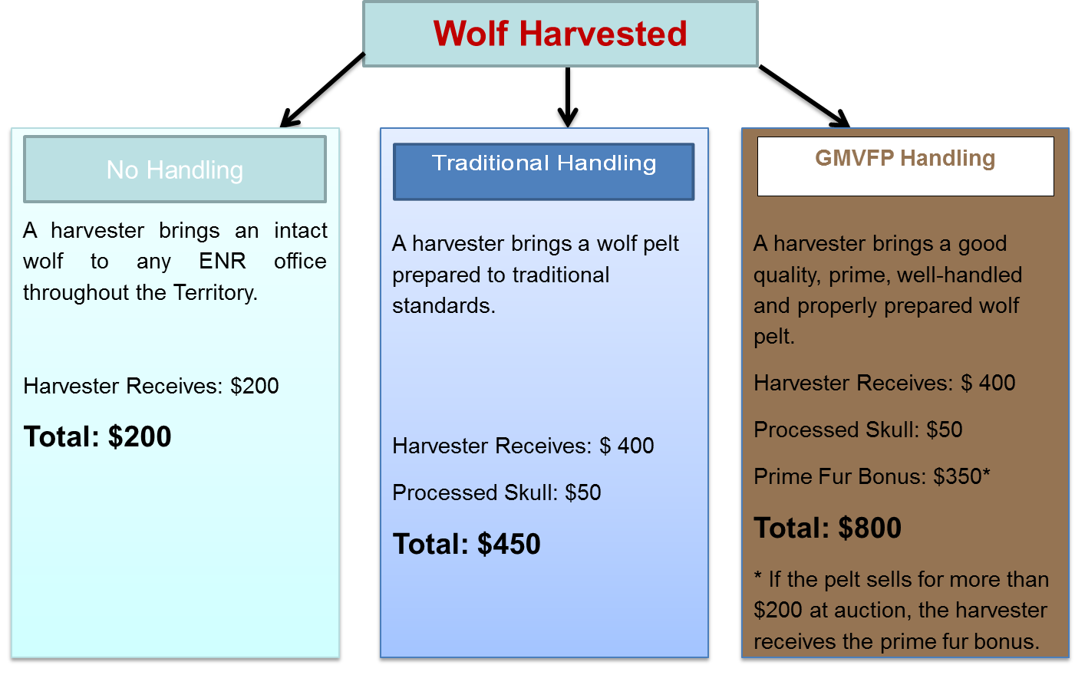

ᓇᓗᓇᐃᒃᑯᑕᖅ 6. ᐊᒪᕈᖅᓯᐅᖁᔨᒍᑎᑦ ᐊᖑᓇᓱᐊᖅᑎᓄᑦ ᑎᓕᐅᕈᑎᑦ ᓄᓇᑦᓯᐊᒥ 2015/2016−ᒥᓗ.

ᑭᓕᑦᓱ ᒐᕙᒪᒃᑯᑦ Tłı̨chǫ ᓄᓇᑦᓯᐊᑉ ᒐᕙᒪᒃᑯᖏᓪᓗ ᐱᓕᕆᖃᑎᒌᒃᖢᑎᒃ ᐱᕙᓪᓕᐊᑎᑎᓯᒪᕗᑦ ᐆᒃᑑᑎᒥᒃ ᓄᓇᓕᖕᓂ ᐊᒪᕈᖅᓯᐅᖃᑦᑕᕐᓂᕐᒧᑦ ᐃᖅᑭᓕᑦ ᑭᓕᑦᓱ ᓄᓇᓕᖏᓐᓂ ᐃᓕᓐᓂᐊᖅᑎᑕᐅᓗᑎᒃ ᐃᑲᔪᖅᑐᖅᑕᐅᓗᑎᒡᓗ ᓄᓇᓖᑦ ᐊᒪᕈᖅᓯᐅᕐᓂᕐᒧᑦ ᐅᑭᐅᒃᑯᑦ ᑐᒃᑐᖃᕐᕕᐅᖃᑦᑕᖅᑐᒥ ᑐᒃᑐᖏᓐᓄᑦ ᕿᖓᐅᑉ ᐃᓕᖁᓯᑐᖃᐃᑦ ᒪᓕᒃᖢᒋᑦ ᑕᐃᒪᓐᓇ ᐱᓕᕆᐊᖃᕐᓂᐊᖅᖢᑎᒃ. ᐊᒻᒪ ᑐᑭᓯᒋᐊᒃᑲᓐᓂᕈᑎᒃᓴᐃᑦ ᐱᑕᖃᖅᐳᖅ ᐱᓕᕆᖃᑎᒋᑉᓗᒋᑦ ᑭᓕᑦᓱ ᒐᕙᒪᒃᑯᖏᑦ−ᓄᓇᒥᐅᑕᓕᕆᔨᒃᑯᓪᓗ ᐊᕙᑎᓕᕆᔨᒃᑯᓪᓗ ᕿᖓᐅᑉ ᑐᒃᑐᐃᖏᑦ ᑲᒪᒋᔭᐅᒋᐊᖃᕐᓂᖏᓐᓄᑦ ᒪᓕᒃᖢᒋᓪᓗ ᑖᒃᑯᐊ ᐱᖁᔭᐅᓯᒪᔪᑦ WRRB ᑲᑎᒪᔨᖏᓐᓄᑦ.

- ᒫᓐᓇ ᐱᑕᖅᑕᐅᓚᐅᖅᑐᑦ ᐊᐅᓚᑕᐅᓂᖏᓪᓗ ᑐᒃᑐᔭᒃᑐᑉ ᒥᒃᓵᓂ ᑲᓇᖕᓇᖓᓂ ᑐᒃᑐᐃᑦ ᓄᓇᑦᓯᐊᒥ 2010-2015

ᑐᒃᑐᔭᖅᑐᑉ ᒥᒃᓵᓂ ᑲᓇᖕᓇᒥᐅᑕᓂᒃ ᑐᒃᑐᓯᐅᕐᓂᖅ 2009-ᒥ 2015-ᒧᑦ ᖃᐅᔨᓴᖅᑕᐅᓚᐅᖅᐳᑦ ᐱᑕᖃᑦᑕᕐᓂᖏᑦ, ᐊᖅᑯᑎᒥᓗ ᐊᖏᕐᕋᐅᕙᓪᓕᐊᓂᖏᓐᓂ ᖃᐅᔨᓴᕐᕕᖕᒥ ᐊᒻᒪ ᐆᒪᔪᓕᕆᔨᒃᑯᑦ ᖃᐅᔨᓴᖃᑕᐅᓪᓗᑎᒃ. ᐆᒃᑑᑎᒋᔭᐅᔪᓐᓇᖅᑐᖅ ᐱᑕᖅᑕᐅᔪᓂᒃ ᖃᐅᔨᓴᕐᓂᖅ ᑕᑯᔭᐅᔪᓐᓇᖅᐳᖅ ᓇᓗᓇᐃᒃᑯᑕᖃᖅᑐᒥ 7. ᖃᑦᓰᕐᓇᕐᓂᕐ ᑐᒃᑐᖃᑦᑕᕆᐊᖃᕐᓂᖏᑦ ᕿᖓᐅᑉ ᑐᒃᑐᖏᓐᓂᒃ ᐱᒋᐊᓚᐅᖅᐳᖅ 2010-ᒥ ᐅᐊᓕᓂᕐᒧᑦ ᑲᓇᖕᓇᓱᒧᓪᓗ ᕿᒪᒃᓯᓯᒪᓚᐅᖅᑐᒃᓴᐅᕗᑦ, ᐃᓚᐅᓪᓗᑎᒡᓗ ᐊᒥᓲᓂᖅᓴᓂᑦ ᑐᒃᑐᔭᖅᑐᑉ ᒥᒃᓵᓂ ᑐᒃᑐᖃᑦᑕᓕᓚᐅᖅᖢᑎᒃ. ᓇᓚᐅᖅᓵᕈᑎᖃᓚᐅᖅᐳᒍᑦ 2009-2010 ᐊᒻᒪ 2013-2014 ᑕᑯᒃᓴᐅᑎᑕᐅᕗᑦ ᓇᓗᓇᐃᔭᖅᓯᒪᓂᖓᓂ ᑕᓕᖅᐱᖃᓂ 7. ᑕᐃᒪᑎᒍᑦ ᐅᒥᒃᑳᕈᑕᐅᓯᒪᓪᓗᓂ/ᓇᓚᐅᑦᓵᖅᑕᐅᓯᒪᓪᓗᓂᓗ ᑐᒃᑐᓚᐅᕐᓂᖏᓐᓄᑦ ᑲᑎᑦᖢᒋᑦ 2750−ᓂᒃ ᑐᒃᑐᓂᒃ/ᐊᕐᕌᒍᑕᒫᑦ, 65% ᐊᕐᓇᓪᓘᓪᓗᑎᒃ. ᑖᒃᑯᐊ ᓇᓚᐅᑦᓵᖅᑕᐅᓯᒪᑐᐃᓐᓇᖅᐳᖅ, ᐃᓚᐅᑎᑦᓯᖏᒻᒪᑕ ᐃᑭᓕᖕᓂᒃ ᐱᔭᐅᖏᓐᓂᑯᓂᒃ; ᐃᓚᖏᓪᓗ ᐅᖃᐅᓯᕆᔭᐅᔪᒃᓴᐅᖏᑦᖢᑎᒃ ᐅᖃᐃᓐᓇᖃᑦᑕᖏᑦᑐᒃᓴᐅᓪᓗᑎᒡᓗ. ᐱᑕᖅᑕᐅᓪᓚᕆᒃᓯᒪᔪᑦ ᐃᒻᒪᖄ 4000/ᐊᕐᕌᒍᒧᑦ ᖁᑦᓯᖕᓂᖅᓴᐅᑐᐃᓐᓇᕆᐊᖃᖅᖢᓂᓗ.

ᑖᒃᑯᐊ ᑐᒃᑐᑕᐅᓚᐅᖅᑐᑦ ᓇᓚᐅᑦᓵᖅᑕᐅᓚᐅᖅᐳᑦ ᐃᓚᐅᓪᓗᓂ ᓄᓇᕗᒥ ᖁᕐᓗᖅᑐᖅ 300-1000/ᐊᕐᕌᒍᒧᑦ ᑐᒃᑐᖃᑦᑕᕐᓂᖏᑦ; ᑕᒪᒃᑯᐊ ᓇᓚᐅᑦᓵᖅᑕᐅᓯᒪᔪᑦ ᐱᔭᐅᓚᐅᖅᐳᑦ ᓄᓇᕗᑦ ᒐᕙᒪᒃᑯᖏᑦᑕ ᐆᒪᔪᓕᕆᓂᕐᒧᑦ ᐱᓕᕆᔨᖏᓐᓂᑦ. ᓄᓇᑦᓯᐊᒥ ᐱᑕᖃᑦᑕᕐᓂᖅᓴᐅᖕᒪᑕ ᐅᑭᐅᒃᑯᑦ ᑎᓴᐱᕆᒥᑦ ᐄᐳᕈᒥᓗ. ᓄᓇᕗᒥ ᐱᑕᖃᑦᑕᖅᖢᑎᒃ ᒪᐃᒥ, ᔫᓐᒥ ᐊᒻᒪ ᔪᓚᐃᒥ, ᑎᑭᑲᐅᑎᒋᔪᓐᓇᕐᓂᖅᐸᑕ ᑐᒃᑐᓄᑦ ᖁᕐᓗᖅᑑᒥᑦ.

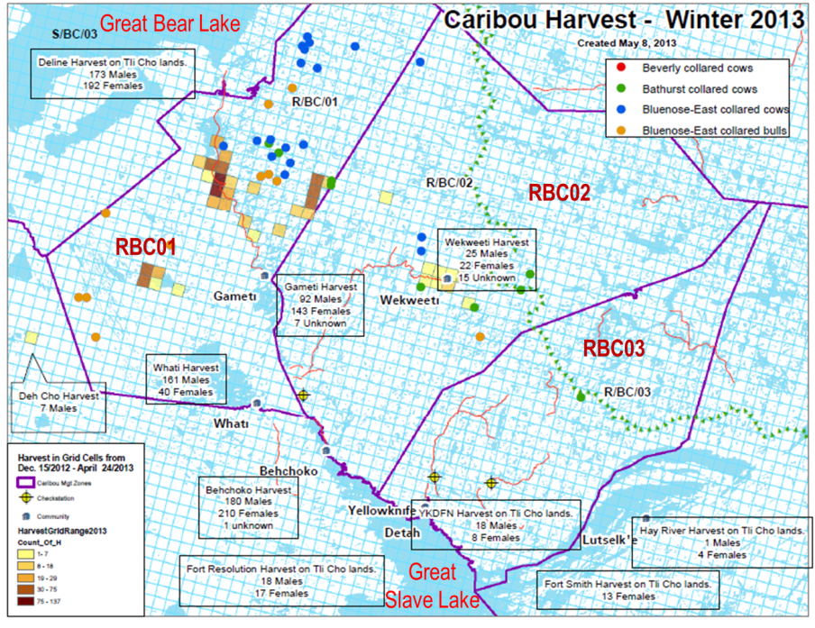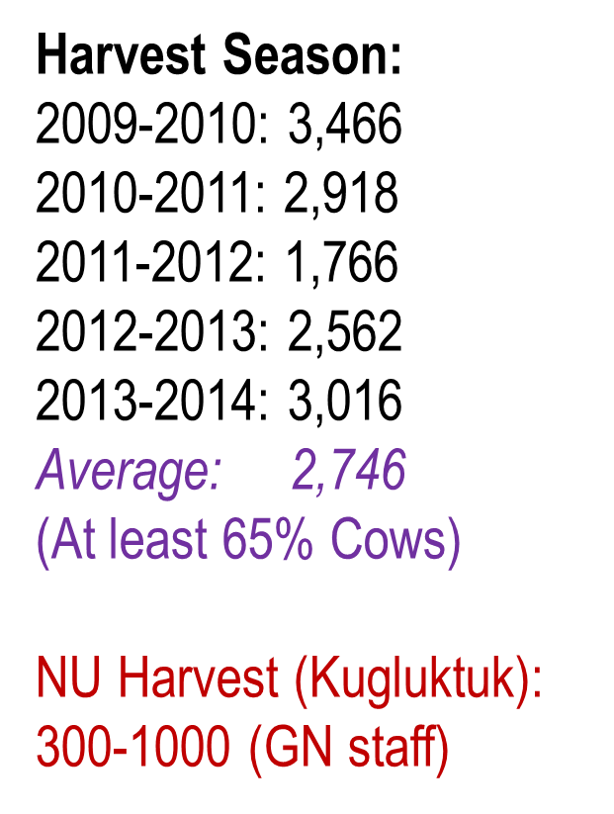

ᓇᓗᓇᐃᒃᑯᑕᖅ 7. ᓄᓇᖑᐊᖅ ᑎᑎᖅᓯᒪᔪᖅ ᑐᒃᑐᕕᐅᖃᑦᑕᖅᑐᓂᒃ North Slave ᒥ ᐊᒻᒪ Sahtu ᐊᓪᓚᐃᑦ ᓄᓇᖏᓐᓂ ᓄᓇᑦᓯᐊᒥ ᐅᑭᐅᖅ 2012-2013. ᑲᓚᓯᒪᔪᑦ ᑭᑉᐹᕆᒃᑐᑦ ᑐᒃᑐᑕᐅᓯᒪᔪᑦ ᐊᖏᓂᖃᖅᑐᒥ ᓇᓗᓇᐃᒃᑯᑕᑐᐃᓐᓇᖅ 10x10km ᑭᑉᐹᕆᒃᑐᕋᓛᓂ. ᑖᒃᑯᐊ RBC02 ᐊᒻᒪ RBC03 ᐊᖏᓂᖅᐹᑦ ᐱᑕᖅᑕᐅᔪᑦ ᐅᓄᕐᓂᖃᕆᐊᖃᓚᐅᖅᖢᑎᒃ 300 ᑐᖔᓂᓘᓐᓃᑦ 2009 ᐊᓂᒍᖅᓯᒪᓕᖅᑎᓪᓗᒍ ᕿᖓᐅᑉ ᑐᒃᑐᖏᓐᓂᒃ ᐱᑦᑕᐃᓕᒪᑎᑕᐅᓪᓗᑎᒃ. ᐆᔭᐅᔭᑦ ᐊᖕᒪᓗᒃᑐᑯᓗᐃᑦ ᖁᖓᓯᕈᓯᖅᑕᐅᓯᒪᔪᑦ ᕿᖓᐅᑉ ᑐᒃᑐᖏᑦ ᑐᖑᔪᖅᑐᖅ ᐊᖕᒪᓗᒃᑐᑯᓗᐃᑦ ᑐᒃᑐᔭᖅᑐᑉ ᒥᒃᓵᓂ ᑲᓇᖕᓇᖓᓂ ᑐᒃᑐᐃᑦ ᖁᖓᓯᕈᓯᖅᓯᒪᔪᑦ. ᐱᑕᖅᑕᐅᔪᑦ ᑐᒃᑐᔭᖅᑐᑉ ᒥᒃᓵᓂ ᑲᓇᖕᓇᖓᓂ ᑐᒃᑐᓂᒃ 2009−2014-ᒧᑦ ᑎᑎᖅᑕᐅᓯᒪᓪᓗᑎᒃ ᑕᓕᖅᐱᐊᓂ ᑎᑎᖅᓯᒪᔪᓂ. ᑖᒃᑯᐊ ᐱᑕᖅᑕᐅᓂᑯᓪᓗ ᓄᓇᕗᒥ.

ᓇᓚᐅᑦᓵᖅᑕᐅᓯᒪᔪᑦ ᑐᒃᑐᑕᐅᓯᒪᔪᑦ 2009-2014−ᒧᑦ ᐊᔾᔨᒌᖏᓐᓇᕐᓚᓚᐅᖅᐳᑦ ᐊᕐᕌᒍᑕᒫᑦ, ᑭᓯᐊᓂ ᑖᒃᑯᓇᓂ ᐊᕐᕌᒍᓂ ᐊᒥᓲᖏᓐᓂᖅᓴᐅᔪᒻᒪᕆᐅᓕᓚᐅᖅᐳᑦ. ᖃᓄᐃᓕᐅᓕᕐᓂᖏᑦ ᑐᒃᑐᑕᐅᖃᑦᑕᕐᓂᖏᓪᓗ ᓇᓗᓇᐃᖅᓯᒪᕗᑦ ᑐᒃᑐᔭᖅᑐᑉ ᒥᒃᓵᓂ ᑲᓇᖕᓇᖓᓂ ᓇᓗᓇᐃᒃᑯᑕᒥ 8−ᒥ. ᐊᒥᓲᖏᓂᖅᓴᐅᕙᓪᓕᐊᑎᓪᓗᒋᑦ ᑐᒃᑐᐃᑦ ᑖᒃᑯᐊ, ᐊᕐᕌᒍᑕᒫᑦ ᐊᖑᓇᓱᐊᖅᑕᐅᓂᖅᓴᐅᓪᓗᑎᒡᓗ ᐱᔾᔪᑎᖃᖅᑐᒃᓴᐅᓪᓗᑎᒡᓗ ᐊᒥᓲᖏᓐᓂᖅᓴᐅᕙᓪᓕᐊᓕᕐᓂᖏᓐᓄᑦ. ᑕᐃᒪᓐᓇᓗ ᑐᒃᑐᖃᑦᑕᖅᖢᑎᒃ 4000/6000−ᓄᑦ/ᐊᕐᕌᒍᒧᑦ ᐊᒥᓲᖏᓕᖅᐸᓪᓕᐊᔪᓂᑦ ᕿᖓᐅᑉ ᑐᒃᑐᖏᑉᓐᓂᑦ ᒥᒃᖠᕙᓪᓕᐊᓯᒪᖕᒪᑕ 2003-2006−ᒥᑦ 2006-2009−ᒧᑦ ( Boulanger et al. 2011).

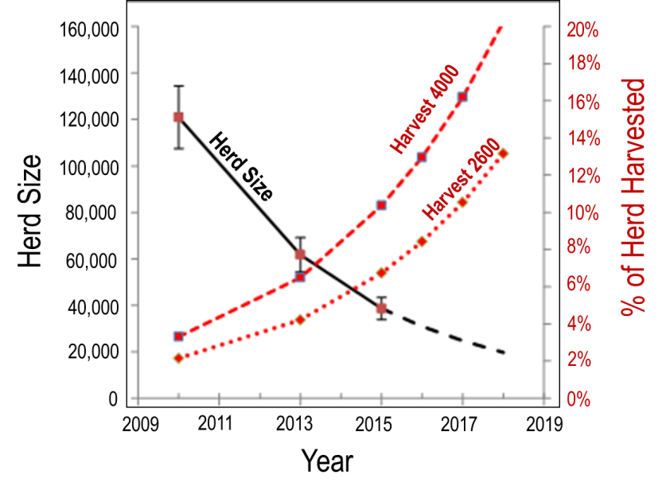
ᓇᓗᓇᐃᒃᑯᑕᖅ 8. ᑐᒃᑐᑕᐅᖏᓐᓇᖃᑦᑕᕐᓂᖏᑦ 2600 − 4000 /ᐊᕐᕌᒍᒧᑦ ᐊᒥᓲᖏᓐᓂᖅᓴᐅᕙᓪᓕᐊᑎᓪᓗᒋᑦ ᑐᒃᑐᔭᖅᑐᑉ ᒥᒃᓵᓂ ᑐᒃᑐᖏᑦ ᑲᓇᖕᓇᒥᐅᑕᐃᑦ 2010-2015-ᒧᑦ ᐊᒻᒪ ᓇᓚᐅᑦᓵᕈᑎᑦ 2018-ᒧᑦ. ᖃᑦᓯᐅᓂᖏᑦ ᑐᒃᑐᐃᑦ ᐊᒥᕐᕋᐃᑦ ᓴᐅᒥᐊᓂ yᖑᐊᖑᓪᓗᓂ ᐊᒻᒪ ᕿᕐᓂᖅᑕᖅ ᑎᑎᖅᓯᒪᔪᖅ, ᐊᒻᒪ ᐊᕐᒪᓗᒃᑯᒐᓛᓂ ᑎᑎᖅᓯᒪᔪᑦ 2015 ᐅᖓᑖᓄᑦ ᓇᓚᐅᑦᓵᕈᑕᐅᓪᓗᓂ. ᐱᑕᖅᑕᐅᔪᑦ 2600 ᐅᕙᓘᓐᓃᑦ 4000/ᐊᕐᕌᒍᒧᑦ ᑕᑯᒃᓴᐅᓪᓗᓂ % ᐊᒥᕐᕋᐃᑦ ᑕᓕᖅᐱᐊᓂ yᖑᐊᒥ ᐊᐅᐸᖅᑐᖅ.

ᓯᕗᓂᐊᓂ 2013, ᓄᓇᖃᖅᑳᖅᓯᒪᔪᑦ ᑐᒃᑐᓯᐅᓗᐊᓚᐅᖏᑉᐳᑦ ᑐᒃᑐᔭᖅᑐᑉ ᒥᒃᓵᓂ ᑲᓇᖕᓇᖓᓂ ᑐᒃᑐᓂᒃ. ᐊᒃᑐᐱᕆ 2010-ᒥ, ᑖᒃᑯᐊ WRRB ᐃᖅᑭᓕᑦ ᑲᑎᒪᔨᖏᑦ ᐅᓂᒃᑳᓕᐅᓚᐅᖅᐳᑦ ᐱᖁᔨᕗᖔᕈᑎᖃᖅᖢᑎᒡᓗ ᐱᔾᔪᑎᖃᓗᐊᖅᖢᑎᒃ ᕿᖓᐅᑉ ᑐᒃᑐᖏᓐᓂᒃ, ᐊᒻᒪᓗ ᑐᒃᑐᔭᖅᑐᑉ ᒥᒃᓵᓂ ᑲᓇᖕᓇᖓᓂ ᑐᒃᑐᖏᓐᓂᒃ. ᐱᖁᔨᕗᖔᕈᑎᑦ ᑐᒃᑐᔭᖅᑐᑉ ᒥᒃᓵᓂ ᑲᓇᖕᓇᖓᓂ ᑐᒃᑐᓂᒃ ᒪᑐᓯᒍᒪᓪᓗᑎᒃ ᓄᓇᓕᖕᓂᒥᐅᓂᒃ ᑮᓇᐅᔭᓕᐅᖅᖢᑎᒃ ᐊᖑᓇᓱᐊᖅᑎᑦᓯᖃᑦᑕᖅᑐᓂᒡᓗ ᐊᒻᒪ ᑐᒃᑐᓯᐅᖃᑦᑕᖅᑐᓂᒃ ᓄᓇᖃᖅᑳᖅᓯᒪᔪᓂᒃ ᑕᒪᒃᑯᓂᖓ ᐊᒥᓲᓂᖃᖅᑐᓂᒃ 2800 ᑐᒃᑐᓂᒃ (4% ᓇᓚᐅᑦᓵᖅᑕᐅᓯᒪᔪᑦ 70,000−ᓂᑦ) 85% ᐊᖑᓴᓪᓗᐃᑦ. ᐱᖁᔨᕗᐋᕈᑎᖓᑦ ᐱᖁᔭᖑᖅᑎᑕᐅᓚᐅᖏᑉᐳᖅ ᑭᓯᐊᓂ 2010-ᒥ ᖃᐅᔨᓴᖅᖢᑕ ᖃᑦᓯᐅᓕᕐᓂᖏᓐᓄᑦ ᖃᐅᔨᓚᐅᖅᐳᒍᑦ 100,000 ᐅᖓᑖᓄᑦ ᐊᒥᓲᓂᖃᕐᓂᖏᓐᓄᑦ ᐊᒥᕐᕋᐃᑦ ᓄᕐᕋᓕᐅᑦᓯᐊᖅᖢᑎᒡᓗ (Adamczewski et al. 2014).

ᐅᑭᐊᒃᓵᓕᖅᑎᓪᓗᒍ ᐅᑭᐅᒥᓗ 2024-2015−ᒥᓗ, ᐊᕙᑎᒥᐅᑕᓕᕆᔨᒃᑯᑦ ᓄᓇᒥᐅᑕᓕᕆᔨᒃᑯᑦ ᐱᖓᓱᓂᒃ ᑲᑎᒪᑎᑎᓚᐅᖅᐳᑦ ᓄᓇᖃᖅᑳᖅᓯᒪᔪᓂᒃ ᓯᕗᓕᖅᑎᓂᒃ (ᐊᐅᒐᓯ 27, ᓄᕕᐱᕆ 7 ᐊᒻᒪ ᓄᕕᐱᕆ 28) ᐊᒻᒪ ᐅᓪᓗᓄᑦ ᒪᕐᕉᖕᓄᑦ ᑲᑎᒪᑎᑦᓯᓪᓗᑎᒃ ᖃᓄᐃᓕᐅᕐᓂᕐᒧᑦ (ᐊᒃᑐᐱᕆ 9-10 ᐊᒻᒪ ᐊᒃᑐᐱᕆ 22-23) ᕿᒥᕐᕈᓂᐊᖅᖢᑎᒃ ᖃᐅᔨᒪᒍᑕᐅᔪᓂᒃ ᓱᖕᒪᑦ ᑐᒃᑐᔭᖅᑐᑉ ᒥᒃᓵᓂ ᑲᓇᖕᓇᖓᓂ ᑐᒃᑐᐃᑦ ᐊᒥᓲᖏᓐᓂᖅᓴᐅᓕᕐᓂᖏᓐᓄᑦ ᐊᒻᒪ ᕿᖓᐅᑉ ᐊᒻᒪ ᐊᐅᓚᑕᐅᒍᑎᒃᓴᓂᒃ ᐋᖅᑭᒃᓯᒍᒪᓪᓗᑎᒃ. ᐱᔾᔪᑎᒋᔭᐅᓗᐊᓚᐅᖅᑐᑦ ᔫᓐ 2014-ᒥ ᖃᐅᔨᓴᓚᐅᖅᖢᑎᒃ ᖃᓄᐃᓕᖓᓂᖓᓄᑦ ᓄᕐᕋᓕᐅᕐᕕᖓᑦ ᓄᕐᕋᓕᐅᓗᐊᖏᓐᓂᖅᓴᐅᓚᐅᖅᖢᑎᒡᓗ ᖃᐅᔨᓴᕈᑎᖃᖅᖢᑎᒃ 2013-ᒥᑦ 2014-ᒧᑦ ᑕᒪᕐᒥᒃ ᑕᒪᒃᑯᐊ ᑐᒃᑐᐃᑦ. ᓇᐃᒡᓕᒋᐊᖅᑕᐅᓯᒪᓪᓗᑎᒃ ᐋᖅᑭᒃᓱᖅᑕᐅᓚᐅᕆᓄᑦ ᑐᒃᑐᔭᖅᑐᑉ ᒥᒃᓵᓂ ᑲᓇᖕᓇᖓᓂ ᐊᒥᕐᕋᐃᑦ ᖃᓄᐃᓐᓂᖏᓐᓄᑦ ᖃᑦᓯᐅᓂᖏᓐᓄᓪᓗ ᓄᓇᒥᐅᑕᓕᕆᔨᒃᑯᓐᓄᑦ ᐊᕙᑎᒥᐅᑕᓕᕆᔨᒃᑯᓐᓄᓪᓗ (2014). ᓇᐃᒡᓕᒋᐊᖅᓯᒪᔪᑦ ᑲᑎᒪᒍᑕᐅᓚᐅᖅᑐᓂᑦ ᐅᑭᐊᒃᓵᒃᑯᑦ 2014-ᒥ ᓇᒃᓯᐅᑎᔭᐅᓚᐅᖅᐳᑦ ᐃᓚᐅᓚᐅᖅᑐᓄᑦ ᐊᕙᑎᒥᐅᑕᓕᕆᔨᒃᑯᓐᓂᑦ ᓄᓇᒥᐅᑕᓕᕆᔨᒃᑯᓐᓂᓪᓗ ᑐᒃᓯᕋᐅᑕᐅᓗᑎᒃ ᐱᔭᐅᔪᓐᓇᖅᐳᑦ.

ᐱᒋᐊᓕᓵᖅᑎᓪᓗᒍ 2015 ᑲᒪᔨᐅᖃᑎᒌᑦ ᐆᒪᔪᓂᒃ ᑲᑐᔾᔨᖃᑎᒌᒃᖢᑎᒃ ACCWM ᐱᖁᔨᓚᐅᖅᐳᑦ, ᐊᒻᒪ ᐊᕙᑎᒥᐅᑕᓕᕆᔨᒃᑯᑦ ᓄᓇᒥᐅᑕᓕᕆᔨᒃᑯᑦ ᐊᖏᓚᐅᖅᖢᑎᒃ, ᓄᓇᑦᓯᐊᒥᐅᑦ ᓄᓇᖃᖅᑳᖅᓯᒪᔪᑦ ᐱᑕᖃᑦᑕᖁᔭᐅᓕᖅᖢᑎᒃ 1800−ᓂᒃ ᑐᒃᑐᔭᖅᑐᑉ ᒥᒃᓵᓂ ᑲᓇᖕᓇᖓᓂ ᑐᒃᑐᓂᒃ, 80% ᖏᑦ ᐊᖑᓴᓪᓘᒌᐊᖃᖅᖢᑎᒃ, ᐊᒥᐊᒃᑯᖏᓐᓂ ᐊᕐᕌᒍᑦ 2014-15. ᓄᓇᕗᒥ ᑕᒪᒃᑯᓂᖓᑦᓴᐃᓐᓇᖅ ᑐᒃᑐᖃᑦᑕᕐᓂᖏᓐᓄᑦ ᖃᐅᔨᓴᖅᑕᐅᓯᒪᓚᐅᖏᑦᖢᑎᒃ, ᓇᓚᐅᑦᓵᕈᑕᐅᓚᐅᖅᖢᑎᒃ ᓄᓇᕗᑦ ᒐᕙᒪᒃᑯᖏᓐᓄᑦ 1000/ᐊᕐᕌᒍᒧᑦ ᑐᒃᑐᖃᑦᑕᕐᓂᖏᓐᓄᑦ ᑕᒪᒃᑯᓂᖓ.

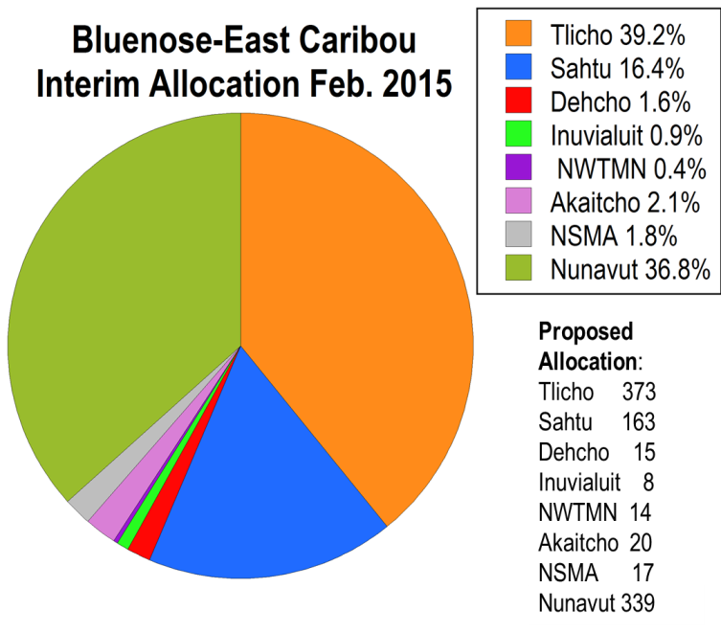

ᓇᓗᓇᐃᒃᑯᑕᖅ 9. ᒫᓐᓇᐅᓂᖓᓂ ᑐᒃᑐᔭᖅᑐᑉ ᒥᒃᓵᓂ ᑲᓇᖕᓇᖓᓂ ᑐᒃᑐᓂᒃ ᐱᑕᓚᐅᖅᑐᑦ 7 ᓄᓇᖃᖅᑳᖅᓯᒪᔪᑦ ᓄᓇᑦᓯᐊᒥ ᕕᕗᐊᕆ 2015-ᒥᑦ (ᑲᓚᓯᒪᔪᑦ ᐊᒻᒪ ᐸᐃᖑᐊᒥ). 2015-ᒥ ᑐᒃᑐᓚᐅᖅᑐᑦ ᓄᓇᑦᓯᐊᒥᑐᐃᓐᓇᖅ ᓄᓇᕗᑦ ᐃᓚᐅᖏᑦᖢᓂ. ᓄᓇᕗᑦ ᐃᓚᐅᑎᑕᐅᕗᖅ ᑕᒡᕙᓂ (ᐃᓱᒪᒋᑐᐃᓐᓇᖅᖢᒋᑦ 18000 ᓄᓇᑦᓯᐊᒥ ᓄᓇᕗᒥᓗ), ᓄᓇᕗᒥ ᖃᑦᓯᕌᓚᐅᕐᓂᖏᓐᓄᑦ ᐋᖅᑭᒃᑕᐅᓂᐊᖅᖢᓂ ᓄᓇᕗᒥ
ᐆᒪᔪᓕᕆᔨᕐᔪᐊᒃᑯᑦ ᑲᑎᒪᔨᖏᓐᓄᑦ. ᑐᒃᑐᑕᐅᖃᑦᑕᕐᓂᐊᖅᑐᑦ (ᐊᑖᓂ ᑕᓕᖅᐱᐊᓂ) 950 ᕌᖅᓯᒪᔪᑦ (ᐊᑖᓂ ᑕᓕᖅᐱᐊᓂ) ᑕᐃᒫᑦᓴᐃᓐᓇᖅ ᓈᓴᐅᑎᖃᖅᐳᑦ.

ᐅᖃᐅᑎᔭᐅᒍᒪᓚᐅᖅᖢᑕ ᓄᓇᖃᖅᑳᖅᓯᒪᔪᓂᑦ ᓄᓇᑦᓯᐊᒥᐅᑕᓂᑦ ᑐᒃᑐᓯᐅᖃᑦᑕᖅᑐᓂᒃ ᑖᒃᑯᓂᖓ ᐊᐅᓚᑦᓯᔨᐅᖃᑕᐅᔪᓂᒡᓗ ᑕᒪᒃᑯᓂᖓ ᑐᒃᑐᓂᒃ, ᐊᕙᑎᒥᐅᑕᓕᕆᔨᒃᑯᑦ ᓄᓇᒥᐅᑕᓕᕆᔨᒃᑯᑦ ᖃᑦᓯᓂᒃ ᐊᒥᕐᕋᓂᑦ ᐱᖃᑦᑕᕋᔭᕐᓂᖏᓐᓄᑦ ᐋᖅᑭᒃᓯᓚᐅᖅᐳᑦ ᓄᓇᑦᓯᐊᒥ. ᑕᒪᓐᓇ ᐋᖅᑭᒃᑕᐅᓚᐅᖅᖢᓂ ᒪᓕᒃᖢᒋᑦ ᑎᑎᕋᖅᓯᒪᔪᑦ ᐱᑕᖅᑕᐅᖃᑦᑕᖅᑐᑦ ᐊᒥᕐᕋᓂᑦ ᑖᒃᑯᓇᖓᑦ ᐊᓯᖏᓐᓂᓪᓗ ᑎᑎᕋᖅᓯᒪᔪᓂᑦ. ᕕᕗᐊᕆ 2015-ᒥ (ᓇᓗᓇᐃᒃᑯᑕᖅ 9) ᑐᒃᑐᑕᐅᓯᒪᓕᐊᓂᒃᑐᑦ, ᐊᒥᖅᑳᖅᑕᐅᓯᒪᔪᓪᓗ 1800−ᓂᒃ ᓂᕕᖓᑖᓂᒃ ᐃᒪᓐᓇ ᐅᑯᐊ 1100 (61.11%), ᓵᑐ 480 (2.67%), ᑎᑦᓱ 45 (2.50%), ᐃᓄᕕᐊᓗᐃᑦ 25 (1.39%), ᓄᓇᑦᓯᐊᒥ ᐊᓪᓚᖓᔪᑦ 40 (2.22%), ᐊᑮᑦᓱ 60 (3.33%), ᐊᒻᒪ North Slave Métis Alliance ᐊᓪᓚᖓᔪᑦ 50 (2.78%). ᒥᒃᓵᒎᖅᓯᒪᑐᐃᓐᓇᖅᐳᑦ ᓄᓇᕗᒥᐅᑦ ᐱᑕᓚᐅᕐᓂᖏᓐᓄᑦ 1000−ᓂᒃ, ᖃᐅᔨᒪᓪᓗᑕ ᑐᒃᑐᑕᐅᔪᓐᓇᖅᑐᑦ ᓄᓇᕗᒥᐅᓄᑦ ᐋᖅᑭᒃᑕᐅᓂᐊᕐᒪᑕ ᓄᓇᕗᒥ ᐆᒪᔪᓕᕆᔨᕐᔪᐊᒃᑯᑦ ᑲᑎᒪᔨᖏᓐᓄᑦ.

ᖃᑦᓯᓂᒃ ᑐᒃᑐᒍᓐᓇᕐᓂᖅ ᐋᖅᑭᒃᑕᐅᓚᐅᖅᐳᖅ ᑎᓴᐱᕆ 2015-ᒥ ᐊᐅᓚᑦᓯᓂᕐᒧᓪᓗ ᑐᒃᓯᕋᐅᑎᖃᖅᖢᑎᒃ ᑖᒃᑯᓄᖓ ᐆᒪᔪᓕᕆᓂᕐᒧᑦ ᑲᑎᒪᔨᓄᑦ ᐃᖅᑭᓕᑦ WRRB, SRRB ᐊᒻᒪ ᐆᒪᔪᑦ ᐊᐅᓚᑕᐅᓂᖏᓐᓄᑦ ᑲᑎᒪᔨᖏᑦ ᓄᓇᑦᓯᐊᒥ WMAC ᑲᑎᑦᖢᒋᑦ 950-ᓂᒃ ᑐᒃᑐᒍᓐᓇᖅᖢᑎᒃ ᑖᒃᑯᓇᖓᑦ ᐊᒥᕐᕋᓂᑦ, ᑕᐃᒫᓐᓇᐃᓐᓇᕐᓗ ᐊᑐᖅᑕᐅᓚᐅᖅᑐᒥᒃ ᕕᕗᐊᕆ 2015-ᒥ ᖃᑦᓯᕌᕈᓐᓇᕐᓂᕐᒧᑦ ᑐᒃᑐᓂᒃ. ᑲᑎᒪᒍᑎᖃᒃᑲᓐᓂᖅᖢᑎᒃ ᖃᑦᓯᕌᕈᓐᓇᕐᓂᕐᒧᑦ ᑐᒃᑐᔭᖅᑐᑉ ᒥᒃᓵᓂ ᑲᓇᖕᓇᖓᓂ ᑐᑦᑐᓂᒃ ᑖᒃᑯᐊ ᑐᒃᑐᓕᐊᖅᐸᒃᑐᑦ ᑖᒃᑯᓇᖓᑦ ᐊᒥᖅᑳᕆᐊᖃᑐᐃᓐᓇᕆᐊᖃᖅᖢᑎᒃ ᒥᑭᓂᖅᓴᓂᒃ ᑐᒃᑐᓯᐅᖃᑎᒌᒃᐸᒃᑐᑦ.

- ᓄᓇᕗᑦ ᒐᕙᒪᒃᑯᖏᑦᑕ ᖃᑦᓯᕌᖃᑦᑕᖁᔨᓂᖏᑦ ᑐᒃᑐᓂᒃ ᑐᒃᑐᔭᒃᑐᑉ ᒥᒃᓵᓂ ᑲᓇᖕᓇᖓᓂᒥᐅᑕᓂᒃ

ᐊᒥᓲᖏᓐᓂᖅᓴᐅᓕᖅᑎᓪᓗᒋᑦ ᑐᒃᑐᔭᖅᑐᑉ ᒥᒃᓵᓂ ᑲᓇᖕᓇᖓᓂ ᑐᒃᑐᐃᑦ, ᑎᓴᐱᕆ 2015-ᒥ ᐊᐅᓚᑦᓯᓂᕐᒧᑦ ᐋᖅᑭᒃᓯᒋᐊᓚᐅᖅᐳᑦ ᐊᕙᑎᒥᑕᓕᕆᔨᒃᑯᑦ ᓄᓇᒥᐅᑕᓕᕆᔨᒃᑯᓪᓗ ᑖᒃᑯᓄᖓ ᑲᑎᒪᔨᖏᓐᓄᑦ ᐆᒪᔪᓕᕆᓂᕐᒧᑦ ᐃᖅᑭᓕᑦ WRRB, SRRB ᐊᒻᒪ ᐆᒪᔪᑦ ᐊᐅᓚᑕᐅᓂᖏᓐᓄᑦ ᑲᑎᒪᔨᖏᑦ WMAC (ᓄᓇᑦᓯᐊᒥ) ᖃᐅᔨᒪᑎᑕᐅᓪᓗᑎᒃ ᐊᒥᕐᕋᐃᑦ ᐊᐅᐸᔮᖅᑐᒦᒻᒪᑕ (ᐊᒥᓲᖏᓐᓂᖅᓴᐅᓕᖅᖢᑎᒃ ᐊᒥᓲᖏᓐᓂᖅᓴᐅᕙᓪᓕᐊᖏᓐᓇᖅᖢᑎᒡᓗ) ᐆᒪᔪᐃᑦ ᐊᐅᓚᑕᐅᓂᖏᓐᓄᑦ ᑲᒪᒋᔭᐅᓂᖏᓐᓄᑦ ACCWM ᐊᐅᓚᑕᐅᔪᒃᓴᐅᓂᕐᒧᑦ ᐸᕐᓇᐅᑎᑦ, ᖃᑦᓯᓂᒡᓗ ᑐᒃᑐᒍᓐᓇᕐᓂᖏᑦ ᓈᒻᒪᒋᔭᐅᒋᖃᖅᖢᑎᑦ ᑖᒃᑯᓄᖓ ᑲᒪᔨᓄᑦ. ᐊᒥᓲᖏᓐᓂᖅᓴᐅᕙᓪᓕᐊᒻᒪᕆᒃᐳᑦ ᐊᒥᓲᖏᓐᓂᖅᓴᐅᓕᕐᓂᖏᓐᓄᑦ ᐋᖅᑭᒃᑕᐅᔪᓐᓇᖅᖢᑎᒃ ᐊᒃᐸᓯᕐᓂᖅᓴᐅᓗᑎᒃ (ᐊᐅᐸᖅᑐᖅ ᓇᓚᐅᑦᓵᖅᑕᐅᓯᒪᓪᓗᑎᒃ 20,000ᖑᓂᖏᓐᓂᒃ ᑐᖔᓂᓘᓐᓃᑦ) ᐊᕐᕌᒍᓂ ᒪᕐᕉᖕᓂ, ᐊᒥᓲᖏᓐᓂᖅᓴᐅᓕᑳᓪᓚᖕᓂᖏᑦ ᐃᓱᒪᒋᔭᐅᒋᐊᖃᖅᖢᑎᒃ ᖃᓄᖅ ᐊᐅᓚᑕᐅᓂᐊᕐᓂᖏᑦ ᖃᑦᓯᐅᓂᖏᓪᓗ ᐊᒥᕐᕋᓂ.

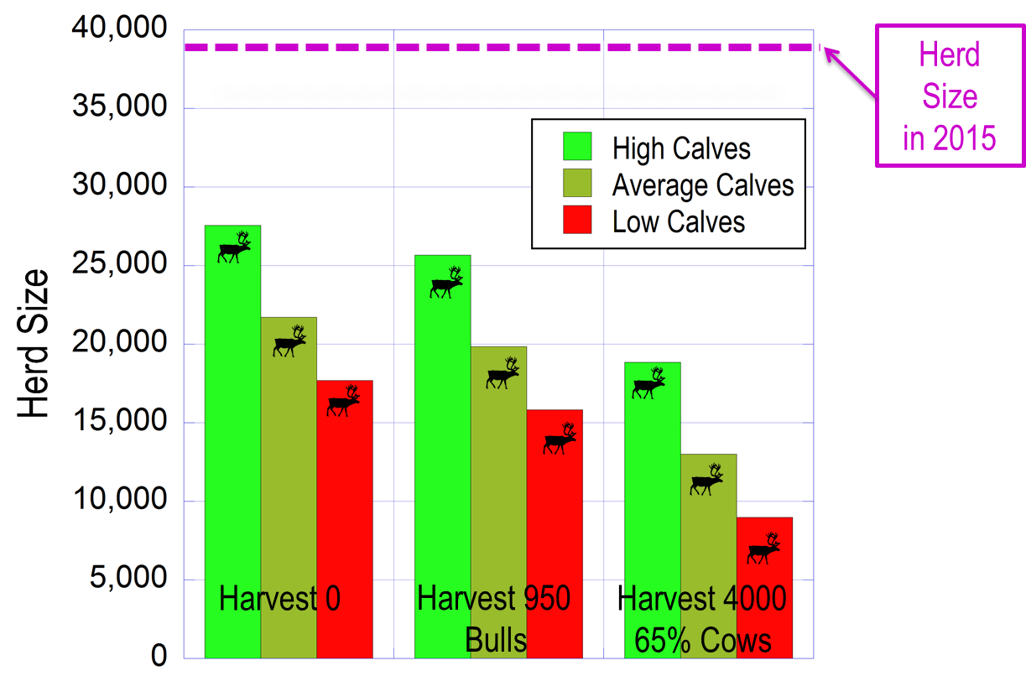

ᓇᓗᓇᐃᒃᑯᑕᖅ 10. ᒥᒃᓵᓂᒐᓱᒋᐅᔪᑦ ᐊᒥᕐᕋᐃᑦ ᐃᓗᐊᓂ ᖃᑦᓯᐅᓂᖏᑦ ᑐᒃᑐᔭᖅᑐᑉ ᒥᒃᓵᓂ ᑲᓇᖕᓇᖓᓂ ᑐᒃᑐᐃᑦ 2018-ᖑᓂᐊᖅᑐᒥ ᐆᒃᑑᑎᒥ ᑎᑎᖅᑕᐅᓯᒪᕗᑦ. ᐊᕐᓇᓪᓗᐃᑦ ᐊᓐᓇᐅᒪᓂᐊᖅᑐᑦ 74%ᖑᓪᓗᑎᒃ ᓇᓚᐅᑦᓵᑐᐃᓐᓇᖅᖢᒋᑦ. ᐱᖓᓲᓕᖓᔪᒥ ᐊᓐᓇᐅᒪᓂᖏᑦ ᓄᕐᕋᖏᑦ (ᑕᐃᒪᓐᓇᑎᑐᑲᓴᒃ ᐅᐱᖓᒃᓵᒥ ᓄᕐᕋᐃᑦ/ᐊᓈᓇᖏᓪᓗ ᖃᑦᓯᐅᓂᖏᑦ 44, 34 ᐊᒻᒪ 25 ᓄᕐᕋᐃᑦ:100 ᐊᕐᓇᓪᓗᐃᑦ) ᐆᔭᐃᔭᐅᓗᑎᒃ, ᓴᓂᐊᓃᑦᑐᕐᓗ ᑖᕐᓂᖅᓴᖅ ᐊᒻᒪ ᐊᐅᐸᖅᑐᖅ. ᓴᐅᒥᐊᓂ ᑎᑎᖅᓯᒪᔪᑦ ᐱᑕᖅᑐᖃᓚᐅᖏᓐᓂᖓ, ᕿᑎᐊᓂ ᑎᑎᖅᓯᒪᔪᑦ 950-ᕌᓚᐅᕐᓂᖏᑦ ᐊᖑᓴᓪᓗᐃᓐᓇᕐᓂᒃ, ᐊᒻᒪ ᑕᓕᖅᐱᐊᓂ ᑎᑎᖅᓯᒪᔪᑦ 4000/ᐊᕐᕌᒍᒧᑦ, 65% ᐊᕐᓇᓪᓗᐃᑦ.

ᖃᑉᓯᐅᒐᔭᕐᓂᖏᓐᓄᑦ ᐆᒃᑑᑎᖃᓚᐅᖅᐳᑦ ᓇᓚᐅᑦᓵᕈᑎᖃᖅᖢᑎᒃ ᐊᒥᕐᕋᐃᑦ ᖃᓄᐃᓐᓂᐊᕐᓂᖏᓐᓄᑦ 2018-ᒥ ᐊᔾᔨᓕᐅᕆᓂᐊᖅᖢᑎᒃ ᓄᕐᕋᓕᐅᕐᕕᖕᓂᒃ (ᓇᓗᓇᐃᒃᑯᑕᖅ 10). ᓇᓚᐅᑦᓵᖅᑕᐅᓯᒪᓪᓗᓂ ᓄᕐᕋᓕᐊᖏᑦ ᐆᒪᓂᐊᕐᓂᖏᓐᓄᑦ 74%ᖏᑦ. ᓴᐅᒥᐊᓂ ᐊᒥᕐᕋᐃᑦ ᖃᑦᓯᐅᓂᐊᕐᓂᖏᑦ 2018-ᒥ ᐱᑕᖅᑕᐅᖃᑦᑕᖏᓪᓗᑎᒃ ᐱᖓᓲᓕᖓᔪᒥ ᓄᕐᕋᐃᑦ ᐆᒪᓂᐊᕐᓂᖏᓐᓄᑦ. ᐃᒪᓐᓇᐃᓐᓂᐊᖅᖢᑎᒃ 17,000 ᐊᒻᒪ 27,000. ᕿᑎᐊᓂ ᓇᓚᐅᑦᓵᖅᑕᐅᓯᒪᔪᑦ 950 ᐊᖑᓴᓪᓗᐃᑦ/ᐊᕐᕌᒍᒧᑦ ᐊᒻᒪ ᐱᖓᓱᐃᓕᖓᔪᑦ ᓄᕐᕋᐃᑦ ᐊᓐᓇᐅᒪᓂᐊᕐᓂᖏᑦ. ᓇᓚᐅᑦᓵᖅᑕᐅᔪᑦ 2018-ᒥ ᐊᑯᓐᓂᖓᓂ 15,000 ᐊᒻᒪ 26,000. ᑕᓕᖅᐱᐊᓂ ᓇᓚᐅᑦᓵᖅᑕᐅᓯᒪᔪᑦ ᐱᑕᖃᑦᑕᕐᓗᑎᒃ 4,000−ᓂᒃ ᑐᒃᑐᓂᒃ/ᐊᕐᕌᒍᒧᑦ ᐊᒻᒪ 65% ᐊᕐᓇᓪᓗᐃᑦ. ᑕᐃᒪᓐᓇ ᐱᑕᖃᑦᑕᖅᑎᒋᓗᑎᒃ, ᓇᓚᐅᑦᓵᖅᐳᒍᑦ 2018-ᒥ ᐊᒥᓲᓂᖃᕐᓂᐊᕐᓂᖏᓐᓄᑦ ᖁᑦᓯᖕᓂᖅᓴᒥ 19,000 ᐊᒥᓲᖏᓐᓂᖅᓴᑦ 8,000. ᐅᔾᔨᕆᔭᐅᒋᐊᖃᖅᐳᖅ ᐊᐅᐸᖅᑐᑦ ᓇᓚᐅᑦᓯᐊᕐᓂᖅᓴᐅᓂᖏᓐᓄᑦ ᓄᕐᕋᓕᐅᖏᓐᓂᖅᓴᐅᓚᐅᕐᓂᖏᓐᓄᑦ ᖃᐅᔨᓴᕈᑕᐅᓚᐅᖅᑐᓂᒃ ᒪᓕᖕᓂᖅᓴᐅᖕᒪᑕ ᒫᓐᓇᓵᖑᓚᐅᖅᑐᒥ ᐊᑐᖅᑕᐅᓚᐅᖅᑐᒥᑦ. ᖃᑦᓯᐅᓂᖏᑦ ᓇᓚᐅᑦᓵᕐᓗᒋᑦ ᐱᑕᖅᑕᐅᖃᑦᑕᕐᓂᖏᓪᓗ ᖃᑦᓯᐅᓂᖏᑦ ᒪᓕᒃᖢᒋᑦ ᐊᖑᓴᓪᓗᑦ/ᐊᕐᓇᓪᓗᑦ, ᐊᒻᒪ ᐊᒥᕐᕋᐃᑦ ᐊᕐᓇᓪᓗᖏᑦ ᐊᓐᓇᐅᒪᖃᑦᑕᖅᑐᑦ ᐊᓐᓇᐅᒪᖃᑦᑕᖏᑦᑐᓪᓗ ᐊᒻᒪ ᓄᕐᕋᓕᐅᖃᑦᑕᕐᓂᖏᑦ ᖃᓄᑎᒋ ᒪᓕᒃᖢᒋᑦ (Boulanger and Adamczewski 2014), ᐊᕙᑎᒥᐅᑕᓕᕆᔨᒃᑯᑦ ᓄᓇᒥᐅᑕᓕᕆᔨᒃᑯᑦ ᐋᖅᑭᒃᓯᓚᐅᖅᐳᑦ “ᒪᓕᒐᒃᓴᒥᖕᓂᒃ” ᐋᖅᑭᒃᓱᐃᓪᓗᑎᒃ ᐱᑕᖅᑕᐅᖃᑦᑕᕋᔭᖅᑐᓂᒃ (ENR 2014b; ᓇᓗᓇᐃᒃᑯᑕᖅ 11), ᑎᑎᕋᖅᑕᐅᓯᒪᔪᖅ ᐊᑖᓂ ᑎᑎᖅᑐᒐᖅᓯᒪᔪᓂ. ᖃᑦᓰᓐᓇᐅᓂᖏᑦ ᐊᒥᓲᖏᓐᓂᖅᓴᐅᓕᖅᐸᓪᓕᐊᓂᖏᓪᓗ, ᑐᒃᑐᔭᖅᑐᑉ ᒥᒃᓵᓂ ᑲᓇᖕᓇᖓᓂ ᑐᒃᑐᐃᑦ 2015-ᒥ ᐅᓗᕆᐊᓇᖅᑐᒦᓐᓂᕋᖅᑕᐅᓇᔭᖅᐳᑦ, ᐱᑕᒐᒃᓴᐅᖏᓐᓂᖅᓴᐅᓗᑎᒃ ᐊᖑᓴᓪᓗᖕᓂᒃ ᐱᑕᕐᓂᖅᓴᐅᖃᑦᑕᖁᔨᓗᑎᒃ.

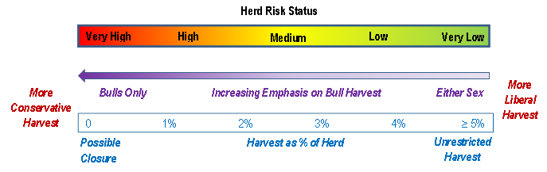
ᓇᓗᓇᐃᒃᑯᑕᖅ 11. ᑐᑦᑐᑕᐅᔪᓐᓇᖁᔭᐅᔪᑦ ᓇᐹᖅᑐᖃᖏᑦᑐᒥᐅᓂᑦ ᐊᒥᕐᕋᖏᑦ ᖃᑦᓯᐅᓂᖏᑦ ᒪᓕᒡᓗᒋᑦ (ENR 2014b), ᐱᑕᖃᑦᑕᕐᓂᖏᑦ ᒪᓕᒃᓗᒋᓪᓗ ᖃᐅᔨᓴᖅᑕᐅᓯᒪᔪᓂ ᑎᑎᕋᖅᓯᒪᔪᑦ ᖃᐅᔨᓴᓚᐅᖅᑕᖏᑦ ᐆᒃᑑᑎᓕᐅᕈᑎᒋᓚᐅᖅᑕᖏᑦ Boulanger ᐊᒻᒪ Adamczewski (2014). ᐊᒥᕐᕋᐃᑦ ᐊᒥᓲᖏᓗᐊᖅᐸᑕ ᐊᒥᓲᖏᓕᖅᐸᓪᓕᐊᓪᓗᑎᒡᓗ ᓱᑲᒃᑐᒥ ᐅᓗᕆᐊᓇᖅᑐᒦᑉᐳᑦ ᐱᑕᖅᑕᐅᔪᓐᓇᕐᕕᐅᒐᓗᐊᖅᖢᑎᒃ, ᐊᒥᓲᓂᖅᓴᐃᓪᓕ ᐊᒥᓱᖑᖅᐸᓪᓕᐊᓪᓗᑎᒡᓗ ᐅᓗᕆᐊᓇᖏᓐᓂᖅᓴᐅᕗᑦ ᐱᑕᖅᑕᐅᔪᓐᓇᖅᖢᑎᒡᓗ.

ᑎᓴᐱᕆ 2015-ᒥ ᐊᐅᓚᑦᓯᓂᕐᒧᑦ ᐋᖅᑭᒃᓱᖅᑕᐅᓯᒪᔪᑦ ᑐᓂᔭᐅᓚᐅᖅᐳᑦ ᑖᒃᑯᓄᖓ ᐃᖅᑭᓕᑦ ᐆᒪᔪᓕᕆᓂᕐᒧᑦ ᑲᑎᒪᔨᖏᓐᓄᑦ WRRB, SRRB ᐊᒻᒪ ᐆᒪᔪᐃᑦ ᐊᐅᓚᑕᐅᓂᖏᓐᓄᑦ ᑲᒪᒋᔭᐅᓂᖏᓐᓄᑦ WMAC, ᐊᕙᑎᓕᕆᔨᒃᑯᑦ ᓄᓇᒥᐅᑕᓕᕆᔨᒃᑯᓪᓗ ᐊᑐᓕᖁᔨᓚᐅᖅᐳᑦ ᓄᓇᓕᖕᓂᒥᐅᑦ ᐊᒻᒪ ᑮᓇᐅᔭᓕᐅᕈᑎᖃᖅᖢᑎᒃ ᑐᒃᑐᓯᐅᖅᑎᑦᓯᕙᒃᑐᑦ ᐱᑕᕆᐊᖃᖏᓐᓂᖏᓐᓄᑦ ᓱᓕ, ᐊᒻᒪ ᓄᓇᖃᖅᑳᖅᓯᒪᔪᑦ ᑭᒡᓕᖃᖅᑎᑕᐅᓗᑎᒃ ᐱᑕᕈᓐᓇᕐᓂᖏᑦ 950 ᑐᒃᑐᐃᑦ/ᐊᕐᕌᒍᒧᑦ ᐊᒻᒪ 100% ᐊᖑᓴᓪᓗᖑᓗᑎᒃ. ᕿᒥᕐᕈᔭᐅᖃᑦᑕᕋᔭᕐᓗᓂ ᐊᕐᕌᒍᑕᒫᑦ ᖃᐅᔨᒋᐊᖅᑕᐅᒃᑲᓐᓂᕐᓗᓂᓗ ᓄᑖᓂᒃ ᑐᑭᓯᒋᐊᕈᑎᖃᓕᑐᐊᖅᐸᑕ. ᓇᓚᐅᑦᓵᑐᐃᓐᓇᕐᓗᒍ ᑕᒪᐃᑎᒍᑦ 38,592 ᐊᒥᕐᕋᐃᑦ ᐊᒥᓲᓂᖃᕐᓗᑎᒃ ᑲᑎᑦᓗᒋᑦ, 950-ᑎᖄᖅᑐᑦ 2.5% ᑲᑎᓪᓗᒋᑦ ᑕᒡᕙᖓᑦ ᐊᒥᕐᕋᓂᑦ. ᐊᕙᑎᓕᕆᔨᒃᑯᑦ ᓄᓇᒥᐅᑕᓕᕆᔨᒃᑯᑦ ᐃᓱᒪᖕᒪᑕ ᐆᒪᔪᐃᑦ ᐊᐅᓚᑕᐅᓂᖏᓐᓄᑦ ᑲᒪᒋᔭᐅᓂᖏᓐᓄᑦ ACCWMᑯᓐᓄᑦ ᐱᖁᔨᒍᑕᐅᓯᒪᔪᑦ ᑭᒡᓕᖃᖅᑎᑕᐅᖁᔭᐅᓪᓗᑎᒃ ᐱᑕᖅᑕᐅᖃᑦᑕᖅᑐᑦ 1800ᓄᑦ (2800 ᑲᑎᓪᓗᒋᑦ ᐊᒥᕐᕋᖏᓐᓂᑦ, ᐃᓚᐅᓗᓂ ᓄᓇᕗᒥᐅᑦ) ᑕᒡᕙᖓᑦ 2014-2015 −ᒧᑦ ᖁᑦᓯᓗᐊᕐᒪᑦ ᑲᔪᓯᓂᐊᕐᓗᓂ, ᒥᒃᖠᕙᓪᓕᐊᑐᐃᓐᓇᕐᓂᖏᓐᓄᑦ ᖃᑦᓰᓐᓇᐅᓯᒪᓪᓗᑎᒡᓗ. ᑖᒃᑯᐊ ᒥᒃᖠᒋᐊᕐᓂᐊᕐᓂᖏᑦ 50%−ᒧᑦ ᐊᕐᓇᓪᓗᖏᑦ 2013 − 2015 ᒥᓗ ᖃᐅᔨᓐᓇᕈᑕᐅᕗᑦ ᐊᕐᓇᓪᓗᖏᑦ ᓄᕐᕋᓕᐅᕈᓐᓇᖅᑐᑦ ᐱᔭᐅᑦᑕᐃᓕᒋᐊᖃᕐᒪᑕ ᒪᑭᑉᐹᓪᓕᕐᓂᐊᕈᑎᒃ. ᐅᖃᐅᓯᕆᔭᐅᓯᒪᖕᒪᑦ ᐸᕐᓇᐅᑎᒋᓯᒪᔭᖏᓐᓂ ᐆᒪᔪᐃᑦ ᐊᐅᓚᑕᐅᓂᖏᓐᓄᑦ ᑲᒪᒋᔭᐅᓂᖏᓐᓄᑦ ACCWM ᐊᖑᓴᓪᓗᐃᓐᓇᕐᓂᒃ ᐱᑕᖁᔭᐅᓂᖏᓐᓄᑦ ᒪᒃᑯᖕᓂᖅᓴᓂᒃ ᒥᑭᓂᖅᓴᓂᒡᓘᓐᓃᑦ ᐸᖕᓂᕐᓂᒃ ᐊᖏᓂᖅᓴᐃᑦ ᓄᓕᐊᕈᓐᓇᕐᓂᐊᕐᒪᑕ. 950-ᓂᒃ ᐊᖑᓴᓪᓗᒃᐸᑕ ᐅᓗᕆᐊᓇᓕᕈᑕᐅᓕᕈᓐᓇᕆᕗᖅ ᑐᒃᑐᓂᒃ ᓄᖑᑉᐸᓪᓕᐊᒐᔭᕐᓂᖏᓐᓄᑦ, ᑭᓯᐊᓂ ᒥᑭᓂᖅᓴᐅᓂᐊᕋᓗᐊᖅᖢᓂ ᐊᕐᓇᓪᓗᖃᑦᑕᕐᓂᖅᓴᐅᓐᓂᖅᐸᑕ (ᓇᓗᓇᐃᒃᑯᑕᖅ 9).

ᑎᓴᐱᕆ 2015−ᒥ ᖃᑦᓯᓂᒃ ᑐᒃᑐᒍᓐᓇᕐᓂᕐᒧᑦ ᑐᒃᓯᕋᓚᐅᕐᒪᑕ ᑐᓂᔭᐅᓪᓗᑎᒡᓗ ᑖᒃᑯᓄᖓ ᐃᖅᑭᓕᑦ ᐆᒪᔪᓕᕆᓂᕐᒧᑦ ᑲᑎᒪᔨᖏᓐᓄᑦ WRRB, SRRB ᐊᒻᒪ ᐆᒪᔪᐃᑦ ᐊᐅᓚᑕᐅᓂᖏᓐᓄᑦ ᑲᒪᒋᔭᐅᓂᖏᓐᓄᑦ ᓄᓇᑦᓯᐊᒥ WMAC-NWT ᑐᒃᑐᒍᓐᓇᖁᔨᓪᓗᑎᒃ ᑲᑎᓪᓗᒋᑦ 611−ᓂᒃ ᓄᓇᑦᓯᐊᒥ (ᐃᖅᑭᓕᑦ Tłı̨chǫ 373, Sahtú 163, Dehcho 15, ᐃᓄᕕᐊᓗᐃᑦ 8, ᓄᓇᑦᓯᐊᒥ ᐊᓪᓚᖓᔪᑦ 14, Akaitcho 20, ᐊᒻᒪ North Slave Métis Alliance 17), ᑖᒃᑯᐊ ᑕᑯᒃᓴᐅᓪᓗᑎᒃ ᓇᓗᓇᐃᒃᑯᑕᖓᓂ 9. ᐊᐅᓚᑦᓯᒍᑎᑦ ᐱᑕᖅᑕᐅᕙᓪᓕᐊᔪᓂᒃ ᓂᕕᖓᑖᖃᖅᑎᑦᓯᖃᑦᑕᖅᖢᑎᒃ, ᐊᓯᖏᓐᓂᒡᓗ ᐱᒋᐊᖅᑕᐅᓂᐊᖅᐳᖅ ᐱᓕᕆᖃᑎᒋᔭᐅᓗᑎᒃ ᓄᓇᖃᖅᑳᖅᓯᒪᔪᑦ ᓄᓇᓕᖕᓂᒥᐅᑕᐃᑦ. ᐊᕙᑎᓕᕆᔨᒃᑯᑦ ᓄᓇᒥᐅᑕᓕᕆᔨᒃᑯᑦ ᐅᔾᔨᕈᓱᖁᔨᕗᑦ ᓯᕗᓕᖅᑎᐅᓯᒪᓂᖏᓐᓄᑦ ᐃᖅᑭᓕᑦ ᑎᓕᓃᒥᐅᑕᐃᑦ Délı̨nę ᐸᕐᓇᒃᓯᒪᒍᑎᖃᕐᒪᑕ ᑐᒃᑐᓗᐊᖅᑕᐃᓕᓂᕐᒧᑦ ᓄᓇᓕᖕᓂᒥᐅᑦ ᐃᓚᒋᔭᐅᓪᓗᑎᒃ ᐊᖑᓴᓪᓗᒐᓱᐊᕐᓂᖅᓴᐅᖃᑦᑕᕐᓗᑎᒃ 150-ᓂᒡᓗ ᑭᓯᐊᓂ ᐊᕐᕌᒍᒧᑦ ᑐᒃᑐᑉᐸᒡᓗᑎᒃ ᑖᒃᑯᐊ ᓄᓇᓖᑦ (Délı̨nę 2016).

ᑕᒪᕐᒥᒃ ᐊᒥᕐᕋᖏᓐᓂᑦ ᐱᑕᖅᑕᐅᔪᓐᓇᖅᑐᑦ 950 ᑕᐃᒪᓐᓇ ᖃᓄᐃᒐᔭᖏᑉᐳᑦ ᐱᓗᐊᖅᑕᐃᓕᔭᐅᓇᔭᕐᒪᑕ, ᐃᓚᐅᑎᑕᐅᓗᓂ 339 ᑐᒃᑐᔭᖅᑐᑉ ᒥᒃᓵᓂ ᑲᓇᖕᓇᖓᓂ ᑐᒃᑐᖏᑦ ᓄᓇᕗᒥ. ᐊᕙᑎᒥᐅᑕᓕᕆᔨᒃᑯᑦ ᓄᓇᒥᐅᑕᓕᕆᔨᒃᑯᓪᓗ ᑲᒪᒋᔭᖃᖏᒻᒪᑕ ᐆᒪᔪᓂᒃ ᑐᒃᑐᓯᐅᕐᓂᖏᓐᓄᓪᓗ ᓄᓇᕗᒥ, ᑭᓯᐊᓂ ᐱᓕᕆᖃᑎᒌᒃᖢᑎᒃ ᐱᔪᓐᓇᕐᓂᖃᖅᑐᓪᓗ ᓄᓇᕗᒥ ᓄᓇᖃᖅᑳᖅᓯᒪᔪᑦ ᑕᒪᕐᒥᒃ ᑐᒃᑐᓯᐅᖅᑎᑕᐅᔪᓐᓇᕐᓗᑎᒃ ᑖᒃᑯᓂᖓ ᑐᒃᑐᓂᒃ ᓄᓇᑦᓯᐊᒥᐅᑦ ᓄᓇᕗᒥᐅᓪᓗ.

ᓇᑭᖔᕐᓂᖏᑦ:

Adamczewski, J., J. Boulanger, B. Croft, T. Davison, H. Sayine-Crawford, ᐊᒻᒪ B. Tracz. 2014. ᐆᒃᑑᑎᒋᔭᐅᓯᒪᔪᑦ ᓇᓗᓇᐃᔭᖅᑕᐅᓯᒪᔪᑦ ᓄᕐᕋᓕᐅᖅᑐᑦ ᐊᒻᒪ ᓄᕐᕋᖃᓕᖅᑐᑦ ᐊᔾᔨᓕᐅᖅᑕᐅᓯᒪᓪᓗᑎᒃ ᑐᒃᑐᓴᒃᑐᑉ ᒥᒃᓵᓂ ᑲᓇᖕᓇᖓᓂ ᑐᒃᑐᐃᑦ ᓇᐹᖅᑐᖃᖏᑦᑐᒥᐅᑕᐃᑦ ᓄᓇᑦᓯᐊᒥ, ᑲᓇᑕᒥ in 2010. ᐊᕙᑎᒥᐅᑕᓕᕆᔨᒃᑯᑦ ᓄᓇᒥᐅᑕᓕᕆᔨᒃᑯᑦ, ᓄᓇᑦᓯᐊᑉ ᒐᕙᒪᒃᑯᖏᑦ. ᑎᑎᕋᖅᑕᐅᓯᒪᔪᓂᒃ ᐅᓂᒃᑳᓂᑦ 244.

ᐆᒪᔪᐃᑦ ᐊᐅᓚᑕᐅᓂᖏᓐᓄᑦ ᑲᒪᔨᑦ (ACCWM). 2014. Taking Care of Caribou – The Cape Bathurst, ᑖᒃᑯᐊ ᑐᒃᑐᖏᑦ ᑐᒃᑐᔭᖅᑐᑉ−ᐱᖓᓐᓇᖓᓂ, ᐊᒻᒪ ᑐᒃᑐᔭᖅᑐᑉ ᒥᒃᓵᓂ ᑲᓇᖕᓇᖓᓂ ᓇᐹᖅᑐᖃᖏᑦᑐᒥᐅᑕᐃᑦ ᑐᒃᑐᐃᑦ ᐊᐅᓚᑕᐅᓂᖏᓐᓄᑦ ᐸᕐᓇᐅᑎᑦ (ᑭᖑᓪᓕᐅᓕᖅᑐᑦ). ᐱᔭᐅᔪᑦ Wek’ èezhı̀i Renewable Resources Board, 102A, 4504 – 49 Avenue, Yellowknife, NT, X1A 1A7.

Boulanger, J., ᐊᒻᒪ J. Adamczewski. 2014. ᖃᓄᖅ ᑲᒪᒋᔭᐅᔪᓐᓇᕋᔭᕐᓂᖏᓐᓄᑦ ᑐᒃᑐᐃᑦ ᐊᒥᕐᕋᖏᑦ ᓄᓇᑦᓯᐊᒥ − ᓯᕗᓪᓕᕐᒥ ᑎᑎᕋᖅᑕᐅᓯᒪᔪᑦ ᐱᖁᔨᕗᖔᕈᑎᑦ ᐅᓂᒃᑳᑦ. ᑎᑎᕋᖅᑕᐅᓯᒪᖏᑦᑐᑦ ᐅᓂᒃᑳᑦ. ᐊᕙᑎᒥᐅᑕᓕᕆᔨᒃᑯᑦ ᓄᓇᒥᐅᑕᓕᕆᔨᒃᑯᓪᓗ, ᓄᓇᑦᓯᐊᑉ ᒐᕙᒪᒃᑯᖏᑦ ᔭᓗᓇᐃᒥ Yellowknife, NT, Canada.

Boulanger, J., A. Gunn, J. Adamczewski, ᐊᒻᒪ B. Croft. 2011. ᑎᑎᕋᖅᑕᐅᓯᒪᔪᑦ ᐆᒃᑑᑎᑦ ᖃᓄᖅ ᑲᒪᒋᔭᐅᔪᓐᓇᕋᔭᕐᓂᖏᓐᓄᑦ ᐊᒥᓲᖏᓕᖅᐸᓪᓕᐊᓂᖏᓐᓄᑦ ᕿᖓᐅᑉ ᒥᒃᓵᓂ ᑐᒃᑐᐃᑦ. ᑎᑎᕋᖅᑕᐅᓯᒪᔪᑦ ᐆᒪᔪᓕᕆᓂᕐᒧᑦ ᐊᐅᓚᑦᓯᓂᕐᒧᑦ ᑎᑎᖃᓂ. 75:883-896.

Boulanger, J., B. Croft, J. Adamczewski, D. Cluff, D. Lee, N. Larter ᐊᒻᒪ L.M. Leclerc. 2016.
ᓇᓚᐅᑦᓵᖅᑕᐅᓯᒪᔪᑦ ᐊᕐᓇᓪᓗᐃᑦ ᓄᕐᕋᓕᐅᖅᑐᑦ ᖃᐅᔨᓴᖅᑕᐅᓯᒪᓪᓗᑎᒡᓗ ᖃᑦᓯᐅᓂᖏᑦ ᑐᒃᑐᔭᖅᑐᑉ ᒥᑦᓵᓂ ᑲᓇᖕᓇᖓᓂ ᐊᒥᕐᕋᐃᑦ ᓇᐹᖅᑐᖃᖏᑦᑐᒥᐅᑕᐃᑦ: 2015 ᓄᕐᕋᓕᐅᕐᕕᑦ ᐊᔾᔨᓕᐅᖅᑕᐅᓚᐅᕐᓂᖏᑦ, ᓯᕗᓪᓕᖅ ᑎᑎᕋᖅᑕᐅᖅᑳᓚᐅᖅᑐᖅ ᕕᕗᐊᕆ Feb. 19, 2016. ᐊᕙᑎᒥᐅᑕᓕᕆᔨᒃᑯᑦ ᓄᓇᒥᐅᑕᓕᕆᔨᒃᑯᓪᓗ, ᓄᓇᑦᓯᐊᑉ ᒐᕙᒪᒃᑯᖏᑦ ᔭᓗᓇᐃᒥ Yellowknife, NWT, Canada.

Délı̨nę. 2015. A Délı̨nę Got’ı̨nę ᐃᖅᑭᓕᑦ ᐸᕐᓇᐅᑎᖏᑦ ᖃᓄᐃᓕᐅᕆᐊᕐᓂᐊᕐᓂᕐᒧᑦ: : Délı̨nę Caribou Conservation Plan. http://srrb.nt.ca/index.php?option=com_docman&view=document&layout=default&alias=1287-2016-009-deline-caribou-plan-approved-16-01-08-edition&category_slug=proposal-for-decision-and-supporting-documentation&Itemid=697

ᐊᕙᑎᒥᐅᑕᓕᕆᔨᒃᑯᑦ ᓄᓇᒥᐅᑕᓕᕆᔨᒃᑯᑦ (ENR). 2014a. ᕿᖓᐅᑉ ᐊᒻᒪ ᑐᒃᑐᔭᖅᑐᑉ ᒥᒃᓵᓂ ᑲᓇᖕᓇᖓᓂ ᑐᒃᑐᐃᑦ: ᖃᑦᓯᐅᓂᖏᑦ 2009-2014. ᑎᑎᕋᖅᑕᐅᓯᒪᖏᑦᑐᑦ ᓯᑉᑕᐱᕆ 2014. ᐊᕙᑎᒥᐅᑕᓕᕆᔨᒃᑯᑦ ᓄᓇᒥᐅᑕᓕᕆᔨᒃᑯᑦ, ᓄᓇᑦᓯᐊᑉ ᒐᕙᒪᒃᑯᖏᓐᓂ ᔭᓗᓇᐃᒥ Yellowknife, NT, Canada.

ᐊᕙᑎᒥᐅᑕᓕᕆᔨᒃᑯᑦ ᓄᓇᒥᐅᑕᓕᕆᔨᒃᑯᑦ (ENR) 2014b. ᐱᑕᖅᑕᐅᔪᓐᓇᖅᑐᑦ ᓇᐹᖅᑐᖃᖏᑦᑐᒥᐅᑕᐃᑦ ᑐᑦᑐᐃᑦ ᖃᑦᓯᐅᓂᖏᑦ ᐊᒥᕐᕋᐃᑦ ᒪᓕᒡᓗᒋᑦ: ᐊᑐᖅᑕᐅᓯᒪᓂᑯᑐᖃᐃᑦ ᒪᓕᒡᓗᒋᑦ. ᑎᑎᕋᖅᑕᐅᓯᒪᖏᑦᑐᑦ 2014. ᐊᕙᑎᒥᐅᑕᓕᕆᔨᒃᑯᑦ ᓄᓇᒥᐅᑕᓕᕆᔨᒃᑯᑦ ᔭᓗᓇᐃᒥ Yellowknife, NT, Canada.

ᓄᓇᑦᓯᐊᑉ ᒐᕙᒪᒃᑯᖏᑦ ᐃᖅᑭᓕᓪᓗ ᒐᕙᒪᒃᑯᖏᑦ Tłı̨chǫ Government (GNWT ᐊᒻᒪ TG) ᑲᑐᔾᔨᖃᑎᒌᒃᖢᑎᒃ ᑲᒪᒋᔭᖃᕐᓂᖏᑦ ᒥᐊᓂᖅᓯᓂᖏᐃᑦ ᑐᒃᑐᔭᖅᑐᑉ ᒥᒃᓵᓂ ᑲᓇᖕᓇᖓᓂ ᑐᒃᑐᓂᒃ: 2016-2019. 2015. ᑐᒃᓯᕋᐅᑕᐅᓯᒪᓪᓗᓂ ᑲᑎᒪᔨᖏᓐᓄᑦ ᐅᑯᐊ WRRB ᑎᓴᐱᕆ 15, 2016.

