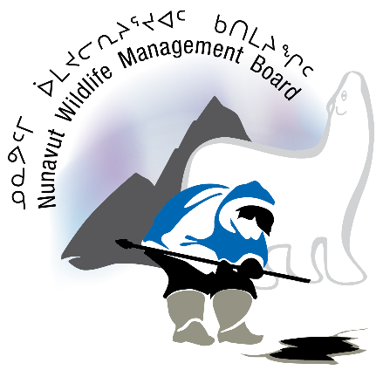

NOTICE OF NUNAVUT WILDLIFE MANAGEMENT BOARD IN-PERSON PUBLIC HEARING

Notice is provided on December 13, 2019 that the Nunavut Wildlife Management Board (NWMB or Board) will be conducting an in-person public hearing to consider the Government of Nunavut-Department of Environment’s Proposal for NWMB Decision to Reduce the Total Allowable Harvest of Bluenose East Caribou from 340 to 107 and to establish a Male Only Harvest Non-Quota Limitation. The hearing is scheduled to take place in Kugluktuk, Nunavut at the Kugluktuk Community Hall on March 2–3, 2020, from 9:00 a.m. to 5:00 p.m. on each day. The NWMB may also hold evening sessions from 7:00 p.m. to 9:00 p.m. or extend to the morning of March 4, 2020, if necessary.

The Proposal and additional documents relevant to the hearing are available for download from the NWMB’s website (www.nwmb.com), or by contacting the NWMB at the coordinates set out at the end of this notice.

The filing of submissions:
The NWMB is inviting interested organizations or persons, including any member of the public, to file written response submissions and supporting documentation concerning the Proposal by no later than 5:00 p.m. Iqaluit time on February 14, 2020. Unless persuasive written reasons are provided to the Board for late filing, the NWMB will not consider materials for this hearing that are not submitted on time. The NWMB will make publicly available all the written materials submitted, subject to relevant confidentiality or privacy concerns.
How to obtain more information:
To receive more information about filing or obtaining submissions, or the rules applying to the in-person public hearing, please contact the NWMB:

NUNAVUT WILDLIFE MANAGEMENT BOARD
P.O. Box 1379, Iqaluit, NU X0A 0H0
Phone: (867) 975-7300
Fax: (888) 421-9832
Email: receptionist@nwmb.com
Website: www.nwmb.com

