FOXE BASIN POLAR BEAR AERIAL SURVEY, 2009 AND 2010



SUMMARY OF FINDINGS

April 23, 2012

Prepared by:

Wildlife Research Section, Department of Environment, Government of Nunavut

INTRODUCTION

The boundaries of the Foxe Basin (FB) polar bear sub-population encompass the northern part of Hudson Bay, the western end of Hudson Strait and Foxe Basin proper (Figure 1). This region is seasonally ice-free, spanning some 1.1 million km² across Nunavut and Nunavik in northern Quebec. Seven communities in Nunavut (Cape Dorset, Chesterfield Inlet, Coral Harbour, Hall Beach, Igloolik, Kimmirut, and Repulse Bay) and four communities in Quebec (Akulivik, Ivujivik, Puvirnituq, and Salluit) lie within the FB bounds.
A mark-recapture study, conducted from 1989 to 1994, using tetracycline as a biomarker estimated the abundance of FB at approximately 2197 (+/- 256 S.E.). This population estimate formed the basis for management of harvest up to 2004. In 2004, estimated population abundance was revised to 2300 based on traditional ecological knowledge suggesting that the population had increased and the opinion of some scientists that historical harvest rates may have been low enough for an increase to occur.
Given the time elapsed since the last study was conducted the size and status of the FB sub-population is uncertain. To update the abundance estimate and reassess status, a study was initiated in 2008. Responding to Inuit concerns about the capture and handling of polar bears for research, the new study employed aerial survey methods. In contrast to the mark-recapture methods typically used to study polar bears, aerial surveying does not involve handling of bears. While this technique is well-established and widely implemented to monitor other wildlife species, its application to polar bears has been limited. However, a recent study in the Barents Sea suggests that aerial surveys may be used to successfully estimate polar bear abundance in certain regions. Interest in using aerial surveys to study FB polar bears was part of a broader Government of Nunavut (GN) initiative to develop and demonstrate alternative ways of monitoring polar bears that are potentially quicker, more cost effective and less invasive than capture-based methods.

OBJECTIVES
The objectives of the study were to:
- Develop and implement an aerial survey to reliably estimate polar bear abundance in Foxe Basin during the late summer, ice-free season.
- Derive aerial survey-based abundance estimates for the Foxe Basin subpopulation.
- Assess polar bear distribution in Foxe Basin during the late summer ice-free season, particularly with respect to environmental variables.

MATERIALS AND METHODS
Aerial surveys in FB were conducted from August to September. During this season, bears were largely confined to land, minimizing the area necessary to survey and therefore permitting a more efficient study. Additionally, the absence of ice and snow during late summer months means that polar bears are readily observable against a dark landscape, ideal conditions for an aerial survey.
To define the extent of the study area, and in particular to determine how far inland the aerial surveys should be extended, information on movement patterns collected from polar bears fitted with satellite collars or ear tags were used. This information was also used to divide the FB study area into sections (termed ‘strata’) which differed in terms of the expected concentration of bears within each (Figure 1). To maximize the number of bears encountered while also ensuring adequate coverage of all regions of the study area, the survey was designed such that more surveying would occur in areas where the highest concentrations of bears were expected to occur. For example, since bears are concentrated near the coast in August and September more time was spent flying in areas within 5 km of the coast in comparison to areas further inland (up to 50 km from the coast).
The survey was flown along a series of predetermined flight paths (‘transects’) which were oriented perpendicular to the coast (i.e. extending inland at 90 degrees to the coast) (Figure 2). These ‘inland’ transects extended up to 50 km inland. In addition to flying inland transects the survey included flights along the coast. These ‘coastal contour’ transects were flown at or near the high-water line with one side of the aircraft dedicated to monitoring tidal flats and near shore waters (i.e. swimming bears). We also sampled as many islands as possible across FB and attempted to completely survey small, remnant ice floes. We recorded all bears sighted in the open water.
Surveys were conducted from a Bell 206 LongRanger, flown at a groundspeed of about 150 km / hr and an above-ground level altitude of roughly 120 m. Flight parameters were based on pilot work conducted during 2008. The survey team consisted of 4 observers, 2 in the front and 2 in the rear of the helicopter, including members of HTO’s from around FB. Field protocols enabled concurrent collection of both double-observer, or sight-resight, and distance sampling data. To ensure that front and rear observers worked independently of each other, we constructed a partition between the seats to ensure that sightings by the front observers did not cue rear observers. Additionally, observers did not talk to one another until after a sighted bear was completely passed.
Bear locations and flight paths were recorded via GPS and perpendicular distances from sighted bears to transects measured in a GIS. We remotely assessed sex and age class, documented group size and approximated body condition using a qualitative fatness index. We also recorded bear activity when first observed (e.g. lying down, running), weather conditions and habitat characteristics; all factors that may have affected the ability of observers to spot bears. Data were analysed using established distance-sampling and sight-resight methods. We also recorded habitat characteristics and weather conditions (qualitative 1 - 3 scale) that may have influenced detection for each sighting.
Data were analysed using established distance-sampling and sight-resight methods that have been previously used in studies of polar bears and other species world-wide.
RESULTS AND DISCUSSION

We completed the FB aerial surveys during August - September, 2009 and August - October, 2010. We successfully sampled nearly all planned transects in both years (Figure 2), despite particularly challenging weather conditions in 2010. We flew more than 300 hours and 40,000 km during each year’s survey including coverage of approximately 50% of the entire coastline.
Key results were as follows:
- We observed 816 and 1,003 individuals in 2009 and 2010, respectively.

- The distribution of polar bears was similar in both years (Figure 3). High concentrations of bears were observed in central Foxe Basin near Lyon Inlet and on Southampton Island and neighbouring Coats, Vansittart, and White Islands and in northern Foxe Basin on Rowley, Koch, Prince Charles, and the Spicer Islands. Relatively few bears were spotted along Hudson Strait and in the Bowman Bay region of western Baffin Island. Bears were most frequently observed along coastal contour transects, in the near-shore inland areas and on large and small islands, but sightings were documented across all regions. Some bears were found more than 40 km inland (Figure 3).

- Survey data were analysed by several different techniques all of which produced remarkably similar results. The survey estimated overall abundance at about 2,580 bears in the Foxe Basin subpopulation, with a 95% confidence interval of 2,093 to 3,180 (CV: 10.7%).

- Although aerial surveys are widely used to monitor a variety of wildlife species, their application to polar bear subpopulations has been largely limited due to logistical and technical constraints. Prior to the FB research, a study conducted over land and on pack ice in the Barents Sea represented the lone, large-scale polar bear aerial survey. The successful implementation of the land-based aerial survey during the ice-free season in FB thus represents a significant advance in polar bear monitoring techniques.

- Importantly, the similarity of our results both across years and between the two survey methods suggests that aerial surveys can generate reliable and precise estimates of abundance and can be a useful tool for monitoring trends in FB and other seasonally ice-free subpopulations.

- A comparison of our abundance estimate (N: ~2,580, SE: 278) with that from the early 1990s (N: ~2,200, SE: 260) suggests that FB may have remained relatively stable. This finding implies that the current harvest management regimen has allowed FB to remain relatively stable since the early 1990s.

- Observed litter sizes were similar between years: in 2009, cub-of-the-year (coy) and yearling / 2-year-old litter sizes averaged 1.57 (SD: 0.55, n = 75) and 1.55 (SD: 0.54, n = 53); mean litter sizes were 1.53 (SD: 0.57, n = 80) and 1.40 (SD: 0.50, n=65) for coy and yearlings / 2-year-olds, respectively, in 2010. These litter sizes were generally comparable to those documented in other subpopulations with robust annual growth rates, including Baffin Bay, suggesting that recruitment is currently indicative of a healthy subpopulation.

- Anecdotally, polar bears observed during the aerial surveys generally appeared to be in good body condition (based on a qualitative fatness index, further supporting the notion that FB is a healthy subpopulation.

- The aerial survey results did not provide evidence to suggest that climate change is negatively influencing FB, though impacts have been documented elsewhere in the region (e.g., Western Hudson Bay).

- Several additional analyses of the survey data are planned. For example, information on polar bear distribution in FB will be combined with similar information collected during a recent (2011) aerial survey of the neighbouring Western Hudson Bay subpopulation. These data will be used to examine the influence of environmental, ecological, and human-related factors on the late summer distribution of bears in the Hudson Bay.

Figure 1. The FB polar bear subpopulation spans more than 1 million km² in Nunavut and northern Quebec. Multiple strata were delineated for the FB aerial surveys.
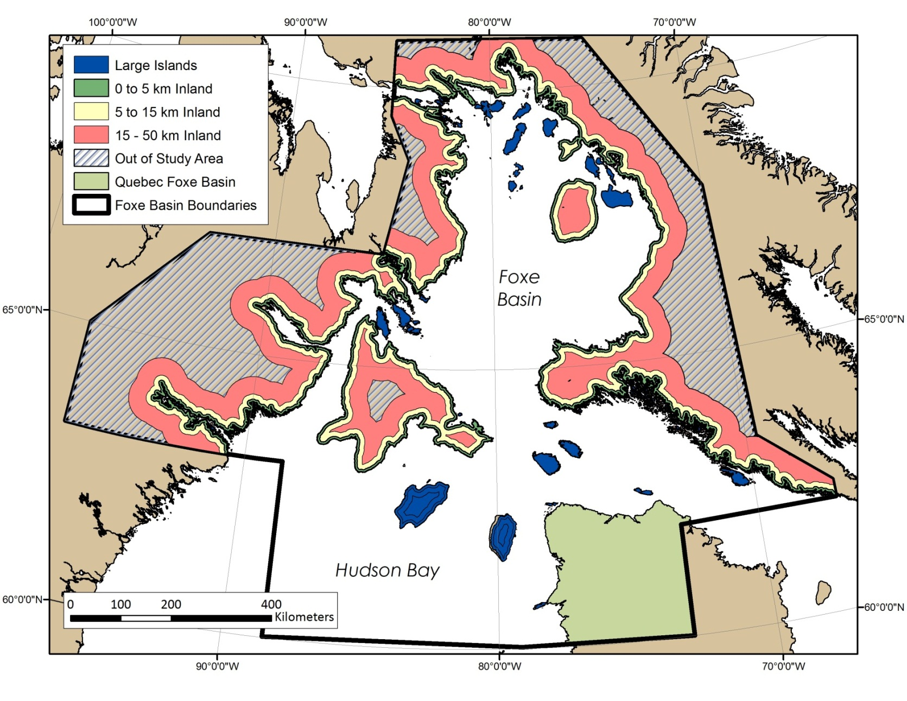
Figure 2. Transects flown during the Foxe Basin polar bear subpopulation aerial survey, August to October, 2010.
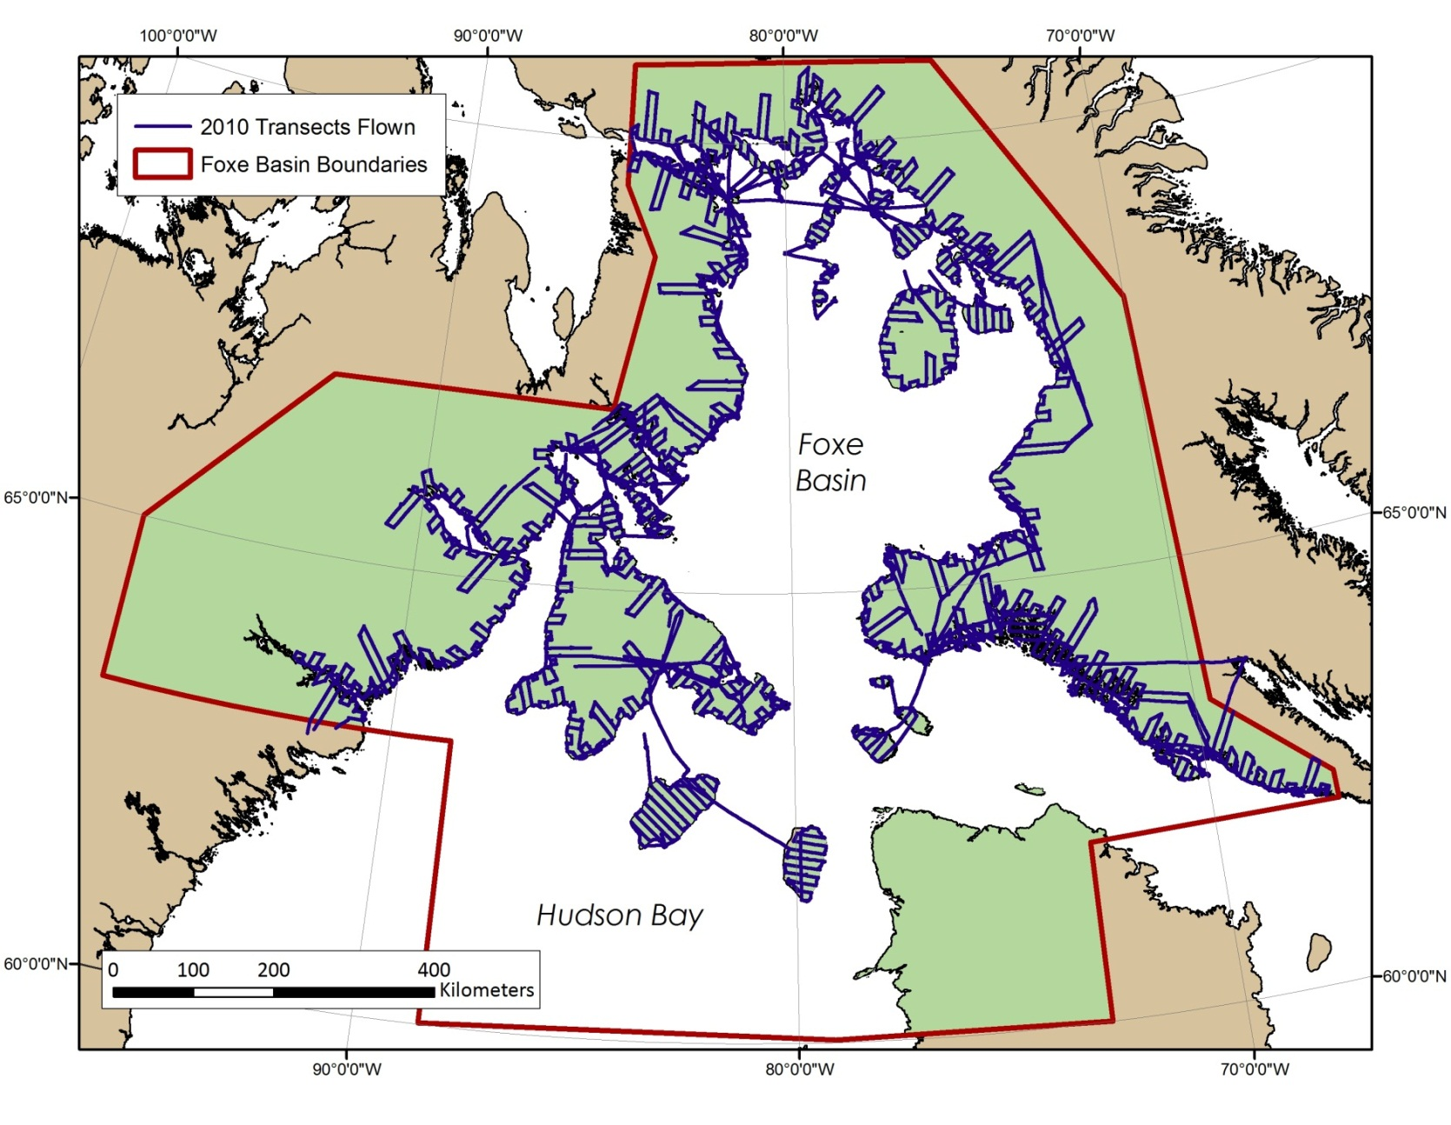
Figure 3. Distribution of polar bears observed during the Foxe Basin aerial surveys.
- 2009
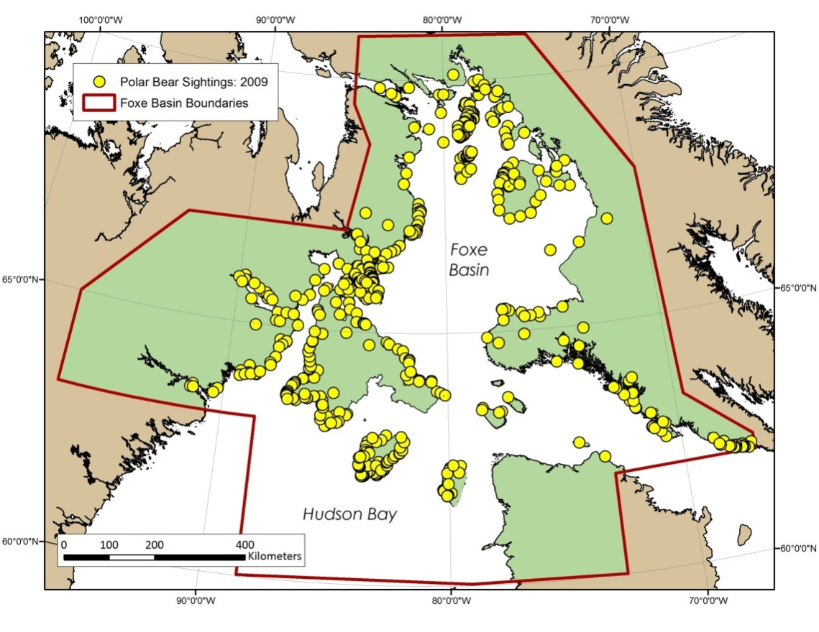
(b) 2010
