FINAL INTERIM PROJECT REPORT
TO THE NUNAVUT WILDLIFE MANAGEMENT BOARD

1. Project #2-13-01

2. Project Title: Distribution and Abundance of Baffin Island Barren-Ground Caribou, March 2014.

3. Project Leader: Mitch Campbell
Kivalliq Regional Biologist
Department of Environment
Government of Nunavut
PO Box 120, Arviat, Nu, X0C 0E0
Ph: (867) 857-2828
mcampbell1@gov.nu.ca

4. Summary:

Barren-ground caribou are the only ungulate that occurs on Baffin Island which represents the northeastern extent of their known range in Nunavut. Currently Baffin communities are concerned over the future of their caribou as IQ and scientific studies have suggested this subpopulation has declined substantially over the last decade creating hardship for subsistence harvesters and the families and communities that rely on them to secure this high quality, healthy country food source.
This research effort estimates the abundance of barren-ground caribou occupying all of Baffin Island using primarily aerial and secondarily ground surveys. The work combined all Baffin Island subpopulations to provide the first Baffin Island wide population estimate and spring distribution map.
The Baffin Island caribou survey began on February 26th and was concluded on March 21st, 2014. During the three-and-half week aerial survey, crews in three planes and one helicopter flew over 46,000 miles, covering nearly all of Baffin Island and much of Melville Peninsula. With the exception of three bad weather days, conditions for flying and sighting caribou were exceptionally good and the survey was successfully completed ahead of schedule. In addition to the aerial survey, community members from the hamlets of Qikiqtarjuaq, Clyde River and Arctic Bay conducted ground surveys that covered large areas surrounding their respective communities.
Using the results of the aerial summary, it was calculated that there are between 3,462 and 6,250 caribou on all of the Baffin Island complex (95% CI (degree of confidence)). These results suggest that the relative densities of caribou within south Baffin remain low and that the relative densities of caribou in north Baffin are extremely low. The results confirm the urgent need to develop a management plan with co-management partners for Baffin caribou that will begin to address concerns of the low number of caribou and ensure their sustainable use and availability into the future.

5. Introduction:
Caribou are circumpolar in their distribution and occur in northern parts of Eurasia and North America. In Canada, caribou are represented by 4 subspecies; Peary, Woodland, Grant’s and Barren ground. Barren-Ground caribou are the most abundant. This subspecies can be further divided into two ecotypes (Nagy et al 2011), taiga wintering migratory barren-ground caribou and Tundra wintering barren-ground caribou. All Baffin Island caribou subpopulations fall into the tundra wintering ecotype. Additionally barren ground caribou on Baffin Island generally occur in smaller groups, with less dramatic migratory behavior and are confined to tundra. Movements of Baffin Island caribou are not completely understood though limited scientific knowledge and IQ suggest that it varies amongst the subpopulations, including but not limited to both altitudinal as well as geographically driven migratory behavior though not of the scale documented for mainland migratory subpopulations.
Previously, three caribou subpopulations across Baffin Island were recognized (Ferguson and Gautier 1992, Department of Environment, 2005). However, the paucity of demographic and movement studies on Baffin Island over the last 20 years has made any divisions that may have existed between these possible subpopulations difficult to verify. Early surveys (1940-1970) were unable to provide reliable population estimates due to limited coverage. These issues were further compounded by small widely dispersed herds, bad weather over the survey period, and rugged terrain over portions of the range (Hall 1980). These early surveys generally focused on discrete portions of caribou range and were almost exclusively limited to South Baffin. Subsequently, a robust population estimate has never been produced for the island or at the subpopulation level though Williams and Heard (1986) suggested that in excess of 100,000 caribou inhabited Baffin Island in 1985. The status was updated in 1991 when it was suggested that populations were stable with 60,000 -180,000 in South Baffin, greater than 10,000 in Northeast Baffin, and between 50,000-150,000 in North Baffin (Ferguson and Gauthier, 1992). Once again these estimates were not the result of robust demographic studies but rather a best guess based on IQ of the time and various incidental aerial observation and movement data. Since the mid-2000s, local hunters across Baffin Island have reported low caribou numbers, and currently many hunters have to travel further from their community to locate caribou (Jenkins et al. 2013). In response to local observations of decline, the Government of Nunavut initially proposed a multi-year aerial survey to provide a population estimate of caribou across Baffin Island and address community concerns over the status of their caribou. The most recent demographic studies conducted on Baffin Island examined southern Baffin Island from March through May 2012 (Jenkins et. al. 2013). Though poor weather extended the survey period and made caribou sightability and survey conditions difficult at times, Jenkins reported that an estimated 1,500 yearling and adult caribou occupied the south Baffin study area. In light of some of the difficulties experienced in this study and the overall objective of arriving at a population estimate for all of Baffin Island, the Government of Nunavut revised its multi-year study design in June 2013, in favour of an island-wide aerial survey.
The 2012 south Baffin caribou survey results suggested a dramatic drop from earlier estimates and are consistent with hunter reports of low numbers of caribou across the Island. Though the mechanisms of the observed decline are unclear, density-dependent factors such as vegetation depletion and disease are believed to be contributing factors (Caribou Workshop 2013, Baffin Community Consultations 2013-2014, Caribou Workshop 2014).
This current research effort provides an estimate of the abundance of barren-ground caribou occupying all of Baffin Island using primarily aerial and secondarily ground surveys. The work combines all Baffin Island subpopulations to provide a Baffin Island wide population estimate and spring distribution map. Upon consultation with HTOs and co-management partners of this revised island-wide caribou survey planned for 2013- 14, wide support was gained at the Baffin Island Caribou Workshop (July 2013). The need to re-survey the south Baffin study area to verify 2012 survey results and to conduct this survey concurrent with the North Baffin caribou abundance survey was supported by all Baffin HTOs.

The identified declines based on information from the recent aerial surveys (2012, 2014), combined with IQ from communities across the Island, have highlighted the urgent need to develop a management strategy aimed at stabilizing the current declines through informed decision making. In this capacity, the results will be used to inform management decisions that will begin to address community concerns of low caribou abundance and promote the recovery of the population for future generations of Nunavumuit. The results of this study provide a benchmark from which the effectiveness of future co-management efforts can be measured and if necessary, modified to meet identified goals.

6. Project Objectives:

The principle goal of this investigation was to determine the abundance and distribution of caribou on Baffin Island. This research was guided by 3 main objectives:
1) Observe and record the number and location of caribou within their late winter range.
2) Estimate yearling and adult caribou abundance.
3) Involve Baffin HTOs and their representatives with the research program in a meaningful way through both ground and aerial survey efforts and survey planning and reporting.

7. Materials and Methods:

We used a stratified random transect aerial survey technique utilizing distance sampling and a double observer platform. The method was chosen for reasons of logistic appropriateness as well as methodological rigor. The stratified random transect aerial survey technique is widely accepted as being the most cost effective means of estimating wild populations of ungulates while providing a high level of precision. The use of a double observer platform improves survey accuracy (Campbell et al., 2012) while the use of the distance sampling method quantifies sightability, maximizing area coverage. The survey was flown in late February and March to maximize sightability and good weather windows while minimizing the chances of large scale movements of caribou.
Strata were broken down into High (Strata 5), Medium to High (Strata 4), low (Strata 3), unknown (Strata 2), and no caribou (Strata 1) within the survey area. Aerial survey visual techniques were applied within each of Strata 5, 4 and 3 with the highest survey intensity applied to strata 5 (7km transect spacing) and strata 4 (8km spacing), and secondary survey effort applied to strata 3 (10km spacing). Strata area coverage increased with increasing strata number though varied within each strata depending on sightability. Within strata 2, Ground surveys were conducted utilizing caribou experts selected by the HTOs of Arctic Bay, Clyde River, and Qikiqtarjuaq. Strata 2 areas were searched utilizing expert hunting and searching techniques captured within IQ and inherent to the Inuit culture. We believe this technique of ground searching is far superior in identifying the use of an area by caribou than any known ground survey techniques for wildlife particularly when considering the expanse and remoteness of the study area. If caribou and/or their sign were detected within a strata 2 area then the strata area was considered for aerial reconnaissance survey. If neither caribou and/or their sign were observed by the ground crews, the strata 2 area was re-classified as strata 1 and not surveyed by air. The selection of all strata classes were made utilizing past aerial survey observations and IQ collected during community consultations prior to the survey effort.
The survey altitude for the strip transect survey was 120 m above ground level with a mean survey speed of 160 km/hour. The total effective strip width ranged from 10-15% in strata 3, 12-20% in strata 4, and 14-25% in strata 5, depending on sightability. The survey included three high wing single engine turbine fixed wing aircraft and one rotary wing aircraft. The multiple aircraft were used to shorten the survey period, take maximum advantage of good weather windows, and reduce the probability of either double counting and/or under counting caribou within the study area (due to movement over time). The double observer platform utilized four independent, dedicated observers, two on the left side of the aircraft and two on the right. Two data recorders, one for the left and one for the right, recorded all
observations as primary (front) secondary (rear) or both (front and rear) for each of the left side and right side.
When caribou were spotted by aircraft observers, data recorders documented the location of the observation (including GPS waypoint, transect, distance bin and strata ID), group size. Each observation represented a group of caribou which we defined as being one or more animals located within 100m of each other. Data recorders also noted snow and weather conditions, speed of the aircraft, and terrain ruggedness for all observations. Observations of caribou sign and other wildlife were also recorded. All observations made on transect were categorized into one of five bins on both sides of the plane based on the distance from the aircraft (0-200m, 200-400m, 400-600m, 600-1000m, and 1000-1500m). Markers on the aircraft struts were used to assist observers in estimating the observation distance, and thus bin number. All observations made while flying on transect and within 1500m from the plane were classified as ‘On transect’. Observations beyond 1500m from the aircraft as well as observations made while ferrying between transect lines were recorded as ‘Off transect’.
A Distance sampling analysis was used to estimate both the abundance and density of caribou in each strata and over the entire survey area.

8. Results:

The Baffin Island Caribou Survey began on February 26th with the fixed-wing component successfully completed March 17, 2014 and the helicopter component successfully completed March 21st, 2014. Over 46,000 miles (76,000 kilometers) of flying were completed ahead of schedule, with only three weather days where all aircraft could not fly (March 3rd, March 4th, and March 6th). (Figure 1). In addition to full time survey and flight staff, over 32 local observers were employed throughout the course of the aerial survey.

All of the information collected during consultations with the Baffin communities (December 2013 and January 2014), including the different zones (strata) where varying densities of caribou were expected to be found, were completed as discussed (Figure 2). In addition, ground surveys, led by the HTOs in Qikiqtarjuaq, Clyde River and Arctic Bay, were completed in early March 2014. The Qikiqtarjuaq HTO reported that no caribou were observed during their survey efforts (Figure 4a.). Ground survey reports from Arctic Bay indicated that they observed 2 caribou in their survey area (Figure 4b.). The Clyde River HTO reported that they saw no caribou in the south survey area (Figure 4c.), and greater than 30 caribou in the north survey area (Figure 4d.). Bylot Island and the Cumberland Peninsula were not surveyed by air as discussed during the consultation process; however a ground survey was undertaken along the north Cumberland Peninsula but no caribou were observed.

In total, 1145 caribou were observed during the aerial survey. The following outlines the number of caribou observations by strata (also see Figure 2):

1. Meta Incognita Peninsula Strata 4 = 98
2. Hall Peninsula Strata 4 = 184
3. Foxe Peninsula Strata 3 = 20
4. Central Baffin Island Strata 4 = 196
5. Prince Charles Island Strata 5 = 554
6. North Central Baffin Strata 3 = 12
7. Mary River Strata 4 = 49
8. Borden Peninsula Strata 3 = 1
9. The Islands Strata-3 = 0
10. Melville Peninsula Strata 3 = 31

Using the previously defined subpopulation separations, 1052 caribou were observed by aerial transect survey in the South Baffin Island subpopulation area, 50 caribou were observed in the North Baffin Island subpopulation area, and 12 caribou were observed in the Northeast Baffin Island subpopulation area (Figure 3). Additionally, a total of 31 caribou were observed on North Melville Peninsula (Figure 3)(see Community Consultation Reports 2011 and 2012, Ferguson and Gautier (1992), for IQ documentation on caribou subpopulations).

Using the 1145 caribou observations from the survey the Government of Nunavut calculated that there are between 3,462 and 6,250 caribou on all of Baffin Island complex (95% CI (degree of confidence); Table 1). North Baffin had only between 97 and 521 caribou at the time of survey. These calculations have been checked and verified by GN and NTI biologists. These low numbers are consistent with what many hunters and the communities have been saying - that there are currently very few caribou on Baffin Island. These very low numbers highlight the need for management actions to reduce the chance of eliminating caribou from areas of Baffin Island.

Table 1. Estimates of abundance by survey area (Strata; Figure 2) from the 2014 Baffin Island survey. The number of individual caribou observed in each stratum is also given for reference.
Strata (Survey Area) | Caribou counted during survey | Caribou estimate |  | 95% Confidence Limit (caribou estimate range)
North Baffin
Borden Peninsula | 1 |  | 6 |  | 1-30
Mary River | 49 |  | 224 |  | 96-521
North Central Baffin | 13 |  | 85 |  | 31-230
Total | 63 |  | 315 |  | 159-622
South Baffin
Central Baffin | 197 |  | 1,091 |  | 662-1,798
Foxe Peninsula | 20 |  | 216 |  | 48-972
Hall Peninsula | 176 |  | 887 |  | 467-1,686
Meta-Incogneta_Penninsula | 91 |  | 539 |  | 256-1,138
Prince Charles Island | 557 |  | 1,603 |  | 1,158-2,220
Total (+ Prince Charles Island) | 824 |  | 4,337 |  | 3,169-5,935
Total | 267 |  | 2,734 |  | 1,777-4,207
Other areas
Melville Peninsula | 26 |  | 220 |  | 88-551
Survey Area Total | 1,130 |  | 4,872 |  | 3,661-6,484
Baffin Island Total | 1,104 |  | 4,652 |  | 3,462-6,250

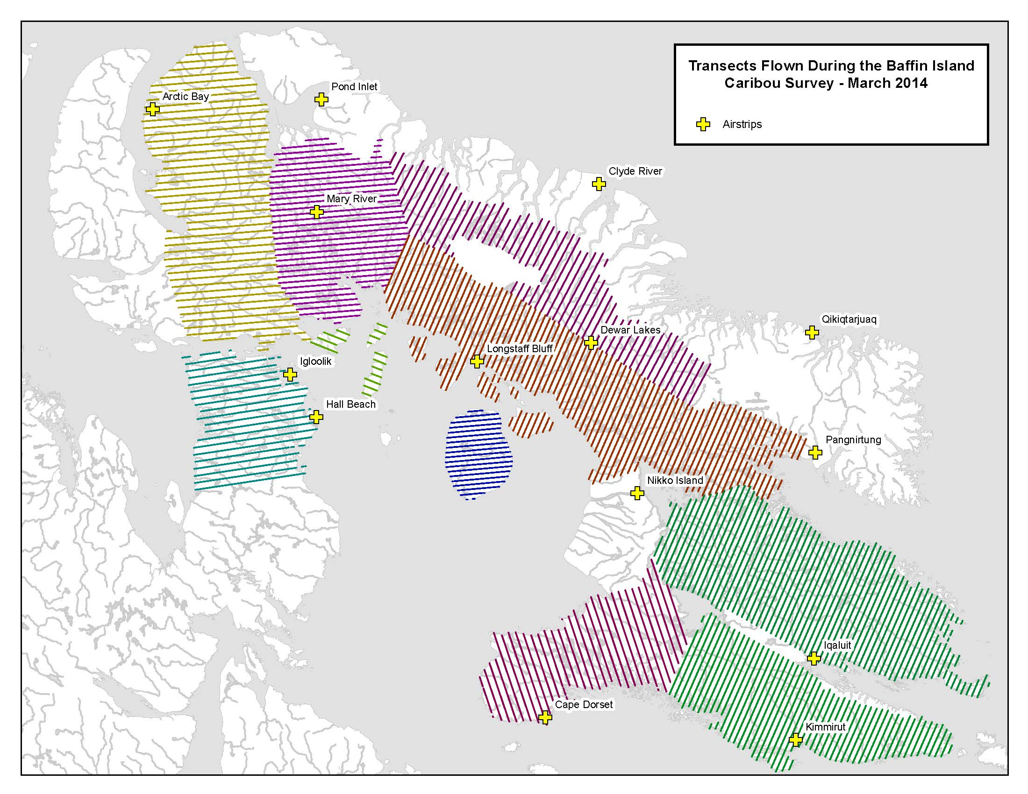
Figure 1. Transects flown during the Baffin Island Caribou Survey, using 3 fixed-wing aircraft and one rotary-wing aircraft between February 26th and March 21st, 2014.

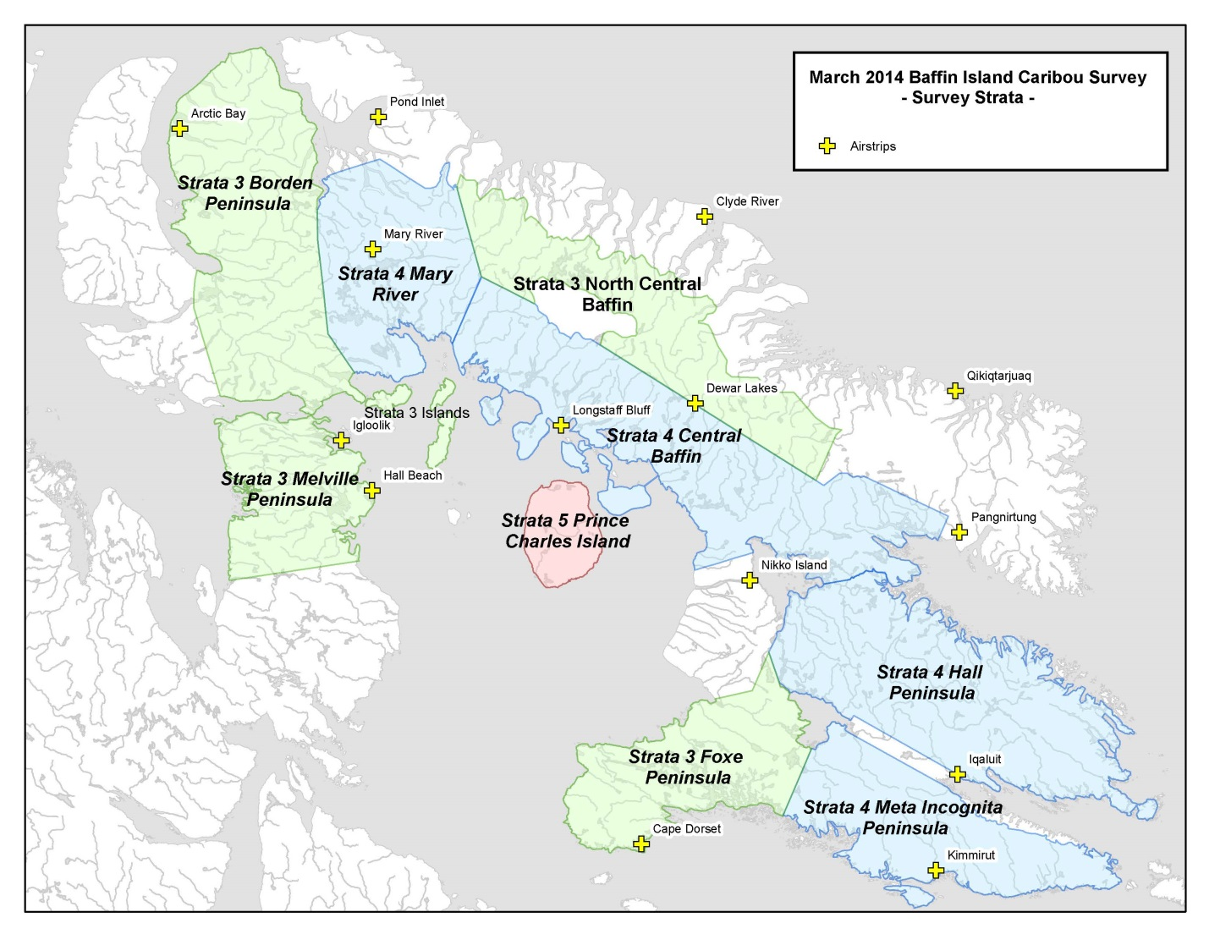
Figure 2. Survey Strata for the Baffin Island Caribou Survey – March 2014. Note: Transect width varied as follows: Strata 3, 10 km spacing (green); Strata 4, 8 km spacing (blue); Strata 5, 7km spacing (red). Areas not highlighted were not systematically flown in transects; however, some of these areas were covered in the HTO-led ground surveys by snowmobile and/or were opportunistically overflown for observation during logistical positioning of aircraft for accommodations in the various communities.

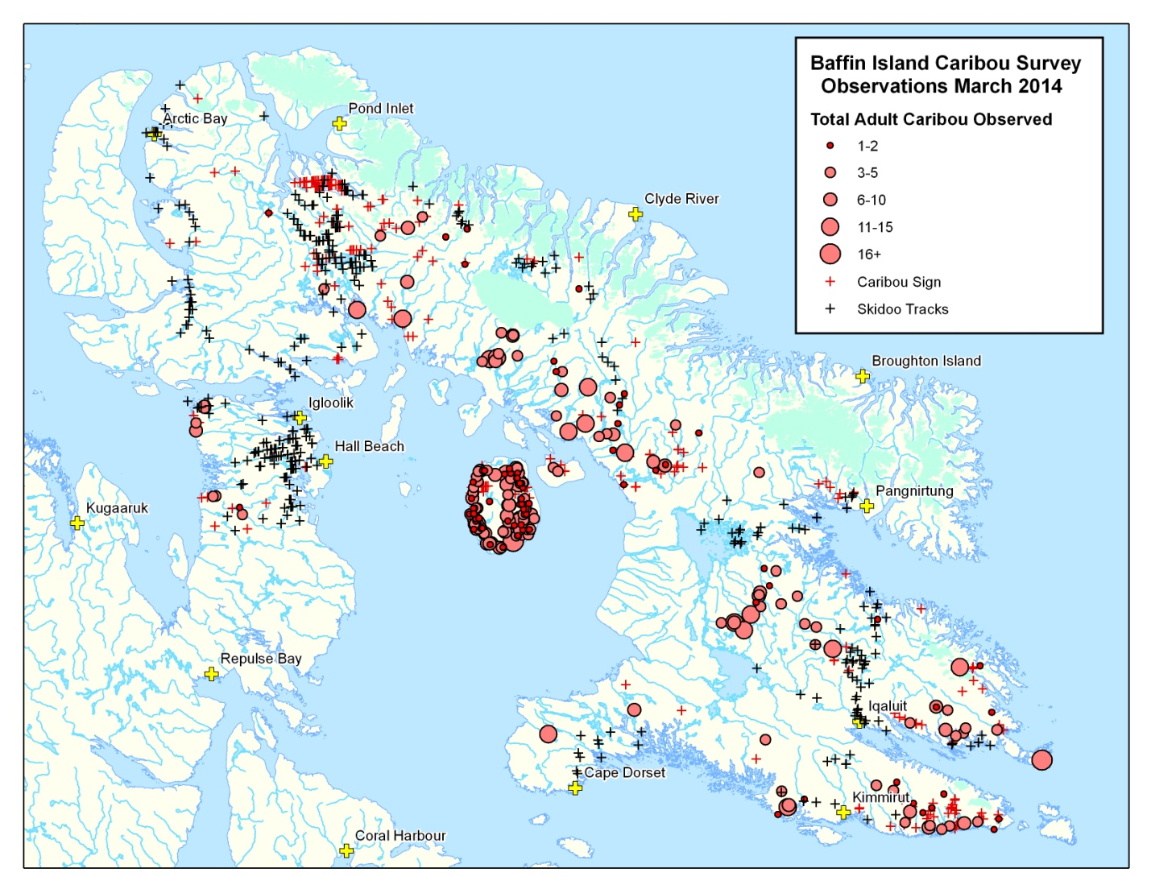
Figure 3. Locations of caribou, caribou signs, and skidoo tracks observed during the aerial survey in late February and March 2014.

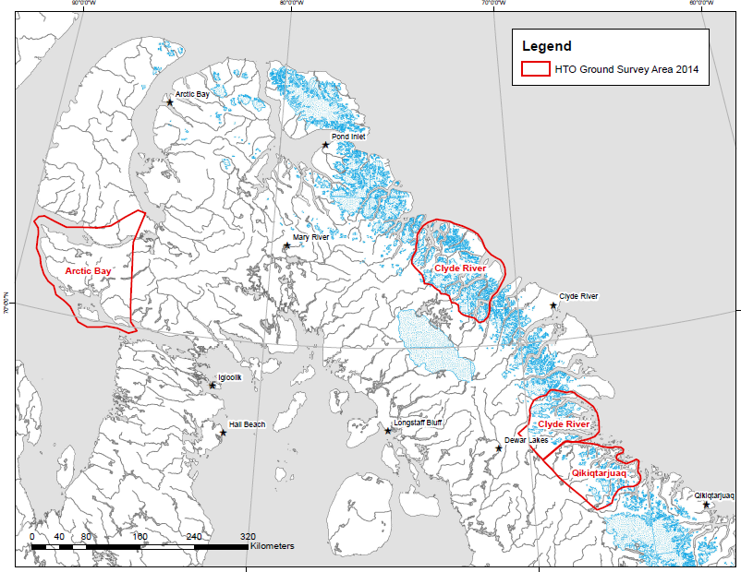
Figure 4. Strata 2 areas surveyed by ground crews during the Baffin Island Caribou survey in March 2014.

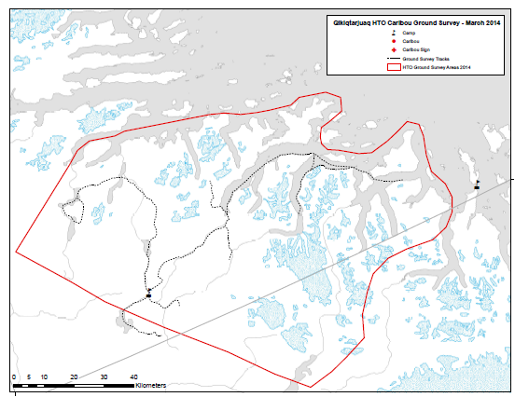
a)
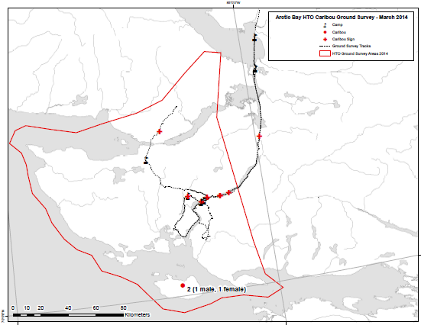
b)
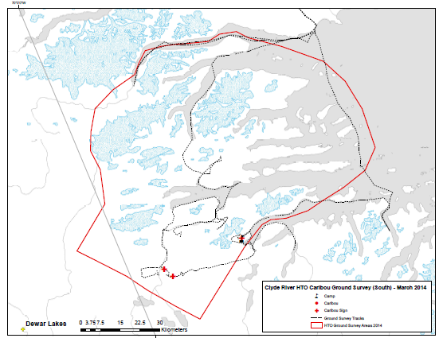
c)
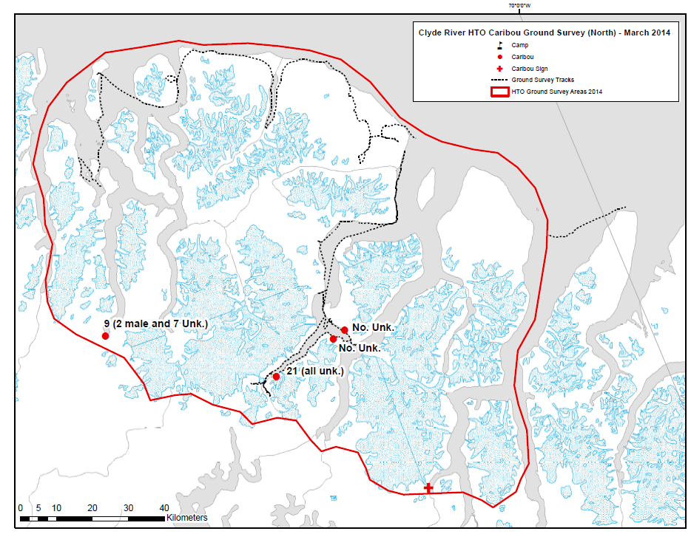
d)

Figure 5. Results of the HTO-led ground surveys conducted in early March 2014 from a) Qikiqtarjuaq, b) Arctic Bay, c) South of Clyde River, and d) North of Clyde River, including caribou observation locations and skidoo tracklogs.

9. Discussion/Management Implications:

The survey estimates suggest that relative densities of caribou within the South Baffin subpopulation area remain low, which is consistent with both IQ expert knowledge collected from hunters during the 2013 South Baffin caribou community consultations as well as the scientific results of the 2012 aerial survey. Of greater concern, relative densities of caribou within each of Northeast Baffin and North Baffin subpopulation areas are extremely low, far lower than expected according to the 2014 North Baffin caribou consultations and previous North Baffin aerial reconnaissance observations made in 2008 and 2009.

Given the identified conservation need emphasized by the results of the aerial survey, the Minister of Environment, Government of Nunavut, declared an interim moratorium on the harvest of caribou on Baffin Island, effective as of January 1, 2015. This interim decision is pursuant to Section 5.3.24 of the Nunavut Land Claims Agreement, that allows the Minister to make an interim decision to modify harvesting activities in “urgent and unusual circumstances”. The interim moratorium is in place until further notice and co-management partners are working together to develop a long-term Baffin Island caribou management plan for spring 2015.

10. Reporting to the Communities/Resource Users:

The survey results were shared with co-management partners, including representatives from the Baffin Hunters and Trappers Organization, Qikiqtaaluk Wildlife Board, Nunavut Tunngavik Inc., the Nunavut Wildlife Management Board, and the DOE Elders Advisory Committee, at a workshop in Iqaluit on November 3rd and 4th. Further, in-community consultations will occur with co-management partners in early spring 2015 to draft a co-management plan for Baffin Island caribou that addresses caribou conservation, restoration and sustainable wildlife management needs.

11. References:

Campbell, M.C., J Boulanger, D.S. Lee, M. Dumond and J. McPherson. 2012. Calving Ground Abundance Estimates of the Beverly and Ahiak Subpopulations of Barren-Ground Caribou (Rangifer tarandus groenlandicus) – June 2011. Government of Nunavut, Department of Environment, Technical Report Summary No:03-2012. 111 pp.
Department of Environment, 2013. Working Together for Baffin Island Caribou, Workshop Report (August 2013), Department of Environment, Government of Nunavut, Iqaluit, NU.
Department of Environment, 2005. Recommendations on Total Allowable Harvest (TAH) Rates for Terrestrial Wildlife Populations in Nunavut. Wildlife Research Section, Department of Environment, Government of Nunavut.
Ferguson, M.A.D. 1993. Working with Inuit to Study the Population Ecology of Baffin Island Caribou. Information North 19(4): 4-7.
Ferguson, M.A.D. and L. Gauthier. 1992. Status and trends of Rangifer tarandus and Ovibos moschatus populations in Canada. Rangifer 12(3): 127-141.
Hall, E. 1980. Baffin Caribou – A Re-evaluation. Department of Renewable Resources. Government of Northwest Territories.
Jenkins D.A. and J. Goorts. 2011. Space Use and Movement Patterns of North Baffin Caribou. Field Summary and Progress Report, September 2011. Department of Environment, Government of Nunavut.
Jenkins et al. in prep. Summary Report – South Baffin Caribou Survey 2012- Abundance and Composition.
Williams, T.M. and D.C. Heard. 1986. World status of wild Rangifer tarandus populations. Rangifer Special Issue No. 1:19-28

