ᑭᖑᓪᓕᖅᐹᒥ ᐅᓂᒃᑳᑦ

ᐱᓕᕆᐊᒧᑦ ᓈᓴᐅᑎᖓ: 32-13-11
ᐱᓕᕆᐊᖅ ᐊᑎᖓ:
ᐅᒥᒻᒪᓂᑦ ᖃᖓᑕᓲᒃᑯᑦ ᖃᐅᔨᓴᕐᓂᖅ (Ovibos moschatus)
ᕿᑎᕐᒥᐅᓂᑦ, ᓄᓇᕗᑦ.

ᐱᓕᕆᐊᒧᑦ ᑐᑭᒧᐊᖅᑎᑦᑎᔨ:
ᓖᓴ-ᒪᕇ ᓕᐊᒃᓗᕐᒃ
ᐊᕕᑦᑐᖅᓯᒪᔪᒧᑦ ᐆᒪᔪᓂᑦ ᖃᐅᔨᓴᖅᑎ, ᕿᑎᕐᒥᐅᑦ
ᐊᕙᑎᓕᕆᔨᒃᑯᑦ, ᓄᓇᕗᑦ ᒐᕙᒪᒃᑯᑦ
P.O. 377, ᖁᓪᓗᖅᑑᖅ, ᓄᓇᕗᑦ, X0B 0E0

ᐱᒋᐊᕐᓂᖓ:
ᐅᒥᒻᒪᒃ (Ovibos moschatus), ᓄᓇᕗᒻᒦᖃᑦᑕᖅᑐᑦ ᐆᒪᔪᐃᑦ, ᓂᕿᓪᓗᐊᑕᕆᔭᐅᔪᑦ ᐃᓄᐃᑦ ᓄᓇᓕᖏᓐᓄᑦ ᕿᑎᕐᒥᐅᓂᑦ. ᐅᒥᒻᒪᐃᑦ ᒫᓐᓇᐅᔪᒥᑦ ᑲᑎᖅᓱᐸᓪᓕᐊᔪᑦ ᐊᑐᖃᑦᑕᖅᓯᒪᔭᑐᖃᖏᓐᓂ, ᓲᕐᓗ King William Island. ᑕᕝᕙᓂ, ᐅᒥᒻᒪᐃᑦ ᑕᑯᔭᐅᒐᔪᖃᑦᑕᓚᐅᖏᑦᑐᑦ ᑭᓯᐊᓂ 1992−ᒥ; ᑭᓯᐊᓂᓕ, ᐊᖑᓇᓱᑦᑏᑦ ᐅᖃᖃᑦᑕᖅᓯᒪᔪᑦ ᐊᒥᓱᕈᖅᐸᓪᓕᐊᓯᒪᓕᖅᑐᑎᑦ ᐊᕐᕌᒍᒐᓚᐅᕋᑖᖅᓯᒪᔪᓂᑦ (ᒐᓐ ᐃᓚᖏᓪᓗ, 1996; ᕗᐊᐃᑦ, 2002).
ᐅᒥᒻᒪᐃᑦ ᐊᒥᓱᕈᕐᐸᓪᓕᐊᔫᔮᕋᓗᐊᖅᑎᓪᓗᒋᑦ ᐃᓚᖏᓐᓂ, ᐊᓯᖏᓐᓂ ᖃᑦᑏᓐᓇᕈᖅᐸᓪᓕᐊᖔᖅᓯᒪᔪᑦ ᐊᓯᖏᓐᓂ. ᐃᖃᓗᑦᑑᑦᑎᐊᒥ ᕿᒥᕐᒥᐅᑦ ᓂᕿᓕᕆᔨᒃᑯᑦ ᑎᒥᖓᑦ. ᓄᖅᑲᑎᑦᑎᓚᐅᖅᑐᑦ ᐊᕐᕌᒍᑕᒫᑦ ᐊᖑᓇᓱᓐᓂᕐᒥᑦ 2013−ᒥ ᖃᑦᑏᓐᓇᐅᓗᐊᕐᓂᖏᓐᓄᑦ ᐅᒥᒻᒪᐃᑦ ᐊᖑᓇᓱᕝᕕᒋᕙᑦᑕᖏᓐᓂᑦ, ᕿᑎᕐᒥᐅᑦ ᓂᕿᓕᕆᔩᑦ ᑎᒥᖓᑦ (Kitikmeot Foods Ltd, 2012). ᐃᓚᒋᐊᕐᓗᒍ, ᑎᑎᕋᖅᑕᐅᕋᑖᖅᓯᒪᔪᑦ ᐅᒥᒻᒪᐃᑦ ᐳᕙᖏᑎᒍᑦ ᐋᓐᓂᐊᖅ (Umingmakstrongylus pallikuukensis) ᕿᑎᖅᐸᓯᐊᓂ ᑭᓪᓕᓂᕐᒥᑦ ᐃᓱᒫᓘᑕᐅᓚᐅᖅᑐᖅ ᐊᐃᑦᑑᑕᑲᐅᓂᖓᓄᑦ ᓄᓇᖅᐸᒥᐅᑕᓄᑦ. ᖁᐱᕐᕉᔪᖅ ᐊᑦᑐᐃᓂᖃᕈᓐᓇᖅᑐᖅ ᐅᒥᒻᒪᐅᑉ ᐆᒪᓇᓱᐊᕐᓂᖓᓂᑦ ᐋᓐᓂᐊᖅᑖᓴᕋᐃᓐᓂᓴᐅᓪᓗᑎ ᐊᓯᖏᓐᓄᑦ, ᐊᒻᒪ ᐊᓯᖏᓐᓄᑦ ᓂᕆᔭᐅᖔᕈᓐᓇᖅᑐᑎᑦ ᐊᒥᓱᓂᑦ ᑕᑯᔪᖃᖃᑦᑕᕐᓂᕋᖅᓯᒪᔪᑦ ᓂᕆᖃᑦᑕᖅᑐᓂᑦ ᐆᒪᔪᓂᑦ. ᑖᒃᑯᐊᓕᒫᑦ ᐊᑦᑐᐃᓂᖃᑲᒻᒪᒍᓐᓇᖅᑐᑦ ᐅᒥᒻᒪᐃᑦ ᐊᒥᓲᓂᖏᓐᓂᑦ ᐊᑦᑐᐃᓂᖃᑦᑕᐅᑎᒋᓗᓂᓗ ᐊᐅᓚᑦᑎᓂᕐᒧᑦ ᐸᕐᓇᐃᓂᕐᒧᑦ ᐃᓱᒪᓕᐅᕐᓂᒧᓪᓗ ᐊᑦᑐᐊᓂᓖᑦ ᐅᒥᒻᒪᑦᑕᐅᔪᓐᓇᖅᑐᓂᑦ.

ᓄᓇᓕᐅᔪᑦ ᐃᖃᓗᑦᑑᑦᑎᐊᖅ, ᐅᖅᓱᖅᑑᖅ, ᐊᒻᒪ ᖁᓪᓗᖅᑑᖅ ᐊᓯᔾᔩᓯᒪᖏᑦᑐᑦ ᒫᓐᓇᐅᔪᒥᑦ ᐅᒥᒻᒪᑦᑕᐅᔪᓐᓇᖅᑐᓂᑦ ᐊᕐᕌᒍᓂᑦ ᖁᓕᐅᓕᖅᑐᓂᑦ. ᕿᑎᕐᒥᐅᑦ ᐆᒪᔪᓕᕆᔨᒃᑯᑦ ᑲᑎᒪᔨᖏᑦ (KRWB) ᖃᐅᔨᒋᐊᕋᑖᖅᓯᒪᔪᑦ ᒫᓐᓇᐅᔪᒥᑦ ᖃᓄᐃᓕᖓᓂᕆᔭᖓᓂᑦ ᐱᖓᓐᓇᖓᓄᑦ ᕿᑎᕐᒥᐅᑦ ᐊᐅᓚᑦᑎᓂᕐᒧᑦ ᐸᕐᓇᐅᑦ, ᓄᑖᖅ ᐅᒥᒻᒪᓂᑦ ᐊᐅᓚᑦᑎᓂᕐᒧᑦ ᐊᒻᒪ ᑰᑕᖏᑦ ᐃᓕᐅᖅᑲᖅᑕᐅᓂᖏᑦ (KRWB, ᐊᑐᓂ ᓄᓇᓕᑎᒍᑦ.). ᑖᒃᑯᐊ ᓄᓇᓖᑦ ᖃᐅᔨᓴᒃᑲᓐᓂᕆᐊᓖᑦ ᑰᑕᖏᓐᓂ ᓄᖑᓴᐃᖏᑦᑐᓂᑦ ᐊᖑᓇᓱᖃᑦᑕᕈᓐᓇᓂᐊᓂᕐᒧᑦ. ᑖᓐᓇ ᐱᓕᕆᐊᖑᔪᓐᓇᖅᑐᖅ ᐅᓪᓗᓕᒥᒨᖓᓕᖅᑎᓪᓗᒍ ᐅᒥᒻᒪᐃᑦ ᒥᔅᓴᐅᓴᑦᑕᐅᓯᒪᔪᑦ ᐊᑐᓂ ᐊᐅᓚᑦᑎᕕᐅᔪᓂᑦ.
ᑖᓐᓇ ᖃᐅᔨᓴᕐᓂᐅᔪᖅ ᑐᕌᒐᖃᖅᑐᖅ ᐱᑕᖃᕆᐊᖃᖅᑐᓂᑦ ᑐᑭᓯᒋᐊᕈᑎᖃᖅᑎᑦᑎᓗᓂ ᐱᑕᖃᕆᐊᖃᖅᑐᑦ ᕿᒥᕐᕈᓗᒋᑦ ᒫᓐᓇᐅᔪᒥᑦ ᐊᐅᓚᑦᑎᓂᕐᒧᑦ ᐸᕐᓇᑕᐅᓯᒪᔪᓂᑦ ᓴᖅᑭᔮᖅᑎᑦᑎᓗᓂᓗ ᐱᐅᖅᓱᐊᓂᕐᒥᑦ ᐅᒥᒻᒪᓂᑦ, ᓯᕗᓂᔅᓴᑎᓐᓂᑦ ᐃᓄᐃᑦ ᐊᖑᓇᓱᖃᑦᑕᕈᓐᓇᓂᐊᕐᒪᒋᑦ ᐅᒥᒻᒪᐃᑦ. ᑕᐃᒪᐃᓐᓂᐊᕐᓗᒍ, ᐅᒥᒻᒪᐃᑦ ᐊᒥᓲᓂᖏᑦ, ᕿᑐᓐᖏᐅᖃᑦᑕᕐᓂᖏᑦ, ᐊᒻᒪ ᓇᒧᓐᖓᖃᑦᑕᕐᓂᖏᑦ ᖃᐅᔨᓴᖅᑕᐅᓂᐊᖅᑐᑦ ᐱᖓᓱᓄᑦ ᐊᖑᓇᓱᖃᑦᑕᖅᑐᓄᑦ ᓄᓇᓕᓐᓄᑦ ᐱᖓᓐᓇᖓᓂ ᕿᑎᕐᒥᐅᑦ: ᖁᓪᓗᖅᑑᖅ, ᐅᖅᓱᖅᑑᖅ ᐊᒻᒪ ᐃᖃᓗᑦᑑᑦᑎᐊᖅ.

ᑐᕌᒐᖏᑦ
ᐱᓕᕆᐊᖅ ᑐᕌᒐᖃᖅᑐᖅ ᐱᓕᕆᐊᖃᕐᓗᓂ ᐃᓱᒫᓘᑕᐅᔪᓂᑦ ᐊᒻᒪ ᐱᔪᒪᔭᐅᔪᓂᑦ ᐃᓄᓐᓂᑦ ᐊᖑᓇᓱᑦᑎᓂᑦ, ᐊᒻᒪᓗᑦᑕᐅᖅ ᒪᕐᕉᒃ ᐊᐅᓚᑦᑎᓂᕐᒧᑦ ᓯᕗᓪᓕᐅᔾᔭᐅᔭᕆᐊᓖᑦ ᓄᓇᕗᒻᒥ ᐆᒪᔪᓕᕆᔨᕐᔪᐊᒃᑯᑦ ᑲᑎᒪᔨᖏᓐᓄᑦ ᕿᑎᕐᒥᐅᓄᑦ. ᓯᕗᓪᓕᐅᔾᔭᐅᔭᕆᐊᓖᑦ 1) ᐅᒥᒻᒪᐃᑦ ᐊᒥᓲᓂᖏᑦ ᖃᐅᔨᓴᖅᑕᐅᓗᑎ King William Island−ᒥ ᐊᒻᒪ 2) ᐊᒥᓲᓂᖏᓐᓂᑦ ᖃᐅᔨᓴᕐᓂᖅ ᒫᓐᓇᐅᔪᒥᑦ ᐅᒥᒻᒪᖃᕕᐅᔪᓂᑦ. ᑕᐃᒪᐃᓐᓂᖓᓄᑦ, ᑐᕌᒐᓪᓗᐊᑕᕆᔭᖏᑦ ᖃᐅᔨᓴᓂᕐᒧᑦ ᐅᑯᐊᖑᔪᑦ:
- ᓇᓗᓇᐃᕐᓗᒋᑦ ᒥᔅᓴᐅᓴᑦᑕᐅᓂᖏᑦ ᐅᒥᒻᒪᐃᑦ;
- ᓇᓗᓇᐃᕐᓗᒋᑦ ᐅᒥᒻᒪᐃᑦ ᓇᒧᓐᖓᖃᑦᑕᕐᓂᖏᑦ;

ᓱᓇᒃᑯᑖᑦ ᐊᒻᒪ ᐊᑐᖅᑕᐅᓂᐊᖅᑐᑦ:
ᔪᓚᐃᒥ 2013, ᓄᑖᒥᑦ ᐅᒥᒻᒪᓂᑦ ᐊᐅᓚᑕᐅᓂᐊᖅᑐᓂᑦ ᓴᖅᑭᑎᑦᑎᓚᐅᖅᑐᑦ ᓄᓇᕗᒻᒥ. ᑭᓪᓕᓂᕐᒥᑦ, ᐱᖓᓲᓚᐅᖅᑐᑦ ᐅᒥᒻᒪᕝᕕᐅᕙᓇᓱᐊᖅᐸᓚᐅᖅᑐᑦ (MX-07, MX-11, ᐊᒻᒪ MX-10) ᐊᑕᐅᓯᕈᖅᑎᑕᐅᓚᐅᖅᑐᑦ, MX-07. King William Island, ᖃᐅᔨᒪᔭᐅᓚᐅᖅᑑᒐᓗᐊᖅ MX-22, ᐃᓚᒋᓕᖅᑕᖓ ᓄᑖᒥᑦ ᐊᐅᓚᑦᑎᓂᐅᔪᒥᑦ ᑕᐃᔭᐅᔪᖅ MX-10. ᐆᒪᔪᕐᓂᐊᑎᒃᑯᑦ ᐅᖅᓱᖅᑑᒥᑦ ᐃᓱᒫᓘᑎᖃᖅᓯᒪᔪᑦ ᐅᒥᒻᒪᓗᐊᖃᑦᑕᑐᐃᓐᓇᕆᐊᖃᕐᓂᖏᓐᓄᑦ ᕿᑭᖅᑕᒥ ᑲᑎᑦᑐᒋᑦ ᐅᒥᒻᒪᑦᑕᐅᔪᓐᓇᖅᑐᑦ (TAH) ᐋᖅᑭᑦᑕᐅᒍᓂ MX-10−ᓕᒫᒧᑦ. ᑕᐃᒪᐃᓐᓂᖓᓄᑦ, ᐃᓱᒪᓕᐅᖅᓯᒪᔪᑦ ᐃᓛᒃᑯᑦ ᐊᐅᓚᑕᐅᓂᐊᕐᓗᑎ ᕿᑭᖅᑕᒦᑦᑐᑦ ᓯᐊᒻᒪᖅᑎᑕᐅᓗᓂ ᐅᒥᒻᒪᑦᑕᐅᔪᓐᓇᖅᑐᑦ ᐊᒻᒪ ᓄᖑᓴᐃᓗᐊᖏᓂᖅᓴᐅᓗᓂ (ᑐᒫᓐᑦ, 2010).
ᖁᓪᓗᖅᑑᒥ ᐆᒪᔪᕐᓂᐊᑎᒃᑯᑦ ᑕᐃᒫᔅᓴᐃᓐᓇᖅ ᐃᓱᒫᓘᑎᖃᓚᐅᖅᑐᑦ ᓄᑖᒧᑦ ᐊᐅᓚᑕᐅᔪᓄᑦ, MX-11, ᐊᖏᔪᒻᒪᕆᐅᒻᒪᑦ ᐱᖃᓯᐅᔾᔨᓚᐅᖅᑐᑦ ᐱᖓᓱᓂᑦ ᐊᐅᓚᑕᐅᔪᑐᖃᕐᓂᑦ (MX-13, MX-14, ᐊᒻᒪ MX-19). ᐊᔾᔨᐸᓗᐊᓂ, ᓴᖅᑭᑎᑦᑎᔪᒪᓚᐅᕐᒥᔪᑦ ᐃᓛᒃᑰᖅᑐᒥᑦ ᐊᐅᓚᑕᐅᓂᐊᖅᑐᓂᑦ ᖁᓪᓗᖅᑑᒥ, ᐊᔪᕐᓇᖏᓐᓂᖅᓴᐅᓂᐊᕐᖓᑦ ᑮᓇᐅᔭᓕᕆᓂᑦᑎᒍᓪᓗᒍ ᓈᒻᒪᓪᓗᓂ ᖃᐅᔨᓴᖃᑦᑕᕐᓗᒋᑦ ᐅᒥᒻᒪᑦᑕᐅᕙᑦᑐᑦ.
ᓄᑖᓄᑦ ᐅᒥᒻᒪᓄᑦ ᐊᐅᓚᑦᑎᔾᔪᑎᐅᓂᐊᖅᑐᓄᑦ, ᐱᖓᓱᑦ ᖃᐅᔨᓴᕐᕕᐅᔪᒪᔪᑦ, MX-19, MX-11 ᐊᒻᒪ MX-22, ᕿᒥᕐᕈᔭᐅᓚᐅᖅᑐᑦ ᐅᖃᖃᑎᖃᓚᐅᖅᑎᓪᓗᒋᑦ NTI, NWMB, ᐊᒻᒪ ᐃᖃᓗᑦᑑᑦᑎᐊᒥ ᖁᓪᓗᖅᑑᒥᓗ ᐆᒪᔪᕐᓂᐊᑎᒃᑯᑦ ᑲᑎᒪᔨᖏᑦ. ᑮᓇᐅᔭᖃᖅᑎᑕᐅᖏᓐᓂᖓᓄᑦ ᐃᖅᑲᓇᐃᔮᖑᔭᕆᐊᓖᓪᓗ 2013−ᒥ ᖃᐅᔨᓴᕐᓂᐅᔪᒥᑦ ᑭᓪᓕᖃᖅᑎᑦᑎᓚᐅᖅᑐᖅ ᐃᓚᒋᔭᖏᓐᓄᑦ ᓄᑖᓄᑦ ᐅᒥᒻᒪᓄᑦ ᐊᐅᓚᑦᑎᕕᐅᔪᓄᑦ, MX-07 ᐊᒻᒪ MX-11. ᖃᐅᔨᓴᕐᓂᖃᖅᑐᑦ ᐅᒥᒻᒪᖃᕐᓂᕆᓛᖓᓂᑦ ᑭᓪᓕᓂᕐᒥᑦ.
ᒪᓕᒐᐃᑦ ᒪᓕᑦᑕᐅᔭᕆᐊᓖᑦ ᐊᑐᖅᑕᐅᓚᐅᖅᑐᑦ ᖃᐅᔨᓴᕐᓂᖃᖅᑎᓪᓗᒋᑦ ᐱᖓᓱᓂᑦ ᐊᕕᑦᑐᖅᓯᒪᔪᓂᑦ. ᐸᕝᕕᓴᐃᓂᖃᓚᐅᖏᑦᑐᑦ ᖃᐅᔨᓴᕐᓂᐅᔪᑦ ᖃᐅᔨᓴᕐᕕᐅᔪᒥᑦ. ᑭᓯᐊᓂᓕ, ᐱᓚᐅᖅᑐᑦ ᓂᕆᐅᒋᔭᐅᔪᓂᑦ ᐅᒥᒻᒪᐃᑦ ᓇᒧᓐᖓᖃᑦᑕᕐᓂᖏᓐᓄᑦ ᐅᐊᑦᑎᐊᕈ ᖃᐅᔨᓴᕐᓂᐅᓯᒪᔪᓂᑦ, ᐊᖑᓇᓱᑦᑏᑦ ᖃᐅᔨᔭᖏᑦ, ᐊᒻᒪ ᐃᓄᐃᑦ ᖃᐅᔨᒪᔭᑐᖃᖏᑦ.

ᖃᐅᔨᓴᕐᕕᐅᔪᖅ
ᐊᐅᓚᑕᐅᔪᒥᑦ, MX-07
ᐊᐅᓚᑕᐅᔪᓂᑦ MX-07 6−ᓄ ᐊᒡᒍᑐᖅᑕᐅᓚᐅᖅᑐᖅ ᖃᐅᔨᓴᑕᐅᓪᓗᓂᓗ ᐊᐅᔮᓐᓂᒃ ᒪᕐᕉᓐᓂᒃ ᑐᖏᓕᕇᑦᑑᓐᓂᒃ, 2013 ᐊᒻᒪ 2014. ᒪᓕᓐᓂᖃᖅᑐᑦ ᒪᓕᑦᑕᐅᔭᕆᐊᖃᖅᑐᓂᑦ ᐊᖅᑐᑕᐅᓚᐅᖅᑐᑦ ᑕᒪᒃᑭᓐᓄ ᐊᕐᕌᒎᓐᓄᒃ. ᖃᐅᔨᓴᕐᕕᐅᔪᒥᑦ, ᖃᐅᔨᓴᖅᑕᐅᔪ 1, 2 ᐊᒻᒪ 3, ᖃᖓᑕᓲᒃᑰᓚᐅᖅᑐᑦ 2013, 4, 5, 6 ᖃᐅᔨᓴᖅᑕᐅᓚᐅᖅᑐᑦ ᐊᐅᔭᕈᕐᒪᑦ. ᖃᐅᔨᓴᕈᓐᓇᖃᑦᑕᓚᐅᖅᑐᑦ ᑭᓯᐊᓂ ᐅᒥᒻᒪᓂᑦ ᑕᑯᔪᖃᕋᐃᒻᒪᑦ ᐊᒻᒪ ᐅᒥᒻᒪᓇᓱᐊᕐᕕᐅᕙᑦᑐᓂᑦ. ᐃᑲᔪᕐᓂᖃᓚᐅᖅᑐᑦ ᖃᖓᑕᕕᐅᔭᕆᐊᓕᓐᓂᑦ, ᐊᒻᒪ 10% ᖃᐅᔨᓴᕐᕕᖃᓚᐅᖅᑐᑦ ᐅᒥᒻᒪᓇᓱᐊᕐᕕᐅᕙᖏᑦᑐᓂᑦ, ᑎᑭᓯᒪᔪᒧᓪᓗ 25% ᐅᒥᒻᒪᓇᓱᐊᕐᕕᐅᕙᑦᑐᓂᑦ.

ᐅᐊᓐᓇᖓᓃᑦᑐᑦ ᑭᓪᓕᓂᖅ (ᐊᒡᒍᑐᖅᓯᒪᔪᑦ 5 ᐊᒻᒪ 6) ᖃᐅᔨᓴᕐᓂᖃᓚᐅᖅᑐᑦ 10%, ᐅᒥᒻᒪᕝᕕᐅᓗᐊᖃᑦᑕᖏᒻᒪᑕ ᐃᓄᓐᓄᓪᓗ ᐊᑐᕐᕕᐅᓂᖏᓐᓄᑦ (ᐊᔾᔨᓐᖑᐊᖅ 1). ᑭᐳᒧᖔᕐᓕ, ᐊᒡᒍᑐᖅᓯᒪᓂᖓ 4 (ᓂᒋᖓᑕ ᐱᖓᓐᓇᖓᓂ) ᖃᐅᔨᓴᕐᑕᐅᓚᐅᖅᑐᖅ 15%−ᖓ ᐊᖑᓇᓱᑦᑎᖃᖏᓗᐊᕐᓂᖏᓐᓄᑦ ᖁᓪᓗᖅᑑᒥ ᓯᑯᒃᑯᑦ ᐃᑳᒐᐸᔪᓲᑦ ᑕᒪᐅᖓ ᐅᒥᒻᒪᓇᓱᐊᖅᑐᑎᑦ.

ᓂᒋᖓᑕ ᑲᓇᓐᓇᖓ ᑭᓪᓕᓂᖅ, ᖃᓂᒋᔭᖓᓂ ᐃᖃᓗᑦᑑᑦᑎᐊᖅ, ᐊᑦᑐᖅᑕᐅᓯᒪᔪᑦ ᑮᓇᐅᔭᓕᐅᕋᓱᓐᓂᒃᑯᑦ ᐅᒥᒻᒪᑦᑕᐅᖃᑦᑕᕐᓂᖏᓐᓄᑦ, ᐊᖑᓇᓱᑦᑕᐅᑐᐃᓐᓇᖅᑐᑎᑦ, ᓂᕿᔅᓴᓄᑦᑕᐅᖅ ᐊᖑᓇᓱᑦᑕᐅᓂᖏᓐᓄᑦ ᓄᓇᓕᒻᒥᐅᑕᓄᑦ, ᐳᓴᓐᑎᒋᔭᖓ ᖃᐅᒡᓴᖅᑕᐅᔭᕆᐊᓕ ᐊᕕᑦᑐᖅᓯᒪᔪᓂ 1, 2, ᐊᒻᒪ 3 ᓇᓗᓇᐃᖅᑕᐅᓚᐅᖅᑐᖅ ᐃᓚᒋᓪᓗᓂᐅᒃ ᓄᓇᒦᑦᑐᓄᑦ ᐊᖑᓇᓱᑦᑕᐅᕙᑦᑐᓄᑦ, ᑐᓐᖓᓂᖃᖅᑐᓂᑦᑕᐅᖅ ᐅᒥᒻᒪᐃᑦ ᐊᒥᓲᓂᖏᓐᓄᑦ ᓇᒧᓐᖓᖃᑦᑕᕐᓂᖏᓐᓄᓪᓗ ᓯᕗᓂᐊᒍᑦ ᐅᑭᐅᒃᑯᑦ ᓄᓇᒃᑯᑦ ᖃᐅᔨᓴᕐᓂᖃᓚᐅᖅᑎᓪᓗᒋᑦ. ᐊᕕᑦᑐᖅᓯᒪᔪᖅ 1 (ᓂᒋᖓᑕ ᑲᓇᓐᓇᖓ) ᐊᒻᒪ ᐊᕕᑦᑐᖅᓯᒪᔪᖅ 2 (ᐅᐊᓐᓇᖓᑕ ᑲᓇᓐᓇᖓ) ᖃᐅᔨᓴᖅᑕᐅᓚᐅᖅᑐᑦ 20%−ᖏᓐᓂ, ᐊᕕᑦᑐᖅᓯᒪᔪᒧᓪᓕ 3 (ᐱᖓᓐᓇᖓᓄᑦ ᐃᖃᓗᑦᑑᑦᑎᐊᖅ) ᖃᐅᔨᓴᖅᑕᐅᓚᐅᖅᑐᖅ 25%.

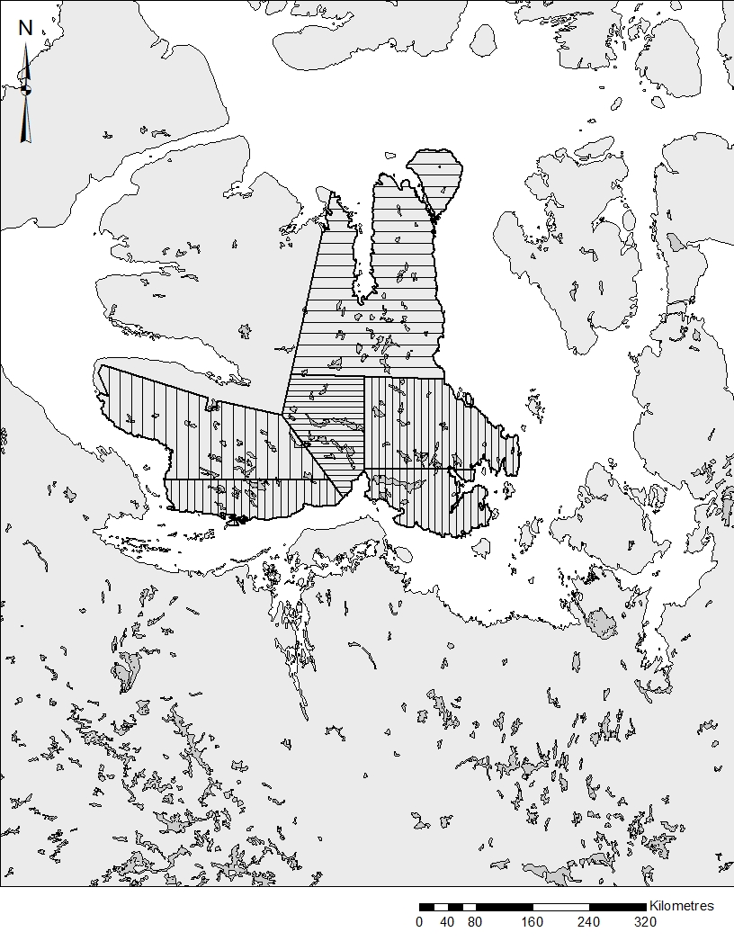
3
6
2
5
4
1
ᐊᔾᔨᓐᖑᐊᖅ 1: ᖃᐅᔨᓴᕐᕕᐅᔪᑦ ᑭᓪᓕᖏᑦ ᐊᒻᒪ 6 ᐊᕕᑦᑐᖅᓯᒪᔪᑦ ᖃᐅᔨᓴᕐᕕᐅᔪᑦ ᑭᓪᓕᖏᑦ (1,2,3,4,5, ᐊᒻᒪ 6) ᐅᒥᒻᒪᓂᑦ ᐊᐅᓚᑕᐅᔪᓂᑦ MX-07 ᐅᒥᒻᒪᓂᑦ ᖃᐅᔨᓴᕐᓂᖃᖅᑎᓪᓗᒋᑦ ᓄᓇᕗᒻᒥ ᑭᓪᓕᓂᖅ, ᐋᒡᒌᓯ 2013 ᐊᒻᒪ 2014.

ᐊᐅᓚᑕᐅᔪᒥᑦ, MX-10
ᒥᑭᓗᐊᕐᓂᖏᓐᓄᑦ King William Island, ᕿᑭᖅᑕᓕᒫᖅ, ᐊᒻᒪᓗᑦᑕᐅᖅ Royal Geographical Society Island, Matty Island ᐊᒻᒪ Tennent Island, ᖃᖓᑕᓲᒃᑰᕐᕕᐅᓚᐅᖅᑐᑦ (ᐊᔾᔨᓐᖑᐊᖅ 2). ᑕᕝᕙᓂ ᑐᑭᓯᒋᐊᕈᑏᑦ ᑐᓐᖓᕕᒋᓪᓗᒋᑦ, ᐊᐅᓚᑕᐅᔪᓂᑦ MX-10 (ᐊᕕᑦᑐᖅᓯᒪᓂᖓ King William Island) ᖃᐅᔨᓴᖅᑕᐅᓚᐅᖅᑐᖅ 20%−ᖓᓂᑦ.

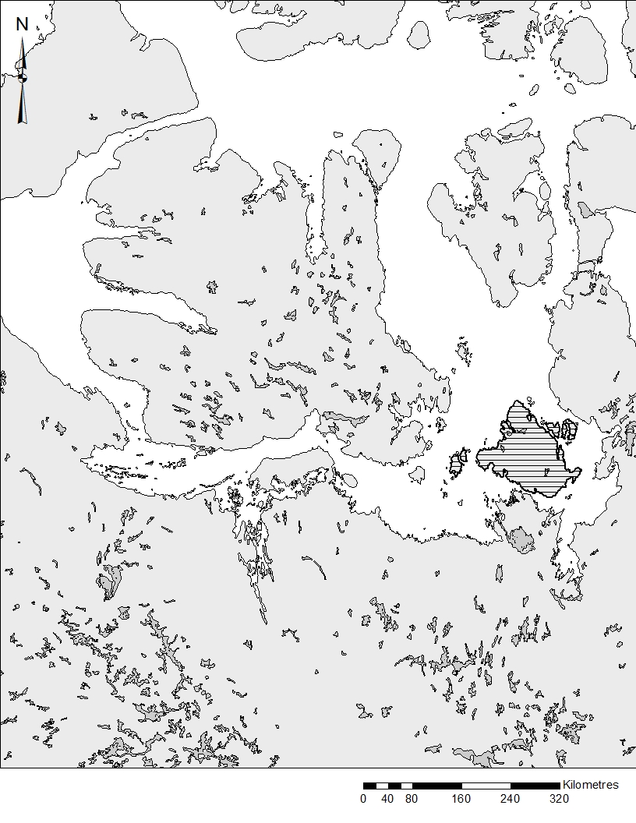
ᐊᔾᔨᓐᖑᐊᖅ 2: ᖃᐅᔨᓴᕐᕕᐅᔪᑦ ᑭᓪᓕᖏᑦ 20%−ᖓ ᐅᒥᒻᒪᓂᑦ ᐊᐅᓚᑕᐅᔪᓂᑦ MX-10 (ᐊᕕᑦᑐᖅᓯᒪᓂᖓ King William Island), ᐅᒥᒻᒪᓂᑦ ᖃᐅᔨᓴᖅᑎᓪᓗᒋᑦ, ᓯᑎᐱᕆ 2013.
ᐊᐅᓚᑕᐅᔪᒥᑦ, MX-11
ᐊᐅᓚᑦᑎᕕᐅᔪᑦ MX-11 (ᐊᕕᑦᑐᖅᓯᒪᓂᖓ ᖁᓪᓗᖅᑑ) ᒪᕐᕈᕈᖅᑎᑕᑲᐅᓚᐅᖅᑐᖅ ᖃᐅᔨᓴᕐᕕᐅᓂᖓ, ᐊᒡᒍᑐᖅᓯᒪᔪᑦ 1 (ᓂᒋᖅ) ᐊᒻᒪ ᐊᒡᒍᑐᖅᓯᒪᔪᖅ 2 (ᐅᐊᓐᓇ), ᐅᐊᓐᓇᖓᓃᑦᑐᑦ ᐱᖃᓯᐅᔾᔨᔪᖅ ᕿᑭᖅᑕᓂᑦ ᐃᒪᐃᓐᓇᒦᑦᑐᓂ (ᐊᔾᔨᓐᖑᐊᖅ 3). ᐳᓴᓐᑎᒋᔭᖓ ᐊᑐᓂ ᐊᒡᒍᑐᖅᓯᒪᔪᑦ ᓇᓗᓇᐃᖅᑕᐅᓚᐅᖅᑐᑦ ᑐᓐᖓᓂᖃᖅᑐᑎᑦ ᐊᒥᓲᓂᖏᓐᓄᑦ ᐊᒻᒪ ᐅᒥᒻᒪᑦᑕᖃᕐᓂᖏᓐᓄᑦ ᖃᐅᔨᔭᐅᓚᐅᖅᑐᓂᑦ, ᐊᒻᒪ ᓄᓇ ᐊᑐᖅᑕᐅᔪᖅ ᐅᒥᒻᒪᓂᐊᕐᕕᐅᕙᑦᑐᓂ. ᐊᒡᒍᑐᖅᓯᒪᔪᖅ 1 ᖃᖓᑕᕕᐅᓚᐅᖅᑐᖅ 20%−ᖓᓂᑦ, ᐊᒡᒍᑐᖅᓯᒪᔪᕐᓕ 2 ᖃᖓᑕᕕᐅᓚᐅᖅᑐᖅ 25%.

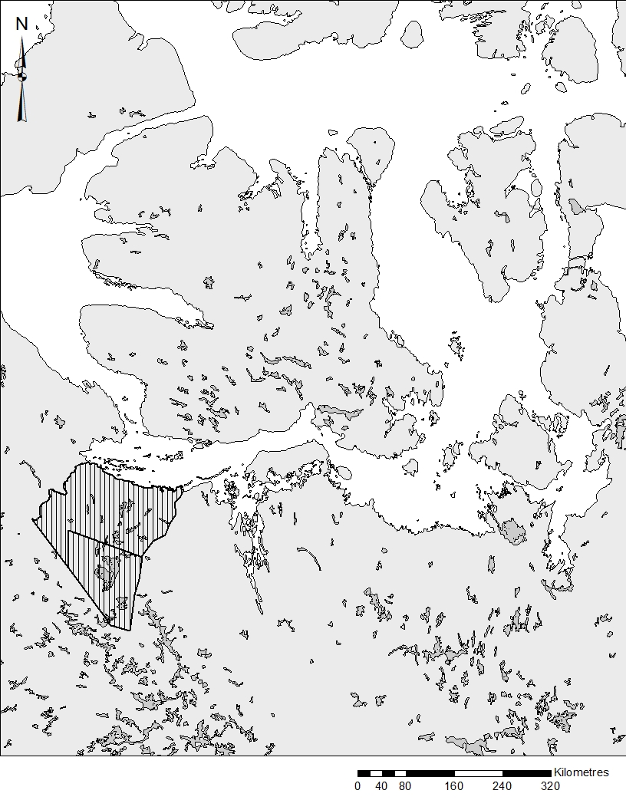
1
2
ᐊᔾᔨᓐᖑᐊᖅ 3: ᖃᐅᔨᓴᕐᕕᐅᔪᑦ ᑭᓪᓕᖏᑦ ᐊᒻᒪ ᒪᕐᕉᒃ ᐊᒡᒍᑐᖅᓯᒪᔪᑦ ᑭᓪᓕᖏᑦ (1 ᐊᒻᒪ 2) ᐅᒥᒻᒪᓂᑦ ᐊᐅᓚᑕᐅᔪᓂᑦ MX-11 ᐅᒥᒻᒪᓂᑦ ᖃᐅᔨᓴᖅᑎᓪᓗᒋᑦ ᑲᓇᓐᓇᖓᓂ ᖁᓪᓗᖅᑑᖅ, ᓄᓇᕗᑦ, ᓯᑎᐱᕆ 2013.

ᖃᖓᑕᓲᒃᑰᕈᑎᓄᑦ ᐋᖅᑭᑦᑕᐅᓯᒪᔪᑦ
ᑐᑭᓕᐊᖅᑐᑎᑦ ᖃᖓᑕᖃᑦᑕᓚᐅᖅᑐᑦ Turbo Beaver−ᒧᑦ, ᖃᖓᑕᓲᕋᓛᖅ ᐊᑕᐅᓯᕐᒥᑦ ᐊᐅᓚᐅᑎᓕᒃ. ᑐᑭᓕᐊᖅᑐᑦ ᖃᐅᔨᓴᖅᑕᐅᓚᐅᖅᑐᑦ ᐃᖏᕋᓂᖃᖅᑐᑎᑦ 160 km/hr. ᐊᑦᑎᓈᕐᓂᖃᐸᓗᑦᑐᑎᑦ 150 ᒦᑕᐃᑦ ᑐᓐᖓᓂᖃᖅᑐᖅ ᓄᓇᐅᑉ ᖃᓄᐃᓕᖓᓂᖓᓂᑦ ᐃᖏᕋᕕᐅᓂᐊᖅᑐᑦ 800 ᒦᑕᐃᑦ ᐃᒐᓛᖓᓅᖅᑕᐅᓚᐅᖅᑐᑦ ᐊᑐᖅᑐᑎ ᓴᓇᓯᒪᔭᖓ ᓄᐊᑕᓐ−ᒍᕆᐱᑦᔅ (1978) (ᒐᓐ ᐊᒻᒪ ᐹᑐᓴᓐ 2000; Hᐊᐅᕗᑦ 2011):

w= W*h/H

ᐅᓇ, W= ᑎᑎᖅᓯᒪᑯᑖᕆᐊᖃᕐᓂᖓ; h= ᖁᑦᑎᓐᓂᖓ ᖃᐅᔨᓴᖅᑑᑉ ᐃᔨᖏᑦ ᒥᕝᕕᒻᒥ; ᐊᒻᒪ H= ᖃᖓᑕᓗᓂ ᖁᑦᑎᓐᓂᕆᔭᕆᐊᖃᖅᑕᖓ.
ᑎᑎᖅᓯᒪᑯᑖᓚᐅᖅᑐᑦ 800 ᒦᑕᓂᑦ ᐊᑐᓂ ᐊᕙᑎᒃᑭᖏᓐᓂ ᖃᖓᑕᓲᒥᑦ ᑲᑎᑦᑐᒍ ᖃᐅᔨᓴᖅᑕᐅᔪᖅ 1.6 ᑭᓚᒦᑕᐃᑦ. ᑎᑎᖅᓯᒪᑯᑖᑦᑐᑦ ᑐᑭᒧᑦ ᐋᖅᑭᔅᓯᒪᓂᖏᑦ ᓇᓗᓇᐃᖅᑕᐅᓚᐅᖅᑐᑦ ᒪᑭᑕᓪᓗᐊᖅᑐᑎᑦ ᐅᖓᓯᓐᓂᖓᓂᑦ ᖃᐅᔨᒪᔭᐅᔪᒥᑦ ᑎᑎᖅᓯᒪᔪᖅ 800 ᒦᑕᐃᑦ. ᒪᕐᕉᒃ ᖃᐅᔨᓴᖅᑏᒃ ᐃᖅᑯᐊᓂ ᕿᓃᓐᓇᖃᑦᑕᓚᐅᖅᑐᑦ ᓈᓴᐃᓪᓗᑎᓪᓗ ᐅᒥᒻᒪᓂᑦ, ᖃᐅᔨᓴᖅᑕᐅᔪᒦᑦᑐᓂᑦ ᓯᓚᑖᓃᑦᑐᓂᓪᓘᓐᓃᑦ; ᐊᒥᓲᓂᖏᑦ ᐅᒥᒻᒫᕋᐃᑦ (0 − 11 ᑕᖅᑭᓖᑦ) ᓈᓴᖅᑕᐅᓚᐅᖅᑐᑦ ᓈᓴᖅᑕᐅᔪᓐᓇᕋᐃᒻᒪᑕ. ᐊᔾᔨᓕᐅᖅᓯᓚᐅᖅᑐᑦ ᐊᒥᓱᕋᔮᓂᑦ (> 20 ᐅᒥᒻᒪᐃᑦ). ᑐᑭᓯᒋᐊᕈᑎᓂᑦ ᑎᑎᕋᖅᑎᐅᔪᖅ ᑎᑎᕋᖅᑐᓂᒋᑦ ᐅᒥᒻᒪᐃᑦ ᐊᒥᓲᓂᖏᑦ. GPS−ᑯᑦ ᓇᒦᓐᓂᖓ ᐊᒻᒪ ᐅᖓᓯᓐᓂᖏᑦ ᖃᐅᔨᓴᕐᕕᐅᔪᓂᑦ ᑐᑭᓕᐊᖅᑐᒥᑦ. ᑖᓐᓇ ᖃᐅᔨᓴᕐᓂᐅᔪᖅ ᐱᔾᔪᑎᖃᓗᐊᓚᐅᖅᑐᖅ ᐅᒥᒻᒪᓂᑦ; ᑭᓯᐊᓂᓕ, ᐊᓯᖏᓐᓂ ᐆᒪᔪᓂᑦ ᑕᑯᔭᐅᖃᑦᑕᖅᑐᑦ, ᓲᕐᓗ ᑐᑦᑐᐃᑦ, ᐊᒃᖤᐃᑦ, ᓇᓄᐃᑦ ᐊᒻᒪ ᐊᒪᕈᐃᑦ, ᑎᑎᕋᖅᑕᐅᓚᐅᕐᒥᔪᑦᑕᐅᖅ.

ᖃᐅᔨᓴᐃᓃᑦ
ᑖᓐᓇ ᖃᐅᔨᓴᕐᓂᐅᔪᖅ ᐱᓇᓱᓗᐊᖅᑑᒐᓗᐊᖅ ᒥᔅᓴᐅᓴᑦᑕᐅᓂᖏᓐᓄᑦ ᐅᒥᒻᒪᐃᑦ ᐊᒥᓲᓂᖏᑦ, ᓇᓗᓇᐃᔭᐃᓯᒪᑦᑎᐊᖅᑐᑦ ᐊᑐᖅᑕᐅᓚᐅᖅᑐᑦ ᓇᓗᓇᐃᖅᓯᓪᓗᑎ ᐅᒥᒻᒪᕋᓛᓂᑦ ᐅᒥᒻᒪᓪᓚᕆᓐᓂᓪᓗ. ᐊᒥᓱᕋᔮᖑᔪᑦ ᓇᓗᓇᐃᖅᑕᐅᓚᐅᖅᑐᑦ ᐃᓐᓇᐅᓂᖏᑎᒍᑦ (ᐊᕐᓇᐃᑦ/ᐊᖑᑎᑦ) ᐊᒻᒪ ᐅᒥᒻᒪᕋᓛᑦ (Hᐊᐅᕗᑦ 2011). ᖃᖓᑕᓂᖓᑕ ᖁᑦᑎᓐᓂᖓ ᓱᑲᓐᓂᖓᓗ ᓇᓗᓇᐃᖅᓯᒍᓐᓇᑎᑦᑎᓚᐅᖏᑦᑐᖅ ᐊᖑᑎᐅᓂᖏᓐᓂ ᐊᕐᓇᐅᓂᖏᓐᓂᑦ ᐅᒥᒻᒪᐃᑦ ᓇᔾᔪᖏᑎᒍᑦ ᓇᓗᓇᐃᖅᓯᒍᑎᐅᔪᓂᑦ. ᑕᐃᒪᐃᓐᓂᖓᓄᑦ, ᐃᓚᒋᔭᖏᑦ ᐅᒥᒻᒪᕋᒫᑦ ᐊᑐᓂ ᐊᕐᓇᓄᑦ ᓇᓗᓇᐃᖅᑕᐅᓚᐅᖏᑦᑐᖅ, ᐊᓯᖏᓐᓂᓪᓗ ᑐᑭᓯ_ᒋᐊᕈᑎᑕᖃᓚᐅᖏᑦᑐᖅ.
ᓇᓗᓇᐃᕐᓂᐊᕐᓗᒋᑦ ᐊᒥᓲᓂᖏᑦ, ᐃᓐᓇᐅᔪᑦ ᐅᒥᒻᒪᐃᑦ ᑎᑎᕋᖅᑕᐅᔪᑦ ᖃᐅᔨᓴᕐᕕᐅᔪᓂᑦ ᐊᑐᓂ ᐊᒡᒍᑐᖅᓯᒪᔪᓂᑦ ᐊᒻᒪ ᐊᑐᓂ ᐊᐅᓚᑕᐅᔪᓂᑦ ᖃᐅᔨᓴᖅᑕᐅᓚᐅᖅᑐᑦ ᐊᑐᖅᑐᑎ ᔮᓕᐅᑉ ᐊᑐᖅᑕᖓ 2 ᐊᔾᔨᒌᖏᑦᑐᓂ ᖃᐅᔨᓴᕋᔅᓴᓂ ᐊᖏᓂᖏᑦ (ᔮᓕ 1969). ᐃᓐᓇᐅᓂᑐᐊᖏᑦ ᓈᓴᖅᑕᑐᐊᖑᓪᓗᑎ ᐊᑐᖅᑕᐅᓚᐅᖅᑐᑦ ᑭᖑᓪᓕᖅᐹᒥ ᒥᔅᓴᐅᓴᑦᑎᓪᓗᒋᑦ ᐊᐅᓚᑕᐅᔪᓄᑦ ᐊᑐᖅᑐᑎᑦ ᑭᓪᓕᖃᖅᑎᑦᑎᔪᒥᑦ 95%.
ᓄᓇᐅᔪᖅ ᓇᔪᖃᑦᑕᖅᑕᖏᑦ ᐊᕐᕌᒍᒥ ᐃᓗᐊᓂ ᐃᓗᐊᓂ ᐊᐅᓚᑕᐅᔪᓂᑦ ᓇᓗᓇᐃᖅᑕᐅᓚᐅᖅᑐᖅ. ᑕᐃᒪᐃᓐᓂᖓᓄᑦ, ᓇᒧᓐᖓᖃᑦᑕᕐᓂᖏᑦ ᑎᑎᖅᑕᐅᓚᐅᖅᑐᑦ ᐊᑐᓂ ᐅᒥᒻᒪᐃᑦ ᑕᑯᔭᐅᔪᓂᑦ ᖃᐅᔨᓴᕐᕕᐅᔪᓂᑦ ᑐᓐᖓᓂᖃᖅᑐᑦ ᓇᒦᓪᓚᕆᓐᓂᕆᔭᖏᓐᓂ ᖁᒻᒧᐊᑦᑎᑕᐅᓯᒪᔪᒃᑯᑦ (GPS). ᐃᓚᒋᐊᕐᓗᒍ, ᐊᔾᔨᒌᖏᓐᓂᑦ ᓈᓴᐅᑎᖏᑦ ᐊᒥᓱᕋᔮᑎᒎᑎᑑᖅᑐᑦ, ᐊᒻᒪ ᐊᒥᓲᓂᖏᑦ ᓇᓗᓇᐃᖅᑕᐅᓚᐅᖅᑐᑦ ᐊᑐᖅᑐᑎ ᐊᖏᓂᖏᓐᓄᑦ ᐊᒥᓱᕈᖅᐸᓪᓕᐊᓂᖏᓐᓄᑦ ᐋᖅᑭᑦᑕᐅᓯᒪᔪᓂᑦ ᐊᑐᖅᑐᑎᑦ ᐊᒥᓲᓂᖏᑎᒍᑦ 1-5, 6-12, 13-20, 21-30, 31-45 ᐊᒻᒪ 46 ᑎᑭᑦᑐᒍ 91 ᐅᒥᒻᒪᐃᑦ.

ᓴᖅᑭᖅᑎᑕᐅᔪᓐᓇᖅᑐᑦ:

- ᐅᓂᒃᑳᓕᐅᕐᓗᑎ ᐅᒥᒻᒪᐃᑦ ᖃᓄᐃᓕᖓᓂᕆᓕᖅᑕᖏᓐᓂ. ᑖᓐᓇ ᐅᓂᒃᑳᖅ ᑐᓂᐅᖅᑲᖅᑕᐅᓂᐊᖅᑐᖅ ᑮᓇᐅᔭᖃᖅᑎᑦᑎᔪᓄᑦ ᑎᒥᐅᔪᓄᑦ.
- ᑐᑭᓯᒋᐊᕈᑎᖃᖅᑎᑦᑎᓗᑎ ᐅᒥᒻᒪᐃᑦ ᐊᒥᓲᓂᖏᓐᓂᑦ ᐊᒻᒪ ᓇᒧᓐᖓᕐᕕᒋᕙᑦᑕᖏᑦ.
- ᐅᔾᔨᕈᓱᑦᑎᑦᑎᒋᐊᒃᑲᓂᕐᓗᓂ ᐅᒥᒻᒪᐃᑦ ᓇᒦᓐᓂᕆᓕᖅᑕᖏᓐᓂ ᓄᓇᓖᑦ ᐃᓗᐊᓐᓂᑦ.
- ᖃᐅᔨᓴᐃᒃᑲᓂᕐᓗᑎ ᒫᓐᓇᐅᔪᒥ ᑰᑕᖏᓐᓂ ᕿᑎᕐᒥᐅᓂᑦ ᐆᒪᔪᕐᓂᐊᑎᒃᑯᑦ ᑲᑎᒪᔨᖏᓐᓂᑦ.
- ᑐᓂᓯᓗᑎ ᖃᐅᔨᓴᕈᑎᒥᓂᕐᓂᑦ ᐊᑐᖅᑕᐅᓂᐊᖅᑐᑦ ᓴᖅᑭᑎᑦᑎᓗᑎ ᐱᖓᓐᓇᓂ ᕿᑎᕐᒥᐅᓄᑦ ᐅᒥᒻᒪᓂᑦ ᐊᐅᓚᑦᑎᓂᕐᒧᑦ ᐸᕐᓇᐅᒻᒥᑦ ᓴᖅᑭᖅᑎᑕᐅᔪᖅ ᐊᕙᑎᓕᕆᔨᒃᑯᓐᓄᑦ, NTI
- ᐃᖅᑲᓇᐃᔭᖅᑎᑦᑎᓗᓂ ᓄᓇᓕᒻᒥ, ᐊᖑᓇᓱᑦᑏᑦ ᐃᓚᒋᔭᐅᓂᐊᖅᑐᑦ ᖃᐅᔨᓴᓂᕐᒥᑦ ᖃᐅᔨᓴᖅᑎᐅᓗᑎ ᖃᐅᔨᓴᕐᓂᖃᖅᑎᓪᓗᒋᑦ.

ᐱᓕᕆᐊᒧᑦ ᐊᑐᖅᑕᐅᓂᐊᖅᑐᑦ
ᑖᓐᓇ ᐱᓕᕆᐊᖑᓚᐅᖅᑐᖅ ᐱᖓᓲᓕᖅᑲᖓᓪᓗᓂ: ᑲᑎᖅᓱᖅᑕᐅᓂᖏᑦ ᐊᖑᓇᓱᑦᑏᑦ ᑕᑯᖃᑦᑕᖅᑕᖏᑦ, ᖃᖓᑕᓲᒃᑯᑦ ᖃᐅᔨᓴᕐᓂᖅ, ᑐᓴᖅᑎᑦᑎᓂᖅ ᓄᓇᓕᓐᓄᑦ, ᐊᖏᔫᓂᖓᓄᑦ ᐱᔾᔪᑎᒋᓪᓗᒍ, ᖃᐅᔨᓴᕐᓂᐅᔪᖅ ᐱᓕᕆᐊᖑᓚᐅᖅᑐᖅ ᐊᕐᕌᒎᓐᓄᒃ ᒪᕐᕉᓐᓄᒃ (2013 ᐊᒻᒪ 2014). ᐱᓕᕆᐊᖑᓂᐊᕐᕕᒋᓯᒪᔭᖓ ᐊᑐᖅᑕᐅᓚᐅᖅᑐᖅ ᐃᓚᖓᒍᑦ, ᐸᕐᓇᑕᐅᓯᒪᓚᐅᖅᑐᒥᑦ:

- ᒫᑦᓯ 2013 ᑎᑭᑦᑐᒍ ᒪᐃ 2013: ᑲᑎᖅᓱᖅᑕᐅᓂᖏᑦ ᑐᑭᓯᒋᐊᕈᑏᑦ ᐅᒥᒻᒪᐃᑦ ᓇᒧᓐᖓᖃᑦᑕᕐᓂᖏᓐᓄᑦ ᖃᐅᔨᔭᐅᔪᑦ ᐃᓄᓐᓄᑦ ᐊᖑᓇᓱᑦᑎᓄᑦ ᐊᒻᒪ ᐊᖑᑕᐅᓯᒪᔪᓂᑦ ᑎᑎᕋᖅᑕᐅᓯᒪᔪᑦ.
- ᐋᒡᒌᓯ 2013 ᐊᒻᒪ ᐋᒡᒌᓯ 2014: ᖃᐅᔨᓴᕐᕕᐅᔪᖅ MX22−ᒥ, King Williams Island., MX11, MX-07, ᐊᒻᒪ MX11, ᓂᒋᖓᑕ ᑲᓇᓐᓇᖓᓂ ᖁᓪᓗᖅᑑᖅ.
- ᐅᑦᑑᐱᕆ 2014: ᐅᒥᒻᒪᓕᕆᓂᕐᒧᑦ ᑲᑎᒪᑎᑦᑎᓚᐅᖅᑐᑦ ᐱᖓᓐᓇᖓᓂ ᕿᑎᕐᒥᐅᑦ ᐆᒪᔪᕐᓂᐊᑎᒃᑯᑦ ᑲᑎᒪᔨᖏᑦ ᐊᐅᓚᑦᑎᖃᑎᖏᓪᓗ. ᑕᑯᔅᓴᐅᑎᑕᐅᓗᑎ ᖃᐅᔨᓴᕈᑎᒥᓃᑦ KRWB ᐊᕐᕌᒍᑕᒫᑦ ᑲᑎᒪᕕᔾᔪᐊᕐᓂᖃᖅᑎᓪᓗᒋᑦ.

ᖃᓄᐃᓐᓂᖏᑦ

ᐊᐅᓚᑕᐅᔪᒥᑦ, MX-07
ᓯᕗᓪᓕᖅᐹᕆᔭᖓ ᖃᐅᔨᓴᓂᕐᒧᑦ, ᐊᒡᒍᑐᖅᓯᒪᔫᓚᐅᖅᑐᑦ 1, 2 ᐊᒻᒪ 3, ᐋᒡᒌᓯ 26−ᒥ ᓰᑏᐱᕆ 3, 2013. ᑲᖓᑕᓲᓚᐅᖏᑦᑐᑦ ᐋᒡᒌᓯᒥ 27 ᐊᒻᒪ ᓰᑏᐱᕆ 1 ᐊᐅᓚᐅᑎᖏᓐᓄᑦ ᓯᓚᖓᓄᓪᓗ ᐱᔾᔪᑎᒋᓪᓗᒋᑦ. ᐱᖓᓱᑦ ᐊᒡᒍᑐᖅᓯᒪᔪᑦ ᖃᐅᔨᓴᖅᑕᐅᓚᐅᖅᑐᑦ 58−ᓂ ᐃᑲᕐᕋᓂᑦ, ᖃᐅᓯᓴᕐᕕᐅᔪᒥᑦᑕᐅᖅ ᐊᒻᒪ ᐅᑎᖅᑕᕐᕕᐅᔪᖅ ᖃᖓᑕᓲᒧᑦ ᐃᖃᓗᑦᑑᑦᑎᐊᒧᑦ.

ᐃᓚᒋᔭᖓᐊ ᐊᐅᓚᑕᐅᔪᓂᑦ MX-07, ᐊᒡᒍᑐᖅᓯᒪᔪᑦ 4, 5 ᐊᒻᒪ 6, ᖃᐅᔨᓴᖅᑕᐅᓚᐅᖅᑐᑦ ᐋᒡᒌᓯ 2 ᐋᒡᒌᓯ 12−ᒧᑦ, 2014. ᓯᓚᓗᓐᓂᖓᓄᑦ ᐊᐅᔾᓚᕈᓐᓇᓚᐅᖏᑦᑐᒍᑦ ᐋᒡᒌᓯ 2 ᐅᖅᓱᐊᓗᒻᒧᑦ ᐊᒻᒪ ᓇᔪᖅᑕᐅᔪᕐᓗ ᓇᒦᓐᓂᖓ ᖃᐅᔨᓴᕐᓂᖅ ᐱᒋᐊᒃᑲᓐᓂᓚᐅᖅᑐᖅ ᐋᒡᒌᓯ 3. ᑕᒪᓐᓇ ᖃᐅᔨᓴᖅᑕᐅᓚᐅᖅᑐᖅ 71−ᓂ ᐃᑲᕐᕋᓂᑦ, ᐱᖃᓯᐅᑎᓪᓗᓂ ᖃᐅᔨᓴᕐᕕᐅᔪᖅ ᐅᑎᖅᑕᕐᕕᐅᐃᓂᖓᓗ ᐃᖃᓗᑦᑑᑎᐊᒧᑦ. ᐊᖏᔫᓂᖓᓄᑦ ᖃᖁᐅᔨᓴᕐᕕᐅᔭᕆᐊᓕᒃ , ᐅᑎᕐᑕᖅᕕᐅᓂᖓᓄᓪᓗ ᐊᑯᓂᐅᓂᖓ ᕿᓚᒥᐅᓂᖅᓴᐅᑎᑕᐅᓚᐅᖅᑐᖅ ᒪᕐᕉᓐᓂᒃ ᐅᖅᓱᐊᓗᒃᑯᕕᖃᖅᑐᑎᑦ ᓇᔪᖅᑕᐅᔪᓪᓗ ᓇᒦᓐᓂᕆᔭᖏᑦ.

ᓈᓴᐅᑎᖏᑦ ᒥᔅᓴᐅᓴᑦᑕᐅᔪᑦ
ᐳᓴᓐᑎᖏᑦ ᐊᑐᓂ ᐊᒡᒍᑐᖅᓯᒪᔪᓂᑦ ᐊᔾᔨᒌᖏᒃᑲᓗᖓᖅᑎᓪᓗᒋᑦ 10%−ᒥᑦ 25%−ᒧᑦ, ᐊᑕᖏᓕᒫᖅᑐᒍ ᐊᐅᓚᑕᐅᔪᒥᑦ ᖃᐅᔨᓴᖅᑕᐅᓚᐅᖅᑐᖅ 17,453.52 20 km², 13%−ᖑᑎᑦᑎᔪᖅ ᖃᐅᔨᓴᕐᕕᐅᓯᒪᔪᓕᒫᒥᑦ (134,933.72 km²). ᖃᐅᔨᓴᕐᓂᖃᖅᑎᓪᓗᒋᑦ, 1,296 ᐃᓐᓇᐃᑦ ᐅᒥᒻᒪᐃᑦ ᑎᑎᕋᖅᑕᐅᓚᐅᖅᑐᑦ ᖃᐅᔨᓴᕐᕕᐅᔪᒥᑦ. ᒥᔅᓴᐅᓴᑦᑕᐅᔪᑦ ᐅᒥᒻᒪᐃᑦ ᐊᒥᓲᓂᓐᖏᑦ ᐊᐅᓚᑕᐅᔪᓂᑦ MX-07, ᑲᑎᓕᒫᖅᑐᒋᑦ 10,026 ± 596.90 (S.E.) (p<0.005, t = 1.984, N = 732 and n = 125). ᒥᔅᓴᐅᓴᑦᑕᐅᔪᒧᑦ, ᐊᒥᓲᓂᖏᑦ ᖃᐅᔨᓴᕐᕕᐅᔪᑦ 100−ᐳᓴᓐᑎᒥᑦ 732 (N) ᐊᒻᒪ 125 (n) ᖃᐅᔨᓴᕐᕕᐅᓂᐊᖅᑐᑦ ᖃᐅᔨᓴᕐᕕᐅᓚᐅᖅᑐᑦ (ᑎᑎᕋᖅᓯᒪᔪᑦ 1).
ᐃᓗᐊᓂ 6−ᓂ ᐊᒡᒍᑐᖅᓯᒪᔪᓂᑦ, ᐊᒥᓲᓂᖏᑦ ᐃᓐᓇᐃᑦ ᐅᒥᒻᒪᐃᑦ ᐊᔾᔨᒌᓚᐅᖏᑦᑐᑦ 112−ᒥᑦ 299−ᒧᑦ, ᒥᔅᓴᓴᑎᑎᓪᓗᑎ 777 ± 143.21 (S.E.) ᑎᑭᑦᑐᒍ 3,032 ± 437.21 (S.E.) ᑐᖏᓕᕇᖅᑐᑎᑦ. ᐊᒡᒍᑐᖅᓯᒪᔪᑦ ᑕᑯᕕᐅᖏᓛᖑᓚᐅᖅᑐᓂᑦ ᓂᒋᖓᓂᐅᓚᐅᖅᑐᖅ ᑭᓪᓕᓂᖅ (ᐊᒡᒍᑐᖅᓯᒪᔪᖅ 4), ᐅᐊᓐᓇᖓᓃᓐᓂᖅᓴᐅᔮᓚᐅᖅᑐᑦ ᐅᒥᒻᒪᐃᑦ ᑭᓪᓕᓂᖅ (ᐊᒡᒍᑐᖅᓯᒪᔪᖅ 6) (ᑎᑎᕋᖅᓯᒪᔪᑦ 1).

ᑎᑎᕋᖅᓯᒪᔪᑦ 1: ᐅᒥᒻᒪᐃᑦ ᒥᔅᓴᐅᓴᑦᑕᐅᔪᑦ ᐅᒥᒻᒪᓂᑦ ᐊᐅᓚᑕᐅᔪᓂᑦ MX-07
ᐊᒡᒍᑐᖅᓯᒪᔪᖅ | ᖃᐅᔨᓴᕐᕕᐅᔪᖅ (km²) | ᑲᑎᑦᑐᒋᑦ  (km²) | ᐅᒥᒻᒪᐃᑦ ᖃᐅᔨᓴᖅᑕᐅᔪᒦᑦᑐᑦ | ᒥᔅᓴᐅᓴᑦᑕᐅᔪᑦ | ᑕᒻᒪᕈᑎᖏᓐᓄᑦ (S.E.) | 95% CL  (±) | CV
1 | 1,899.94 | 11,854.85 | 251 | 1,566 | 140.88 | 295.99 | 0.090
2 | 3,711.14 | 22,642.23 | 229 | 1,397 | 180.26 | 374.94 | 0.129
3 | 2,798.61 | 14,147.27 | 232 | 1,173 | 186.81 | 389.70 | 0.159
4 | 1,663,63 | 11,538.85 | 112 | 777 | 143.21 | 297.02 | 0.184
5 | 2,800.80 | 28,320.87 | 173 | 1,750 | 239.57 | 501.42 | 0.137
6 | 4,579.40 | 46,429.65 | 299 | 3,032 | 437.21 | 915.07 | 0.144
MX-07 | 17,453.52 | 134,933.72 | 1,296 | 10,026 | 596.90 | 1,184.26 | 0.060

ᓇᒧᓐᖓᖃᑦᑕᕐᓂᖏᑦ
ᓇᒧᓐᖓᖃᑦᑕᕐᓂᖏᑦ ᐊᒥᓲᓂᖏᓪᓗ ᐅᒥᒻᒪᐃᑦ ᒪᕐᕉᓐᓂᒃ ᖃᐅᔨᓴᖅᑕᐅᔫᓐᓂᒃ, ᐋᒡᒌᓯ 26 ᑎᑭᑦᑐᒍ ᓯᑎᐱᕆ 3, 2013 (ᐊᒡᒍᑐᖅᓯᒪᔪᑦ 1, 2 ᐊᒻᒪ 3), ᐊᒻᒪ ᐋᒡᒌᓯ 2 ᑎᑭᑦᑐᒍ ᐋᒡᒌᓯ 12, 2014 (ᐊᒡᒍᑐᖅᓯᒪᔪᑦ 4, 5, ᐊᒻᒪ 6), ᑲᑎᑦᑎᑕᐅᓯᒪᔪᑦ ᐊᔾᔨᓐᖑᐊᒥ ᐊᑖᓂ (ᐊᔾᔨᓐᖑᐊᖅ 4).ᐅᒥᒻᒪᐃᑦ ᓯᐊᒻᒪᑎᖅᓯᒪᓚᐅᖅᑐᑦ ᖃᐅᔨᓴᕐᕕᐅᔪᒥᑦ. ᐊᒥᓱᕋᔮᖑᔪᑦ ᖃᑦᑏᓐᓇᐅᓚᐅᖅᑐᑦ, ᐊᒥᓲᓂᖃᐸᓗᑦᑐᑎ 6−ᒥᑦ 12−ᒧᑦ ᐊᑐᓂ. ᐅᒥᒻᒪᓂᑦ ᑕᑯᔪᖃᓚᐅᖏᑦᑐᖅ ᐃᓗᐊᓂ 50 km ᖃᓂᒋᔭᖓᓂ ᐃᖃᓗᑦᑑᑦᑎᐊᖅ (ᒪᓕᓐᓂᖃᖅᑐᖅ ᓄᓇᓕᒻᒥᐅᑕᓄᑦ ᖃᐅᔨᒪᔭᐅᓂᖓ), 10 km ᐅᐊᓐᓇᖓᑕ ᐱᖓᓐᓇᖓᓂ Washburn Lake, ᑲᓇᓐᓇᖓᓂ Mount Bumpus, ᐅᕝᕙᓘᓐᓃᑦ ᑲᓇᓐᓇᖓᓂ ᐅᐊᓐᓇᖓᓂᓗ Storkerson Peninsula ᐊᒻᒪ Stefansson Island.

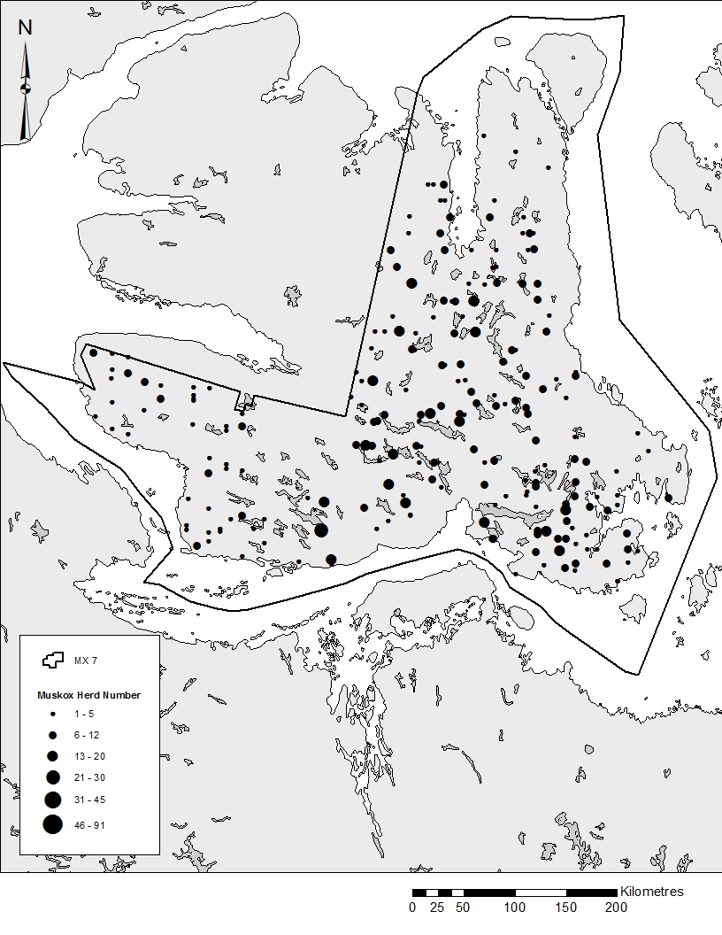
ᐊᔾᔨᓐᖑᐊᖅ 4: ᐅᒥᒻᒪᐃᑦ ᓇᒧᓐᖓᖃᒃᑦᑕᕐᓂᖏᑦ ᐊᒥᓲᓂᖏᓪᓗ ᑎᑎᕋᖅᑕᐅᔪᑦ ᐊᐅᓚᑕᐅᔪᓂᑦ MX-07 ᖃᐅᔨᓴᕐᓂᖃᖅᑎᓪᓗᒋᑦ ᐋᒡᒌᓯ 26 ᑎᑭᑦᑐᒍ ᓯᑎᐱᕆ 3, 2013 (ᐊᒡᒍᑐᖅᓯᒪᔪᖅ 1, 2 ᐊᒻᒪ 3) ᐊᒻᒪᓄ ᐋᒡᒌᓯᒥᑦ 2 ᑎᑭᑦᑎᒍ ᐋᒡᒌᓯ 12, 2014 (ᐊᒡᒍᑐᖅᓯᒪᔪᑦ 4,5, ᐊᒻᒪ 6), ᐊᒥᓱᕋᔮᖑᓂᕆᖃᑦᑕᓚᐅᖅᑕᖏᑦ ᐅᒥᒻᒪᐃᑦ 1-5, 6-12, 13-20, 21-30, 31-45, ᐊᒻᒪ 46-91.
ᐊᐅᓚᑕᐅᔪᒥᑦ, MX-10
ᖃᐅᔨᓴᕐᓂᖃᓚᐅᖅᑐᑦ ᓰᑎᐱᕆ 4 ᓯᑎᐱᕆ 5−ᒧᑦ. ᖃᐅᔨᓴᕐᓂᐅᔪᖅ ᐊᐅᓚᑕᐅᔪᓂᑦ MX-10 ᓯᓚᖓᓄᑦ ᓄᖅᑲᖓᑎᑦᑎᓚᐅᖏᑦᑐᑦ. ᖃᐅᔨᓴᖅᑕᐅᓚᐅᖅᑐᖅ ᐃᑲᕐᕋᓂᑦ 15−ᓂᑦ, ᐱᖃᓯᐅᑎᓪᓗᑎ ᖃᐅᔨᓴᕐᓂᐅᔪᖅ ᐅᑎᖅᑕᖃᑦᑕᕐᓂᖓᓗ ᐅᖅᓱᖅᑑᒧᑦ.

ᓈᓴᐅᑎᑦ ᒥᔅᓴᐅᓴᑦᑕᐅᔪᑦ

ᖃᐅᔨᓴᕐᓂᖃᖅᑎᓪᓗᒋᑦ, 280 ᐃᓐᓇᐃᑦ ᐅᒥᒻᒪᐃᑦ ᑎᑎᕋᖅᑕᐅᓚᐅᖅᑐᑦ 2,496 km² ᖃᐅᔨᓴᕐᕕᐅᔪᒥᑦ ᖃᖓᑕᕕᐅᓪᓗᓂ, 20−ᐳᓴᓐᑎᓪᓗᐊᖓ ᐊᐅᓚᑕᐅᔪᓂᑦ. ᒥᔅᓴᐅᓴᑦᑕᐅᓂᖓᓄᑦ, ᑲᑎᑦᑐᒋᑦ ᖃᐅᔨᓴᕐᕕᐅᔪᑦ 100%−ᒥ ᐊᑕᖐᔪᑦ 78 (N) ᐊᒻᒪ 29 (n) ᑖᒃᑯᓂᖓ ᓈᓴᐅᑎᓂᑦ ᖃᐅᔨᓴᖅᑕᐅᓚᐅᖅᑐᓂᑦ. ᒪᓕᓐᓂᖃᖅᑐᖅ ᒥᔅᓴᐅᓴᑦᑕᐅᔪᒥᑦ ᐊᑕᖏᖅᑐᒥᑦ (13,935) of 1,564 ± 182.2 (S.E.) ᐅᒥᒻᒪᒃ (p<0.005, t = 2.048, N = 78 ᐊᒻᒪ n = 29) (ᑎᑎᕋᖅᓯᒪᔪᑦ 2).

ᑎᑎᕋᖅᓯᒪᔪᑦ 2: ᐅᒥᒻᒪᐃᑦ ᒥᔅᓴᐅᓴᑦᑕᐅᔪᑦ ᐊᐅᓚᑕᐅᔪᒥᑦ MX-10
ᐊᒡᒍᑐᖅᓯᒪᔪᖅ | ᖃᐅᔨᓴᕐᕕᐅᔪᖅ (km²) | ᑲᑎᑦᑐᒋᑦ  (km²) | ᐅᒥᒻᒪᐃᑦ ᖃᐅᔨᓴᖅᑕᐅᔪᒦᑦᑐᑦ | ᒥᔅᓴᐅᓴᑦᑕᐅᔪᑦ | ᑕᒻᒪᕈᑎᖏᓐᓄᑦ (S.E.) | 95% CL  (±) | CV
MX-10  ᐊᕕᑦᑐᖅᓯᒪᓂᖓ | 2,496 | 13,935 | 280 | 1,564 | 182.26 | 373.27 | 0.116

ᓇᒧᓐᖓᖃᑦᑕᕐᓂᖏᑦ

ᖃᐅᔨᓴᕐᓂᖃᖅᑎᓪᓗᒋᑦ, ᓯᑯᓯᐅᓚᐅᖏᑦᑐᑦᖃᓂᒋᔭᖓᓂ ᐊᒻᒪ/ᐅᕝᕙᓘᓐᓃᑦ ᐱᖃᓯᐅᔾᔨᔪᒥᑦ King William Island ᖁᒻᒧᐊᑦᑎᑕᐅᓯᒪᔪᒃᑯᑦ ᕿᑭᖅᑕᖏᓐᓄᑦ. ᐊᒥᓲᓂᖅᓴᐅᔪᑦ ᐅᒥᒻᒪᐃᑦ King William Island−ᒥᑦ ᕿᑎᖅᐸᓯᐊᓃᓚᐅᖅᑐᑦ ᕿᑭᖅᑕᐅᑉ, ᐊᕙᑎᒃᑭᓅᕐᕕᒋᕙᑦᑐᓂᒋᑦ (ᐊᔾᔨᓐᖑᐊᖅ 5). ᐊᒥᓱᕋᔮᖑᓂᖅᐹᖑᓚᐅᖅᑐᑦ ᐅᒥᒻᒪᓂᑦ, 36 ᐅᒥᒻᒪᐃᑦ, ᑕᑯᔭᐅᓚᐅᖅᑐᑦ ᓂᒋᖅᐸᓯᐊᓂ ᕿᑭᖅᑕᖓᑕ. ᖃᖓᑕᒃᑲᓂᕐᕕᐅᔪᖅ ᑕᕝᕙᓂ ᑕᑯᒃᑲᓐᓂᓚᐅᖏᑦᑐᑦ ᑕᐃᒪᓐᓇᑎᒋ ᐊᒥᓲᔪᓂᑦ ᖃᐅᔨᓴᕐᕕᐅᔪᓂᑦ. ᐊᒥᓱᕋᔮᖅᑕᖃᓚᐅᕐᒥᔪᖅ ᑕᓪᓕᒪᐅᓪᓗᑎᑦ ᐅᒥᒻᒪᐃᑦ ᐱᖓᓐᓇᖓᓂ Matty Island. ᐅᒥᒻᒪᑦᑕᖃᓚᐅᖏᑦᑐᖅ ᐃᓗᐊᓂ 50 km ᖃᓂᒋᔭᖓᓂ ᐅᖅᓱᖅᑑᖅ ᐊᒻᒪ Royal Geographical Society Island.
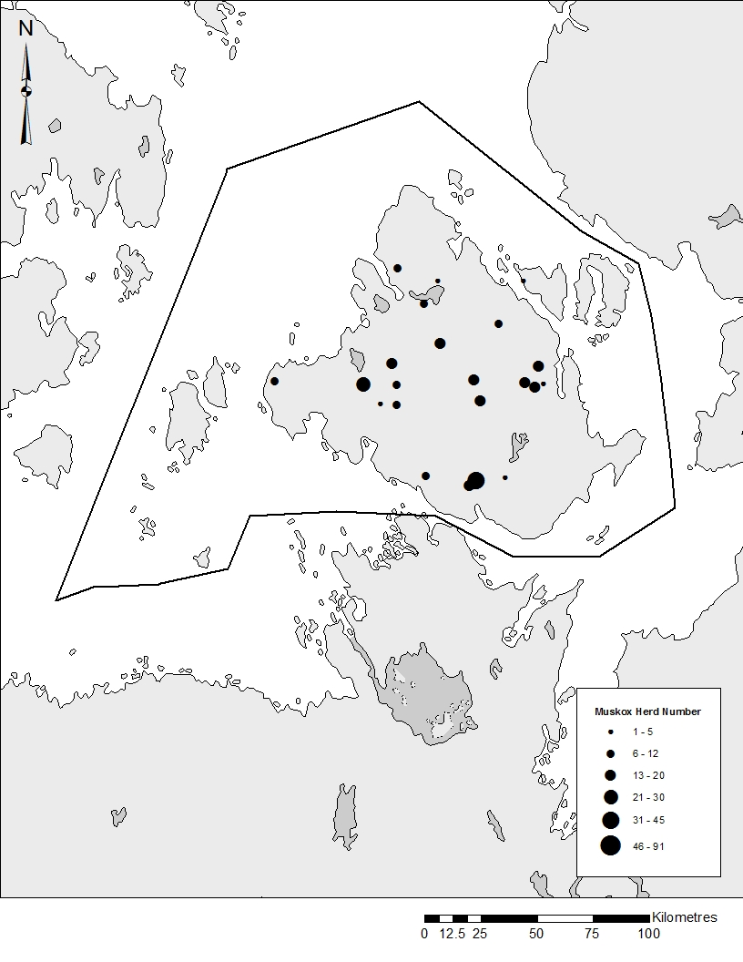
ᐊᔾᔨᓐᖑᐊᖅ 5: ᐅᒥᒻᒪᐃᑦ ᓇᒧᓐᖓᖃᑦᑕᕐᓂᖏᑦ ᐊᒥᓲᓂᖏᓪᓗ ᑎᑎᕋᖅᑕᐅᓯᒪᔪᑦ ᐊᐅᓚᑕᐅᔪᒥᑦ MX-10 ᖃᐅᔨᓴᕐᓂᖃᖅᑎᓪᓗᒋᑦ ᓰᑎᐱᕆ 4 ᐊᒻᒪ 5, 2013, ᐊᒥᓱᕋᔮᖑᓂᕆᕙᓚᐅᖅᑕᖏᑦ ᐅᒥᒻᒪᐃᑦ 1-5, 6-12, 13-20, 21-30, 31-45, and 46-91.

ᐊᐅᓚᑕᐅᔪᒥᑦ, MX-11

ᖃᐅᔨᓴᕐᓂᖃᓚᐅᖅᑐᑦ ᓯᑎᐱᕆ 9−ᒥᑦ ᓯᑎᐱᕆ 17, 2013. ᓯᓚᑲᒻᒪᓯᐅᖅᑐᑎ ᐅᓪᓗᖏᓐᓂ ᓯᑎᐱᕆ 9, 12, 15 ᐊᒻᒪ 16. ᑕᕝᕙᓂ ᓯᓚᑲᒻᒪᓯᐅᖅᑎᓪᓗᒋᑦ, ᑕᑯᕕᔅᓴᐅᓂᖓ ᐊᑦᑎᓗᐊᓚᐅᖅᑐᖅ ᐃᓚᖓᓄᑦ ᖃᐅᔨᓴᕐᕕᐅᔪᒧᑦ ᖁᕝᕙᓯᑦᑐᓃᑦᑐᓂᑦ. ᖃᐅᔨᓴᖅᑕᐅᓚᐅᖅᑐᖅ ᐃᑲᕐᕋᓂᑦ 46 hours, ᐱᖃᓯᐅᑎᓪᓗᑎ ᖃᖓᑕᓂᕆᕙᑦᑕᖏᑦ 4,386km ᖃᐅᔨᓴᕐᕕᐅᔪᑦ ᐊᒻᒪ ᐅᑎᖅᑕᖃᑦᑕᕐᓂᖓ ᖁᓪᓗᖅᑑᖅ ᖃᖓᑕᓲᒃᑯᕕᖓᓐᓄᑦ.

ᓈᓴᐅᑎᖏᑦ ᒥᔅᓴᐅᓴᑦᑕᐅᔪᑦ
ᖃᐅᔨᓴᕐᓂᖃᖅᑎᓗᒋᑦ, 1,331 ᐃᓐᓇᐃᑦ ᐅᒥᒻᒪᐃᑦ ᖃᐅᔨᓴᖅᑕᐅᔪᒥᑦ ᑎᑎᕋᖅᑕᐅᓚᐅᖅᑐᑦ 7,017.57 km² ᑐᑭᓕᐊᖅᑐᒥᑦ ᖃᐅᔨᓴᕐᕕᐅᔪᒥᑦ. ᒥᔅᓴᐅᓴᑦᑕᐅᔪᑦ ᐊᒥᓲᓂᖏᑦ ᐅᒥᒻᒪᐃᑦ ᐊᐅᓚᑕᐅᔪᓂᑦ MX-11, ᐊᕕᑦᑐᖅᓯᒪᓂᖓ ᖁᓪᓗᖅᑑᖅ (35,564 km²), ᑲᑎᓕᒫᖅᑐᒋᑦ 6,746 ± 904.25 (S.E.) (p<0.005, t = 2.048, N = 185 and n = 46). ᒥᔅᓴᐅᓴᑦᑕᐅᔪᒧᑦ, ᐊᒥᓲᓂᖏᑦ ᑐᑭᓕᐊᖅᑐᑦ ᖃᐅᔨᓴᕐᕕᐅᔪᑦ 100% ᐊᑕᖏᖅᑕᐅᔪᖅ 185 (N) ᐊᒻᒪ 46 (n) ᑐᑭᓕᐊᖅᑐᑦ ᖃᐅᔨᓴᕐᕕᔅᓴᐃᑦ ᖃᐅᔨᓴᖅᑕᐅᔪᑦ (20% ᖃᐅᔨᓴᕐᕕᐅᔪᓕᒫᒥᑦ) (ᑎᑎᕋᖅᓯᒪᔪᑦ 3). ᐃᒻᒥᑰᖅᑐᑎ, ᒥᔅᓴᐅᓴᑦᑕᐅᓯᒪᔪᑦ ᓂᒋᖓᓄᑦ ᐊᒡᒍᑐᖅᓯᒪᔪᒥᑦ (1) ᐅᓇᐅᔪᖅ 955 ± 246.29 (S.E.) (p<0.005, t = 2.145, N = 61 ᐊᒻᒪ n = 15) ᐊᒻᒪ 5,744 ± 870.06 (S.E.) (p<0.005, t = 2.042, N = 124 ᐊᒻᒪ n = 31) ᐅᐊᓐᓇᖓᓄᑦ ᐊᒡᒍᑐᖅᓯᒪᔪᖅ (2).

ᑎᑎᕋᖅᓯᒪᔪᑦ 3: ᐅᒥᒻᒪᐃᑦ ᒥᔅᓴᐅᓴᑦᑕᐅᔪᑦ ᐅᒥᒻᒪᓂᑦ ᐊᐅᓚᑕᐅᔪᓂᑦ MX-11, ᐊᕕᑦᑐᖅᓯᒪᔪᖅ ᖁᓪᓗᖅᑑᖅ
ᐊᒡᒍᑐᖅᓯᒪᔪᖅ | ᖃᐅᔨᓴᕐᕕᐅᔪᖅ (km²) |  | ᑲᑎᑦᑐᒋᑦ  (km²) |  | ᐅᒥᒻᒪᐃᑦ ᖃᐅᔨᓴᖅᑕᐅᔪᒦᑦᑐᑦ | ᒥᔅᓴᐅᓴᑦᑕᐅᔪᑦ | ᑕᒻᒪᕈᑎᖏᓐᓄᑦ (S.E.) | 95% CL  (±) | CV
1 | 2,366.54 | 12,271.52 |  | 184 |  | 955 | 246.29 | 528.29 | 0.258
2 | 4,651.03 | 23,292.52 |  | 1,147 |  | 5,744 | 870.06 | 1,776.67 | 0.151
MX-11  ᐊᒡᒍᑐᖅᓯᒪᔪᖅ | 7,017.57 | 35,564 |  | 1,331 |  | 6,746 | 904.25 | 1,851.0 | 0.134

ᓇᒧᓐᖓᖃᑦᑕᕐᓂᖏᑦ
ᖃᐅᔨᓴᕐᓂᖃᖅᑎᓪᓗᒋᑦ, ᐃᓐᓇᐃᑦ ᐅᒥᒻᒪᐃᑦ ᖃᐅᔨᓴᖅᑕᐅᔪᒦᑦᑐᑦ, ᒪᕐᕉᓗᐊᓚᐅᖅᑐᑦ ᓇᒦᓐᓂᕆᔭᖏᑦ (ᐊᔾᔨᓐᖑᐊᖅ 3). ᐊᖏᓂᕆᔭᖓ ᐅᐊᓐᓇᖓᓂ ᐅᐊᓐᓇᖓᑕ Contwoyto Lake ᓂᕆᖓᓄᑦ ᓯᔾᔭᖓᑕ Coronation Gulf ᐊᒥᓲᓪᓗᑎᑦ ᐊᒥᓱᕋᔮᖑᔪᑦ ᖃᓂᒋᔭᐸᓗᖏᓐᓂ 31−ᒥ 45−ᒧᑦ ᑕᑯᔭᐅᔪᑦ ᐃᒪᖅᐸᓯᐊᓂ. ᐊᐃᑉᐸᕆᔭᖏᑦ ᐅᖓᓯᓐᓂᖃᓚᐅᖅᑐᑦ 25 km ᓂᒋᖓᓂ ᖁᓪᓗᖅᑑᖅ. ᑕᕝᕙᓂᑦᑕᐅᖅ, ᐊᒥᓱᕋᔮᖑᔪᑦ 46 ᑎᑭᑦᑐᒍ 91 ᑕᑯᔭᐅᓚᐅᖅᑐᑦ. ᒪᓕᓐᓂᖃᖅᑐᖅ ᐊᖑᓇᓱᑦᑏᑦ ᐅᖃᖃᑦᑕᖅᑕᖏᓐᓂ, ᐅᒥᒻᒪᒃ, (ᐊᑕᐅᓯᖅ ᐅᒥᒻᒪᒃ ᐊᒻᒪ ᐊᒥᓱᕋᔮᑦ ᑕᓪᓕᒪᐅᓪᓗᑎᑦ) ᑕᑯᔭᐅᓚᐅᖅᑐᑦ ᐃᓚᖏᓐᓂ ᕿᑭᖅᑕᖏᓐᓂ ᐅᐊᓐᖓᑕ ᖁᓪᓗᖅᑑᖅ, ᐅᒥᒻᒪᑦᑕᖃᓚᐅᖏᑦᑐᖅ 25 ᑭᓚᒦᑕᓂᑦ ᓂᒋᖓᓂᑦ ᑲᓇᓐᓇᖓᓄᑦ ᑭᓪᓕᖏᓐᓄᑦ ᐊᐅᓚᑕᐅᔪᓂᑦ.

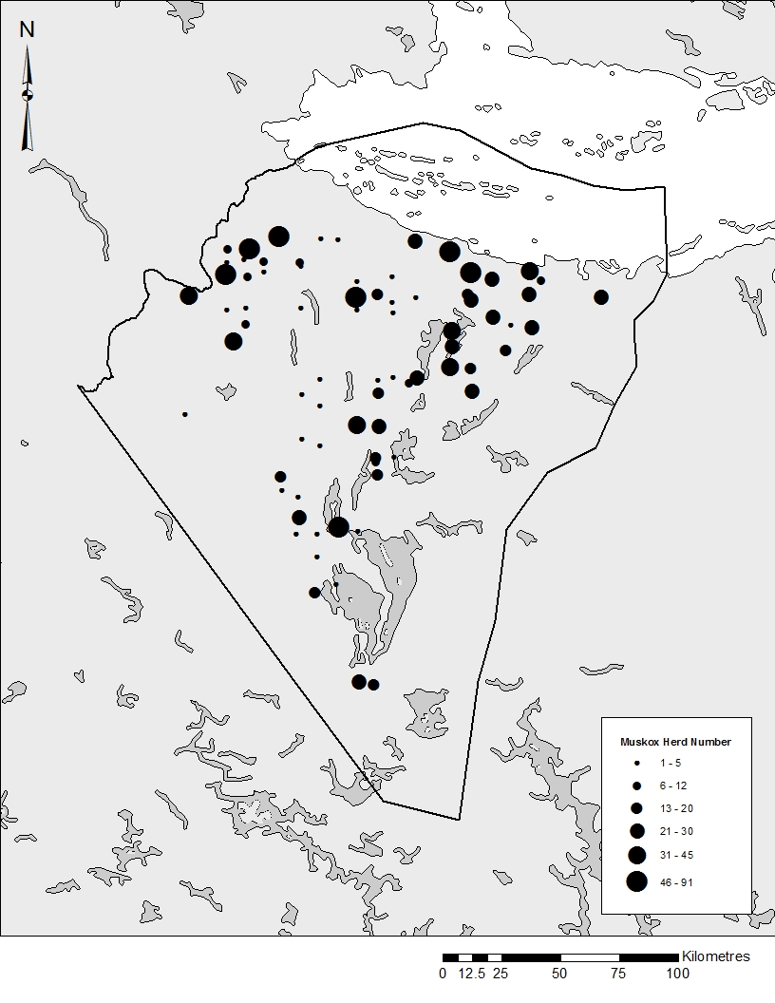
ᐊᔾᔨᓐᖑᐊᖅ 3: ᐅᒥᒻᒪᐃᑦ ᓇᒧᓐᖓᖃᑦᑕᕐᓂᖏᑦ ᐊᒥᓲᓂᖏᓪᓗ ᑎᑎᕋᖅᑕᐅᓯᒪᔪᑦ ᐊᐅᓚᑕᐅᔪᒥᑦ MX-11 ᐅᕕᑦᑐᖅᓯᒪᔪᖅ ᖁᓪᓗᖅᑑᖅ, ᖃᐅᔨᓴᕐᓂᖃᖅᑎᓪᓗᒋᑦ ᓰᑎᐱᕆ 19 ᑎᑭᑦᑐᒍ 17, 2014, ᐊᒥᓱᕋᔮᖑᓂᕆᕙᓚᐅᖅᑕᖏᑦ ᐅᒥᒻᒪᐃᑦ 1-5, 6-12, 13-20, 21-30, 31-45, ᐊᒻᒪ 46-91.

ᐅᖃᐅᓯᐅᒋᐊᓐᖓᖅᓯᒪᔪᑦ ᐊᐅᓚᑦᑎᓂᕐᒧᓪᓗ ᐊᑐᓕᖁᔭᐅᔪᑦ:

ᐊᐅᓚᑕᐅᔪᓂᑦ MX-07, MX-10 ᐊᒻᒪ MX-11 ᐊᕐᕌᓂ ᓴᖅᑭᖅᑎᑕᐅᓚᐅᖅᑐᖅ, ᐊᔾᔨᒌᓐᖑᐊᖅᑎᒐᔅᓴᐅᑎᐊᖏᑦᑐᖅ ᓯᕗᓂᐊᒍᑦ ᖃᐅᔨᓴᕐᓂᐅᓯᒪᔪᒥᑦ ᐊᔾᔨᒌᖏᓐᓂᖏᓐᓄᑦ ᖃᐅᔨᓴᕐᕕᐅᔪᑦ. ᒫᓐᓇᐅᔪᒥᑦ, ᐱᕕᔅᓴᖃᒃᑲᓐᓂᕆᐊᓖᑦ ᐅᖃᐅᓯᕆᔭᐅᒃᑲᓂᕐᓗᓂ ᖃᓄᐃᓐᓂᕆᔭᖏᑦ ᒥᔅᓴᐅᓴᑦᑕᐅᔪᑦ ᑕᕝᕙᓐᖓᑦ ᐅᒥᒻᒪᓂᑦ ᖃᐅᔨᓴᓂᕐᒧᑦ ᐱᓕᕆᐊᒥᑦ. ᑕᐃᒪᐃᒃᑲᓗᐊᖅᑎᓪᓗᒍ, ᐃᓚᖏᓐᓂ ᐅᒥᒻᒪᐃᑦ ᖁᕝᕙᕆᐊᖅᓯᒪᔫᔮᕋᓗᐊᖅᑎᓪᓗᒋᑦ ᖃᓂᒋᔭᖏᓐᓂ ᖁᓪᓗᖅᑑᖅ ᐊᒻᒪ ᐅᖅᓱᖅᑑᖅ, ᖃᑦᑏᓐᓇᕈᖅᐸᓪᓕᐊᔫᔮᖔᖅᑐᑦ ᑭᓪᓕᓂᕐᒥᑦ. ᒥᔅᓴᐅᓴᑦᑕᐅᓯᒪᔪᑦ ᐅᒥᒻᒪᐃᑦ ᐊᑐᓂ ᐊᐅᓚᑕᐅᔪᓂᑦ ᐊᔾᔨᖃᕐᓂᖃᖅᑐᖅ ᐊᖑᓇᓱᑦᑎᓄᑦ ᑕᑯᔭᐅᔪᓄᑦ ᓄᓇᓕᓐᓂᑦ.

ᐅᒥᒻᒪᐃᑦ ᐊᒥᓲᓂᖏᑦ ᐊᔾᔨᒌᖏᓐᓂᖏᑦ ᐊᑦᑐᐃᓂᖃᖅᑐᑦ ᐊᐅᓚᑦᑎᓂᕐᒧᑦ ᐸᕐᓇᐅᒻᒥᑦ ᐃᓱᒪᓕᐅᕐᓂᒥᓪᓗ ᐊᑦᑐᐊᓂᓖᑦ ᖁᕝᕙᓯᓐᓂᖏᓐᓄᑦ ᐅᒥᒻᒪᑦᑕᐅᔪᓐᓇᖅᑐᑦ. ᐊᑐᓕᖁᔭᐅᔪᑦ ᕿᓚᒥᐅᔪᒨᕐᓂᐊᖅᑐᑦ ᑐᓐᖓᓂᖃᕐᓗᑎ 2013 ᐊᒻᒪ 2014 ᖃᐅᔨᓴᕐᓂᐅᓯᒪᔪᓂᑦ. ᖃᐅᔨᓴᖅᑎᓄᑦ ᑐᑭᓯᒋᐊᕈᑎᖏᓐᓂ, ᐊᐅᓚᑦᑎᓂᕐᒧᑦ ᐊᑐᓕᖁᔭᐅᔪᑦ, ᐱᖃᓯᐅᑎᓯᒪᔪᑦ ᑕᕝᕙᓂ ᐅᓂᒃᑳᓂᑦ, ᐊᑐᖅᑕᐅᓂᐊᖅᑐᑦ ᓄᓇᓕᒻᒧᑦ ᑐᓴᖅᑎᑦᑎᒍᑎᐅᓗᑎ ᑎᑎᕋᖅᓯᒪᔫᓗᑎ ᐅᒥᒻᒪᓄᑦ ᐊᐅᓚᑦᑎᓂᕐᒧᑦ ᐸᕐᓇᐅᒻᒥᑦ. ᐅᒥᒻᒪᓕᕆᓂᕐᒧᑦ ᑲᑎᒪᓂᖃᖅᑎᓪᓗᒋᑦ ᐸᕐᓚᑕᐅᓯᒪᔪᖅ ᐅᑦᑑᐱᕆ 14-15, 2014, ᖃᐅᔨᓴᕈᑎᒥᓃᑦ ᕿᒥᕐᕈᔭᐅᓂᐊᖅᑐᑦ ᐅᖃᐅᓯᕆᔭᐅᓗᑎᓪᓗ ᐊᐅᓚᑦᑎᖃᑎᖏᓐᓄᑦ ᐱᓕᕆᖃᑎᖏᓐᓄᑦ ᐊᒻᒪ ᐊᐅᓚᑦᑎᓂᕐᒧᑦ ᐊᑐᓕᖁᔭᐅᔪᑦ ᐊᑯᓂᐅᔪᒥᑦ ᐅᖃᐅᓯᐅᓂᐊᖅᑐᖅ. ᑕᐃᒪᐃᓐᓂᐊᓄᑦ, ᒫᓐᓇᐅᔪᒥᑦ ᐊᐅᓚᑦᑎᓂᕐᒧᑦ ᐊᑐᓕᖁᔭᐅᔪᓂᑦ ᐅᓂᒃᑳᒦᑦᑐᖃᖏᑦᑐᖅ.

ᓄᓇᓕᒻᒥᐅᑕᐃᑦ ᐃᓚᐅᖃᑕᐅᔪᓐᓇᕐᓂᖏᑦ:
ᓄᓇᓕᒻᒥ ᐊᒻᒪ ᐃᓄᐃᑦ ᖃᐅᔨᒪᔭᖏᑦ ᐅᒥᒻᒪᐃᑦ ᓇᒧᓐᖓᖃᑦᑕᕐᓂᖏᑦ ᐊᑐᖅᑕᐅᓚᐅᖅᑐᑦ ᐋᖅᑭᑕᐅᑎᓪᓗᒍ ᐳᓴᓐᑎᖓ ᖃᐅᔨᓴᕐᕕᐅᔪᓂᑦ ᐊᑐᓂ ᐊᒡᒍᑐᖅᓯᒪᔪᓂᑦ. ᓄᓇᓕᒻᒥᐅᑕᐃᑦ ᖃᐅᔨᓴᖃᑕᐅᔪᓐᓇᓚᐅᖅᑐᑦ ᖃᖓᑕᓲᒃᑯᑦ. ᐃᓕᓚᐅᖅᑐᑦ ᖃᐅᔨᓴᖅᑎᓄᑦ ᐊᑐᖅᑕᐅᓲᓄᑦ, ᓈᓴᖅᑐᒋᑦ ᐅᒥᒻᒪᐃᑦ, ᓄᓇᒋᔭᖓ ᑕᑯᓪᓗᓂᐅᑦᑕᐅᖅ. ᑎᑎᕋᖅᓯᒪᔪᑦ ᐊᑖᓂ (ᑎᑎᕋᖅᓯᒪᔪᑦ 4) ᑎᑎᕋᖅᓯᒪᔪᑦ ᖃᐅᔨᓴᖃᑕᐅᓚᐅᖅᑐᑦ ᐊᑐᓂ ᓄᓇᓕᓐᓂ. ᑲᑎᑦᑐᒋᑦ, ᖁᓕᑦ ᓄᓇᓕᒻᒥᐅᑕᐃᑦ ᖃᐅᔨᓴᖃᑕᐅᓚᐅᖅᑐᑦ ᑕᒪᒃᑭᖅᓯᒪᓪᓗᒋ ᒪᒃᑯᑦᑐᓂᑦ ᐊᒻᒪ ᐊᖑᓇᓱᑦᑎᓪᓚᕆᓐᓂ ᖃᐅᔨᓴᖅᑎᖃᖅᑐᓂ ᖃᖓᑕᓲᒥᑦ ᓈᒻᒪᑦᑎᐊᓚᐅᖅᑐᖅ. ᒪᒃᑯᑦᑐᖅ ᐊᐱᖅᓱᕈᓐᓇᖅᓯᓚᐅᖅᑐᖅ ᐃᓕᑦᑐᓂᓗ ᓄᓇᖓᓂᑦ, ᐊᖑᓇᓱᕝᕕᐅᔪᓂᑦ, ᐊᒻᒪ ᐱᒻᒪᕆᐅᔪᑦ ᓄᓇᓕᒻᒧᑦ. ᐊᐅᔭᖓᓂ 2014, ᐅᕝᔨᐳᓱᑦᑎᐊᓚᐅᖅᑐᒍᑦ ᒪᒃᑯᑦᑐᖃᕐᓗᑕ ᐃᓐᓇᑐᖃᕐᒥᓪᓗ ᖃᐅᔨᓴᖅᑎᐅᓗᑎ, ᐊᑐᖅᑐᒍ ᖁᕕᐊᓇᒻᒪᕆᓚᐅᖅᑐᖅ ᒪᒃᑯᑦᑐᓄᑦ ᖃᐅᔨᓴᖅᑎᐅᖃᑕᐅᓪᓗᑎ.

ᑎᑎᕋᖅᓯᒪᔪᑦ 4: ᐃᓕᓐᓂᐊᖅᑎᑕᐅᓯᒪᔪᑦ ᖃᐅᔨᓴᖅᑏᑦ
ᓄᓇᓕᖓ | ᖃᐅᔨᓴᖅᑏᑦ
ᖁᓪᓗᖅᑑᖅ | ᐃᐅᕆᒃ ᕼᐃᑦᑯᓚᒃ
 | ᑎᐊᓇᔅ ᑯᑲᒃ
 | ᒍᐊᑕᓐ ᑯᑲᒃ
ᐅᖅᓱᖅᑑᖅ | ᑲᐃᔪ ᐊᒡᓘᑲᖅ
 | ᔪᐊᔾᔨ ᑯᓇᓇ
 | ᓵᒻ ᑕᒃᑯᕈᖅ
ᐃᖃᓗᑦᑑᑦᑎᐊᖅ | ᑭᓕᐅᕋᓐᔅ ᑭᓕᐊᓂᕘᒡ
 | ᔫᓴᑉ ᑎᒃᕼᐊᒃ
 | ᔨᒥ ᕼᐊᓂᓕᐊᒃ
 | ᔫᓴᑉ ᑎᒃᕼᐊᒃ

ᓄᓇᓕᒻᒥ ᑐᓴᖅᑎᑦᑎᓂᕐᒧᑦ ᐸᕐᓇᐅᑦ ᐊᒻᒪ ᐅᓂᒃᑳᓕᐅᕐᓂᖅ:
ᑖᓐᓇ ᐱᓕᕆᐊᖅ ᑐᓐᖓᕕᖃᓗᐊᖅᑐᖅ ᐃᑲᔪᓱᖅᑕᐅᓂᖓᓄᑦ ᓄᓇᓕᐅᔪᓂᑦ ᖁᓪᓗᖅᑑᖅ, ᐅᖅᓱᖅᑑᖅ ᐊᒻᒪ ᐃᖃᓗᑦᑑᑦᑎᐊᖅ. ᒪᕐᕉᔫᒃ ᑕᓪᓕᒪᓂᑦ ᓄᓇᓕᓐᓂᑦ ᕿᑎᕐᒥᐅᓂᑦ ᐅᒥᒻᒪᖏᓐᓂᑦ ᖃᐅᔨᓴᖁᔨᒻᒪᑕ, ᑖᓐᓇ ᐱᔪᒪᔾᔪᑎᐅᔪᖅ ᐱᓕᕆᖃᑎᖃᖅᑎᑦᑎᓚᐅᖅᑐᖅ ᐆᒪᔪᕐᓂᐊᑎᒃᑯᑦ ᑲᑎᒪᔨᖏᓐᓂ ᐋᖅᑭᑦᑕᐅᑎᓪᓗᒋᑦ ᑐᕌᒐᖏᑦ ᐱᓕᕆᐊᒧᑦ ᐊᒻᒪ ᐱᕕᒋᓪᓗᒋᑦ ᐅᖃᐅᓯᔅᓴᖏᓐᓂᑦ ᐊᒻᒪ ᐊᑐᖅᑕᐅᖁᔭᖏᓐᓂ.
ᖃᐅᔨᒪᑦᑎᑦᑎᐊᖏᓐᓇᓚᐅᖅᑐᒍᑦ ᓄᓇᓕᐅᔪᒥᑦ ᖃᐅᔨᓴᕐᓂᓕᒫᖑᔪᒥᑦ ᑐᓴᕐᕕᒋᔪᓐᓇᕐᓗᒋᑦ ᐃᓱᒪᒋᔭᖏᓐᓂᓪᓗ. ᖁᓪᓗᖅᑑᒥ ᐆᒪᔪᕐᓂᐊᑎᒃᑯᑦ ᑲᑎᒪᔨᖏᑦ ᓄᓇᓕᒻᒥᑦ ᑲᑎᒪᑎᑦᑎᓚᐅᖅᑐᑦ ᐃᓱᒫᓗᔭᖏᓐᓂ ᑐᓴᕐᕕᒋᓪᓗᒋᑦ ᐊᒻᒪ ᓴᖅᑭᑎᑦᑎᓗᑎ ᐅᒥᒻᒪᓂᐊᕐᕕᐅᔪᓐᓇᓂᐊᖅᑐᓂᑦ ᐊᐅᓚᑕᐅᓂᖓ ᖃᓂᒋᔭᖓᓂ ᖁᓪᓗᖅᑑᖅ. ᓄᓇᓕᒻᒥᐅᑕᐃᑦ ᑭᓪᓕᖏᓐᓂᑦ ᖃᐅᔨᑦᑎᐊᓚᐅᖅᑐᑦ. ᐃᓚᒋᐊᕐᓗᒍ, ᑐᑭᓯᒋᐊᕈᑏ*ᑦ ᑐᓂᔭᐅᓚᐅᖅᑐᑦ ᐆᒪᔪᕐᓂᐊᑎᒃᑯᑦ ᑲᑎᒪᔨᖏᓐᓄᑦ ᐃᖃᓗᑦᑑᑦᑎᐊᒥᑦ ᓯᕗᓂᐊᒍᑦ ᑭᖑᓂᐊᒍᓪᓗ ᖃᐅᔨᓴᕐᓂᐅᔪᓂᑦ. ᓇᒧᓐᖓᖃᑦᑕᕐᓂᖏᑦ ᐅᒥᒻᒪᐃᑦ ᐊᒻᒪ ᐊᓯᖏᑦ ᑕᑯᔭᐅᓚᐅᖅᑐᑦ ᑐᓂᔭᐅᔪᑦ ᐆᒪᔪᕐᓂᐊᑎᒃᑯᑦ ᑲᑎᒪᔨᖏᓐᓄᑦ ᐋᒡᒌᓯ 2014.
ᐅᑦᑑᐱᕆᒥ 2013, ᖃᐅᔨᓴᕆᐊᓐᖓᐅᑎᑦ ᑐᓂᔭᐅᓚᐅᖅᑐᑦ KRWB−ᑯᑦ ᐊᕐᕌᒍᑕᒫᑦ ᑲᑎᒪᕕᔾᔪᐊᕐᓂᖃᖅᑎᓪᓗᒋᑦ ᐃᖃᓗᑦᑑᑦᑎᐊᒥᑦ. ᐆᒪᔪᕐᓂᐊᑎᒃᑯᑦ ᑲᑎᒪᔨᖏᑕ ᐊᓪᓚᑦᑎᖏᑦ ᖁᕕᐊᓚᐅᖅᑐᑦ ᐅᓂᒃᑳᓂᑦ ᖃᓄᐃᓘᖅᑕᐅᓚᐅᖅᑐᓂᑦ ᐊᒻᒪ ᖃᐅᔨᓴᕐᓂᐅᔪᖅ ᑲᔪᓯᑦᑎᐊᖅᓯᒪᔪᖅ (ᓲᕐᓗᖃᐃ ᓄᖅᑲᖓᑎᑕᐅᖏᑦᑐᖅ ᓯᓚᖓᓄᑦ). ᐃᓚᒋᐊᕐᓗᒍ, ᑲᑎᒪᔭᕆᐊᖃᖅᑐᒋᑦᑎᓚᖁᖅᑐᑦ ᐅᒥᒻᒪᖏᓐᓄᑦ ᐱᖓᓐᓇᖓᑕ ᕿᑎᕐᒥᐅᑦ.
ᑕᐃᒪᐃᓐᓂᖓᓄᑦ, ᐅᑦᑑᐱᕆᒥ 14-15, 2014 ᐅᒥᒻᒪᓕᕆᓂᕐᒧᑦ ᑲᑎᒪᓂᖃᓚᐅᖅᑐᑦ ᐅᖃᐅᓯᖃᖅᑐᑎᑦ ᖃᐅᔨᓴᕈᑎᒥᓂᕐᓂᑦ ᐃᒥᒻᒪᓂᑦ, ᑭᓯᐊᓂᓗᑦᑕᐅᖅ ᓄᓇᓕᒻᒥ ᐅᒥᒻᒪᓕᕆᓂᕐᒧᑦ ᐱᓕᕆᐊᓂᑦ, ᑲᑎᒪᓂᐅᔪᖅ ᒪᑐᐃᖓᓂᐊᖅᑐᖅ ᐅᖃᐅᓯᖃᕐᓗᑎ ᖃᐅᔨᓴᖅᑎᓄᑦ ᓄᓇᓕᒻᒥᐅᑕᓄᓪᓗ ᖃᐅᔨᒪᔭᐅᔪᓂᑦ ᖃᐅᔨᓴᕈᑎᒥᓂᐅᔪᓂᑦ ᓇᓗᓇᐃᖅᑕᐅᔪᓪᓗ ᖃᐅᔨᔭᐅᔪᑦ. ᒫᓐᓇᐅᔪᒥᑦ ᐊᐅᓚᑦᑎᓂᐅᔪᖅ ᕿᒥᕐᕈᔭᐅᓂᐊᖅᑐᖅ ᑕᕝᕙᓂ ᑲᑎᒪᓂᐅᔪᒥᑦ ᐊᒻᒪ ᐊᑐᓕᖁᔭᐅᔪᓪᓗ ᐊᑐᓂ ᐅᓂᒃᑳᓂᑦ ᐊᐅᓚᑕᐅᔪᓂᑦ. ᓇᓗᓇᐃᔭᖅᓯᒪᔪᑦ ᑐᓂᔭᐅᓂᐊᕐᒥᔪᑦ KRWB AGM−ᖓᓂ 2014. ᐊᕙᓗᒥᐅᑕᓕᐅᓂᐊᖅᑐᑦ ᓄᓇᓕᒻᒨᖅᑕᐅᓗᑎᑦ ᖃᐅᔨᒃᑲᐃᓗᑎᑦ ᑭᒃᑯᑐᐃᓐᓇᕐᓂᑦ ᖃᓄᐃᓐᓂᕆᔭᖏᓐᓂᑦ ᐅᒥᒻᒪᐃᑦ ᓄᓇᓕᖓᑕ ᖃᓂᒋᔭᖏᓐᓂ.

ᑐᑭᓯᒋᐊᕐᕕᐅᓯᒪᔪᑦ:

ᑐᒫᓐᑦ, M. 2010. Muskox Management Consultation 2010-2011. Supporting Information on Muskox populations in the East Kitikmeot. 11 p.

ᒐᓐ, A., ᓛᒻᐳᕐᑦ, K. ᐊᒻᒪ ᒧᐊᕆᓴᓐ R., 1996. Distribution and Abundance of Muskoxen on Adelaide Peninsula, NWT. Gov. of N.W.T., File Report No. 117, 19 pp.

ᒐᓐ, A., ᐊᒻᒪ ᐹᑐᓴᓐ, B.R., 2000. Distribution and Abundance of Muskoxen on Southeastern Victoria Island, Nunavut. Gov. of the N.W.T., Unpubl. Rep.

Hᐊᐅᕗᑦ, F., 2011. Aerial Wildlife Survey Manual. Aerial Procedure Manual v. 0.9 (Uganda). Wildlife Conservation Society. 81 pp.

ᔮᓕ, G.M., 1969. Sampling methods for aerial census of wildlife populations. East Afr. Agric. For. J. 34: 46-49.
ᕿᑎᕐᒥᐅᑦ ᓂᕿᓕᕆᔩᑦ ᑎᒥᖓ, 2012. Cancellation of the 2013 Commercial Muskox Harvest. Letter to the Board of Directors, Ekaluktutiak Hunters and Trappers Organization. December 10, 2012.

ᓄᐊᕐᑎᓐ−ᒍᕆᐱᑦᔅ, M. 1978. Counting Animals. Serengetti Ecological Monitoring Programme Handbook No.1. Afropress Ltd., Nairobi Kenya. 139 pp.

ᕗᐊᐃᑦ. D., 2002. Muskoxen Density and Distribution on King William Island, Nunavut. Gov. of Nunavut, Unpubl. Rep., 22pp.

