Nunavunmi Uumayuliriyitkut Aulapkainingat Katimayiit Ihumalirutigilugu Aviktuqhimayuni Angunahuarungnaqtauyut Qingaungmi Tuktut Naalaktittinahuat June 14-15, 2016

Tukhiqtuqtauyut Nunattiap Kavamatkuannit (GNWT), Avatilirinikkut Nunamiuttalirinikullu (ENR)

Naittuq Titirarnia: Una titiraq naittumik tuhaqtittidjutauyuq qanurinninganik Qingaup tuktuutainnik, qangannuaq uvvalu tukhirauyuq aulanikhaatigut hulidjutikhainnik Nunattiarmi (NWT), ukuallu Nunattiarmi Kavamatkuat pitquhimayaitigut angunahuarnikhaannik Qingaup tuktuutainnik. Naunaittiaqhimayut tuhaqtauyukhat tuktutigut nalvaanginnarialgit ikayuqtuidjutinik titiqqani. Uvani 1986-mi Qingaungmi tuktuutait angitqiyauhimayuugaluit ingilravaktut napaaqtuqanngittumik tuktuutait uvani ukiuqtaqtumi Kanatami, immaqaak 470,000-nguyut tuktuit. Talvanngat tahapkuat tuktuit ikiglihimaliqtut 96%-nguyumik ikiglihimaliqtut ataani 20,000 tuktuit 2015-mi. Hapkuat tuktuit ikiglihimaliqtut kayumiktumik uvani 2006-2009, uvallu aulayaanngiblutik uvani 2009-2012 unaublutik 32,000-35,000 tuktuit, talva kihimi kayumiktumik ikiglivalliangmiyut uvani 2012-2015. Tuktuit tadja hapkuat naahautigilluaqtait (arnalluit annakpaktut, nurrait annakpaktut, uvvalu iluiutaqaqtut hingaiyut) naunaipkutauyuq ilaa tuktuit ikiglivallianginnarniaqtut. Aulanikkut hulidjutiginiaqtaat Nunattiarmi (NWT) una atulihaaqtillugu 2010 angunahuaqpaktut ikiglivaalliqtut uvanngat 4000-6000 tuktut/ukiuq, ukuavalluit arnallut, angunahuaqtauyukhat kigliqaqtukhat 300 tuktut/ukiuq, 80%-nguyt anguhalluit Nunaqaqqaaqtut angunahuarungnaqtait uvanngat 2010-2014. Inungnut uvvalu niuviqtauyukhatigut angunahuaqpauhiat umikhimaliqtuq January 2010-mi. Hamna nuutauyungnaqtumi hapummidjutauyuq atuliqtauyuq angunahuaqtailinikhakkut hapkuninnga Qingaunmi tuktuutainnik uvani January 2015-mi, uvvalu huli atuqhutigik 2015/2016. Uvani December 2015-mi, ukuat Nunattiarmi Kavamatkuat (GNWT) ukuallu Tłı̨chǫ Kavamatkuat (TG) tunihihimayut atauttimiuyumik aulanikhakkut tukhiqtuutainnik ukununnga Wek'èezhìi Renewable Resources Board Annguhiqiyut Nunamiuttaniglu Katimayiinut (WRRB) haffuminnga ilaqaqhuni 0 angunahuaqtauyukhat Qingaungmi tuktuutainnik Nunattiarmi uvani 2016-2019-mi, tunngavigiblugit kayumiktumik nutqaqhimaittumiglu ikiglivalliadjutaitigut. Ukuat Nunattiarmi Kavamatkuat (GNWT) pitquidjutiqaqhimayut 0 angunahuarnikhaannik Qingaungmi tuktuutainnik Nunavunmi(NU) ihumaaluutigilluaqhimangmadjuk qanurinningat tuktuit, uvvalu ihumagilluarlugit ukuat tuktuyungnanngittut Nunattiarmi (NWT) ilaa ukuninnga inuutjutiqarningannik. Haffumani ilagiyauyuni naittumik tuhaqtaudjutigiyauyukhat hapkuanguyut: (1) Qingaungmi tuktuutait qanurinningait, (2) Aulanikhaitigut qanurinnikhaatigut Qingaungmi tuktuutaitigut, (3) Naittumik-hivikitjutikhaatigut aulanikhaitigut Qingaungmi tuktuutaitigut Nunattiarmi (NWT) 2009-2015, (4) Qangahaannuaq angunahuaqtauhimavaktut uvvalu angunahuarnikkut aulapkainingannik uvani Nunattiarmi (NWT), uvvalu (5) Nunattiarmi Kavamatkuat (GNWT) angunahuarnikhakkut aulapkainikhaannik Qingaun gmi tuktuutainnik.

- Qingaungmi tuktuutait qanurinngat

Ukuat Qingaungmi tuktuutaita initurligivagait naunaiyaqtauhimaniatigut qunguhiqtuqtauvaktunik tuktuit naniitpagiakhaita uvanngat 1996 hamaniitpaktut nayuqpagainni unauyuq 350,000 km² ungahingniqaqtut (Titirauyaq 1). Hapkuat tuktuit nurraliurvigivagait uvanngat 1996-mit uataanimit Qingaup uvvalu amigaitqiyariyaat auyami nayuqpagaat Nunavunmi. Hapkuat ilangit tuktuit nayuqpagaat, ukuallu ukiumi nayuqpagaat, uvani Nunattiarmi (NWT); ilaani Qingaup tuktuutait ukiumi nayuliqpagaittauq uvani ukiuqtaqtauni Saskatchewan. Uvanngat tuktuit ikiglivalliadjutigiyaanni naahautait uvani kinguani 2006, nayuqpagaat tunuanunngauvalliayut uvvalu ukiumi nayuqpagaat ikiglivalliahimayut, atuttiaruiqhugit nayuqpagaat uvani hivuraani kivataani uvanilu hivuraani uataani.

Ukuat June 2015-mi nurraliurvianni piksaliuqhutik qauhiyarnianni piviqaqhimayut 8,075 ± 3,467 (95% CI) arnalluit irniuqpaktut, uvvalu qaffiuyaakhaita tuktuqarningat itqurniaqtauhimayut immaqaak unauyut 19,769 ± 7,420 Qingaungmi tuktuutait (Boulanger et al. 2016). Hapkuat qauyiharnirup qanurinningat naunaiqhihimayut hapkuat tuktuit ikiglivallianginnaqtut ukiuq tamaat, uvvalu aulainnaqpaktut uvani June 2014-mi takuuriyaublutik qauyiharnianni ikiglivallianginnaqtut arnalluit ivavaktut. Titirauyaq 2 naunaipkutauyuq qaffiungmangaata tuktuit arnalluit ivavaktut Qingaungmi tuktuutainni uvanngat1986 uvunga 2015, uvanngaaqhimayut atuqhugit nurraliurviuvaktut piksaliurnikkut qauhiyarviuvaktuni. Uvanngat 1986 uvunga 2015 arnalluit tuktut nurraliuqpaktut ikiglivaalliqhimayut 11%-mik ukiuq atauhirmi. Takuuriyaublutik naahautainnik aallannguqpauhiatigut ukunani 2003 uvanilu 2009 takukhauniqaqtuq hapkuat arnalluit ivavaktut ikiglivaallirniqaqtut haffumani ~26% ukiuq atauhirmi. Kingullirmi nurraliurviuyuni qauyiharutait takukhauniqaqtuq arnalluit ivavaktut aallannguqpalliannginnikkut uvanngat 2009 uvunga 2012. Qanurlikiaq una 2015 nurraliurviuyuni qauyiharutait naunaipkutaqaqtuq ukuat arnalluit ivayut ikiglivalliadjutiqaqtut haffumani 23%-nguyumik ukiuq atauhiq uvanngani 2012. Titirauyaq 2 takukhauniqaqtuqtauq Qingaungmi tuktuit qaffiungmangaata 1986-2015. Hapkuat tuktuit ikiglivaalliqhimayut 96%-mik uvanngat 1986-mi haffumani 470,000 tuktuit ataaniiliqhutik 20,000 titiraqhimadjutainni uvani 2015-mi.

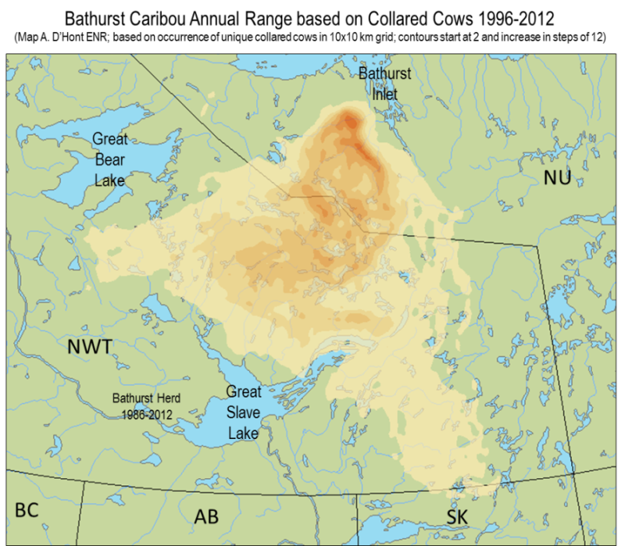

Titirauyaq 1. Qingnaungmi tuktuutait nayurvigivaktaat Nunattiarmi (NWT) Nunavunmilu (NU) naunaipkutauyuq qunguhiqtuqtauhimayuni arnalluit tuktut 1996-2012. Qaumatqiyat nayugauhimayut atuqtaulluanngittut uvvalu taatqiyat nayugaulluaqtauhimavaktut.

Ahiit qanurinningani naunaipkutigiyaat Qingaungmi tuktuit ikiglivallianginnaqtut haffumap akunnganni 2012 uvanilu 2015:
- ukiumi-kinguvaqhimayut nurrait:arnalluit qaffiuyaakhaita ataani 30 nurrait:100 arnalluit (qaffiuningat 30-40 nurrait: 100 arnalluit uvvaluunniit amigaitqiyauyut tuktuqarnirni);
- itqurniaqtauhimayut arnalluit annakpaktut ataaniitpaktut 80%-nguyuni nalaumattiarniarumik tuktuit; uvvalu
- ilumiutaqaqtullu ikitqiyauvaktut ilanginni ukiurni, uvanilu ukiunganni 2014-2015.

Ilitturilluaqtauhimayukharlu ukuanginnauyut 61%-nguyut tuktuit takuuriyauvaktut Qingaungmi nurraliurviuvaktut uvani June 2015-mi arnalluuhimayut ivavaktut; qaffiuningat niriugiyauvaktuq unauniarumi 80%-nguyuq uvvaluunniit amigaitqiyauniarungnaqhivuq nurriuraangata, uvaniittutigut 2009 (84%) uvanilu 2012 (82%). Qanurinninganut munariyauningit ukuat Qingaungmi uvanilu Bluenose-East Kivalliani (BNE) tuktuutait naunaiqhihimayaat ENR-kutigut kinguvani 2014 (ENR 2014), naunaiyattiaqhimayuni qauyiharniqaqtut uvvalu qaffiuyaakhaita titiraqhimayut talvani naittumi titirauhiani. Naunaiyattiaqhimayuq titiralihaaqtaani qauyiharnikkut unipkaaliuqhimayauyut ukuat Qingaungmi tuktuutait uvani 2015-mi hailihimayut atulihaaqtillugu 2016 (Boulanger et al. 2016). Una unipkaaq ilaqaqhimayuqtauq qanurinningannik tuktuit naniittaakhaita naunaipkutiqaqhuni.

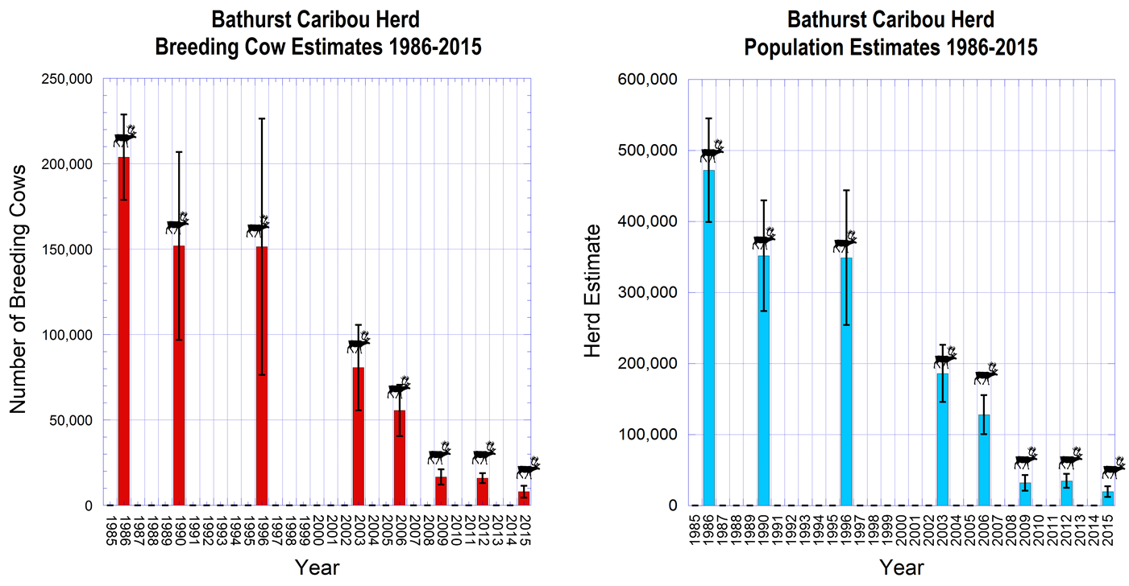
Titirauyaq 2. Itqurniarningat qaffiuyaakhaita arnalluit ivayut (haumik, aupayaaqtuq) uvvalu inirnirit tuktuit (taliqpik, tungungayuq) Qingaungmi tuktuutait 1986-2015, naunaipkutariblugu nurriuviuvaktuni piksaliuqhutik qauyiharniannik uvani June-mi.

- Auladjutikhaat Qingaungmi tuktuutainnik

Tamatkiumanikkut aulapkainikhaat: Ukuat Tłı̨chǫ (Nunataarnikkut Nanminiqarnianni) Angirutaanni pivikhaqarniqaqtuq haffumani WRRB, TG, GNWT uvanilu Kanatami hanalutik hivituyumik-piviqarlutik aulanikhakkut parnaiyaqpalliadjutikhaannik Qingaungmi tuktuutaitigut. Hamna havauhikhaq pivalliadjutigiyakhait ukuat kituuyut nunagiyaqaqtuni kituniglikiaq ilagiyaanni Qingaungmi nayugauvaktut uvvalu Nunaqaqqaaqhimayut inuit angunahuarvigivagait tahapkuat tuktuit, ukuallu ilagiblugit kituuyut ukuallu nunallaat Nunavunmi. Qaffiiqtuqhutik katimadjutiqaqhimayut naunaiyattiarahuaqhugu hamna hivituyumik-pivikhaqarniatigut pilihaaqhimayuq 2012-mi, uvvalu havauhirimmaaqhugu aulattiarutikhaatigut Qinguangmi tuktuutaitigut. Malrungnik ublungnik katimadjutigiblugu January 2016-mi Yellowknife-mi uqautiqaqhutik qanurli hivumuuqpalliadjutiqarniarumik hivituyumik-pivikhaqarnianik Qingaungmi aulanikhakkut parnaiyautikhaqarniannik, uvvalu ilauqatauhimayut Kavamatkuat Nunavunmi(GN) uvvalu qaffiuyullikiaq Inuit timigiyait. Ikayuqtuttiaqtut makipkaiyumablutik haffuminnga Qingaungmi Tuktuit Angiqatigiingnikkut Uqaudjiyiuluni Katimayiralaakhainni, uvvalu titiralihaaqhimayumik naunaipkutakhaannik piyariiqhutik. Makihimaliqqat, una uqaudjiyukhat tuhaqtittilluarungnaqtut aulanikhaatigut Qingaungmi tuktuutainni.

Nunat aturutikhait uvvalu nayuqtaunikhatigut parnaiyarniq: Ilitarihimablugu ihumagittiaqtauninga initurliuvaktut hapummiyauttiarlutik uvvalu aulaniqattiarlutik, uvvalu tadja tukhiqtugaunikkullu pivalliadjutikhaannik Qingaungmi tuktuutait ukiuq tamaat ingilravigivagait, havauhirilugu initurlikhaitigut parnaiyaqpallialutik Qingaungmi tuktuutaitigut pilihaaqhimayaat Nunattiarmi Kavamatkuannit (GNWT) uvani 2013-mi. Hamna initurlikhaani parnaiyautikhaat naunaipkutigittiarniaqtaat qanurli munariniarumikku, qauyiharniarumikku uvvalu aulapkainiarumikku aktuumaniqarniarumik inuit tahamaniitpagiakhaita nayugauvaktuni Qingaungmi tuktuutainnik. Tahapkuat tuhagakhauyut katitiqtauvangniani haffumani parnaiyautikhami ukuanguyut qunguhiqtuqtauvaktut uvvalu qauyiharnirmut-tunngaviuvaktuni qauyimaningit tuktuit hunautillugu hila uvvalu ukiuq tamaat initurligivagait, Inuit Qauyimayatuqangit uvanngaaqhimayut Nunattiarmit (NWT) uvanngallu Nunavunmit atuqpauhiannik tuktuit initurliannik uvvalu imakkuuqhutik ikaarviqaqpaktut, uvvalu naniittaakhaita tamaita tadja atuqtauvaktut apqutit uvvalu apqutiliuqtauniaqtuttauq, uyarakhiurviit ukuallu nunamiuttatigut havivaluit atuqutiqarniarumik. Hamna parnaiyautikhaq tadja hanayauliqtuq amigaittunik ilagiiqatiqarlutik haffuminnga havauhikhatigut.

ENR-kut ilauqatauvaktut tamainni qangahaannuaq Avatilirinikkut Qauhiyarnianni (EA-kunnik taiyauvaktuq) havauhiannik iluani Qingaungmi nayugarivagainni Nunattiarmi (NWT) (ukunatitut Gahcho Kue, Jay Havauhiriyaanni), aktuumaniqarnianngitkumi Qingaungmi tuktuutainnut ihumagittiaqtaulutik akhuurviuyungnanngillunilu. ENR-kut ilauqatauhimangmiyuttauq EA-kunni havauhiriyaanni Nunavunmi (NU) havaakhanut aktuumaniqarniaqtunut Qingaungmi tuktuutaita irniurvigivagainni uvvalu auyami nayuqpagainni (ukunatitut Sabina). Qaffiuyullikiaq Nunaqaqqaaqtut kavamagiyait ukuallu ahiit ilagiiktut ilauqatauhimangmiyuttauq EA-kunni havauhiriyaanni Nunattiarmi (NWT) uvanilu Nunavunmi (NU). ENR-kut ilauqatauhimayut qaffiuyunik katimadjutiqarmata Nunavunmi (NU) ihumagilluaqhugit hapumminikhaannik tuktuit initurligiyainni.

Niqainnaqhiuqpaktunik aulapkainiq: Talvuuna angiyumik uvvalu nutqaqhimaittumik ikiglivallianingat uvani Qingaungmi uvanilu BNE tuktuutainni, ukuat Nunattiarmi Kavamatkuat (GNWT) hivunniurutigiyaat uvvaluunniit ikayuqtuidjutigiyaat qaffiuyunigli pinahuarutikhakkut amigaiqpaallirnikhaatigut amaqqunik angunahuaqpakkumik amigaiqpaallirniarumik inirnirit tuktuit uvvalu nurrait annaumakpangniarumik. Hapkuat pidjutigiyumaiyait uvaniitput:

Nunattiarmi Kavamatkuat (GNWT) ENR-kullu hivunniuqtiuniaqtut qauyiharnikkut amaqqunik aulapkainikhaanni 2016-mi, ihumaliurutigilugu nakuukpat, akiqarnikhaaniglu, uvvalu ihuarniqarniarumi aadjikkiinngittut aulapkaidjutikhanik. Qimilruurutiqarumayut amaqqut aulapkaidjutikhaannik atulirniarumik ukunani hungiutiqarniarumik aulanikhainni havaariyauyukhat ikayuutauniarumik napaaqtuqarnirmiinngittut tuktuit. Hamna qimilruurutikhaq hanayauniaqtuq piqatiqarlutik TG-kunnik uvvalu ahiit Nunaqaqqaaqtuni kavamauyut ukuallu aulapkaiqatigiikpaktuni ilagiiktunut.

Uvani 2015-kut, ukuat Nunattiarmi Kavamatkuat (GNWT) ihuaqhaqhimayaat ikayuqtuutikhanik amaruqhiuqpakunut ilaliutiqarlutik pingahunik (3) pivikhaqarnikhaannik (Titirauyaq 3). Hapkuat naliakkuurumayut angunahuaqtuq qarridjilutik amiiyaqhimaittumik, iliktiriiqhimanngittumik amarurmik akiqarluni $200, ikayuutauniarumik $450 taamna amaruq amiiyaqhimakpat, uvvalu $800 pinnitqiyaukpat amiiyattiaqhimakpat akiliqhiyungnaqtut.

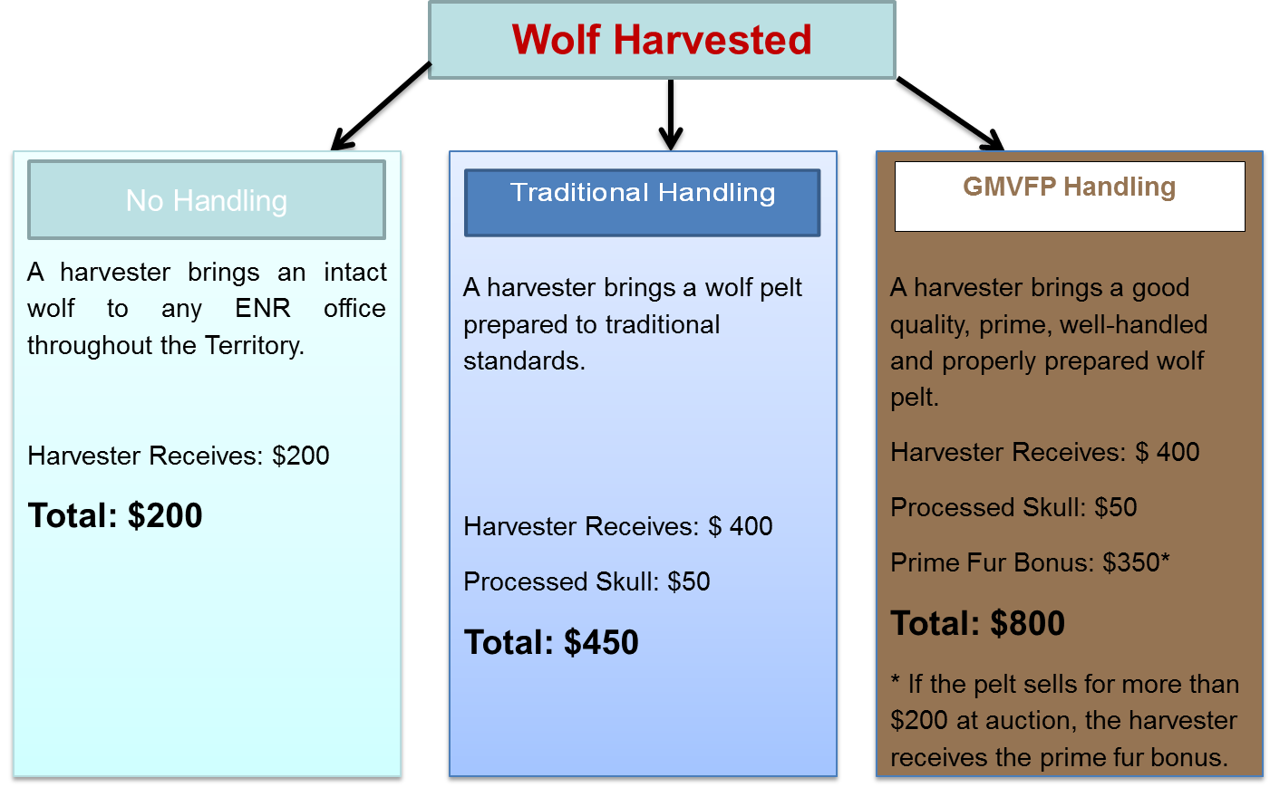

Titirauyaq 3. Ikayuutauyukhat amaqqut amiit hailiniaqtut amaruqhiuqpaktunut Nunattiarmi (NWT) uvani 2015-mi.

Ukuat Tłı̨chǫ Kavamatkuat ukuallu Nunattiarmi Kavamatkuat (GNWT) ikayuqtuutait pivalliadjutiqaqhimayut hivullirmik nunalingni-tunngaviqaqhutik amaruqhiurnikkut havaakhaanik piqatigiblugit Tłı̨chǫ nunallaangit ayuiqhapkainiarumik ikayuqtuiniarumik amaruqhiurnikhakkut ukiumi nayuqpagainni Qingaungmi tuktuutait pitquhiminikkuurlutik pivakkumik. Tuhaffaarumaguvit uvani atauttimiuyut TG-ENR Qingaungmi tuktuit aulaningani tukhiqtugauyut ukununnga WRRB-kunnut.

- Qangahaani aulatauningat Qingaungmi tuktuit uvani Nunattiarmi (NWT) 2009-2015

Hivituyumik-pivikhaqaqqat aulanikhakkut parnaiyautikhaannik hivumuurnikkut uvvalu aulanikhakkut parnaiyautaat atuliqqata, qangahaaq aulapkainikhaat Qingaungmi tuktuutait Nunattiarmi (NWT) atuliqhimayaat aulapkainikhakkut tukhirautaitigut pingahut ukiuni uvanngaaqhimayut TG ukuninngalu ENR ukununnga WRRB, havaqatigiblugit Nunattiarmi Kavamatkuat (GNWT) ukuallu ahiit Nunaqaqqaaqtuni Kavamatkuit ukuallu timiuyut angunahuaqpaktut Qingaungmi tuktuutainnik. Naittumik titirauhiqaqtut tahapkuat tukhirautit katimayitkullu naalaktittivangniat uvanngat 2009 uvunga 2015 uva ataaniitput titirauhiat.

Atauttimiuyuni aulapkainikhakkut tukhiqtuqhimayaat Qingaungmi tuktuutainnut tuniyauhimayuq WRRB-kunnut ukunatigut TG ukuallu ENR uvani November 2009-mi. Ilaa TG ukuallu ENR angiqatigiikhimayut aulapkainikhaatigut munaqhinikhakkullu titiraqhimayuq tukhiraunmi, angiqatigiikhimanngittut aulapkaidjutikhaannik Nunaqaqqaaqtut angunahuarnikhaatigut.

Uvani December 2009-mi una Minista ukunanit ENR nutqaqtittihimayut angunahuaqpagainnik Qingaungmi tuktuutainnik Nunattiarmi (NWT) (inmi niqikhaitigut, niuviqtittinikhakkut, uvvalu Nunaqaqqaaqtunut) pilihaaliqhutik January 2010-mi ukunani malruuyungni angiyuni aulapkaivianni (RBC02 unalu RBC03); hapkuat uuktuutikhait atuqtauyukhat qimilruuqhiniq uvvalu pitquihimayauniq uqaqtaukpata ukunanngat WRRB uvani 2010-mi.

Una tallimat ublut (5) naalaktittihimayut WRRB-kut uvani March 2010-mi uqautigiblugit Qingaungmi tuktuutaita aulapkainingannik. Hamna naalaktittiniq taimaaqtitauyuq tukhiqtuqtaaramikku TG ukuallu ENR taimaaquiblutik utiffaarniaramikku ihumaaluutauvaktuq Nunaqaqqaaqtut angunahuaqpauhiannik hapkuninnga Qingaungmi tuktuutainnut.

Ihuaqhaqhimayuq atauttimiuyuni tukhirautauyuq uvanngat TG ukuallu ENR tuktut aulapkaidjutigiyaitigut tuniyauhimayuq WRRB-kunnut uvani May 2010-mi. Una pitquidjutauhimalluaqtuq tukhiraunmi makipkaihimalirlutik ukiuq tamaat angunahuarnikhakkut haffumani 300 ± 10%-nguyumik Qingaungmi tuktuutainnik kituungmangaani avvariyaat haffuminnga 80%-nguyunik anguhalluit, umikhimavaglutik inmikkut niqikhainnik uvvalu niuviqtittinikhakkut angunahuarniatigut. Una angunahuarnikhaq avvaulutik piyauyukhaq, 150-nguyut tuktuit hailihimalutik ukununnga Tłı̨chǫ angunahuaqtiinut uvvalu 150-nguyut Nunaqaqqaaqtut atuqtakhainut.

Ukuat WRRB aippaanik naalaktittihimayut uvani August 2010-mi uvvalu unipkaaliuqhimablutik October 2010-mi 60-nguyunik pitquyauhimanirnit aulapkainikhakkut Qingaungmi tuktuutainnik uvvalu ilanganiittut napaaqtuqanngittumiittut tuktuit (Bluenose-Kivataani, Beverly/Ahiak; WRRB 2010). Tahapkuat pitquyauhimaniit angiqatigiigutauyut uuktuutiginahuaqhugit ihuaqhainikhakkut TG – ENR atauttimiuyuni aulapkainikhakkut tukhirautainni.

Uvani October 2010-mi, ENR atiliuqatigihimayaat Yellowknives Dene First Nation (YKDFN) Itqiliit atataqarnikhakkut uvvaluunniit angiqatigiikhanikkut titirannuarmik piqarlutik 150-nguyunik Qingaungmi tuktuutainnut, ilagiyaqaqhutik kituungmangaanik 80%-nguyunik anguhalluit.

Upin’ngakhami 2013-mi, WRRB-kut pitquihimaniqaqtut hivikittumik-piviqarluni angunahuaqtauyukhanik Qingaungmi tuktuutainnik kigliqaqpaglutik huli 300-nguyunik tuktunik uvvalu 80%-ngulutik anguhalluit, uvvalu hivittuqpaalliqhugu 2010-nguyumi pitquyauhimaniit Qingaungmi tuktuutainnik huli atuqtauvaglutik 2013-2014 angunahuarvigiyainnut.

Uvani July 2014-mi ublumimiiqtauhimayuq atauttimi aulapkainikhakkut tukhirautaa uvanngat TG ukuninngallu ENR tuniyauhimayuq WRRB-kunnut pitquihimaniqaqhutik huli angunahuaqpaglutik Qingaungmi tuktuutainnik ukuangulutik 300 tuktuit uvvalu angunahuaqpaglugittauq amaqqut ukunani Tłı̨chǫ ukiivianni. Una tukhiraut nutqaqtitauhimahimayuugaluaq qanurinningat uvani June 2014-mi tingmiblutik qauyihaqhutik ukuninnga Qingaungmi tuktuit nurraliurvianni naunaiqhihimayut ikiglivaalliqhimayut tuktuit talvani.

Ukiakhami uvanilu ukiulihaaqtillugu 2014-mi, ENR-kut katimapkaihimayut pingahunik Nunaqaqaaqhimayuni hivuliqtiinut (August 27, November 7 uvanilu November 28) uvvalu malruk (2) ubluk ayurnarniqaqtumi katimablutik (October 9-10 uvanilu
October 22-23) qimilruuqhiblutik huurlikiaq ikiglivallianginnaqtut Qingaungmi uvanilu BNE tuktuutainni uvvalu ihumaliurutigiyumablugit aulapkainikhakkut uqautiginiarumikku ikiglivallianginnaqtut huurlikiaq. Katimaqatauhimayut ilitarihimayaat tahamna ihumaaluutauvaktuq talva kihimi angiqatigiinngittut angunahuaqpauhikhakkut pitquihimaniqarniit kitumullikiaq tuktunut.

Uvani January 2015-mi, ENR-kut tunihihimayut tukhiraunmik WRRB-kunnut tadja aulapkainikhaatigut Qingaungmi tuktuutainnut. Una tukhiraut pitquihimaniqaqtuq atuqtauvaglutik hapkuat Nuutauyuminaqtut Qitqaniittukhamik Qingaungmi Tuktuit Hapummivikhaani Nayugakhat hapkuat qunguhiqtuqtauhimayut tuktuit uvani ukiungani 2014-2015, tuktuviunngilluni tahamani iluani nuutirviuyumi. Uvani January 2015-mi, WRRB-kut angiqhimayaat una tukhiqtuutauhimayuq tunngaviqallagluni haffumani ilangani uumap 2014-2015 angunahuarvianni.

Uvani Dec. 2015-mi, TG ukuallu ENR tunihihimayut atauttimiuyumik aulapkainikhakkut tukhiqtuutaunmik ukununnga Qingaungmi tuktuutainni uvani 2016-2019 ukununnga WRRB (GNWT ukununngalu TG 2015). Hamna ilaqaqtuq pitquihimanianik 0 angunahuannginnikkut tuktunik, huli atuqpaglunigit hamna Nuutauyuminaqtut Qitqaniittukhamik Qingaungmi Tuktuit Hapummivikhaani Nayugakhat uvvaluunniit himmauhikhatigut pinahuaqpaglutik aulapkainiannik angunahuarnirup hapkuat tuktuit ukiumi nayuqpagainni, una atulihaaqtait Tłı̨chǫ-hivunniuqhutik nunalingni-tunngaviqaqhutik amaruqhiurnikhakkut tahamani ukiumi nayugauvaktuni, una ENR-hivunniuqhutik havaqatigiikhutik ayurnarniqaqtumik ihuaqhaqtauyariaqaqtumik qimilruurutiqarumayut amaqqaut aulapkainikhaatigut qanurlikiaq, uvvalu huli munaqhiqattarlutik tuktunik qimilruuqhivaglutik, qunguhiqtuivaglutiglu uvvalu ahiitigut munaqhivaglutik.

- Qangahaaq angunahuaqpauhiit uvvalu angunahuaqpangnikkut aulapkainiq Nunattiarmi (NWT)

Angunahuarniit Qingaungmi tuktuutainnik uvani Nunattiarmi (NWT) angiyuuhimayut uvunngaqtinnagu 2009, uvvaluttauq angunahuaqpaktullu qaffiuyuniglikiaq Nunaqaqaaqhimayunit, inminut niqikhaqhiuqpaktut ukuallu angiyunik-niryutinik angunahuarnikkut havaaqaqtunut. Angunahuarniit uvani 2007-2008 uvanilu 2008-2009 titiraqtauhimattianngittut talva kihimi itqurniarutaanni itqurniaqtauvaktut, nunalingni munaqhivakhutik, nunalingni apiqhuivakhutik, uvvalu annguhiqiyut munaqhivakhutik uqaqhimablutik angunahuaqtauyungnarniqaqhutik 4000-6000/ukiuq (Adamczewski et al. 2009). Hamna tuktuhiurniq apqutikkut tikittuminaqtuq ukiumi apquhiuqhimayumi tunuani-uataani Yellowknife ilaa ikiglivalliagaluaqhutik tuktuit. Kinguani June 2009-mi nurraliurviit piksaliuqtaublutik-ihivriuqtauvangniat naunaiqhihimayut kayumiktumik ikiglivallianginnaqtut uvanngat amigaitqiyauhimayunit 100,000 uvunga 32,000 uvani pingahut (3) ukiurni, angunahuarniq ilaa ikiglititauhimayuq atulihaaqtillugu 2010 (Titirauyaq 4); naunaipkutait tukhirautini, naalaktittinirni uvvalu pitquyauhimanirni titiraqtauhimayuq uvani qulaannittumi. Tamatkiumanikkut, angunahuarniq ikiglititauhimayuq 95%-ngutigut uvunga angunahuaqtauvaktauyukhanut 300-nik Qingaungmi tuktuutainnik ukunatigut malruuyuk angiyutigut aulapkaiviqarlutik, RBC02 uvanilu RBC03 Nunaqaqqaaqtuni angunahuaqtiinut (Titirauyaq 4). Inminut niqikhaqhiurniq uvvalu niuviqtauyukhatigut angunahuarniq, ukuallu ilaliutilugit angunahuaqtittivaktut haffuminnga tuktunik, nutqaqtitauhimayuq.

Uvani June 2014-mi tingmiblutik qauhiyaigamik Qingaungmi tuktuutaita nurrarviurviit naunaipkutariyaat hapkuat arnalluit ukuallu tuktuit qaffiuningat ikigliyuummiqhimayut akhuraaluk uvanngat 2012-mit. Angunahuarniit nutqaqtitauhimayut Nunattiarmi (NWT) nutqaqtitauhimakaffuktuugaluaq ukiumi 2014-2015 angunahuarviani; una Nuutauyuminaqtut Qitqaniittukhamik Qingaungmi Tuktuit Hapummivikhaani Nayugakhat hapkuninnga qunguttiqtauhimayut tuktuit nayuqpagainni atuqtauhimavaktuq angunahuarviunngilluni (Titirauyaq 5). Hamna nuutirviuvangnikkut angunahuarviuyukhaunngittuq huli atuqpagaat 2015-2016, uvvalu aulapkainikhakkut tukhiqtuut ukunanngaaqtut TG uvanngallu ENR tadja qimilruuqpalliayaat WRRB-kut huli angunahuarviunianngittuq ukuat Qingaugmi tuktuutait amigaiqpallianiarumik naunaiqhimaniaqquq talvuuna.

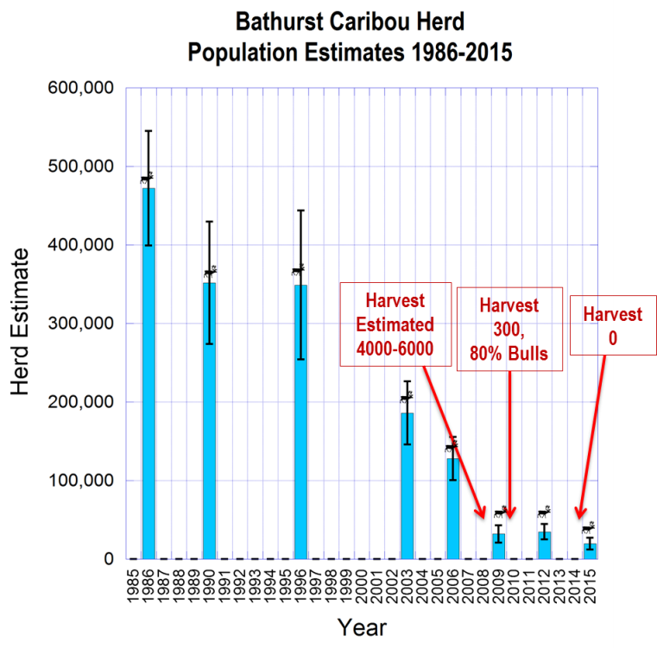

Titirauyaq 4. Qaffiuningat Qingaungmi tuktuutait 1986-2015 uvanilu aallanngurningat angunahuarnikhakkut aulapkainingannik 2009-2015.

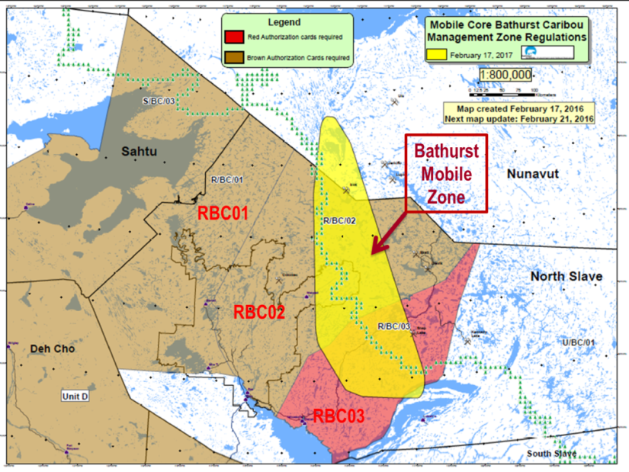

Titirauyaq 5. Una uuktuutauyuq haffumani Nuutauyuminaqtut Qitqaniittukhamik Qingaungmi Tuktuit Hapummivikhaani Nayugakhat (quriiqtauyumi) uvani February 2016-mi. Hamna nuutirviunikkut nayurviani umikhimayuq uvunngauhimayuq Nunavunmut ilaa ilangit qunguhiqtuqtauhimayut tunuaniinmata hilataani napaaqtuqanngittumi, talva kihimi nuutauyuminaqtuq aulapkainiqannginmat hilataani Nunattiarmi (NWT). RBC02 unalu RBC03 ukuanguyuk malruk (2) angiyuk kigliqarviuyuk ukuat Qingaungmi tuktuutait angunahuarnikkut kigliqaqtut uvunga 300 uvani 2010-2014.

- Nunattiarmi Kavamatkuat (GNWT) tukhiqtuutauyuq angunahuarvikhakkut aulapkainikhaatigut Qingaungmi tuktuutainnut

Titiraqhimayumi uvani tadja atauttimiunikkut aulapkaidjutimut tukhirautaa uvani 2016-2019 ukunanngaaqhimayuk TG ukuninngalu GNWT WRRB-kunnut, ukuak malruuyuk kavamatkuk pitquihimaniqaqtuk hapkuat Nunaqaqqaaqtut angunahuaqpaktut Qingaungmi tuktuutainnik ilaa tuktuhiuqpanngillutik Nunattiarmi (NWT), ukiuq tamaat qimilruuqtauvaglutik uvvalu naunaiqpalliadjutikhat hailivallialirumik. Inminik niqikhaqhiurniq uvvalu niuviqtittiniillu ilaa umikhamallangniaqtut. Hamna huurlikiaq angunahuarutaunianngittut haffumani ataani titiraqhimavut:

- Hapkuat tuktuit ikigliyuummiqhimaliqtut 96%-nguyumik uvanngat 1986-mit. Akunnganni 2012 uvanilu 2015, kayumiktumik tuktuit ikiglihimalirmata ukunannganit 35,000 ukununnganut 20,000 niryutikhat, uvvalu amigaihimayut arnalluit ikiglihimaliqtut ~23%-nguyumik ukiuq atauhirmi, avvauyumik naunaipkutaqaqhutik ~pingahut (3) ukiut. Qaffiuninganik naunaipkutaqaqtut ukunatigut inuunahaaqpaktut nurrait: arnalluit qaffiungmangaani, qaffiuniarmangaata arnalluit annakpauhiat, uvvalu qangahaannuaq ilumiutaqaqtut hingaiyut qaffiungmangaata ilaa nalaumaniqaqtut ikiglivallianinganni, uvvalu ikiglivallianginnarniarungnaqhiyut.

- Ilaa hamna "aupayaaqtuq inigiyauyuq" inuqarnini qaffiungmangaat, ataani tamaita angunahuarniit nutqaqtitauhimaniaqtut, makipkaqtauhimanngittut huli uvvaluunniit angirutauhimanngitturlu Qingaungmi tuktuutait, uuktuutigilugu nutqaqtitauniaqtut angunahuarniq ahinit tuktunit ilaa tahapkuat ikiglivallianginnaqtunit:

- Tamaita angunahuarniit hapkuninnga Cape Bathurst tuktuutainnik lnuvingmi nunagiyaanni nutqaqtitauhimayuq uvanngani 2007 naahautait ikiglihimaliqpiarmata uvani 2006-mi unauliqhutik ~2,000 anngutikhat, ikiglivalliqhimayut uvanngat ~19,000 uvani 2000-mi. (Anngutikhanut Aulapkainikkut Uqaudjiyiuyuni Katimayit (NWT) pitquihimaniit, atuliqtaat GNWT).

- Ukuat Angunahuaqtut Aulapkainingat Parnaiyautaa haffumunnga Porcupine tuktuutainnik atuliqtauhimayuq 2010-mi (PCMB 2010) unaqaqtuq " aupayaaqtuq inigiyauyuq " pilihaarutiqaqtuq 45,000 tuktunik, ikigilihimaniqaqtut angunahuarnikkut nutqaqtitauhimaniaqtuq. Qauyiharnikkut ilitturiyauhimayut ukuat tuktuit amigaitqiyauhimanngittut 200,000 amigainninginni. Talvuuna hamna aupayaaqtuq inigiyauyuq unauyuq 23%-mik qaffiungmangaani.

- Aulapkaidjutikhap parnaiyautikhaanik hanahimayut Uqaudjiyiuyuni Katimayiralaangit Havaqatigiigahuarlutik Anngutikhatigut Aulapkaininga hapkununnga Cape Bathurst, Bluenose-Uataani ukuallu BNE tuktuit uvani 2014-mi (ACCWM 2014) makipkaqtauhimayuttauq" aupayaaqtuq inigiyauyuq " ukununnga pingahuuyut (3) tuktut atauttimiuyut, ilaa una parnaiyautikhaq nutqaqtittinngitpiarlutik angunahuarnikkut tahapkuninnga tuktunik ikiglihimaliraluaqtillugit. Ukuat pingahuuyut tuktuit atauttimiuyut, qaffiuyuniglikiaq naahautiqarniit uvvalu una aupayaaqtuq inigiyauyuq pilihaarutikhaat, ihumagiblugu: Cape Bathurst qulaaniittut 19,000 uvvalu aupayaaqtuq inigiyauyuq 4,000 (21.0%-nguyumik qulaaniittut); Bluenose-Uataani qulaaniittut 112,000 uvvalu aupayaaqtuq inigiyauyuq 15,000 (13.4%-nguyumik qulaaniittut); BNE qulaaniittut 120,000 uvvalu aupayaaqtuq inigiyauyuq 20,000 (16.7%-nguyumik qulaaniittut).

- Aktikuurutigiblugit ahiit tuktuit atauttimiuyut, ukuat Qingaungmi tuktuutait immaqaak unauyuq 4%-mik angitqiyariblugu tuktuutait takuuriyauvaktut 1986-mi uvvalu ilaa ikiglivallianginnarniaqtut. Ukuak TG ukuallu ENR pitquihimaniqaqtut Qingaungmi tuktuutainnik angunahuanngillugit pingahut (3) ukiunit kihiani qauyihaqtaaqtinnagit nurraliurningit uvani 2018-mi naunaiqpaalliqqaarlugu qaffiuyaakhaita tuktuit talvani, ukiuq tamaat qimilruuqattaqpaglugit naunaiqpaallirutikhamik qaffiuhimayaakhaita.

Qingaungmi tuktuutait naahautait atpaqhimayut uvvalu ikiglivallianginnaqtut, Nunattiarmi Kavamatkuat (GNWT) pitquihimaniqaqtut angunahuanngillutik Nunavunmi kihiani amigaiqpaallirniarumik naunaiyaqqaarlugu, aulapkaittiaqtauniarumik hapkuat tuktuutit uvvalu ihumagittiarlugit Nunaqaqqaaqtut angunahuaqtiit Nunattiarmi (NWT) ilaa nutqaqtittinikkut haffuminnga tuktunit.

Uqautauhimayut:

Uqaudjiyiuyut Katimayiralaat Angiqatigiingnikkut Anngutikhani Aulapkainiq (ACCWM). 2014. Munariblugit Tuktuit – Ukuat Cape Bathurst, Bluenose-Uataani, uvvalu Bluenose-Kivataani Napaaqtuqarnirmiinngittut Tuktuit Aulapkainingani Parnaiyautaat (Kingulliq). C/O Wek’èezhı̀i Renewable Resources Board, 102A, 4504 – 49 Avenue, Yellowknife, NT, X1A 1A7.

Adamczewski, J., J. Boulanger, B. Croft, H. D. Cluff, B. Elkin, J. Nishi, A. Kelly, A. D’Hont, unalu C. Nicolson. 2009. Ikiglivallianingat Qingaungmi tuktuutait 2006–2009: qimilruuqtauhimaniit naahaqtaunikkut uuktuutikkullu. Avatilirinikkut Nunamiuttalirinikullu, Nunattiarmi Kavamatkuat, Yellowknife, NWT, Kanata.

Boulanger, J., B. Croft, J. Adamczewski, D. Cluff, M. Campbell, D. Lee unalu N. Larter. 2016.
Itqurniaqhimaniat arnalluit irniuqtut uvvalu naniinmangata ukuat Qingaungmi tuktuutait napaaqtuqarnirmiinngittut: 2015 nurriurviit piksaliuqtaublutik qauyiharniq, titiranngautaa Feb. 8, 2016-mi. Avatilirinikkut Nunamiuttalirinikullu, Nunattiarmi Kavamatkuat, Yellowknife, NWT, Kanata.

Avatilirinikkut Nunamiuttalirinikullu (ENR). 2014. Qingaungmi & Bluenose-Kivataani Tuktuit: Ihumagiyauningit Qaffiungmangaata Pitquhiat 2009-2014. Titirannguqhimanngittuq Unipkaaq Sept. 2014. Havagviat Avatilirinikkut Nunamiuttalirinikullu, Nunattiarmi Kavamatkuat, Yellowknife, NT, Kanata.

Kavamatkuat Nunattiarmi ukuallu Tłı̨chǫ Kavamangit (GNWT ukuallu TG) Ilagiikhutik Tukhiqtuutait haffumani Tuktuit Aulapkaininganni Pinahuarutaat ukunani Qingaungmi tuktuutainni: 2016-2019. 2015. Tukhiqtuut tuniyauhimayuq ukununnga WRRB Dec. 15, 2016-mi.

Porcupine Tuktuit Aulapkainikkut Katimayit. 2010. Angunahuarnikkut Parnaiyautaat ukununnga Porcupine Tuktuit Atauttimiuyut Kanatami (kingulliq
). http://www.pcmb.ca/PDF/general/Plan/Harvest%20Management%20Plan%202010.pdf

