Bluenose-East Caribou Harvest Allocation
Meeting Summary

January 20th 2016
Tree of Peace Friendship Centre - 5011 51 St, Yellowknife
_____________________________________________________________________________

Purpose and Background

The Gwich’ín Renewable Resources Board (GRRB), Sahtú Renewable Resources Board (SRRB), Wildlife Management Advisory Council (NWT) (WMAC) and the Wek’èezhìi”Renewable Resources Board (WRRB) asked that a meeting of traditional harvesters and wildlife management authorities from the Bluenose-East (BNE) caribou herd range be held to discuss and establish a long term proportional harvest allocation for the BNE herd.
`
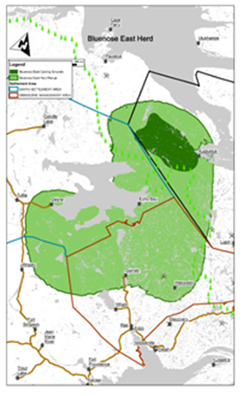
In December 2015, the Government of the Northwest Territories Department of Environment and Natural Resources (ENR) invited representatives of traditional users and wildlife management authorities to meet to discuss and come to agreement on a proportional harvest allocation for the BNE herd for the 2016-2017 harvest season and beyond.

This Meeting Summary reports on the key understandings and conclusions with respect to a long term proportional harvest allocation formula for the BNE herd.

Considerations

Participants identified a number of considerations in the context of setting long term harvest allocations, including:

- Harvest allocations for the BNE herd are a new reality

- It is difficult to make hard conservation decisions as it affects the way of life of Aboriginal people

- Common rules and understandings on harvesting and conservation are needed between user groups

- Elders knowledge is important

- Community-based Caribou Plans are a strong tool to gather support for conservation decisions
and harvest allocations

- “We all need to work together to make this work”
Goal – Contribute to the Long Term Recovery of the BNE Herd

Meeting participants agreed that any long term harvest allocation formula needs to be guided by a common goal that helps ‘contribute to the recovery of the BNE herd’. Participants recognized that there are “no Aboriginal rights to be exercised if there are no caribou.”

Draft Long Term Harvest Allocation Proposal

The GNWT presented the interim harvest allocation formula used in 2014-15 and 2015-16 harvest seasons for participants to review and consider as a starting point for a long-term allocation formula, as identified in the pie chart and table below. The long-term allocation would be identified as a percentage allocation for identified harvesters. The percentage allocation would then be applied to the annually set harvest limit.

There were many factors that guided the thinking behind the interim allocation formula, including:

- The average harvest level by harvester group over the last five years
- The inclusion of all rights holders
- The size of communities related to rights holders
- Overall hardship of communities
- Community and rights-holder access to other wildlife opportunities

Draft Long Term Harvest Allocations – Bluenose-East Caribou Herd

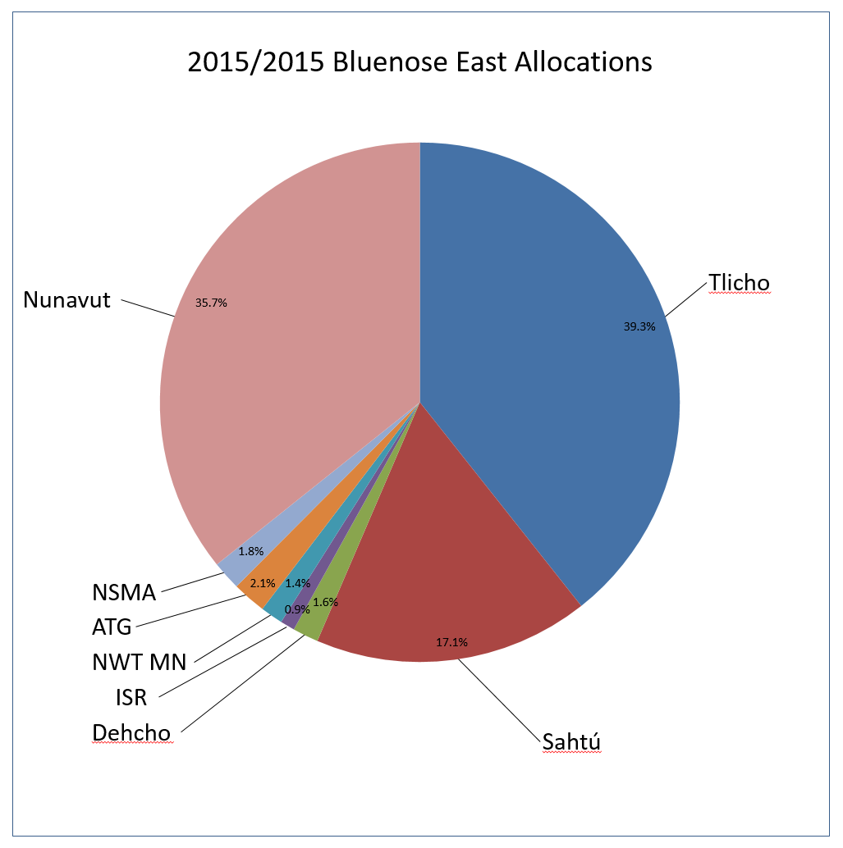
  Harvest Group | 2015/2016 | % Per Cent
  Tlicho | 373 | 39.3
  Kugluktuk | 339 | 35.7
  Sahtu | 163 | 17.1
  Dehcho | 15 | 1.6
  Inuvialuit | 8 | 0.9
  NWT Metis | 14 | 1.4
  Akaitcho | 20 | 2.1
  North Slave Metis Alliance (NSMA) | 17 | 1.8
  Total | 950 | 100

Harvest Allocation Conclusions and Recommendations

Participants reviewed and discussed the long term harvest allocation formula at length and came to the following conclusions and/or recommendations:

- A long-term harvest allocation formula is needed
- The proposed draft harvest allocation formula is ‘not too far off’ and should be seriously considered and consulted on by all groups
- The concept of a minimum percent harvest allocation for groups with a smaller harvest of the BNE herd (i.e. Dehcho, Inuvialuit, NWT Metis, NSMA and Akaitcho) was brought forward as a proposal for other groups to consider. This proposal was not uniformly accepted in the Workshop and was undertaken as a future consideration
- The need to continually respect traditional harvesters and consult and communicate with them on allocation is recognized

Next Steps

Meeting participants recommended the following next steps:
- Representatives to review the long term harvest allocation formula and work together with ENR to come to consensus on final allocation formula
- Community-based communications and education around the harvest formula should be developed
- Common media messaging from harvest users around long-term harvest allocation is needed

Participants

- Lynda Yonge – ENR, GNWT
- Bruno Croft, ENR, GNWT – Support
- Jan Adamczewski – ENR, GNWT - Support
- Chief Ernest Betsina – Yellowknives Dene First Nation (YKDFN) – N’Dilo
- Chief Edward Sangris – YKDFN – Dettah
- Elder Napoleon Mackenzie – YKDFN
- Elder Alfred Baillargeon –YKDFN
- Doug Doan – GRRB
- Al Harman Jr. – North Slave Métis Alliance (NSMA)
- Arnold Enge – Director of NSMA
- Ema Qaggutaq – Kitikmeot Regional Wildlife Board (KRWB)
- Simon Qingnaqtuq – KRWB
- Larry Adjun – KRWB – Kugluktuk Hunters and Trappers Association (HTA)
- Sam Kapolak –KRWB, Bathurst Inlet HTA
- Peter Kapolak – KRWB, Bay Chimo/Umingmaktok HTA
- Earl Evans – Northwest Territories M$é$tis Nation
- Patrick Gruben – Inuvialuit Game Council (IGC)
- Jen Lam – IGC
- Lawrence Ruben – IGC
- Sjoerd van der Wielen – Tłı̨chǫ Government (TG)
- John B. Zoe – TG
- Jonas Lafferty – WRRB
- Grant Pryznyk – WRRB
- Jody Pellissey – WRRB
- Mike Neyelle – Sahtú Renewable Resources Board (SRRB)
- Deborah Simmons – SRRB (via teleconference)
- Chief Leonard Kenny –Sahtú Secretariat Inc. (SSI) – Observer
- David Codzi – Proxy for SSI
- Walter Bezha – Deline Support Staff
- Drikus Gissing –Department of Environment, Government of Nunavut (GN) – Observer
- Lisa-Marie Leclerc – GN
- Erin Keenan – Nunavut Wildlife Management Board – Observer
- Larry Carpenter – WMAC-NWT – (via teleconference)

