Nunavut Uumayuligiyiqyuatkut Katimayit Inungnik Naalakvik Ihumagininut tamna Nunaliit Avikhimaniani Katitlugit Pilagutit Angunahuaqnit tapkuat Bluenose-Kanangnani Tuktut Amihuaqyuit Juni 16-17, 2016

Tuniyat tapkunanga Kavamatkut Nunatsiaqmi (GNWT), Timingat Avatiligiyit tapkuatlu Nunamittutuqat Piqaqnit (ENR)

Nainaqhimayuq: Una titigaq nainaqhimayai tuhagakhat qanugittanginut tapkuat Bluenose-Kanangnani tuktut amihuaqyuit, qangahaq angunahuaqni aulataunilu uumunga amihuaqyuit nunatsiaqmi (NWT), tapkuatlu GNWT-kut atugahuaquyai angunahuaqni tapkuat Bluenose-Kanangnani tuktut. Unniqpaliqhimani tuhagakhat tapkununga amihuaqyuit naniyauyut ikayuqtutini titiqani. 2010-mi tapkuat Bluenose-Kanangnani amihuaqyuit mikhaanittut avataani 100,000 tuktut, kihimik talvanga ikiklivalliqtut mikhaanut 68,000 talvani 2013-mi tamnalu 38,600 talvani 2015-mi. Akungani 2013 tamnalu 2015 tapkuat mikhaani qaphiuni nugiuqtut kulavait ikikliyut mikhaanut 50% malguinakni ukiukni. Tapkuat amihuaqyuit qangahaq atuqniqhai amigaitni (kulavait anaumanit, nugait annaumanit, iblaulgitlu amigaitnit) piniagahugiyauyut hulivalliq ikiklivaliqniat. Tahamani NWT-mi, nunaliuyut maniliugutitlu angunahuaqnit uumunga amihuaqyuit umiktauyut talvani Januari 2010-mi. Nunaqaqaqtut angunahuaqni kiliqaqtitauyut tikitlugu 2014-2015 tapkuat angunahuaqni kiklikhat tamnautitlugu 1,800 tapkuatlu 80% pangniit uuktutauyut tapkunanga Uqautyiyit Katimayigalaat tapkununga Ikayuqtigikni tapkununga Angutikhanut Aulataunit (ACCWM) naamagiyat tapkuat ENR. Talvani Tisaipa 2015, tapkuat GNWT-kut tapkuatlu Tłı̨chǫ Kavamatkut (TG) tuniyat katutyiplutik uuktugut tapkununga Wek'èezhìi Atutqikhalat Piqaqnit Katimayit (WRRB) tamna atugahuaqunia Katitlugu PIlaqnit Angunahuaqni 950 tuktut (tamaita pangniit) tapkununga Bluenose-Kanangnani amihuaqyuit-tamaat piplugu. Una atugahuaqunia pihimayuq akhut amigaitnit ikilivaliqninut taimangat 2010, tapkuatlu qilamik ikiklivaliani nugiuqtut kulavait talvanga 2013-2015. Taimattauq uuktut tuniyauyuq tapkunanga GNWT-kut tapkununga Sahtú Atutqikhalaqtut Piqaqnit Katimayit (SRRB) tapkuatlu Angutikhat Aulataunit Uqautyiyit Katimayit – NWT (WMAC-NWT), ilaliklu ayyikkutai amihuaqyuit-tamaat Katitlugit Pilaqnit Angunahuaqni. Tamna uuktugut hanivaqtai ilaqalat 611 taphumunga NWT tapkuatlu 339 taphumunga Nunavut, pigaluaqtitlugit GNWT-kut tapkuatlu ahii NWT-mi piqatauyut ilittugini pilagutaittut Nunavutmi. Tamna uuktutauyuq hanivaiviunit tapkuninga 611 atuqatigiktukhautauyuq tapkunanga Tłı̨chǫ, Sahtu, Dehcho, Inuvialuit, Nunatsiaqmi Métis Nunaqaqaqtut, Akaitcho tapkuatlu North Slave Métis Katutyiqatigit. Tapkuat hippakui uuma nainaqhimayut tuhagakhalgit tahapkuninga pityutinik: (1) Bluenose-Kanagnani amihuaqyuit qanugitni, (2) Aulataunit piplugit tapkununga Bluenose-Kanagnani amihuaqyuit, (3) Qangahaq angunahuaqni aulataunilu tapkuat Bluenose-Kanagnani tuktut tahamani NWT-mi 2010-2015, tamnalu (4) GNWT-kut uuktuguta angunahuaqninut aulatauni tapkuat Bluenose-Kanagnani amihuaqyuit.

- Bluenose-Kanagnani amihuaqyuit qanugitni

Tapkuat Bluenose-Kanagnani tuktut tikitpaknit naunaiqhimani tapkunanga qunguhiaqtauhiqni tuktut inigiyai taimanga 1996 tikitpaktai nunat 200,000-250,000 km² (Titigauyaq 1). Tapkuat amihuaqyuit nugiuqvi nunat taimanga ikitniqhanik 2000 tahamanitpaktut pinagnaani Kugluktuk Nunavutmi, ilagiyalu tapkuat amihuaqyuit auyami tikitpaktat Nunavut. Tapkuat hippakui tapkuat amihuaqyuit tikitpaktat, ilautitlugu ukivakniqhauvi tikitpakni, tahamna NWT, aturniqhamik kanangnani nigianilu Tahiqpaup Tahia.

Talvani Juni 2015 nugiuqvi nunat piksaliugaqnut naunaiyaqni tapkuat Bluenose-Kanagnani tuktut amihuaqyuit mikhaanittut 17,396 ± 4,616 (95% Naunaiqhimayat Akutnit) iblaulgit kulavait, tapkuat hutqikni tapkununga Juni 2013 mikhautni tapkuat 34,472 ± 4,363 naunaiqtauni tapkuat amigaitnit ikiklivalliqtut taphuminga ~29% ukiumun (Titigauyaq 2; Boulanger et al. 2016). Tahapkuat naunaiyautit qanugitnit arliknaqtut malguknut piplugit: 1) tamna aktilanga ikiklivalianit kayumikhivallirtuq qangahaq ukiuni piplugu malguiqhugu kayumitqiyauliqnia piplugu -14% ukiumun aktilanga ahianguqnia tautugauyuq akungani nugiuqvi nunat naunaiyaqni 2013-mi tamnalu 2010-mi; tamnalu 2) Pikpat tautugauyuq ukiumun aktilanga tamna -29% kayuhinaqat, tapkuat amigaitnit iblaulgit kulavait ikitqiyauliqniat nappaanit tapkuat ublumiuyuq qangiqtitnagu 2 ukiuk, tamna tunganittuq tuklikhaq nugiuqvi nunat naunaiyaqni atugakhaliat taphumunga Juni 2018. Tapkuat kayumikhivalliqni ikiklivaliani amigaitninut tapkuat Bluenose-Kanagnani amihuaqyuit ayyikkutagikmiyat tapkuat kayumikni aktilangiikilivalianit tautugauyut tapkunani Bathurst amihuaqyuit 2006-2009, piyagangat ukiumun aktilanga ikiklivaliani piplugit nugiuqnikulavait mikhaani avatqutninik ~-30%. Tamna 2015 piksa naunaiyaut qanugitnit naunaigutauyuq tapkuat anmuqpiaq pitquhit tapkunani Bluenose-Kanagnani amihuaqyuit pinigaqtai tapkunanga Juni 2014 naunaiyagauni naunaiyaqni uuma amihuaqyuit nugiuqvi nunat. Tapkuat hivulliqpamik BNE amihuaqyuit mikhautni tamna 38,592 ± 4,733 (CI) taphumunga 2015, tapkuat hutqikniat 68,295 ± 18,041 talvani 2013-mi ikitniqhamik 100,000 talvani 2010-mi (Titigauyaq 3).

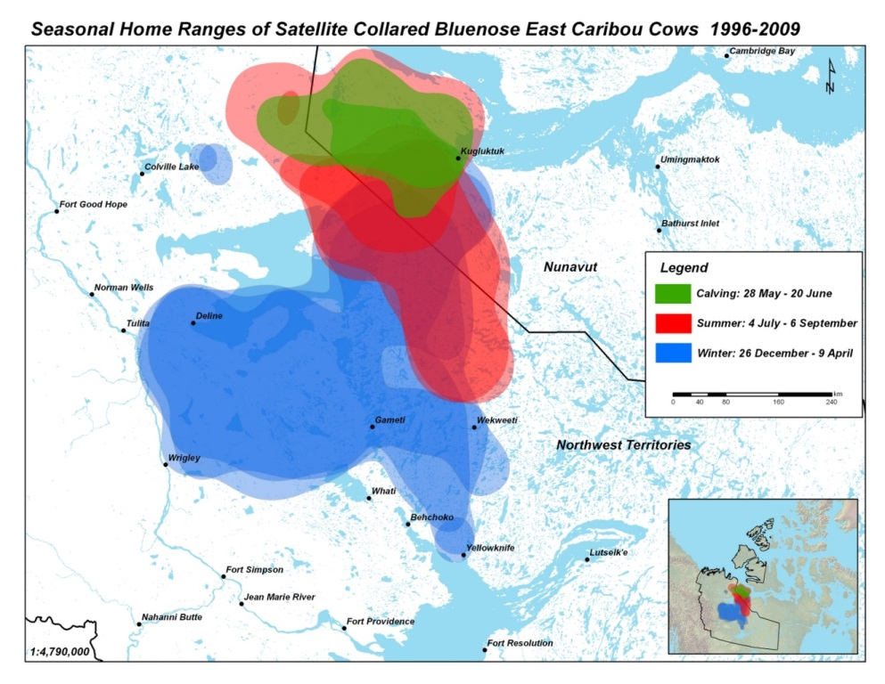

Titigauyaq 1: Nugiuqni, auyami, ukiumilu tikitpaknit tapkuat Bluenose-Kanagnani tuktut amihuaqyuit, 1996-2009, piplugit katihimani nalautit qunguhiaqtat inigiyai kulavait. Tamna inigiya tapkuat Bluenose-Kanagnani tikitpaktai aturniqhat tahamna NWT tamnalu NU takukhauyuq iluani. Talvanga Boulanger et al. (2016).

Ahii amigaitninut naunaipkutat tapkununga Bluenose-Kanagnani amihuaqyuit qangahaq ukiuni malikhaqtut tapkununga qilamik ikiklivaliani pitquhit 2010-2015. Kinguvartuq-ukiumi nugaq:kulavait avikhimanit qangahaq ukiuni aturpakniqhat tungani 30 nugait:100 kulavait (avikhimani tapkuat 30-40 nugait:100 kulavait tamnaluniit amigaitqiyat piqatai huniumaittut amihuaqyuit). Mikhaani kulavait anaumanit mikhaanittut taphumunga 2012-2015 talvani 71%, tunganitqiyavaumit taphuma 80% piyalgit huniumaitninut amihuaqyuit (Boulanger et al. 2016). Naunaipkutalik pukkittuni iblaulgit amigaitnit ilaitni ukiuni, ilautitlugit 2010, 2012 tamnalu 2015 (ENR 2014a). Pigaluaqtitlugit naunaiqtugat aktilangi mikiyut, naunaipkutat katitauyut tapkunanga Tłı̨chǫ angunahuaqtit atuqtitlugu ukiungani angunahuaqnit pinigaqtauyut tapkuat kulavait nakuttiangitni akungani 2010 tamnalu 2014, piluaqtumiklu 2010-2012 (ENR 2014a). Atuqpiaqtut naunaiqni kihimik 61% tapkuat tuktut tautugauyut tapkunani Bluenose-Kanangnani nugiuqvit nunat talvani Juni 2015 iblaulgit kulavait; aturniqhauyuq una ilagiya nigiugiyauyuq mikhaanitnia 80% puqtutqiyanikluniit amihuniqhani nugiuqnit, taphumatut 2009 (84%) tamnalu 2012 (82%). Unniqtutiaqniqhauni naunaiyautinut munaqhityutitlu uumunga amihuaqyuit piqaqtitauyut ikayuqhiutininut titiqat; tapkuat amigaitninut naunaiyautit tuhagakhaliat (Boulanger et al. 2016) ilalgit qauyihaqninik qangahaq amigaitnit tapkunani amihuaqyuit.

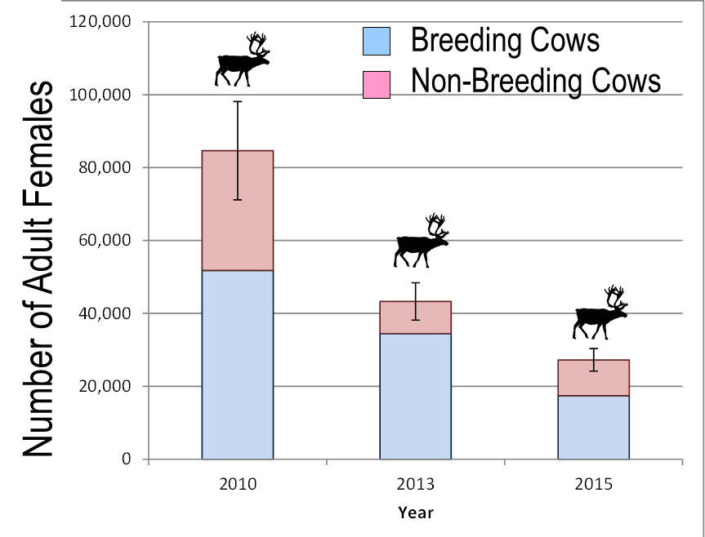

Titigauyaq 2. Mihautni qaphiuni iblaulgit iblaungittutlu kulavait (± 95% CI) tapkunani Bluenose-Kanangnani amihuaqyuit 2010-2015, piplugit nugiuqvit nunat piksaliugaqnut naunaiyaqni.

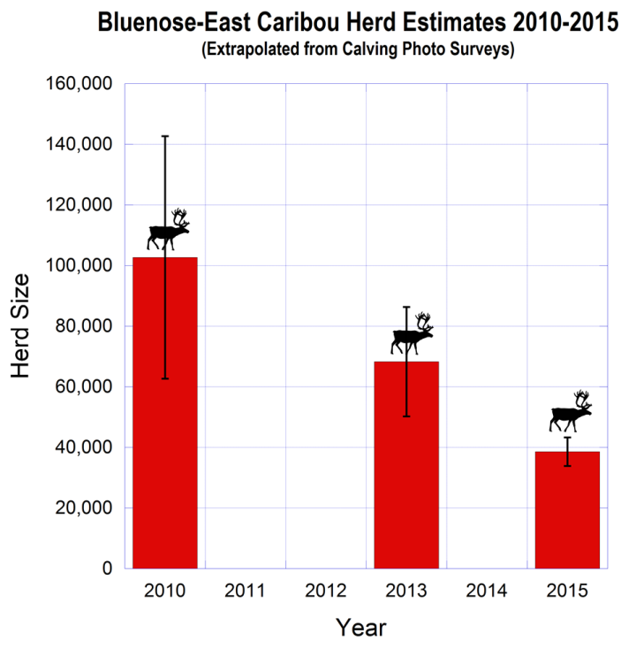

Titigauyaq 3. Mihautni qaphiuni iniqtut tuktut (± 95% CI) tapkunani Bluenose-Kanangnani amihuaqyuit 2010-2015, piplugit ahivaqni nugiuqvikni nunat piksaliugat naunaiyaqni.

- Aulataunit hunaunai tapkununga Bluenose-Kanangnani amihuaqyuit

Tamaitnut aulataunit: Tamna aulatauninut upalungaiyaut tapkununga Cape Bathurst, Bluenose-Pingangnani tapkuatlu Bluenose-Kanangnani tuktut amihuaqyuit taiyauyut Munaginit tapkuat Tuktut pivaliatitauhimayut tapkunanga Uqautyiyit Katimayigalaat tapkuat Ikayuqtigikni tapkununga Angutikhat Aulataunit (ACCWM). Una upalungaiyaut iniqtigauyuq 2014-mi, kivgaqtutauniaqlu tapkununga GNWT-kut hivulliqmik hivuligutauni aulatauninut tahapkuat pingahut amihuaqyuit. Tapkuat katimayit kigvgaqtuiyut tapkunani ACCWM ilautitlugit tapkuat Angutikhat Aulataunit Uqautyiyit Katimayit NWT-mi (WMAC-NWT), tapkuat Gwich’in Atutqikhalat Piqaqnit Katimayit (GRRB), tapkuat Ɂehdzo Got’ı̨nę Gots’ę̨́ Nákedı – Sahtú Atutqikhalat Piqaqnit Katimayit (SRRB), tapkuat Wek’èezhìi Atutqikhalat Piqaqnit Katimayit (WRRB), tapkuat Kitikmeot Nunaliit Avikhimaniani Angutikhaligiyit Katimayit (KRWB), tapkuatlu Tuktut Nogait Nunaqyuaqmi Minnguiqhiqvit Aulatauninut Katimayit (TNNPMB).

Tapkuat ACCWM-kut upalungaiyauta ilalik tamaitnut pityuhiq aulatauninut tapkuat 3 amihuaqyuit piplugit tapkuat tukligikni tapkuat tamaitnut amigaitni atuqpaknit tapkuat amihuaqyuit naliaknitni (Titigauyaq 4). Piqaqtuq 4 tukligiknit: tunguyartuq piqtuyuq qaphiuni, quqhurtuq akuniqhiurtuq qaphiuni ilavaliayuqlu, auraisi akuniqhiurtuq qaphhiuni ikiklivaliayuqlu, aupayartuqlu ikitpiaqtut qaphiuni. Tapkununga Bluenose-Kanangnani amihuaqyuit, tapkuat pihimani tapkuat aupayaqtuq tukligikni tamna 20,000 ikitqiyailuniit pihimani tapkuat tunguyaqtut tukligikni tamna 60,000 puqtutqiyailuniit.

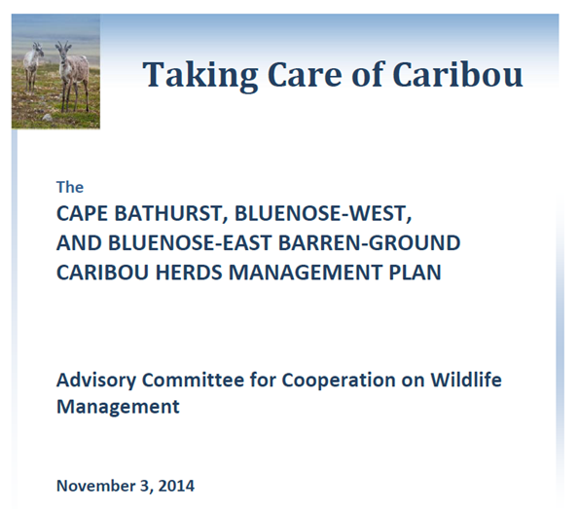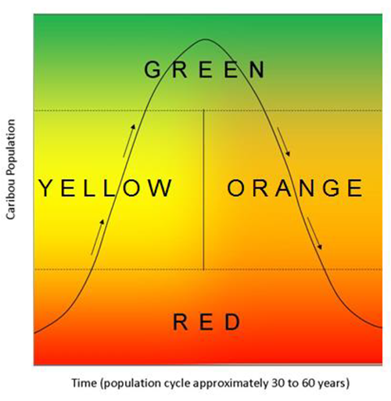

Titigauyaq 4. Tapkuat ACCWM-kut tuktut aulatauninut upalungaiyautit Munagini Tuktut (haumiani) tapkuatlu taqhai tukligikni titiqat tapkununga amihuaqyuit piplugit amigaitni aktilangi pitquhitlu.

Piplugit mikhautni aktilangi tapkuat 38,600 talvani 2015-mi qilamiklu ikiklivalianit pitquhit, tapkuat Bluenose-Kanangnani amihuaqyuit pilat tatya ihumagiyaunit auraisimi (ikiklivaliayut) tukligikni. Pikpat tatya aktilanga ikiklivaliani kayuhinit, tapkuat amihuaqyuit piniaqtukhauyut aupayaqtumi tukligiknit (pukkittut qaphiuni tapkuat 20,000 tunganiluniit) tapkunani 2-3 ukiuni. Tapkuat aulatauninut upalungaiyautit unniqtuqtai qaphiuni aulatauninut atulaqnit ihumagiyaulat pikpat amihuaqyuit tapkunanitni auraisi tukligikni; una ilalik Katitlugit Pilaqnit Angunahuaqni naamagiyauni tapkunanga ACCWM-kut, akhuqyuminilu angunahuaqni nukatukkat, uhuligait. Ahii aulatauninut atulaqnit ilalgit huliniit tapkununga angunahuaqtit aulataunit, nunap atuqnia aulatauni munagiyaunilu.

Nunap atuqni avatiliqutitlu naunaiyaqni: Piittuq tatya huliyunik uyagakhiuqvit tahamani Bluenose-Kanangnani tikitpaknit tahamani NWT tamnalu NU (Titigauyaq 5), tapkuatut ingittut Bathurst tuktut tikitpakni tahamunga Kanangnani tapkuat piqaqtut 4 atuqtut qiplagiktut uyagakhiuqvit qaphitlu ukiuq tamaat apqutauyut ukiumilu apqutit. Tundra Copper atuqhimayat havikhait havikhaqhiuqni havat tahamani nugiuqvit nunait tapkuat Bluenose-Kanangnani amihuaqyuit talvani 2014 tamnalu 2015. Tapkuat GNWT-kut qaphitlu tapkuat NWT-mi ilagit akigaqtuqtai ukuat pivaliatitni nugiuqvit nunani piplugit aktualaqnit kulavaknut nugalgit qanugililanuaqnut pivigiyat ukiuq ilagiyani.

ENR piqatauyut tamaitni qangahaq Avatiliqutit Naunaiyaqni (EA) pityuhit tahamani NWT-mi aktualanut iluiliup tuktuini tikitpaktai. ENR piqataukmiyuttauq tapkunani EA pityuhini talvani NU-mi havanguyunut aktualanik tapkununga Bluenose-Kanangnani amihuaqyuit nugiuqvi nunat auyamilu tikitpaktai (naunaipkutagiplugu Tundra Copper). Qaphit Nunaqaqaqtut kavamait ahiilu ilagit piqataukmiyuttauq tapkunani EA pityuhini tahamani NWT tamnalu NU. ENR piqatauyut qaphini havaqatigikni ilihaqnit tahamani NU-mi pinahuaqhugit hapuhimanit tuktut nayuqpaktai, akigaqtuqtailu kitutliqak pivaliatitnit iluilikmi tuktut nugiuqvi nunat.

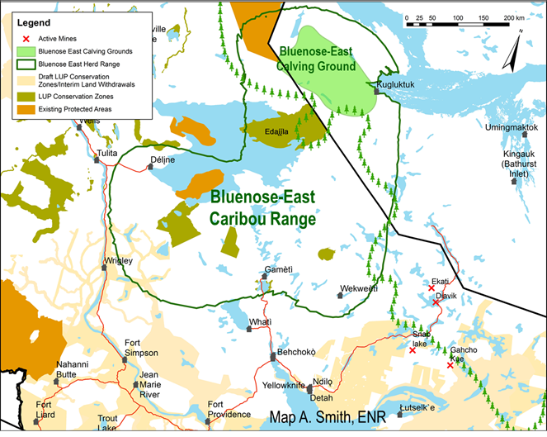

Titigauyaq 5. Ukiumi tikitpaktai tapkuat Bluenose-Kanangnani tuktut amihuaqyuit tahamani NWT tamnalu NU. Tapkuat BNE nugiuqvi nunat pingangnaani Kugluktuk. Atuqtut hapuhimaviuyut nunat nunguttailivitlu takukhauyut quqhuyaqtuni aurausinilu. Nunaliuyut atuqtutlu uyagakhiuqvit apqutitlu ilaliutihimayut.

Angunahuaqtit aulataunit: Piplugu tamna angiyuq kayuhinilu ikiklivalianit tapkunani Bathurst tamnalu BNE amihuaqyuit, tapkuat GNWT-kut hivuliqtat ikayuqtugailuniit qaphit pityuhit ilagiaqninik tapkuat angunahuaqni amaqqut qanuqlu ilagiaqni tuktut iniqtut nugaitlu annaumanit aktilangi. Tahapkuat pityuhit ilalgit:

GNWT ENR hivuliqniaqtai ikayuqtigiknit pitquhiliqutit atuguminaqnit naunaiyaqni tamaitnut tikitpakni amaqqut aulatauninut atulaqnit 2016-mi, ihumagininut tapkuat atuguminaqni, akitunit, atuttialaqnitlu allatqit aulatauninut huliniit. Tamna pinahuaqnia naunaiyaqni tapkuat atuguminaqni amaqqut aulatauninut atulaqnit atuqpalianikhai tapkunani atugauliqnit aulatauni havagutit ikayuqhiutilat utiqtitninik iluilikmi tuktut amihuaqyuit. Una naunaiyaqnia pivaliatitauniat ikayuqtigiklutik tapkununga TG ilaliutyaqnilu ahii Nunaqaqaqtut kavamait aulattiqatigiknilu katutyiqatigit.

2015-mi, tapkuat GNWT-kut nutanguqtauni atugumatyutit tapkununga ammaqqut hangunahuaqnit ilalgit 3 atulaqnit (Titigauyaq 3). Tahapkuat ilalgit atulaqni angunahuaqtut agyaqni aktuqhimaittut, huniumaittut amaqut taphumunga $200, atugumatyutikhat $450 amaqumun aktuqhimayuq atuqtauvaktut atuqpakninut, atulaqnilu tikitlugu $800 nakuniqpamun amiq aktuqhimayuq amiligiyit atuqpakninut.

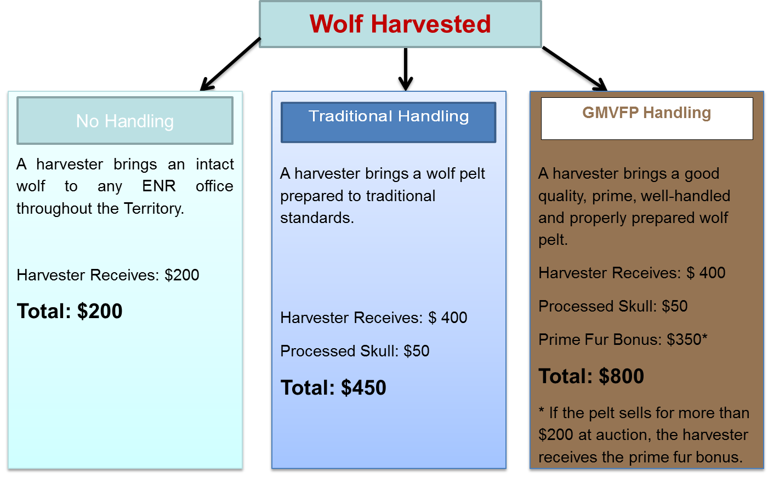

Titigauyaq 6. Atugumatyutit ammaqqut amitpiyaulat anaguqhiuqtinut talvani NWT-mi taphumunga 2015/2016.

Tapkuat Tłı̨chǫ Kavamatkut piqatigiplugit GNWT-kut ikayurtuqni pivaliatitauyut uuktutaupluni nunalikni-piplugit anaguqhiuqnit havagutit piqatigini tapkuat Tłı̨chǫ nunaliuyut tapkuat ilalgit ilihautini ikayuqtuqnilu amaguqhiurniq ukiumi tikitpaknini tapkuat Bathurst amihuaqyuit ilitquhiqnut naamagiyauyunik pityuhiqnik. Hulivalliq tuhagakhat piqaqtitauyut katutyiqatigiplugit TG-ENR Bathurst tuktut katutyiqatigit aulatauni uuktugutit tapkununga WRRB-kut.

- Qangahaq angunahuarniq aulataunilu tapkuat Bluenose-Kanangnani tuktut tahamani NWT-mi 2010-2015

Angunahuaqni tapkuat Bluenose-Kanangnani tuktut talvanga 2009 tikitkugu 2015 naunaiqtauhimayut tahamani NWT-mi tapkunanga katitlugit nunaliuyuni munagiyauni, naunaiqtuqvit uumayuligiyitlu havaktit takuyaqtuinit. Naunaipkutaunia tapkuat angunahuaqni munagiyaunit tuhagakhat takukhauyuq talvani Titigauyaq 7. Angunahuaqtut kikliqaqtitni tapkunani aturniqhani Bathurst tikitpaktai tahamani NWT-mi pigiaqtut 2010-mi pityutauyunaqhiyut ilai angunahuaqtut pipkaqni pingangnanut kanangnanutlu tapkuat Bathurst tikitpaktai, ilautitlugit ilagiaqni angunahuaqni tapkununga Bluenose-Kanangnani amihuaqyuit. Mikhaani angunahuaqni ukiup ilagiyanut akungani 2009-2010 tamnalu 2013-2014 piqaqtitauyut taliqpiani taphuma Titigauyaq 7. Tapkuat aturniqhat tuhaqhitauni/mikhautni angunahuaqnit mikhanittut 2750 tuktut/ukiumun, piplugit ikitniqhanik 65% tahapkuat kulavautitlugit. Tahapkuat mikhautnit ihumagiyauyut tungautnahugiyauni-mikhautnit, tapkuat ilaliutingitninut annaiyauyut tammainit; ilai angutauyut tuhaqhitauyuitpakmata tuhaqhitnilu-tungauttugit. Tamna atuqpiaqnia angutat ihumagiyauyuq pihimaniqhaunia 4000/ukiumun avataanutluniit.

Thapkuat angunahuaqni mikhautnit ilalgit mikhautninik Nunavut angunahuaqni talvanga Kugluktuk tapkuat 300-1000/ukiumun; tahapkuat mikhautnit piqaqtitauyut tapkunanga GN uumayuligiyit havaktinit. Tapkuat NWT-mi angunahuaqni atuqtut piniqhauplugit ukiumi akungani Tisaipa tamnalu Aipuru. Tapkuat Nunavut angunahuaqni atuqtut atuqniahamik talvani Mai, Juni tamnalu Julai, piplugit qanuqtut tikittuminaqni amihuaqyuit talvanga Kugluktuk.

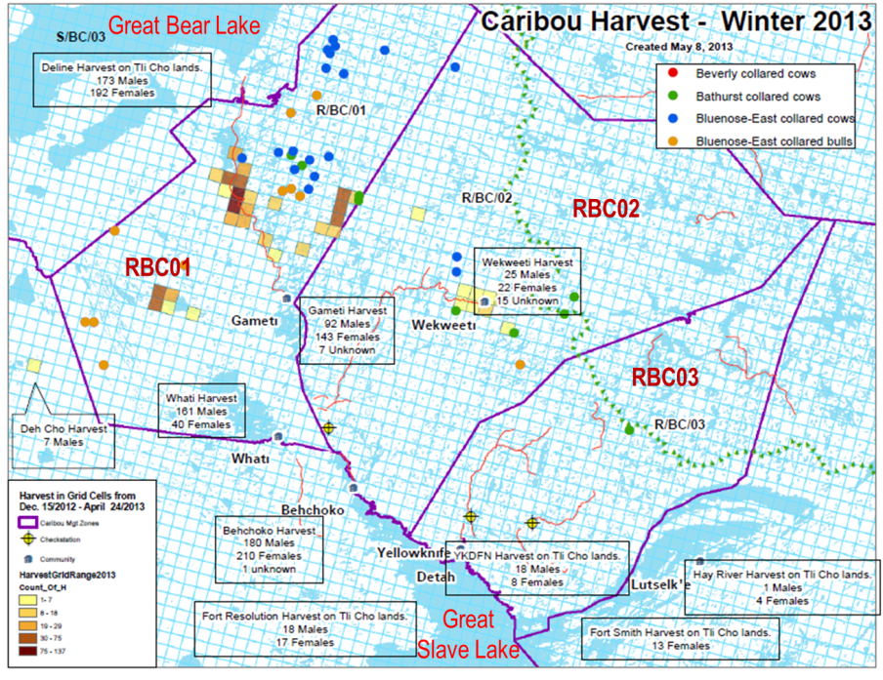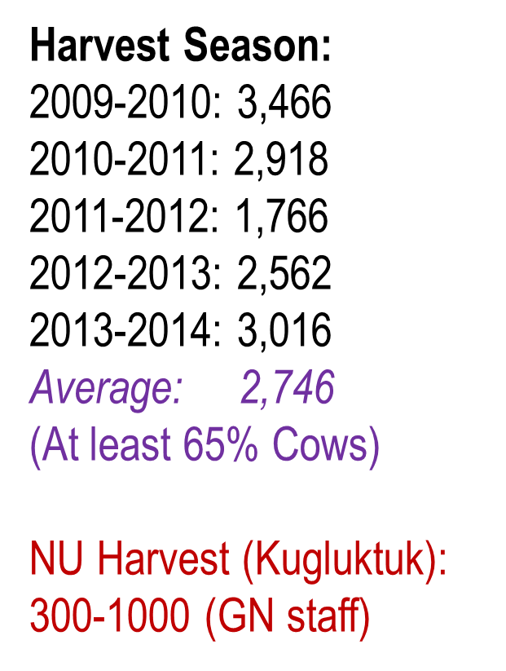

Titigauyaq 7. Nunauyaq tuhaqhitninut tuktut angutauyut tahamani North Slave tamnalu Sahtu nunaliit avikhimanini NWT-mi ukiunganut 2012-2013. Taqhalgit kikagiktut takukhautitai aturniqhat angutauni talvani 10x10 km titiqtuqninik kikagiktut. RBC02 tamnalu RBC03 tapkuat 2 anginiqhat aviknit tapkununga angutat kikliqaqnit tapkuninga 300 tunganiluniit kinguagut 2009 nunguttailininut Bathurst tuktut. Tunguyaqtut titiqni tapkuat qunguhiaqtuliqhimayut Bathurst tuktut tapkuatlu tunguqtut titiqni Bluenose-Kanangnani qunguhiaqtalgit tuktut. Angunahuaqni mikhautni tapkuat Bluenose-Kanangnani amihuaqyuit 2009-2014 titiqhimayut taliqpiani. Tahapkuat ilalgit mikhautnit angutauyunut tahamani NU-mi.

Tapkuat mikhautnit angutauyut 2009-2014 malikhimaniqhauyut ukiumin ukiumun, kihimik taphuma pivigiyani tapkuat amihuaqyuit ikiklivalianginaqtut. Tamna aktuania angunahuanginnaqninut ikiklivalianinut BNE amihuaqyuit takukhauyut talvani titigauyaq 8. Tapkuat amihuaqyuit ikiklivalianiani, tapkuat aktuanit angunahuaqninut aglivalianginnaqtun ukiuq tamaat ikayuqhiutiyukhauyutlu amihuaqyuit anmukpalianinut kayumikni. Taimattauq aktuanit angunahuanginnaqni tapkuat 4000-6000/ukiumun tapkunanga ikiklivaliayut Bathurst amihuaqyuit ikayuqhiutiyukhauyut taimattauq amihuaqyuit anmut kayumikhivaliani talvanga 2003-2006 tikitlugu 2006-2009 (Boulanger et al. 2011).

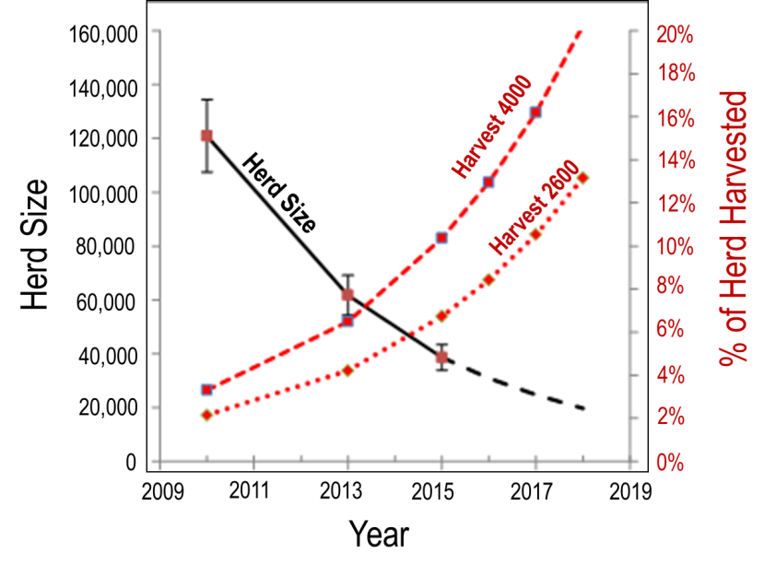
Titigauyaq 8. Aktuanit angunahuanginnaqni tapkuat 2600 tamnaluniit 4000 tuktut/ukiumun tapkunanga ikiklivaliayut Bluenose-Kanangnani amihuaqyuit 2010-2015 tapkuatlu atuqniagahugini tikitlugu 2018. Amihuaqyuit aktilanga takukhauyuq haumiani y-axis titiqtauplutiklu qirnagiktumik titiqnia, titiqtuqnilu avataanut 2015 takukhaupkagianga uuktutauyuq atuqniagahugini. Tapkuat angutauni 2600 tamnaluniit 4000/ukiumun takukhauyuq tamnaunia % tapkuat amihuaqyuit taliqpiani y-axis aupayaqtumik.

Hivuagut 2013, Nunaqaqaqtut angunahuaqnit tapkuat Bluenose-Kanangnani tuktut tahamani NWT-mi kikliqangittut. Talvani Aktuupa 2010, tapkuat WRRB-kut tuniyat tuhagakhaliaq piqaqtitlugu tukliginik atugahuaqunit piluaqtumik tapkununga Bathurst amihuaqyuit, kihimiktauq tapkununga BNE amihuaqyuit. Atugahuaquni tapkuat Bluenose-Kanangnani amihuaqyuit ilalgit umikninik nunalikni maniliugutinilu angunahuaqni ikayuqtuilutiklu Angunahuaqnit Tugagakhat Nunaqaqaqtunut angunahuaqtit tapkuninga 2800 tuktut (4% tapkuat mikhautnit 70,000) aturniqhauninut 85% pangniit. Tamna atugahuaquyauyuq angunahuaqnit tugagaq atulingittuq kinguagut 2010 amigaitninut naunaiyaqni takukhaunit tapkuat amihuaqyuit avatanitni 100,000 nakuuyumiklu nugiuqni pitaqnit (Adamczewski et al. 2014).

Ukiakhami ukiumilu 2014-2015, ENR-kut atuqtitai pingahut katimanit Nunaqaqaqtut hivuliqtit (Aagasi. 27, Nuvipa 7 tamnalu Nuvipa 28) malguklu 2-ubluk pitquhiliqutinut katimanik (Aktuupa 9-10 tamnalu Aktuupa 22-23) naunaiyaqninik naunaipkutat ikiklivalianinut tapkuat Bluenose-Kanangnani amihuaqyuit ihumagiyaunilu aulattauninut huliniit tapkuatlu Bathurst amihuaqyuit ihumagiyaunilu aulatauninut huliniit hugiaqninut tahapkuat ikiklivaliani. Piluaqtumik ihumalutauni qanugitnit talvanga Juni 2014 naunaiqtutainut naunaiyautit tapkunani nugiuqvit nunat pinigagutai angipyaktumik ikikligiaqnit talvanga 2013 tikitlugu 2014 tamatkikni amihuaqyuni. Tugangayut tuhagakhat tapkununga Bluenose-Kanangnani amihuaqyuit qanugitnit amigaitninutlu nainaqtauhimayut tapkunanga ENR-kutnit (2014). Nainaqhimani tahapkunanga katimanit ukiakhani 2014 tuyutauyut piqatauyunut piyaulatlu tapkunanga ENR-kutnit tukhiqata.

Atulihaqtitlugu 2015 tapkuat ACCWM-kut atugahuaquyai, tapkuatlu ENR-kut angiqtai, anguyauyut kikliqaqni tapkununga NWT-mi Nunaqaqaqtut angunahuaqtit taphuminga 1800 Bluenose-Kanangnani tuktut, piqaqhutik ikitniqhanik 80% tahapkunani pangniutitlugit, hippakuanut ukiungani 2014-2015. Pigaluaqtitlugu tapkuat NU-mi angunahuaqnit tapkuat
BNE-kut amihuaqyuit titigaqtauttiaqhimaittut, mikhautauyut tapkunanga GN-kut uumayuligiyit havaktinit qaphiuninut tikittugu 1000/ukiumun.

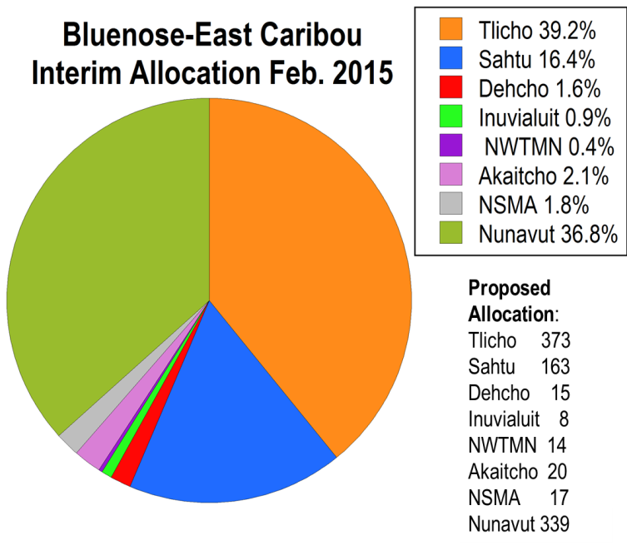
Titigauyaq 9. Atulakni hanivaqtauni tapkuat Bluenose-Kanangnani tuktut angunahuaqni tapkunanga 7 Nunaqaqaqtut ilagit tahamani NWT-mi talvanga Fibruari 2015 (taqhaliqhimayut kikagiknit tamnalu kaivyagiktuq aviktuqnia). Tapkuat 2015 hanivaqhimani tahamunga NWT kihimiuyuq ilaliutihimaittuq NU. Nunavut ilaliutihimayuq hamunga naunaipkutaunia (pinahugiplugu 1800 taphumunga NWT tamnalu 1000 taphumunga NU), ilittugiplugit tapkuat angutaunit kikligiyai taphumunga NU naunaiqtauniat tapkunanga Nunavut Uumayuligiyiqyuat Katimayit. Uuktugutauyuq hanivagaunit (ataani taliqpiani) tapkununga amihuaqyuit tamaitnut Katitlugit Angunahualaqnit 950 tuktut (ataani taliqpiani) pihimayai ayyikkutanik avikhimanit nappanik hanivaqtaunit.

Qiniqaqhugit uqauhiqaqviunit hanivaqtauninut talvanga NWT-mi Nunaqaqaqtut atuqtiuyut ilagit uumunga amihuaqyuit aulattiqatigiknilu katimayit, ENR-kut naunaiqtai hanivaiviuni tapkuat amihuaqyuit NWT-mi. Una pihimayuq anginiqhamik qangahaq titigaqnit angutauyut uumanga amihuaqyuknit kihimiktauq qaphit ahii tuhagakhat ilautitlugit naunaiyaqni ahii anguttikhat. Tamna hanivaqnit talvani Fibruari 2015 (Titigauyaq 9) ihumagiyat angutaunit tuktut piyautaqhimayut, atuqatigiknilu tapkuat 1800 haviktakhat tahapkununga: Tłı̨chǫ 1100 (61.11%), Sahtú 480 (2.67%), Dehcho 45 (2.50%), Inuvialuit 25 (1.39%), NWT Métis Nunaqaqaqtut 40 (2.22%), Akaitcho 60 (3.33%), tapkualu North Slave Métis Katutyiqatigit 50 (2.78%). Tamna pinahugiyauyuq NU-mi angutaunit tamnauyuq 1000, ilittugiplugit tapkuat angutauninut kiklikhai taphumunga NU-mun naunaiqtauniat tapkunanga Nunavut Uumayuligiyiqyuat Katimayit.

Tamna uuktugutauyuq hanivaiviuni talvani Tisaipa 2015 aulatauninut uuktutauyuq tuniyat tapkununga WRRB-kut, SRRB-kut tapkuatlu WMAC-kut tamna katitlugu 950 tuktut tamaat amihuaqyuit, atuqhunilu tamna ayyikkuta pityuhiq aviktauninut hanivaiviuni atuqtauyut talvani Fibruari 2015 hanivaqnit. Hulivalliq uqaqatigiknit hanivaininut tapkuat Bluenose-Kanangnani tuktut angutaunit tahapkunanga BNE-kut atuqtinit ilagit pilaqtut ihuaqhigiaqtaunit atuqatigikni ihuaqhautit tahapkunanga ilaginit.

- GNWT-kut uuktutai angutat aulatauninut tapkuat Bluenose-Kanangnani amihuaqyuit

Tautukhugit tapkuat qangahaq qilamik ikiklivalianit tapkuat Bluenose-Kanangnani amihuaqyuit, tamna Tisaipa 2015-mi aulatauninut uuktutai ENR-kut tuniyat tapkununga WRRB-kut,
SRRB-kut tapkuatlu WMAC-kut (NWT) ilittugiyai tapkuat amihuaqyuit tapkuat auraisi tukligiknit (akunniqhiuqtut ikiklivaliayutlu) tapkuat ACCWM-kut aulatauninut upalungaiyautit, tapkuat Katitlugit Angutaulaqnit (TAH) naamagiyauni tapkunanga ACCWM-kut ihuaqhiyaulat. Tamna aktilanga ikiklivaliani piyut tapkuat amihuaqyuit tikilaqni pukkitniqpamik amigaitni pihimani (tamna aupayartuq aviknia tapkuat amihuaqyuit mikhauhimani tapkuninga 20,000 tunganiluniit) talvani 2 ukiukni, tamnalu qilamik ikiklivaliani ihumagiyalgit uuktutauyumi aulatauninut piqatigiplugit amihuaqyuit aktilangat.

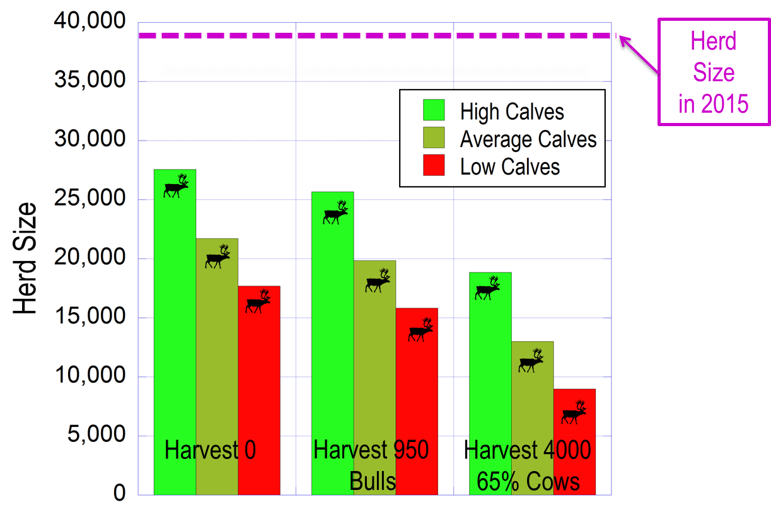

Titigauyaq 10. Hapuhimanit amihuaqyuit aktilangat tapkuat Bluenose-Kanangnani amihuaqyuit 2018-mi tapkunanga amigaitninut uuktutauninit. Tamna ilitquhia kulavait annaumanit aktilanga 74% pinahugiyauyuq. Pingahut puqtutqikni nugait annaumanit (ayyikkuta upingami nugait:kulavait aviktaunit tamna 44, 34 tamnalu 25 nugait:100 kulavait) takukhauyut tunguyaqtut, quqhuyaqtuq aupayartuqlu. Titiqni haumiani tapkununga 0 angutaunit, qitiqni qitqani tapkununga angutauni 950 pangniit kihimik, titiqnitlu taliqpiani tapkununga angutauni 4000/ukiumun, 65% kulavait.

Tamna amigaitninut uuktutaunia atuqtauyuq nalauttaqnit tapkuat amihuaqyuit atulaqnikhai aktilanga 2018-mi piniani tukliqmik nugait piksaliuqnit naunaiyaqni nigiugiyauni (Titigauyaq 10). Tamna atuqniagahugini ihumagiyauyut ilitquhit kulavait anniumani aktilanga 74%. Haumiani tapkuat amihuaqyuit mikhautauni taphumunga 2018 angutaunittumik tamnalu 3 puqtutqit nugait annaumanit. Tamna piniagahuginia amihuaqyuit mikhautni uumani atuqniagahuginiani akunganittut 17,000 tamnalu 27,000. Akunganittut tapkuat atuqniagahugini piplugit angutauni tapkuat 950 pangniit/ukiumun tamnalu 3 puqtutqit nugait annaumanit. Tapkuat amihuaqyuit mikhautni taphumunga 2018 tikitpaknit akungani 15,000 tamnalu 26,000. Taliqpianittut atuqniagahugini piplugit angutaunit 4,000 tuktut/ukiumun tamnalu 65% kulavait. Piplugu una puqtunia angutauni, tapkuat amihuaqyuit mikhautni taphumunga 2018 tikitpaknit talvanga puqtuniqpaq mikhaani 19,000 talvunga pukkitniqpaq mikhaani 8,000 tuktut. Naunaigialik tapkuat aupayartut titiqni aturniqhaulat atuqniagahugini piplugit pukkitniqhat nugait anniumani qangahaq takuyauni uumani amihuaqyuit. Piplugit amigaitni uuktutaunit tikitpaktaini angutaunit puqtunit tapkuatlu anguhallut aqnallut avikhimanit, amihuaqyuitlu allatqinik puqtunilgit kulavait anniumanit nugiuqnilu (Boulanger tamnalu Adamczewski 2014), ENR-kut pivaliatitat tamna “maliktauvaknit” pityuhit atugahuaquninut angutat puqtunit (ENR 2014b; Titigauyaq 11), ihuaqhiyauyuq titiqani ataani. Piplugit pukkipyaknigiyai qaphiuni qilamiklu ikiklivaliani pitquhit, tapkuat Bluenose-Kanangnani amihuaqyuit 2015-mi ihumagiyaulat hivuganarniqpat, taimaittumnik pukkitnit aktilanga angutaunit puqtuyumiklu akhuqyumini pnganiit atugahuaquyaulat.

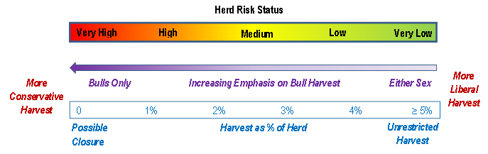
Titigauyaq 11. Atugahuaquni tikitpaknit tapkunanga iluiliup tuktut amihuaqyuit piplugit amihuaqyuit aktilanga pitquhitlu (ENR 2014b), piplugit angutauni uuktutauni tapkunanga Boulanger tamnalu Adamczewski (2014). Amihuaqyuit pukkitniqhani qaphiunini ikiklivalianilu qilamik hivuganarniqpauyut hulivalliq angiyumik ikiklivalliqnit pipkagaulaitniqhaitlu angipyaktumik angutauninik.

Talvani Tisaipa 2015-mi aulatauninut uuktutauni tuniyauyut tapkununga WRRB-kut, SRRB-kut tapkualu WMAC-kut, ENR-kut atugahuaquyai tapkuat nunaliuyut maniliugutitlu angutaunit ukunanga amihuaqyuit huniumaittukhat talvani 0, tapkuatlu Nunaqaqaqtut angutauni kikliqaqtitakhat amihuaqyuit-tamaitnut piplugit talvunga 950 tuktut/ukiumun tamnalu 100% pangniit. Una angutaunia naunaiyaqtaulutik ukiuq tamaat piplugit naunaiyatqikhaqlugitlu nutat tuhagakhat piyaulaliqata. Atuqniagahuginianut tamaitnut amihuaqyuit aktilanga mikhautnia tamna 38,592, angutaunia tamna 950 kivagtutauyuq 2.5% tapkuninga amihuaqyuit. ENR-kut ihumagiyat tapkuat ACCWM-kut atugahuaqunit angutauni kiklikhat tamna 1800 (2800 katitlugu tapkunanga amihuaqyuit, ilautitlugu NU-mi) talvanga 2014-2015 puqtuvallaq kayuhinikhanut, piplugit tapkuat amihuaqyuit qilamik ikiklivaliani naamangittumiklu amigaitninut naunaipkutat. Tamna 50% ikiklivaliani tapkuat amihuaqyuit iblaulgit kulavait talvanga 2013 tikitlugu 2015 naunaipkutauyut tapkuat amihuaqyuit iblaulgit kulavait nunguttailiyalgit piniaqata amihuaqyuit hunniumaititnit utiqpalianilu. Tuhaqhitauniani talvani ACCWM-kut upalungaiyautit, angutauni pangniit pinahuagakhat nukatugaqnut uhuligaqnutlu piyakhaini amigaitniqhat pangniit nugiuqtikhauninut. Angutauyut tapkuat 950 pangniit ilaliutingittut hivuganaqninut ikiklivaliqniqhainut tapkuat amihuaqyuit, kihimik mikiniqhamun piplugit tapkunangaunganit hivuganarniqhat angutaunit ilalgit anginiqhamik kulavaknut (Titigauyaq 9).

Tamna Tisaipa 2015 uuktugutit tapkununga Katitlugit Angutaulat aviktaunilu tuniyauyut tapkununga WRRB-kut, SRRB-kut tapkuatlu WMAC-NWT-mi uuktutauyut angutauninik 611 tuktut tahamani NWT-mi (Tłı̨chǫ 373, Sahtú 163, Dehcho 15, Inuvialuit 8, NWT Métis Nunaqaqaqtut 14, Akaitcho 20, tapkuatlu North Slave Métis Katutyiqatigit 17), takukhautitani Titigauyaq 9. Aulatauni tapkuat angutauyut atuqhugit haviktait, pilagutit ahiilu pityuhit pivaliatitauniat ikayuqtigiklutik tapkununga Nunaqaqaqtut nunaliuyut. ENR-kut ilihimaniaqtukhat tamna hivuligutat takukhauyuq nunaliuyunit talvani Délı̨nę pivaliatitninik nunalikningaqtut tuktut nunguttailini upalungaiyautit akhuqyuminiaqtai pangniit angunahuaqni kiklikhailu 150 tuktut ukiumun taphumunga nunaliuyuq (Délı̨nę 2016).

Atuqhugit uuktutauyuq amihuaqyuit-tamaita Katitlugit Angutaulat tapkuat 950 ikayuqhiqninut nunguttailiyauni ukuat amihuaqyuit, una uuktutauyuq ilaqalaq hanivaqtauninikk tapkuat 339 Bluenose-Kanangnani tuktut Nunavutmun. ENR-kut pilagutilgit angutikhat aulatauninut tuktutluniit angunahuaqni Nunavutmi, kihimik ikayuqtigikniat havaliknut pilaqtitiyinut Nunavutmi mikhaanut ayyikkiktumik tamaitnut pityuhiqnut Nunaqaqaqtut angunahuaqnit ukuninga amihuaqyuknik NT-mi tahamanilu unalu Nunavut.

Naunaipkutat:

Adamczewski, J., J. Boulanger, B. Croft, T. Davison, H. Sayine-Crawford, tamnalu B. Tracz. 2014. Hutqiyauni nugiuqvit nugiuqaqtitlugitlu nunat piksatigut naunaiyautit tapkununga Bluenose-Kanangnani amihuaqyuit iluiliup tuktuinut Nunatsiaqmi, Kanata 2010-mi. Avatiligiyit Nunamitutuqatlu Piqaqnit, Kavamatkut Nunatsiaq. Titigaqhimayut Tuhagakhaliat 244.
Avatiligiyit tapkuatlu Nunamittutuqat Piqaqnit (ENR). 2014a. Bathurst tapkuatlu Bluenose-Kanangnani Tuktut Amihuaqyuit: Tamaita Takuyauni Amigaitnit Pitquhit 2009-2014. Makpigaliuqtaungittuq Tuhagakhaliaq Saptaipa 2014. Timinga Avatiligiyit Nunamittutuqatlu Piqaqnit, Kavamatkut Nunatsiaqmi, Yellowknife, NT, Kanata.
Avatiligiyit tapkuatlu Nunamittutuqat Piqaqnit (ENR). 2014b. Angunahuaqtut atugahuaquyai tapkununga iluilikmi tuktut piplugit amihuaqyuit nungutnahuquqni piplugit: Maligaq atuqpaknia pityuhiq. Makpigaliuqtaungittuq Tuhagakhaliaq 2014. Timinga Avatiligiyit Nunamittutuqatlu Piqaqnit, Kavamatkut Nunatsiaqmi, Yellowknife, NT, Kanata.
Boulanger, J., A. Gunn, J. Adamczewski, tamnalu B. Croft. 2011. Tuhagakhanit-pihimayut amigaitninut uuktugutit qiniqtauninut ikiklivaliani tapkuat Bathurst tuktut amihuaqyuit. Taiguat tapkununga Angutikhat Aulatauninut 75:883-896.
Boulanger, J., B. Croft, J. Adamczewski, D. Cluff, D. Lee, N. Larter tamnalu L.M. Leclerc. 2016. Mikhautni iblaulgit kulavait qauyihaqnilu amigaitni tapkununga Bluenose-Kanangnani amihuaqyuit iluiliup tuktuit: 2015 nugiuqvit nunat piksaliugaqnut naunaiyainiq, uuktugut Fibruari 19, 2016. Avatiligiyit Nunamittutuqatlu Piqaqnit, Kavamatkut Nunatsiaqmi, Yellowknife, NWT, Kanata.
Boulanger, J., tamnalu J. Adamczewski. 2014. Tamaitnut pityuhit angunahuaqniqmun uuktutauni tuktunut amihuaqyuit tahamani NWT-mi – uuktut atugahuaqninut thagakhaliat. Makpigaliuqhimaittuq Tuhagakhaliat. Timinga Avatiligiyit Nunamittutuqatlu Piqaqnit, Kavamatkut Nunatsiaqmi, Yellowknife, NT, Kanata.
Délı̨nę. 2015. Tamna Délı̨nę Got’ı̨nę Upalungaiyaut Huliniinut: Délı̨nę Tuktut Nunguttailinit Upalungaiyautit. http://srrb.nt.ca/index.php?option=com_docman&view=document&layout=default&alias=1287-2016-009-deline-caribou-plan-approved-16-01-08-edition&category_slug=proposal-for-decision-and-supporting-documentation&Itemid=697
Kavamatkut Nunatsiaqmi tapkuatlu Tłı̨chǫ Kavamait (GNWT tamnalu TG) Katutyiqatigit Uuktuta tapkununga Tuktut Aulatauninut Huliniit tapkununga Bluenose-Kanangnani amihuaqyuit: 2016-2019. 2015. Uuktut tuniyat tapkununga WRRB-kut Tisaipa 15, 2016.
Uqautyiyit Katimayigalaat tapkununga Ikayuqtigiktut tapkuat Angutikhat Aulaninut (ACCWM). 2014. Munagini Tuktut – Tapkuat Cape Bathurst, Bluenose-Pingangnani, tapkuatlu Bluenose-Kanangnani Iluiliup Tuktuit Amihuaqyuit Aulatauninut Upalungaiyautit (Kingulliqpaq). C/O Wek’ èezhı̀i Atutqikhalat Piqaqnit Katimayit, 102A, 4504 – 49 Avenue, Yellowknife, NT, X1A 1A7.

