

DISTRIBUTION AND ABUNDANCE OF PEARY CARIBOU (Rangifer tarandus pearyi)
AND MUSKOXEN (Ovibos moschatus) ON DEVON ISLAND, MARCH 2016

MORGAN ANDERSON¹

Version: 13 July 2016

¹Wildlife Biologist High Arctic, Department of Environment
Wildlife Research Section, Government of Nunavut Box 209 Igloolik NU X0A 0L0

STATUS REPORT 2016-01
NUNAVUT DEPARTMENT OF ENVIRONMENT
WILDLIFE RESEARCH SECTION
IGLOOLIK, NU
Anderson, M. 2016. Distribution and abundance of Peary caribou (Rangifer tarandus pearyii) and muskoxen (Ovibos moschatus) on Devon Island, March 2016. Nunavut Department of Environment, Wildlife Research Section, Status Report 2016-01, Igloolik, NU.

Summary
We flew a survey of Devon Island including Philpots Island (Muskox Management Zone MX-04), by Twin Otter in 58 hours between March 22 and 30, 2016, to update the population estimate for caribou and muskoxen in the study area. The previous survey, in 2008, reported a minimum count of 17 Peary caribou and population estimate of 513 muskoxen (302-864, 95%CI). The 2016 survey found the highest reported abundance estimate for muskoxen (1,963 ±343 SE), and a minimum count of 14 Peary caribou suggests that they continue to persist at low densities on the island, although the low number of observations precludes calculation of a reliable population estimate.

Muskoxen were abundant in the coastal lowlands where they have been found historically, at Baring bay, Croker Bay, Dundas Harbour, and the Truelove Lowlands. They were also abundant on the north coast of the Grinnell Peninsula, and particularly abundant on Philpots Island, where we observed 310 muskoxen. Although most previous surveys covered only part of Devon Island, they did target these lowlands and their abundance estimates or minimum counts likely represent the majority of the muskox population. This survey indicates a large increase in muskoxen on Devon Island, with more observations in all lowland areas compared to 2008, and a particular increase on Philpots Island. This population trend is mirrored on neighboring Bathurst Island to the west, surveyed in 2013, and southern Ellesmere Island to the north, surveyed in 2015.

We only saw 14 Peary caribou during the survey, concentrated on the north shore of the Grinnell Peninsula, and tracks were seen south of Baring Bay. No caribou were seen in the Truelove Lowlands, although hunters from Grise Fiord have caught caribou there over the past several years. It is likely that the low density and patchy distribution of caribou in this area meant that they were not detected on the survey flights. Previous surveys also found caribou in small numbers in specific locations, including a minimum count of 17 caribou in 2008 and 37 caribou on western Devon Island in 2002. Combined with the local knowledge of residents of Grise Fiord and Resolute Bay, it is likely that this population of Peary caribou remains stable at low densities, patchily distributed on Devon Island.

Contents

List of Figures iv
List of Tables vi
Introduction 7
Study Area 8
Methods 9
Aerial Survey 9
Analysis 12
Results 14
Abundance Estimates 14
Population Trends 16
Calf Recruitment 16
Group Size 16
Discussion 16
Population Trends 16
Changes in Distribution 17
Calf Recruitment 18
Group Sizes 18
Management Recommendations 19
Acknowledgements 20
Literature Cited 20
Appendix 1. Devon Island survey transects, 2016. 23
Appendix 2. Delineation of survey strata for Devon Island. 27
Appendix 3. Alternate population calculations. 32
Jolly Method II Calculations 32
Stratified Systematic Survey Calculations 33
Appendix 4. Daily flight summaries for south Ellesmere survey flown by Twin Otter, March 2015. 34
Appendix 5. Incidental wildlife observations. 35

List of Figures

Figure 1. Major landmarks of the study area, with glaciers in stippled blue and transects in dark red running east-west. 9
Figure 2. Transects and survey strata for Devon Island, March 2016 survey. Dark green and C transects are the low density stratum, flown with transects 15 km apart, bright green and B transects are intermediate density stratum, flown with transects 10 km apart, and pale green and A transects is high density stratum flown with transects 5 km apart. 10
Figure 3. Derivation of wing strut marks for strip boundaries, where w and w₂ are calculated as described in the text, h is measured (2.2 m for Twin Otter on wheel-skis), and dotted lines indicate observer sightlines as modified from Norton-Griffiths (1978). 11
Figure 4. Observations of Peary caribou and muskoxen on Devon Island, March 2016, including observations on and off transect, and on ferry flights. 14
Figure 5. Population estimates for muskoxen and caribou on Devon Island. Muskox estimates prior to 1980 were extrapolations from minimum counts (Tener 1963, Freeman 1971, Hubert 1977, Decker in Urquhart 1982, Case 1992), followed by minimum counts (Pattie 1990, GN data unpublished for 2002) and then systematic surveys covering part (GN data unpublished for 2002) or all (Jenkins et al. 2011 and this survey) of Devon Island. Caribou estimates are guesses (Tener 1963) or minimum counts (Jenkins et al. 2011, this survey). 17
Figure 6. Minimum counts of muskoxen recorded on surveys of lowland areas where muskoxen congregate (Freeman 1971, Hubert 1977, Decker in Urquhart 1982, Pattie 1990, Case 1992, GN data unpublished for 2002 and 2008, Jenkins et al. 2011, and this survey). Not all areas were surveyed in all years. 17
Figure 7. Locations of muskox harvest from Grise Fiord, Resolute Bay, and Arctic Bay, 1990-2015. Survey strata are indicated by shaded green – high density (pale green), intermediate density (bright green), low density (dark green). 27
Figure 8. Locations of caribou and muskoxen seen on aerial surveys in 2002 and 2008. Survey strata are indicated by shaded green – high density (pale green), intermediate density (bright green), low density (dark green). 28
Figure 9. Telemetry locations of 4 collared female caribou, 2003-2006, on Devon Island. Survey strata are indicated by shaded green – high density (pale green), intermediate density (bright green), low density (dark green). 29
Figure 10. Telemetry locations of 5 collared female muskoxen, 2003-2006, on Devon Island. Survey strata are indicated by shaded green – high density (pale green), intermediate density (bright green), low density (dark green). 30
Figure 11. Land cover classification developed from Landsat imagery 1999-2002 (Olthof et al. 2008; available online through Natural Resources Canada). Survey strata are outlined and hatched by light green (intermediate density) or dark green (low density), with remaining non-icecap areas as high density strata. 31
Figure 12. Incidental observations, Mar 22-30 2016, and flight lines for an aerial survey of Devon Island. Some track lines are incomplete due to loss of satellite coverage. A total of 37 polar bears were observed, as well as 5 ringed seals basking on the sea ice in Wellington Channel, and 2 groups of beluga (6 and 7 individuals) along the floe edge south of Grise Fiord. Polar bear family groups included very small cubs recently emerged from dens, and one den was seen with tracks, 40 km northwest of Maxwell Bay. 35

List of Tables

Table 1. Survey strata for Devon Island, March 2016. 9
Table 2. Muskox population calculations for 3 strata on Devon Island with variance calculated by nearest neighbor methods and by deviations from the sample mean. 15
Table 3. Peary caribou population calculations for 3 strata on Devon Island with variance calculated by nearest neighbor methods and by deviations from the sample mean. 15
Table 4. Transect end points and strata on Devon Island for a fixed-wing survey, March 2016. 23
Table 5. Abundance estimates (Jolly 1969 Method II) for muskoxen on Devon Island, March 2016. N is the total number of transects required to completely cover study area Z, n is the number of transects sampled in the survey covering area z, y is the observed caribou/muskoxen, Y is the estimated caribou/muskoxen with variance Var(Y). The coefficient of variation (CV) is also included. 32
Table 6. Summary by day of survey flights and weather conditions for March 2015 Peary caribou and muskox survey, southern Ellesmere Island. 33

Introduction

Peary caribou (Rangifer tarandus pearyi) are a small, light-coloured subspecies of caribou/reindeer inhabiting the Canadian Arctic Archipelago in the Northwest Territories and Nunavut from the Boothia Peninsula in the south to Ellesmere Island in the north. They are sympatric with muskoxen (Ovibos moschatus) over much of their range although diet, habitat preferences, and potentially interspecific interactions separate the two species at a finer scale (Resolute Bay Hunters and Trappers Association [HTA] and Iviq HTA, pers. comm.). Arctic wolves (Canis lupus arctos) occur at low densities throughout Peary caribou range, but the most significant cause of population-wide mortality appears to be irregular die-offs precipitated by severe winter weather and ground-fast ice that restricts access to forage (Miller et al 1975, Miller and Gunn 2003, Miller and Barry 2009).

Peary caribou have been surveyed infrequently and irregularly on the Canadian Arctic Archipelago since Tener’s 1961 survey, which provided a best guess estimate of 150 Peary caribou on Devon Island, although persistent fog prevented the Colin Archer Peninsula from being surveyed (Tener 1963). Since Tener’s survey, unsystematic surveys have been conducted irregularly, usually with a focus on muskoxen in the lowland areas where they are concentrated. In 2002, the western Devon Island was surveyed as part of a program to update population estimates for Peary caribou across their range, and a minimum count of 37 was recorded (Jenkins et al. 2011). The entire island was surveyed in 2008, with a minimum count of 17 caribou (Jenkins et al. 2011). Residents of Grise Fiord and Resolute Bay have not noticed a marked increase or decline in caribou on Devon Island (Iviq HTA, pers comm.), but with higher caribou populations to the west on the Bathurst Island Complex, residents of Resolute were interested in whether caribou have moved onto northern or western Devon Island. Grise Fiord hunters regularly travel the Truelove Lowlands and catch caribou there. Community members were interested in the abundance and distribution of caribou in that area as well as in other areas where the caribou potentially move to.

Population estimates for muskoxen on Devon Island have mostly been estimated based on their abundance in discrete lowland habitat patches. In 1961, Tener surveyed the entire island (except the Colin Archer Peninsula, due to fog) at 6% coverage, and estimated that the population was about 200 muskoxen (Tener 1963). Subsequent surveys focused on the lowland areas where muskoxen could be reliably located. The overall population of muskoxen was believed to be around 300-400 through the 1970s to 1990s (Freeman 1971, Hubert 1977, Decker in Urquhart 1982, Pattie 1990, Case 1992), reaching 513 (302-864 95%CI) by 2008 (Jenkins et al 2011). This was also the first systematic survey of the entire island, although much of Devon Island is unsuitable habitat and it is unlikely that the unsystematic surveys of lowlands missed large numbers of muskoxen. Muskoxen were located consistently in the lowlands around Baring Bay, Maxwell Bay, Dundas Harbour, Philpots Island, Truelove Inlet, Sverdrup Inlet, and the northeast shores of Grinnell Peninsula.

The Peary caribou and muskoxen of western and northern Devon Island are important to the communities of Resolute Bay and Grise Fiord. Arctic Bay hunters also access the southern shores of Devon Island, and with the decline in Baffin Island caribou, Devon Island might become more important in the harvest activities of Arctic Bay. Muskoxen have been hunted in the area since the government ban on muskox hunting was lifted in 1969. As species of presumption of need, subsistence tags are currently set aside and allocated for subsistence, commercial use, and sport hunts according to the allocation of Regional Wildlife Organization (RWO) and Hunter and Trapper Organizations/Associations (HTOs/HTAs). Caribou have been regularly hunted in the region since the communities of Resolute Bay and Grise Fiord were established in the 1950s, although parts of Devon Island have been important harvest areas for centuries. This survey was conducted to update the population estimates, demographic characteristics, and distribution of Peary caribou and muskoxen on Devon Island.

Study Area

The survey area is predominantly polar desert and semi desert, with rugged topography along the mountains and fiords of the south and east coasts, which rise from sea level to 700 m, transitioning to rolling terrain dissected by deep river valleys in the interior and on the Grinnell Peninsula. The island is dominated by the 14, 590 km² Devon Ice Cap, rising to 1800 m AMSL in the center, which is also the highest point on the island. Several smaller glaciers are scattered along the south coast, Grinnell Peninsula, and Colin Archer Peninsula. Cushion forb barrens or cryptogam-herb barrens dominate the island, usually at <5% cover and <100 g/m² biomass, with isolated patches of prostrate dwarf shrub and prostrate dwarf shrub/graminoid tundra in the coastal lowlands, where vegetation cover increases to 5-50% and biomass increases to 100-500 g/m² (Gould et al. 2003, Walker et al. 2005).

Mean July temperatures are 3-5°C on the west side of the study area and 5-7°C in the east (Gould et al. 2003 and references therein). In March 2016, the average daily low and high temperatures in Resolute were -32.2°C and -26.1°C; in Grise Fiord, average daily low temperatures were -32.4°C and average daily high temperatures were -25.6°C (Environment Canada weather data, available http://climate.weather.gc.ca/index_e.html). Most of the study area was snow-covered, although some valleys, particularly along the northeast coast, were largely windswept. There was 26-29 cm snow recorded on the ground at Resolute in March 2016 and 4.3 mm of precipitation, compared to 0-5 cm of snow on the ground in Grise Fiord and 5.1 mm of precipitation (Environment Canada weather data).

The March 2016 aerial survey was flown to cover the same study area as the previous 2008 survey (Jenkins et al. 2011), excluding North Kent Island and Bailie Hamilton Island. We stratified the study area to allocate more effort to good habitat where caribou or muskoxen had previously been reported with a 5-km transect spacing and areas with moderate habitat that might have wildlife were survey with a 10-km spacing. We flew transects spaced 15 km apart over barren parts of the island that were unlikely to be occupied by caribou of muskoxen, but where animals could be travelling between suitable habitat patches (Figure1).

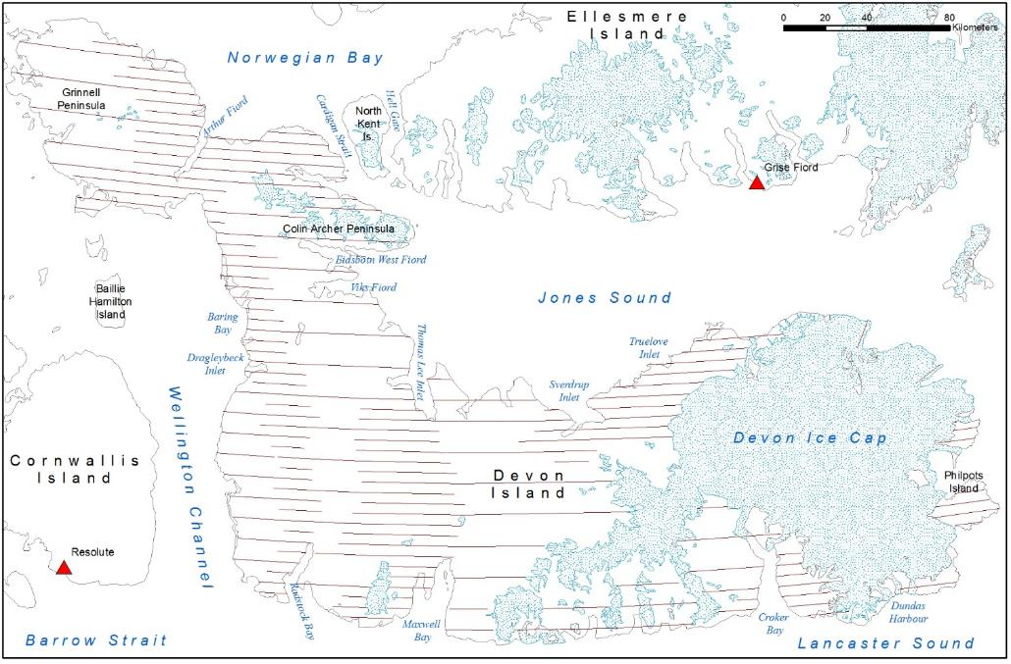
Figure 1. Major landmarks of the study area, with glaciers in stippled blue and 2016 transect lines in dark red running east-west.

Methods

Aerial Survey
Survey transects (n=166, Appendix 1) followed the transects established for the 2008 distance sampling helicopter survey, parallel to lines of latitude with 5, 10, or 15 km spacing and a 500 m strip on either side of the aircraft. Ice caps were excluded, and we did not detect any caribou, muskoxen, or their tracks on any ice caps during ferry flights. We stratified the study area to maximize survey effort in areas expected to have caribou or muskoxen, since much of Devon Island is barren gravel and till, unlikely to support wildlife. The high density (A) stratum was flown with transects spaced 5 km apart, the intermediate stratum (B) flown at 10 km spacing, and the low density stratum (C) was flown at 15 km spacing. Strata and transects are shown in Figure 2 and Table 1. Data used for delineation of the strata is provided in Appendix 2.

Table 1. Survey strata for Devon Island, March 22-30 2016.
Block ID | Stratum | Strata Area, Z (km²) | Transect Spacing (km) | Transects Surveyed | Survey Area, z (km²) | Sampling Fraction, f (%)
A | High Density | 18438 | 5 | 117 | 3388 | 18.4%
B | Medium Density | 6360 | 10 | 21 | 581 | 9.1%
C | Low Density | 15076 | 15 | 28 | 1024 | 6.8%

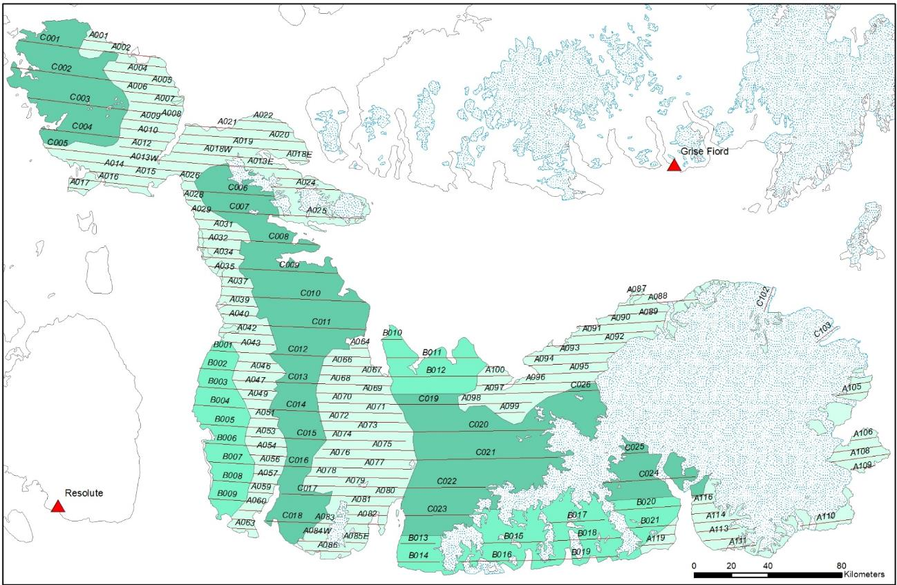
Figure 2. Transects and survey strata for Devon Island, March 22-30, 2016. A transects are the high density stratum flown with transects 5 km apart (pale green), B transects are the intermediate density stratum, flown with transects 10 km apart (bright green), and C transects are the low density stratum, flown with transects 15 km apart (dark green).

To define the transect width, we marked survey aircraft wing struts following Norton-Griffiths (1978):
$$w=W\left(\frac{h}{H}\right)$$

where $W$ is the strip width, $H$ is the flight height, $h$ is the observer height when the plane is on the ground and $w$ is calculated, measured and marked on the ground to position wing strut marks (Figure 3). For this survey we only used one mark representing 500 m marked on the wing strut. Fixed-wing strip transect sampling has been successfully used in the high arctic since 1961, and can be useful when observations are insufficient to determine the effective strip width required for distance sampling.

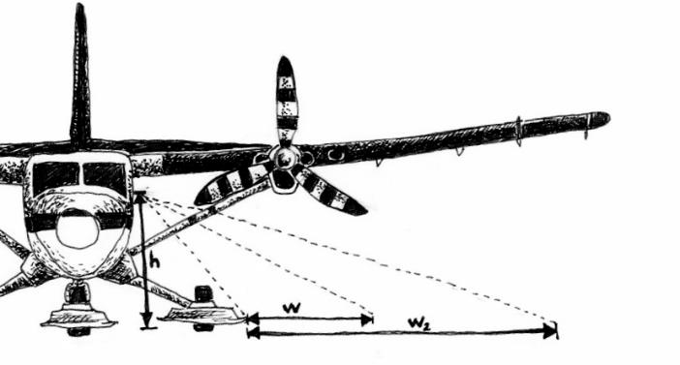
Figure 3. Derivation of wing strut marks for strip boundaries, where w and w₂ are calculated as described in the text, h is measured (2.2 m for Twin Otter on wheel-skis), and dotted lines indicate observer sightlines as modified from Norton-Griffiths (1978).

Transects were flown between 160-220 km/hr with a DeHavilland Twin Otter – higher speeds were used for uniform, snow-covered landscapes where visibility was excellent. Surveys were only conducted on good visibility days to facilitate detection of animals, tracks, and feeding craters, as well as for operational reasons to ensure crew safety. Flight height was set at 152 m (500 ft) using a radar altimeter. In rugged terrain, the flight height was adhered to as closely as possible within the constraints of crew safety and aircraft abilities.

A Twin Otter with 4-6 passengers (2 front observers, 2-4 rear observers, one of whom was also data recorder) was used to follow the double-observer methodology, which has been successful in other muskox and caribou surveys in Nunavut (see Campbell et al. 2012 for an overview of the methodology) and specifically in the High Arctic on Bathurst and Ellesmere islands (Anderson 2014, Anderson and Kingsley 2015). Front and rear observers on the same side of the plane were able to communicate and all observations by front and rear observers were combined. Estimates of group size are a potentially large source of error in calculating population estimates. However, Peary caribou and muskoxen are generally distributed in relatively small groups where observer fatigue is likely to be a more important source of error (A. Gunn, pers. comm.). We found obvious benefits of using the platform where having the added observers not only increased the accuracy of age and sex classification, but also allowed some crew members to classify with binoculars while others continued to scan for nearby groups and individuals.

All observations of wildlife and tracks were marked on a handheld Garmin Montana 650 global positioning system (GPS) unit, which also recorded the flight path every 15 seconds. Sex and age classification was limited, since the aircraft did not make multiple passes (to minimize disturbance), but adult/short yearling (calves from the previous spring, i.e. 10-11 months old) determination was often straightforward for muskoxen and aided by binoculars. Muskoxen were frequently spotted more than a kilometer off transect due to their large aggregations and dark colour in contrast to the snowy background. Depending on distance and topography, an accurate count could not always be determined for these groups. Newborn muskoxen were obvious based on size, but their small size and close association with other animals in the herd made them difficult to count in larger groups or when muskoxen were tightly grouped. GPS tracks and waypoints were downloaded through DNR-GPS and saved in Garmin GPS eXchange Format and as ESRI shapefiles. Data was entered and manipulated in Microsoft Excel and ArcMAP (ESRI, Redlands, CA).

Analysis
Flights linking consecutive transects were removed for population analysis, although survey speed and height were maintained and all observations recorded as if on survey. Similarly, sections of transect crossing sea ice and ice fields were removed, as these areas were not included in the area used for density calculations.

Although Jolly’s (1969) Method II is widely used for population estimates from surveys, it is designed for a simple random design, rather than for a systematic survey of a patchy population. For comparison, population calculations following Jolly’s Method II are provided in Appendix 4, along with calculations following a systematic stratified survey design (Cochran 1977). The muskoxen and caribou detected in this survey were patchily distributed and serially correlated, not randomly distributed. For systematic samples from serially correlated populations, estimates of uncertainty based on deviations from the sample mean are expected to be upwardly biased and influenced by the degree of serial correlation; high serial correlation implies that there is less random variation in the unsurveyed sections between systematically spaced transects than if serial correlation were low (Cochran 1977). Calculating uncertainty based on nearest-neighbor differences incorporates serial correlation, and the upward bias in the uncertainty is expected to be less than if it were calculated based on deviations from the sample mean. Nearest-neighbor methods have been used previously to calculate variance around survey estimates on the unweighted ratio estimate (Kingsley et al. 1981, Stirling et al. 1982, Kingsley et al. 1985, Anderson and Kingsley 2015).

The model for observations on a transect survey following Cochran (1977) is:

$$y_{i}=Rz_{i}+ε_{i}\sqrt{z_{i}}$$

Where $y_{i}$ is the number of observations on transect i of area $z_{i}$, $R$ is the mean density and error terms $ε_{i}$ are independently and identically distributed. In this model, the variance of the error term is proportional to the area surveyed. The best estimate of the mean density $\hat{R}$ is:

$$\hat{R}=\frac{\sum_{i}{y_{i}}}{\sum_{i}{z_{i}}}$$

The error sum of squares, based on deviations from the sample mean, is given by:

$$\left(\sum_{i}{\frac{{y_{i}}^{2}}{z_{i}}}\right)-\frac{{\left(\sum_{i}{y_{i}}\right)}^{2}}{\sum_{i}{z_{i}}}$$

The finite-population corrected error variance of $\hat{R}$ is:

$$Var\left(\hat{R}\right)= \frac{\left(1-f\right)}{\left(n-1\right)\sum_{i}{z_{i}}}\left(\left(\sum_{i}{\frac{{y_{i}}^{2}}{z_{i}}}\right)-\frac{{\left(\sum_{i}{y_{i}}\right)}^{2}}{\sum_{i}{z_{i}}}\right)$$

Where $f$ is the sampling fraction and $n$ is the number of transects. The sampling fraction also provides the scaling factor for moving from a ratio (population density) to a population estimate. It is calculated as ${(\sum{z_{i})}}/Z$, where $Z$ is the study area and $\sum{z_{i}}$ is the area surveyed. The irregular study area boundaries mean that $f$ varies from the 20% sampling fraction expected from a 1-km survey strip and 5-km transect spacing.

If we were to apply a model $y_{i}=Rz_{i}+ε_{i}$ instead, then the variance of the error term would be independent of $z$, so the variance would depend on the number of items in the sample, but not their total size. This would lead to a least squares estimate of $R$ of $\sum{zy}/\sum{z^{2}}$, rather than the more intuitive density definition and model for $R$ presented above.

To incorporate serial correlation in the variance, we used a nearest-neighbor calculation, with the error sum of squares given by:
$$\sum_{i=1}^{n-1}{\left(\frac{y_{i}^{2}}{z_{i}}+\frac{y_{i+1}^{2}}{z_{i+1}}-\frac{{\left(y_{i}+y_{i+1}\right)}^{2}}{z_{i}+z_{i+1}}\right)}$$

i.e. the sum of squared deviations from pairwise weighted mean densities. The nearest-neighbor error variance of $\hat{R}$ is:

$$Var\left(\hat{R}\right)= \frac{\left(1-f\right)}{\left(n-1\right)\sum_{i}{z_{i}}} \sum_{i=1}^{n-1}{\left(\frac{y_{i}^{2}}{z_{i}}+\frac{y_{i+1}^{2}}{z_{i+1}}-\frac{{\left(y_{i}+y_{i+1}\right)}^{2}}{z_{i}+z_{i+1}}\right)}$$

Both variance calculations were applied to the Devon Island survey data. In addition, calculations for these strata based on Jolly’s (1969) Method II and Cochran’s (1977) systematic survey models are provided in the appendices for comparison. For the final estimate, we used the nearest neighbor variance. All distance measurements used North Pole Azimuthal Equidistant projection and area-dependent work used North Pole Lambert Azimuthal Equal Area, with central meridian at 88°W and latitude of origin at 76°N (centered over the study area for high precision).

Population growth rates were calculated following the exponential growth function, which approximates growth when populations are not limited by resources or competition (Johnson 1996):

$N_{t}=N_{0}e^{rt}$ and $λ= e^{r}$

Where $N_{t}$ is the population size at time t and $N_{0}$ is the initial population size (taken here as the previous survey in 2008). The instantaneous rate of change is $r$, which is also represented as a constant ratio of population sizes, $λ$. When $r$ >0 or $λ$ >1, the population is increasing; when$r$ <0 or $λ$ <1 the population is decreasing. Values of $r$ ~0 or $λ$ ~1 suggest a stable population.

Results

We flew surveys on March 22-30 for a total of 57.4 hours (43.2 h and 5162 km on transect). Incidental wildlife sightings are presented in Appendix 3 and daily flight summaries are presented in Appendix 4. Visibility was excellent for all survey flights with clear skies (visual estimates of <20% cloud, except some low cloud over open water along the coasts) and high contrast. Temperatures were steady about -30°C during the survey. We saw 14 caribou and 830 muskoxen (plus 6 newborn calves) in total, including off transect sightings. This included 13 Peary caribou and 344 muskoxen on transect. Spatial data presented in Figure 4 represents waypoints taken during the survey along transects and includes on- and off-transect sightings. Except for groups observed on the transect line, waypoints have error associated with the group’s distance from the plane. While observations on transect are within 500 m, some muskox groups off transect were more than 2 km away.

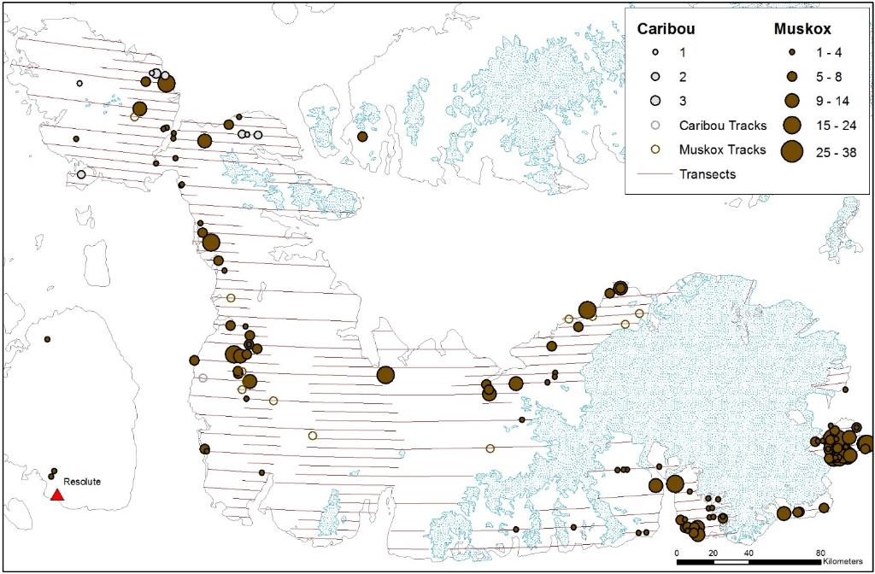
Figure 4. Observations of Peary caribou and muskoxen on Devon Island, March 2016, including observations on and off transect, and on ferry flights.

Abundance Estimates
The low number of observations in the intermediate density stratum B (9 muskoxen in 3 groups) and low density stratum C (1 group of 2 muskoxen) precluded calculation of precise population estimates for those areas, but they have been included in the overall population estimate for the island to reflect the low densities of muskoxen present in these strata. A population estimate was calculated for Peary caribou, but the few observations, which were spatially limited to the northwestern part of the study area, also prevent calculation of a precise estimate. Population estimates and variances are presented in Table 2 for muskoxen and Table 3 for caribou.

Table 2. Muskox population calculations for three strata on Devon Island with variance calculated by nearest neighbor methods and by deviations from the sample mean.
Stratum | Stratum area Z (km²) | Surveyed area z (km²) | Count, y | Estimate, $\hat{Y}$ | Density, $\hat{R}$ | Nearest Neighbor |  |  |  | Deviations from sample mean
 |  |  |  |  |  | Error Sum of Squares | Var ($\hat{Y})$ | SE | CV | Error Sum of Squares | Var ($\hat{Y})$ | SE | CV
High Density | 18438.26 | 3387.77 | 2 | 1865 | 0.002 | 168.718 | 117524.7 | 342.8 | 0.184 | 246.355 | 171604.6 | 414.3 | 0.222
Medium Density | 6359.77 | 580.54 | 9 | 69 | 0.016 | 1.101 | 2217.7 | 47.1 | 0.684 | 0.954 | 1922.6 | 43.8 | 0.637
Low Density | 15076.34 | 1023.81 | 344 | 30 | 0.101 | 0.050 | 371.9 | 19.3 | 0.655 | 0.075 | 556.5 | 23.6 | 0.801
Total | 39874.37 | 4992.12 | 355 | 1963 |  |  | 120114.3 | 346.6 | 0.186 |  | 174083.7 | 417.2 | 0.224

Table 3. Peary caribou population calculations for three strata on Devon Island with variance calculated by nearest neighbor methods and by deviations from the sample mean.
Stratum | Stratum area Z (km²) | Surveyed area z (km²) | Count, y | Estimate, $\hat{Y}$ | Density, $\hat{R}$ | Nearest Neighbor |  |  |  | Deviations from sample mean
 |  |  |  |  |  | Error Sum of Squares | Var ($\hat{Y})$ | SE | CV | Error Sum of Squares | Var ($\hat{Y})$ | SE | CV
High Density | 18438.26 | 3387.77 | 13 | 69 | 0.004 | 1.314 | 2658.0 | 51.6 | 0.751 | 1.380 | 930.7 | 30.5 | 0.445
Medium Density | 6359.77 | 580.54 | 0 | 0 | 0
Low Density | 15076.34 | 1023.81 | 0 | 0 | 0
Total | 39874.37 | 4992.12 | 13 | 69 |  |  | 2658.0 | 51.6 | 0.751 |  | 930.7 | 30.5 | 0.445

Population Trends
Muskoxen have increased since the last survey in 2008. Based on a population estimate of 1963±SE343 in 2016 and 513 in 2008 (302-864, 95%CI; Jenkins et al. 2011), the instantaneous growth rate $r$ is 0.08, and lambda λ is 1.09. More sophisticated analyses incorporating uncertainty in the estimates have not been undertaken.

A population estimate for caribou was not calculated in 2008 due to the small number of observations. If the groups observed in 2008 had been observed in 2016 with a fixed-width strip transect survey instead, then 3 of the 4 groups (13 of 17 individuals) would have been on transect in the high density stratum. The 2008 population estimate would have been 69±SE47, compared to the 2016 estimate of 69±SE52. The wide confidence interval and few observations in both years make these estimates questionable. Furthermore, neither survey detected caribou in the Truelove Lowlands, where they are known to occur. The 2016 survey also did not detect caribou around Baring Bay, another area where they are known to exist. Lack of observations could be due to movement of animals out of these areas, but it is also possible that they were present but not detected.

Calf Recruitment
Although we observed 119 groups of muskoxen, many of these were too far away or individuals were grouped too closely for sex/age identification, and 59 of these groups had at least some individuals with an unknown age. It is also likely that newborn calves were missed in tightly grouped herds, since they are still small and would be inconspicuous or deliberately hidden behind the adults. Newborns were identified in herds with 5, 7, 7, 8, and 15 1+-year-old muskoxen – larger or more tightly clumped groups could easily have concealed others. The distinct size difference between yearlings and adults would also be less obvious under these circumstances. Eleven yearlings were conclusively identified in groups without any unknown age class animals, making them 4.8% of the population. This is based on a biased sample of groups, however, since the larger groups which had animals of unknown age and sex class likely had more yearlings.

Group Size
We observed 119 groups of muskoxen, with group sizes ranging from single animals to a herd of 38, with an average of 7.0 muskoxen per group (SD=6.0). Caribou were seen in smaller groups of 1 to 4.

Discussion

Population Trends
Previous surveys of Devon Island have used different survey platforms (Piper Super Cub and deHavilland Beaver, Tener 1963; ground surveys, Freeman 1971; Bell 206 helicopter, Case 1992, Jenkins et al. 2011; Twin Otter, this survey). They have also concentrated on different parts of the island, usually with the goal of estimating muskox populations and therefore focusing on the lowland areas of the north, west, and southeast coasts. The largely unsuitable habitat for caribou or muskoxen on the rest of the island minimizes the bias in estimates derived from these surveys however, especially compared to other island groups that have historically been partially surveyed. Case (1992) did note that muskoxen on the 1990 survey may have been missed inland from Baring Bay and a search of that area would have improved the survey results.

Figure 5. Population estimates for muskoxen and caribou on Devon Island. Muskox estimates prior to 1980 were extrapolations from minimum counts (Tener 1963, Freeman 1971, Hubert 1977, Decker in Urquhart 1982, Case 1992), followed by minimum counts (Pattie 1990, GN data unpublished for 2002) and then systematic surveys covering part (GN data unpublished for 2002) or all (Jenkins et al. 2011 and this survey) of Devon Island. Caribou estimates are guesses (Tener 1963) or minimum counts (Jenkins et al. 2011, this survey).

Figure 6. Minimum counts of muskoxen recorded on surveys of lowland areas where muskoxen congregate (Freeman 1971, Hubert 1977, Decker in Urquhart 1982, Pattie 1990, Case 1992, GN data unpublished for 2002 and 2008, Jenkins et al. 2011, and this survey). Not all areas were surveyed in all years.

Muskox and Caribou Distribution
Muskox concentrations have been reported consistently in the lowlands around Baring Bay, Truelove/Sverdrup Inlet, Dundas Harbour, and Philpots Island, and these continued to be places with high muskox densities. The area around Arthur Fiord on the Grinnell Peninsula also supported relatively high densities of muskoxen. Although the distribution has not changed dramatically, each of the lowland areas, and particularly Philpots Island, has experienced an increase in muskox population since the last survey in 2008. The Truelove Lowlands have historically supported larger muskox populations than the number observed during this survey, although more survey effort in these areas in the past compared to a systematic survey makes it difficult to directly compare this years’ observations with historic counts. The increasing muskox population is still largely confined to discrete areas of suitable habitat, however, and the unsuitable habitat in the barren interior of the island remains largely unoccupied. Increasing populations on the Bathurst Island Complex and on southern Ellesmere Island indicate that muskox populations are increasing across the region. The increase on Devon Island may be due to recruitment within the population rather than large-scale movement of muskoxen from other neighboring island groups. High calf recruitment of 15-20% starting with a population of 531 muskoxen over the last 8 years could account for an increase to a 2016 population of 1600-2300 muskoxen, but this would be contingent on other factors like adult survival. Relatively little is known about muskox movements in the area.

Caribou distribution has apparently also remained similar to previous surveys and reports. We were unable to locate caribou in the Truelove Lowlands, despite local knowledge of their presence. This may not be surprising if the caribou persist at low densities in small isolated habitat patches. We were also unlikely to have found tracks across this part of the study area, since much of the lowlands were either windswept or had hard-packed snow, which was not conducive to track detection.

We also checked for tracks and animals along the sea ice and shorelines during short ferry flights between transects, allowing us to cover 50% of the shoreline. We did not see any caribou or muskox tracks on the sea ice that would suggest recent movement among islands, and no major movement to or from Devon Island was evident during the survey.

Calf Recruitment
The recorded proportion of muskox yearlings in the population (5%) was much lower than recorded for southern Ellesmere Island in summer 2014 (24%, Anderson and Kingsley 2015), and lower than the 10.5% calf production which Freeman (1971) estimated would be required to offset natural mortality based on observations in 1965 and 1967. Since no unusual mortality or calf crop losses have been noticed by harvesters, it is likely that the recorded proportion of yearlings represents biased sampling of small, dispersed, and often adult-dominated, muskox groups, without taking into account the proportion of yearlings in larger or tightly grouped herds. The proportion of newborn calves will be biased low due to detectability, and because the survey was at the beginning of calving season.

Lack of observations prevents any conclusions on calf recruitment for Peary caribou.

Group Sizes
Muskox groups are largest early in the spring and smaller as summer progresses (Freeman 1971, Gray 1973), with winter (including April and May) groups about 1.7 times larger than summer groups (Heard 1992). Muskoxen were encountered in herds of 2-38, with some lone adults seen as well, and averaged 7.0 muskoxen per herd. This is slightly smaller than the 10.0 muskoxen per herd encountered by Freeman (1971) and slightly smaller than herd sizes encountered in March 2015 on southern Ellesmere Island (8.9-12.1 muskoxen/group, 95%CI, Anderson and Kingsley 2015), although the degree to which muskoxen move among the two islands is not clear and group size could be different for different populations.

Ferguson (1991) suggested that caribou groups are largest in August and smaller in late winter, and Fischer and Duncan (1976) noted that groups across the Arctic islands averaged 4.0 caribou in late winter, 2.8 caribou in early summer, and 8.8 caribou in mid-summer. Peary caribou were seen singly or in small groups of 2-4, but not enough groups were observed to make any meaningful conclusions on group sizes.

Management Recommendations

Peary caribou and muskoxen on Devon Island are an important source of country food and cultural persistence for Inuit. Consistent with the Nunavut Land Claim Agreement, and the Management Plan for High Arctic Muskoxen of the Qikiqtaaluk Region, 2012-2017 (DOE 2014), these management recommendations emphasize the importance of maintaining healthy populations of caribou and muskox that support sustainable harvest.

Under the Management Plan for the High Arctic Muskoxen of the Qikiqtaaluk Region, 2013-2018 (DOE 2014), Devon Island is considered a single management unit, MX-04, with a Total Allowable Harvest (TAH) of 15. The high numbers of muskox suggest that the TAH could be increased or removed, although with 3 communities harvesting from the island, maintaining a TAH might facilitate harvest management and co-ordination by the 3 HTAs (i.e. maintaining tags to track harvest, but setting the TAH high enough to ensure any interested hunter could receive a tag). The current TAH reflects a conservative harvest rate of 4% on a population of about 400 muskoxen, which is close to the population estimates from the 1970s until 2008. The 2016 population estimate, however, is close to four times the 2008 estimate. At the same harvest rate of 4%, 79 muskox tags could be issued. At a 5% harvest rate, 98 tags could be issued. Muskoxen do move across the barren interior of the island and among habitat patches (based on unpublished GN telemetry data, and local knowledge in Grise Fiord and Resolute), but dispersing harvest among several lowlands would prevent having to wait for muskoxen to re-establish themselves in areas that might be more isolated.

It is highly recommended that a harvest reporting system be maintained even if the TAH is removed. This would allow biologists, community members, and decision makers to track harvest patterns over time and to determine whether changes to management zones or harvest restrictions have the desired effect. With muskoxen concentrated in discrete lowland habitats that can be reliably accessed for harvesting, it may be particularly useful to distribute harvest pressure among these areas or to target under-utilized areas for larger community hunts. A large, coordinated community hunt with distributed harvest pressure in the more concentrated areas could be considered for 2016-17 with harvest monitoring recommended without TAH limitation. Following this, a TAH of 100 could be considered for future years, with ongoing population monitoring at regular intervals. As local knowledge and previous surveys have demonstrated, population changes can be rapid and unexpected if severe weather causes localized or widespread starvation or movement, so continuous monitoring and adaptive management is necessary even when populations are at high levels.

Harvest trends for muskoxen over the last decade suggest that Grise Fiord and Resolute Bay harvest fewer muskoxen than in the 1990s (Anderson 2016), but changing the configuration of management zones may encourage more harvesting in areas that were previously accessible but not included in a management unit. The major decline in caribou on Baffin Island, and subsequent harvest restrictions, has also reduced the availability of country food for Baffin communities, including Arctic Bay, which has harvested muskoxen on Devon Island in the past. The community of Arctic Bay has been in discussions with Grise Fiord to determine whether they would be able to harvest several muskoxen to offset the lack of Baffin caribou, and this should be further considered given the healthy populations of muskoxen on southern Ellesmere and Devon islands.

Although we saw only 14 caribou during the survey, the results of previous surveys over the same areas suggest that caribou have persisted at relatively low densities on Devon Island. There may or may not have been a decline from the 2008 survey, the few observations recorded from both surveys make it difficult to tell. Most caribou harvest activity from Resolute Bay has been focused on Bathurst Island, reducing the available recent knowledge of caribou on Devon Island, although residents of Resolute still visit Devon Island for other harvesting activities and during travel. Hunters from Grise Fiord report seeing caribou fairly regularly in the Truelove Lowlands, and a few are caught there each year. It is unlikely that harvest restrictions on Peary caribou will result in any marked increase in the population, as harvest is restricted to a small human population with limited access to the caribou range, and lack of suitable habitat on Devon Island is likely a more important factor limiting caribou population growth in the area. Monitoring sightings and harvest will continue to provide a more complete picture of where caribou are on the landscape.

Acknowledgements

Thank you to everyone involved in this survey – without their hard work, this kind of project could never be completed. Thanks to the survey observers for Grise Fiord and Resolute for their sharp eyes and welcome insights: PJ Attagootak, Saroomie Manik, Oolat Iqaluk, Debbie Iqaluk, James Iqaluk, Aksakjuk Ningiuk, Jopee Kiguktak, Frankie Noah, Olaph Christianson, Simon Singoorie, and Junior Kakkee. Kenn Borek pilots Phil Amos and Reagan Schroeder flew us for 9 days straight with more enthusiasm than any pilot on any of my projects should ever have, and engineer Brian Warness kept an eye on KBH while we had her in Grise Fiord. Thanks to the other Borek engineers in Resolute too, who pulled long days to keep us safely surveying. As always, thanks to the Iviq HTA (Grise Fiord) and Resolute Bay HTA for their guidance and support, and HTA managers Terry Noah and Nancy Amarualik organized observers – as did PJ Attagootak on our arrival in Grise Fiord. Wildlife Officer Tabitha Mullin in Resolute also provided guidance. Mike Kristjanson, Tim McCaugherty, Glenn Parsons, Jodi MacGregor, Barry Hough, Tanya Lemieux, and the rest of the team at Polar Continental Shelf Program provided logistical support and legendary snacks.

Funding for this work was provided by the Nunavut Department of Environment Wildlife Research Section, Environment Canada’s Habitat Stewardship Fund, and NatureServe Canada. The Polar Continental Shelf Program provided logistical support (Project 301-16). The work was completed under Government of Nunavut Wildlife Research Section permit 2016-009.

Literature Cited
Anderson, M. 2014. Distribution and abundance of Peary caribou (Rangifer tarandus pearyi) and muskoxen (Ovibos moschatus) on the Bathurst Island Group, May 2013. Nunavut Department of Environment, Wildlife Research Section, Status Report, Igloolik, NU. 39 pp.
Anderson, M. 2015. High arctic muskox (Ovibos moschatus) and Peary caribou (Rangifer tarandus pearyi) harvest summary 1990-2015. Nunavut Department of Environment, Wildlife Research Section, Status Report 2015-03, Igloolik, NU. 62 pp.
Anderson, M. and M. C. S. Kingsley. 2015. Distribution and abundance of Peary caribou (Rangifer tarandus pearyi) and muskoxen (Ovibos moschatus) on southern Ellesmere Island, March 2015. Nunavut Department of Environment, Wildlife Research Section, Status Report, Igloolik, NU. 46 pp.
Buckland, S.T., D.R. Anderson, K.P. Burnham, J.L. Laake, D.L. Borchers and L. Thomas. 2001. Introduction to distance sampling: estimating abundance of biological populations. Oxford University Press. 432 pp.
Campbell, M., J. Boulanger, D. S. Lee, M. Dumond, and J. McPherson. 2012. Calving ground abundance estimates of the Beverly and Ahiak subpopulations of barren-ground caribou (Rangifer tarandus groenlandicus) – June 2011. Nunavut Department of Environment, Technical Summary, Arviat NU. 111 pp.
Case, R. 1992.Distribution and abundance of muskoxen on Devon Island, NWT, August 1990. Department of Renewable Resources, Government of the Northwest Territories, Manuscript Report 58, Yellowknife, NT. 11 pp.
Caughley, G. 1977. Sampling in aerial survey. Journal of Wildlife Management 41(4): 605-615.
Cochran, W. G. 1977. Sampling techniques. 3rd ed. Wiley, New York, NY. 428 pp.
Department of Environment (DOE), in collaboration with Nunavut Tunngavik Inc. (NTI) Wildlife, Resolute Bay Hunters and Trappers Association, Ikajutit Hunters and Trappers Organization (Arctic Bay), Iviq Hunters and Trappers Association (Grise Fiord) and the Qikiqtaaluk Wildlife Board. 2013. Management Plan for the High Arctic Muskoxen of the Qikiqtaaluk Region, 2013-2018. Nunavut Department of Environment, Iqaluit, NU. 20 pp.
Ferguson, M. A. D. 1991. Peary caribou and muskoxen on Bathurst Island, Northwest Territories, from 1961-1981. Government of Northwest Territories, Pond Inlet. File report 88. 54 pp.
Fischer, C. A. and E. A. Duncan. 1976. Ecological studies of caribou and muskoxen in the Arctic Archipelago and northern Keewatin. Renewable Resources Consulting Services. Report to Polar Gas Project. 194 pp.
Freeman, M. M. R. 1971. Population characteristics of musk-oxen in the Jones Sound region of the Northwest Territories. Journal of Wildlife Management 35(1): 103-108.
Gould, W. A., M. Raynolds, and D. A. Walker. 2003. Vegetation, plant biomass, and net primary productivity patterns in the Canadian Arctic. Journal of Geophysical Research 108 (D2): 8167, doi:10.1029/2001JD000948.
Gray, D. R. 1973. Social organization and behavior of muskoxen (Ovibos moschatus) on Bathurst Island, NWT. PhD Thesis. University of Alberta, Edmonton, AB. 212 pp.
Heard, D. 1992. The effects of wolf predation and snow cover on muskox group size. The American Naturalist 139(1): 190-204.
Hubert, B. A. 1977. Estimated productivity of muskox on Truelove Lowland. Pp. 467-491 in L. C. Bliss. Truelove Lowland, Devon Island, Canada: a High Arctic ecosystem. University of Alberta Press, Edmonton, AB.
Jenkins, D., M. Campbell, G. Hope, J. Goorts, and P. McLoughlin. 2011. Recent trends in abundance of Peary Caribou (Rangifer tarandus pearyi) and muskoxen (Ovibos moschatus) in the Canadian Arctic Archipelago, Nunavut. Department of Environment, Government of Nunavut, Wildlife Report No. 1, Pond Inlet, Nunavut. 184 pp.
Johnson, D. H. 1996. Population analysis. In: T. A. Bookhout, ed. Research and management techniques for wildlife and habitats. The Wildlife Society, Bethesday, MD: 419-444.
Johnson, C.A., Neave, E., Blukacz-Richards, A., Banks, S.N., and P.E. Quesnelle. 2016. Knowledge assessment (community and scientific) to inform the identification of critical habitat for Peary caribou, Rangifer tarandus pearyi, in the Canadian Arctic. Environment and Climate Change Canada, Science and Technology, Ottawa, Ontario, Canada.
Jolly, G. M. 1969. Sampling methods for aerial censuses of wildlife populations. East African Agricultural and Forestry Journal 34 (special issue):46-49.
Kingsley, M. C. S., and G. E. J. Smith. 1981. Analysis of data arising from systematic transect surveys. Pp 40-48 in F. L. Miller and A. Gunn, eds. Proceedings, Symposium on Census and Inventory Methods for Populations and Habitats, Banff, AB, April 1980.
Kingsley, M. C. S., I. Stirling, and W. Calvert. 1985. The distribution and abundance of seals in the Canadian high arctic, 1980-82. Canadian Journal of Fisheries and Aquatic Sciences 42 (6): 1189-1210.
Miller, F. L. and S. J. Barry. 2009. Long-term control of Peary caribou numbers by unpredictable, exceptionally severe snow or ice conditions in a non-equilibrium grazing system. Arctic 62(2): 175-189.
Miller, F.L., and A. Gunn. 2003. Catastrophic die-off of Peary caribou on the western Queen Elizabeth Islands Canadian High Arctic. Arctic 56: 381–390.
Miller, F. L., R. H. Russell and A. Gunn. 1975. The decline of caribou on the western Queen Elizabeth Islands. Polarforschung 45: 17-22.
Norton-Griffiths, M. 1978. Counting animals. In: J. J. R. Grimsdell, ed. Handbooks on techniques currently used in African wildlife ecology. No 1. AWLF, Nairobi, Kenya.
Olthof, I., R. Latifovic and D. Pouliot. 2008. Circa-2000 northern land cover of Canada. Earth Sciences Sector, Canada Centre for Remote Sensing, Natural Resources Canada.
Pattie, D. L. 1990 Muskox (Ovibos moschatus Zimmermann) populations on the notherneast coast of Devon Island. Northern Institute of Technology: 633-641.
Stirling, I., M. C. S. Kingsley and W. Calvert. 1982. The distribution and abundance of seals in the Beaufort Sea, 1974-1979. Canadian Wildlife Service Occasional Paper 47.
Taylor, A. D. M. 2005. Inuit Qaujimajatuqangit about population changes and ecology of Peary caribou and muskoxen on the High Arctic Islands of Nunavut. MA Thesis. Queen’s University, Kingston ON. 123 pp.
Tener, J. S. 1963. Queen Elizabeth Islands game survey, 1961. Canadian Wildlife Service Occasional Paper No. 4. 50 pp.
Urquhart, D. R. 1982. Life history and current status of muskox in the NWT. Northwest Territories Department of Renewable Resources Yellowknife, NWT.
Walker, D. A., M. K. Raynolds, F. J. A. Daniëls, E. Einarsson, A. Elvebakk, W. A. Gould, A. E. Katenin, S. S. Kholod, C. J. Markon, E. S. Melnikov, N. G. Moskalenko, S. S.Talbot, B. A. Yurtsev, and the other members of the CAVM Team. 2005. The Circumpolar Arctic vegetation map. Journal of Vegetation Science 16: 267-282.

Appendix 1. Devon Island survey transects, 2016.
Table 4. Transect end points and strata on Devon Island for a fixed-wing survey, March 2016.
Transect | Stratum | Lon (West) | Lat (West) | Lon (East) | Lat (East)
A001 | High | -95.4515 | 76.9729 | -94.5496 | 76.9736
A002 | High | -95.5004 | 76.9283 | -93.7822 | 76.9278
A003 | High | -94.7150 | 76.8833 | -93.6314 | 76.8824
A004 | High | -94.9700 | 76.8372 | -93.5000 | 76.8371
A005 | High | -94.7862 | 76.7916 | -93.3761 | 76.7913
A006 | High | -94.5015 | 76.7461 | -93.1818 | 76.7466
A007 | High | -94.3147 | 76.7014 | -93.2004 | 76.7013
A008 | High | -94.2895 | 76.6557 | -93.2195 | 76.6559
A009 | High | -94.4366 | 76.6110 | -93.2781 | 76.6106
A010 | High | -94.4592 | 76.5652 | -93.3219 | 76.5653
A011 | High | -94.4104 | 76.5201 | -93.4145 | 76.5200
A012 | High | -94.4379 | 76.4753 | -93.5371 | 76.4743
A013 | High | -95.5015 | 76.4292 | -90.8734 | 76.4297
A014 | High | -95.5037 | 76.3837 | -92.6704 | 76.3843
A015 | High | -95.0002 | 76.3382 | -93.4020 | 76.3383
A016 | High | -95.4086 | 76.2931 | -93.7747 | 76.2934
A017 | High | -95.3984 | 76.2480 | -94.9366 | 76.2486
A018 | High | -93.3600 | 76.4744 | -90.4714 | 76.4742
A019 | High | -93.2573 | 76.5203 | -90.5103 | 76.5198
A020 | High | -93.1695 | 76.5650 | -90.5891 | 76.5652
A021 | High | -92.2238 | 76.6103 | -90.8334 | 76.6108
A022 | High | -91.9925 | 76.6557 | -90.9958 | 76.6558
A023 | High | -91.1194 | 76.3840 | -90.2572 | 76.3837
A024 | High | -91.2429 | 76.3394 | -89.8187 | 76.3386
A025 | High | -91.0414 | 76.2040 | -89.3047 | 76.2023
A026 | High | -93.0451 | 76.3390 | -92.8219 | 76.3387
A027 | High | -93.0268 | 76.2946 | -92.7023 | 76.2936
A028 | High | -92.9776 | 76.2478 | -92.6527 | 76.2479
A029 | High | -92.7997 | 76.2024 | -92.4764 | 76.2025
A030 | High | -92.7452 | 76.1573 | -92.0528 | 76.1574
A031 | High | -92.6659 | 76.1118 | -91.6568 | 76.1119
A032 | High | -92.6472 | 76.0663 | -91.8596 | 76.0690
A033 | High | -92.6542 | 76.0211 | -91.7933 | 76.0209
A034 | High | -92.5567 | 75.9763 | -91.6839 | 75.9766
A035 | High | -92.4049 | 75.9306 | -91.7767 | 75.9314
A036 | High | -92.1608 | 75.8853 | -91.6562 | 75.8857
A037 | High | -92.1191 | 75.8399 | -91.4810 | 75.8389
A038 | High | -92.1076 | 75.7946 | -91.4616 | 75.7956
A039 | High | -92.1276 | 75.7492 | -91.3693 | 75.7499
A040 | High | -92.0838 | 75.7040 | -91.3943 | 75.7037
A041 | High | -92.0019 | 75.6590 | -91.0036 | 75.6591
A042 | High | -92.0969 | 75.6130 | -91.0329 | 75.6135
A043 | High | -91.9416 | 75.5678 | -91.0005 | 75.5677
A044 | High | -91.7431 | 75.5229 | -91.0916 | 75.5224
A045 | High | -91.6967 | 75.4771 | -90.9195 | 75.4770
A046 | High | -91.7627 | 75.4319 | -90.7419 | 75.4321
A047 | High | -91.7767 | 75.3852 | -90.9011 | 75.3865
A048 | High | -91.6819 | 75.3410 | -90.9186 | 75.3418
A049 | High | -91.5624 | 75.2962 | -90.9901 | 75.2959
A050 | High | -91.5011 | 75.2503 | -91.4406 | 75.2504
A051 | High | -91.3900 | 75.2043 | -90.8364 | 75.2054
A052 | High | -91.4369 | 75.1599 | -90.8372 | 75.1600
A053 | High | -91.4721 | 75.1145 | -90.6935 | 75.1145
A054 | High | -91.4349 | 75.0696 | -90.6713 | 75.0696
A055 | High | -91.3613 | 75.0243 | -90.6430 | 75.0249
A056 | High | -91.2629 | 74.9785 | -90.7010 | 74.9785
A057 | High | -91.2693 | 74.9338 | -90.7616 | 74.9338
A058 | High | -91.3129 | 74.8880 | -90.8166 | 74.8878
A059 | High | -91.3528 | 74.8429 | -90.8916 | 74.8427
A060 | High | -91.4164 | 74.7973 | -90.9834 | 74.7973
A061 | High | -91.5014 | 74.7520 | -91.0738 | 74.7524
A062 | High | -91.6261 | 74.7065 | -91.1911 | 74.7067
A063 | High | -91.6055 | 74.6614 | -91.1491 | 74.6611
A064 | High | -89.4999 | 75.5675 | -89.1716 | 75.5679
A065 | High | -89.9996 | 75.5219 | -89.1295 | 75.5227
A066 | High | -90.0587 | 75.4768 | -88.9798 | 75.4771
A067 | High | -90.0836 | 75.4316 | -88.6913 | 75.4319
A068 | High | -90.1396 | 75.3866 | -88.7039 | 75.3865
A069 | High | -90.1529 | 75.3415 | -88.6963 | 75.3418
A070 | High | -90.1137 | 75.2960 | -88.5720 | 75.2960
A071 | High | -90.0533 | 75.2507 | -88.4995 | 75.2504
A072 | High | -90.0618 | 75.2053 | -88.3821 | 75.2051
A073 | High | -89.9997 | 75.1599 | -88.3181 | 75.1599
A074 | High | -89.9242 | 75.1146 | -88.4192 | 75.1148
A075 | High | -89.9997 | 75.0694 | -88.2573 | 75.0698
A076 | High | -90.1350 | 75.0240 | -88.2871 | 75.0240
A077 | High | -90.1881 | 74.9784 | -88.3126 | 74.9785
A078 | High | -90.2849 | 74.9335 | -88.3626 | 74.9326
A079 | High | -90.3433 | 74.8877 | -88.3949 | 74.8878
A080 | High | -89.7865 | 74.8426 | -88.4362 | 74.8430
A081 | High | -89.5025 | 74.7966 | -88.7032 | 74.7974
A082 | High | -89.5010 | 74.7520 | -88.7710 | 74.7525
A083 | High | -90.0525 | 74.7068 | -88.8018 | 74.7066
A084 | High | -90.2588 | 74.6614 | -89.1049 | 74.6617
A085 | High | -90.3994 | 74.6157 | -89.1419 | 74.6158
A086 | High | -90.2637 | 74.5705 | -89.4294 | 74.5707
A087 | High | -84.0040 | 75.7944 | -83.7115 | 75.7945
A088 | High | -84.2406 | 75.7490 | -82.6540 | 75.7493
A089 | High | -84.4573 | 75.7043 | -83.2935 | 75.7036
A090 | High | -85.0695 | 75.6586 | -83.3435 | 75.6585
A091 | High | -85.1656 | 75.6136 | -83.5736 | 75.6132
A092 | High | -85.6929 | 75.5679 | -84.1179 | 75.5682
A093 | High | -86.1124 | 75.5229 | -84.3768 | 75.5222
A094 | High | -86.0504 | 75.4775 | -84.5217 | 75.4767
A095 | High | -85.8495 | 75.4322 | -84.5947 | 75.4319
A096 | High | -87.0686 | 75.3870 | -84.7760 | 75.3866
A097 | High | -87.3422 | 75.3412 | -85.4043 | 75.3412
A098 | High | -87.4193 | 75.2959 | -86.0030 | 75.2958
A099 | High | -86.7360 | 75.2507 | -86.1493 | 75.2508
A100 | High | -86.9984 | 75.4318 | -86.4147 | 75.4318
A101 | High | -86.8880 | 75.4776 | -86.6370 | 75.4777
A104 | High | -79.9315 | 75.2511 | -79.5140 | 75.2505
A105 | High | -80.2150 | 75.2056 | -79.5756 | 75.2049
A106 | High | -80.0445 | 74.9786 | -79.5506 | 74.9782
A107 | High | -80.4098 | 74.9334 | -79.4804 | 74.9333
A108 | High | -80.4593 | 74.8879 | -79.3482 | 74.8880
A109 | High | -80.1173 | 74.8423 | -79.6645 | 74.8426
A110 | High | -81.1654 | 74.5974 | -80.2187 | 74.5974
A111 | High | -82.6603 | 74.5250 | -81.9998 | 74.5251
A112 | High | -82.9629 | 74.5704 | -82.2931 | 74.5706
A113 | High | -83.0611 | 74.6157 | -82.2674 | 74.6165
A114 | High | -83.1139 | 74.6612 | -82.2818 | 74.6615
A115 | High | -83.1294 | 74.7063 | -82.6106 | 74.7063
A116 | High | -83.1117 | 74.7522 | -82.6943 | 74.7522
A117 | High | -83.1035 | 74.7973 | -82.6953 | 74.7969
A118 | High | -83.8110 | 74.6163 | -83.4697 | 74.6147
A119 | High | -84.1586 | 74.5706 | -83.4989 | 74.5710
B001 | Medium | -92.2611 | 75.5225 | -91.7431 | 75.5229
B002 | Medium | -92.4253 | 75.4319 | -91.7627 | 75.4319
B003 | Medium | -92.4319 | 75.3413 | -91.6819 | 75.3410
B004 | Medium | -92.4867 | 75.2507 | -91.5011 | 75.2503
B005 | Medium | -92.3308 | 75.1599 | -91.4369 | 75.1599
B006 | Medium | -92.2119 | 75.0691 | -91.4349 | 75.0696
B007 | Medium | -92.1187 | 74.9786 | -91.2629 | 74.9785
B008 | Medium | -92.0224 | 74.8882 | -91.3129 | 74.8880
B009 | Medium | -92.0776 | 74.7972 | -91.4164 | 74.7973
B010 | Medium | -88.9181 | 75.6133 | -88.4986 | 75.6130
B011 | Medium | -88.8185 | 75.5222 | -87.0187 | 75.5222
B012 | Medium | -88.6913 | 75.4319 | -86.9984 | 75.4318
B013 | Medium | -88.5004 | 74.6154 | -87.8639 | 74.6159
B014 | Medium | -88.5684 | 74.5253 | -87.7900 | 74.5256
B015 | Medium | -86.9721 | 74.6158 | -85.8925 | 74.6148
B016 | Medium | -87.4396 | 74.5258 | -85.8803 | 74.5241
B017 | Medium | -85.7538 | 74.7063 | -84.7336 | 74.7067
B018 | Medium | -85.6999 | 74.6155 | -84.4595 | 74.6160
B019 | Medium | -85.8803 | 74.5241 | -84.5302 | 74.5254
B020 | Medium | -84.5960 | 74.7519 | -83.3208 | 74.7524
B021 | Medium | -84.3724 | 74.6606 | -83.4318 | 74.6597
C001 | Low | -96.8561 | 76.9279 | -95.5004 | 76.9283
C002 | Low | -96.9199 | 76.7922 | -94.7862 | 76.7916
C003 | Low | -96.4657 | 76.6559 | -94.2895 | 76.6557
C004 | Low | -96.1059 | 76.5168 | -94.4104 | 76.5201
C005 | Low | -95.9554 | 76.4259 | -95.5015 | 76.4292
C006 | Low | -92.7023 | 76.2936 | -91.1545 | 76.2941
C007 | Low | -92.4764 | 76.2025 | -91.2682 | 76.2033
C008 | Low | -91.8596 | 76.0690 | -90.2112 | 76.0666
C009 | Low | -91.7767 | 75.9314 | -89.8083 | 75.9305
C010 | Low | -91.4616 | 75.7956 | -89.2222 | 75.7949
C011 | Low | -91.0036 | 75.6591 | -89.2157 | 75.6586
C012 | Low | -91.0916 | 75.5224 | -89.9996 | 75.5219
C013 | Low | -90.9011 | 75.3865 | -90.1396 | 75.3866
C014 | Low | -91.0024 | 75.2506 | -90.0533 | 75.2507
C015 | Low | -90.6935 | 75.1145 | -89.9242 | 75.1146
C016 | Low | -90.7010 | 74.9785 | -90.1881 | 74.9784
C017 | Low | -90.7393 | 74.8424 | -89.7865 | 74.8426
C018 | Low | -90.9777 | 74.7063 | -90.0525 | 74.7068
C019 | Low | -88.5720 | 75.2960 | -87.4193 | 75.2959
C020 | Low | -88.3181 | 75.1599 | -85.7670 | 75.1600
C021 | Low | -88.2871 | 75.0240 | -85.5456 | 75.0245
C022 | Low | -88.3949 | 74.8878 | -86.9173 | 74.8876
C023 | Low | -88.4291 | 74.7518 | -87.2422 | 74.7531
C024 | Low | -84.7369 | 74.8883 | -83.0024 | 74.8876
C025 | Low | -84.3593 | 75.0242 | -83.8459 | 75.0245
C026 | Low | -85.4042 | 75.3443 | -84.7132 | 75.3416
C102 | Low | -81.3948 | 75.6551 | -81.1461 | 75.7744
C103 | Low | -80.4653 | 75.4746 | -80.0000 | 75.5419

Appendix 2. Delineation of survey strata for Devon Island.

The following figures show the boundaries for high, intermediate, and low density strata for caribou and muskoxen. Both species were considered together, since much of the information indicated overlapping ranges and both species were targeted for the survey. In addition to the maps provided below, we used maps provided in Case (1992) of high muskox density areas and locations indicated by community members (summarized in Taylor 2005 and Johnson et al. 2016, but also indicated by elders and hunters prior to and during the survey).
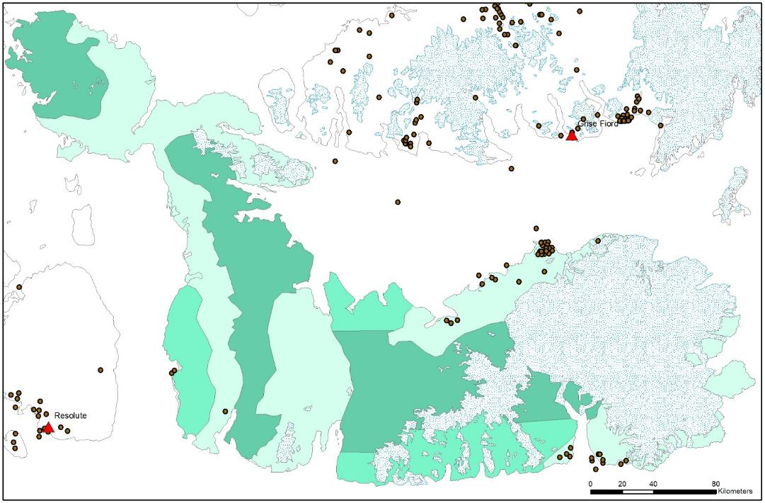
Figure 7. Locations of muskox harvest from Grise Fiord, Resolute Bay, and Arctic Bay, 1990-2015. Survey strata are indicated by shaded green – high density (pale green), intermediate density (bright green), low density (dark green).

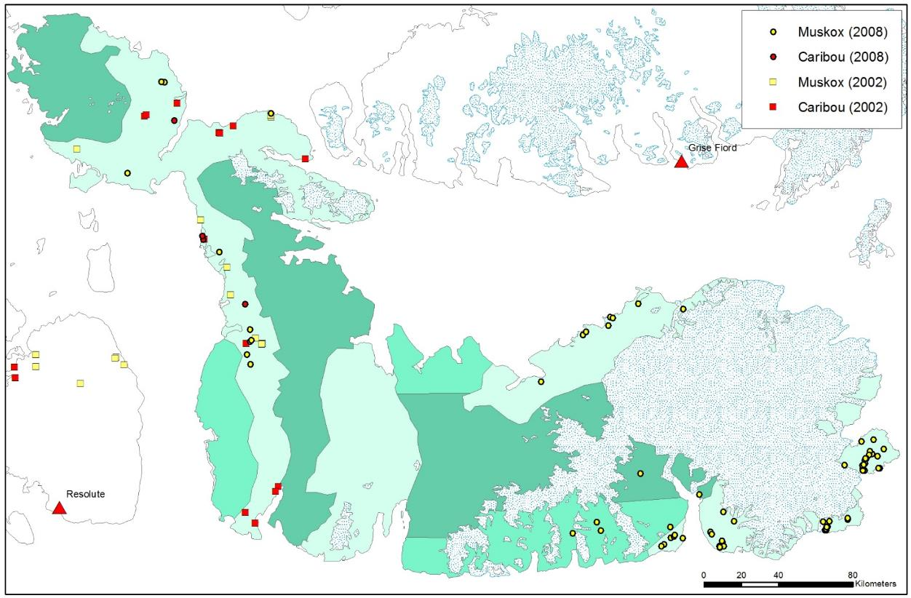
Figure 8. Locations of caribou and muskoxen seen on aerial surveys in 2002 and 2008. Survey strata are indicated by shaded green – high density (pale green), intermediate density (bright green), low density (dark green).

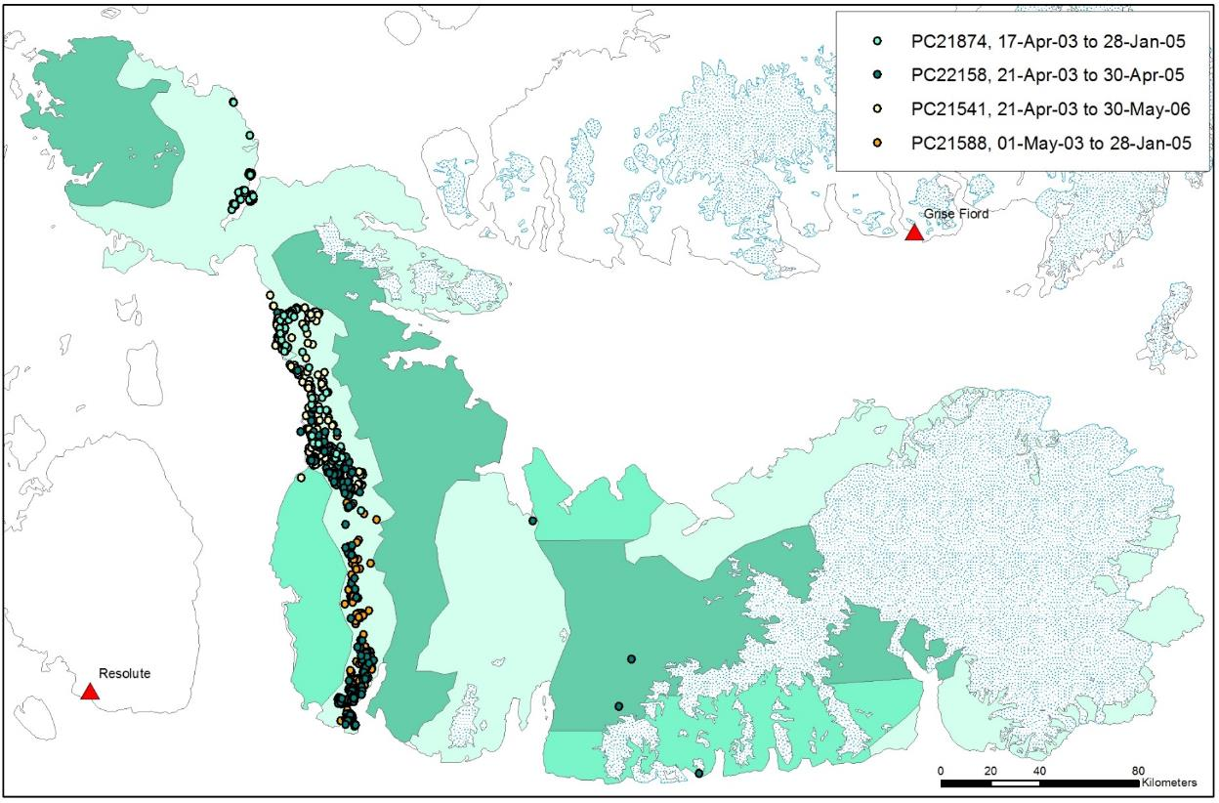
Figure 9. Telemetry locations of 4 collared female caribou, 2003-2006, on Devon Island. Survey strata are indicated by shaded green – high density (pale green), intermediate density (bright green), low density (dark green).

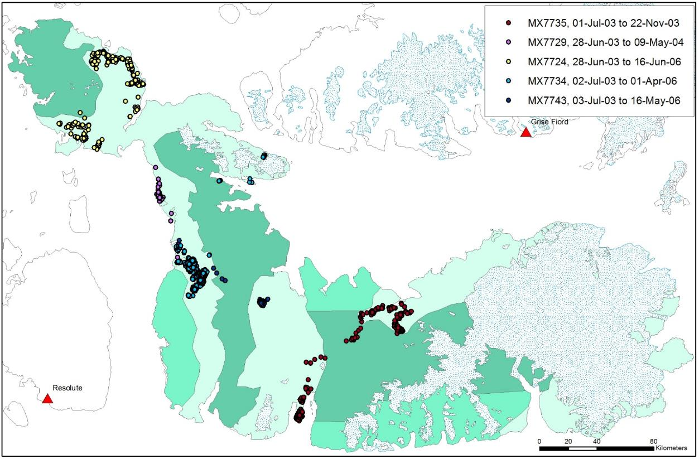
Figure 10. Telemetry locations of 5 collared female muskoxen, 2003-2006, on Devon Island. Survey strata are indicated by shaded green – high density (pale green), intermediate density (bright green), low density (dark green).
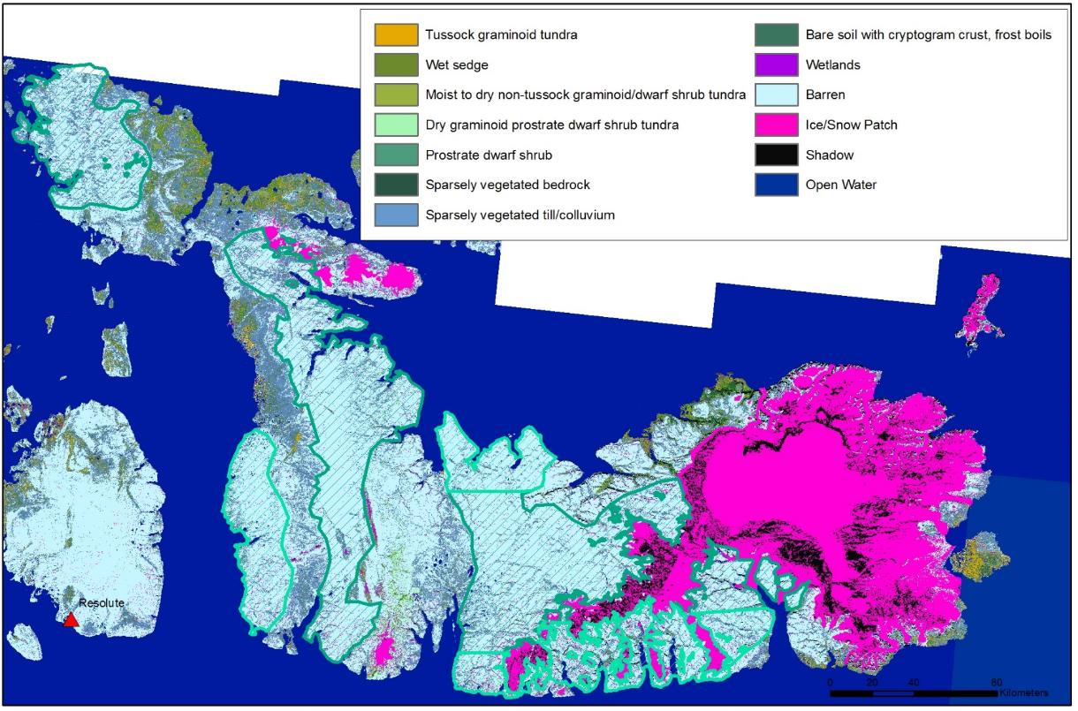
Figure 11. Land cover classification developed from Landsat imagery 1999-2002 (Olthof et al. 2008; available online through Natural Resources Canada). Survey strata are outlined and hatched by light green (intermediate density) or dark green (low density), with remaining non-icecap areas as high density strata.

Appendix 3. Alternate population calculations.

Jolly Method II Calculations
In this report, we used a systematic sampling approach to analysis, since we were estimating abundance of a patch population rather than estimating density in a habitat (which varied across the study area). Other systematic aerial surveys have frequently used Jolly’s Method II, and estimates derived from both analyses were similar. Population estimates for fixed-width strip sampling using Jolly’s Method 2 for uneven sample sizes (Jolly 1969; summarized in Caughley 1977) are derived as follows:

$$\hat{Y}=RZ=Z\frac{\sum_{i}{y_{i}}}{\sum_{i}{z_{i}}}$$

Where $\hat{Y}$ is the estimated number of animals in the population, $R$ is the observed density of animals (sum of animals seen on all transects $\sum_{i}{y_{i}}$ divided by the total area surveyed $\sum_{i}{z_{i}}$), and $Z$ is the total study area. The variance is given by:

$$Var\left(\hat{Y}\right)= \frac{N(N-n)}{n}\left(s_{y}^{2}-2Rs_{zy}+R^{2}s_{z}^{2}\right)$$

Where $N$ is the total number of transects required to completely cover study area $Z$, and $n$ is the number of transects sampled in the survey. $s_{y}^{2}$ is the variance in counts, $s_{z}^{2}$ is the variance in areas surveyed on transects, and $s_{zy}$ is the covariance. The estimate $\hat{Y}$ and variance $Var\left(\hat{Y}\right)$ are calculated for each stratum and summed. The Coefficient of Variation (CV = σ/$\hat{Y}$) was calculated as a measure of precision.

Table 5. Abundance estimates (Jolly 1969 Method II) for muskoxen on Devon Island, March 2016. N is the total number of transects required to completely cover study area Z, n is the number of transects sampled in the survey covering area z, y is the observed muskoxen, Y is the estimated muskoxen with variance Var(Y). The coefficient of variation (CV) is also included.
Stratum | Y | Var(Y) | n | Z  (km²) | z  (km²) | N | y | Density  (per km²) | CV
A | 1815.81 | 39767.06 | 117 | 18438.26 | 3479.02 | 288 | 344 | 0.098 | 0.110
B | 95.85 | 847.56 | 21 | 6359.77 | 597.17 | 138 | 9 | 0.015 | 0.400
C | 27.77 | undefined | 28 | 15076.34 | 1085.68 | 288 | 2 | 0.002
Total | 1939.43 |  | 166 | 39874.37 | 5161.87 | 288 | 355

Table 5. Abundance estimates (Jolly 1969 Method II) for Peary caribou on Devon Island, March 2016. N is the total number of transects required to completely cover study area Z, n is the number of transects sampled in the survey covering area z, y is the observed caribou, Y is the estimated caribou with variance Var(Y). The coefficient of variation (CV) is also included.
Stratum | Y | Var(Y) | n | Z  (km²) | z  (km²) | N | y | Density  (per km²) | CV
A | 70.46 | 1806.83 | 117 | 18438.26 | 3479.02 | 288 | 13 | 0.004 | 0.603
B | 0 |  | 21 | 6359.77 | 597.17 | 138 | 0 | 0
C | 0 |  | 28 | 15076.34 | 1085.68 | 288 | 0 | 0
Total | 70.46 |  | 166 | 39874.37 | 5161.87 | 288 | 13

Stratified Systematic Survey Calculations
Following Cochran (1977), the abundance estimate for a systematic survey is given by:

$$\hat{Y}= \frac{S}{w}×\sum{n_{i}}$$

Where $\hat{Y}$ is the population estimate, S is the transect spacing (5 km), w is the transect width (1 km), and n_{i} is the total number of animals observed on transect i, the sum of which is all animals observed on I transects in the survey. The configuration of the study area may mean that the actual sampling fraction (proportion of the study area that is surveyed) varies, which was partly why Cochran’s ratio estimator was used instead, and why the estimate varied between methods and stratification regimes. The variance is based on the sum of squared differences in counts between consecutive transects:

$$Var\left(Ŷ\right)= \frac{\frac{S}{w} × \left(\frac{S}{w}-1\right) ×I}{2×(I-1)} ×\sum{{(n_{i}-n_{i-1})}^{2}}$$

Table 6. Abundance estimates for a stratified systematic survey (Cochran 1977) of muskoxen on Devon Island, March 2016. I is the number of transects sampled.
Stratum | Estimated Abundance $\hat{Y}$ | Var($\hat{Y}$) | I | Transect Spacing S (km) | Transect Width w (km) | Observed Individuals y | Density  (per km²) | CV
A | 1720 | 67436.38 | 117 | 5 | 1 | 344 | 0.098 | 0.151
B | 90 | 2740.50 | 21 | 10 | 1 | 9 | 0.015 | 0.582
C | 30 | 871.11 | 28 | 15 | 1 | 2 | 0.002 | 0.984
Total | 1840 | 71047.99 | 166 |  |  | 355

Table 7. Abundance estimates for a stratified systematic survey (Cochran 1977) of Peary caribou on Devon Island, March 2016. I is the number of transects sampled.
Stratum | Estimated Abundance $\hat{Y}$ | Var($\hat{Y}$) | I | Transect Spacing S (km) | Transect Width w (km) | Observed Individuals y | Density  (per km²) | CV
A | 65 | 67436.38 | 117 | 5 | 1 | 13 | 0.004 | 0.557
B | 0 | 2740.50 | 21 | 10 | 1 | 0 | 0
C | 0 | 871.11 | 28 | 15 | 1 | 0 | 0
Total | 65 | 71047.99 | 166 |  |  | 13

Appendix 4. Daily flight summaries for south Ellesmere survey flown by Twin Otter, March 2015.
Table 8. Summary by day of survey flights and weather conditions for March 2015 Peary caribou and muskox survey, southern Ellesmere Island.
Date | Time Up | Time Down | Time Up 2 | Time Down 2 | Time Up 3 | Time Down 3 | Flying Time | Transect Time | Area | Comment
22-Mar-16 | 9:35 | 13:15 | 13:54 | 17:15 |  |  | 7:01 | 4:18 | Grinnell Peninsula | Clear, calm, -31°C, light wind ~20 kph at Arthur Fiord for fuel; right engine 'hiccup' but likely just water/ice in fuel line and fixed itself
23-Mar-16 | 10:00 | 13:45 |  |  |  |  | 3:45 | 1:03 | Grinnell Peninsula | Sunny clear calm -32°C except severe/moderate turbulence in hills s of Arthur Fiord; left generator not working so only one flight
24-Mar-16 | 9:05 | 13:20 | 14:25 | 17:35 |  |  | 7:25 | 4:59 | Colin Archer Peninsula; west coast | Clear -32°C slight wind N/NW ice crystals
25-Mar-16 | 8:45 | 13:00 | 13:41 | 17:34 |  |  | 8:08 | 5:17 | West coast | Clear -32°C with ice crystals/fog along south shore (unable to fly below 3000' so moved north); burning off in pm
26-Mar-16 | 9:08 | 13:35 | 14:15 | 18:11 |  |  | 8:23 | 5:28 | West central | -29°C clear some cloud/ice crystals/foggy cover at south end but burned off in pm. Late start/one flight since autofeather not engaging.
27-Mar-16 | 10:07 | 12:41 |  |  |  |  | 2:34 | 0:51 | YRB-YGF, some lines in between | -29°C clear, some low cloud west of transects
28-Mar-16 | 8:34 | 12:46 | 13:26 | 13:56 | 14:41 | 17:30 | 7:31 | 3:27 | Truelove and east coast | -30°C calm clear, landed at Truelove cache and scraped teflon off the left ski, so no more offstrip until its back to YRB for repair
29-Mar-16 | 7:50 | 12:00 | 12:46 | 16:25 |  |  | 7:49 | 16:13 | Dundas Harbor and south coast | -30°C clear calm, some cloud south over Lancaster Sound
30-Mar-16 | 9:54 | 13:05 |  |  |  |  | 3:11 | 1:35 | YGF-YRB, some lines in between | -30°C clear calm
Pilots – Phil Amos, Reagan Schroeder; Navigator - Morgan Anderson
Observers: Mar 22 – Morgan Anderson, Saroomie Manik, PJ Attagootak, James Iqaluk, Oolat Iqaluk
Mar 23 – Morgan Anderson, Saroomie Manik, PJ Attagootak, James Iqaluk, Oolat Iqaluk
Mar 24 – Morgan Anderson, Saroomie Manik, PJ Attagootak, James Iqaluk, Oolat Iqaluk
Mar 25 – Morgan Anderson, PJ Attagootak, Debbie Iqaluk, Oolat Iqaluk
Mar 26 – Morgan Anderson, PJ Attagootak, Debbie Iqaluk, Oolat Iqaluk
Mar 27 – Morgan Anderson, PJ Attagootak
Mar 28 – Morgan Anderson, Jopee Kiguktak, Aksakjuk Ningiuk, Frankie Noah, Simon Singoorie, Olaph Christianson
Mar 29 – Morgan Anderson, Jopee Kiguktak, Aksakjuk Ningiuk, Frankie Noah, Simon Singoorie, Junior Kakkee
Mar 30 – Morgan Anderson, PJ Attagootak

Appendix 5. Incidental wildlife observations.
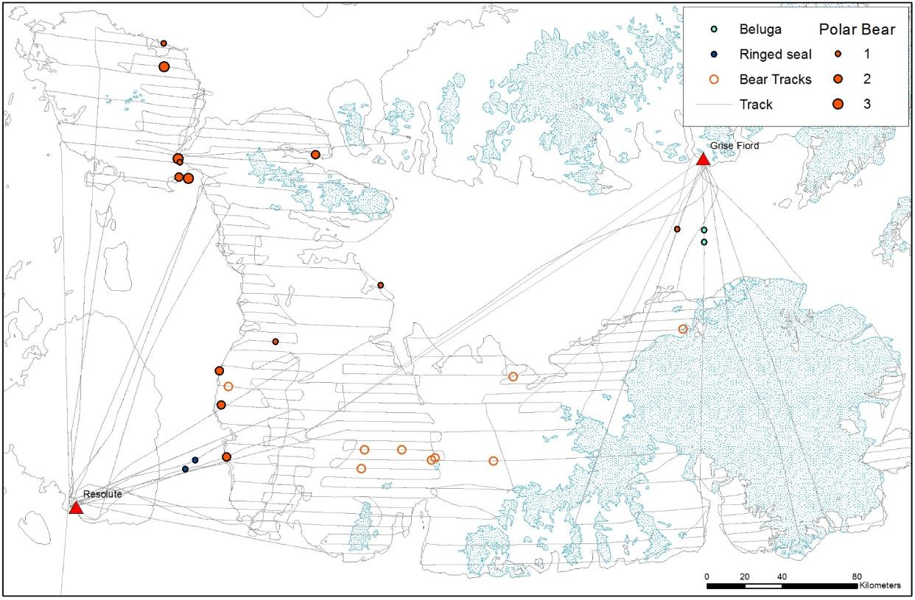
Figure 12. Incidental observations, Mar 22-30 2016, and flight lines for an aerial survey of Devon Island. Some track lines are incomplete due to loss of satellite coverage. A total of 37 polar bears were observed, as well as 5 ringed seals basking on the sea ice in Wellington Channel, and 2 groups of beluga (6 and 7 individuals) along the floe edge south of Grise Fiord. Polar bear family groups included very small cubs recently emerged from dens, and one den was seen with tracks, 40 km northwest of Maxwell Bay.

